**ASSIGNMENT-4**

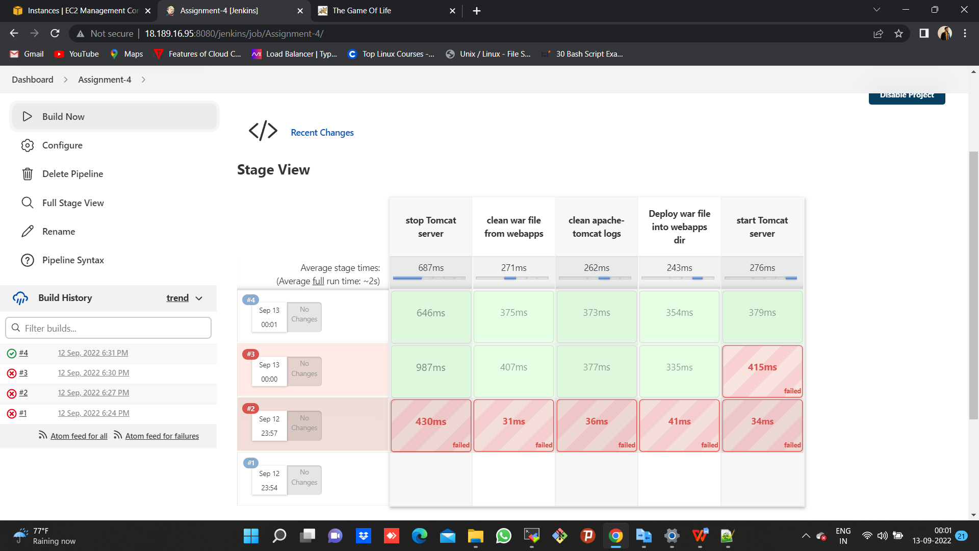

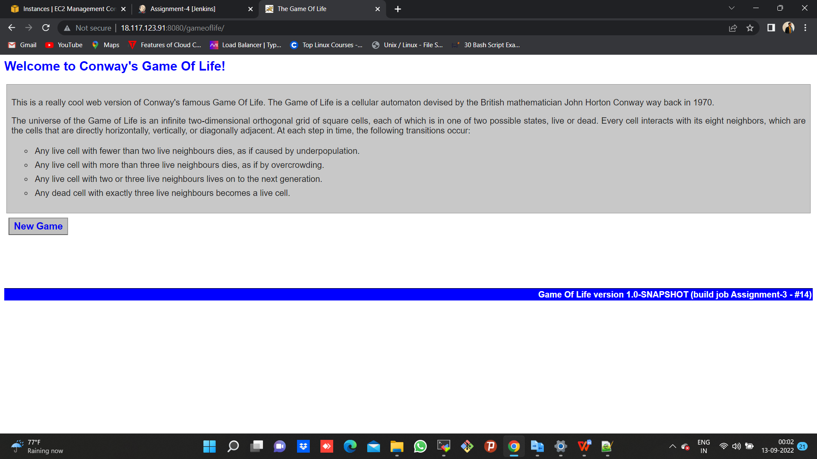

**CODE**

pipeline {

agent {

node {

label "172.31.30.34-Slave-2"

customWorkspace "/mnt/servers"

}

}

stages {

stage ('stop Tomcat server') {

steps {

dir ("apache-tomcat-9.0.65/bin") {

sh "bash shutdown.sh"

}

}

}

stage ('clean war file from webapps') {

steps {

dir ("apache-tomcat-9.0.65/webapps") {

sh "sudo rm -rf gameoflife.war"

}

}

}

stage ('clean apache-tomcat logs') {

steps {

dir ("apache-tomcat-9.0.65/logs") {

sh "sudo rm -rf *"

}

}

}

stage ('Deploy war file into webapps dir') {

steps {

sh "cp -r /mnt/projects/game-of-life-nup/gameoflife-web/target/gameoflife.war /mnt/servers/apache-tomcat-9.0.65/webapps"

}

}

stage ('start Tomcat server') {

steps {

dir ("apache-tomcat-9.0.65/bin") {

sh "bash startup.sh"

}

}

}

}

}