**1. Write the appropriate command to create the table in your database**

**Table name: edgeict**

Answer:

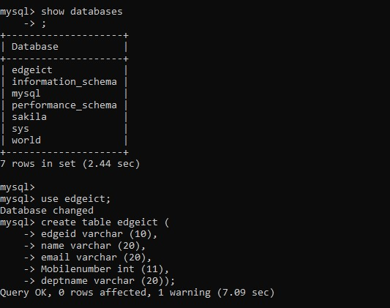

2. Insert at least ten records into the table edgeict

Answer:

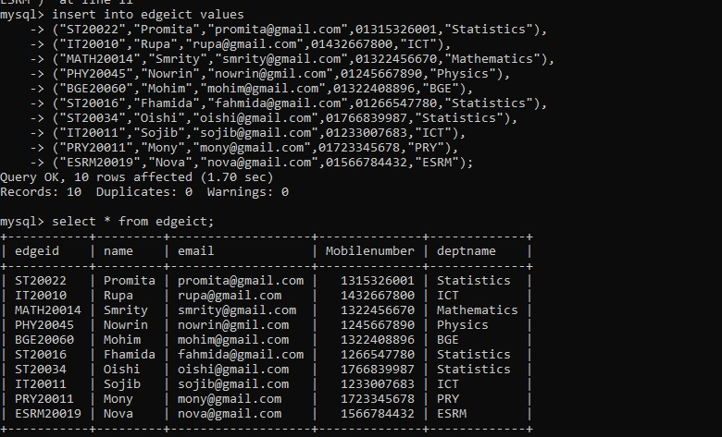

3. Write down the sql command to chage the column name deptname to departname

Answer:

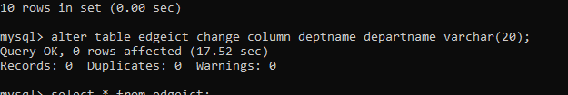

4. Write down the appropriate commands to show all records

Answer:

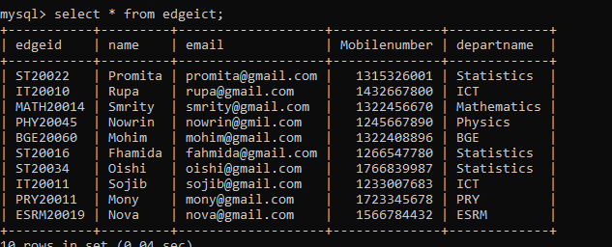

5. Write down the appropriate commands to show first 5 records.

Answer:

