EXPERIMENT 1
Containerize and Run a Simple Python
Web Application

Name | Nupur Bagave
USN | 01FE24BCI029
Division | A
Roll No. | 125

1. Objective and Learning Outcomes
The supplied lab document defines this experiment as an introduction to application containerization. The workflow is: create a Flask application, define its dependency, create a Dockerfile, build the image, run the container, verify the port mapping, inspect logs, and access the application through the browser.
- Create a basic Python Flask web application.
- Create and understand a Dockerfile.
- Build a Docker image from the application files.
- Create and run a Docker container.
- Map a host port to a container port and access the application through a browser.

2. Project Files
The project folder used in the actual execution was:
C:\Users\Nupur\docker-python-app
The directory listing in the execution shows the following files:
- app.py
- Dockerfile
- requirements.txt

3. Application and Docker Configuration
The experiment document specifies the following Flask application:
from flask import Flask
app = Flask(__name__)
@app.route("/")
def home():
return "Hello! My first Docker application is running."
app.run(host="0.0.0.0", port=5000)
requirements.txt:
flask
Dockerfile:
FROM python:3.12-slim
WORKDIR /app
COPY requirements.txt .
RUN pip install -r requirements.txt
COPY app.py .
EXPOSE 5000
CMD ["python", "app.py"]

4. Execution and Command Outputs

4.1 Verify Docker Installation and Hello World
The Docker installation was verified using the Docker version command, followed by the Docker Hello World test container.
docker --version
docker run hello-world
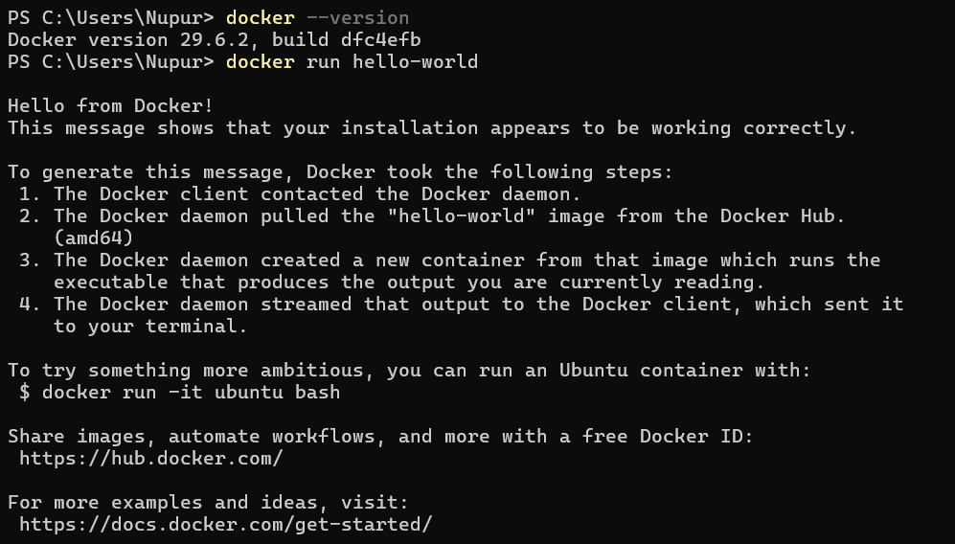
Figure 1: PowerShell output showing Docker version 29.6.2 and successful docker run hello-world execution.

4.2 Create and Verify the Project Directory
The project directory was created as docker-python-app. The actual execution used C:\Users\Nupur\docker-python-app rather than the Desktop location shown in the generic lab document.
mkdir docker-python-app
cd docker-python-app
dir
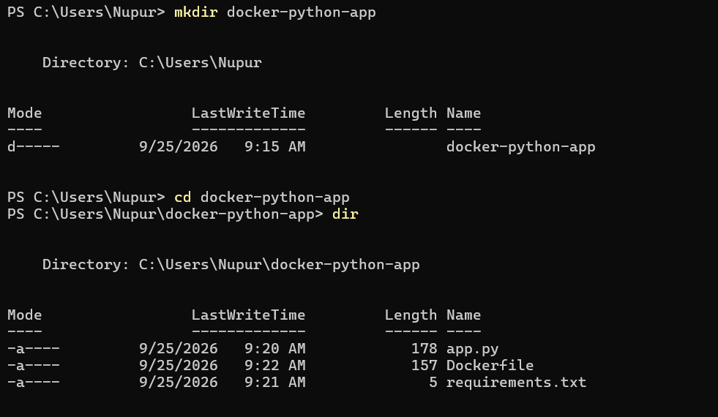
Figure 2: PowerShell output showing creation of docker-python-app and the project files app.py, Dockerfile, and requirements.txt.

4.3 Build the Docker Image
The image was built from the project directory using the command specified in the experiment.
docker build -t my-python-app .
The build completed successfully. Docker used python:3.12-slim as the base image, installed Flask from requirements.txt, copied app.py, and created the image tagged as my-python-app:latest.
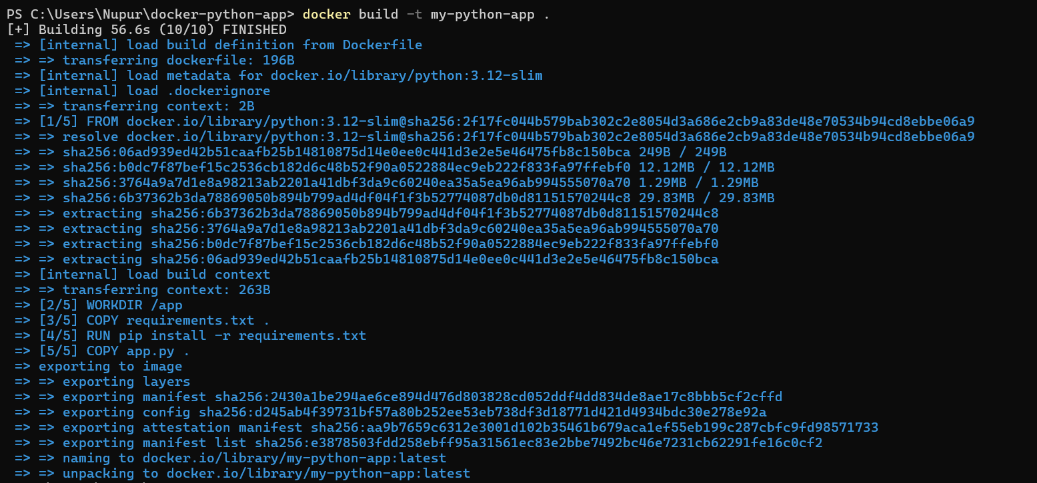
Figure 3: Successful Docker image build for my-python-app using python:3.12-slim.

4.4 Check Images, Run the Container, and Inspect Logs
The created image was checked and then started as a background container with port 5000 mapped from host to container.
docker images
docker run -d -p 5000:5000 --name my-python-container my-python-app
docker ps
docker logs my-python-container
The output confirms that my-python-container is running from the my-python-app image, with 0.0.0.0:5000 mapped to container port 5000. The Flask server is listening on all interfaces at port 5000.
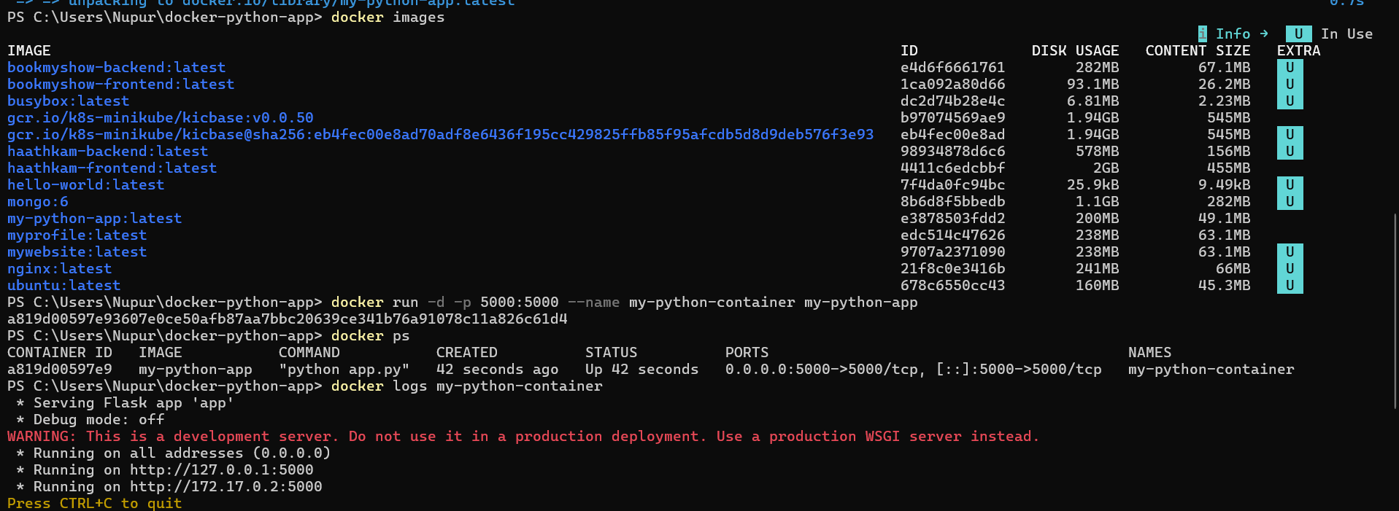
Figure 4: Docker image listing, container creation, docker ps status, port mapping, and Flask container logs.

4.5 Access the Application Through the Browser
The application was accessed at:
http://localhost:5000
The browser displayed the expected Flask response, demonstrating that the host port was successfully forwarded to port 5000 inside the Docker container.
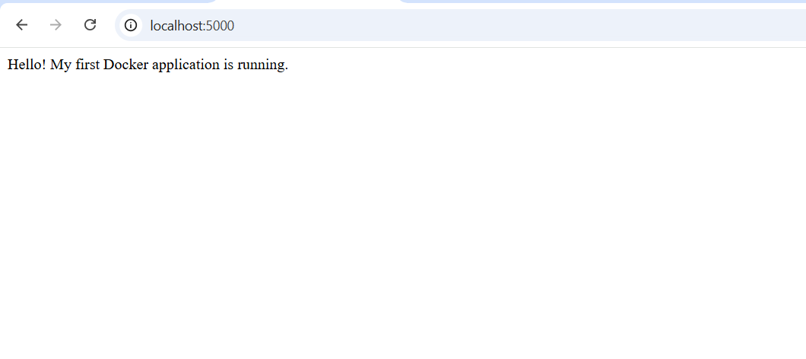
Figure 5: Browser output showing the running Flask application at http://localhost:5000.

5. Working of the Experiment
The complete workflow follows the architecture described in the supplied lab document:
Component | Role
app.py | Python Flask application
requirements.txt | Required Python package(s)
Dockerfile | Instructions for creating the Docker image
docker build | Builds the reusable Docker image
my-python-app | Docker image containing the application and runtime
docker run | Creates and starts a container from the image
my-python-container | Running container instance
Port 5000 | Connects the host port to the container port
http://localhost:5000 | Browser endpoint used to access the application

6. Important Docker Commands Used
Command | Purpose
docker --version | Check installed Docker CLI version.
docker run hello-world | Verify that Docker can download and run a test container.
mkdir docker-python-app | Create the project directory.
cd docker-python-app | Move into the project directory.
dir | List project files in PowerShell.
docker build -t my-python-app . | Build and tag the Docker image.
docker images | List locally available Docker images.
docker run -d -p 5000:5000 --name my-python-container my-python-app | Run the application container in the background and map ports.
docker ps | Display currently running containers.
docker logs my-python-container | Display application/container logs.
docker stop my-python-container | Stop the running container.
docker start my-python-container | Start the existing stopped container again.
docker rm my-python-container | Remove the container.
docker ps -a | Display running and stopped containers.

7. Result
Result: The Python Flask web application was successfully containerized using Docker. The image my-python-app was built successfully, the container my-python-container was started with host port 5000 mapped to container port 5000, and the application was successfully accessed through http://localhost:5000.

8. Conclusion
This experiment demonstrates the basic Docker containerization workflow described in the supplied lab document: source code → Dockerfile → Docker image → Docker container → port mapping → browser. The successful command outputs and browser result confirm that the Flask application is running inside the Docker container.

