*Visualization Engineering, Fall 2018*

**Visualization Project in R**

Group 16

Nupur Dongare

Sreya Pedamalla

929-435-2083

313-564-9222

[dongare.n@husky.neu.edu](mailto:dongare.n@husky.neu.edu)

pedamalla.s@husky.neu.edu

**Percentage of Effort Contributed by Student 1: 50%**

**Percentage of Effort Contributed by Student 2: 50%**

**Signature of Student 1: Nupur Dongare**

**Signature of Student 2: Sreya Pedamalla**

**Submission Date: 18/10/2018**

#### Interactive chart 1

Rate of Fatalities Vs Rate of Illness.

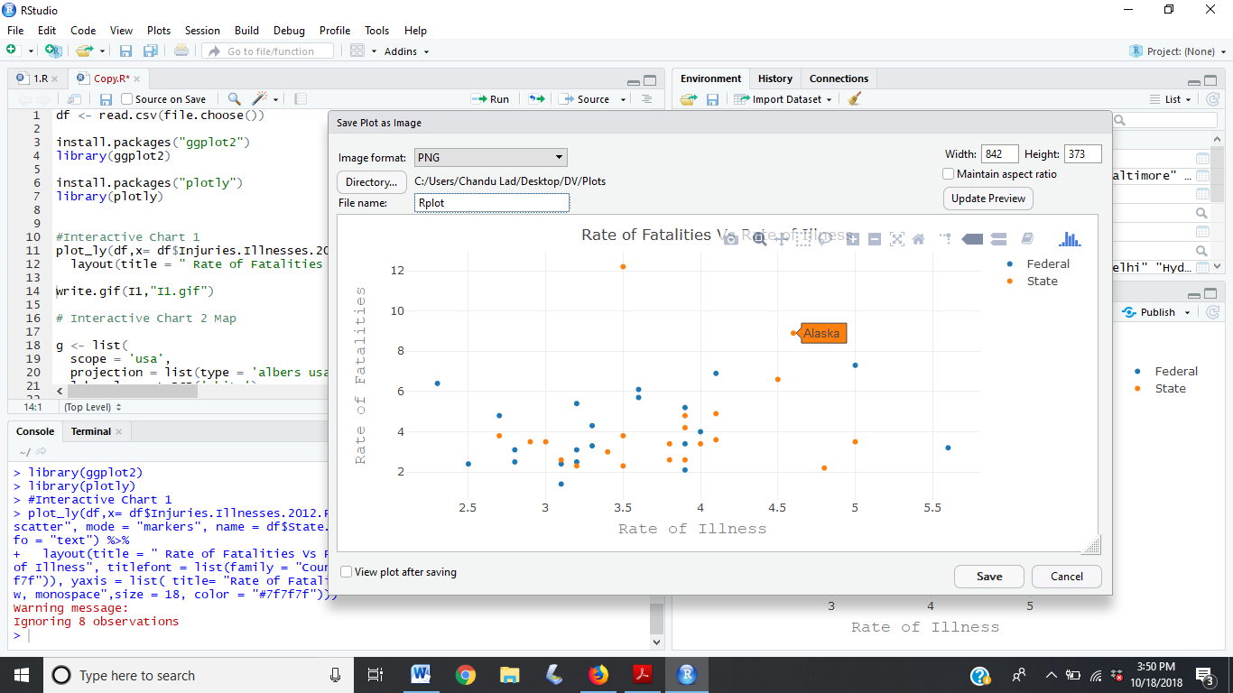

## Interactive chart 2

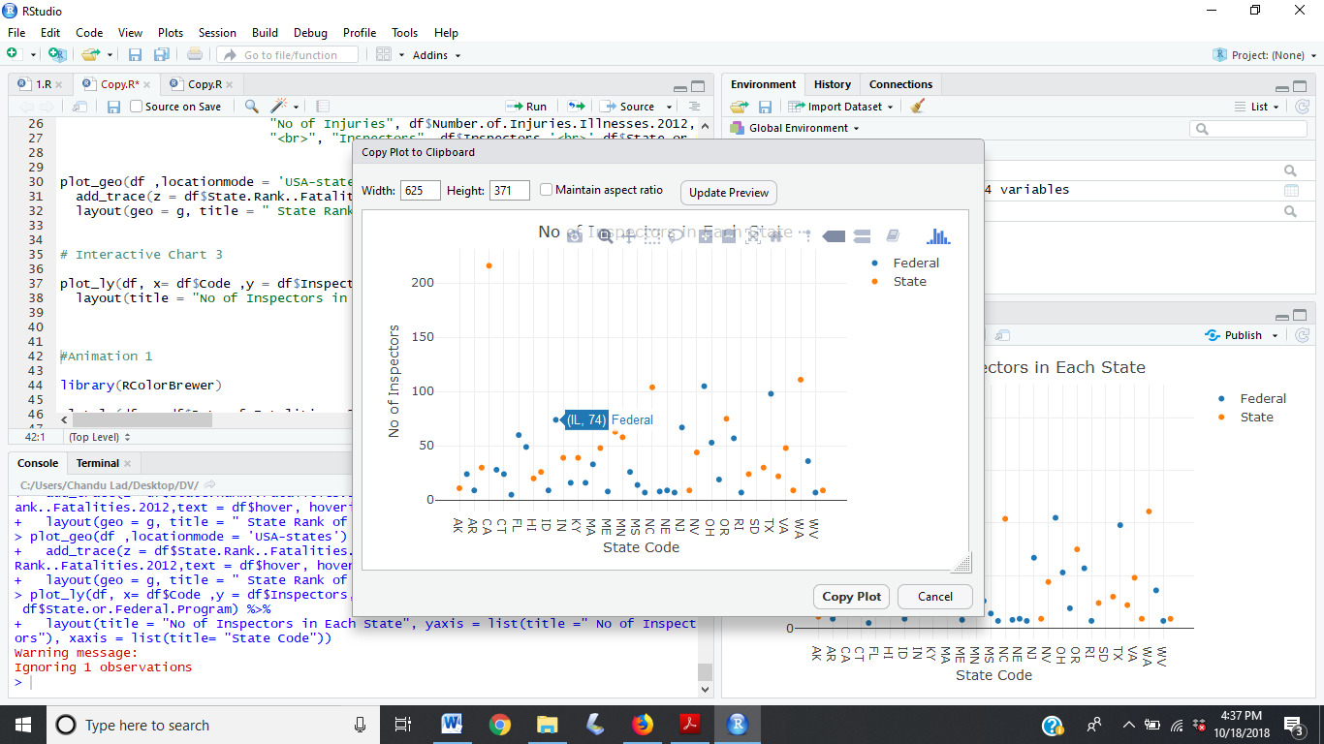

#### Interactive Chart 3

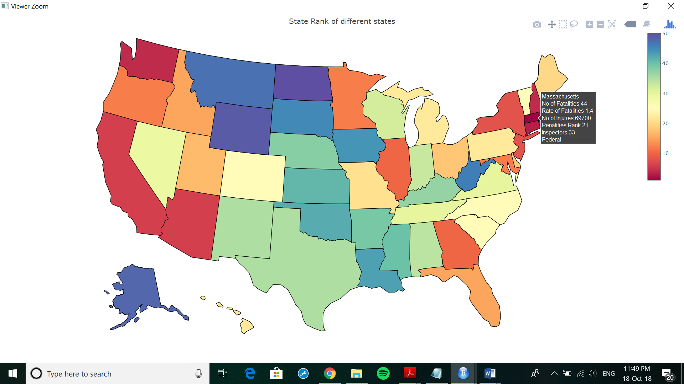

#### Animation chart 1

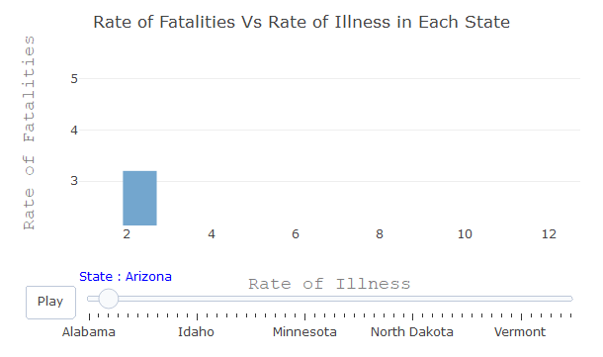

#### Animated Chart 2

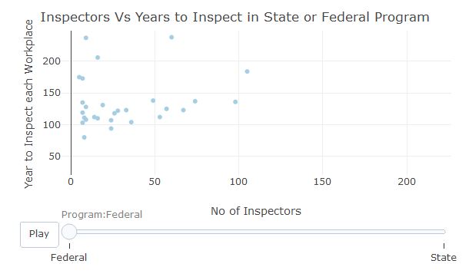

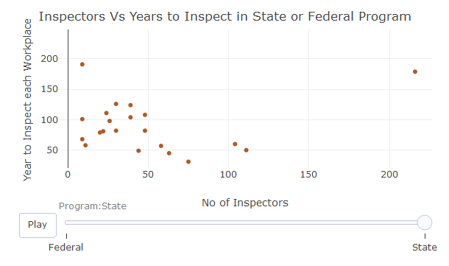

#### Animated Chart 3

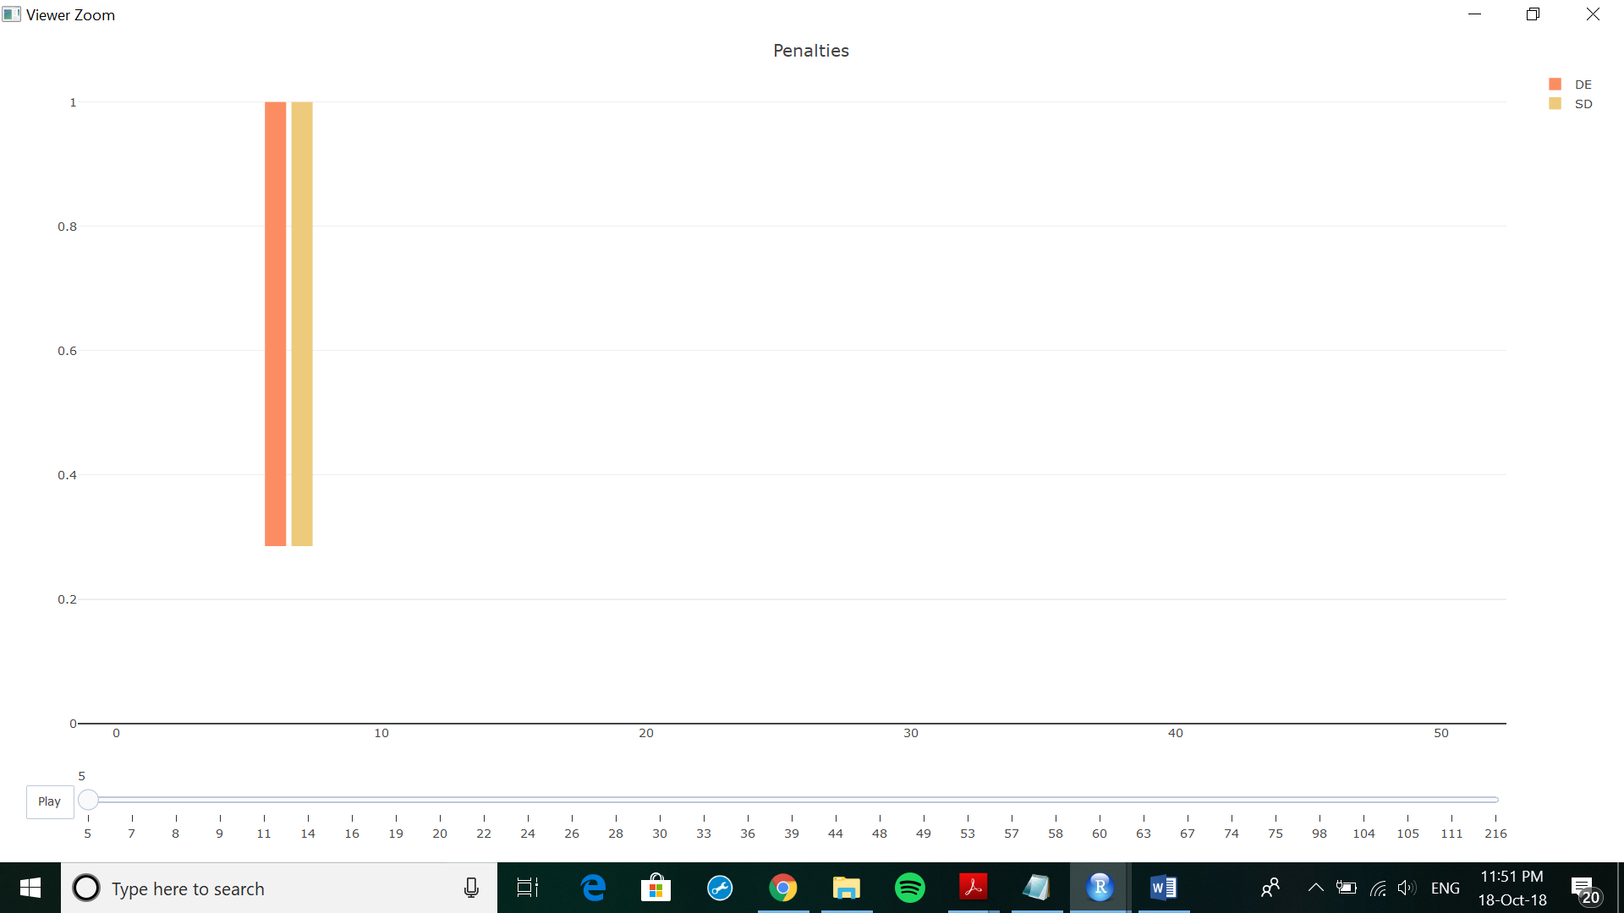

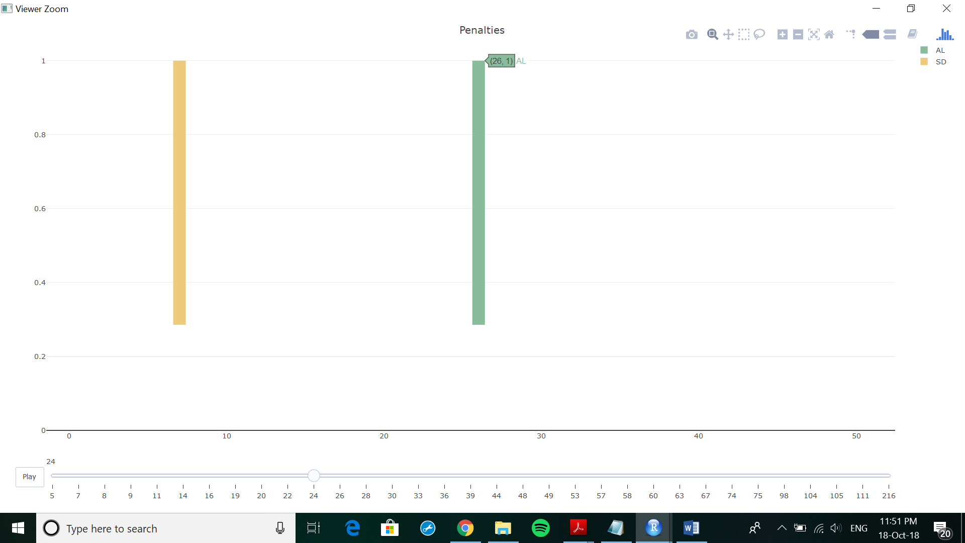

#### Static Chart 1

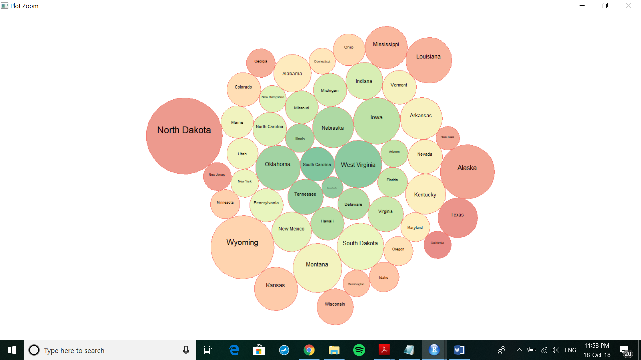

#### Static Chart 2

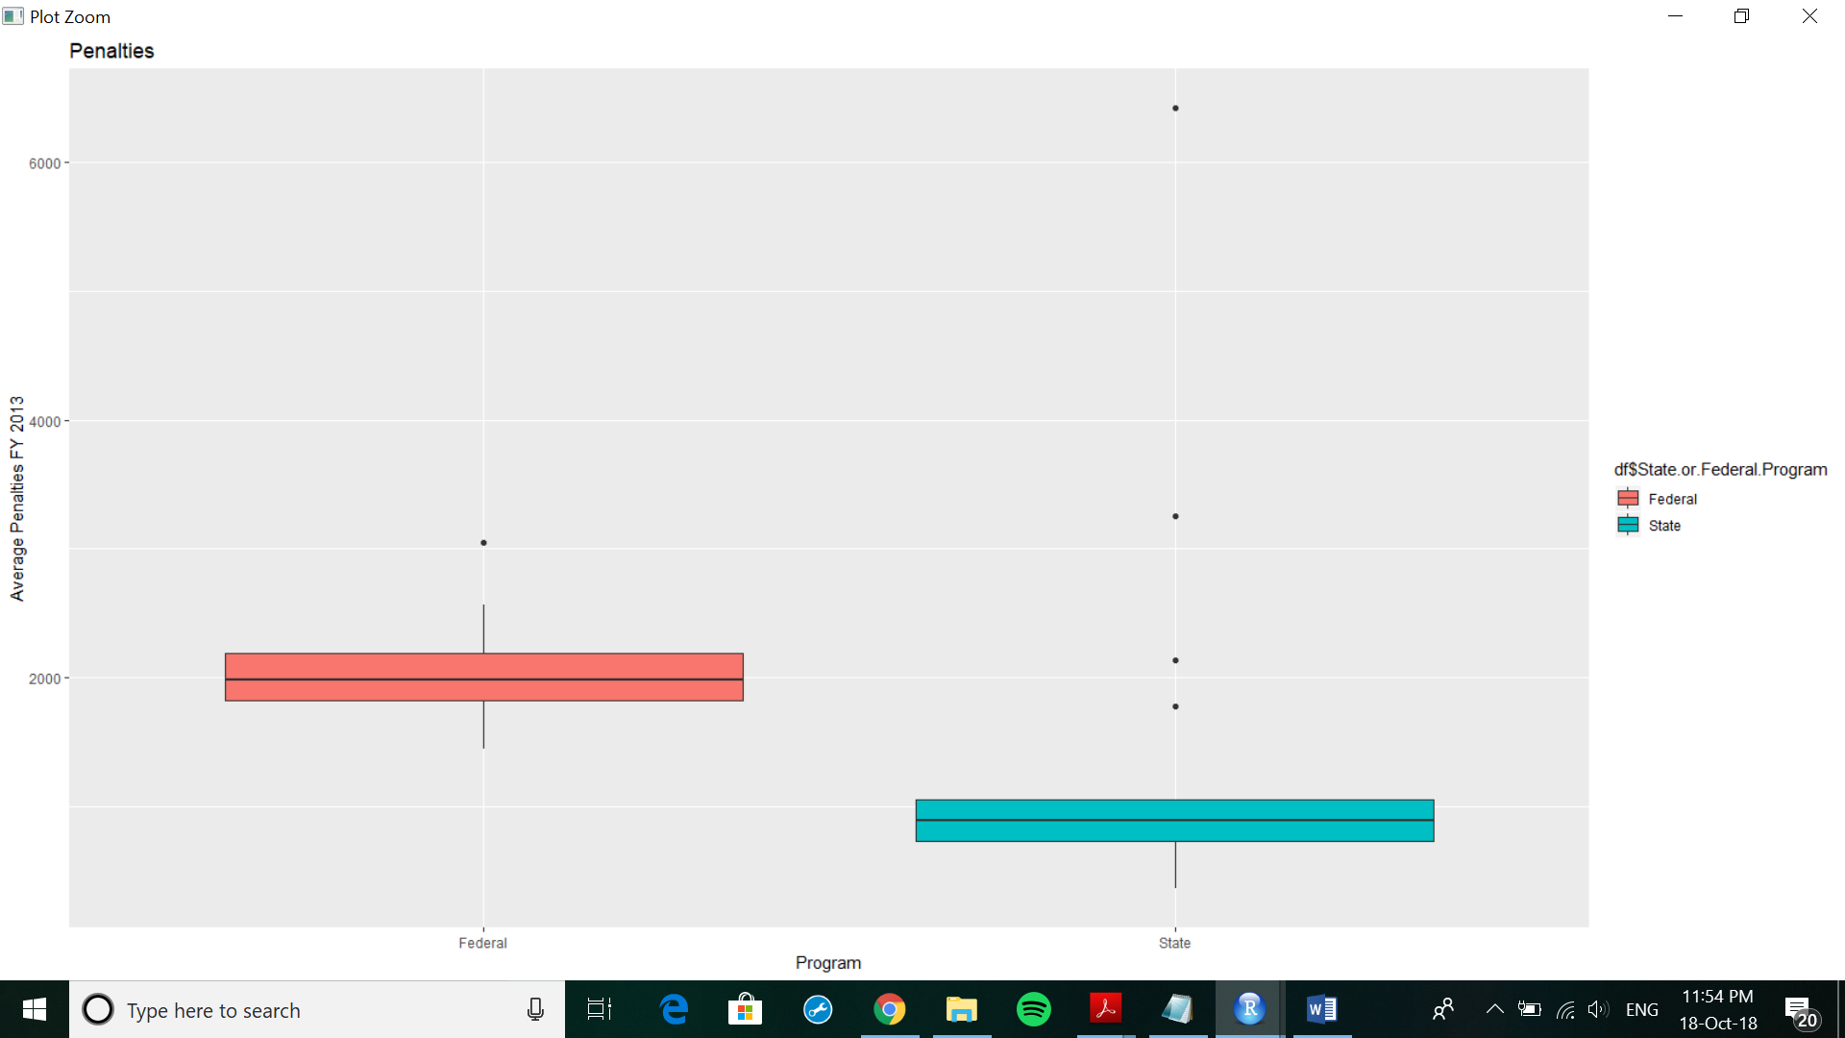

#### Static Chart 3

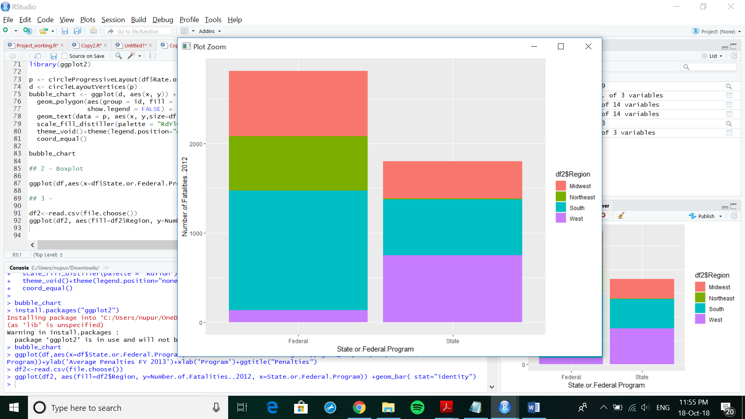

Conclusion:

We studied the US Workplace Public Health & Safety dataset for favorable insights to the viewer.