# Assignment #5: Introduction to JavaScript

Course: Web Technologies

Project: CloseWant Website

Student: Nurdaulet Omar

Group: SE-2401

Date: October 2025

# 1. Objective

The goal of this assignment is to learn how to create interactive web features using JavaScript, including form validation, accordions, pop-up forms, background color changes, and displaying the current date and time.

# 2. Task 1: Form Validation

Implemented on the contact page. The form validates the name, email, and message fields before submission. If any field is empty or invalid, an alert message is shown. When the form is correctly filled, a success popup appears.

Screenshot 1: 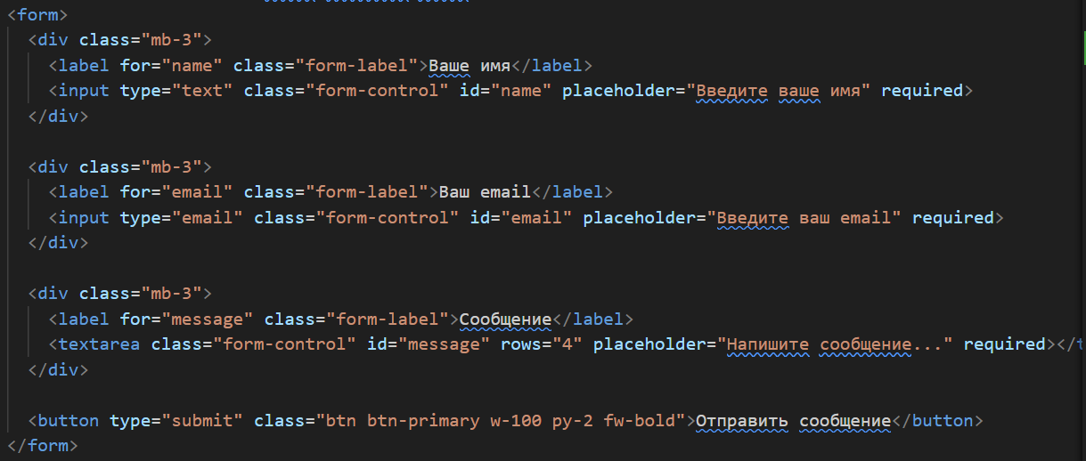

Screenshot 2: 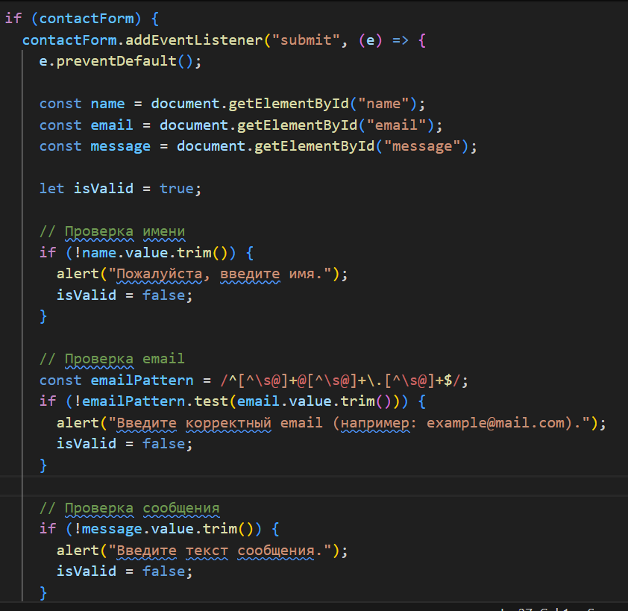

Screenshot 3: 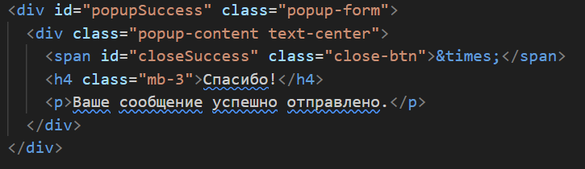

# 3. Task 2: Accordion for FAQs

Added an accordion section in the About page (about.html) using Bootstrap. Each question expands or collapses to show or hide the answer with a smooth animation.

Screenshot 4: 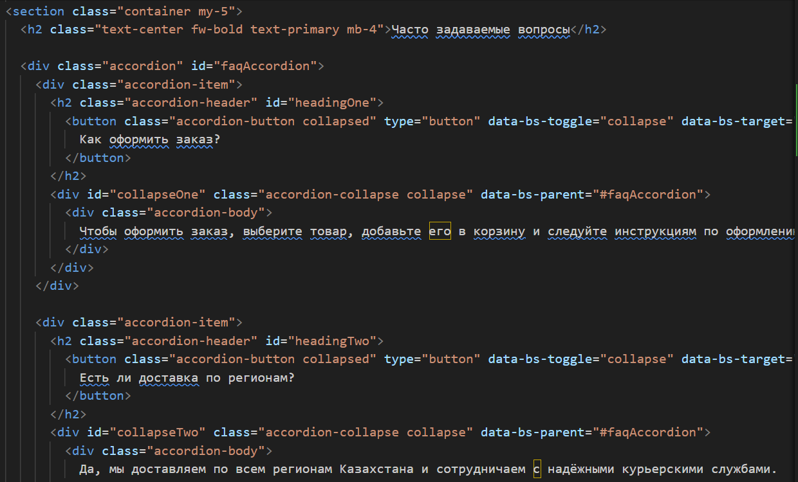

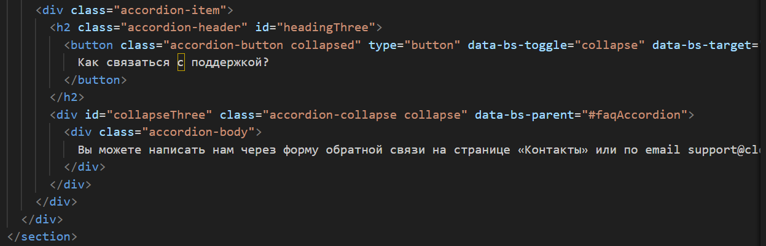

# 4. Task 3: Popup Subscription / Contact Form

A pop-up subscription form is implemented on the main page (index.html). When the user clicks the subscribe button, a popup window appears, allowing them to enter their email. The email is validated before submission.

Screenshot 5:

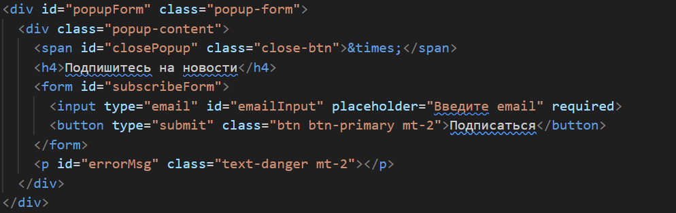

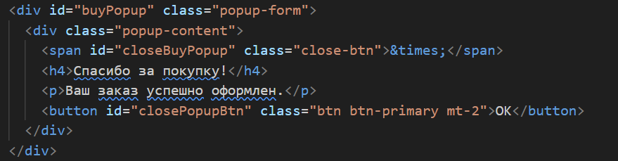

Screenshot 6: 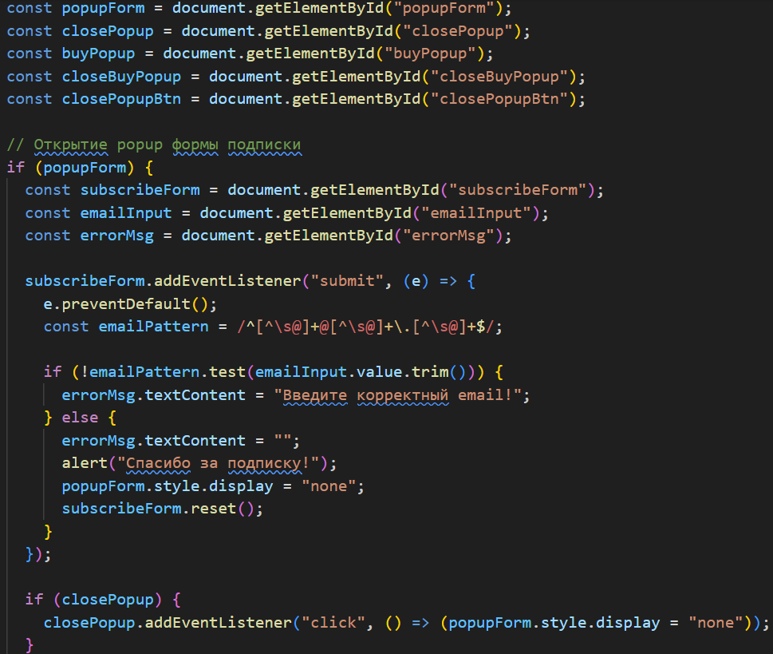

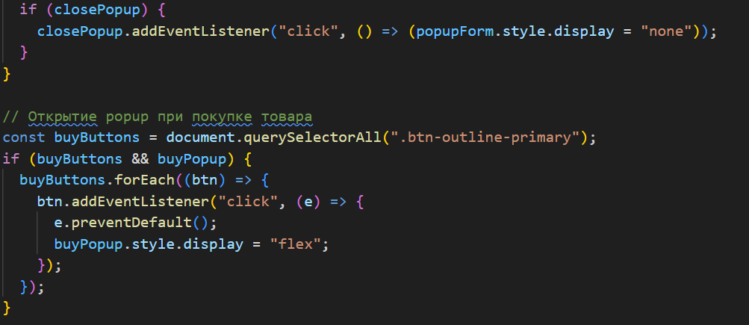

# 5. Task 4: Change Background Color

A floating button was added to all pages. When clicked, it changes the background color of the page dynamically, cycling through a predefined list of colors.

Screenshot 7:



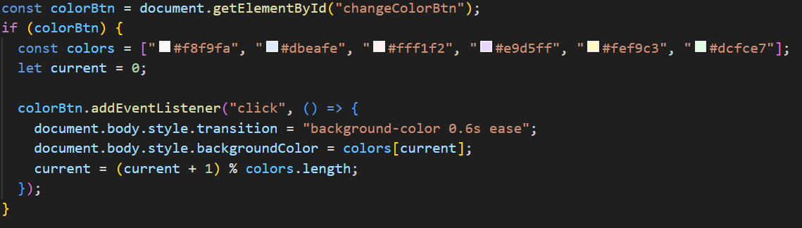

# 6. Task 5: Display Current Date and Time

Using JavaScript’s Date object, the current date and time are displayed dynamically at the bottom of each page (in the footer). The date updates every second.

Screenshot 8:



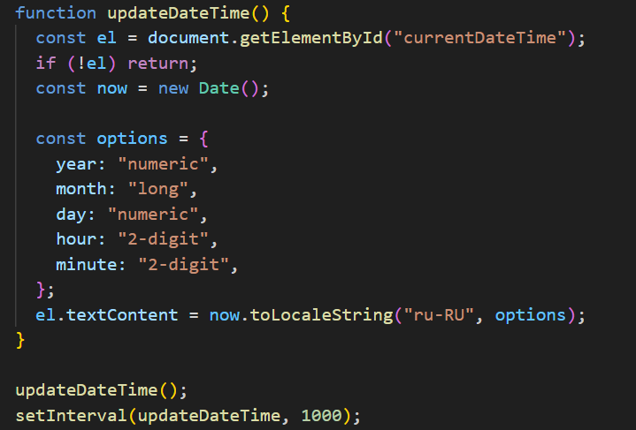

# 7. Website Deployment

The project was deployed using GitHub Pages / Netlify. All files (HTML, CSS, JS, and images) were uploaded to the repository. Below is the live website URL:

[Paste your live URL here]

# 8. Conclusion

Through this assignment, I gained practical experience in using JavaScript to enhance user interactivity on a website. I learned how to validate forms, implement accordions, manage popups, dynamically update webpage styles, and display real-time information using JavaScript's Date object.