Report: Programming Project 1

Nur Arafat

P100096845

# Code

## HelloWorld.java

**package** edu.ohio.ise.ise6900.helloworld;

/*

* ISE6900 Object Oriented Application in Industrial Engineering

* Programming Project 01

*

* @author Nur Shomik Arafat

* Date: 2017-01-14

* @version 1.0

*

*/

/**

* Demonstration of a simple Hello-World class.

* The class consists of only the main() method that prints

* "Hello, Java World!"

*/

**public** **class** HelloWorld {

/**

* **@param** args

*/

**public** **static** **void** main(String[] args) {

System.***out***.println("Hello, Java World!");

}

}

## Rectangle.java

**package** edu.ohio.ise.ise6900.geometry.rectangle;

/*

* ISE6900 Object Oriented Application in Industrial Engineering

* Programming Project 01

*

* @author Nur Shomik Arafat

* Date: 2017-01-14

* @version 1.0

*

*/

**import** java.util.Scanner;

/**

* Class Rectangle represents a geometric Rectangle.

* It has two attributes: width and height.

* The class has methods that calculate other measurements

* for the rectangle using the width and the height.

*

* **@author** Nur Shomik Arafat

*

*/

**public** **class** Rectangle {

/**

* Class attributes:

* Class Rectangle has two attributes:

* Width and Height

*/

**private** **double** width, height;

/**

* **@return** the area of the rectangle

*/

**protected** **double** getArea(){

**return** **this**.width * **this**.height;

}

/**

* **@return** the perimeter of the rectangle

*/

**protected** **double** getPerimiter(){

**return** 2 * (**this**.width + **this**.height);

}

/**

* **@return** the diagonal of the rectangle

*/

**protected** **double** getDiagonal(){

**return** Math.*sqrt*(Math.*pow*(width, 2) + Math.*pow*(height, 2));

}

/**

* **@return** the area of the circumscribed circle

*/

**protected** **double** getAreaOfCircumscribedCircle(){

**return** Math.***PI*** * Math.*pow*((**this**.getDiagonal()/2), 2);

}

/**

* **@param** args

*/

**public** **static** **void** main(String[] args) {

Rectangle rec = **new** Rectangle();

Scanner sin = **new** Scanner(System.***in***);

System.***out***.print("Please enter height and width.\n Height: ");

rec.setHeight(Double.*parseDouble*(sin.nextLine()));

System.***out***.print(" Width: ");

rec.setWidth(Integer.*parseInt*(sin.nextLine()));

sin.close();

System.***out***.println(rec.toString());

System.***out***.println("Area of the rectangle: " + rec.getArea());

System.***out***.println("Perimeter of the rectangle: " + rec.getPerimiter());

System.***out***.println("Length of diagonal of the rectangle: " + rec.getDiagonal());

System.***out***.println("Area of the circumscribed circle of the rectangle: " + rec.getAreaOfCircumscribedCircle());

}

/* (non-Javadoc)

* @see java.lang.Object#toString()

*/

@Override

**public** String toString() {

**return** "Rectangle [width=" + width + ", height=" + height + "]";

}

/* (non-Javadoc)

* @see java.lang.Object#hashCode()

*/

@Override

**public** **int** hashCode() {

**final** **int** prime = 31;

**int** result = 1;

result = (**int**) (prime * result + height);

result = (**int**) (prime * result + width);

**return** result;

}

/* (non-Javadoc)

* @see java.lang.Object#equals(java.lang.Object)

*/

@Override

**public** **boolean** equals(Object obj) {

**if** (**this** == obj)

**return** **true**;

**if** (obj == **null**)

**return** **false**;

**if** (getClass() != obj.getClass())

**return** **false**;

Rectangle other = (Rectangle) obj;

**if** (height != other.height)

**return** **false**;

**if** (width != other.width)

**return** **false**;

**return** **true**;

}

/**

* **@return** the width of the rectangle

*/

**public** **double** getWidth() {

**return** width;

}

/**

* **@param** width the width to set of the rectangle

*/

**public** **void** setWidth(**double** width) {

**this**.width = width;

}

/**

* **@return** the height of the rectangle

*/

**public** **double** getHeight() {

**return** height;

}

/**

* **@param** height the height to set of the rectangle

*/

**public** **void** setHeight(**double** height) {

**this**.height = height;

}

}

# Screen-shots

## HelloWorld.java

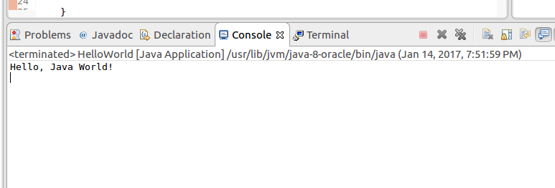

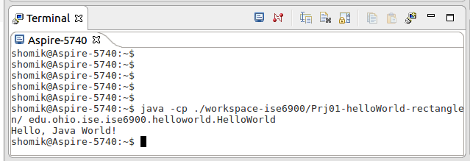

## Rectangle.java

