SCHOOL OF INDIA, K.R. PET

HOBBY CLASS REPORT 2026-27

Std: ____VII_______ Date: __9/7/2026_________

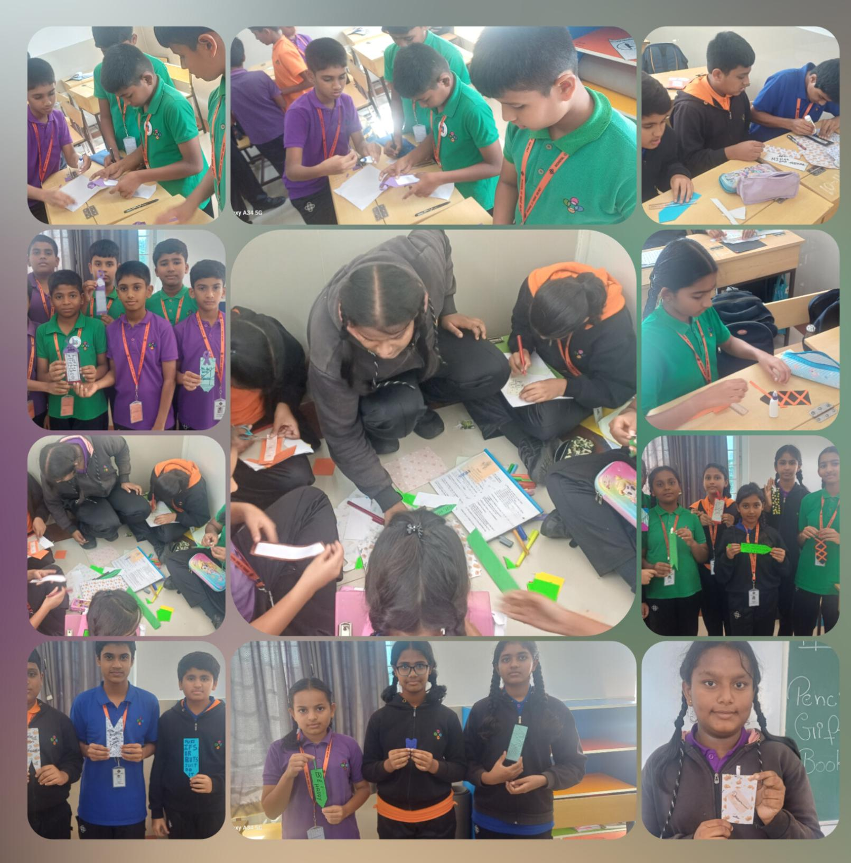
- Activity: ________Book marker

Signature of Teacher In Charge:

