How to login in the system?
ወደ ሲይስተሙ እንዴት ይገባሉ?
You use in the form of the below figure You must use capita letter and small letter appropriately

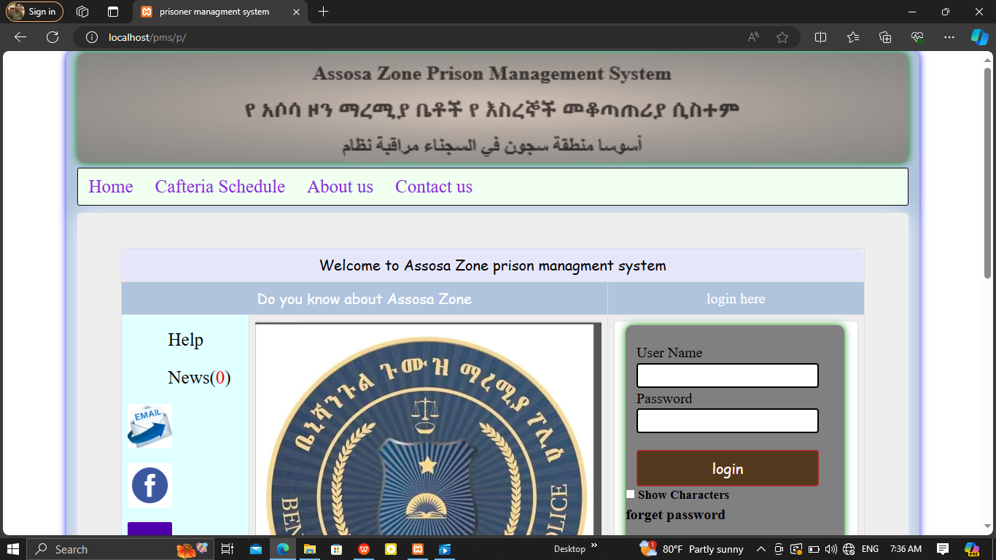
Enter your usearname properly
Enter your password properly
After you enter data login to the sysytem
If you need see your password you can cheak by clik show character password

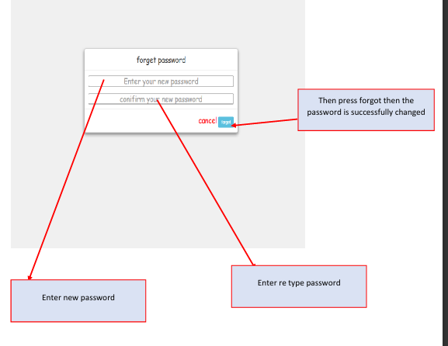

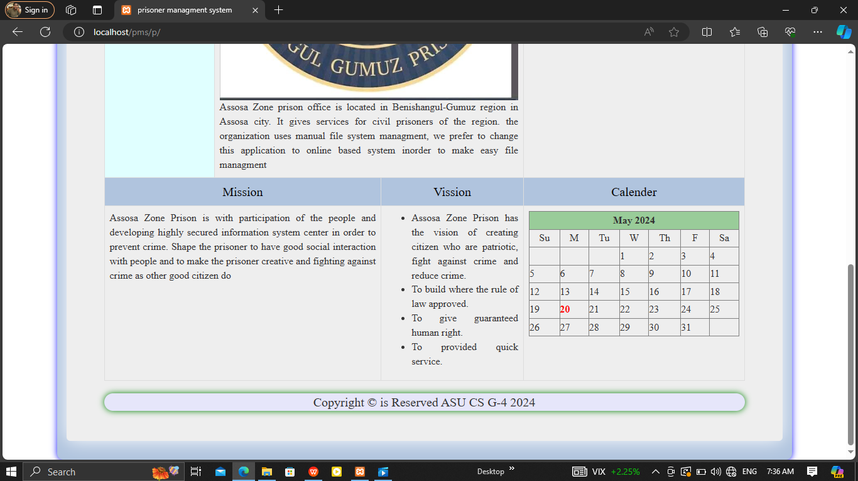
This all about our organaization information and don’t concern about this

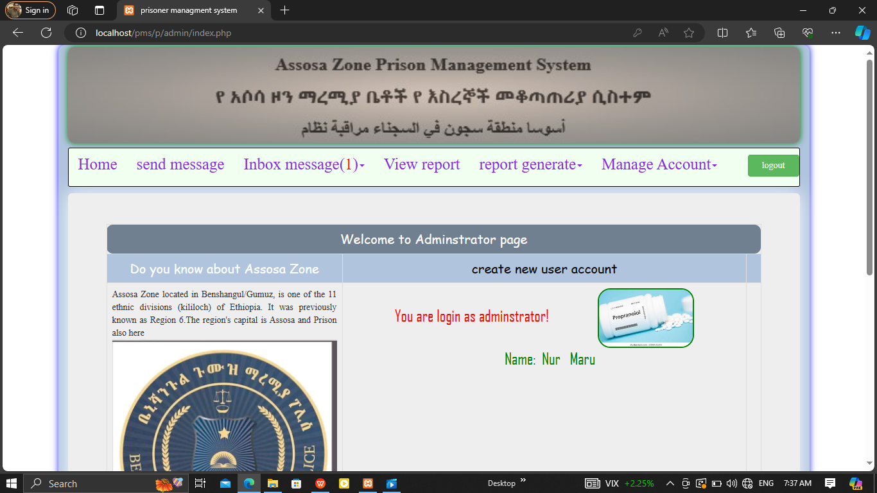
If you need logout to the system click logout

Assosa Zone Prison Management System

