Final Project Report
Students: Akhmetov Nurali, Yergalyuly Daniyar, Talasbek Kasymbek
Group: SE-2404
Abstract
This report presents the RWA Governed Protocol, a full-stack blockchain final project built with Solidity, Foundry, React, ethers.js, and The Graph-compatible indexing. The system implements an asset-backed governance token, an ERC4626-style vault, a constant-product AMM, a Chainlink-style oracle adapter, proposal voting with timelock execution, a UUPS-style issuer upgrade path, and a classroom-ready frontend demo. The project was validated with deterministic Foundry tests, fuzz tests, invariant tests, frontend production build checks, static analysis evidence, deployment documentation, and screenshots from the working dApp.

1. Introduction
The selected final project direction is an RWA tokenization platform. The goal is to demonstrate how a decentralized protocol can represent off-chain collateral on-chain, route that token through DeFi primitives, and place system changes under transparent governance. The implementation is intentionally broad: it combines token standards, upgradeability, oracle integration, AMM mechanics, vault accounting, event indexing, and a usable frontend.
From the user perspective, the application supports connecting MetaMask, checking wallet RWA balance, delegating voting power, depositing into a vault, interacting with AMM liquidity, and voting on proposals. From the evaluator perspective, the repository includes source contracts, tests, documentation, screenshots, deployment scripts, and a reproducible local Anvil demo path.

2. Development Environment and Tools
- Solidity and Foundry were used for contract development, compilation, unit testing, fuzz testing, invariant testing, coverage, and deployment scripting.
- React, Vite, and ethers.js were used for the frontend dApp and wallet transaction flow.
- The Graph subgraph schema and mappings were prepared for protocol event indexing.
- Slither was used as the static analysis tool for security-oriented checks.
- Local Anvil chain 31337 is used for a clean classroom demo when external L2 faucets are unavailable.
- The L2 deployment path is parameterized for Arbitrum Sepolia, Base Sepolia, Optimism Sepolia, and zkSync Sepolia.

3. Requirement Coverage Matrix
Rubric requirement | Implementation | Evidence
Advanced Solidity | UUPS proxy path, CREATE/CREATE2 factory, inline Yul utility | src/upgrade, src/factory, src/utils/YulMath.sol
Token standards | GovernanceToken, AssetBadgeNFT, RwaVault shares | src/token, src/vault
DeFi primitive | Constant-product AMM with LP shares, 0.3% fee, slippage checks | src/amm/ConstantProductAMM.sol
Oracle | Chainlink-style adapter with stale and invalid price rejection | src/oracle/ChainlinkOracleAdapter.sol
Governance | Delegate, propose, vote, queue, execute through Governor and Timelock | src/governance
Subgraph | Schema and mappings for deposits, swaps, proposals, and votes | subgraph/schema.graphql, subgraph/src/mapping.ts
Frontend | Wallet connection, live reads, write transactions, local demo automation | frontend/src/App.jsx
Testing | 101 deterministic passing tests plus fork test implementation | test/ProtocolTest.t.sol, test/RequirementMatrixTest.t.sol, test/ForkIntegrationTest.t.sol
Security | Slither high/medium clean evidence and manual audit report | docs/audit-report.md
Deployment | Local Anvil broadcast and L2-ready runbook | docs/deployment-addresses.md, docs/deployment-runbook.md

4. System Architecture
The protocol is structured around a central RWA governance token. The token can be deposited into a vault, traded through an AMM, and used as voting power in governance. The oracle adapter reads external price data and rejects stale or invalid answers. The governor and timelock control privileged protocol actions after a delay.
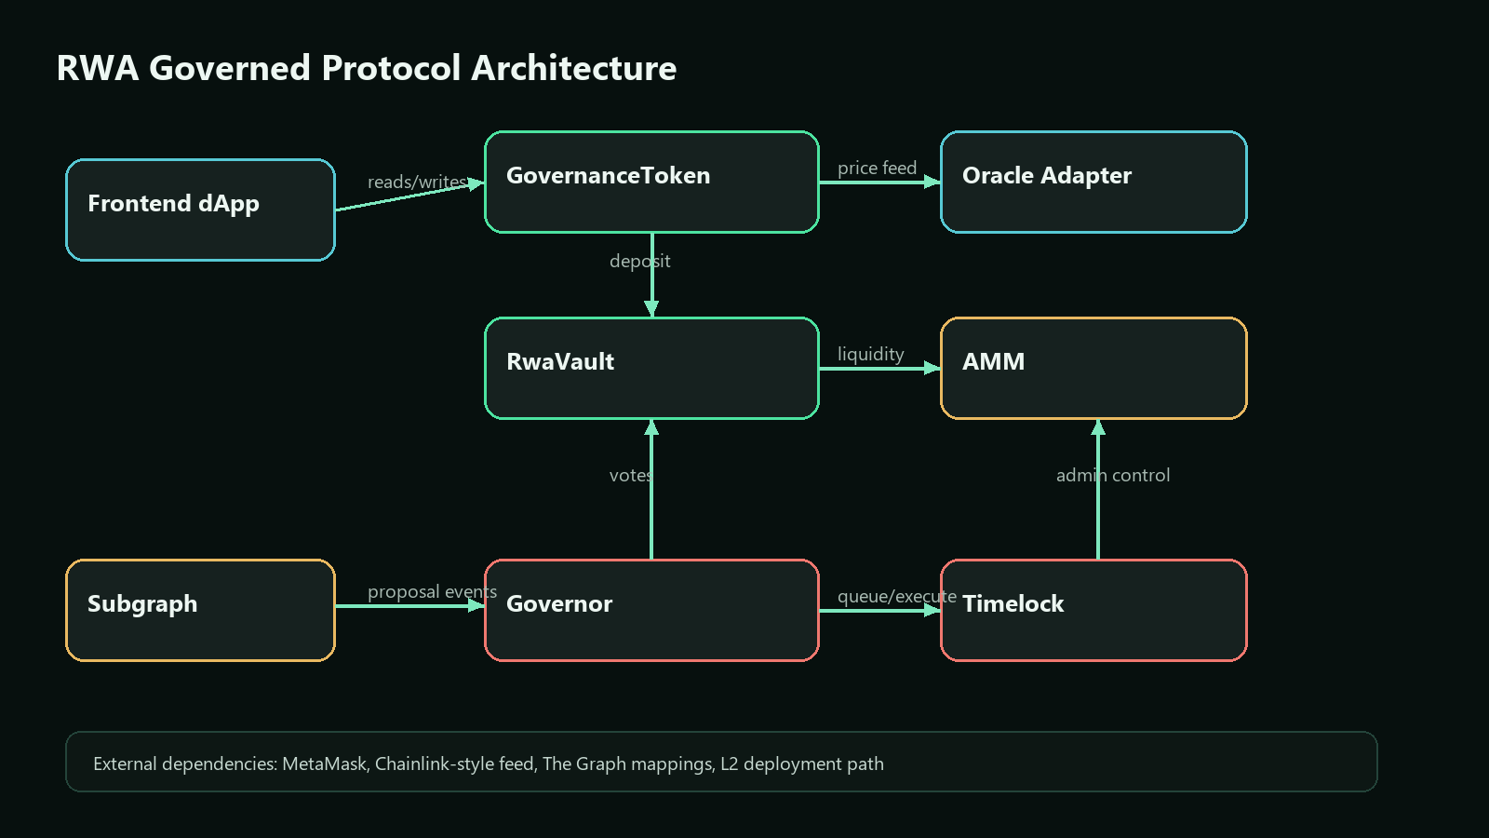

5. Smart Contract Modules

5.1 GovernanceToken and Asset Issuance
GovernanceToken is the main RWA token. It supports balances, allowances, delegation, voting power, permit-style approval logic, and role-gated issuance. The issuer role is designed for accounts or issuer proxy contracts that represent off-chain collateral verification.

5.2 AssetBadgeNFT
AssetBadgeNFT provides an NFT-style proof badge for collateral or issuer metadata. This satisfies the non-fungible token requirement and gives the protocol a place to attach asset proof references.

5.3 RwaVault
RwaVault is an ERC4626-style vault. Users approve the vault, deposit RWA assets, and receive vault shares. The vault exposes totalAssets, convertToShares, convertToAssets, deposit, and withdraw flows.

5.4 ConstantProductAMM
The AMM implements the educational Uniswap V2-style invariant x*y=k. Liquidity providers deposit two assets and receive LP shares. Traders swap one asset for another with a 0.3% fee and minimum-output slippage protection.

5.5 Upgradeability and Factory
RwaIssuerUpgradeable demonstrates a UUPS-style upgrade path through an ERC1967 proxy. ProtocolFactory demonstrates both standard CREATE deployment and deterministic CREATE2 proxy deployment.

6. Protocol User Flows
Flow | Steps | Important protection
Issue RWA | Authorized issuer calls issue -> token mints backed balance -> event emitted | ISSUER_ROLE and governance-managed issuer rotation
Deposit vault | User approves token -> vault deposit -> shares minted | Zero deposit rejection and share accounting
AMM swap | Trader approves token -> swap computes output -> reserves sync | Slippage check, nonReentrant, reserve invariant
Governance vote | User delegates -> proposal created -> vote for/against -> counters update | Proposal threshold, quorum, ALREADY_VOTED protection
Timelock execution | Succeeded proposal queued -> delay passes -> execution called | Operation hash and delay gate

7. Frontend dApp Evidence
The frontend is a React/Vite dashboard designed as an institutional DeFi control panel. It connects to MetaMask, detects the active chain, reads contract state, and sends real wallet transactions for delegate, deposit, swap, and vote actions.
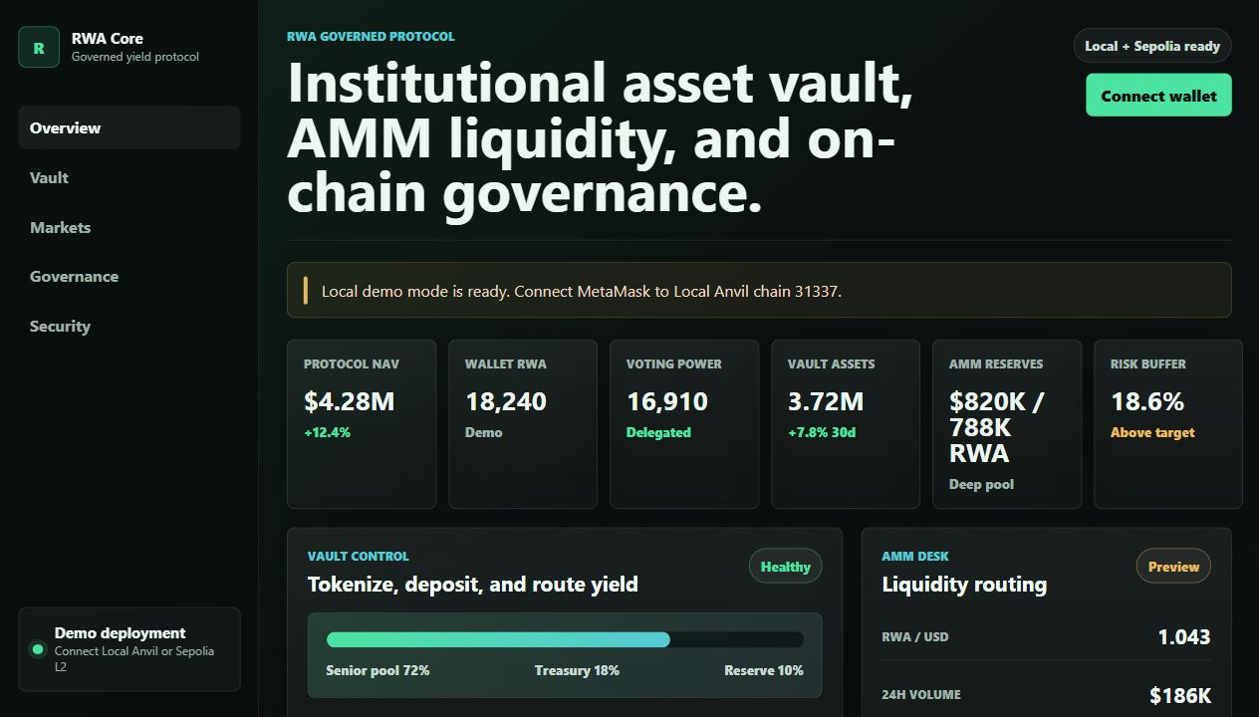
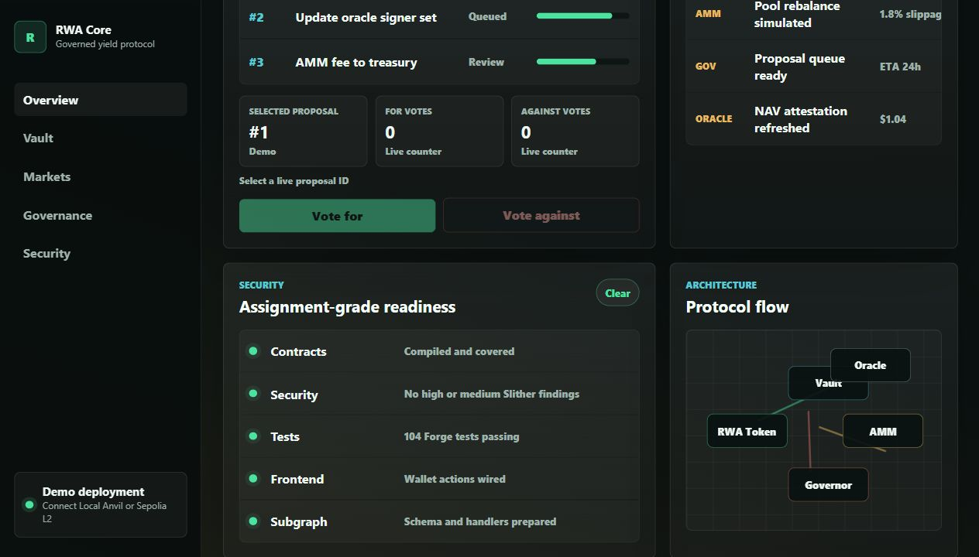
For demonstration reliability, local chain 31337 includes helper logic: Proposal ID 0 creates the next proposal automatically, and Proposal ID 1, 2, 3, etc. can create missing local proposals before voting. This makes the demo repeatable without changing accounts, while still preserving the real smart contract rule that one wallet can vote only once per proposal.

8. Testing Evidence
The deterministic local test suite currently passes with 101 tests and 0 failures when excluding external fork RPC tests. The repository also contains fork integration tests for mainnet USDC, Uniswap V2, and Chainlink ETH/USD. The fork tests are separated because they depend on live RPC availability.
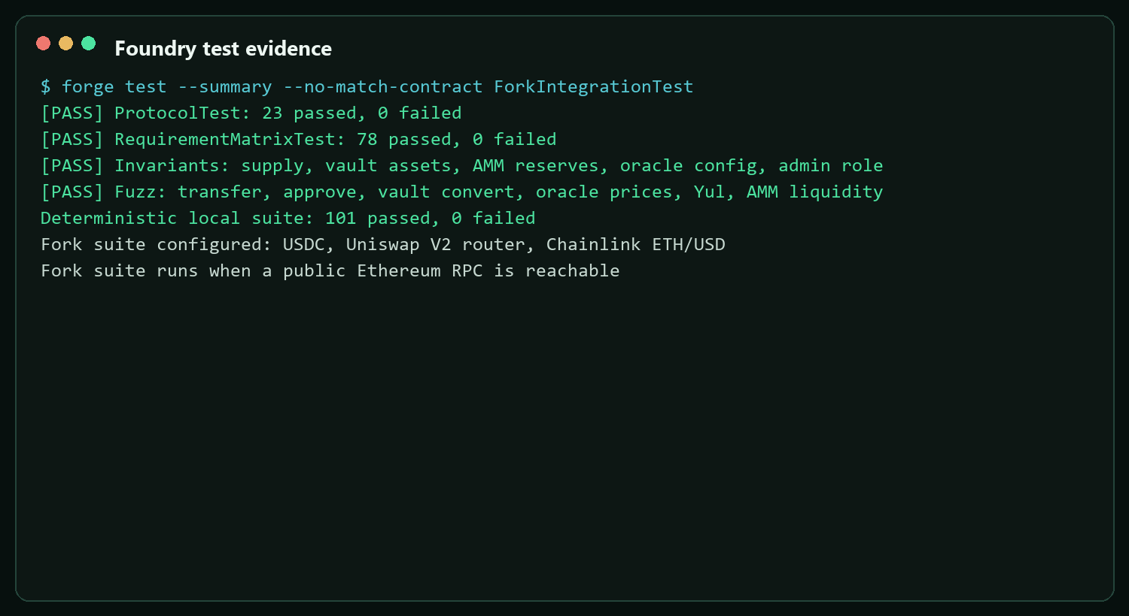
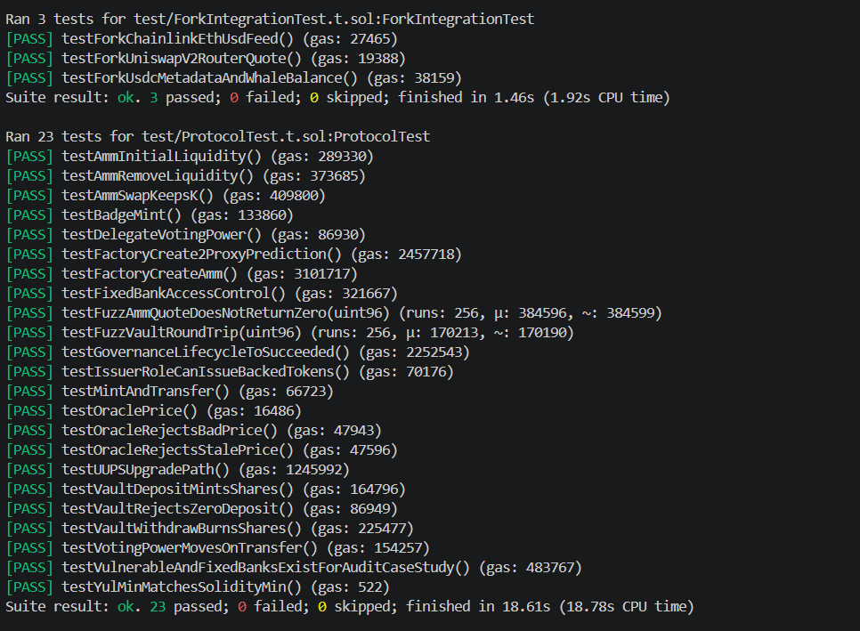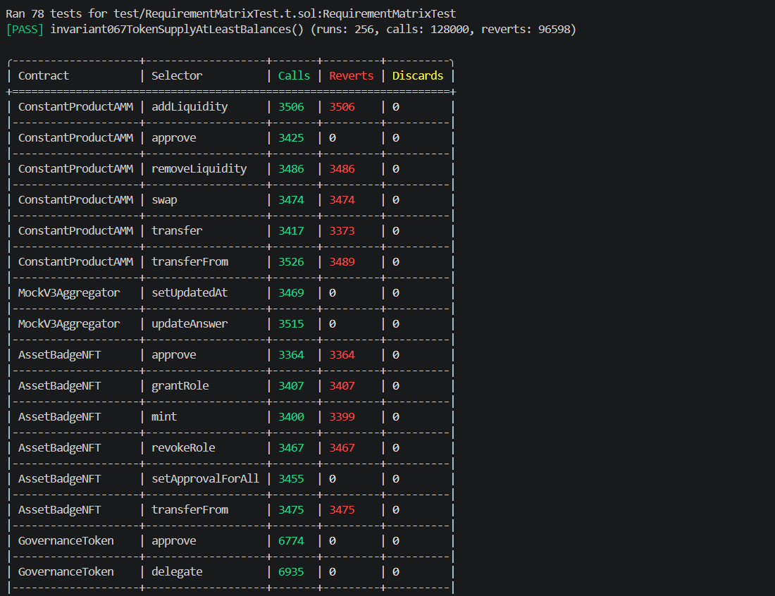
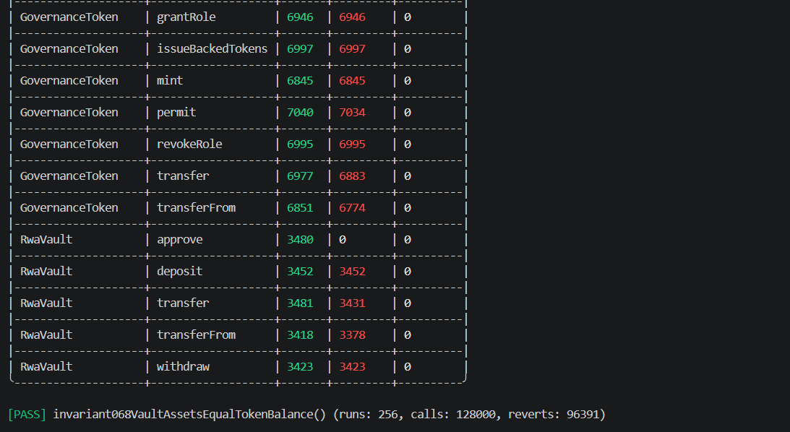
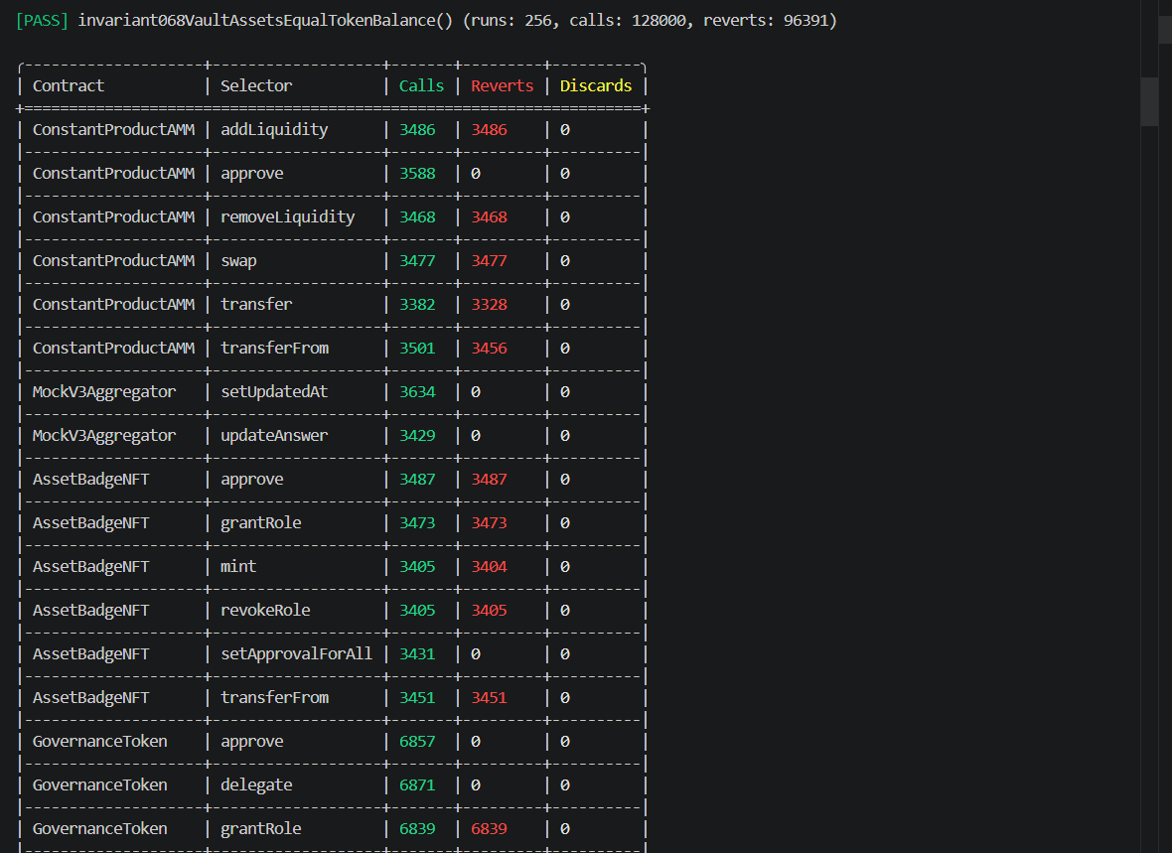
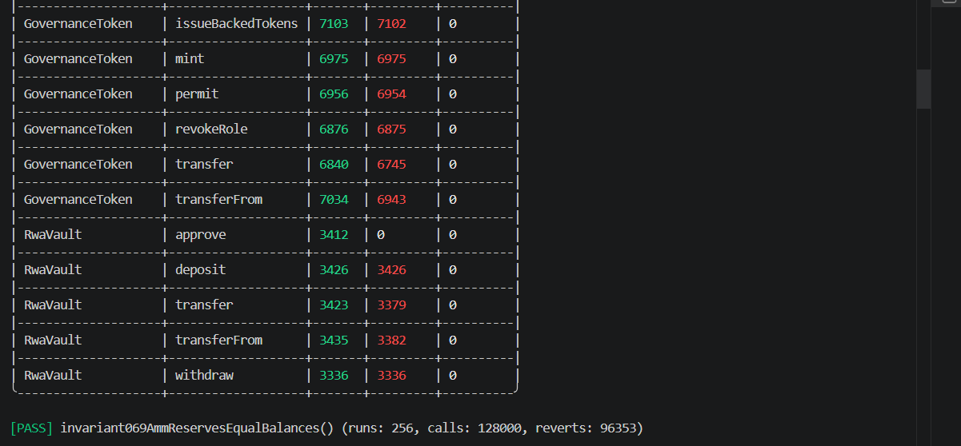
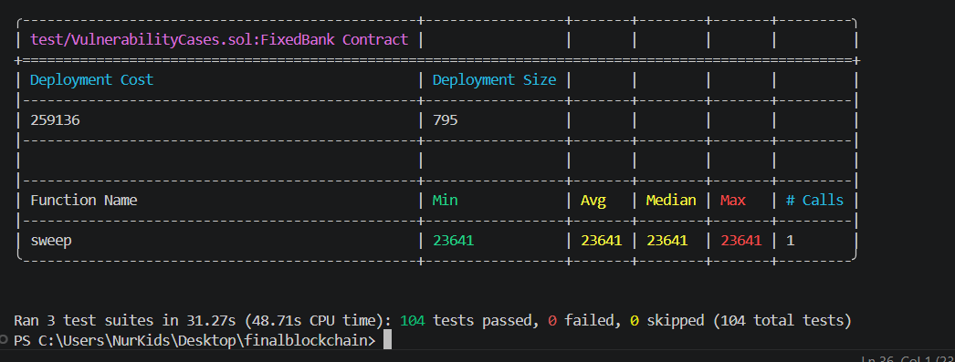

Test type | Purpose | Examples
Unit tests | Verify expected behavior for known cases | mint, transfer, vault deposit, AMM swap, oracle reads
Fuzz tests | Explore many randomized inputs | transfer amount, AMM liquidity amount, vault conversion
Invariant tests | Verify state properties after many calls | supply, vault assets, AMM reserves, oracle configuration
Fork tests | Validate integrations against live mainnet contracts | USDC, Uniswap V2 router, Chainlink ETH/USD

9. Security Review
The project includes a dedicated audit report and security evidence. Static analysis was run with Slither high/medium filters and reports 0 high or medium findings. The code also includes vulnerability case studies to show understanding of reentrancy and access control failures, followed by fixed versions.
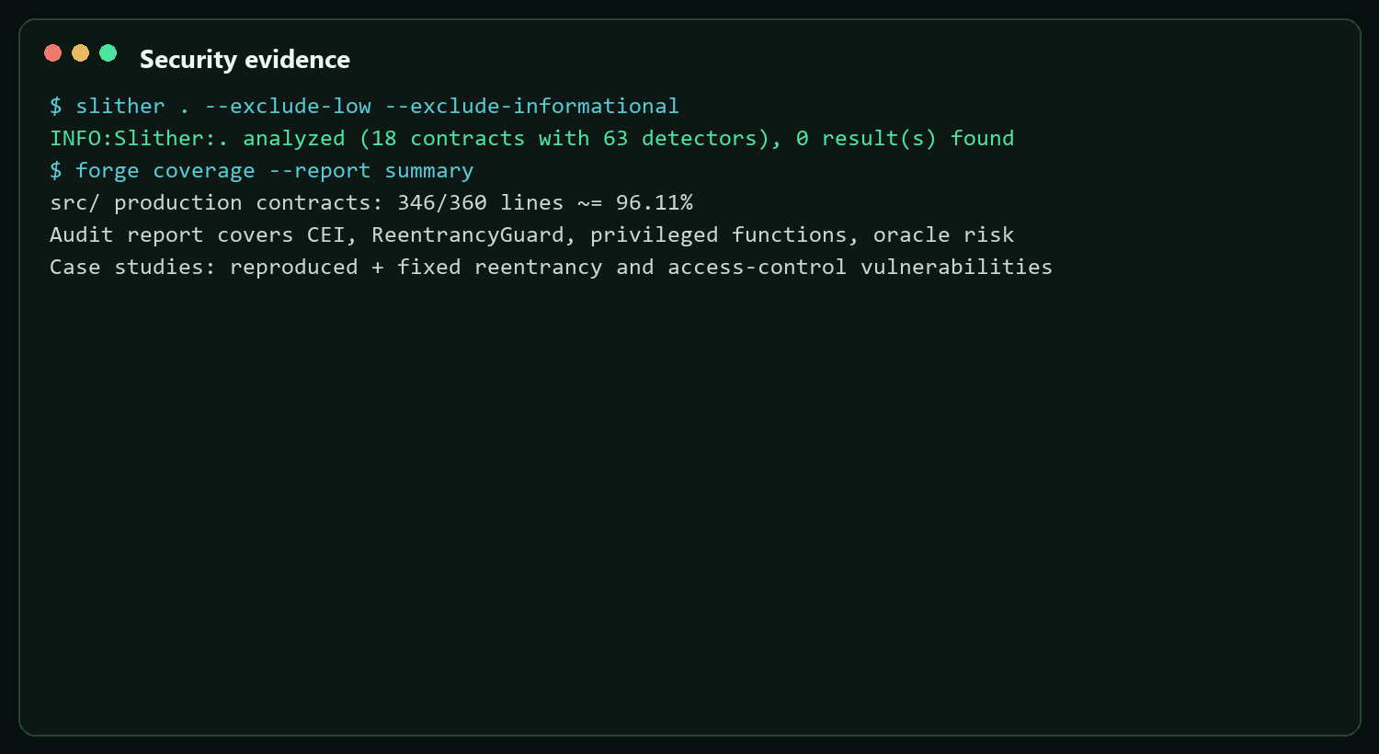
- RwaVault and ConstantProductAMM use nonReentrant guards around value-moving logic.
- Privileged minting and issuer administration are role-gated.
- The Chainlink adapter rejects stale, zero, or negative prices.
- The timelock prevents immediate execution of governance-controlled actions.
- The audit report documents remaining operational risks and production recommendations.

10. Subgraph and Indexed Data
The subgraph layer is prepared for The Graph indexing. It defines entities for tokens, vault deposits, swaps, proposals, and votes. The frontend can read from VITE_SUBGRAPH_URL when a hosted endpoint is configured, and it falls back to demo indexed activity for local presentation mode.
query Proposals { proposals(first: 10) { id proposer description state forVotes againstVotes } }

11. Deployment Evidence
The deployment path is implemented through Foundry scripts. Local Anvil deployment is automated and deterministic for classroom presentation. The L2 deployment command is ready for Arbitrum Sepolia and similar L2 testnets. A real L2 broadcast was not completed in the current workspace because the prepared deployer wallet had 0 testnet ETH; therefore this report documents local deployment evidence and L2 dry-run status honestly.
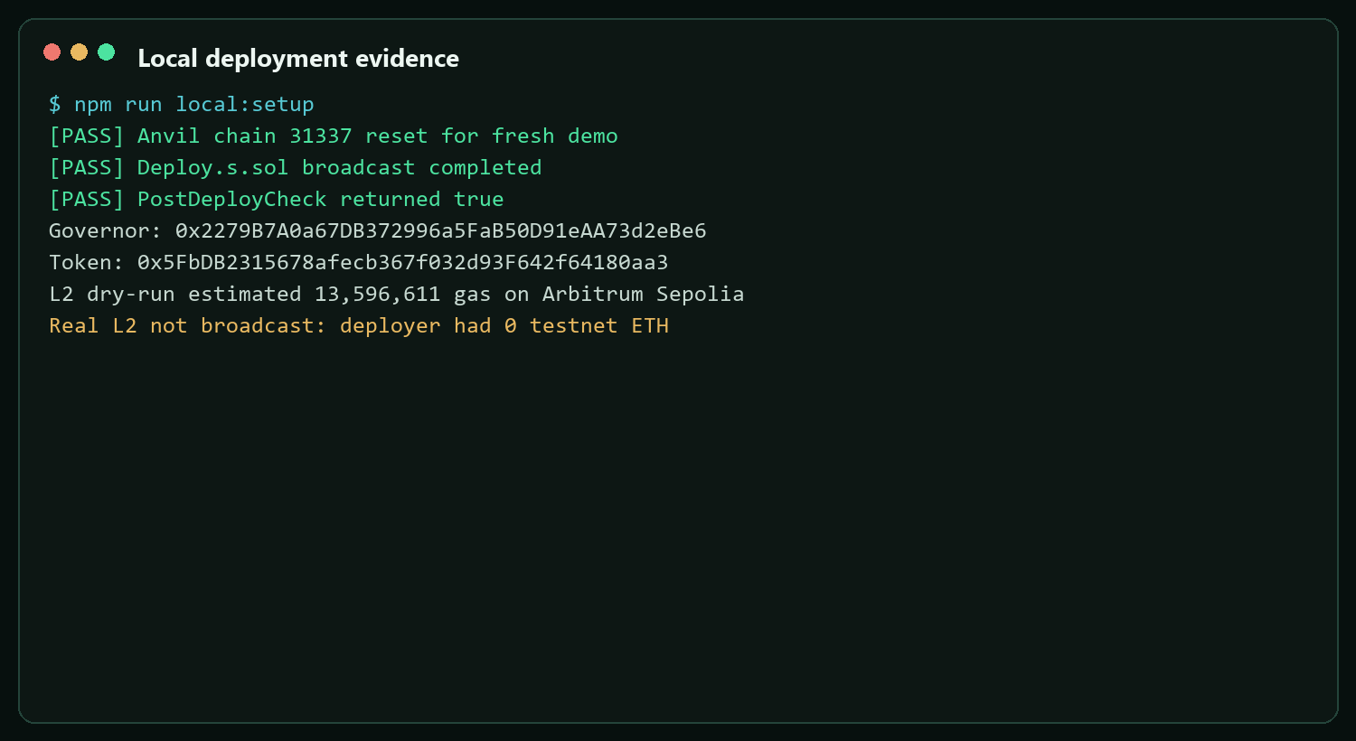
npm run local:demo MetaMask network: Network name: Local Anvil RPC URL: http://127.0.0.1:8545 Chain ID: 31337 Currency: ETH

12. Comparison With Course Criteria
The project is intentionally designed to cover the final assignment criteria as completely as possible. It includes advanced Solidity patterns, multiple token models, a DeFi primitive, oracle integration, governance, frontend transactions, testing evidence, security documentation, and deployment automation.
Area | Status | Notes
Advanced Solidity | Implemented | UUPS, CREATE2, Yul, access control, timelock state machine
DeFi | Implemented | AMM, vault, LP shares, fees, slippage, reserves
Oracle | Implemented | Chainlink-style feed adapter and stale checks
Governance | Implemented | Delegate, propose, vote, queue, execute
Frontend | Implemented | MetaMask, live reads, transactions, local demo UX
Subgraph | Prepared | Schema and mappings ready; hosted URL configurable
Testing | Strong | 101 deterministic local tests plus fork test implementation
Security | Strong | Slither high/medium clean and manual audit report
L2 deploy/verify | Partially blocked | Dry-run and command ready; real verification needs faucet ETH

13. Conclusion
The RWA Governed Protocol demonstrates a complete blockchain application rather than a single isolated contract. It combines tokenization, vault accounting, AMM liquidity, oracle safety checks, on-chain governance, event indexing, and a polished frontend interface. The local demo is reproducible with one command and the validation evidence shows that the deterministic test suite and frontend build pass successfully.
The main operational limitation is real L2 verification, which depends on obtaining testnet ETH. This does not block the technical deployment path: the runbook, scripts, addresses, and dry-run evidence are already prepared.

