Laboratory Work 3 - Database DML Operations
Student: Izbay Nuradil
University: KBTU
Course: Databases (Fall 2026)

1. Airline Table (`airline`)
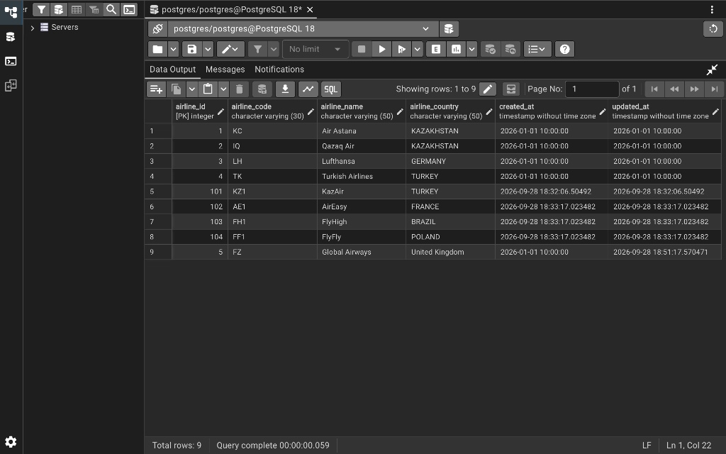

2. Airports Table (`airports`)
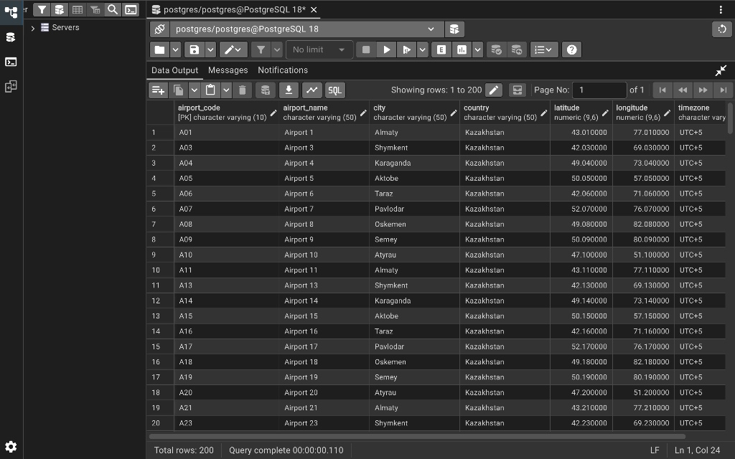

3. Booking Table (`booking`)
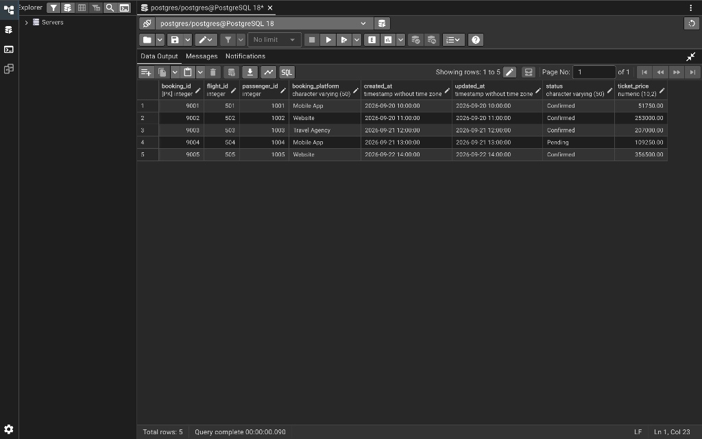

4. Passengers Table (`passengers`)
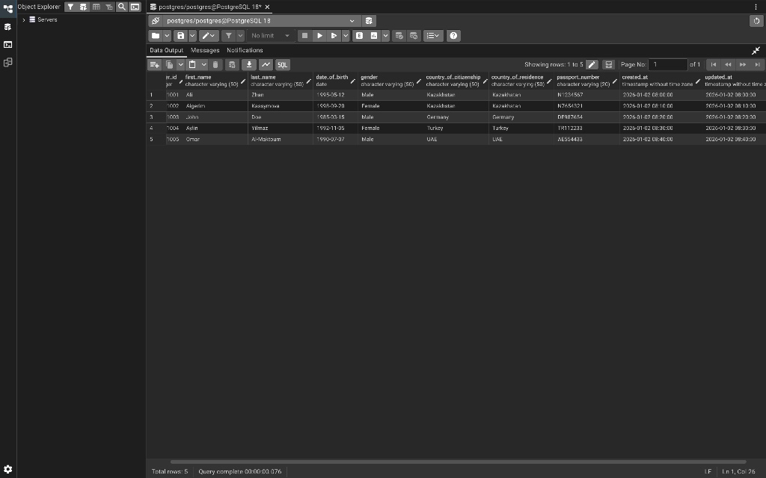

5. Baggage Check Table (`baggage_check`)
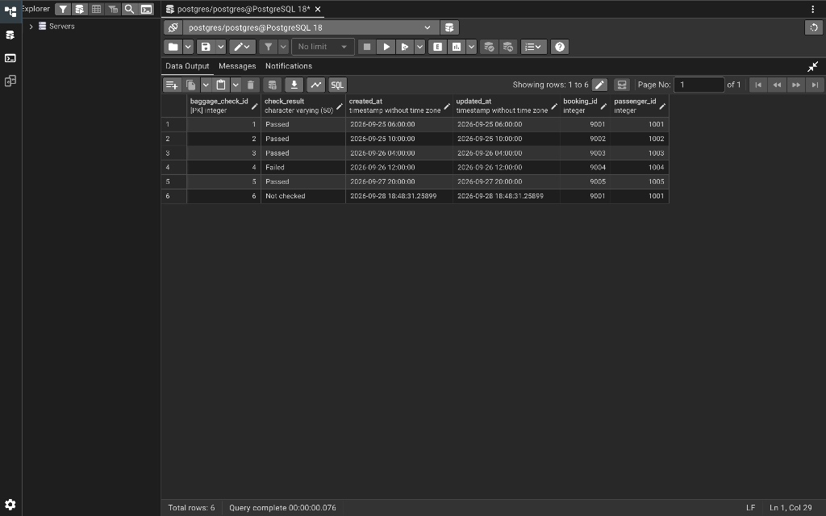

6. Flights Table (`flights`)
