

**Theory Assignment Report**

|  |  |  |  |  |  |  |
| --- | --- | --- | --- | --- | --- | --- |
| **Only for course Teacher** | | | | | | |
|  | | **Needs Improvement** | **Developing** | **Sufficient** | **Above Average** | **Total Mark** |
| **Allocate mark & Percentage** | | **25%** | **50%** | **75%** | **100%** | **5** |
| **Clarity** | **1** |  |  |  |  |  |
| **Content Quality** | **2** |  |  |  |  |  |
| **Spelling & Grammar** | **1** |  |  |  |  |  |
| **Organization and Formatting** | **1** |  |  |  |  |  |
| **Total obtained mark** | | | | | |  |
| **Comments** |  | | | | | |

**Semester: Spring 25**

**Student Name:** Nur Ahmed

**Student ID:** 222-35-1111

**Batch:** 38th  **Section:** A

**Course Code:** SE442

**Course Name:** Management Information System

**Course Teacher Name:** Dr. Imran Mahmud

**Designation:** Professor & Head

**Submission Date:** 10/04/2025

**Contents**

**Police Department Data Analysis** 3

**Data Preview** 3

**Digital Dashboard** 4

**Box Plot** 5

**Violin plot** 6

**Sieve diagram** 7

**Venn Diagram** 8

**Resources** 9

# **Police Department Data Analysis**

## **Data Preview**

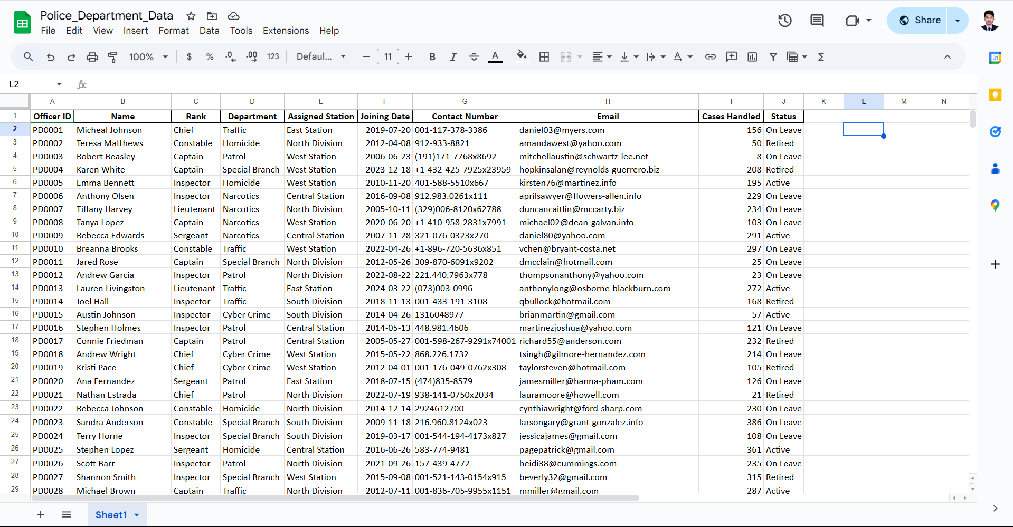

## **Digital Dashboard**

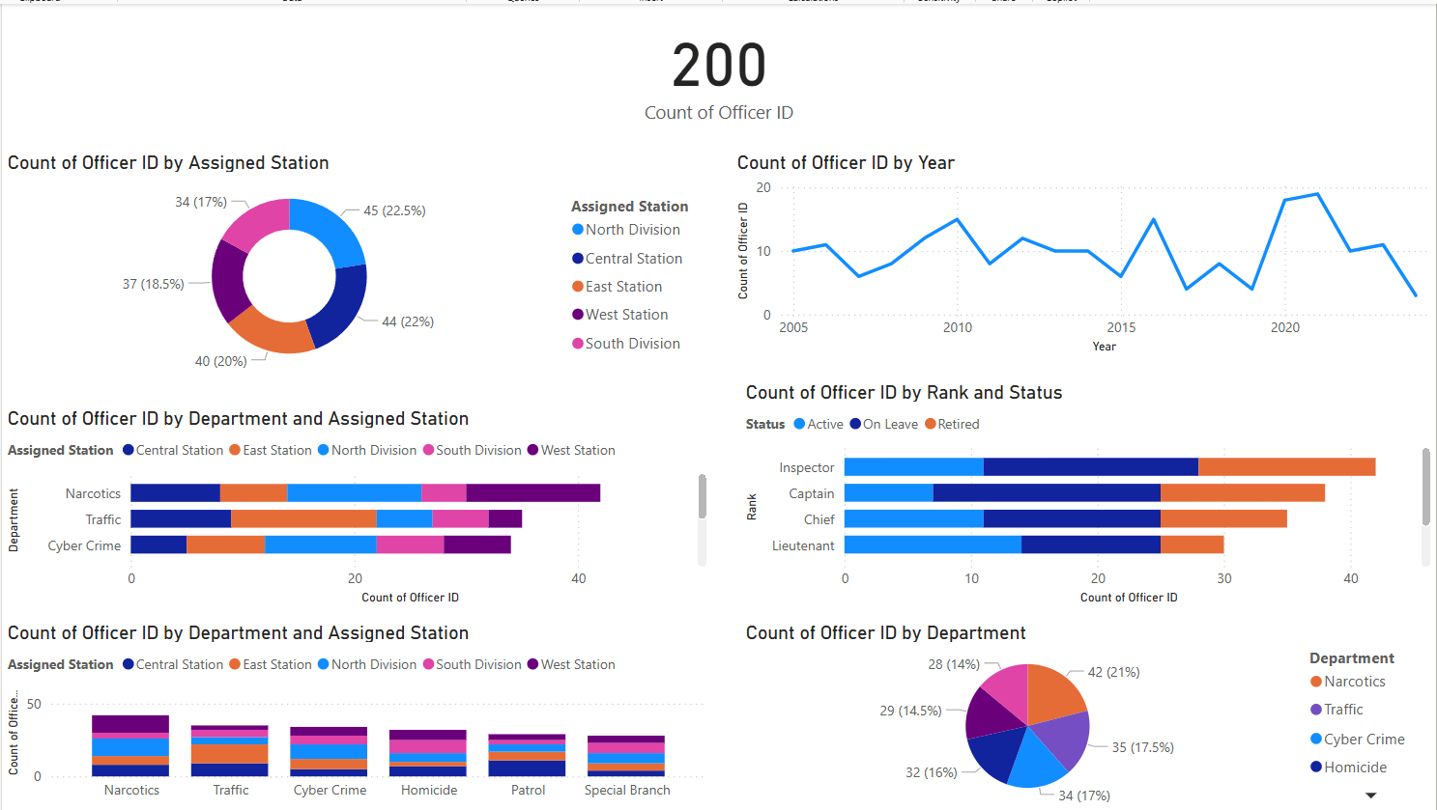

## **Box Plot**

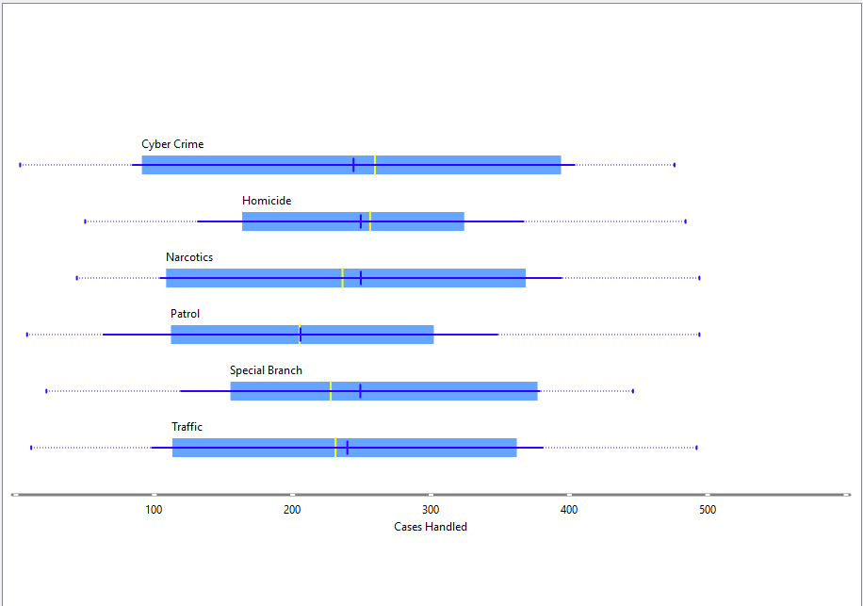

## **Violin plot**

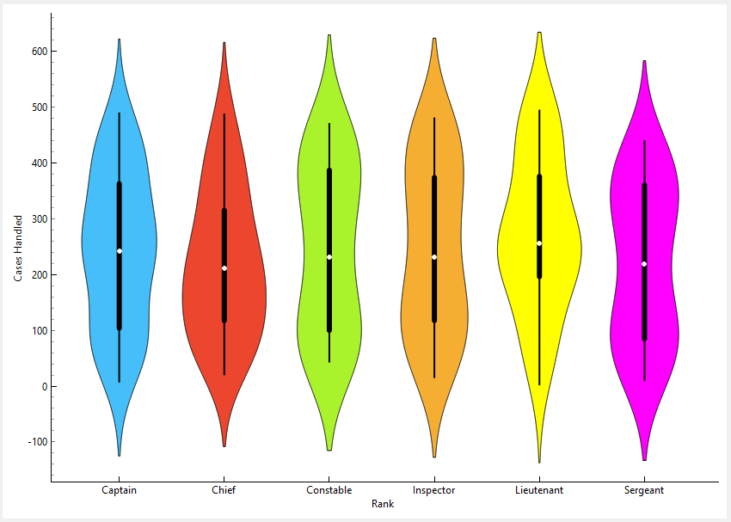

## **Sieve diagram**

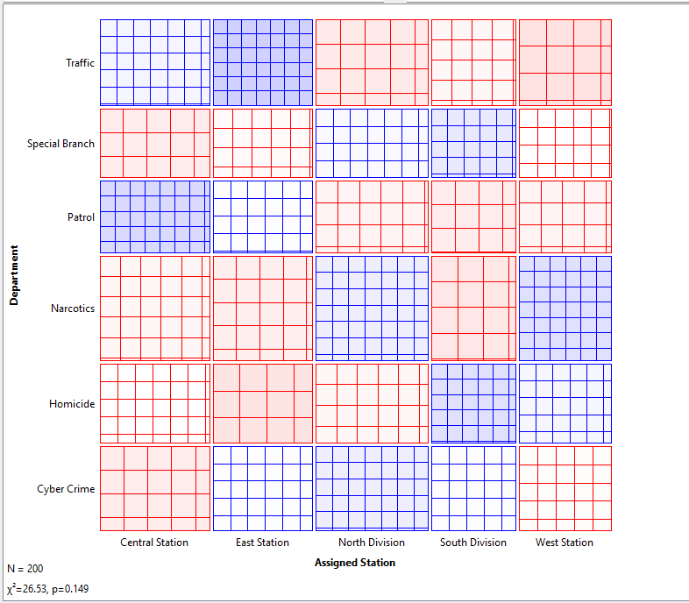

## **Venn Diagram**

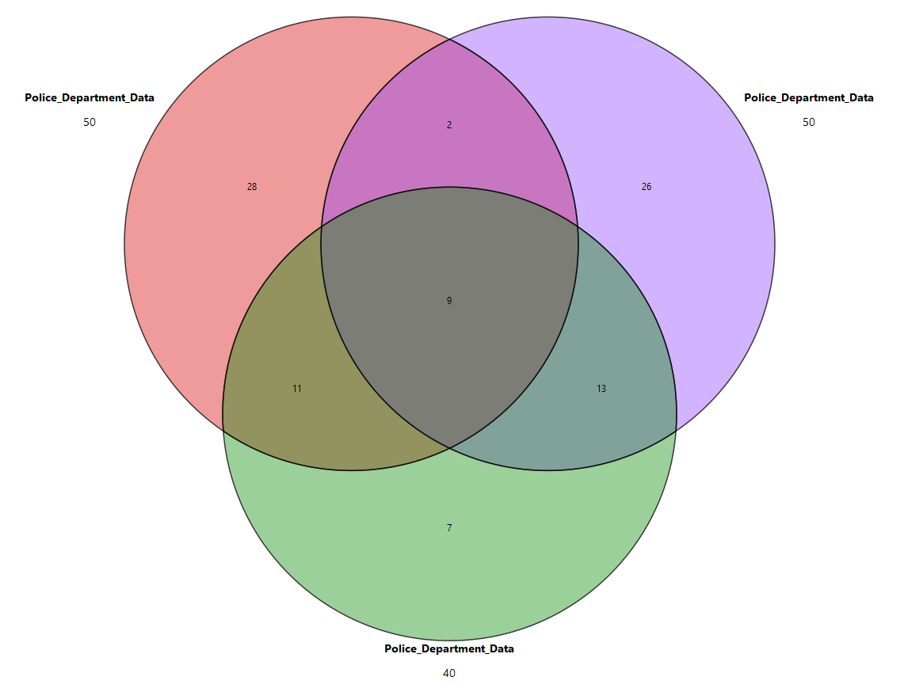

## **Resources**

[Dataset](https://docs.google.com/spreadsheets/d/1IJHGHccacmuE24G-vxs2oPvLonMR_8Fpd9rZn6ESqD0/edit?usp=sharing)

[Digital Dashboard](https://drive.google.com/file/d/1BDU0da-NZJbmCSiCWvW6icXul-yRZd-P/view?usp=sharing)

[Orange ML](https://drive.google.com/file/d/1ySqXXqjabV1HenewY4vaWtWEEP2RZrQQ/view?usp=sharing)