Ministry of Science and Higher Education of the Republic of Kazakhstan
Astana IT University

INTERNSHIP REPORT
on industrial internship
Topic: Development of the KZCRMS CRM system for service businesses

Internship base: MSSP.GL LLP
Student: Akbergen Nurakhmad
Educational program: Software Engineering
Group: SE-2308
Internship period: 09.03.2026 – 02.05.2026
Company supervisor: Seitov Sanzhar
AITU supervisor: ____________________

Astana, 2026

TABLE OF CONTENTS
Introduction
1. General Characteristics of the Internship Base
2. Purpose, Objectives, and Subject of the Internship
3. Work Performed According to the Calendar Plan
4. Development of the KZCRMS CRM System
5. Security and Reliability Measures
6. Practical Results Obtained During the Internship
Conclusion
References
Introduction
The industrial internship was completed at MSSP.GL LLP from March 9, 2026 to May 2, 2026. During the internship, the main practical task was the design, implementation, and iterative improvement of a web-based CRM system named KZCRMS.
The relevance of the selected topic is determined by the fact that many service businesses still manage appointments, clients, and payments through messengers, spreadsheets, and disconnected tools. This creates scheduling conflicts, weak client retention, limited reporting capabilities, and a high dependence on manual coordination by administrators.
The internship therefore focused on the creation of a unified information system that combines client management, appointment scheduling, service configuration, staff workload tracking, payment handling, reporting, onboarding, and basic access control in a single SaaS-oriented product.
1. General Characteristics of the Internship Base
MSSP.GL LLP acted as the internship base and provided the environment for applied development, testing, and product iteration. The internship was organized around a real software engineering workflow: requirements clarification, interface revision, backend implementation, testing, deployment, documentation, and iterative improvement based on practical scenarios.
Within this environment, the internship tasks were directly connected with the creation of a commercial-grade CRM system suitable for service businesses such as dental clinics, barbershops, salons, studios, and other appointment-based organizations.
2. Purpose, Objectives, and Subject of the Internship
The purpose of the internship was to apply academic knowledge in software engineering to the development of a practical CRM web application and to improve the product up to a level suitable for future business use.
The main objectives of the internship were:
• to design the overall architecture of the CRM system;
• to implement the main business entities: clients, staff, services, appointments, payments, and business settings;
• to improve usability, navigation, and product logic for real administrators;
• to organize secure authentication, access control, and account verification;
• to prepare the project for cloud deployment and domain-based operation;
• to test, debug, and document the implemented solution.
3. Work Performed According to the Calendar Plan
Week 1. The first stage included familiarization with the internship goals, analysis of the future CRM concept, clarification of the main user roles, and preparation of the initial project structure.
Week 2. The application data model and first business entities were developed. The project began to support clients, staff members, services, appointments, and payments as core CRM components.
Week 3. The user interface and product navigation were revised. The distinction between the landing page, dashboard, profile, and settings was improved to make the system closer to a real SaaS product rather than a technical prototype.
Week 4. Authentication flows were upgraded. The project received email-based registration, email confirmation, password reset, Google sign-in, and cloud deployment preparation.
Week 5. Industry adaptation and terminology logic were improved. The CRM was adjusted for multiple appointment-based niches such as dentistry, barbershops, clinics, and salons.
Week 6. Internal workflows were strengthened: client cards, staff cards, business profile, payment methods, trial access management, and appointment history behavior were refined.
Week 7. Security and production-readiness tasks were completed, including the transition to safer destructive actions, hardened deployment settings, and protection against authentication abuse.
Week 8. Documentation, screenshots, reporting materials, and final polishing of the system were prepared for practice defense and future presentation of the product.
4. Development of the KZCRMS CRM System
KZCRMS was developed as a web-based CRM platform for service businesses where appointment scheduling and client retention are operationally critical. The application is built on Django and includes a public landing page, authentication pages, business dashboard, appointment journal, client cards, staff cards, financial reporting, configurable payment methods, profile management, settings, and trial-based access control.
The system supports multiple industry templates and adapts terminology for different niches while preserving a common product core. This makes it possible to use the same application for dentistry, barbershops, salons, studios, clinics, and similar businesses without duplicating the product architecture.
A significant amount of work was devoted to product quality: better empty states, more consistent wording, refined onboarding logic, a clearer distinction between profile and settings, a custom domain, working email verification, Google OAuth, and a more serious visual style for both the CRM interface and the landing page.
5. Security and Reliability Measures
A separate block of internship work was devoted to the security and reliability of the system. The goal was not only to implement business functionality, but also to reduce risks that typically appear in early-stage web products.
First, production configuration was hardened. The application was configured to reject startup in production when a real SECRET_KEY is not provided. At the same time, secure cookie flags, HTTPS redirection, HSTS, and browser-level protective headers were added.
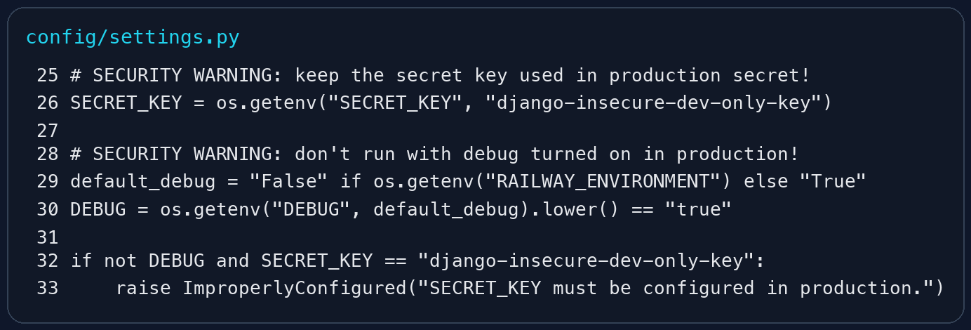
Figure 1. Protection against using a fallback SECRET_KEY in production.
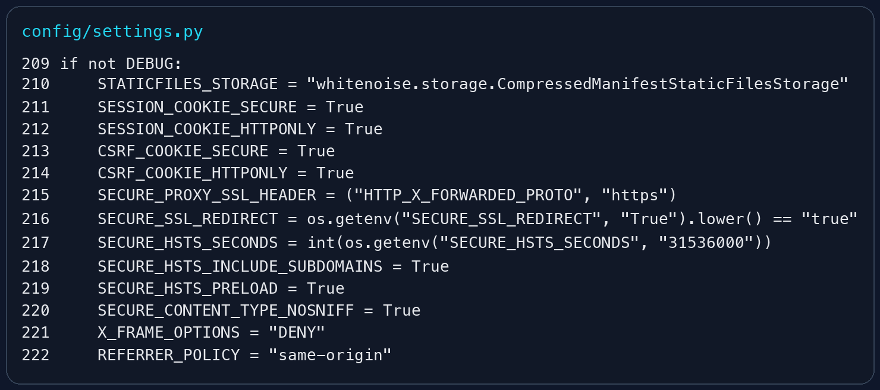
Figure 2. Secure production settings: HTTPS redirect, HSTS, secure cookies, and browser security headers.
Second, authentication-related abuse was limited by a basic rate-limiting mechanism for login, registration, and password reset requests. The limitation is IP-based and prevents rapid repeated attempts that could be used for brute-force attacks or abuse of public forms.
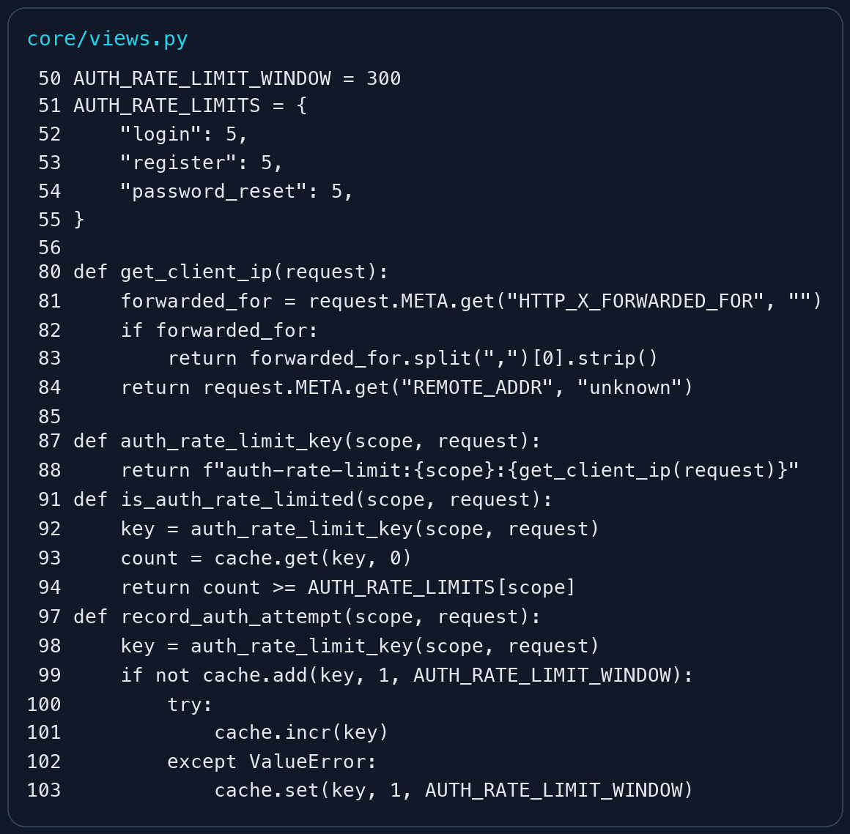
Figure 3. Utility functions for authentication rate limiting by client IP address.
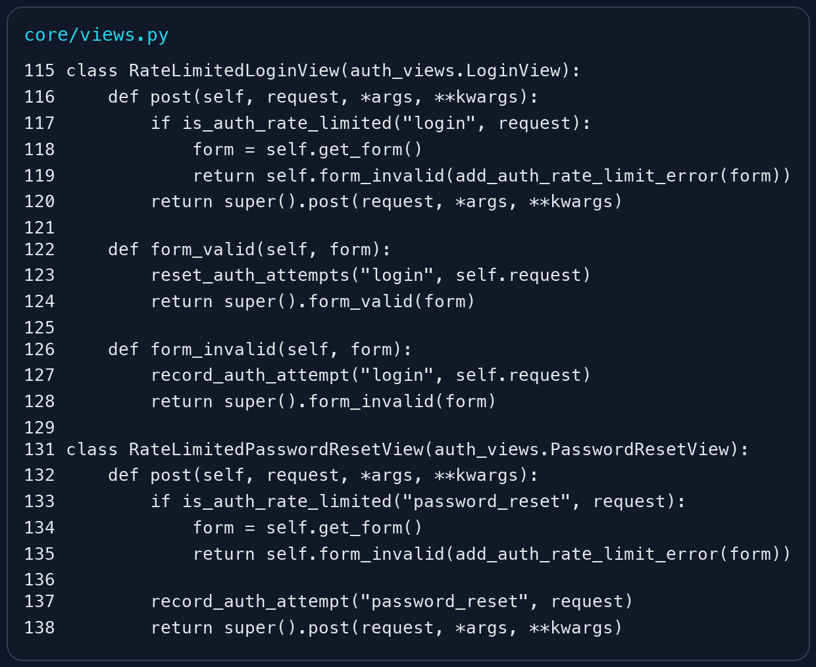
Figure 4. Rate-limited login and password reset views.
Third, destructive actions were made safer. Previously, some delete operations could be triggered through simple links. This was corrected by moving such actions to POST-only views and by using CSRF-protected forms in templates.
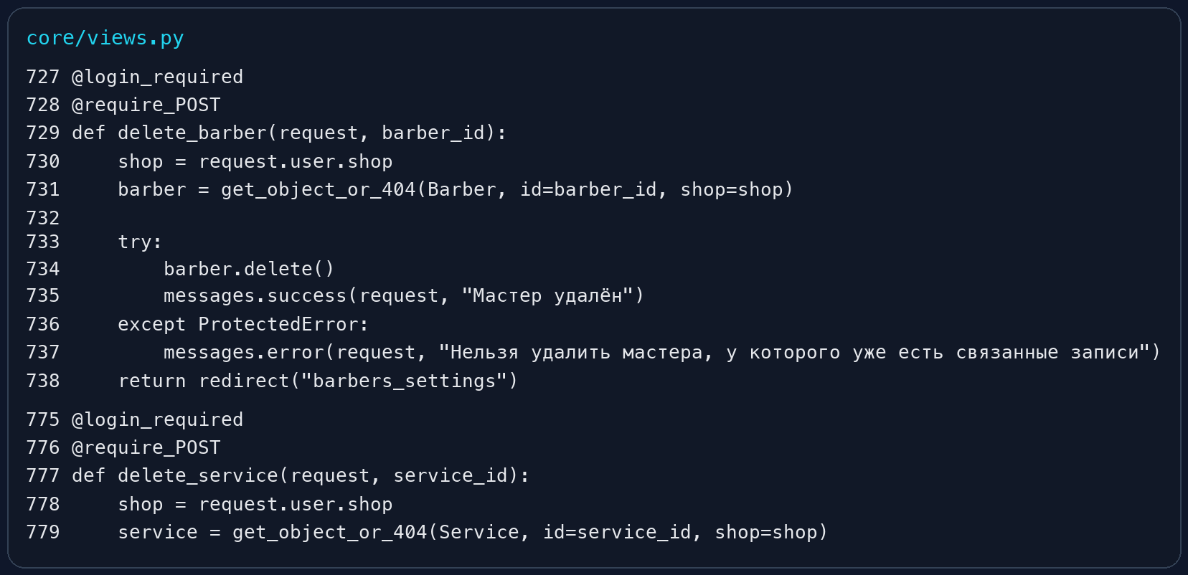
Figure 5. Destructive operations are protected by @require_POST and authorization checks.
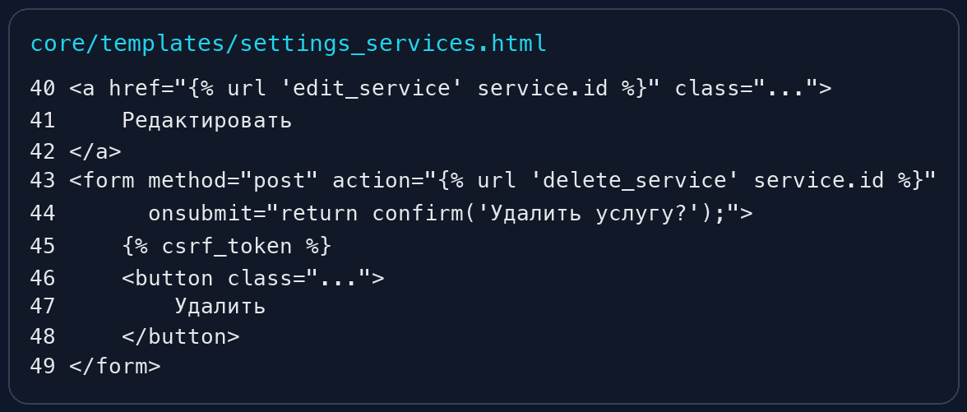
Figure 6. Deletion is performed through POST forms with CSRF tokens in templates.
Fourth, the registration flow was revised so that internal email transport errors are no longer exposed directly to end users. Instead of leaking low-level SMTP or API details, the system now shows a safe user-facing message while logging the technical exception internally.
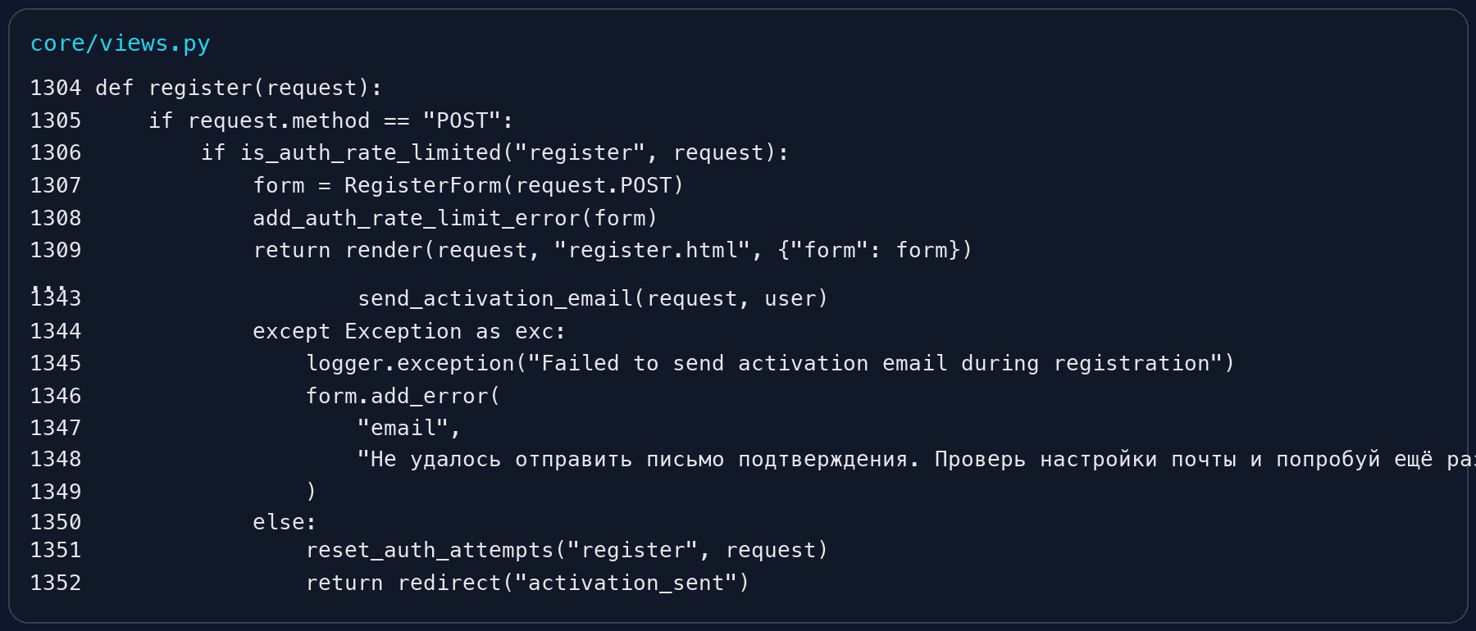
Figure 7. Safe handling of email delivery errors without leaking internal technical details.
Finally, automated tests were added to verify that the implemented security measures behave correctly. These tests cover safe error handling, request method restrictions, and rate-limiting behavior.
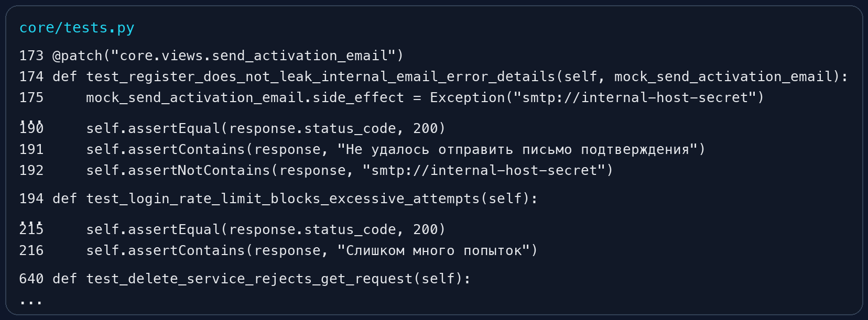
Figure 8. Automated tests for non-leaking errors, rate limiting, and GET deletion rejection.
6. Practical Results Obtained During the Internship
As a result of the internship, a working CRM prototype evolved into a significantly more complete SaaS-oriented product. The system now includes public entry points, protected business logic, configurable business entities, authentication options, trial access support, cloud deployment, custom domain operation, and a strengthened security baseline.
The project demonstrates both practical programming work and applied systems thinking: not only were individual functions implemented, but the application was shaped as a coherent product intended for future client use.
Conclusion
The industrial internship made it possible to apply theoretical software engineering knowledge to a real product-oriented project. During the internship, the KZCRMS system was designed and refined as a CRM platform for appointment-based service businesses.
The completed work covered backend logic, frontend structure, authentication, deployment, business workflows, security hardening, testing, and documentation. The result is a substantially improved system that can serve as the basis for further product growth and future commercial use.
References
1. Django Software Foundation. Django Documentation. https://docs.djangoproject.com/
2. Mozilla Developer Network. Web Security Guidelines. https://developer.mozilla.org/
3. Railway Documentation. Deployment and configuration materials. https://docs.railway.com/
4. Google Cloud Documentation. OAuth 2.0 configuration materials. https://cloud.google.com/
5. Resend Documentation. Transactional email configuration materials. https://resend.com/docs

