Methodology and Core Practical Implementation
Research Methods and Tools | Assignment 3
Students: Nurassyl Orazbek, Anuar Zhenissov Group: SE-2405

1. Final Research Title
Identifying Partner-Specific Requirement Divergence in Freight ANSI X12 Implementation Guides: An X12 214 Case Study (unchanged from Assignment 2).

2. Primary Research Question, Aim and Objectives
Primary research question. How consistently can a shared, evidence-linked classification scheme identify and categorize partner-specific requirement differences across comparable ANSI X12 214 (004010) truckload implementation guides?
Aim. To develop and assess an evidence-linked classification scheme for identifying partner-specific requirement differences in comparable freight X12 214 (004010) implementation guides.
- O1. Select two to three publicly available guides using explicit criteria for X12 version, truckload scope, message direction and identifiable document revision.
- O2. Define the unit of comparison and operational categories for segment or element usage, permitted codes, repetition, conditional instructions and insufficiently documented cases.
- O3. Independently annotate corresponding constraints with page and text evidence using the shared scheme, then compare the resulting labels across guide pairs.
- O4. Assess coding agreement and examine disagreements by category to determine which distinctions are reproducible and which require clearer definitions or source evidence.
Relation to the dissertation. The dissertation develops an automated comparison toolkit. This RMT study stops one step earlier: it tests whether the human reference labels that such a toolkit needs can be produced reliably. The pipeline in Section 9 therefore prepares evidence for human coding; toolkit accuracy is not an outcome of this study.

3. Research Approach and Design
The study uses a mixed-methods approach in which qualitative document analysis is the main strand and inter-coder agreement is the quantitative strand. The specific design is a comparative multiple-document case study with a two-coder reliability study, supported by a technical extraction-and-alignment pipeline. Document analysis fits because implementation guides are existing organisational records that can be examined systematically without contacting the organisations (Bowen, 2009). Coding is directed: initial categories come from prior work on extension, omission and adaptation of standards (Egyedi, 2007) and are refined during calibration (Hsieh & Shannon, 2005).
Unit of analysis: one aligned requirement unit, i.e. one X12 214 position (a segment, or an element of a segment, identified by table area, position number, segment ID and element reference) in one guide pair, with every attribute both guides state for it and the page and line where each statement appears.
Fit and evidence produced. The question asks about consistency of classification, so the design must produce two independent classifications of identical units and a way to explain where they differ. It yields a documented set of aligned units, agreement coefficients per variable, and a reasoned account of each disagreement.
Rejected alternative. A practitioner survey on perceived guide differences would measure opinion and recall, not documented constraints, and could not show whether two readers classify the same text in the same way. Runtime testing with real 214 messages was also rejected: it needs confidential carrier data and answers a different question (operational failure rather than documented divergence).

4. Sample, Dataset and Research Context
Target material. Publicly available, partner-specific implementation guides for ANSI X12 214 (Transportation Carrier Shipment Status Message), release 004010, in which a shipper, broker or logistics provider specifies what it expects to receive from truckload carriers.
Inclusion: X12 214, version 004010; inbound direction (carrier sends, guide owner receives); truckload scope stated or truckload requirements separable from other modes; identifiable organisation and revision date; downloadable without login or non-disclosure agreement; English. Exclusion: other versions or transaction sets (204 and 210 are context only); outbound guides published by carriers; air, ocean or parcel-only guides; documents without an identifiable revision; generic X12 documentation that states no partner requirements.
Sample and size. The purposive sample is the three candidate guides from Assignment 2: C.H. Robinson (2021), KBX Technology Solutions (2022) and Domtar Industries (2008), giving three guide pairs. Every position documented by at least one guide of a pair becomes a unit, so dataset size is set by the guides. If the total exceeds 360 units, a random sample of 120 units per pair, stratified by whether the position is documented in one or both guides, is coded; otherwise all units are coded. This keeps the work near 6–8 hours per coder; precision is reported through bootstrap confidence intervals rather than assumed.
Strategy and access. Criterion-based purposive sampling is used because the goal is like-for-like comparison, not an estimate of how common divergence is in freight. All three PDFs are published openly by the organisations or their EDI providers, so access is realistic; files are stored locally, identified by SHA-256 hash and not redistributed. Each inclusion or exclusion decision is logged (Appendix A).
Selection bias. Organisations that publish guides are likely large, mature EDI users, and the Domtar guide is more than a decade older than the others. Scope and date are recorded per guide, requirements stated only for non-truckload modes are coded out of scope, and agreement is reported both for all pairs and for the CHR–KBX pair alone as a sensitivity check without the oldest guide.

5. Variables, Constructs, Measures and Metrics
Main construct: documented requirement divergence – a difference between two partners' stated requirements for the same X12 position that would require a sender to behave differently.
- Divergence status (nominal, per unit and coder): NONE / DIFFERENT / UNKNOWN. UNKNOWN is used when one guide does not document the position or a deciding attribute; absence is never read as “not used”.
- Category flags (binary, only when DIFFERENT): USAGE, CODES, REPETITION, LENGTH_FORMAT, CONDITION. LENGTH_FORMAT is added to the Assignment 2 list because length and data type are stated in every guide and would otherwise be forced into a wrong category.
- Inputs (extracted per position): usage, requirement designator, maximum use, loop repeat, minimum and maximum length, data type, permitted code set, free-text notes – each with page number and source line.
- Agreement metrics: percent agreement and Cohen's kappa (Cohen, 1960) for status and each flag, with percentile bootstrap 95% confidence intervals (2,000 resamples of units); Gwet's AC1 (Gwet, 2008) because kappa can be low despite high raw agreement when one label, likely NONE, dominates.
- Disagreement cause (qualitative, assigned at adjudication): ambiguous wording, missing documentation, extraction or alignment error, scope confusion, codebook definition gap.
- Extraction quality: records per guide, unparsed lines, pages without a text layer, and precision of a manually checked sample of records.
Extraction quality shows whether units are trustworthy inputs (O2); label distributions describe the differences found (O3); agreement coefficients and disagreement causes show which distinctions are reproducible (O4) and so answer the research question directly.

6. Data Collection, Preparation and Procedure
- Guide confirmation (O1). Download the PDFs; record URL, access date, revision date and SHA-256; complete the eligibility checklist.
- Extraction (O2). Run the pipeline (Section 9): pdftotext reads each page in layout mode; a rule-based parser turns segment headers, element tables, code lists and notes into constraint records that keep the page number and original line.
- Extraction audit. Per guide, 30 records drawn with seed 20261023 are checked against the PDF by one student and re-checked by the other. Errors go into a corrections file, never into the source; systematic errors lead to parser fixes.
- Alignment. Records are joined on area, position, segment ID and element reference into units for each guide pair.
- Calibration. Both students code 20 units outside the main set, discuss differences and freeze codebook v1.0. Calibration units are excluded from the agreement analysis.
- Independent coding (O3). Each student receives an identical workbook – same units, same random order, evidence from both guides, drop-down label columns and the codebook. The pipeline's rule-based candidate labels are removed to prevent anchoring; units are not discussed until both sheets are submitted.
- Agreement analysis (O4). The agreement script reads the two unchanged sheets, which are archived read-only.
- Adjudication. Each disagreement is discussed with the PDF page open; the agreed label and its cause are recorded. The adjudicated set becomes the reference data for the dissertation toolkit.
- Codebook revision. Changes are recorded as v1.1 with reasons; agreement is not recomputed on re-coded data, which would inflate reliability.
Environment: Python 3.13.17, pandas 3.0.5, openpyxl 3.1.5, scikit-learn 1.9.1 (test cross-check only), poppler pdftotext 24.02.0; seed 20261023; every run writes run_info.json with versions and file hashes.

7. Data Analysis Plan
- O1 – guide selection: eligibility matrix (criterion × guide) with the evidence for each decision; descriptive.
- O2 – unit and categories: extraction statistics per guide (records, segments, unparsed lines, audit precision) and a qualitative summary of changes from draft codebook to v1.0.
- O3 – annotation: frequencies of status and categories per coder and guide pair, then of adjudicated labels; cross-tabulation of category by segment group (B10, L11, N1 loop, AT7/MS1/MS2, AT8) to show where divergence concentrates. With a small purposive sample these describe the documents, not the industry.
- O4 – reliability: percent agreement, Cohen's kappa and Gwet's AC1 with bootstrap 95% CIs for status (overall and per pair) and for each category flag, the latter on units both coders marked DIFFERENT so a status disagreement is not counted twice; a 3×3 confusion matrix for status. Kappa is read with the Landis and Koch (1977) bands and McHugh's (2012) warning that values below about 0.60 indicate weak reliability. A distinction is treated as reproducible when kappa is at least 0.61 and its disagreements are not dominated by one definitional cause. Disagreements are then analysed qualitatively by cause and category to explain what wording or evidence rule must change. No directional hypothesis is tested (Assignment 2).

8. Research Quality, Ethics, Privacy and Reproducibility
Validity. Categories are grounded in standards research and tested in calibration. The extraction audit measures parser error separately from coder disagreement, so a parser mistake is not misread as an unreliable category.
Reliability and dependability. Two independent coders blind to candidate labels, plus an audit trail of codebook versions and adjudication decisions (O'Connor & Joffe, 2020). Because the coders are also the researchers, shared expectations may raise agreement; independence before adjudication and identical evidence reduce but do not remove this, and it is reported as a limitation.
Reproducibility. PDFs are identified by hash; code, configuration, seed and versions are recorded; every reported number is produced by a script from files in out/.
Ethics and privacy. The core study involves no human participants; the only coders are the authors. The guides are public company documents, but some pages list names, e-mails and phone numbers of EDI staff; these pages are excluded from coding and contact details are not copied into derived data. PDFs are kept for private study, and derived files hold short evidence lines only.
AI and cloud tools. No confidential data is involved. AI assistance was used for code drafting and language checking within course rules; all methodological decisions, outputs and citations were checked by the students.
Limitations. Three guides of different dates, one transaction and one version cannot support claims about freight in general; scanned pages are not processed automatically in this pilot.

9. Core Practical Component / Initial Implementation
Track: Computer Vision / NLP / Algorithmic Project – a document-processing pipeline that turns implementation-guide PDFs into evidence-linked comparison units and computes coder agreement. Objectives supported: O2 (operational unit and categories), O3 (blind coding instrument) and O4 (agreement and disagreement analysis).
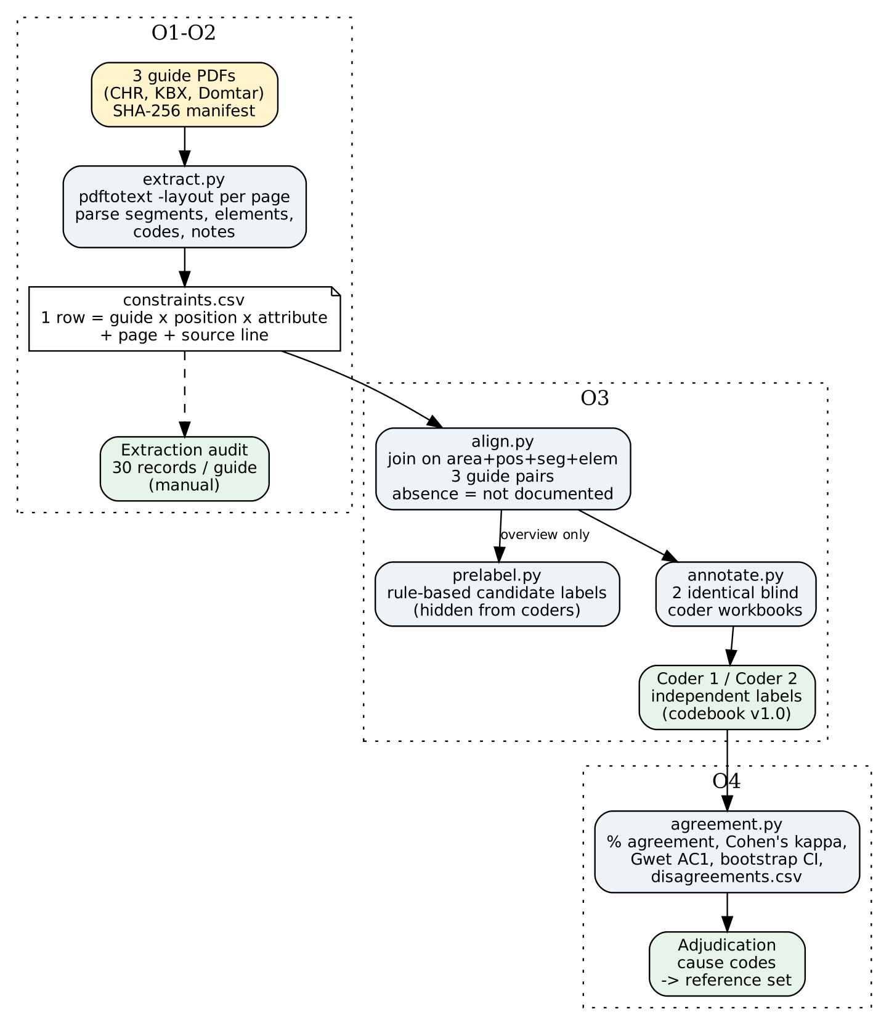
Figure 1. Pipeline architecture. Blue boxes are implemented scripts; green boxes are manual research steps; prelabel.py output is never shown to coders.

9.1 What is implemented
Component | Function | Status
extract.py | Reads each PDF page with pdftotext -layout; parses segment headers (Pos, Max, Usage), element rows (Ref, Id, Req, Type, Min/Max, Usage), code lists and notes into constraint records with page + source line; logs unparsed lines and pages without text; writes SHA-256 manifest | Implemented; tested on fixture PDFs
align.py | Joins records of two guides on area + position + segment ID + element reference; outer join keeps positions documented in one guide only, marked “not documented” | Implemented; unit-tested
prelabel.py | Rule-based candidate status/categories (normalises Must use = Mandatory, compares code sets, detects conditional wording); used for overview only | Implemented; unit-tested
annotate.py | Writes two identical blind coder workbooks (same order, drop-downs, codebook sheet, candidate labels removed) | Implemented; tested
agreement.py | Percent agreement, Cohen's kappa, Gwet's AC1, bootstrap 95% CI, 3×3 confusion matrix, disagreements.csv for adjudication | Implemented; kappa cross-checked against scikit-learn
run_pipeline.py | Runs the chain and writes manifest, constraints, units, overview tables, coder sheets and run_info.json | Implemented; first run on the guides pending (see 9.4)

9.2 Test evidence
Four automated tests pass (full log in Appendix D). The end-to-end test generates two small PDFs written by us in the usual guide layout (test fixtures, not partner guides or research data) and runs them through extraction, alignment, candidate labelling and coder-sheet export. It confirms that page evidence is kept, that “Must use” vs “Used” for the same element becomes a DIFFERENT unit, that “Must use” vs “Mandatory” is treated as equivalent, that a position missing from one guide becomes UNKNOWN rather than “not used”, and that no candidate label leaks into the coder workbook.
tests/test_end_to_end.py::test_pdf_to_coder_sheet PASSED [ 25%]
tests/test_pipeline.py::test_kappa_matches_sklearn PASSED [ 50%]
tests/test_pipeline.py::test_perfect_and_chance_agreement PASSED [ 75%]
tests/test_pipeline.py::test_alignment_and_absence_rule PASSED [100%]
============================== 4 passed in 1.20s ===============================

9.3 Design decisions
- Alignment key = X12 position, not element name. Guides rename elements and segments, but positions are fixed by the 004010 standard, so aligning on area + position + segment + element avoids treating a renamed element as a new requirement.
- Absence is not prohibition. Following Assignment 2, a position missing from one guide yields UNKNOWN; only an explicit “Not used” counts as a usage difference.
- Blind coding. Candidate labels exist only to check that the coding sample covers all categories; showing them would anchor coders and inflate agreement.
- Two agreement coefficients. Cohen's kappa is the standard, but with many NONE units it can be low despite high raw agreement; Gwet's AC1 is reported alongside to make this visible.

9.4 Limitations and unresolved issues found so far
- Source access. Automated download of the guides was blocked in our analysis environment, so the PDFs must be downloaded manually and registered by hash before the first real run. Running the pipeline with an empty guide folder stops with an explicit message rather than producing empty results: “need at least two guides with extracted records; see out/manifest.json”.
- Parser coverage on real layouts is not yet measured. The parser targets the common tabular guide layout; the 2008 Domtar guide may use a different layout. Unparsed lines are logged per guide so coverage can be audited instead of assumed.
- Revision and scope ambiguity (O1). During source review we noted that the KBX guide carries a 2022 date with later revision entries, and that the Domtar guide states separate truckload and LTL status requirements. Both must be resolved in the eligibility checklist (exact revision; truckload-only requirements) before alignment.
- Rare categories. Categories such as REPETITION may occur in few units, which makes kappa unstable; bootstrap intervals will be reported and categories with very few units will be described qualitatively.
Next step: run run_pipeline.py on the three registered PDFs, audit 30 records per guide, run calibration on 20 units, then start independent coding.

10. Methodology Alignment Table
Research Objective | Data / Evidence Needed | Source / Sample / Dataset | Collection / Instrument | Analysis Method | Evidence for RQ
O1 Select comparable guides | Version, direction, mode, revision and access for each candidate | Public X12 214 004010 guides: CHR 2021, KBX 2022, Domtar 2008 | Guide search log; eligibility checklist; SHA-256 manifest | Eligibility matrix; descriptive comparison of scope and dates | Ensures like-for-like units, so disagreement is not caused by scope
O2 Define unit and categories | Constraint records with page evidence; calibration outcomes | All text pages of the three guides; 20 calibration units | extract.py, align.py; codebook v1.0; extraction audit sheet | Extraction coverage and audit precision; summary of codebook changes | Shows the unit and categories are operational and evidence-linked
O3 Independent annotation | Status and category labels per unit from two coders | Aligned units of 3 guide pairs (all, or 120 per pair stratified) | Blind coder workbooks from annotate.py | Frequencies per coder, pair and category; cross-tab by segment group | Describes which differences the scheme identifies
O4 Agreement and disagreements | Paired labels; adjudication decisions and causes | Completed coder1 and coder2 workbooks | agreement.py; adjudication log | % agreement, Cohen's kappa, Gwet's AC1, bootstrap 95% CI; confusion matrix; cause coding | Answers “how consistently” and which distinctions are reproducible

11. References
Bogner, J., Kotstein, S., Abajirov, D., Ernst, T., & Merkel, M. (2024). RESTRuler: Towards automatically identifying violations of RESTful design rules in Web APIs. Proceedings of IEEE ICSA 2024, 123–134. https://doi.org/10.1109/ICSA59870.2024.00020
Bowen, G. A. (2009). Document analysis as a qualitative research method. Qualitative Research Journal, 9(2), 27–40. https://doi.org/10.3316/QRJ0902027
C.H. Robinson. (2021). Truckload TL carrier X12-214 implementation guide. https://www.chrobinson.com/en/-/media/chrobinson/documents/carrier-specs-docs/carrier-specs-dec-2020/chr-truckload-tl-carrier-x12-214.pdf
Cohen, J. (1960). A coefficient of agreement for nominal scales. Educational and Psychological Measurement, 20(1), 37–46. https://doi.org/10.1177/001316446002000104
Domtar Industries. (2008). Paper transportation EDI implementation guidelines: ASC X12 4010 214 transportation carrier shipment status message. https://www.iconnect-corp.com/specifications/vendors/Domtar/214SPECS_toolkit.pdf
Egyedi, T. M. (2007). Standard-compliant, but incompatible?! Computer Standards & Interfaces, 29(6), 605–613. https://doi.org/10.1016/j.csi.2007.04.001
Egyedi, T. M., & Verwater-Lukszo, Z. (2005). Which standards' characteristics increase system flexibility? Comparing ICT and batch processing infrastructures. Technology in Society, 27(3), 347–362. https://doi.org/10.1016/j.techsoc.2005.04.007
Gwet, K. L. (2008). Computing inter-rater reliability and its variance in the presence of high agreement. British Journal of Mathematical and Statistical Psychology, 61(1), 29–48. https://doi.org/10.1348/000711006X126600
Hsieh, H.-F., & Shannon, S. E. (2005). Three approaches to qualitative content analysis. Qualitative Health Research, 15(9), 1277–1288. https://doi.org/10.1177/1049732305276687
KBX Technology Solutions. (2022). ASC X12 4010 EDI implementation guidelines: 214 transportation carrier shipment status message. https://kbx.com/wp-content/uploads/2025/09/KBXTECH214-1.pdf
Landis, J. R., & Koch, G. G. (1977). The measurement of observer agreement for categorical data. Biometrics, 33(1), 159–174. https://doi.org/10.2307/2529310
McHugh, M. L. (2012). Interrater reliability: The kappa statistic. Biochemia Medica, 22(3), 276–282. https://doi.org/10.11613/BM.2012.031
O'Connor, C., & Joffe, H. (2020). Intercoder reliability in qualitative research: Debates and practical guidelines. International Journal of Qualitative Methods, 19, 1–13. https://doi.org/10.1177/1609406919899220

12. Appendix

Appendix A. Guide eligibility checklist (to be completed at registration)
Criterion | CHR (2021) | KBX (2022) | Domtar (2008)
Transaction / version 214 004010 | to confirm | to confirm | to confirm
Direction: carrier → guide owner | to confirm | to confirm | to confirm
Truckload scope stated or separable | to confirm | to confirm | TL and LTL stated separately – TL only
Exact revision / date | to confirm | 2022 date with later revisions – record exact revision | to confirm
Public, no login | yes (URL in references) | yes | yes
SHA-256, pages, access date | from out/manifest.json | from out/manifest.json | from out/manifest.json

Appendix B. Codebook v0.9 (calibration draft)
Type | Label | Operational definition
Status | NONE | Both guides document the position and every stated attribute is equivalent; differences are only wording, layout or element names.
Status | DIFFERENT | Both guides document the position and at least one stated requirement differs so that a sender would have to behave differently.
Status | UNKNOWN | The position or a deciding attribute is not documented in one guide, or the text is too ambiguous to decide. Absence is never read as “Not used”.
Category | USAGE | Segment or element usage or requirement differs (Must use / Used / Not used).
Category | CODES | The sets of permitted code values differ (added, removed or restricted).
Category | REPETITION | Maximum use of a segment or repeat of a loop differs.
Category | LENGTH_FORMAT | Minimum/maximum length or data type differs.
Category | CONDITION | A conditional or semantic instruction (if / when / only) applies in one guide and is absent or different in the other.
Rule | Scope | Requirement stated only for a non-truckload mode → UNKNOWN, note “scope”.
Rule | Evidence | Every label rests on the shown page text; if the PDF is opened, cite the page in the note.
Rule | Independence | No discussion of units until both workbooks are submitted.

Appendix C. Repository structure and key code
rmt214/
config.py guide registry, codebook labels, seed 20261023, 2000 bootstrap resamples
extract.py PDF -> page text -> constraint records (+ manifest, unparsed log)
align.py records -> aligned units per guide pair
prelabel.py rule-based candidate labels (overview only, hidden from coders)
annotate.py blind coder workbooks
agreement.py kappa, AC1, bootstrap CI, confusion matrix, disagreements
run_pipeline.py end-to-end run
tests/ unit + end-to-end tests (fixtures are self-made, not research data)
data/guides/ the three PDFs (local only, not redistributed)
out/ all generated evidence
Core of the agreement computation (agreement.py):
def cohen_kappa(a, b, labels=None):
po = percent_agreement(a, b) # observed agreement
ca, cb = Counter(a), Counter(b)
pe = sum((ca[k]/n) * (cb[k]/n) for k in labels) # chance agreement
return (po - pe) / (1 - pe)

def gwet_ac1(a, b, labels=None):
pi = {k: (ca[k] + cb[k]) / (2*n) for k in labels}
pe = sum(p * (1 - p) for p in pi.values()) / (q - 1)
return (po - pe) / (1 - pe)
Absence rule in candidate labelling (prelabel.py):
if row['documented_in'] != 'both':
return {'cand_status': 'UNKNOWN', ...,
'cand_reason': f"position documented only in {row['documented_in']}"}

Appendix D. Test log
$ python3 -m pytest -v tests
collected 4 items
tests/test_end_to_end.py::test_pdf_to_coder_sheet PASSED [ 25%]
tests/test_pipeline.py::test_kappa_matches_sklearn PASSED [ 50%]
tests/test_pipeline.py::test_perfect_and_chance_agreement PASSED [ 75%]
tests/test_pipeline.py::test_alignment_and_absence_rule PASSED [100%]
============================== 4 passed in 1.20s ===============================

$ python3 run_pipeline.py # guide folder not yet populated
need at least two guides with extracted records; see out/manifest.json

Appendix E. Coder workbook layout
Column group | Content
Identification | unit_id, guide_pair, x12_position (e.g. H020 B10 / B1002), documented_in
Evidence guide A / B | For each attribute: value, page, source line (columns ending __A / __B)
Labels (empty) | status (drop-down NONE / DIFFERENT / UNKNOWN); cat_USAGE … cat_CONDITION (Y/N); note
Other sheets | codebook (Appendix B); about (coder, number of units, guide labels)

