Report
Course: Software Design Patterns
Instructor: Almas Ospanov
Student: Nurassyl Orazbek
Group: SE-2405
Topic: Factory Method Pattern
link: https://github.com/nurashi/software-design-patterns/tree/main/factory-pattern

Introduction
The Factory Method is a creational design pattern that defines an interface for creating objects, but allows subclasses or specific factories to decide which class to instantiate.
This pattern helps to encapsulate the object creation logic and supports the Open/Closed Principle from SOLID: the code is open for extension but closed for modification.
In this assignment, the Factory Method pattern is implemented in Golang to handle different types of notifications (Email, SMS, Telegram).

Implementation

Structure
- Notification (interface): Defines a contract with the Send(to, message) method.
- Concrete Notifications: EmailNotification, SMSNotification, TelegramNotification. Each has its own implementation of the Send method.
- NotificationFactory (interface): Declares the method CreateNotification() for creating notifications.
- Concrete Factories: EmailFactory, SMSFactory, TelegramFactory. Each creates its corresponding notification type.
- Client (main): Works only with interfaces and does not depend on concrete classes.

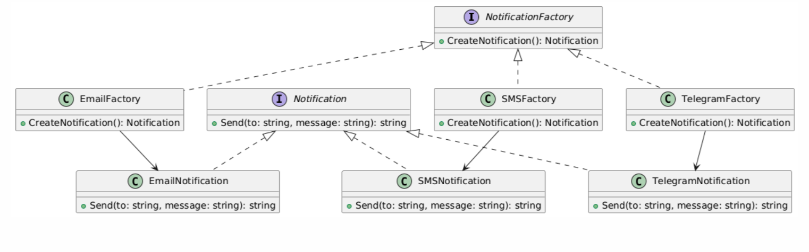
UML Diagram:

Clean Code Principles Applied
- Meaningful Names: Classes and methods clearly describe their purpose (CreateNotification, Send).
- Small Functions: Each function performs only one responsibility.
- Comments only where necessary: Only for contracts/interfaces; the code is self-explanatory otherwise.
- Dependency Inversion: Client code depends on abstractions (Notification, NotificationFactory), not concrete classes.

Conclusion
The Factory Method pattern allows decoupling the client code from the concrete implementations.
It simplifies the extension of the application: adding a new notification type only requires creating a new class and its factory, without changing the existing code.

