Software Design Patterns | Almas Ospanov
Student: Nurassyl Orazbek
Group: SE-2405
Topic: Builder Pattern – Assignment 1
Link: https://github.com/nurashi/software-design-patterns/tree/main/builder_pattern

Introduction
Builder Pattern – in software engineering, its about giving responsability of object creation to the other class, it makes code more flexiable, readiable, and object creation becomes more resource efficient. The istance of an object we want to build, is always in the perfect state we want, we only creat it, after only we configure it.
Problem:
Configuring a project can sometimes be a real challenge, especially when dealing with API keys and the configurations of various technologies. Managing these sensitive pieces of information and ensuring they’re correctly set up across different systems - like databases, messaging services, or external APIs - can lead to complexity and potential errors if not handled carefully. The builder pattern here can be very usefull when we should to validate the each key.

Implementation
For this assignment, I implemented the Builder Pattern in Go using a configuration system.
The main structure is Config, which consists of three sub-configurations:
- PostgreSQL – database settings
- Telegram – bot configuration
- OpenRouter – AI model configuration
Example Usage at director.go - This approach makes the configuration readable and flexible.

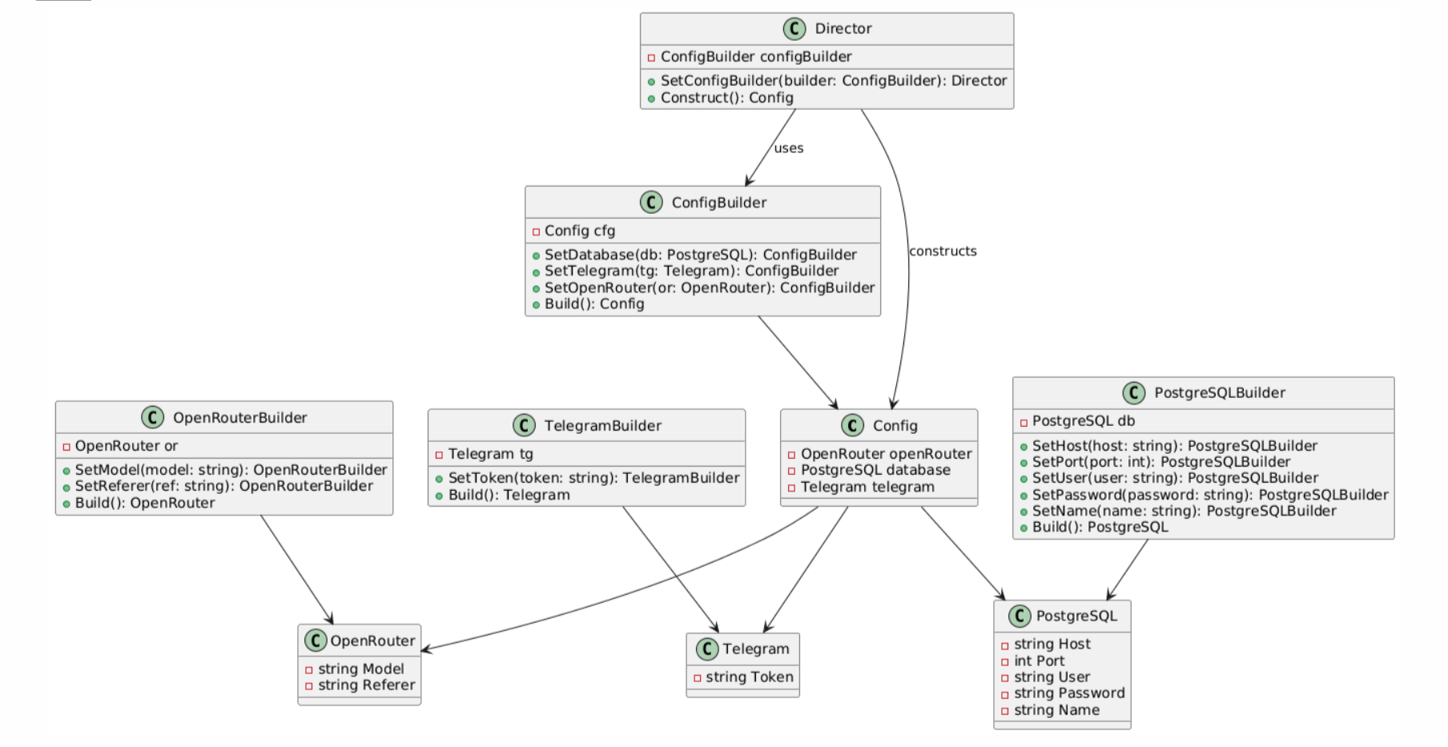
UML Diagram

Conclusion
The Builder Pattern helps construct complex objects in a step-by-step and controlled manner.
In this project, it was applied to building application configuration, demonstrating how design patterns improve code readability, maintainability, and flexibility.
Builder pattern at this case, the building or setting configuration of application sometimes can be diffucult, API-keys, at .env, or just general settings, so finding new way of building this was my main goal, overall builder pattern is good for this task.

Resources:
* UML Diagram drawed - The UML diagram was drawn in a notebook and transferred to png using - www.plantuml.com
* Builder Pattern understanding - https://refactoring.guru/design-patterns/builder

