**Used Images**

**For training**

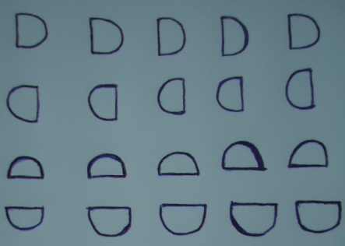



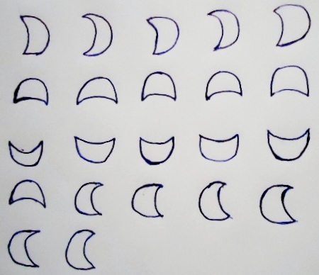

**For Testing:**

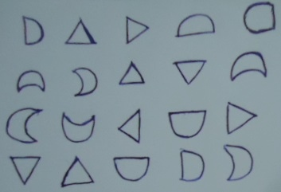

**MATLAB FILES:**

**Preprocessing.m :** Reads images and label them to find objects and cut them to save in a file.

**FDs.m :** is a function which is finding significant 20 Fourier descriptors of objects

**Bound2im.m :** is a function which is used to plot boundaries of an image according to boundary points

**FourierDescriptors.m:** calculates fourier descriptors by using FDs.m and bound2im.m functions and creates a matrix for datasets.

FOLDERS:

**and,or,inverter and test folder:** includes images of components after preprocessing operation.

**Reconstruction folder:** includes codes and an image for an example of reconstruction operation. (Reconstruct images from Fourier descriptors, we can change number of descriptor and see the changings)

**Neural folder:** Includes datasets which are extracted for training and testing by using nprtool.