DARK REALM
Game Design Document
Version 1.0 | May 2026

Dark Realm is a 2D top-down action RPG built with libGDX (Java). The player navigates three procedurally generated dungeon zones, battles a roster of eight enemy archetypes, completes NPC-driven quests, and confronts the three-phase final boss Malgrath — the Fallen God.
Engine | libGDX (Gradle project)
Language | Java 17
Resolution | 480 × 320 px (fixed viewport)
Tile Size | 16 × 16 px
Grid | 30 columns × 20 rows
Platform | Desktop (LWJGL3 launcher)
Package | com.narxoz.darkrealm

Narxoz University | com.narxoz.darkrealm

Table of Contents

1. Game Overview
2. Architecture & Project Structure
3. Core Systems
4. Player
5. Enemies
6. Boss: Malgrath the Fallen God
7. World & Dungeon Generation
8. Quest System
9. HUD & UI
10. Controls
11. Game Flow & Screens
12. Balance Constants
13. Design Patterns Used
14. Known Limitations & Future Work

1. Game Overview

Concept & Premise
Dark Realm is a single-player, top-down action RPG set in a world consumed by an ancient shadow curse. The player controls an unnamed warrior who must battle through three escalating dungeon zones — Ashen Plains, Cursed Citadel, and the Void Realm — before confronting Malgrath, the Fallen God, in a climactic three-phase boss fight.

Core Pillars
- Action Combat: Fast-paced melee and ranged combat with dodge mechanics and MP-fuelled special abilities.
- Procedural Dungeons: Every run generates a unique layout using attempt-based random room placement with L-shaped corridors.
- Progression: Enemies drop EXP; levelling up grants stat points and increases max HP/MP.
- Quest Narrative: A Village Elder NPC provides context and objectives for each zone.
- Challenge Escalation: Enemies grow in variety and aggression across zones; Zone 3 adds void-pool hazards and a fog-of-war vignette.

Win / Lose Conditions
Win | Defeat Malgrath in Zone 3 → VictoryScreen
Lose | Player HP reaches 0 → GameOverScreen
Zone Progress | Clear all enemies + reach EXIT tile → advance to next zone

2. Architecture & Project Structure

The project follows the standard libGDX multi-module Gradle layout. The
Package / File | Responsibility
DarkRealmGame.java | Application entry — owns SpriteBatch, ShapeRenderer, BitmapFont, SoundManager, global state (zone, kills, quests).
C.java | Central constants — resolution, tile size, speeds, cooldowns, damage values.
screens/ | One Screen per game state: MainMenu, Game, Pause, GameOver, Victory.
entities/ | Player, abstract Enemy, concrete enemy sub-classes, VillageElder NPC, EnemyFactory.
systems/ | BulletPool, CollisionSystem, ParticleSystem, QuestManager, HUD, KeyboardInputHandler, SoundManager.
world/ | DungeonGenerator (procedural layout), Room (rectangle helper).
interfaces/ | IDamageable, IInputHandler, IRenderable, IUpdatable — contracts that decouple systems.

Rendering Pipeline
All game graphics are drawn procedurally using ShapeRenderer (filled shapes — rectangles, circles, triangles, lines). There are no sprite assets; every character and tile is hand-coded geometry. Text is rendered with BitmapFont via SpriteBatch. Two cameras are used: a world camera following the player and a fixed HUD camera for the overlay.

3. Core Systems

3.1 CollisionSystem
Axis-aligned tile collision with independent X/Y resolution so entities slide along walls. Key methods:
- move(x, y, dx, dy, r) — step-and-slide movement for any circular entity.
- solid(map, px, py) — static tile query; WALL tiles are impassable.
- circles(ax, ay, ar, bx, by, br) — fast circle overlap test for bullet hits.
- hasLineOfSight(map, ax, ay, bx, by) — ray-march at 0.5-tile steps; used by ranged enemies and abilities.
- dist / angle — Euclidean distance and atan2 direction helpers.

3.2 BulletPool
Object pool of Bullet instances. Each bullet carries position, velocity angle, speed, damage, lifetime, and a fromPlayer flag. Bullets are returned to the inactive list on expiry or wall collision — prevents GC pressure during heavy combat.

3.3 ParticleSystem
Lightweight burst emitter. burst(x, y, color, count, speed, life) spawns a radial spread of velocity particles that fade out over time. Used for hit sparks, death explosions, skill activations, and shrine pickups.

3.4 SoundManager
Wraps libGDX audio. Exposes: playHit, playEnemyDeath, playPlayerHurt, playPickup, playLevelUp. All sounds load from the assets/ directory.

3.5 KeyboardInputHandler
Implements IInputHandler. WASD/Arrows for movement, mouse or Z for attack, right-click/X for dodge, Q for skill, E for interact, ESC for pause. Mouse world position is unprojected from the game camera to give free-aim direction.

4. Player

Base Stats (Level 1)
HP | 100 | Grows +10 per level; fully restored on level-up
MP | 60 | Grows +5 per level; regenerates 2 MP every 0.3 s
ATK | 10 | Flat melee damage; chest rewards can add +2 ATK
DEF | 5 | Subtracted from incoming damage (minimum 1 dealt)
Speed | 180 px/s | C.PLAYER_SPEED = 3.0 × 60
Radius | 5 px | Collision circle
EXP Scale | ×1.5/level | Threshold: 100, 150, 225, 337...

Movement & Dodge
Normal movement: 180 px/s, 8-directional. Dodge (right-click / X): speed triples to 630 px/s for 0.25 s in the aim direction, granting 0.25 s of invincibility frames. Movement is tile-collision resolved via CollisionSystem.move().

Basic Attack
Melee swing with 40 px range in the facing direction, 0.4 s cooldown. Deals player.atk damage to all enemies within range that have line-of-sight. Triggers a blade particle burst.

Special Abilities
Ability | MP Cost | Cooldown | Effect
Shadow Strike (SS) | 20 MP | 2 s | Dashes 48 px forward, deals 3× ATK to all enemies within 80 px. Grants 0.3 s i-frames. Purple burst FX.
Void Shield (VS) | 30 MP | 8 s | Activates 2 s damage-absorbing barrier (blocks all incoming damage). Pulsing blue aura on player.
Soul Drain (SD) | 25 MP | 6 s | Drains 20 HP from the nearest enemy within 60 px LOS. Heals player for 20 HP. Red/green burst FX.

Levelling
Each level-up grants 3 stat points (tracked but UI for spending is a future feature), +10 max HP (restored to full), and +5 max MP. The EXP threshold multiplies by 1.5 each level.

5. Enemies

All enemies extend the abstract Enemy base class which provides: health bar rendering, hit-flash animation, patrol AI, tile-collision movement, and the takeDamage / isAlive contract. Each sub-class overrides update(dt) and draw(sr).

Zone 1 — Ashen Plains
Name | HP | DMG | Speed | EXP | Behaviour
Shadow Wraith | 40 | 8 | 108 px/s | 30 | Zigzag pursuit (sin-wave offset); bobbing vertical animation; detect 140 px; melee contact damage.
Bone Archer | 30 | 6 | 66 px/s | 25 | Ranged attack every 1.1 s (±0.25 rad spread); retreats if player within 70 px; detect 160 px.

Zone 2 — Cursed Citadel
Name | HP | DMG | Speed | EXP | Behaviour
Cursed Knight | 80 | 14 | 78 px/s | 50 | Melee contact + shield-bash (20 dmg) every 2.2 s within 28 px; purple particle on bash; detect 160 px.
Plague Hound | 50 | 10 | 120 px/s | 40 | Fastest regular enemy; melee contact; toxic burst FX on hit; animated leg swing; detect 130 px.

Zone 3 — Void Realm
Name | HP | DMG | Speed | EXP | Behaviour
Void Sorcerer | 70 | 18 | 51 px/s | 60 | 3-bullet spread every 1.5 s; teleports 80 px if cornered (5 s CD); pulsing orb staff; detect 190 px.
Golem Sentinel | 120 | 20 | 36 px/s | 80 | Highest HP; ground slam (30 dmg) within 40 px every 3 s with rock-burst FX; animated crystal core; detect 140 px.

Spawning Rules
EnemyFactory.spawnForZone() iterates over all rooms except the first and last, spawning 2–3 enemies per room. Enemy type is chosen by weighted random roll per zone:
- Zone 1: 60% Shadow Wraith / 40% Bone Archer
- Zone 2: 35% Cursed Knight / 35% Plague Hound / 30% Shadow Wraith
- Zone 3: 40% Void Sorcerer / 35% Golem Sentinel / 25% Cursed Knight

6. Boss — Malgrath, the Fallen God

Malgrath is the final encounter, exclusive to Zone 3. He spawns only after the player has cleared all regular enemies and approaches the exit tile. He has 500 HP split across three escalating phases.

Phase Thresholds
Phase 1 (ONE) | 500–301 HP | Standard behaviour — melee + orb volley
Phase 2 (TWO) | 300–151 HP | Adds minion summoning every 15 s
Phase 3 (THREE) | ≤ 150 HP | Speed ×1.8, 8-shot orb burst, death nova every 3 s, blink teleport

Attack Repertoire
Attack | Damage | Phase | Notes
Melee Contact | 30 dmg | All | Continuous — damages player on touch each frame
Slash Strike | 30 / 45 (P3) | All | Within 80 px LOS; 1.8 s cooldown
Orb Volley | 24 dmg each | All | 5-shot spread (8 in P3); 2.0 s CD → 1.2 s in P3
Minion Summon | — | P2 + P3 | Spawns 2 Shadow Wraiths near boss every 15 s
Death Nova | 36 dmg each | P3 only | 12-bullet radial burst every 3 s
Blink | — | P3 only | Teleports within 30 px of player every 4 s if dist > 100 px

Visual Design
Drawn entirely with ShapeRenderer: layered aura circles (radius 28–76 px), jagged wing triangles, dark armour plating, a rune-staff with orbiting crystals, and exposed rib-runes. Phase progression reflected by aura intensity and colour-coded phase ring (orange P2, red P3). All geometry whites-out on hit-flash.

7. World & Dungeon Generation

Generation Algorithm
- Fill entire 30×20 grid with WALL tiles.
- Attempt up to 300 placements of randomly-sized rooms (4–9 wide, 3–6 tall).
- Accept a room only if it doesn't overlap any existing room (+1 px margin).
- Stop when the target room count is reached (6 + zone number).
- Connect rooms in order with L-shaped corridors (horizontal then vertical).
- Zone 3 only: randomly mark 6% of FLOOR tiles as HAZARD (void pools).
- Mark the last room's centre tile as EXIT.
- Player spawns at the first room's centre.

Tile Types
WALL (1) | Impassable — dark purple rendered tile
FLOOR (0) | Walkable — subtle checkerboard tint
EXIT (2) | Warp to next zone (glows green when all enemies cleared)
HAZARD (3) | Zone 3 void pool — 5 DPS to any player standing on it

Interactables
Each run places a Healing Shrine in the first room (+30 HP, single-use). Rooms 2 through second-to-last have a 50% chance of spawning a Treasure Chest which yields one of: HP heal (20–50), EXP bonus (40–100), or +2 ATK — opened with the E key.

8. Quest System

QuestManager maintains Quest objects with states: INACTIVE → ACTIVE → DONE. Zone quests activate on zone entry. Progress is driven by notify calls from GameScreen.
ID | Name | Zone | Objective | EXP
first_shadow | The First Shadow | 1 | Defeat 5 Shadow Wraiths | 300
lost_dark | Lost in the Dark | 1 | Find the missing scout | 200
shattered | Shattered Ramparts | 2 | Destroy 3 Cursed Barricades | 500
antidote | Antidote Run | 2 | Collect 5 Moonbloom Herbs | 400
void_crystals | Voices in the Void | 3 | Destroy 4 Void Crystals | 800
silence | Silence Malgrath | 3 | Defeat the final boss | —

Note: lost_dark, shattered, antidote, and void_crystals have notify hooks but no triggerable world objects yet — designed for future collectible/destructible content.

Village Elder NPC
VillageElder is placed in the second room of Zones 1 and 2. Pressing E within 30 px cycles through pre-set dialogue lines. Lines containing 'Quest:' trigger quest activation and display a HUD notification.

9. HUD & UI

- HP Bar: Top-left — 100 × 8 px red fill bar with grey background.
- MP Bar: Below HP — 80 × 7 px blue fill bar.
- Skill Icons: Three 16×16 px cooldown icons (SS/VS/SD) with fill animation showing readiness.
- Status Text: HP x/y, MP x/y, LVL, KILLS, ZONE — displayed at bottom-left.
- Quest Notification: Centre-screen pop-up with 3 s duration for quest and chest events.
- Chest Hint: '[E] Open chest' appears at screen centre-bottom when within 20 px of unopened chest.
- Boss HP Bar: 200 px bar at screen bottom-centre during boss fight.
- Boss Name: 'MALGRATH - THE FALLEN GOD' displayed above boss HP bar.
- Mini-map: 60 × 40 px top-right corner — shows floor, exit, hazards, chests, enemies, boss, and player.
- Dialogue Box: Semi-transparent bar at screen top during NPC interaction (3 s duration).
- Dark Vignette: Zone 3 only — black overlay with circular cutout (radius 72 px) around player.

10. Controls

Action | Primary | Alternate | Description
Move | WASD | Arrow Keys | 8-directional movement
Attack | Left Mouse | Z | Melee swing in aim direction
Dodge | Right Mouse | X | i-frame dash in aim direction (0.25 s)
Use Skill | Q | Q | Shadow Strike → Void Shield → Soul Drain (priority order)
Interact | E | E | Talk to NPC / Open chest
Pause | ESC | ESC | Switch to PauseScreen
Aim | Mouse cursor | — | Free-aim world-space direction

11. Game Flow & Screens

Screen State Machine
MainMenuScreen | Animated floating particles. Controls and story blurb. ENTER or touch to start.
GameScreen (Zone 1) | Procedural dungeon, enemies, quests, NPC. No vignette.
GameScreen (Zone 2) | Harder enemy mix, barricade quest NPC. No vignette.
GameScreen (Zone 3) | Dark vignette, hazard tiles, void enemies, Malgrath boss.
PauseScreen | Overlay with Resume / Main Menu options. ESC to pause.
GameOverScreen | Shows zone reached and kill count. Play again / Main menu.
VictoryScreen | Shows kills and quests completed. Return to menu.

Zone Transition Logic
At the end of each update tick, the game checks: (a) all enemies are dead, (b) boss is dead if in Zone 3, and (c) player is within 16 px of the EXIT tile. If all conditions hold and zone < 3, a new GameScreen(zone+1) is created. If zone == 3 and boss is dead, VictoryScreen is shown.

12. Balance Constants (C.java)

Constant | Value | Description
PLAYER_SPEED | 180 px/s | 3.0 × 60
DODGE_DURATION | 0.25 s | —
DODGE_SPEED_MULT | 3.5 × | —
IFRAMES_DURATION | 0.5 s | Post-hit invulnerability window
ATTACK_RANGE | 40 px | Melee reach
ATTACK_COOLDOWN | 0.4 s | —
BULLET_SPEED | 330 px/s | 5.5 × 60
BULLET_LIFE | 2.5 s | Max bullet lifetime
BULLET_RADIUS | 3 px | Collision circle
CD_SHADOW_STRIKE | 2 s | —
CD_VOID_SHIELD | 8 s | —
CD_SOUL_DRAIN | 6 s | —
SHADOW_STRIKE_RANGE | 80 px | AOE radius after dash
SOUL_DRAIN_RANGE | 60 px | Max drain distance
VOID_SHIELD_DURATION | 2 s | Active block window
MP_REGEN_INTERVAL | 0.3 s | —
MP_REGEN_AMOUNT | 2 MP | Per regen tick
HAZARD_DPS | 5 dmg/s | Void pool damage rate
EXP_SCALE | 1.5 × | Level threshold multiplier

13. Design Patterns Used

Interface Segregation
IDamageable, IInputHandler, IRenderable, IUpdatable — entities and systems depend only on the contracts they need. CollisionSystem and BulletPool don't require full Enemy internals.

Object Pool (BulletPool)
Reuses Bullet instances to avoid per-frame allocation, reducing GC pauses during heavy combat.

Factory (EnemyFactory)
Centralises enemy construction and zone-based weighted random selection, keeping GameScreen free of construction logic.

State Machine
Malgrath.Phase and QuestManager.QuestState use explicit enums with guarded transitions for boss behaviour and quest progression.

Observer-lite (QuestManager.notify)
GameScreen calls notifyKill after each enemy death; QuestManager updates matching quests without coupling the two systems.

Screen Stack (libGDX Game.setScreen)
Pause and overlay screens are pushed without destroying the underlying GameScreen, enabling seamless resume.

Data Class (C.java)
All magic numbers are named constants in a single class — editing balance requires no code search.

14. Known Limitations & Future Work

Current Limitations
- Stat-point allocation UI is missing — points are tracked but cannot be spent in-game.
- lost_dark, shattered, antidote, and void_crystals quests have no triggerable world objects (scouts, barricades, herbs, void crystals) — only kill-based quests fully complete.
- Sound files may not be present in assets/ — SoundManager loads gracefully but silently.
- No save/load system — progress resets on every run.
- All rendering uses ShapeRenderer; no texture atlas or sprite animations.
- Single resolution (480×320) — no responsive layout for larger windows.

Suggested Future Features
Feature | Description
Sprite Animations | Replace ShapeRenderer art with TextureAtlas sprite sheets and skeletal animation.
Stat Allocation Screen | Pause menu sub-screen to spend stat points on ATK/DEF/HP/MP.
Quest World Objects | Add destructible barricades, herb pickups, void crystals, and a scout NPC.
Difficulty Scaling | Per-zone HP/damage multipliers configurable at game start.
Full Audio | Complete SFX and zone-specific background music tracks.
Item System | Equippable weapons and armour with stat modifiers dropped by enemies.
Save System | JSON serialisation of player stats, zone, and quest progress.
More Zones & Bosses | Expand beyond Zone 3 with additional unique bosses.
Controller Support | libGDX Controllers extension for gamepad input.

Required Diagrams (draw.io)

Game Flow Diagram

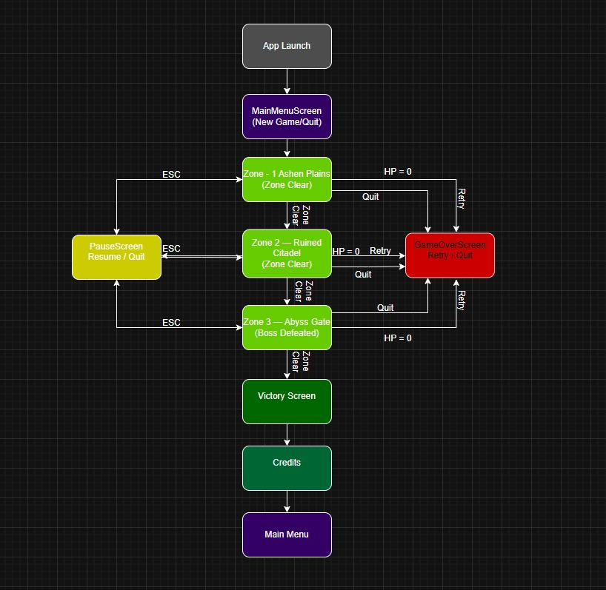

Core Class Diagram (Planned)

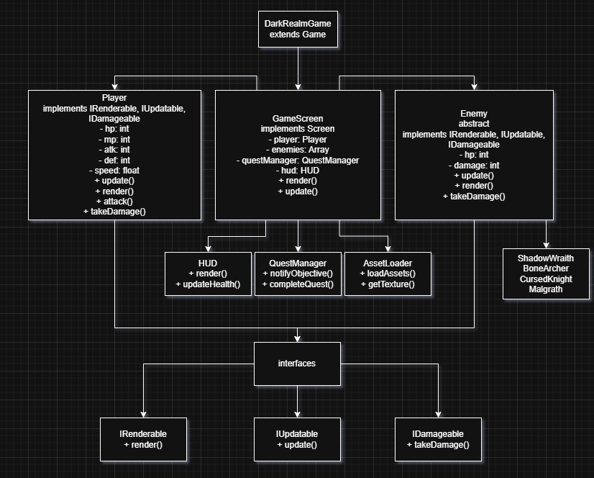

Level Sketch

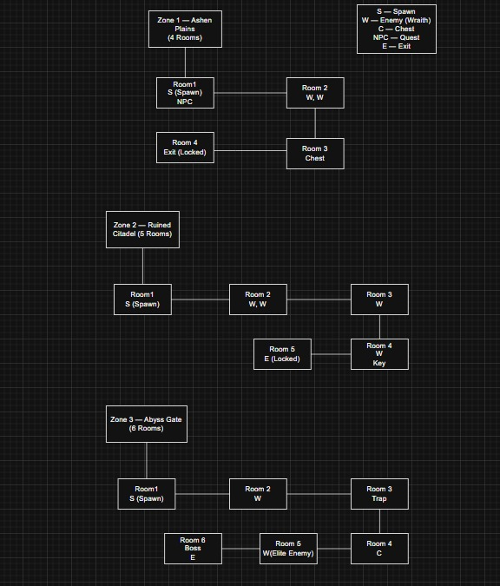

Dark Realm GDD v1.0 — Generated from source code — May 2026

