Lab 10
Task 1:
CREATE OR REPLACE PROCEDURE insert_new_flight(
p_flight_id VARCHAR(50),
p_sch_departure_time TIMESTAMP,
p_sch_arrival_time TIMESTAMP,
p_departing_airport_id INT,
p_arriving_airport_id INT,
p_departing_gate VARCHAR(10),
p_arriving_gate VARCHAR(10),
p_airline_id INT,
p_country VARCHAR(100),
p_act_departure_time TIMESTAMP,
p_act_arrival_time TIMESTAMP
)
LANGUAGE plpgsql
AS $$
BEGIN
INSERT INTO flights(
flight_id,
sch_departure_time,
sch_arrival_time,
departing_airport_id,
arriving_airport_id,
departing_gate,
arriving_gate,
airline_id,
act_departure_time,
act_arrival_time,
country,
created_at,
updated_at
)
VALUES(
p_flight_id,
p_sch_departure_time,
p_sch_arrival_time,
p_departing_airport_id,
p_arriving_airport_id,
p_departing_gate,
p_arriving_gate,
p_airline_id,
p_act_departure_time,
p_act_arrival_time,
p_country,
NOW(),
NOW()
);
END;
$$;
FOR THE PROCEDURE TO WORK:
CALL insert_new_flight('FL123', '2024-01-20 10:00:00', '2024-01-20 12:00:00', 1, 2, 'A1', 'B2', 1, 'USA');
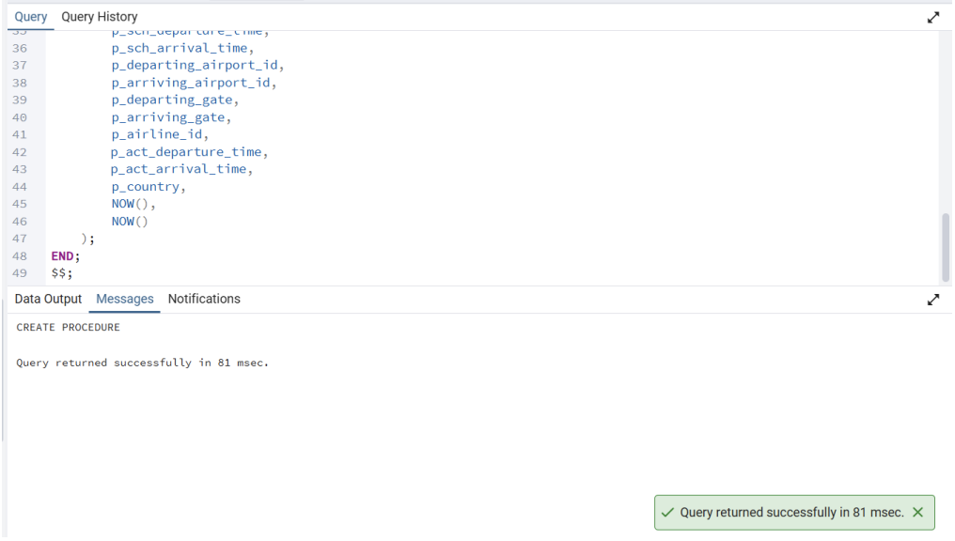
Task 2:
CREATE OR REPLACE PROCEDURE uppdate_flights_status(
p_flight_id INT,
p_status VARCHAR(50)
)
LANGUAGE plpgsql
AS $$
BEGIN
UPDATE booking
SET status = p_status
WHERE flight_id = p_flight_id;
END;
$$;
FOR THE PROCEDURE TO WORK:
CALL uppdate_flights_status(5, 'Delayed');
CREATE OR REPLACE PROCEDURE uppdate_flights_status(
p_flight_id INT,
p_status VARCHAR(50)
)
LANGUAGE plpgsql
AS $$
BEGIN
UPDATE booking
SET status = p_status
WHERE flight_id = p_flight_id;
END;
$$;
FOR THE PROCEDURE TO WORK:
CALL uppdate_flights_status(5, 'Delayed');
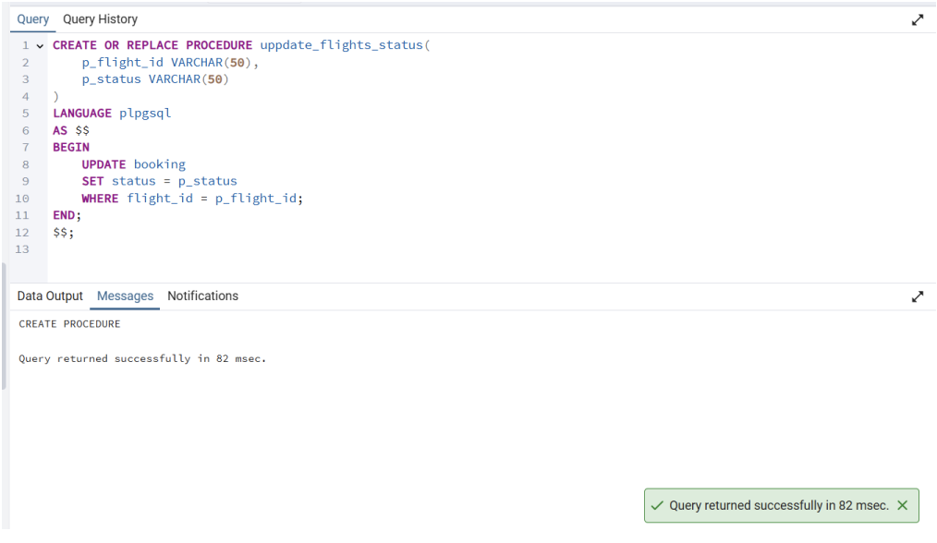
Task 3:
CREATE OR REPLACE FUNCTION GetFlightsByDeparture(
p_departure_airport VARCHAR(5)
)
RETURNS TABLE (
flight_number VARCHAR(10),
departure_airport VARCHAR(5),
arrival_airport VARCHAR(5),
departure_time TIMESTAMP,
arrival_time TIMESTAMP,
status VARCHAR(20)
)
LANGUAGE plpgsql
AS $$
BEGIN
RETURN QUERY
SELECT *
FROM flights
WHERE departure_airport = p_departure_airport;
END;
$$;
SELECT * FROM GetFlightsByDeparture('SVO');
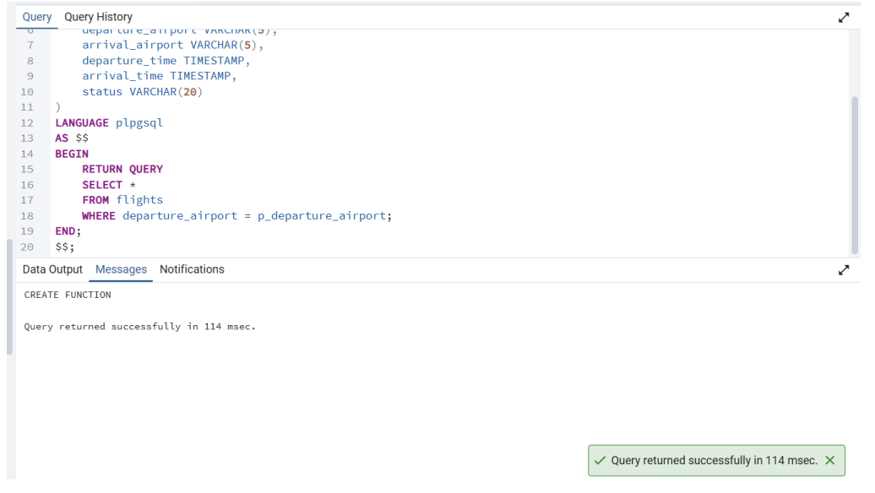
Task 4:
CREATE OR REPLACE FUNCTION AvgDelayByArrivalAirport(
p_airport_id INT
)
RETURNS INTERVAL
LANGUAGE plpgsql
AS $$
DECLARE
avg_delay INTERVAL;
BEGIN
SELECT AVG(act_arrival_time - sch_arrival_time)
INTO avg_delay
FROM flights
WHERE arriving_airport_id = p_airport_id
AND act_arrival_time IS NOT NULL
AND sch_arrival_time IS NOT NULL;
RETURN avg_delay;
END;
$$;
SELECT AvgDelayByArrivalAirport(55)
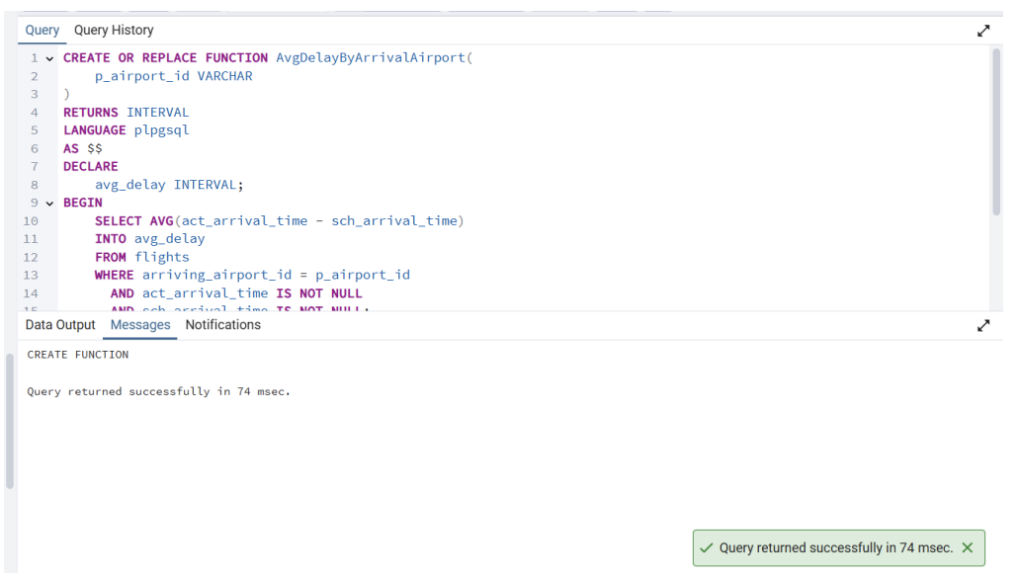
Task 5:
CREATE OR REPLACE FUNCTION GetPassengersByFlight(
p_flight_number VARCHAR(10)
)
RETURNS TABLE (
passenger_id INT,
first_name VARCHAR(50),
last_name VARCHAR(50),
)
LANGUAGE plpgsql
AS $$
BEGIN
RETURN QUERY
SELECT p.passenger_id, p.first_name, p.last_name
FROM passengers p
JOIN tickets t ON t.passenger_id = p.passenger_id
WHERE t.flight_number = p_flight_number;
END;
$$;
SELECT * FROM GetPassengersByFlight('SU1005');
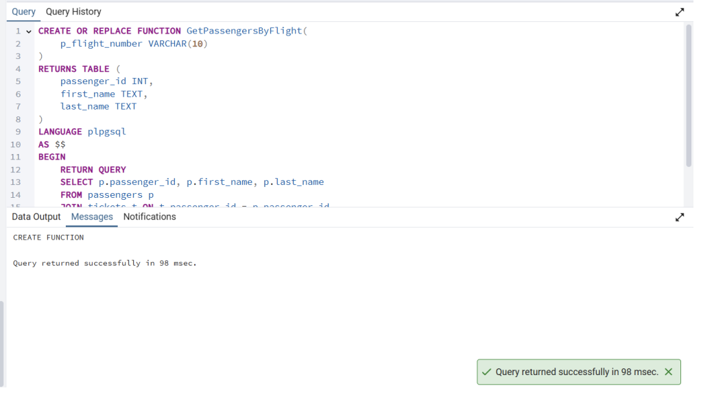
Task 6:
CREATE OR REPLACE FUNCTION GetTopPassenger()
RETURNS TABLE (
passenger_id INT,
first_name VARCHAR(50),
last_name VARCHAR(50),
flights_taken BIGINT
)
LANGUAGE plpgsql
AS $$
BEGIN
RETURN QUERY
SELECT p.passenger_id,
p.first_name,
p.last_name,
COUNT(*) AS flights_taken
FROM tickets t
JOIN passengers p ON p.passenger_id = t.passenger_id
GROUP BY p.passenger_id, p.first_name, p.last_name
ORDER BY flights_taken DESC
LIMIT 1;
END;
$$;
SELECT GetTopPassenger()
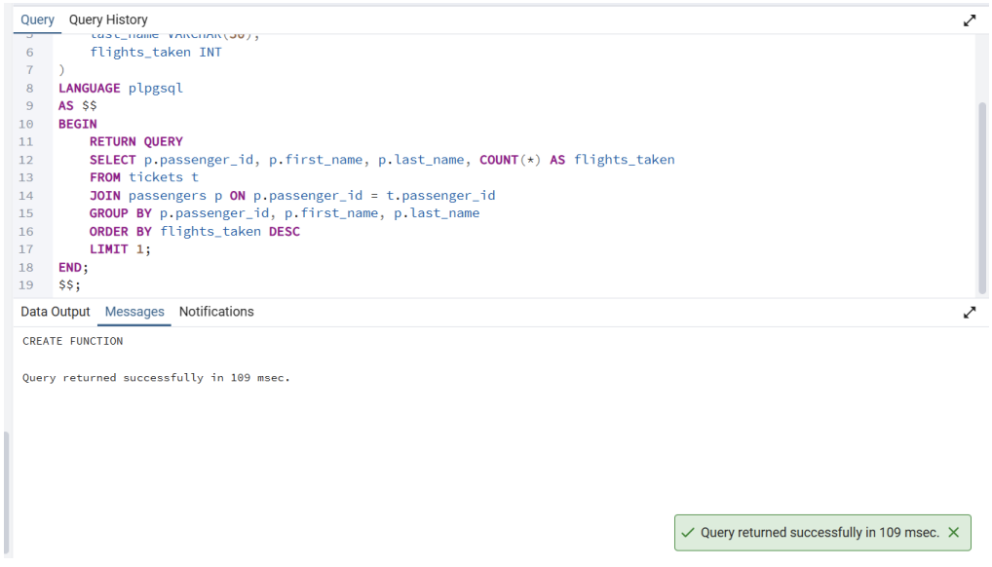
Task 7:
CREATE OR REPLACE FUNCTION GetFlightsDelayed24h()
RETURNS TABLE (
flight_id INT,
delay_interval INTERVAL,
delay_minutes NUMERIC
)
LANGUAGE plpgsql
AS $$
BEGIN
RETURN QUERY
SELECT
f.flight_id,
(f.act_arrival_time - f.sch_arrival_time) AS delay_interval,
EXTRACT(EPOCH FROM (f.act_arrival_time - f.sch_arrival_time)) / 60 AS delay_minutes
FROM flights f
WHERE f.act_arrival_time IS NOT NULL
AND f.sch_arrival_time IS NOT NULL
AND (EXTRACT(EPOCH FROM (f.act_arrival_time - f.sch_arrival_time)) / 60) > 1440;
END;
$$;
SELECT * FROM GetFlightsDelayed24h();
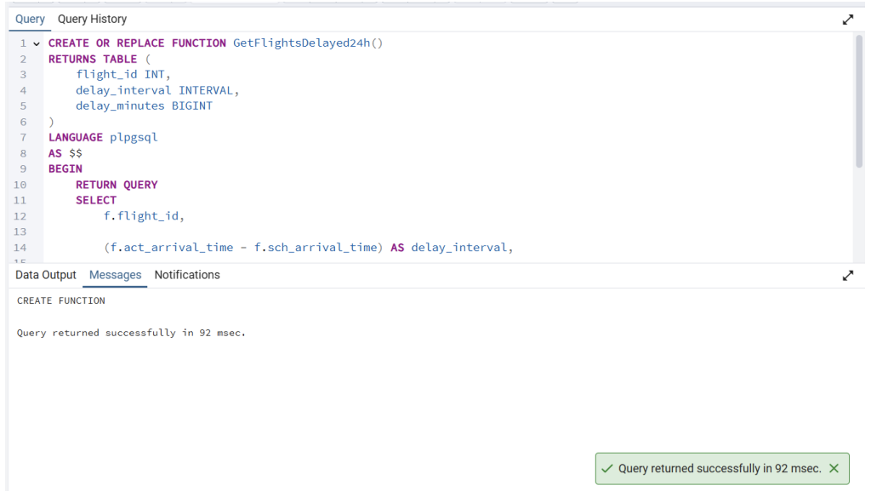
Task 8:
CREATE OR REPLACE FUNCTION CountFlightsByAirline(
p_airline_id INT
)
RETURNS BIGINT
LANGUAGE plpgsql
AS $$
DECLARE
cnt BIGINT;
BEGIN
SELECT COUNT(flight_id)
INTO cnt
FROM flights
WHERE airline_id = p_airline_id;
RETURN cnt;
END;
$$;
SELECT CountFlightsByAirline(1);
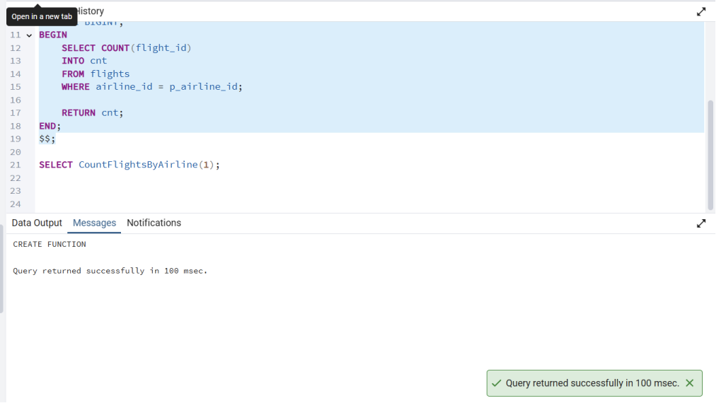
Task 9:
CREATE OR REPLACE FUNCTION AvgTicketPriceByFlight(
p_flight_number VARCHAR(50)
)
RETURNS NUMERIC
LANGUAGE plpgsql
AS $$
DECLARE
avg_price NUMERIC;
BEGIN
SELECT AVG(price)
INTO avg_price
FROM tickets
WHERE flight_number = p_flight_number;
RETURN avg_price;
END;
$$;
SELECT AvgTicketPriceByFlight('SU1005');
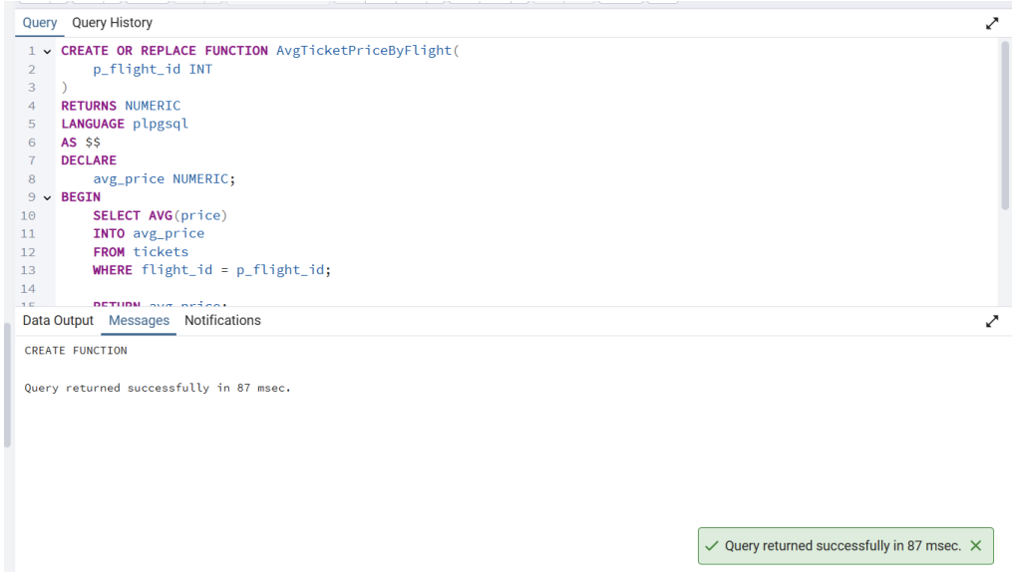
Task 10:
CREATE OR REPLACE FUNCTION GetMostExpensiveFlight()
RETURNS TABLE (
flight_id INT,
departing_airport_id VARCHAR(50),
arriving_airport_id VARCHAR(50),
price NUMERIC
)
LANGUAGE plpgsql
AS $$
BEGIN
RETURN QUERY
SELECT f.flight_id,
f.departing_airport_id,
f.arriving_airport_id,
t.price
FROM tickets t
JOIN flights f ON f.flight_id = t.flight_id
ORDER BY t.price DESC
LIMIT 1;
END;
$$;
