LAB 5
Task 1:
ALTER TABLE passengers
ADD CONSTRAINT chk_passenger_age
CHECK (date_of_birth <= CURRENT_DATE - INTERVAL '10 years');
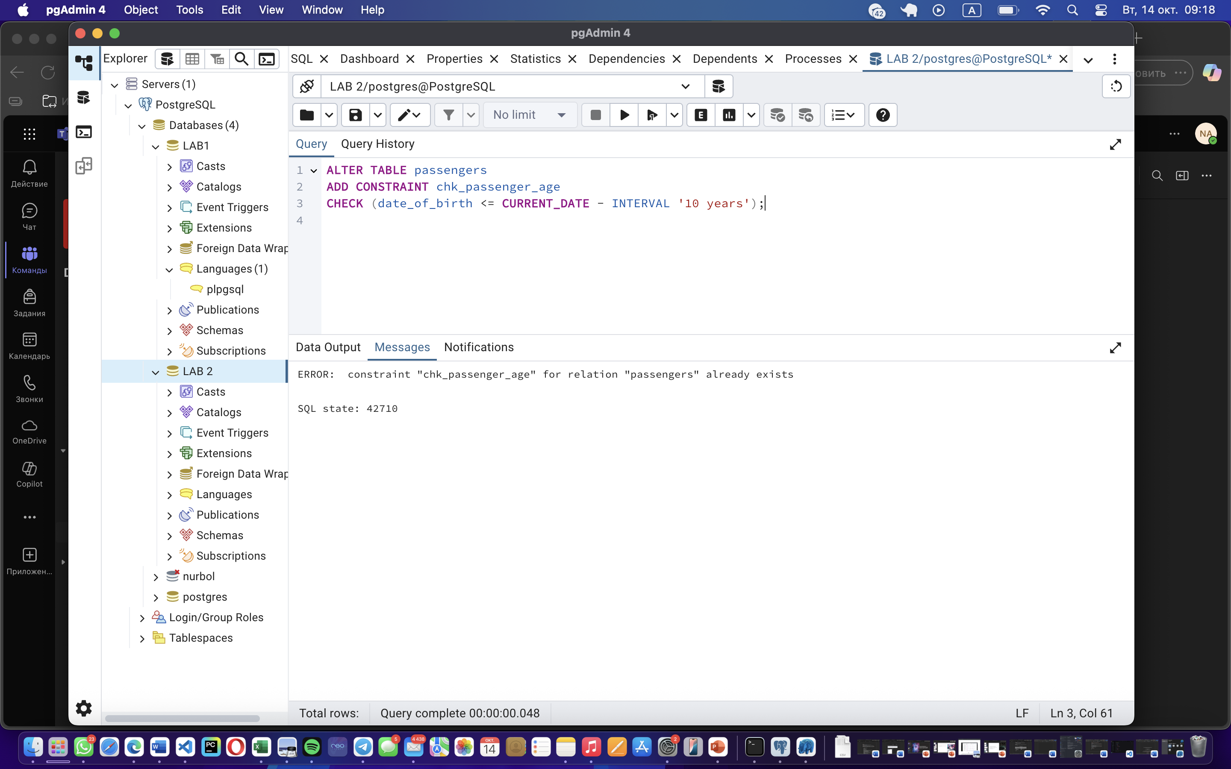
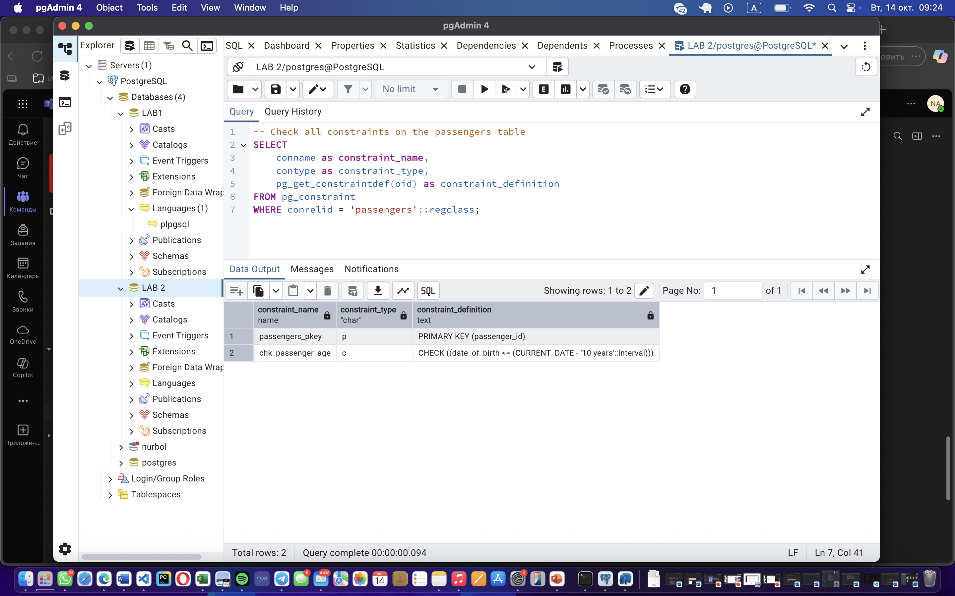
Task 2:
ALTER TABLE booking
ADD CONSTRAINT chk_booking_price_range
CHECK (price >= 0 AND price <= 50000);
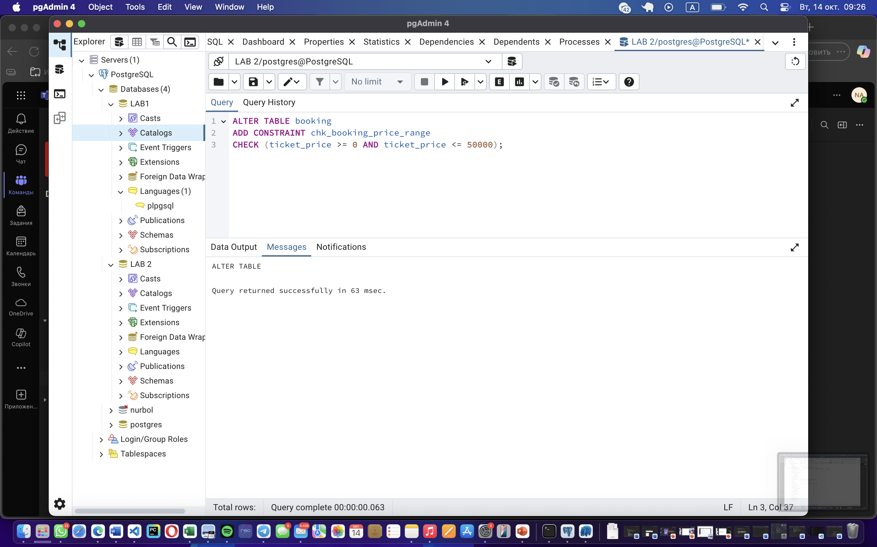
Task 3:
ALTER TABLE luggage
ADD CONSTRAINT chk_luggage_weight_range
CHECK (weight >= 1 AND weight <= 23);
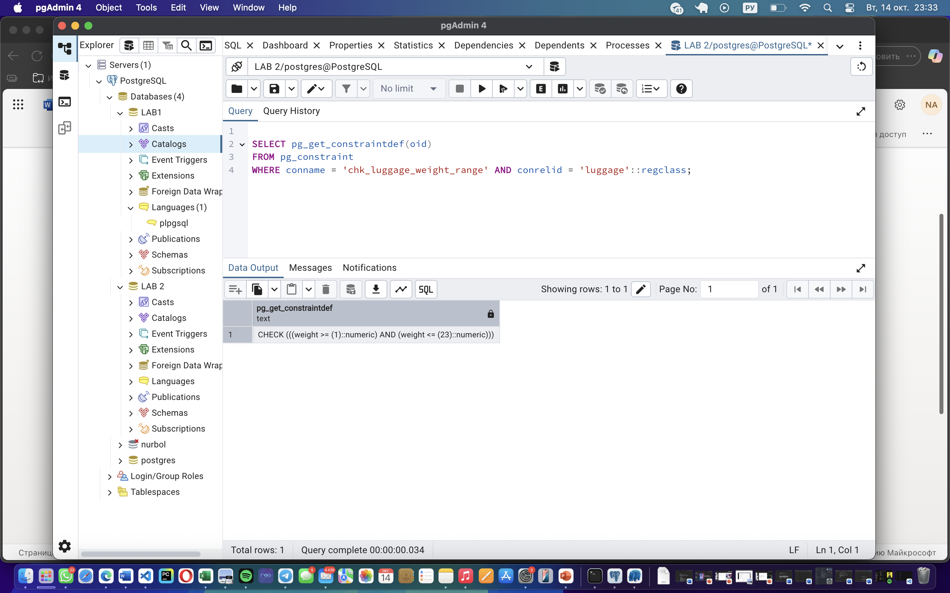

Task 4:
ALTER TABLE airport
ADD CONSTRAINT chk_airport_name_length
CHECK (LENGTH(TRIM(airport_name)) >= 10);
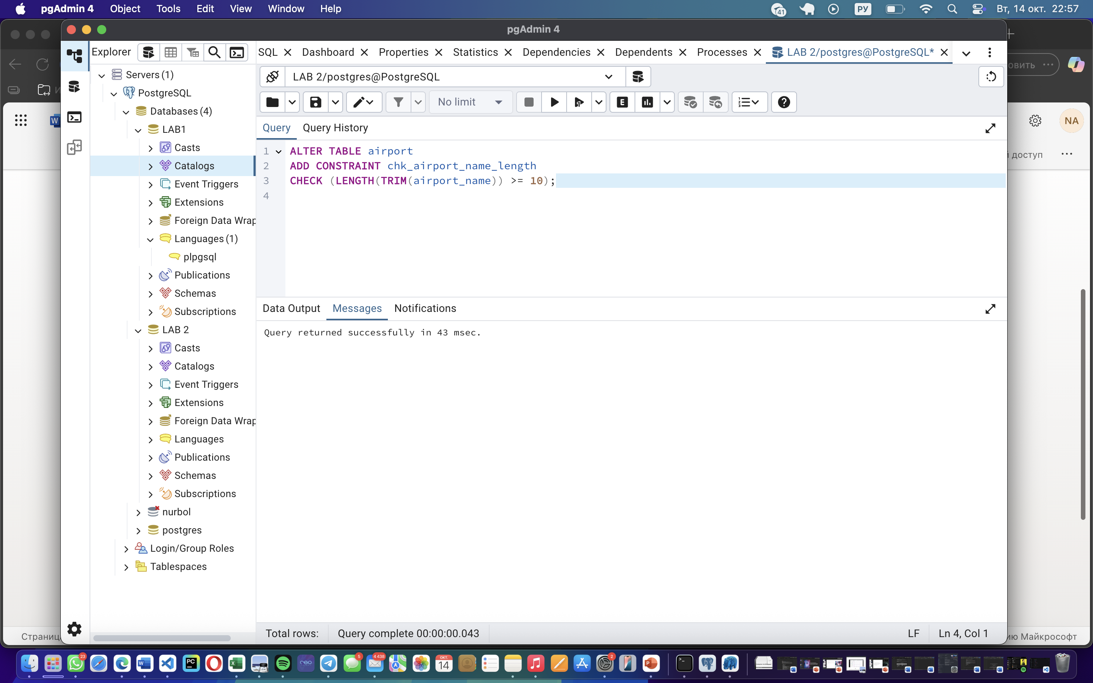
Task 5:

ALTER TABLE passengers ADD CONSTRAINT uk_passengers_passport UNIQUE (passport_number);

ALTER TABLE airport ADD CONSTRAINT uk_airport_code UNIQUE (airport_code);

ALTER TABLE flights ADD CONSTRAINT uk_flights_id UNIQUE (flight_id);

ALTER TABLE booking ADD CONSTRAINT uk_booking_passenger_flight UNIQUE (passenger_id, flight_id);
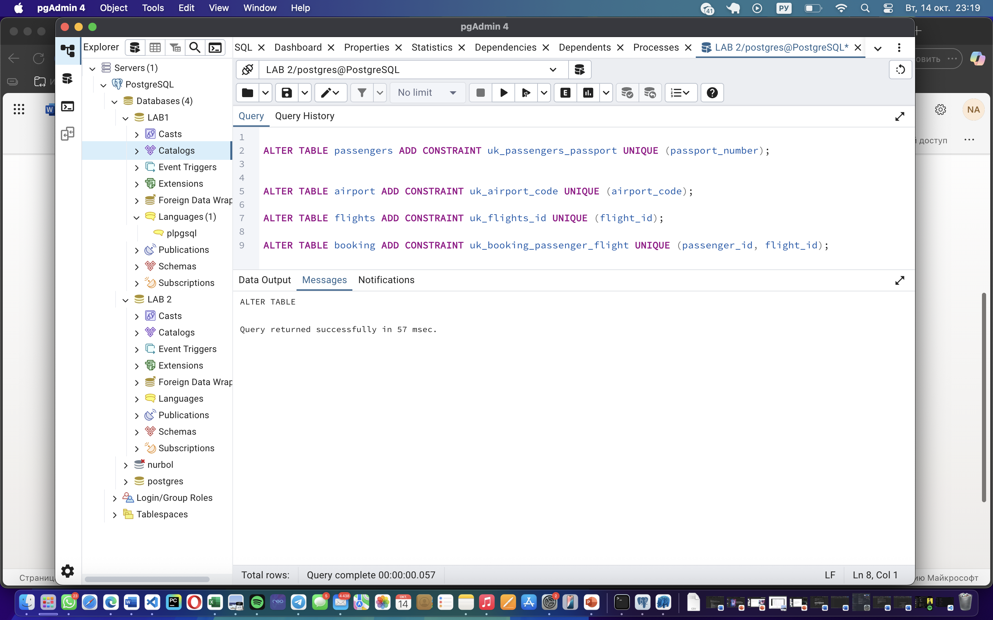
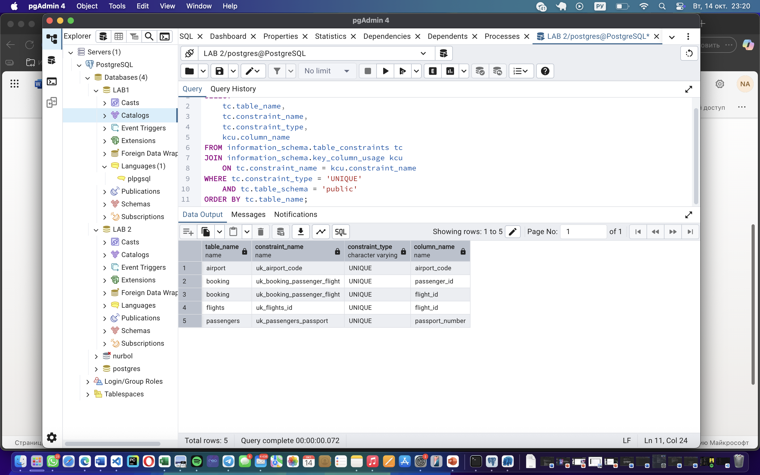
Task 6:
ALTER TABLE passengers
ADD CONSTRAINT chk_passenger_age_gender
CHECK (
(gender = 'M' AND date_of_birth <= CURRENT_DATE - INTERVAL '18 years') OR
(gender = 'F' AND date_of_birth <= CURRENT_DATE - INTERVAL '19 years') OR
(gender NOT IN ('M', 'F'))
);
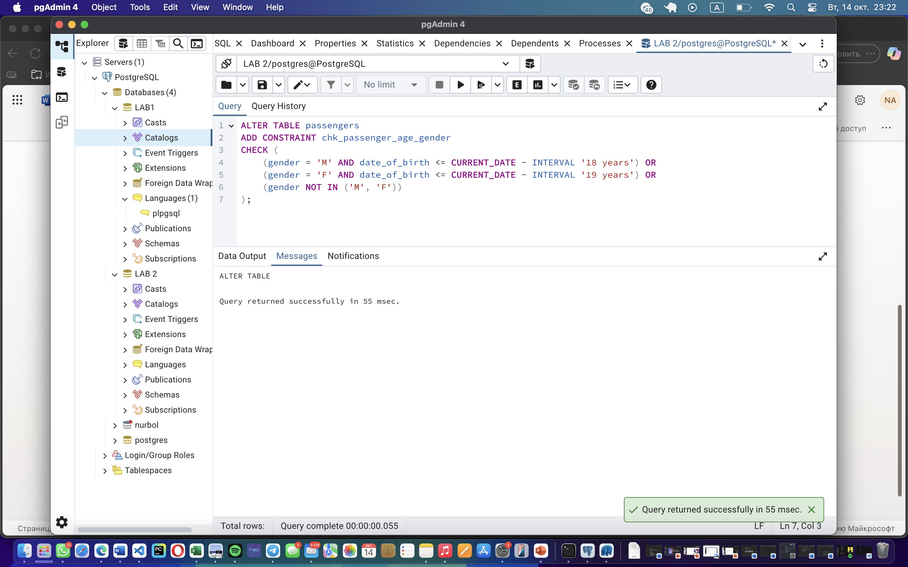
Task 7:
ALTER TABLE passengers
ADD CONSTRAINT chk_passenger_age_by_country
CHECK (
(country_of_citizenship = 'Kazakhstan' AND date_of_birth <= CURRENT_DATE - INTERVAL '18 years') OR
(country_of_citizenship = 'France' AND date_of_birth <= CURRENT_DATE - INTERVAL '17 years') OR
(country_of_citizenship NOT IN ('Kazakhstan', 'France') AND date_of_birth <= CURRENT_DATE - INTERVAL '19 years')
); 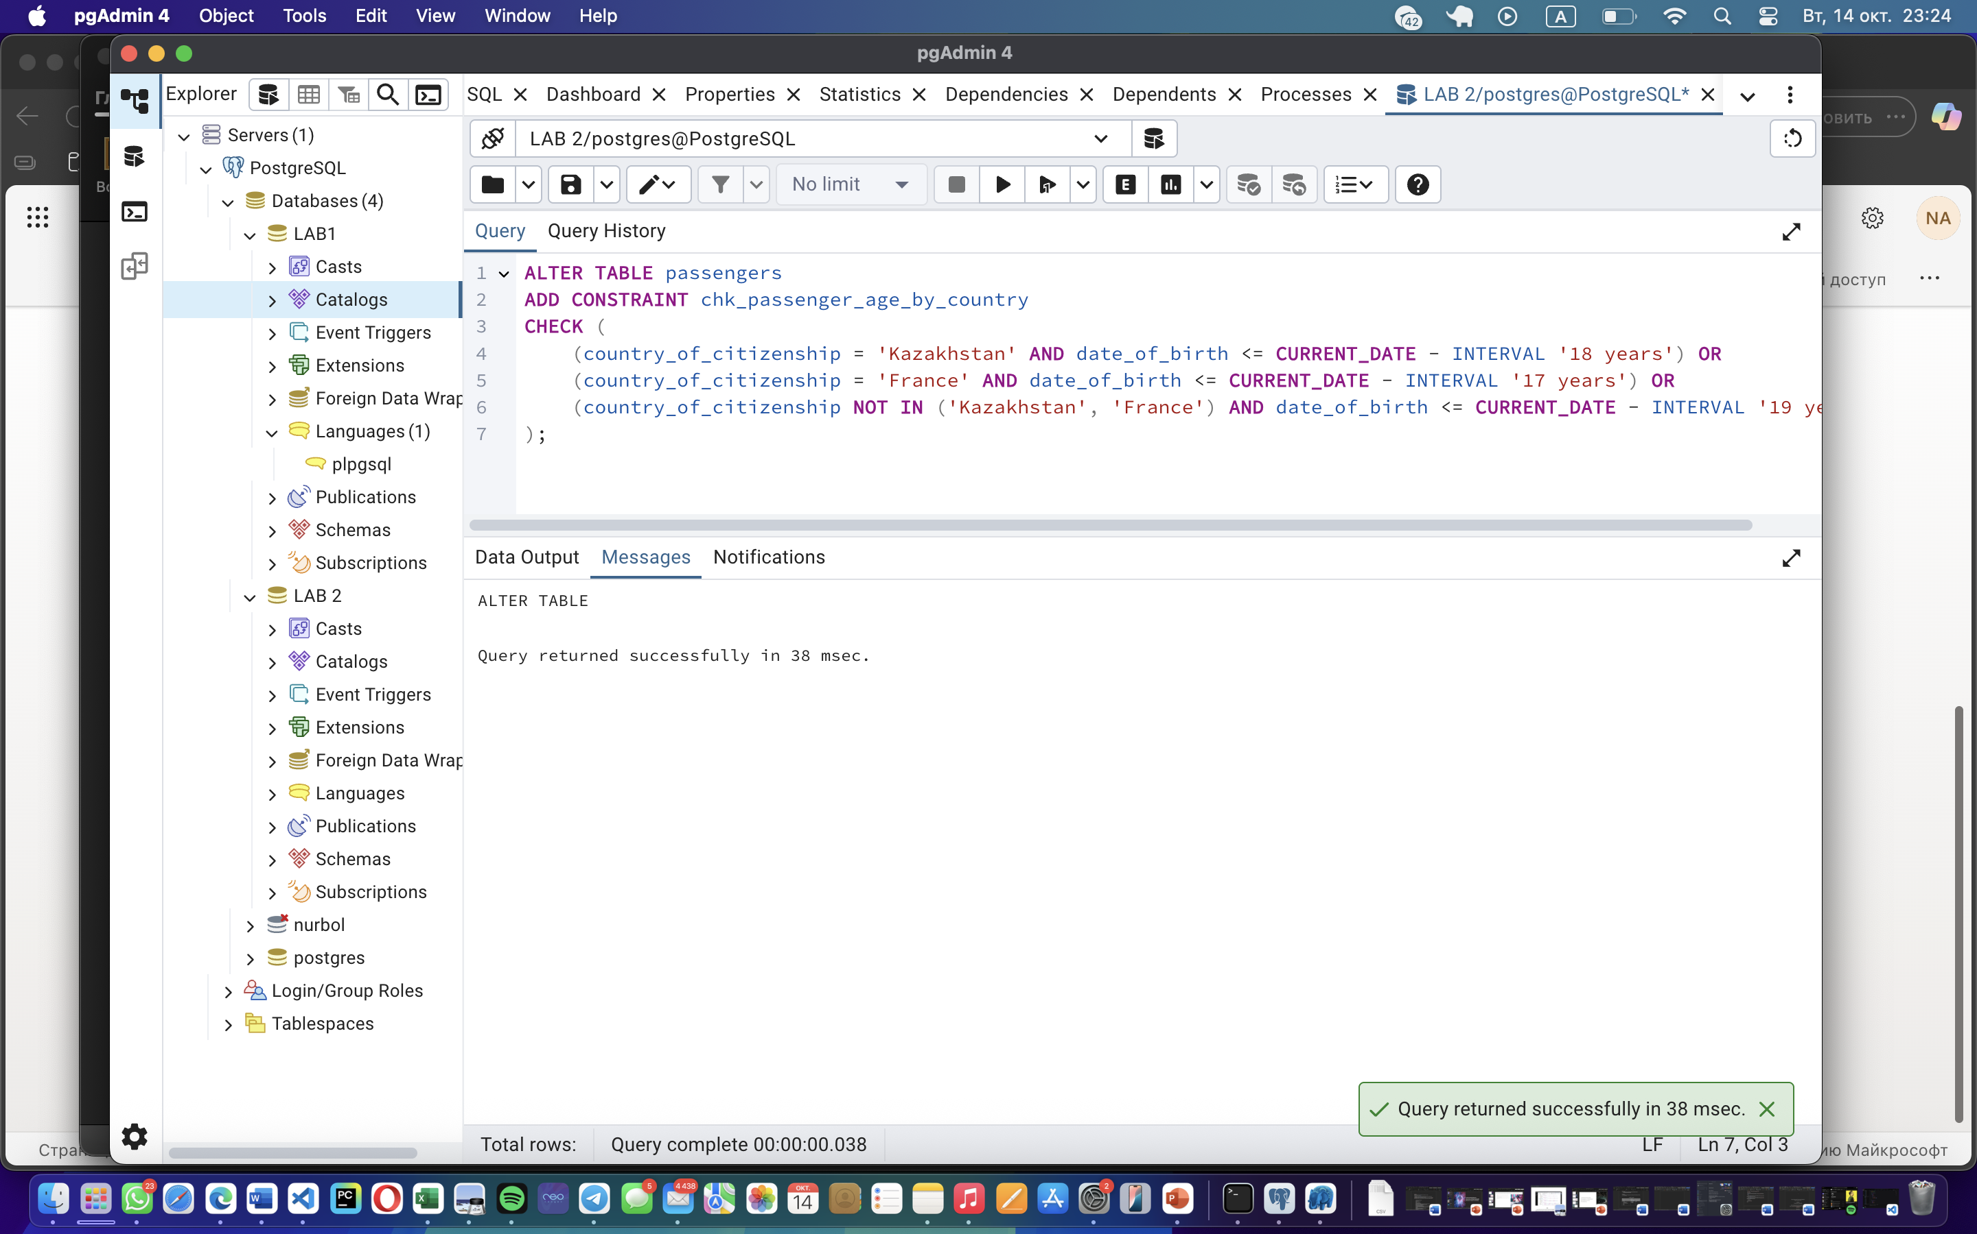
Task 8:

ALTER TABLE booking
ADD CONSTRAINT chk_ticket_discount
CHECK (
(created_at < '2024-01-01' AND ticket_discount = ROUND(ticket_price * 0.10, 2)) OR
(created_at >= '2024-01-01' AND ticket_discount = ROUND(ticket_price * 0.05, 2))
);
