Kazakh-British Technical University
Data collection and preparation
STUDENTS' INDEPENDENT STUDY (SIS) №1

Economy and Population: How GDP per Capita Relates to Human Development

Full Name: Tajikossov Nurbolsyn
ID: 24B032042

27.10.2026
Almaty

Economy and Population: How GDP per Capita Relates to Human Development
1. Goal
The goal of this project was to go through the full data collection and preparation process on real data: collect data from an API and from a web page, clean and merge it, and analyse it. The topic is the relation between the economy and the population. The main question is whether countries with higher GDP per capita also have a higher Human Development Index (HDI) and a longer life expectancy, and how population growth and unemployment are connected to income.
2. Data sources
The first source is the World Bank Indicators API (JSON). With requests I downloaded five indicators for 2000–2023: GDP per capita (current US$), total population, life expectancy at birth, annual population growth and unemployment rate. The API returns data in pages and also returns aggregates such as “World”, so I handled pagination in a loop and removed the aggregates using the country metadata. After this the table had 217 countries and 5,208 country-year rows.
The second source is the Wikipedia page “List of countries by Human Development Index”. I checked robots.txt first and then scraped the tables with requests and BeautifulSoup. The parser takes the country name and the HDI value by the content of the cells and not by column numbers. In total 174 rows with HDI were extracted; 157 of them matched countries from the World Bank data, and most of the others are regional or group averages (for example “Arab states”).
3. Cleaning and merging
The year column came from the API as text, so I converted it to integer and all indicators to numbers. No duplicate country-year rows were found. Missing values are real (for example, 13.9% of rows have no unemployment data), so I did not fill them with the mean. Only short gaps (up to 2 years) inside a country’s GDP and life expectancy series were linearly interpolated, in total 6 cells; all other gaps were left as missing and dropped only where the variable was needed. From the HDI value I also created the development tier (low, medium, high, very high).
The two sources have no common ID, so countries were joined by name. I normalised the names (lower case, no accents or punctuation) and used a dictionary for different spellings, for example “Korea, Rep.” and “South Korea”. For 2022, 157 countries matched and 153 of them had GDP, life expectancy and HDI at the same time, so the analysis uses 153 countries. GDP per capita is strongly skewed to the right (skewness 3.17), so I used log10 of GDP, which reduced the skewness to 0.12.
4. Results
GDP per capita and HDI have a very strong positive relation (Figure 1): Pearson r = 0.94 between log GDP and HDI, and the linear model explains 89% of the variation of HDI (R² = 0.89). Each ten-fold increase in GDP per capita is associated with an increase of about 0.23 in HDI. The correlation with life expectancy is also strong (Pearson r = 0.79, Spearman ρ = 0.87). The Pearson value is lower mainly because of one extreme value of about 19 years in the low-income group (Figure 2); rank correlation is not affected by it. Median HDI grows from 0.50 in low-income to 0.91 in high-income countries, and median life expectancy from 63.0 to 80.9 years (Table 1). By region, Sub-Saharan Africa has the lowest median HDI (0.56) and Europe & Central Asia one of the highest (0.89).
Population growth is only weakly related to income (Spearman ρ = –0.38) and is highest in low-income countries (2.5% per year); high-income countries have a slightly higher median (0.8%) than upper middle income ones (0.4%), probably because of migration. Unemployment has almost no relation with income (ρ ≈ 0.00). Compared with their income, the highest HDI is observed in Tajikistan, Georgia, Iran, Uzbekistan and Ukraine, and the lowest in Djibouti, Liechtenstein, Chad, Mali and Qatar.
Table 1. Medians by World Bank income group (2022)
Income group | Countries | Median HDI | Median life expectancy, years
Low income | 18 | 0.50 | 63.0
Lower middle income | 43 | 0.62 | 67.4
Upper middle income | 44 | 0.78 | 73.8
High income | 48 | 0.91 | 80.9

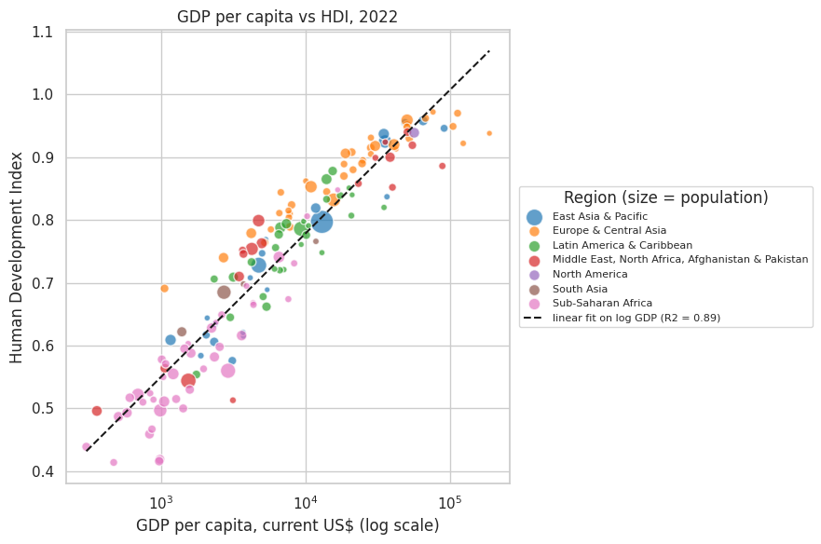
Figure 1. GDP per capita (log scale) vs HDI, 2022; bubble size = population
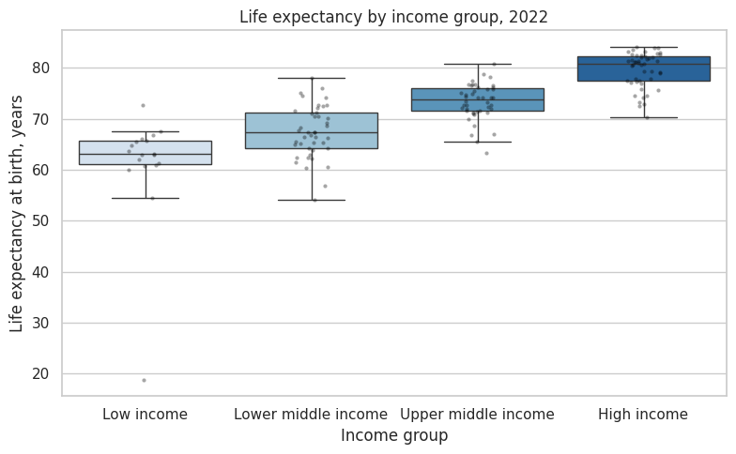  Figure 2. Life expectancy by income group (2022) | 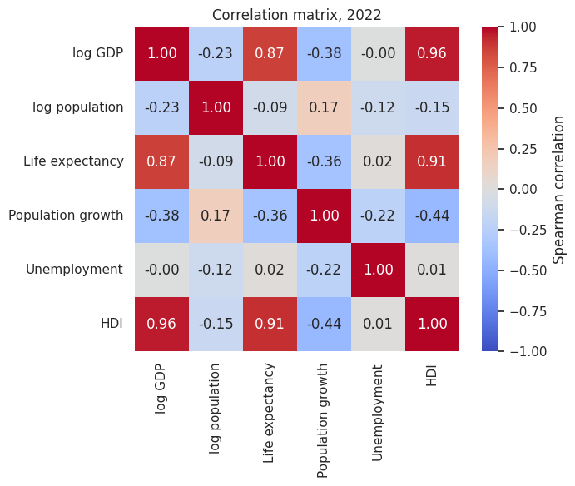  Figure 3. Spearman correlation matrix
5. Conclusion
The analysis shows that richer countries tend to have higher human development and longer life expectancy, which supports the initial idea. The relation with population growth is weaker and not linear, and unemployment is not related to income in this data. These results show correlation, not causation: HDI already includes an income component, so part of the strong link is expected, and better health and education can also increase income. Limitations: only one year (2022) is used for the cross-section, the HDI year on Wikipedia can differ from the World Bank year, the parser did not extract every country of the HDI list, so some countries are missing from the analysis, and unemployment data has gaps. In the future the work can be extended with a panel analysis over all years and more scraped indicators.

