________________________________________
A Thesis
Presented to
The Faculty of the Department of Computer Science
East Africa University (EAU)
________________________________________
In Partial Fulfillment
of the Requirements for the Degree of
Computer science
________________________________________
By:
[YOUR NAME HERE]

DECLARATION
I hereby declare that the project work entitled "University Fee Management System" built using React for the frontend, Node.js/Express for the backend, and MongoDB for the database (MERN Stack), submitted to East Africa University, is a record of original work done by me. Except where acknowledged in the text, the material has not been submitted, either in whole or in part, for a degree at this or any other university.

[YOUR NAME HERE]
Sign: ¬¬¬¬______________________
Date:

Computer science
East Africa University (EAU)
Bosaso, Bari, Somalia

APPROVAL
This thesis has been submitted for examination with our approval as University Supervisor.

Supervisor: [SUPERVISOR NAME HERE]
Sign: ________________________
Date:

DEDICATION
I dedicate this project to my family and friends, whose unwavering support and encouragement have been invaluable throughout this journey. Their belief in my abilities has inspired me to pursue and achieve my goals.
I also dedicate this work to my mentors and professors at East Africa University, whose guidance and wisdom have been instrumental in my academic and personal growth.
Finally, I dedicate this project to all those who strive for excellence and innovation in the field of technology. May this work serve as a testament to the power of dedication and hard work.

ACKNOWLEDGMENT
Firstly, we extend our gratitude to Allah for granting us the ease and strength to accomplish this significant goal.
Secondly, we wish to express our deepest appreciation to our Supervisor, whose insightful ideas and substantial abilities have consistently and convincingly conveyed a spirit of expertise in research and a passion for teaching. Without his supervision and constant support, this thesis would not have been possible.
Likewise, we would like to thank our friends, teachers, and institutions that have contributed to the successful completion of this work. We also wish to express our heartfelt gratitude to our cherished parents, who brought us into this world and worked tirelessly to educate us, enabling us to reach this important milestone.
Finally, we extend our thanks to our dedicated teachers who have taught us various courses and to the friendly administration of East Africa University for their perfect guidance and support.

CHAPTER 1
1. INTRODUCTION
1.1 Background
This thesis introduces a web-based application designed to streamline the university fee management and administrative processes, making it more accessible and efficient for users while providing immense value to university administration. By leveraging the MERN Stack framework, this system offers a robust solution for managing educational data, ensuring a seamless experience across all modern web browsers.

1.2 Background of the Project
The University Fee Management System facilitates tracking, managing, and recording a wide range of university operations, such as students, finance, hostels, teachers, transport, library, settings, and courses. With its user-friendly dashboard interface, administrators can easily access detailed information about student fee payments, course availability, and staff records, enabling informed decision-making and simplifying the administrative process.

1.3 Motivation
The motivation for creating a University Fee Management System lies in overcoming the limitations of traditional paper-based university administration methods. By providing a convenient, web-friendly platform, the system addresses the demands of modern educational institutions for a streamlined and reliable recording process. It also caters to the university's need for strict financial tracking and optimized data storage, offering features like real-time payment updates and dynamic dashboard analytics.

1.4 Problem Statement
Universities face several challenges in managing administrative data, including lost paper records, time-consuming fee calculations, uncertainties about hostel or transport capacity, lack of remote accessibility, and concerns over data security and privacy. A comprehensive University Fee Management System aims to address these issues by offering a unified dashboard, intuitive search and filtering features, real-time updates, secure financial tracking, and excellent interconnectivity between modules, thereby enhancing administrative satisfaction and streamlining the university's workflow.

1.5 Objectives
An objective University Fee Management System aims to provide users with a seamless and efficient experience for managing institutional data. Key features include a user-friendly interface, robust search and filtering options, detailed student and teacher listings, a secure finance tracking system, user accounts for managing access (Settings), and interconnected modules for Courses, Library, Hostel, and Transport.

1.6 Purpose of project
Storing Data For future use: -
The previous university service was not based on a systematic and computerized history for storing student information and transactions such as registrations, expenses, and fee payments for future use.

1.7 Specific objectives
1. Increase Administrative Efficiency: Implement centralized features to increase how quickly staff can interact with student data.
2. Enhance User Experience: Focus on improving the usability and intuitiveness of the system through streamlined registration processes, intuitive navigation, and visually appealing dashboard design.
3. Expand Data Inventory: Forge digital connections between various university departments (Finance, Transport, Hostel, Library) to offer a comprehensive selection of management tools.
4. Improve Search Accuracy: Develop advanced search algorithms and filters to help users find relevant students, teachers, or financial records instantly.
5. Boost Financial Accuracy: Optimize the fee management process by minimizing calculation errors and providing clear, transparent pricing for courses and hostels.

1.8 Scope of the project
1. Platform: Develop a web application compatible with modern browsers, ensuring seamless functionality across various screen sizes using responsive design.
2. Features:
- User Registration and Authentication: Allow administrators to login securely and manage information.
- Search and Filtering: Implement advanced search options for students, teachers, and finance records.
- Module Listings: Display detailed information across Dashboard, Student, Finance, Hostel, Teachers, Transport, Library, Setting, and Course pages.
- Finance System: Enable administration to track fee payments, generate receipts, and manage university expenses.
- User Profiles: Provide profiles for managing teacher and student data.
- Notifications: Send timely alerts for pending fees and system updates.
- Security: Implement industry-standard security measures (JWT) to protect user data and financial records.
3. Data Management: Develop a robust backend system (Node.js/MongoDB) for managing all university entities.
4. Deployment: Publish the system to a live web server for remote institutional access.

1.9 Significance of study
1. Enhanced Administrative Experience: By understanding university workflows, developers can optimize the system's features.
2. Efficient Registration Process: Researching student enrollment patterns helps streamline the registration process.
3. Data Accuracy and Loyalty: By eliminating manual calculation errors in the Finance module, the system fosters trust among students and parents.
4. Competitive Advantage: A modern MERN stack system gives the university a competitive edge over institutions using outdated software.

CHAPTER 2: Literature Review
2.1 Introduction
The educational sector has seen significant advancements due to technological innovations, particularly in the domain of university management systems. The integration of web applications has enhanced user experience, streamlined operations, and increased convenience for management. This literature review examines the technological frameworks and methodologies involved in developing a Fee Management System using React for the front end and Node.js with MongoDB for the backend.

2.2 Web Application Development Frameworks.
2.2.1 React.js
React, an open-source UI software development toolkit created by Facebook, is widely recognized for its capability to create dynamic web applications. Several studies highlight the benefits of using React, such as rapid development, expressive and flexible UI, and a rich set of components.
Performance and Development Speed: React's Virtual DOM feature allows developers to see changes in real-time, significantly speeding up the app.
UI/UX Design: React allows developers to create visually appealing and user-friendly interfaces, which is crucial for modern dashboard systems.

2.3 Backend Technologies
2.3.1 Node.js and Express
Node.js, a popular server-side JavaScript runtime, is known for its ease of use, extensive support, and robust performance in web development. It is often used in conjunction with MongoDB to create dynamic systems.
Flexibility and Scalability: Node.js is highly flexible and can handle increasing numbers of users and transactions, which is essential for a university system that experiences high traffic during enrollment periods.

2.3.2 MongoDB
MongoDB, a NoSQL database management system, is known for its reliability, performance, and flexibility with JSON-like documents.
Data Management and Security: MongoDB's robust data management capabilities ensure that a university system can securely store sensitive information such as student details and financial records.

2.4 Conclusion
The combination of React for the front end and Node.js with MongoDB for the backend (MERN stack) presents a robust solution for developing a university fee management application.

Chapter 3: Methodology
3.1 Introduction
This chapter outlines the methodology employed in the development of the university application using React and Node.js/MongoDB. It details the tools and technologies used, the design and development processes, and the testing strategies.

3.2 Tools Used to Developed Project
3.2.1 Introduction to React
React is a user interface (UI) library developed for creating fast web applications. It uses JavaScript and provides a rich set of pre-built components.

3.2.6 Introduction to Node.js
Node.js is a server-side runtime environment commonly used for web development. It's powerful for creating dynamic web APIs.

3.2.10 Database (MongoDB)
A database is a well-organized collection of data that are related in a meaningful way. MongoDB was chosen to design the database because it can hold complex JSON data structures efficiently.

3.2.20 Theoretical and conceptual development
A computerized database can solve many problems found in a manual system. Without a computerized system, university management may have to write all records in a register, which leads to mistakes. When student fees are paid, the information can be entered easily. This way of maintaining records will save a lot of time and provide accurate accounts so no one can cheat the system.

3.2.21 User Requirement Specification
The University Management uses a database to store information on students, finance, and staff, so the requirement becomes obvious that it will handle all registrations automatically via computerization.

3.2.24 USE CASE DIAGRAM
UML Use Case Diagram describes a set of actions that the admin can perform in collaboration with the system (e.g., Manage Students, Manage Finance, Manage Transport).

3.1.8 Database Design
3.1.8.1 E-R DIAGRAM
ER Diagram helps to explain the logical structure of databases, mapping out entities like Students, Courses, Fees, and Departments.

3.2.25 System Functions.
The main functions of the new system are:
✓ The system is user-friendly and easy to use.
✓ The system is database dependent.
✓ Automatic generation of financial reports.
✓ The new system must be able to upgrade easily any time.

3.2.23 Compare between existing system and current system
Characteristics | Existing System | Current System
Authentication | NO | YES
Result verifiability | NO | YES
Secrecy | Yes | YES
Transparency | NO | YES
Reliability | NO | YES
Security | NO | YES
Efficiency | Not efficient | Very Efficient

3.2.24 Weaknesses of Previous System
✓ It was very hard for transparency
✓ Poor interface design
✓ Lack of reliability of manual management system
✓ Calculation errors make loss in university finance.

3.2.25 Current System
✓ This system will be reliable and give confidence to owners.
✓ Application makes it easier to manage university data.
✓ The system has accounts for its users and only authorized users can access the system with a username and password.

Chapter Four: System Design and Implementation
4.1 Introduction
In this chapter, we delve into the design and implementation of the university fee management application. We provide an overview of the various components, covering the dashboard, student, finance, hostel, teachers, transport, library, setting, and course pages.

4.2 Sign Up & Login
"Login" refers to the action of accessing an existing account on the platform by providing the required credentials, such as an admin email address and a password.

4.3 Dashboard Page
The dashboard is the main introductory webpage of the system. It serves as the starting point, providing an overview of the total students, total revenue, and active courses through visual analytics and charts.

4.4 Student Page
The student module handles the registration and management of student records, allowing admins to view, edit, and delete student data.

4.5 Finance Page
The finance page manages the institutional cash flow, generating tuition fee invoices and tracking university expenses.

4.6 Hostel Page
The hostel module tracks student accommodation, room assignments, and boarding fees.

4.7 Teachers Page
The teachers page manages faculty profiles, their designations, and their associated departments.

4.8 Transport Page
The transport page tracks university bus routes, driver assignments, and schedules.

4.9 Library Page
The library page manages university books, tracking issuance and returns by students.

4.10 Course Page
The course module allows admins to create and assign academic courses to respective university departments.

4.11 Setting Page
The setting page configures global system options, user accounts, and currency preferences.

CHAPTER 5
5.1 Conclusion
This thesis aimed to develop a comprehensive university fee management system leveraging modern MERN stack technologies. The system was designed to streamline the administration process for both staff and administrators, providing a user-friendly interface and robust backend functionality.

5.2 Summary of Work Done
Throughout this project, we successfully developed a feature-rich web application using React, offering intuitive navigation and real-time updates on student and financial data. The backend was implemented in Node.js, utilizing MongoDB databases to store and manage data efficiently.

5.3 Achievements and Contributions
Our system represents a significant contribution to the educational industry by offering a modern and efficient solution for managing university operations.

5.4 Evaluation of Results
The evaluation of our system demonstrated its effectiveness in handling registration requests, managing financial inventory, and generating reports. User feedback indicated a high level of satisfaction with the management process.

5.5 Implications and Applications
The system developed in this thesis has significant implications for educational institutions, offering a scalable platform for managing fees and improving administrative service.

5.6 Future Work
Future enhancements could include:
- SMS Notification Integration for fee reminders.
- Online Payment Integration (Stripe/PayPal) for direct student payments.
- Student Portal for students to log in and check their own grades and fee status.

5.6.1 Conclusion
In conclusion, the university fee management system developed in this thesis represents a significant advancement in web app development. By leveraging the MERN stack, we have created a versatile and scalable solution that addresses the needs of modern universities.

REFERENCE
1. React Documentation. Meta Platforms, Inc.
2. Node.js Documentation. OpenJS Foundation.
3. MongoDB Native Driver Documentation.
4. Tailwind CSS Documentation for UI styling.
5. Express.js API Documentation.

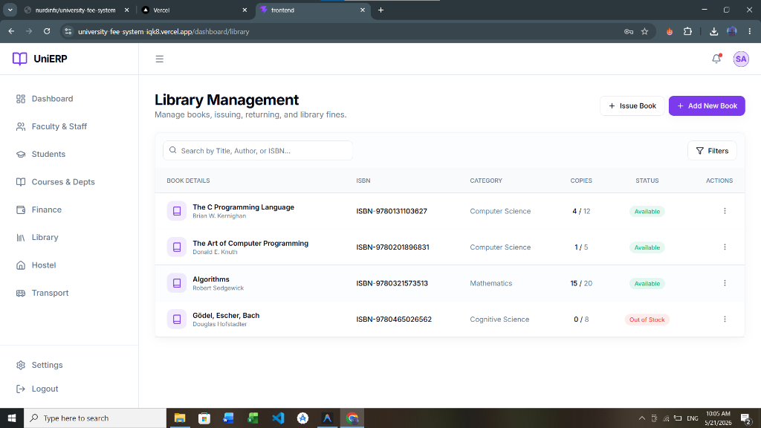

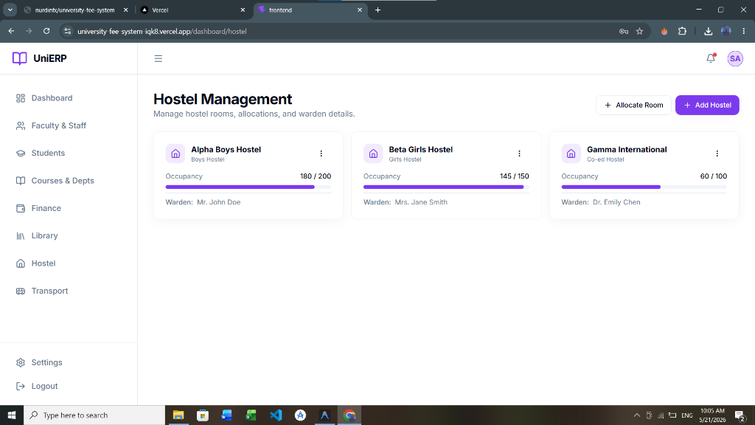

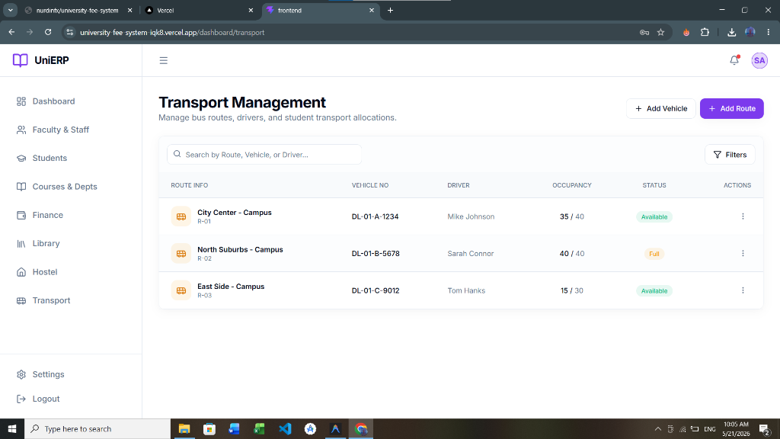

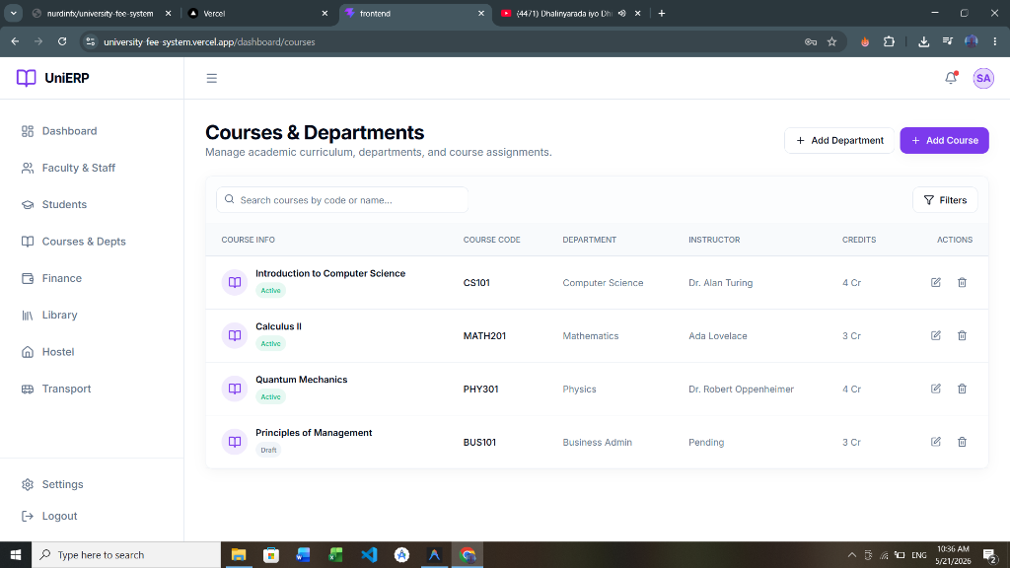

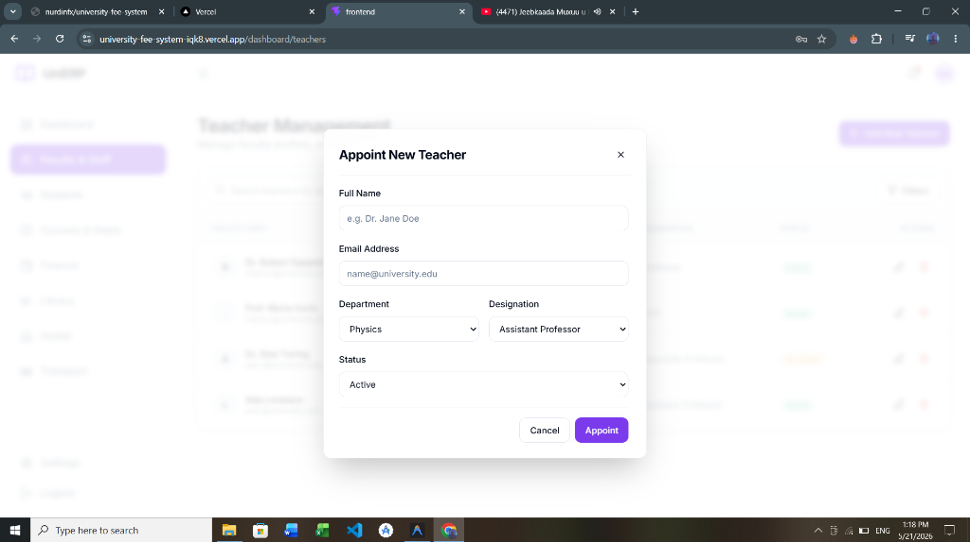

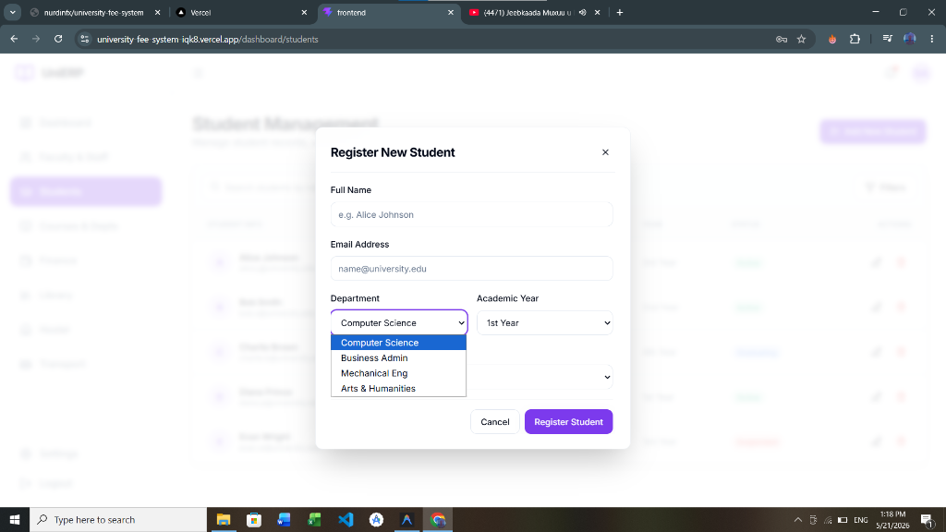

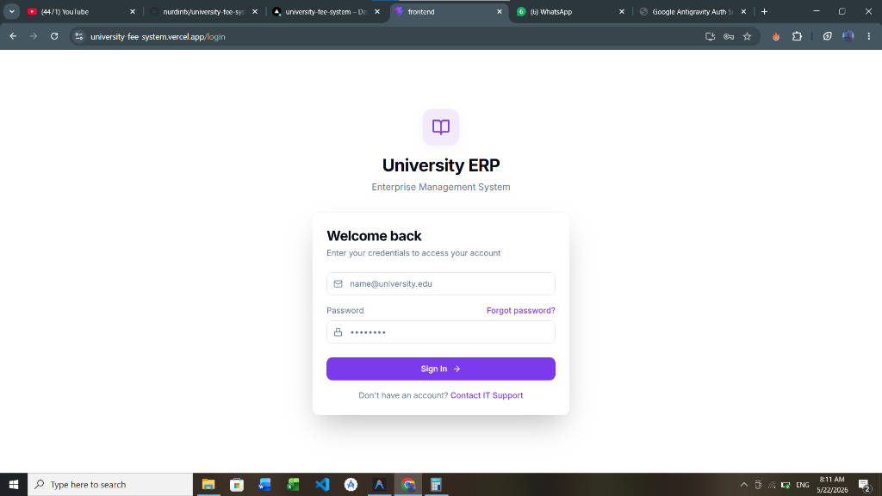

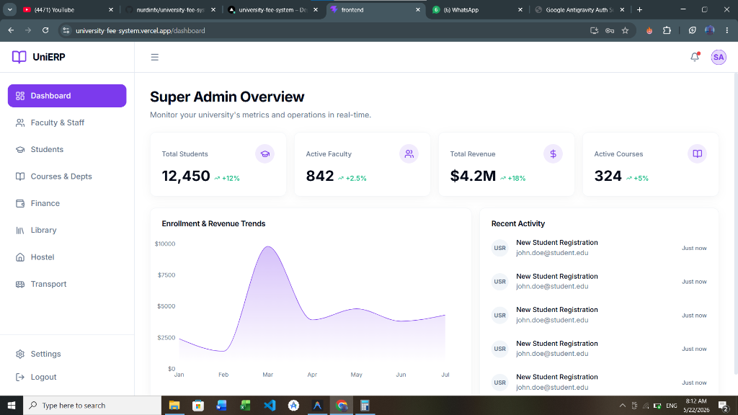

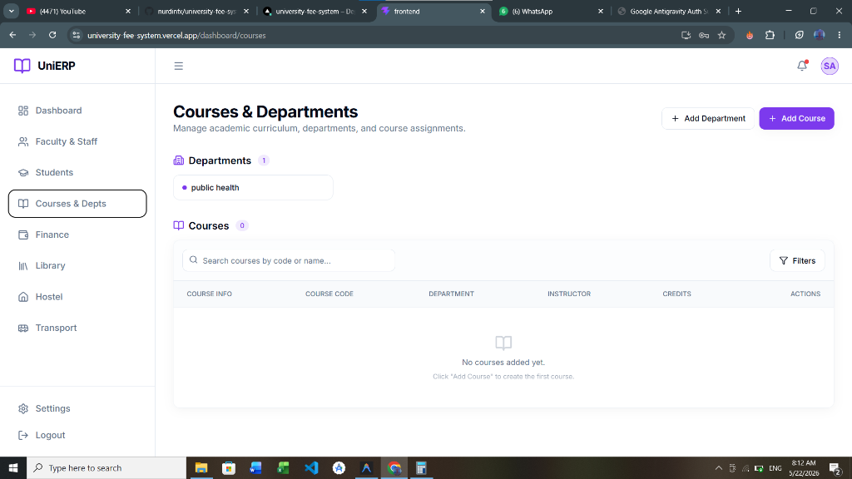

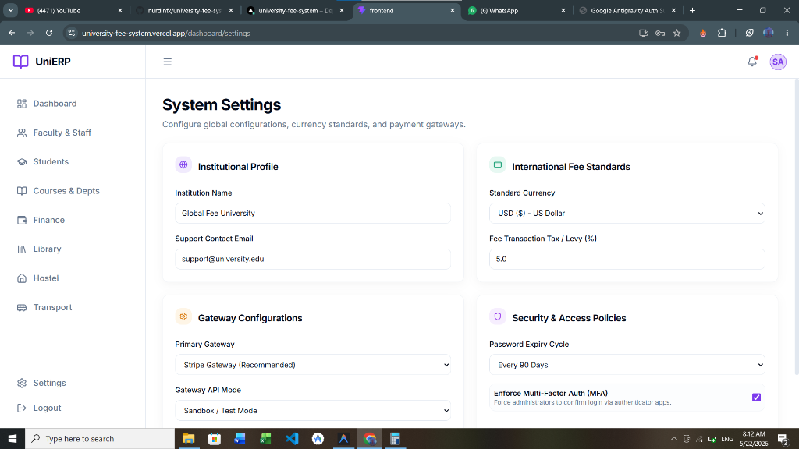

APPENDIX 1

Reserved for university administration notes or extra diagrams.

APPENDIX 2

Reserved for university administration notes or extra diagrams.

APPENDIX 3

Reserved for university administration notes or extra diagrams.

APPENDIX 4

Reserved for university administration notes or extra diagrams.

APPENDIX 5

Reserved for university administration notes or extra diagrams.

APPENDIX 6

Reserved for university administration notes or extra diagrams.

APPENDIX 7

Reserved for university administration notes or extra diagrams.

APPENDIX 8

Reserved for university administration notes or extra diagrams.

APPENDIX 9

Reserved for university administration notes or extra diagrams.

APPENDIX 10

Reserved for university administration notes or extra diagrams.

