HITMC API IMPORT DATA GUIDE

Version: 0.1

----------oOo----------

- Import data for events and speakers
Support user to import data from google spreadsheet, so will save pretty much time for user.

Example format google spreadsheet: https://docs.google.com/spreadsheets/d/1hfl4AgMFRWlCAg8Zm8szKarPrK-K4H2VPOWxJOWP3WU/edit#gid=34910122
Permission: read (share permission)

> To make import data correct as you expected, we have rules, you should follow:
- Page name: “events” for event data, “speakers” for speaker data. Goolge spreadsheet could have both page events and speakers or only events page or only “speakers” page.
- The code will import speaker first, then import events
- Only valid record will be saved to database. Otherwise will be ignored.
- We can run import many times to import a new data, and the code won't import duplicated event or speaker.
+ To know event is already exists, we will using event title and event start_date to find. if this event has already existed, it will be changed from insert new to update exist one.
+ To know speaker is already exists, we will using speaker linkedin username or twitter usename to find. If this speaker has already existed, it will be changed from insert new to update exist one.

- Understanding url: https://docs.google.com/spreadsheets/d/1hfl4AgMFRWlCAg8Zm8szKarPrK-K4H2VPOWxJOWP3WU/edit#gid=34910122
(red text is the key of shared spreadsheet document, we will use it for import data. This mean we can use any page for import events and speaker just follow exactly format, so we can import correct data as we expected. I will update document soon when import data function has done with tests )

The format should use in google spreadsheet:

FOR EVENT:
["index", "title", "description", "start_date", "end_date", "location", "speakers"]
- speakers should an array of linkedin_handle(linkedin username), split by "," withouts pace, lowercase. Exp: "erik-samarin,brian-russel-davis-4556583,luong-walker-stuff"
- Each event row should has speakers itself
- required field: title and start_date

- Example:
["index", "title", "description", "start_date", "end_date", "location", "speakers"],
[0.0, "Welcome Keynote", "Intro to HITMC conference", Fri, 07 Apr 2017 09:00:00 +0000, Fri, 07 Apr 2017 09:30:00 +0000, "main", "erik-samarin,brian-russel-davis-4556583,luong-walker-stuff"]

FOR SPEAKER:
["index", "name", "bio", "twitter_handle", "company_name", "linkedin_handle"]
- twitter_handle: should be a username, should not be a link
- linkedin_handle: should be a username, should not be a link
- required fields: name and linkedin_handle

- Example:
["index", "name", "bio", "twitter_handle", "company_name", "linkedin_handle"],
[0.0, "Brian Davis", "Creator of HITMC App ", "verynerdymoney", "axiom88", "brian-russel-davis-4556583"]

- ROUTES

GET / POST /imports/import_data
Permission: admin
Params:
token: string (access token. It's user authentication_token
spreadsheet_key: string (shared key of google spreadsheet)

https://docs.google.com/spreadsheets/d/1hfl4AgMFRWlCAg8Zm8szKarPrK-K4H2VPOWxJOWP3WU/edit#gid=34910122 (red key is the speadsheet_key for example)
In this spreadsheet has 1 speaker, 30 events, but only 10 event data valid so that only 10 events imported to database.

Data returns:

HTML:
success imported: 1 speakers and 10 events, Events: ["Welcome Keynote", "Live Your Life Like the Best Story Ever", "How to Increase Your KLAS Score", "Storytelling Workshop: How to Write Killer Case Studies", "The Do’s and Don’ts of Sponsored Media", "Public Relations Panel – PR is Much More than Press Releases", "Learn How to Harness \"Whole Brain\" Marketing", "Innovation in Social Media Content Creation", "Search Engine Optimization (SEO): What’s Real and What’s Myth", "Re-Imagine Digital Marketing through Authentic Storytelling"]. Speakers: ["Brian Davis"]
JSON:
{
"imported": {
"events_length": 10,
"events": [
"Welcome Keynote",
"Live Your Life Like the Best Story Ever",
"How to Increase Your KLAS Score",
"Storytelling Workshop: How to Write Killer Case Studies",
"The Do’s and Don’ts of Sponsored Media",
"Public Relations Panel – PR is Much More than Press Releases",
"Learn How to Harness \"Whole Brain\" Marketing",
"Innovation in Social Media Content Creation",
"Search Engine Optimization (SEO): What’s Real and What’s Myth",
"Re-Imagine Digital Marketing through Authentic Storytelling"
],
"speakers_length": 1,
"speakers": [
"Brian Davis"
]
}
}

Errors:
No permission:
{
"Error": "You are not authorized to access this page.. Not able to read google spreadsheets. Make sure you are using the correct shared key and shared permission."
}

not found google spreadsheets
{
"Error": "could not open https://docs.google.com/spreadsheets/d/1hfl4AgMFRWlCAg8Zm8szKarPrK-K4H2VPOWxJOWP3WU1/export?format=xlsx. Not able to read google spreadsheets. Make sure you are using the correct shared key and shared permission."
}

Postman

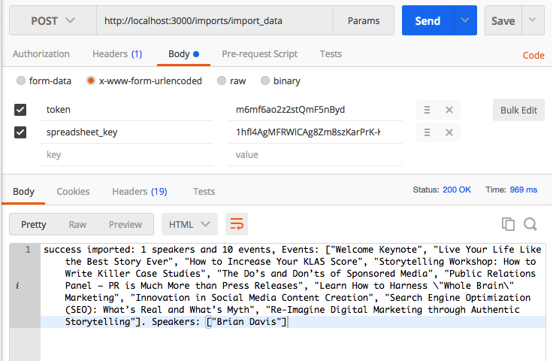

HMTL:
