PimBuddy administrator handover
  - Design and operation of model based privileged access
5 October 2026 | Version 2.0 | CloudFellows PIM framework 3.0

Purpose and operating decision
PimBuddy helps a customer administrator establish and maintain a consistent privileged access model in Microsoft Entra and Intune. This handover explains the product design, the available models, deployment, daily operation, verification and recovery.
The required customer experience is to open PimBuddy, choose Deploy my model, select Small business, Large one region or Large multi-region, supply customer-specific choices, and have the approved model created and verified. No customer-run PowerShell, local scripts, agents or command-line setup belong in that onboarding journey.

Current capability and target experience
The current repository already contains browser deployment through Microsoft Graph. It creates and updates supported configuration after a preview and tenant confirmation. It is not yet a complete automatic onboarding service: people, some approval prerequisites, authentication-context enforcement and several optional components still require separate work.
Sections 2–5 and 8–10 explain the current design and operating procedure. Sections 6–7 define the required end-to-end experience and its completion contract. Section 11 records the remaining delivery work and validation evidence. Proposed behavior is labelled as a target, not presented as released functionality.
Read this first | Where
Understand the architecture and choose the right model | Sections 2 and 3
Understand how an administrator receives access | Section 4
Deploy using the current browser workflow | Section 5
Understand Deploy my model and what it must create | Sections 6 and 7
Prepare, operate, recover and accept the service | Sections 8 to 10
Review outstanding work and supporting evidence | Section 11

Service owner: to be assigned by the customer. Operational owner, security approvers, emergency access custodians and Intune owner must be recorded before production acceptance.

2 Product design and architecture
PimBuddy is Workspace 02 within ENCA. Its shared sign-in and Microsoft Graph connection support PIM-specific tools. The browser combines a versioned baseline with the selected model and any customer variant, reads the tenant, calculates differences and builds an ordered change plan.
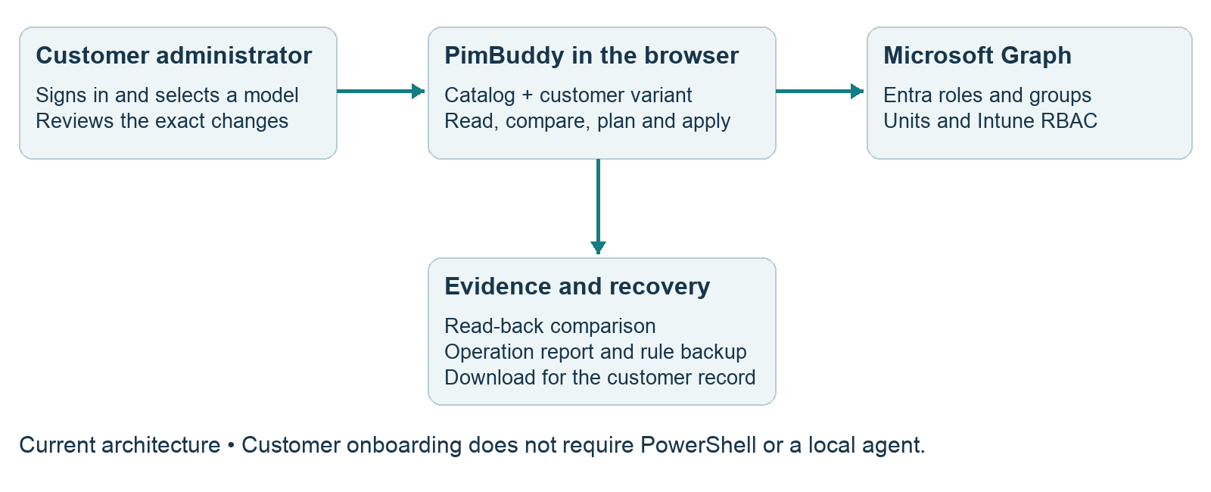
Figure 1 Current browser deployment architecture
Area | Administrator purpose
Baseline T48 | Compare role policies, groups, assignments and regional objects against the selected model.
Roles T49 and PIM groups | Inspect who holds which access, through which group, at which scope and until when.
Designer T50 | Save a customer variant of tier settings, role tiers, approvers, mailbox and authentication context.
Deploy T51 | Choose configuration, preview the operations, apply them and read the tenant again.
Intune RBAC T53 | Compare Intune roles, assignments, scope groups and tags.
Checks and operational views | Investigate PIM findings, activation requests, approvals, changes and restricted units.

Configuration and evidence ownership
The bundled catalog is the reference model; a Designer variant records customer differences. Variants and some recovery data are kept in browser storage. Download them into the customer change record because browser storage is not a shared or durable administrative archive. A fresh tenant read is the evidence of configuration; a catalog label or a successful request is not evidence of effective access.

3 Choose the customer model
Choose by operating structure and separation of duties, not employee count alone. The size descriptions are catalog guidance. The same customer can require a stricter variant if its approval, audit or recovery needs exceed the default model.
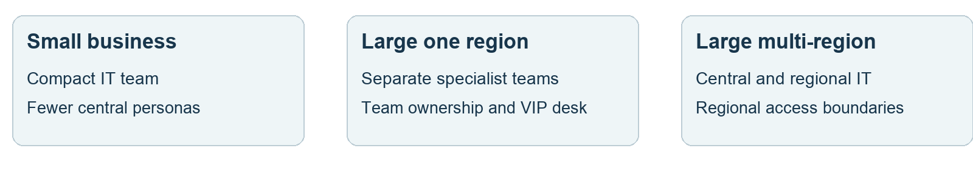
Figure 2 Choose by operating structure
Model | Design and fit | Important differences
Small business | Catalog guide: 25–250 people and two to six IT staff. Four central M365 personas; two Intune access groups. | Global Administrator activation is two hours with approval. Other Tier 0 roles use authentication context and justification without approval by default.
Large one region | Separate Identity, Workplace, Collaboration, Applications, Service Desk and Audit responsibilities. | Ticket requirement on Tier 0 and Tier 1; dedicated Tier 0 approver group. Optional executive restricted unit and scoped VIP desk.
Large multi-region | Central teams plus local IT. Regional user, group and device units, scoped Entra eligibilities and regional Intune access. | Regional definitions determine boundaries. Central broad access remains a separate path. Executive protection is not automatically included in this profile.

Customer choices to record
1. People and teams Identify the actual administrator accounts, their personas, access end dates, approvers and operational owners. The current catalog contains no people.
2. Included services Choose Entra and, where applicable, Intune, regions, Azure and executive protection. Optional services must have their own readiness and completion state.
3. Activation controls Approve the tier settings, activation durations, approval coverage, ticket requirement, alert destination and authentication context. A ticket field does not by itself validate a ticket in an ITSM system.
4. Regional boundaries Record unique region codes, names, matching attributes, device rules and approvers. Validate which existing users and devices match before deployment.
5. Exceptions Record justified standing reader access and emergency access separately. Switching profiles must generate a migration plan, not silently remove or replace an existing model.

Designer variants
Use Designer when the standard model needs different policy settings. Review its differences before deployment and retain the variant with the catalog release. A variant changes the desired configuration; it does not prove that the tenant has adopted it. The next Baseline comparison and Deploy plan must use the same variant.

4 Understand the access model
PimBuddy framework 3.0 uses three activation paths: job groups for most work, direct groups for Tier 0 and for the Exchange, SharePoint and Purview roles, and access groups for Intune, Defender XDR and Exchange RBAC. Tell each administrator which path applies before assigning access. [M1]
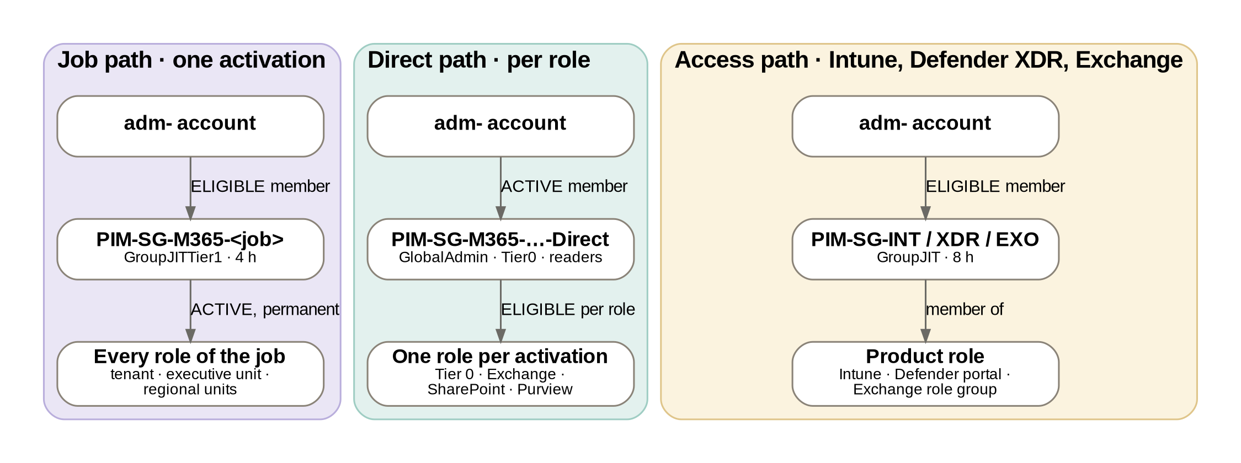
Figure 3 The three activation paths (framework 3.0)

Entra and Microsoft 365 roles
Job groups: an administrator is an ELIGIBLE member, for at most a year; the group holds every role of the job ACTIVE and permanently. One activation of the group (four hours; MFA and justification, plus a ticket in the large model) gives all those roles together. Direct groups: an administrator is an ACTIVE member, for at most a year; the group is ELIGIBLE for each role and the person activates the one role needed, under that role’s policy. Tier 0 roles and the Exchange, SharePoint and Purview roles are always on the direct path. Never leave an ACTIVE member in a job group: that person would hold every role of the job standing. After an activation, sign out of the admin centre and back in if the new rights do not show.
Tier 0 can require an authentication context, approval and justification; the exact requirements depend on model and variant. The authentication-context identifier is only useful when an appropriate enabled Conditional Access policy actually enforces it. Verify the applicable users, exclusions and controls rather than accepting an identifier alone.

Intune roles
Intune RBAC assignments point to dedicated PIM-SG-INT access groups. Administrators are eligible members and activate group membership. The group’s Member policy is the activation gate. Do not substitute an always-active persona group for a privileged Intune access group. Intentionally standing read-only access is a separate documented exception.

Defender XDR roles
Defender XDR unified RBAC assignments point to the dedicated PIM-SG-XDR access groups: PIM-SG-XDR-Admin, -Operator-T3, -Operator-T2, -Operator-T1 and -Reader, after the five roles of the customer RBAC baseline document. Administrators are eligible members and activate group membership; the Operator and Reader groups use the Intune pattern (GroupJIT, eight hours, MFA and justification), the Admin group — which can hand out every other Defender role — activates for two hours with authentication context c1 and approval (GroupJITTier0). The Defender XDR roles, their permission sets, the assignments that name the groups and the data sources are configured in the Defender portal and are not read, written or verified by PimBuddy; Deploy lists that work under By hand. Small business uses Admin, Operator-T3 and Reader; the large models use all five, centrally. Global and Security Administrators keep full Defender access regardless of unified RBAC.
Exchange RBAC: the PIM-SG-EXO-Recipients, -HelpDesk, -Hygiene and -Reader access groups have eligible members and are members of the Exchange Online role groups Recipient Management, Help Desk, Hygiene Management and View-Only Organization Management. Deploy creates the groups and their membership policies; adding each group to its role group is done in Exchange (a By hand item). Measure the delay between activation and access on first use.

Scope and protection
Regional Entra roles are held actively by the regional job groups, scoped to the region’s administrative units. Intune permissions, scope groups and scope tags jointly define intended reach; broader assignments can provide another access path. Keep role-assignable PIM groups outside restricted management administrative units. Microsoft documents membership-management limitations for those groups inside restricted units. [M3]

5 Deploy with the current browser workflow
This is the current repository workflow. It runs in the browser; the customer does not download or execute deployment scripts. The menu currently says Deploy, with Pick, Preview and Verify stages.
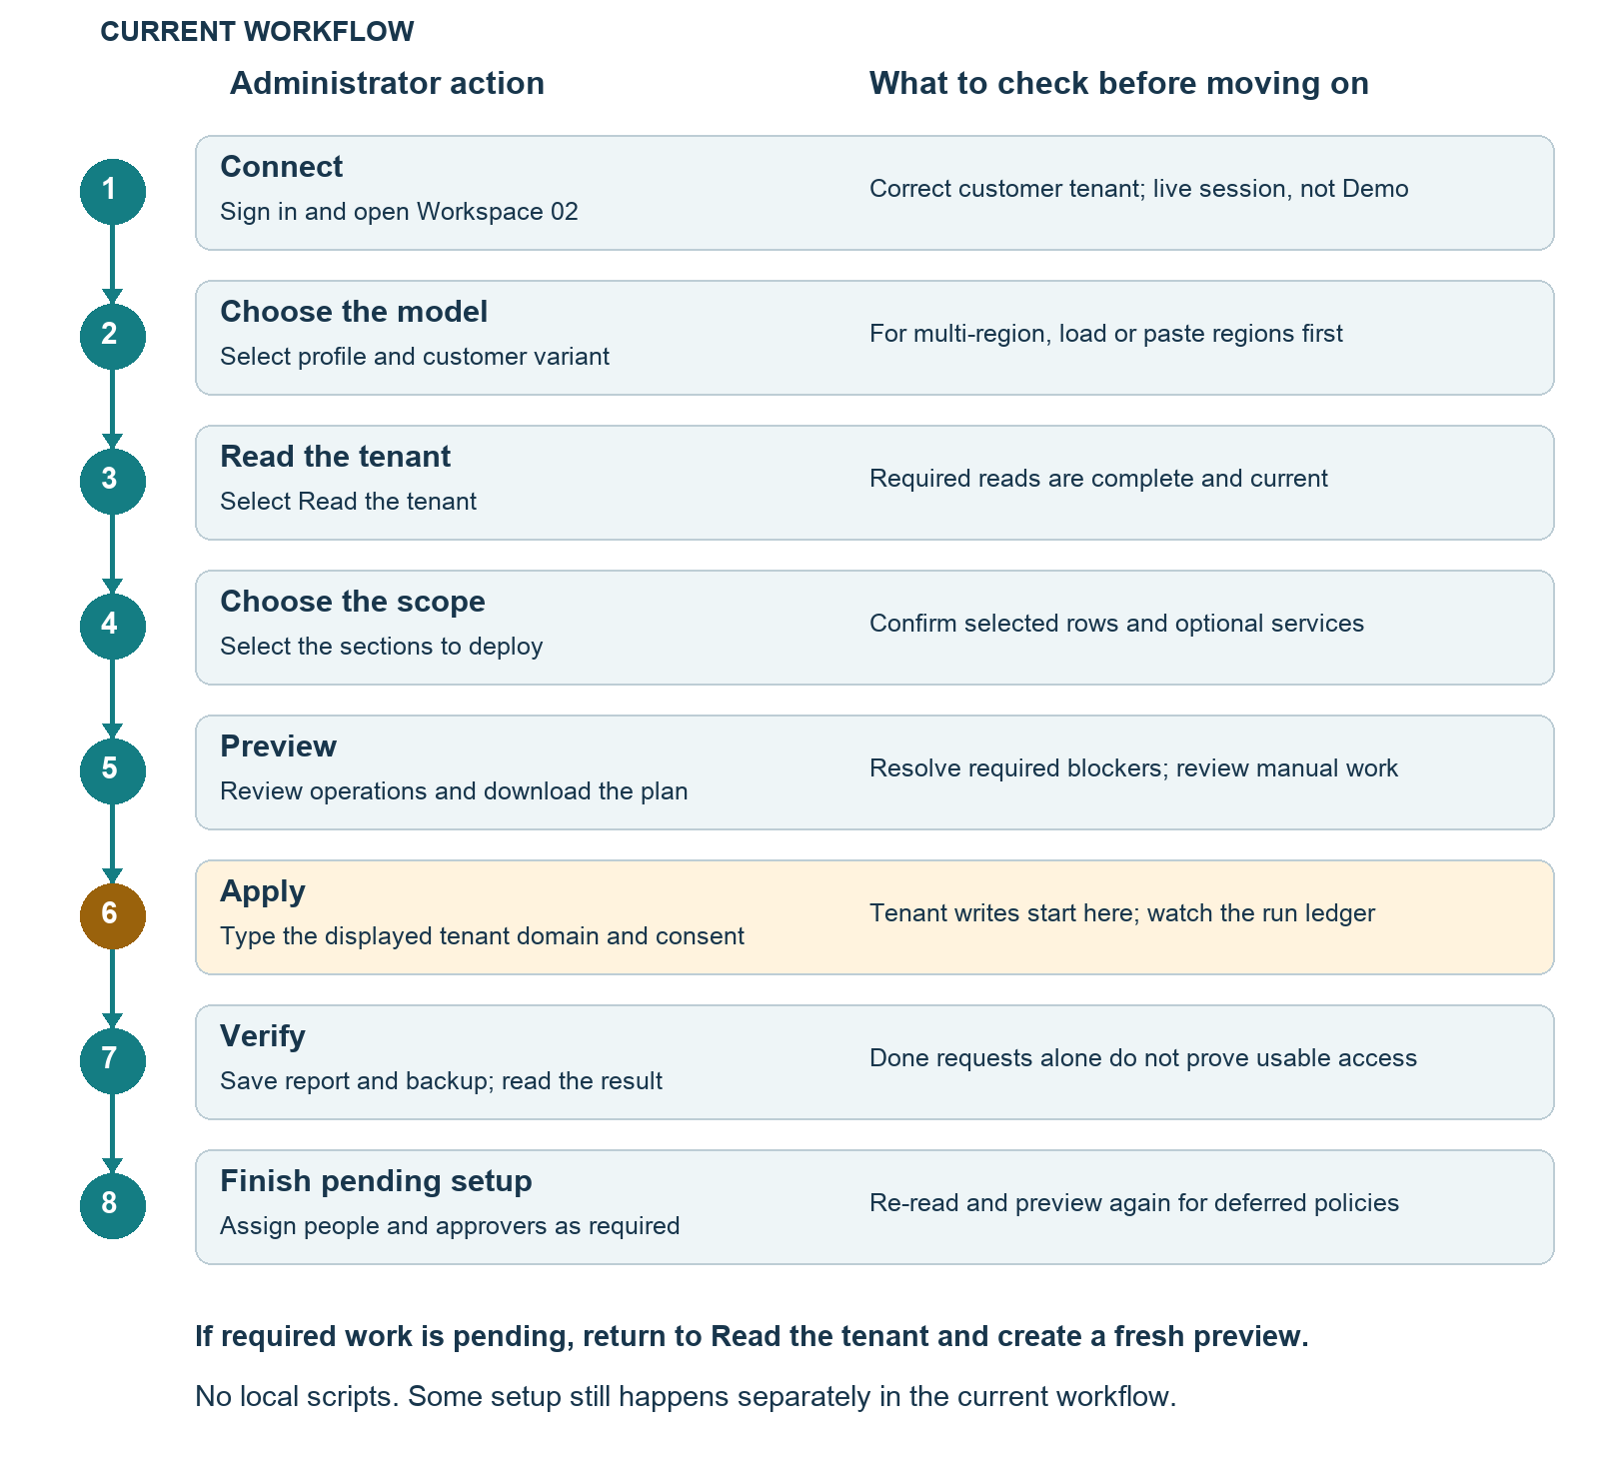
Figure 4 Current deployment from sign in to verified configuration
Use this flow as the quick reference. The following page explains each numbered step and the access impact. Required manual or deferred work means the model is not yet complete.

5 Deployment step details
1. Connect and confirm the tenant Sign in, open Workspace 02 and confirm the customer tenant. Ensure the session is live, not Demo. Verify the customer’s domain, especially when using an MSP or guest account.
2. Choose the profile and variant Open Deploy and select the model. If using Designer, confirm that the intended customer variant is active. For multi-region, load or paste region definitions in Baseline → Regions first.
3. Read the tenant Select Read the tenant. Review PIM, groups, units and Intune completeness. Resolve unread sources before treating objects as absent. Re-read after any external change.
4. Choose what to take Select the required sections. Restricted units and Azure groups are off by default. A deployment opened from selected Baseline rows can be limited to those roles and groups; confirm that this is intentional. Defender XDR groups is on by default and creates only the PIM-SG-XDR groups and their Member policies; the Defender roles and assignments are portal work.
5. Review the preview Inspect every operation, finding and “By hand” item. Review impact, permissions and recovery. Download the plan. A Blocked finding currently leaves parts out; it does not guarantee that the entire Apply action is disabled. Do not interpret a partial plan as a complete model.
6. Confirm and apply Type the customer domain displayed by the tool, grant the requested permissions through the browser and select Apply. Keep the session available during execution. The ledger shows done, later, failed and skipped operations.
7. Save evidence and verify Save the outcome report and rule backup. Verify triggers another configuration read. Open Baseline, Roles and Intune to inspect remaining differences. A done operation is not the same as an accepted, usable access model.
8. Finish current manual prerequisites Assign people with the correct active or eligible membership type in PIM for Groups, populate approvers and complete listed dependencies. New group policies can remain deferred until the group is known to PIM. Read again and build a new preview to apply remaining policy settings. For Defender XDR, create the roles with the documented permission sets and one assignment per PIM-SG-XDR group at scope All in the Defender portal, then activate unified RBAC per workload; PimBuddy lists this under By hand and does not verify it.

Impact of deployment
Creating empty groups alone does not grant human access. Changing role policies affects subsequent activation behavior. Making a job group ACTIVE in its roles gives every ACTIVE member of that group those roles at once: convert active members to eligible before approving that operation (Deploy says so for every existing job group). Eligibility assigned to an existing populated direct group enables its active members to activate roles. Inspect existing memberships and alternate access before approving. The standard Deploy plan does not remove existing assignments; a 2.x eligibility left on a job group is reported, not removed.

6 Required Deploy my model experience
Target design. The customer starts in PimBuddy and completes onboarding there. Model selection supplies the standard configuration; customer-specific identities, regions, scopes and business choices are collected in the same guided flow. “Everything” means every component of the explicitly selected and supported model, with no hidden manual configuration tail.
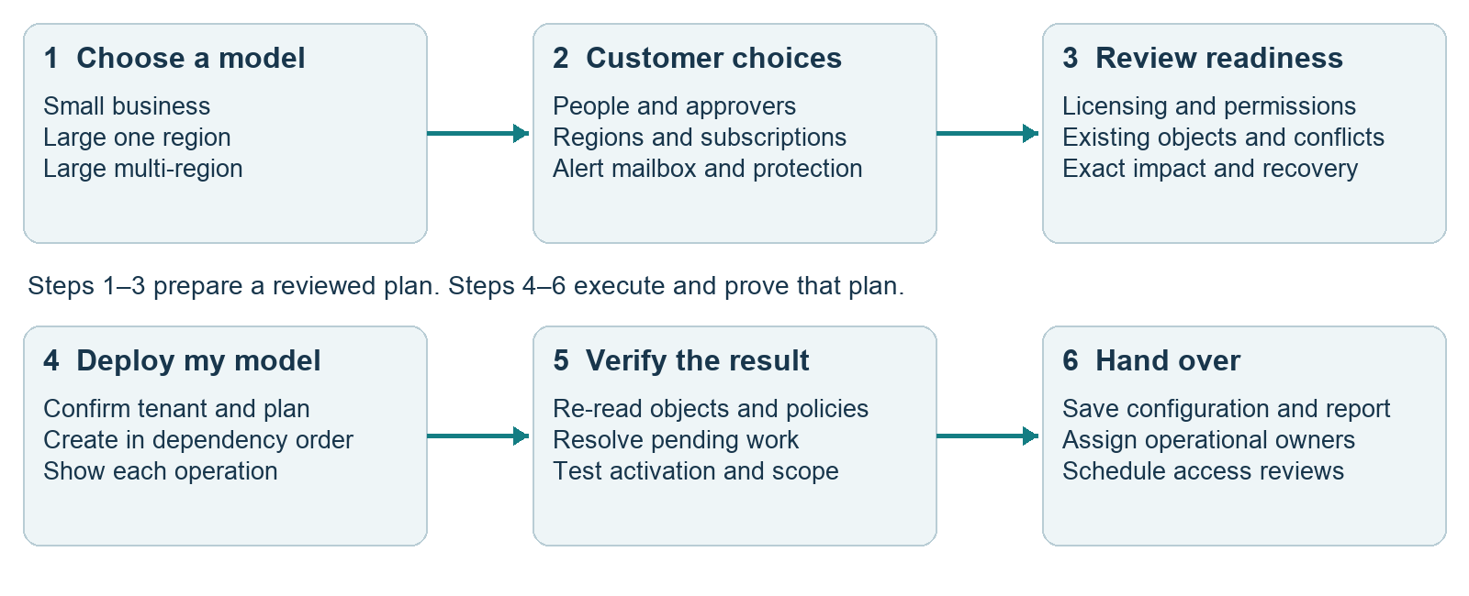
Figure 5 Proposed customer journey for Deploy my model

Make decisions visible and defaults useful
Present three model cards with plain descriptions and a recommended fit. The next screen collects administrators, approvers, alert destination, regions and optional services. Use directory pickers and editable region rows; file import can be an option, not a requirement. Resolve selections to immutable tenant IDs and show the resulting membership types and scopes.

Use one reviewed deployment plan
Read all selected services, resolve existing objects and stop on ambiguous identities or incomplete required reads. Show create, reuse, update and excluded operations with the expected access effect. Bind the approved plan to the tenant, catalog version, customer choices and a freshness check. Revalidate before writing.

Complete work inside PimBuddy
The workflow must create groups, configure policies, assign customer-selected people and approvers, establish supported dependencies, verify them and issue the handover record. It must safely sequence initial PIM group onboarding so that users do not receive an ungoverned activation opportunity while policies are still pending. This sequence needs live validation before release.

Give an honest final result
Use Not started, Checking, Ready for review, Deploying, Waiting, Needs action, Failed and Verified. A required component that is deferred or unread keeps the model incomplete. Optional unsupported capabilities must be excluded before approval or block that model; they must never disappear behind a green completion message.

7 Define what the model creates
Target completion contract. These are the components a customer can reasonably understand as part of “deploy my model.” The current column describes observed code behavior, not live tenant acceptance. Optional features apply only when selected.
Component | Current browser path | Required complete experience
Persona and approver groups | Creates missing groups; duplicate names or incompatible group types produce blockers. | Create or explicitly reuse verified groups; capture owners and people in the wizard.
Entra role policies and assignments | Updates policy rules; makes job groups ACTIVE (permanent) in their roles after the role allows it, and direct groups ELIGIBLE per role. | Apply exact role IDs, scopes and schedules; verify policy and resulting assignments.
Administrator membership | Persona and Intune group membership are left for people to assign. | Assign selected people: eligible job-group membership; active time-limited direct-group membership; eligible Intune, Defender XDR and Exchange access-group membership.
Approvers and group policies | Some regional members can be added. Empty approver groups and new PIM policies can require a second pass. | Populate and validate approvers; finish group onboarding and policies automatically, with safe ordering.
Authentication context and alerts | References a context and alert address. Context enforcement and mailbox creation are outside Deploy. | Verify or provision selected dependencies through supported hosted integrations; prove enforcement and alert delivery.
Regional and Intune objects | Creates supported units, scope groups, roles, tags and assignments. Some settings remain manual. | Collect region data in the wizard; verify membership processing, scope and complete selected RBAC.
Azure | Creates optional Azure-named groups only. | If offered as complete, add Azure role, scope and PIM-policy integration and verification; otherwise exclude it clearly.
Executive restricted unit | Optional empty unit and scoped eligibilities in the large one-region profile. | Select supported protected objects and verify scoped recovery before adding them.
Reviews and Autopilot | Regional review and Autopilot work appear as manual tasks. | Automate when included using supported APIs, or exclude from the selected model before approval.

No local scripts also applies to recovery and future updates. If a supported operation needs a backend service, PimBuddy should invoke a managed hosted integration. The administrator must not be instructed to run PowerShell locally. Such a hosted extension is a proposed architecture addition, not part of the verified current deployment path.

8 Readiness and ownership

Customer readiness
Confirm appropriate Entra PIM licensing for the people using the selected features; PIM is available through Entra ID P2 or Entra ID Governance licensing routes. Intune and other optional services have their own requirements. Do not infer PIM entitlement from a Small business model or a Business Premium label alone. Check the current licensing terms and assigned entitlements. [M2]
Confirm the signed-in administrator has the required directory roles and service authority, and that the application can obtain the selected API permissions. API consent does not replace the administrator’s authorization. A customer may need a separate consent administrator. Keep the deployment identity and emergency recovery path available throughout the change.
Responsibility | Accountable owner | Evidence to retain
Model and exceptions | Customer service owner | Approved profile, variant, included services and exceptions.
Privileged identities | Identity administrator | Persona membership, expiry and business purpose.
Activation approval | Security or nominated approver lead | Available approvers and tested approval route.
Intune and regional boundaries | Endpoint owner and regional lead | Allowed and denied access tests for each scope.
Recovery and emergency access | Emergency access custodians | Independent recovery test and controlled recovery record.
Change evidence and review | Change owner | Plan, outcome, backup, acceptance and next review date.

Permissions surfaced by the current plan
The current runner aggregates permissions from the selected operations and asks for consent on Apply. Core write permissions include Group.ReadWrite.All, RoleManagement.ReadWrite.Directory, RoleManagementPolicy.ReadWrite.Directory and RoleManagementPolicy.ReadWrite.AzureADGroup. AdministrativeUnit.ReadWrite.All is added for unit operations. Intune operations require their corresponding Intune write permissions. This is a description of the implementation, not a complete least-privilege certification.

Required readiness checks
Before customer acceptance, demonstrate complete discovery, known approver membership, working authentication-context enforcement, validated notification delivery, sufficient privileges, compatible group types and a tested emergency route. Resolve duplicate names to explicit IDs. Keep the exact readiness results in the deployment record; a missing read must remain Unknown.

9 Operate and troubleshoot PimBuddy
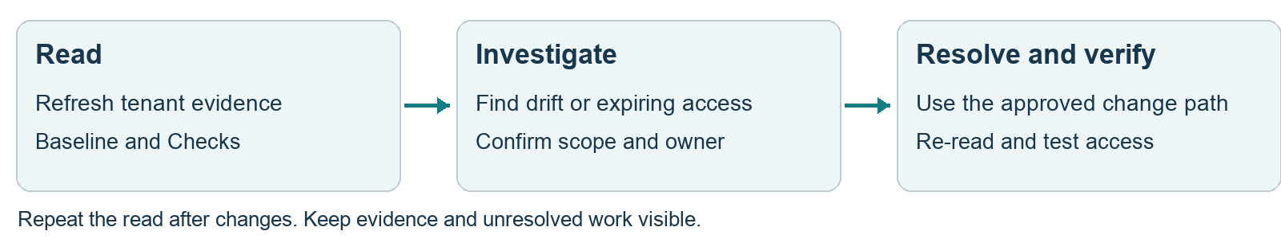
Figure 6 Routine operating cycle

Routine administration
At each operational review, refresh Baseline and Checks, investigate unexpected permanent access, inspect expiring assignments and review recent activations and changes. Record an owner and review date for accepted deviations. Renew access only after the responsible owner confirms the continuing need. Calendar review is not the same as a configured automated access review.
For a joiner or role change, approve the persona and scope first. Assign the correct membership type, test activation and record expiry. For a leaver, remove the relevant membership and assignments through the approved administration process, then verify that no direct or alternative path remains. A new model import is not a leaver-cleanup mechanism.
Symptom | Interpretation and next action
Read denied or incomplete | Check tenant, consent and administrator rights. Repeat the read. Do not create replacement objects based on unread data.
Duplicate group or wrong type | Resolve the exact objects and references with the identity owner. Do not delete or rename a live group merely to make the preview green.
Membership policy shown as later | Group onboarding or policy availability is pending. Complete the supported initial membership step, re-read and create a new preview.
No approver or approval not enabled | Check actual membership and availability of the configured approver group. Populate it, then preview again. Do not treat an unknown member count as ready.
Operation failed or was skipped | Read the failed dependency and outcome report. Fix the cause, refresh the tenant and generate a new plan; inspect what already succeeded.
Activation succeeds but work fails | Check the correct role or group path, assignment scope, propagation and workload permissions. Test allowed and denied actions with the actual operator.
Browser closed or session interrupted | Do not assume rollback or automatic resume. Reconnect, re-read and reconcile the tenant against saved evidence before applying another plan.

Escalation record
Include tenant, model and catalog version, affected object IDs, read time, operation summary, observed error and correlation ID where available. State whether the issue is configuration drift, incomplete evidence or failed effective access. Keep tokens, credentials and unnecessary personal data out of the support record.

10 Recover and accept the deployment
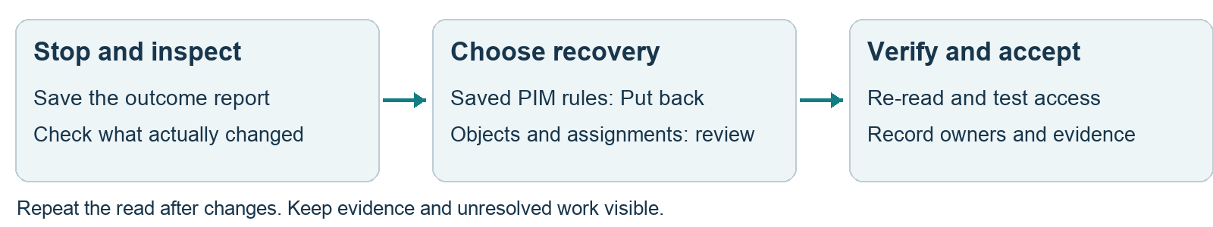
Figure 7 Recovery and acceptance route

Recovery from a configuration problem
1. Stop further work Stop scheduling changes and save the available report. Requests already accepted by the service can still complete; inspect the resulting tenant state.
2. Identify the affected objects Compare the plan, outcome and fresh read. Separate policy changes, newly created objects and assignments. Establish whether later administrative changes would be overwritten.
3. Restore policy rules when appropriate Current Deploy → Put back accepts the tool’s policy-rule backup for the same tenant, presents a preview and applies it after confirmation. It restores saved PIM rules; it is not a full tenant or model rollback.
4. Handle objects and assignments separately Review removal of newly created objects or eligibilities through the relevant admin interface. Check memberships, ownership and external references first. Intune role changes and other resources are not covered by the PIM-rule restore file.
5. Re-read and test Confirm the intended policy and access state, then repeat activation and scope tests. Record the incident, remaining work and recovery approval. Use the independent emergency route if normal administration is blocked.
A restricted administrative unit’s restricted flag is fixed at creation. Treat replacement or removal as a separate controlled change; “Put back” cannot turn it into an ordinary unit. [M3]

Acceptance criteria
Gate | Required evidence
Configuration | All required components match the approved model; no unexplained missing, deferred, failed or unread item remains.
Entra activation | A nominated operator activates the intended role with the required controls, can perform the intended task and loses privileged access after expiry or deactivation.
Intune and regions | An eligible operator gains the intended group-based access. Test an allowed action and a denied action outside the intended scope; check broader assignments.
Approval and alerts | Approval works for a legitimate request; the rejection path and notification delivery are demonstrated.
Recovery and ownership | Emergency access works; recovery evidence is retained; responsible owners and the next review date are recorded.

Acceptance record: customer tenant __________ Model and variant __________ Change reference __________ Service owner __________ Security acceptance __________ Date __________ Next review __________

11 Delivery gaps and supporting evidence

Required work before complete customer onboarding
1. Unify the journey Add the model cards, people and approver selection, editable regions and optional-service choices to one Deploy my model flow. Preserve the existing role-versus-group activation design.
2. Close the automatic provisioning gaps Implement supported membership scheduling, group-policy completion and dependency setup. Integrate optional services before advertising them as complete. Prove the bootstrap sequence does not expose weaker interim access.
3. Strengthen readiness gates Build 32431 keeps approval unchanged when the approver user count is unknown and prevents blocked plans from running. Broader readiness work remains: required unread data and absent authentication-context enforcement must stop dependent deployment. Current CA checks require supplied policy data and remain findings.
4. Make completion durable and verifiable Bind approval to a fresh tenant-specific plan, retain recoverable operation outcomes, reconcile interrupted work and verify asynchronous requests to their resulting assignments. The current runner records request responses as done and then performs aggregate read-back; it does not itself poll every schedule request to a terminal state.
5. Prove and release Run controlled live acceptance for each model and recovery path. Publish the supported scope and remaining exclusions. For an ENCA release, update Help → Waiting for production, the changelog and the validation report together.

Evidence at handover
Reviewed source snapshot: ENCA build 32436 (framework 3.0, revised 5 October 2026: job groups, direct groups, Exchange RBAC access groups), inspected on 5 October 2026. Current application code takes precedence over the older hardening plan. The PIM and Intune regression suites and documentation contract checks pass at this build.
Implementation references: js/workspaces.js; js/pimBaselineData.js; js/pimbaseline.js; js/pimdesigner.js; js/pimdeploy.js; js/pimplan.js; js/app.js functions pimApply, pimPlanWire, pdpReadAll and pdpVerify; js/intunerbac.js. Test evidence includes tools/intunerbac.test.cjs and tools/pimdocs.test.cjs alongside the PIM suites. Read the PimBuddy Baseline Design and Object Reference before this handover. The historic plan is docs/pimbuddy-hardening-plan.md.

Microsoft reference material
M1 PIM for Groups — activation patterns and role-assignable groups
https://learn.microsoft.com/en-us/entra/id-governance/privileged-identity-management/concept-pim-for-groups
M2 Microsoft Entra ID Governance licensing fundamentals
https://learn.microsoft.com/en-us/entra/id-governance/licensing-fundamentals
M3 Restricted management administrative units — limitations
https://learn.microsoft.com/en-us/entra/identity/role-based-access-control/admin-units-restricted-management
M4 Microsoft Defender unified RBAC — custom roles and assignments to Microsoft Entra groups
https://learn.microsoft.com/en-us/defender-xdr/create-custom-rbac-roles

