PimBuddy baseline design and object reference
The baseline defines who can administer Microsoft Entra, Microsoft 365 and Intune, the scope of that access, and how privileged access is activated. This reference is the design document to read before the administrative handover.
It covers all three catalog models, every central group, all 38 Entra role definitions, policy templates, administrative units, regional objects, Intune permissions and Azure group intentions. Customer identities and deployed object IDs belong in the completed deployment record.
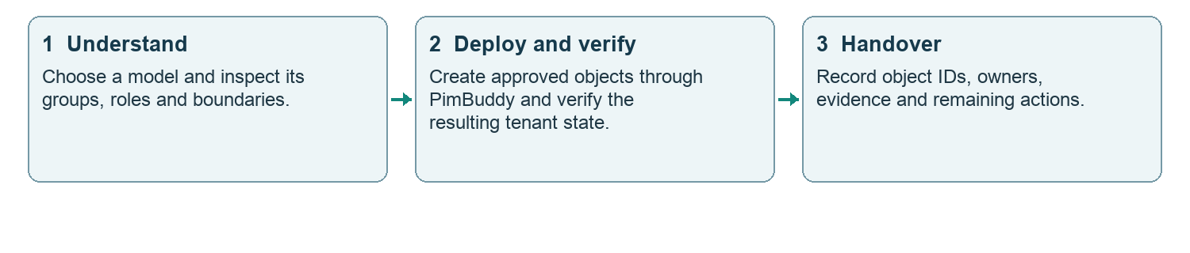
Figure 1. From baseline design to operational ownership

Document control
Field | Reference
Version | 2.0 • 5 October 2026
Audience | Customer administrator, implementation lead and security owner
Baseline | Framework 3.0 • catalog revised 5 October 2026
Application snapshot | Build 32436 • framework 3.0: job groups, direct groups and Exchange RBAC access groups
Status | Design reference, not a tenant deployment certificate

The requested experience is choose a model → deploy everything in PimBuddy → verify completion. That experience remains a product target. This document identifies catalog components and dependencies without implying that every component is already automated.

1 Reading map and design boundaries
Sections | Purpose
2–5 | Architecture and three model inventories
6–8 | Every Entra role mapping and exact role identifiers
9–11 | Activation, expiration and notification policies
12–14 | Central Intune assignments for each model
15–18 | Regional groups, administrative units, rules and access
19 | Executive restricted management unit
20 | Azure group and intended scope inventory
21–22 | Complete custom Intune permission set
23–25 | Dependencies, deployment completion and customer decisions

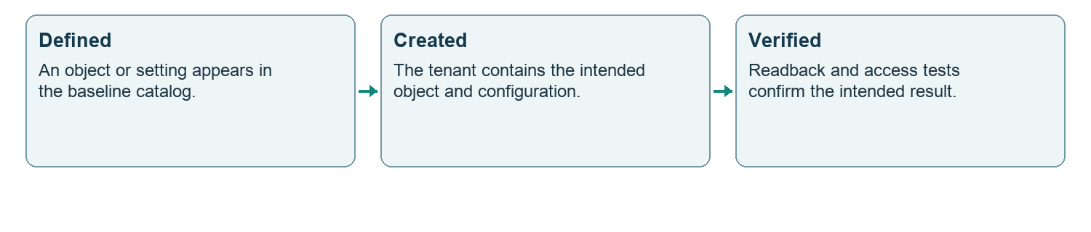
Figure 2. From definition to verification
A successful creation request is not proof that membership has propagated or that an administrator can perform the intended task. Keep defined, created, verified and handed over as separate statuses.

Naming
Prefix | Meaning
PIM-SG-M365- | Central Entra and Microsoft 365 persona group
PIM-SG-INT- | Intune privileged access group
PIM-SG-XDR- | Defender XDR privileged access group; its role and assignment live in the Defender portal
PIM-SG-AZ- | Azure persona group with an intended ARM scope
PIM-SG-<REG>- | Regional persona or approval group
AU- / AU-RM- | Administrative unit / restricted management unit
INT-SG- / INT-TAG- / INT-RBAC- | Intune scope group / scope tag / assignment
INT-ROLE- | Custom Intune role definition

Names are human labels. Use the resolved tenant object ID, role definition ID and scope ID when recording assignments. The regional naming format is an intentional variant of the central naming pattern.

2 How privileged access is connected
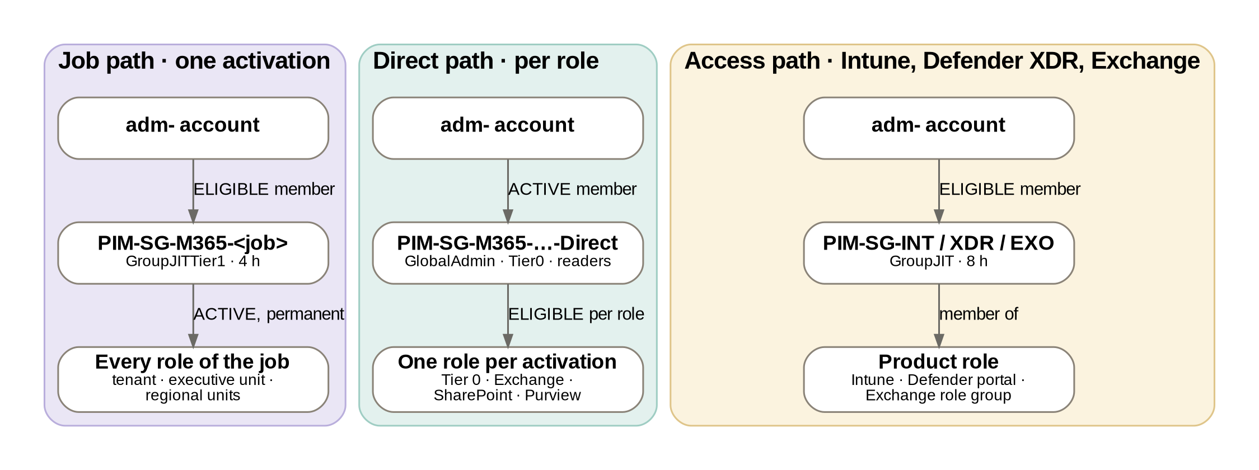
Figure 3. The three activation paths in framework 3.0
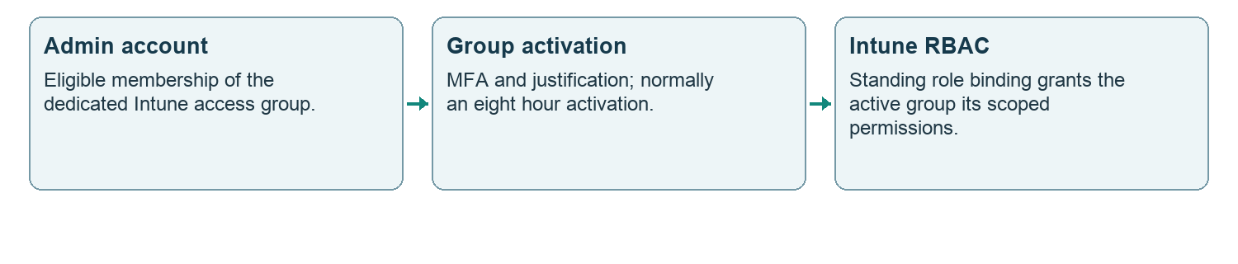
Figure 4. Intune membership activation
Framework 3.0 uses three activation paths. Job groups: administrators are ELIGIBLE members and the group holds every role of the job ACTIVE and permanently, so one activation (GroupJITTier1, four hours) gives the whole job. Direct groups: administrators are ACTIVE members and the group is ELIGIBLE for each role, activated one at a time — used for Tier 0, which is never bundled, and for the Exchange, SharePoint and Purview roles, because Microsoft documents that activation through PIM for Groups can take hours to reach those portals (up to 24 hours for SharePoint). Access groups (Intune, Defender XDR, Exchange RBAC): ELIGIBLE members, the group is a member of the product role. Every role a job group holds allows a permanent active assignment; the gate is the eligible membership. An administrator who is an ACTIVE member of a job group would hold every role of the job standing — do not leave active members in job groups.
Defender XDR follows the Intune pattern since framework 2.2. The five PIM-SG-XDR access groups (Admin, Operator-T3, Operator-T2, Operator-T1 and Reader, after the roles of the customer RBAC baseline document) hold eligible members who activate the group; the Defender XDR roles, their permission sets, the assignments that name the groups and the data sources are configured in the Defender portal and are outside PimBuddy. PimBuddy creates and compares the groups and their Member policies only; it never reads or writes the portal. A persona group never sits in a Defender assignment. [M6]
Exchange RBAC follows the same access pattern since framework 3.0: PIM-SG-EXO-Recipients (Recipient Management), PIM-SG-EXO-HelpDesk (Help Desk), PIM-SG-EXO-Hygiene (Hygiene Management) and PIM-SG-EXO-Reader (View-Only Organization Management) have eligible members; each group is added to its Exchange Online role group in Exchange, not through Microsoft Graph. Exchange accepted a role-assignable Entra group as a role group member on cloudfellows.dev (5 October 2026); how long Exchange takes to honour an activation is measured on the first use. Exchange Administrator stays on the direct path for anything above these role groups.
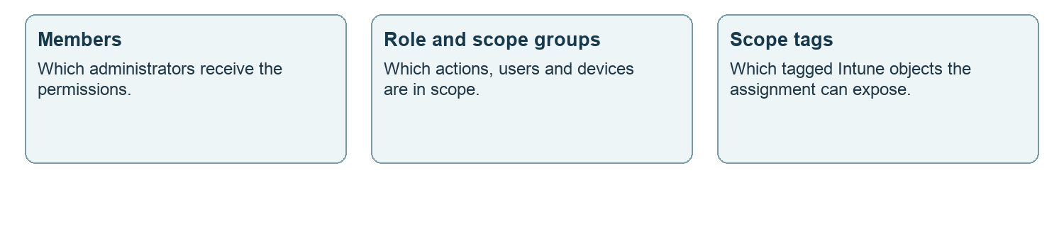
Figure 5. An Intune assignment combines three boundaries
An administrative unit scopes supported Entra administrative operations. An Intune scope group and scope tag serve a different system. Membership in an AU does not automatically tag devices or grant Intune permissions. [M1, M3]

3 Small business model
25 to 250 people, two to six in IT.
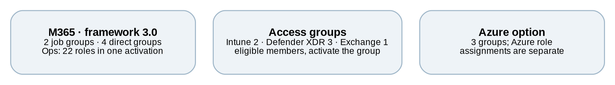
Figure 6. Model composition
Central group | Membership policy
PIM-SG-M365-GlobalAdmin | GroupMember · direct group: active members
PIM-SG-M365-SecOps | GroupJITTier1 · job group: eligible members
PIM-SG-M365-SecOps-Direct | GroupMember · direct group: active members
PIM-SG-M365-Ops | GroupJITTier1 · job group: eligible members
PIM-SG-M365-Ops-Direct | GroupMember · direct group: active members
PIM-SG-M365-SecOpsReader | GroupMember · direct group: active members
PIM-SG-EXO-Recipients | GroupJIT · Exchange RBAC access group
PIM-SG-INT-Ops | GroupJIT
PIM-SG-INT-SecOps | GroupJIT
PIM-SG-XDR-Admin | GroupJITTier0
PIM-SG-XDR-Operator-T3 | GroupJIT
PIM-SG-XDR-Reader | GroupJIT
PIM-SG-AZ-Tenant-Owner | GroupMember
PIM-SG-AZ-Sub-Owner | GroupMember
PIM-SG-AZ-Sub-Contributor | GroupMember

Two job groups (Ops with 22 roles, SecOps) and four direct groups (GlobalAdmin for Global Administrator, Privileged Role Administrator and Privileged Authentication Administrator; SecOps-Direct; Ops-Direct for Exchange and SharePoint; SecOpsReader). Global Administrator activates for two hours with approval. The other Tier 0 roles retain c1 and justification but do not require approval. Job activations alert on critical events only in this model. The small model contains no administrative units.
Central PIM catalog total: 15 groups including optional Azure groups, the three Defender XDR access groups (Admin on the Tier 0 gate, Operator-T3 for IT, Reader) and PIM-SG-EXO-Recipients. The plain central approval group is additional and is not included in that total. All listed central PIM groups are role assignable; customer memberships and owners must be supplied separately.

4 Large one region model
One country, several IT teams, a service desk, an ITSM tool.
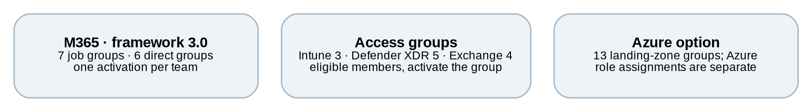
Figure 7. Model composition
Central group | Membership policy
PIM-SG-M365-GlobalAdmin | GroupMember · direct group: active members
PIM-SG-M365-Tier0 | GroupMember · direct group: active members
PIM-SG-M365-SecOps | GroupJITTier1 · job group: eligible members
PIM-SG-M365-SecOps-Direct | GroupMember · direct group: active members
PIM-SG-M365-SecOpsReader | GroupMember · direct group: active members
PIM-SG-M365-Audit | GroupMember · direct group: active members
PIM-SG-M365-Identity | GroupJITTier1 · job group: eligible members
PIM-SG-M365-Workplace | GroupJITTier1 · job group: eligible members
PIM-SG-M365-Collab | GroupJITTier1 · job group: eligible members
PIM-SG-M365-Collab-Direct | GroupMember · direct group: active members
PIM-SG-EXO-Recipients | GroupJIT · Exchange RBAC access group
PIM-SG-EXO-HelpDesk | GroupJIT · Exchange RBAC access group
PIM-SG-EXO-Hygiene | GroupJIT · Exchange RBAC access group
PIM-SG-EXO-Reader | GroupJIT · Exchange RBAC access group
PIM-SG-M365-Apps | GroupJITTier1 · job group: eligible members
PIM-SG-M365-ServiceDesk | GroupJITTier1 · job group: eligible members
PIM-SG-M365-ServiceDesk-VIP | GroupJITTier1 · job group: eligible members
PIM-SG-INT-Ops | GroupJIT
PIM-SG-INT-HelpDesk | GroupJIT
PIM-SG-INT-SecOps | GroupJIT
PIM-SG-XDR-Admin | GroupJITTier0
PIM-SG-XDR-Operator-T3 | GroupJIT
PIM-SG-XDR-Operator-T2 | GroupJIT
PIM-SG-XDR-Operator-T1 | GroupJIT
PIM-SG-XDR-Reader | GroupJIT
PIM-SG-AZ-Tenant-Owner | GroupMember
PIM-SG-AZ-Platform-Owner | GroupMember
PIM-SG-AZ-Platform-Contributor | GroupMember
PIM-SG-AZ-Connectivity-Owner | GroupMember
PIM-SG-AZ-Connectivity-Contributor | GroupMember
PIM-SG-AZ-Management-Owner | GroupMember
PIM-SG-AZ-Management-Contributor | GroupMember
PIM-SG-AZ-LandingZone-Owner | GroupMember
PIM-SG-AZ-LandingZone-Contributor | GroupMember
PIM-SG-AZ-Corp-Owner | GroupMember
PIM-SG-AZ-Corp-Contributor | GroupMember
PIM-SG-AZ-Online-Owner | GroupMember
PIM-SG-AZ-Online-Contributor | GroupMember

Seven job groups (Identity, Workplace, Collab, Apps, SecOps, ServiceDesk and ServiceDesk-VIP) and six direct groups (GlobalAdmin, Tier0, SecOps-Direct, Collab-Direct for Exchange and SharePoint, Audit, SecOpsReader). ServiceDesk-VIP holds its desk roles actively at AU-RM-Executives only. Tier 0, Tier 1 and job activations require ticket information. The optional executive restricted unit is detailed in section 19.
Central PIM catalog total: 38 groups including optional Azure groups, the five Defender XDR access groups (the Admin group activates under GroupJITTier0 with a ticket and approval by the Tier 0 rota) and the four Exchange RBAC access groups. The plain central approval group is additional and is not included in that total. All listed central PIM groups are role assignable; customer memberships and owners must be supplied separately.

5 Large multi-region model
Several regions, central IT plus local IT per region.
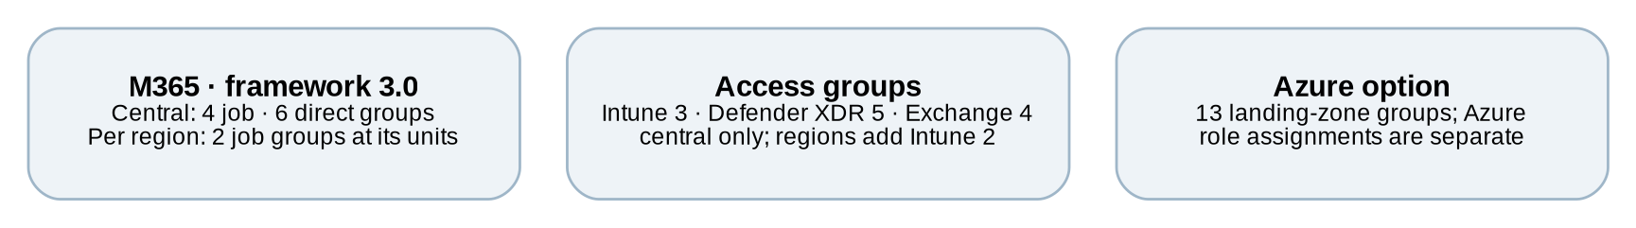
Figure 8. Model composition
Central group | Membership policy
PIM-SG-M365-GlobalAdmin | GroupMember · direct group: active members
PIM-SG-M365-Tier0 | GroupMember · direct group: active members
PIM-SG-M365-SecOps | GroupJITTier1 · job group: eligible members
PIM-SG-M365-SecOpsReader | GroupMember · direct group: active members
PIM-SG-M365-Ops | GroupJITTier1 · job group: eligible members
PIM-SG-M365-Helpdesk | GroupJITTier1 · job group: eligible members
PIM-SG-M365-AppOps | GroupJITTier1 · job group: eligible members
PIM-SG-M365-SecOps-Direct | GroupMember · direct group: active members
PIM-SG-M365-Ops-Direct | GroupMember · direct group: active members
PIM-SG-M365-AppOps-Direct | GroupMember · direct group: active members
PIM-SG-INT-Ops | GroupJIT
PIM-SG-INT-HelpDesk | GroupJIT
PIM-SG-INT-SecOps | GroupJIT
PIM-SG-XDR-Admin | GroupJITTier0
PIM-SG-XDR-Operator-T3 | GroupJIT
PIM-SG-XDR-Operator-T2 | GroupJIT
PIM-SG-XDR-Operator-T1 | GroupJIT
PIM-SG-XDR-Reader | GroupJIT
PIM-SG-EXO-Recipients | GroupJIT · Exchange RBAC access group
PIM-SG-EXO-HelpDesk | GroupJIT · Exchange RBAC access group
PIM-SG-EXO-Hygiene | GroupJIT · Exchange RBAC access group
PIM-SG-EXO-Reader | GroupJIT · Exchange RBAC access group
PIM-SG-AZ-Tenant-Owner | GroupMember
PIM-SG-AZ-Platform-Owner | GroupMember
PIM-SG-AZ-Platform-Contributor | GroupMember
PIM-SG-AZ-Connectivity-Owner | GroupMember
PIM-SG-AZ-Connectivity-Contributor | GroupMember
PIM-SG-AZ-Management-Owner | GroupMember
PIM-SG-AZ-Management-Contributor | GroupMember
PIM-SG-AZ-LandingZone-Owner | GroupMember
PIM-SG-AZ-LandingZone-Contributor | GroupMember
PIM-SG-AZ-Corp-Owner | GroupMember
PIM-SG-AZ-Corp-Contributor | GroupMember
PIM-SG-AZ-Online-Owner | GroupMember
PIM-SG-AZ-Online-Contributor | GroupMember

Two levels of IT: central IT first, then regional IT. Centrally, four job groups (Ops, Helpdesk, AppOps, SecOps) and six direct groups (GlobalAdmin, Tier0, SecOps-Direct, Ops-Direct, AppOps-Direct, SecOpsReader). Each customer region adds seven groups — the regional Helpdesk and Ops are job groups that hold their roles actively at the region’s own units — three administrative units, eight scoped Entra role bindings, one scope tag and two Intune role bindings. The effective multi-region profile has no preconfigured executive restricted unit.
Central PIM catalog total: 35 groups including optional Azure groups, the five Defender XDR access groups and the four Exchange RBAC access groups, all central only: the region template adds no Defender XDR or Exchange objects. The plain central approval group is additional and is not included in that total. All listed central PIM groups are role assignable; customer memberships and owners must be supplied separately.

6 Entra role mappings 1 to 13
Mappings are tenant-wide unless a separate AU scope is explicitly listed later. Every group name in the model columns has the prefix PIM-SG-M365-. A dash means the policy is defined but no persona assignment is generated.
Entra role | Policy | Small | Large | Multi
Global Administrator | Tier0 | GlobalAdmin (eligible) | GlobalAdmin (eligible) | GlobalAdmin (eligible)
Privileged Role Administrator | Tier0 | GlobalAdmin (eligible) | Tier0 (eligible) | Tier0 (eligible)
Privileged Authentication Administrator | Tier0 | GlobalAdmin (eligible) | Tier0 (eligible) | Tier0 (eligible)
Conditional Access Administrator | Tier0 | SecOps-Direct (eligible) | SecOps-Direct (eligible) | SecOps-Direct (eligible)
Security Administrator | Tier0 | SecOps-Direct (eligible) | SecOps-Direct (eligible) | SecOps-Direct (eligible)
Exchange Administrator | Tier1 | Ops-Direct (eligible) | Collab-Direct (eligible) | AppOps-Direct (eligible), Ops-Direct (eligible)
SharePoint Administrator | Tier1 | Ops-Direct (eligible) | Collab-Direct (eligible) | AppOps-Direct (eligible), Ops-Direct (eligible)
Teams Administrator | Tier1 | Ops (active) | Collab (active) | Ops (active)
Intune Administrator | Tier1 | Ops (active) | Workplace (active) | Ops (active)
Application Administrator | Tier1 | Ops (active) | Apps (active) | Ops (active)
Cloud Application Administrator | Tier1 | Ops (active) | Apps (active) | AppOps (active)
Application Developer | Tier1 | Ops (active) | Apps (active) | AppOps (active)
Power Platform Administrator | Tier1 | Ops (active) | Collab (active) | AppOps (active), Ops (active)

Immutable role template identifiers
Role | Template ID
Global Administrator | 62e90394-69f5-4237-9190-012177145e10
Privileged Role Administrator | e8611ab8-c189-46e8-94e1-60213ab1f814
Privileged Authentication Administrator | 7be44c8a-adaf-4e2a-84d6-ab2649e08a13
Conditional Access Administrator | b1be1c3e-b65d-4f19-8427-f6fa0d97feb9
Security Administrator | 194ae4cb-b126-40b2-bd5b-6091b380977d
Exchange Administrator | 29232cdf-9323-42fd-ade2-1d097af3e4de
SharePoint Administrator | f28a1f50-f6e7-4571-818b-6a12f2af6b6c
Teams Administrator | 69091246-20e8-4a56-aa4d-066075b2a7a8
Intune Administrator | 3a2c62db-5318-420d-8d74-23affee5d9d5
Application Administrator | 9b895d92-2cd3-44c7-9d02-a6ac2d5ea5c3
Cloud Application Administrator | 158c047a-c907-4556-b7ef-446551a6b5f7
Application Developer | cf1c38e5-3621-4004-a7cb-879624dced7c
Power Platform Administrator | 11648597-926c-4cf3-9c36-bcebb0ba8dcc

7 Entra role mappings 14 to 26
Mappings are tenant-wide unless a separate AU scope is explicitly listed later. Every group name in the model columns has the prefix PIM-SG-M365-. A dash means the policy is defined but no persona assignment is generated.
Entra role | Policy | Small | Large | Multi
Authentication Administrator | Tier1 | Ops (active) | Identity (active), ServiceDesk (active) | Helpdesk (active), Ops (active)
Authentication Policy Administrator | Tier1 | Ops (active) | Identity (active) | Ops (active)
User Administrator | Tier1 | Ops (active) | Identity (active) | Helpdesk (active), Ops (active)
Groups Administrator | Tier1 | Ops (active) | Identity (active) | Helpdesk (active)
License Administrator | Tier1 | Ops (active) | Identity (active), ServiceDesk (active) | Helpdesk (active), Ops (active)
Password Administrator | Tier1 | Ops (active) | ServiceDesk (active) | Helpdesk (active)
Cloud Device Administrator | Tier1 | Ops (active) | Workplace (active) | Helpdesk (active)
Microsoft Entra Joined Device Local Administrator | Tier1 | Ops (active) | Workplace (active) | Helpdesk (active), Ops (active)
Hybrid Identity Administrator | Tier1 | — (rules only) | — (rules only) | — (rules only)
Directory Writers | Tier1 | — (rules only) | — (rules only) | — (rules only)
Identity Governance Administrator | Tier1 | Ops (active) | Identity (active) | Ops (active)
Lifecycle Workflows Administrator | Tier1 | Ops (active) | Identity (active) | Ops (active)
Service Support Administrator | Tier1 | Ops (active) | ServiceDesk (active) | Ops (active)

Immutable role template identifiers
Role | Template ID
Authentication Administrator | c4e39bd9-1100-46d3-8c65-fb160da0071f
Authentication Policy Administrator | 0526716b-113d-4c15-b2c8-68e3c22b9f80
User Administrator | fe930be7-5e62-47db-91af-98c3a49a38b1
Groups Administrator | fdd7a751-b60b-444a-984c-02652fe8fa1c
License Administrator | 4d6ac14f-3453-41d0-bef9-a3e0c569773a
Password Administrator | 966707d0-3269-4727-9be2-8c3a10f19b9d
Cloud Device Administrator | 7698a772-787b-4ac8-901f-60d6b08affd2
Microsoft Entra Joined Device Local Administrator | 9f06204d-73c1-4d4c-880a-6edb90606fd8
Hybrid Identity Administrator | 8ac3fc64-6eca-42ea-9e69-59f4c7b60eb2
Directory Writers | 9360feb5-f418-4baa-8175-e2a00bac4301
Identity Governance Administrator | 45d8d3c5-c802-45c6-b32a-1d70b5e1e86e
Lifecycle Workflows Administrator | 59d46f88-662b-457b-bceb-5c3809e5908f
Service Support Administrator | f023fd81-a637-4b56-95fd-791ac0226033

8 Entra role mappings 27 to 38
Mappings are tenant-wide unless a separate AU scope is explicitly listed later. Every group name in the model columns has the prefix PIM-SG-M365-. A dash means the policy is defined but no persona assignment is generated.
Entra role | Policy | Small | Large | Multi
Edge Administrator | Tier1 | Ops (active) | Workplace (active) | Ops (active)
Office Apps Administrator | Tier1 | Ops (active) | Collab (active) | AppOps (active), Ops (active)
Guest Inviter | Tier1 | Ops (active) | Collab (active) | AppOps (active), Ops (active)
Compliance Administrator | Tier1 | SecOps-Direct (eligible) | SecOps-Direct (eligible) | SecOps-Direct (eligible)
Compliance Data Administrator | Tier1 | SecOps-Direct (eligible) | SecOps-Direct (eligible) | SecOps-Direct (eligible)
Cloud App Security Administrator | Tier1 | SecOps (active) | SecOps (active) | SecOps (active)
Security Operator | Tier1 | SecOps (active) | SecOps (active) | SecOps (active)
Helpdesk Administrator | Tier2 | Ops (active) | ServiceDesk (active) | Helpdesk (active)
Message Center Reader | Tier2 | Ops (active), SecOps (active) | Apps (active), Collab (active), Identity (active), SecOps (active), ServiceDesk (active), Workplace (active) | AppOps (active), Helpdesk (active), Ops (active), SecOps (active)
Global Reader | Reader | SecOpsReader (eligible) | Audit (eligible), SecOpsReader (eligible) | SecOpsReader (eligible)
Security Reader | Reader | SecOpsReader (eligible) | SecOpsReader (eligible) | SecOpsReader (eligible)
Directory Readers | Reader | — (rules only) | — (rules only) | — (rules only)

Immutable role template identifiers
Role | Template ID
Edge Administrator | 3f1acade-1e04-4fbc-9b69-f0302cd84aef
Office Apps Administrator | 2b745bdf-0803-4d80-aa65-822c4493daac
Guest Inviter | 95e79109-95c0-4d8e-aee3-d01accf2d47b
Compliance Administrator | 17315797-102d-40b4-93e0-432062caca18
Compliance Data Administrator | e6d1a23a-da11-4be4-9570-befc86d067a7
Cloud App Security Administrator | 892c5842-a9a6-463a-8041-72aa08ca3cf6
Security Operator | 5f2222b1-57c3-48ba-8ad5-d4759f1fde6f
Helpdesk Administrator | 729827e3-9c14-49f7-bb1b-9608f156bbb8
Message Center Reader | 790c1fb9-7f7d-4f88-86a1-ef1f95c05c1b
Global Reader | f2ef992c-3afb-46b9-b7cf-a126ee74c451
Security Reader | 5d6b6bb7-de71-4623-b4af-96380a352509
Directory Readers | 88d8e3e3-8f55-4a1e-953a-9b9898b8876b

9 Activation and assignment policy templates
These are the base template values. Section 10 lists profile and role overrides. An assignment limit is a maximum permitted duration, not evidence that a particular assignment exists.
Template | Activation | Requirements | Approval | Context
Tier0 | 2 hours | Justification | Yes | c1
Tier1 | 2 hours | MFA, Justification | No | None
Tier2 | 8 hours | MFA, Justification | No | None
Reader | 8 hours | MFA | No | None
GroupMember | 1 hour | MFA, Justification | Yes | None
GroupJIT | 8 hours | MFA, Justification | No | None
GroupJITTier0 | 2 hours | Justification | Yes | c1
GroupJITTier1 | 4 hours | MFA, Justification | No | None

Template | Permanent eligible | Eligible limit | Permanent active | Active limit
Tier0 | No | 365 days | No | 30 days
Tier1 | No | 365 days | No | 30 days
Tier2 | No | 365 days | No | 30 days
Reader | Yes | 365 days | No | 90 days
GroupMember | No | 365 days | No | 365 days
GroupJIT | No | 365 days | No | 30 days
GroupJITTier0 | No | 365 days | No | 30 days
GroupJITTier1 | No | 365 days | No | 30 days

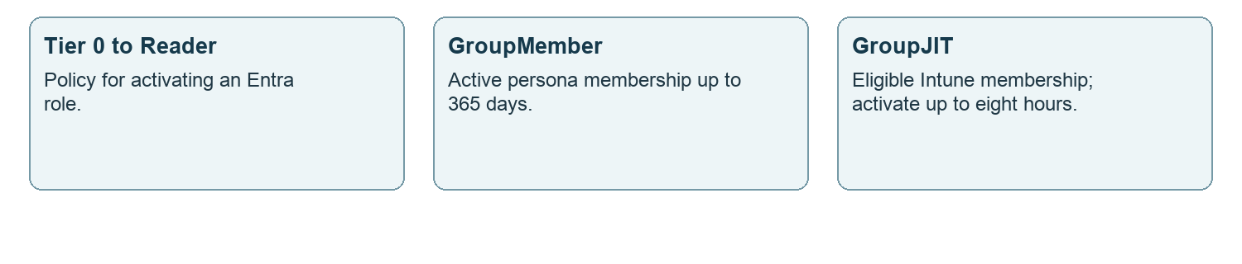
Figure 9. Choose the correct template family
GroupMember is the direct-group policy: members are ACTIVE for at most a year, and the one hour activation with approval only applies if someone is made eligible anyway, which is not the intended pattern. GroupJITTier1 (framework 3.0) is the job-group policy: ELIGIBLE members, one activation of four hours with MFA and justification (a ticket in the large model). A 365 day expiry does not schedule or perform an access review. GroupJITTier0 (framework 2.2) applies the Tier 0 gate to eligible membership of the Defender XDR administrator group, PIM-SG-XDR-Admin: two hours, justification, authentication context c1 and approval; the other Defender XDR access groups and the Exchange RBAC access groups use GroupJIT.

10 Model overrides and approval groups
Model | Template or role | Setting | Effective override
small | Tier0 | Approval required | False
small | Tier0 | Approvers | None
small | Tier1 | Activation alerts | Critical; default recipients enabled; pim-alerts
large | Tier0 | Activation requirements | Justification, Ticketing
large | Tier0 | Approvers | PIM-SG-Approvers-Tier0
large | Tier1 | Activation requirements | MFA, Justification, Ticketing
large | GroupMember | Approvers | PIM-SG-Approvers-Tier0
large | GroupJITTier0 | Activation requirements | Justification, Ticketing
large | GroupJITTier0 | Approvers | PIM-SG-Approvers-Tier0
small | Global Administrator | Activation duration | PT2H
small | Global Administrator | Approval required | True
small | Global Administrator | Approvers | PIM-SG-Approvers
small | Directory Readers | Allow permanent active | True
large | Global Administrator | Activation duration | PT1H
large | Directory Readers | Allow permanent active | True
multi | Global Administrator | Activation duration | PT1H
multi | Directory Readers | Allow permanent active | True
small | GroupJITTier1 | Activation alerts | Critical; default recipients enabled; pim-alerts
large | GroupJITTier1 | Activation requirements | MFA, Justification, Ticketing
small, large, multi | Every role a job group holds | Allow permanent active | True (the job group holds it; people are eligible members)

PT1H / PT2H mean one / two hours. True and false are enabled and disabled. Overrides take precedence over template values. Directory Readers permits permanent active assignments in all models, but its empty persona mapping creates no assignment.

Approval groups
Name | Use
PIM-SG-Approvers | Small Global Administrator; base Tier 0, GroupMember fallback and GroupJITTier0 (Defender XDR Admin) policies
PIM-SG-Approvers-Tier0 | Large model Tier 0, GroupMember and GroupJITTier0 policies; catalog intent is a rota of three
PIM-SG-<REG>-Approvers | Regional plain security group; an optional approval gate must be explicitly configured

Approval groups are ordinary security groups, not role assignable PIM personas. Deploy requires a successfully read count of at least two users in an existing approval group before changing approval. This count does not prove availability; test approval behavior. Creating a regional approver group alone does not connect it to a policy; the base GroupJIT template requires no approval.

11 Notifications and activation experience
Template | Activation alert | Eligible assignment alert | Active assignment alert
Tier0 | All | All | All
Tier1 | All | All | All
Tier2 | Critical | All | All
Reader | Critical | Critical | All
GroupMember | All | All | All
GroupJIT | Critical | All | All
GroupJITTier1 | All | All | All

All base notification entries enable default recipients and include the pim-alerts recipient. Resolve this alias to the customer’s actual mailbox. The small model changes Tier 1 activation alerts to Critical; eligible and active assignment alerts stay All. Tier 2 activation alerts are already Critical.
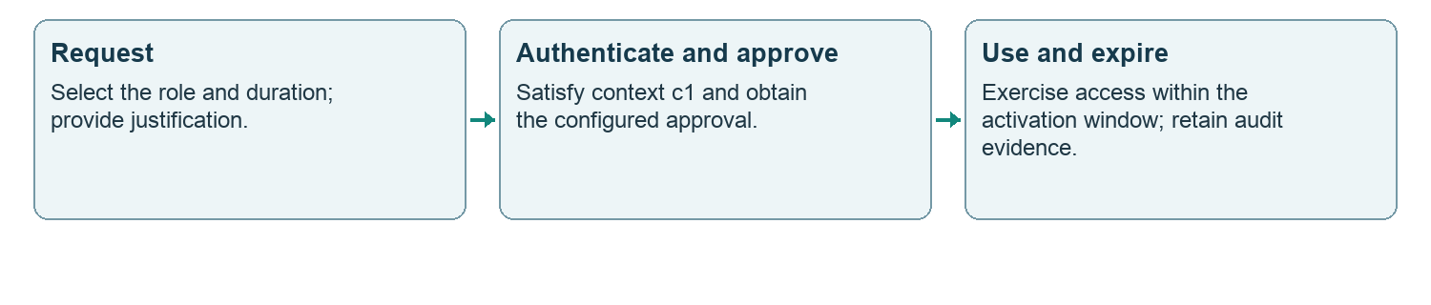
Figure 10. Tier 0 activation in the base model
The large model adds ticket information for Tier 0 and Tier 1. The small model keeps approval only on Global Administrator among the Tier 0 role policies. The c1 context remains required for Tier 0 in all models.

External control attached to c1
The intended Conditional Access control requires phishing resistant MFA and a compliant device. It belongs to Workspace 01. A c1 reference in a PIM policy does not prove that this Conditional Access control exists, is enabled, or covers the correct users. Verify the connection and test activation before handing over.

Operational recipients
The baseline references pim-alerts@<customer domain>. Mailbox provisioning, access, delivery testing and retention are separate operational dependencies. Default recipients remain enabled; the shared mailbox is additional.

12 Small business Intune assignments
Each catalog entry can reference multiple roles. The first entry expands into two role bindings, so four entries represent five role bindings in each model.

INT-RBAC-Ops-All
Property | Value
Roles | Policy and Profile Manager  Application Manager
Members | PIM-SG-INT-Ops
Scope and tags | all users and devices; tags: none specified

INT-RBAC-HelpDesk-All
Property | Value
Roles | Help Desk Operator
Members | PIM-SG-INT-Ops
Scope and tags | all users and devices; tags: none specified

INT-RBAC-SecOps-All
Property | Value
Roles | Endpoint Security Manager
Members | PIM-SG-INT-SecOps
Scope and tags | all devices; tags: none specified

INT-RBAC-Reader-All
Property | Value
Roles | Read Only Operator
Members | PIM-SG-M365-SecOpsReader
Scope and tags | all users and devices; tags: none specified

The reader assignment uses active SecOpsReader persona membership and therefore provides standing Intune read access while that membership is active. It does not use the GroupJIT activation pattern. “Every” is a catalog selector that must be resolved to the tenant’s scope tags; it is not a literal tag name.
Catalog tenant settings: Allow access to unlicensed admins. Treat these as separately assessed tenant settings, not automatic consent to enable them. Custom roles: none.

13 Large one region Intune assignments
Each catalog entry can reference multiple roles. The first entry expands into two role bindings, so four entries represent five role bindings in each model.

INT-RBAC-Workplace
Property | Value
Roles | Policy and Profile Manager  Application Manager
Members | PIM-SG-INT-Ops
Scope and tags | all users and devices; tags: default, INT-TAG-Workplace

INT-RBAC-HelpDesk
Property | Value
Roles | Help Desk Operator
Members | PIM-SG-INT-HelpDesk
Scope and tags | all users and devices; tags: default

INT-RBAC-SecOps
Property | Value
Roles | Endpoint Security Manager
Members | PIM-SG-INT-SecOps
Scope and tags | all devices; tags: default

INT-RBAC-Reader-All
Property | Value
Roles | Read Only Operator
Members | PIM-SG-M365-SecOpsReader
Scope and tags | all users and devices; tags: every

The reader assignment uses active SecOpsReader persona membership and therefore provides standing Intune read access while that membership is active. It does not use the GroupJIT activation pattern. “Every” is a catalog selector that must be resolved to the tenant’s scope tags; it is not a literal tag name.
Catalog tenant settings: Allow access to unlicensed admins; Scoped permissions (preview): run the Permissions Assessment Report first; the switch is one-way. Treat these as separately assessed tenant settings, not automatic consent to enable them. Custom roles: none.

14 Large multi-region Intune assignments
Each catalog entry can reference multiple roles. The first entry expands into two role bindings, so four entries represent five role bindings in each model.

INT-RBAC-PolicyProfile-Central
Property | Value
Roles | Policy and Profile Manager  Application Manager
Members | PIM-SG-INT-Ops
Scope and tags | all users and devices; tags: default

INT-RBAC-HelpDesk-Central
Property | Value
Roles | Help Desk Operator
Members | PIM-SG-INT-HelpDesk
Scope and tags | all users and devices; tags: default

INT-RBAC-SecOps-Central
Property | Value
Roles | Endpoint Security Manager
Members | PIM-SG-INT-SecOps
Scope and tags | all devices; tags: default

INT-RBAC-Reader-All
Property | Value
Roles | Read Only Operator
Members | PIM-SG-M365-SecOpsReader
Scope and tags | all users and devices; tags: every

The reader assignment uses active SecOpsReader persona membership and therefore provides standing Intune read access while that membership is active. It does not use the GroupJIT activation pattern. “Every” is a catalog selector that must be resolved to the tenant’s scope tags; it is not a literal tag name.
Catalog tenant settings: Allow access to unlicensed admins; Scoped permissions (preview): run the Permissions Assessment Report first; the switch is one-way. Treat these as separately assessed tenant settings, not automatic consent to enable them. Custom roles: INT-ROLE-Regional-Ops.

15 Multi region object map
Each region is an isolated repeatable set of Entra and Intune scopes. The Netherlands example below uses the sample code EU-NL; it is illustrative, not a live customer inventory.
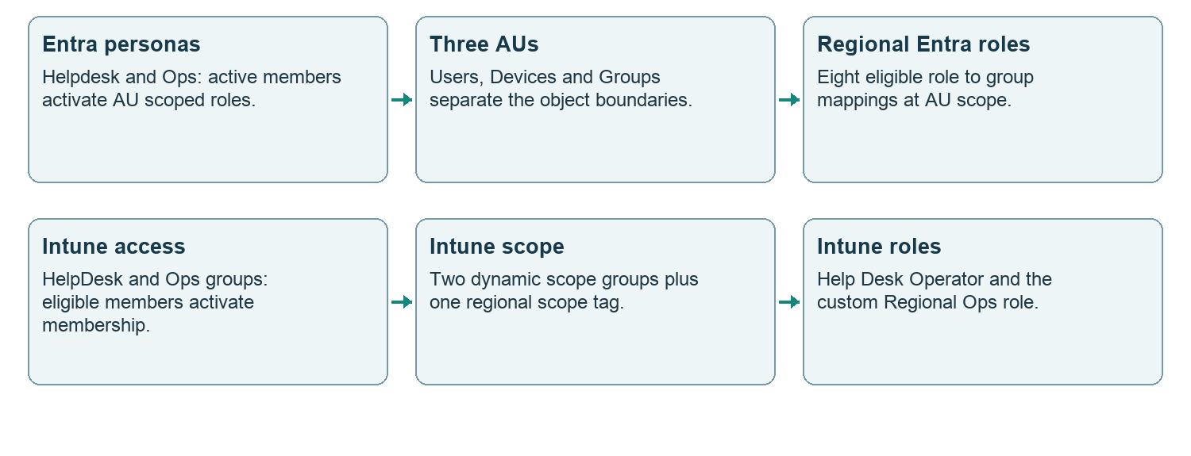
Figure 11. One region expands into connected scopes
Per region | Count | Purpose
Persona and Intune access groups | 4 | Two GroupJITTier1 job groups and two GroupJIT access groups
Plain approval group | 1 | Optional customer approval routing
Dynamic Intune scope groups | 2 | User and device populations
Administrative units | 3 | Two dynamic units and one assigned unit
Entra scoped role mappings | 8 | Four Helpdesk and four Ops mappings
Intune scope tag and bindings | 1 + 2 | One tag and two assignments

Full multi-region catalog totals for N regions, including optional Azure groups: 36 + 7N groups when the central plain approval group is included; 3N regional AUs; 5 + 2N Intune role bindings. The custom Intune role is shared across regions. Existing objects may be reused, so these are design counts.

16 Regional groups and administrative units
Exact sample group | Policy or type
PIM-SG-EU-NL-Helpdesk | GroupJITTier1 (job group)
PIM-SG-EU-NL-Ops | GroupJITTier1 (job group)
PIM-SG-INT-HelpDesk-EU-NL | GroupJIT
PIM-SG-INT-Ops-EU-NL | GroupJIT
PIM-SG-EU-NL-Approvers | Plain security group
INT-SG-USR-EU-NL-All | Dynamic user scope group
INT-SG-DEV-EU-NL-All | Dynamic device scope group

The first four groups are role assignable. The regional approval group and the two Intune scope groups are not role assignable. Region approvers come from the region input; operators, eligible members and group owners require customer selection.

AU-EU-NL-Users
Membership: dynamic; object type: user.
(user.extensionAttribute1 -eq "EU-NL")

AU-EU-NL-Devices
Membership: dynamic; object type: device.
(device.extensionAttribute1 -eq "EU-NL") -or (device.displayName -startsWith "NL-")

AU-EU-NL-Groups
Membership: assigned; object type: group.
Populate with the region’s approved groups. Dynamic AU membership does not support groups.
The two dynamic AUs use different populations from the Intune scope groups. The AU device rule checks an extension attribute or device name; the Intune device rule checks enrollment profile name or device name. Verify actual membership in both systems before granting access.

17 Regional role bindings and Intune rules
Role | Persona suffix | AU suffix
Helpdesk Administrator | Helpdesk | Users
Password Administrator | Helpdesk | Users
Authentication Administrator | Helpdesk | Users
License Administrator | Helpdesk | Users
User Administrator | Ops | Users
Groups Administrator | Ops | Groups
Teams Administrator | Ops | Groups
Cloud Device Administrator | Ops | Devices

Persona prefix: PIM-SG-EU-NL-. AU prefix: AU-EU-NL-. The regional Helpdesk and Ops groups are job groups: each holds its roles ACTIVE, permanently, at the region’s own units, and its eligible members activate the group once. AU assignments only authorize operations supported at AU scope; they do not reproduce the full tenant-wide role. Teams AU support is task dependent. Test the intended Teams operations explicitly. [M1, M2]

INT-SG-USR-EU-NL-All
(user.extensionAttribute1 -eq "EU-NL") -and (user.accountEnabled -eq true)

INT-SG-DEV-EU-NL-All
(device.enrollmentProfileName -startsWith "EU-NL") -or (device.displayName -startsWith "NL-")
Assignment | Role | Member group
INT-RBAC-HelpDesk-EU-NL | Help Desk Operator | PIM-SG-INT-HelpDesk-EU-NL
INT-RBAC-Ops-EU-NL | INT-ROLE-Regional-Ops | PIM-SG-INT-Ops-EU-NL

Both assignments scope to INT-SG-USR-EU-NL-All and INT-SG-DEV-EU-NL-All, and use INT-TAG-EU-NL. That tag is automatically assigned from INT-SG-DEV-EU-NL-All. The custom role permissions are listed in sections 21 and 22.

18 Region input and worked example
Input | Example | Meaning
code | EU-NL | Required region code
name | Netherlands | Required region label
attribute | extensionAttribute1 | Extension attribute 1 to 15
value | EU-NL | Default is the region code
devicePrefix | NL- | Default is final code segment plus hyphen
autopilotTag | EU-NL | Default is region code
itLead | it-lead-nl@contoso.nl | Access review owner
approvers | a@contoso.nl; b@contoso.nl | Customer selected approver identities
timezone | Europe/Amsterdam | Regional context

The supplied addresses are examples only. Replace them with resolved customer identities. The parser accepts up to 250 rows and 262,144 bytes. Region codes follow ^[A-Z]{2,5}(-[A-Z0-9]{2,6}){1,2}$. Do not use names or email addresses as immutable object references.
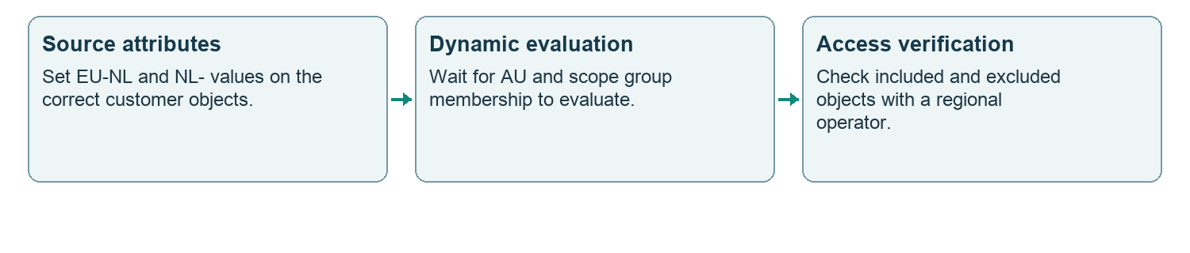
Figure 12. How the Netherlands example is populated

Adjacent objects remain separate
Autopilot profile: Autopilot · EU-NL. Device naming: NL-%SERIAL%. Group tag: EU-NL. These are catalog intentions and dependencies, not proof that an Autopilot profile is deployed. The dynamic device scope rule uses enrollmentProfileName, so validate its actual values rather than assuming the Autopilot group tag makes the rule match.
Yearly review: Access review · EU-NL, covering the four regional PIM access groups, owned by the region’s IT lead. The catalog marks this review manual. Expiration and a named reviewer do not create an access review schedule.

19 Executive restricted management unit
The large single-region model defines the optional AU-RM-Executives. It is filled only after scoped administrators are assigned and tested. The effective multi-region profile does not include this unit; executive protection requires a separate customer extension.
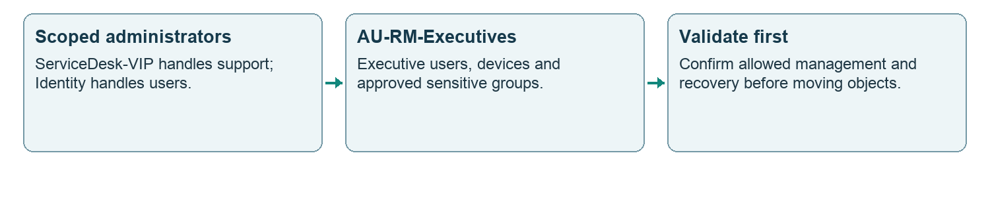
Figure 13. Restricted executive administration
Role held actively at the unit | Group | Scope
Helpdesk Administrator | PIM-SG-M365-ServiceDesk-VIP | AU-RM-Executives
Password Administrator | PIM-SG-M365-ServiceDesk-VIP | AU-RM-Executives
Authentication Administrator | PIM-SG-M365-ServiceDesk-VIP | AU-RM-Executives
User Administrator | PIM-SG-M365-Identity | AU-RM-Executives

Membership boundaries
Keep PIM-SG groups and privileged administrative accounts out of the executive RMAU design. The intended sensitive groups are not role assignable. Restricted management units have service and governance limitations, including restrictions affecting PIM for Groups, access reviews and lifecycle workflows. Validate supported object types and operations before moving objects. [M4]

Safe sequence
Create the empty unit → establish scoped administration → test with a controlled object → verify recovery access → add approved executive objects → confirm allowed and denied operations. Record object IDs and a recovery owner in the deployment record.
An RMAU is a management restriction, not a general confidentiality boundary. Do not infer that administrators lose every ability to read an object or that every workload honors the same boundary. The baseline’s role-assignable group protection does not remove the need to govern owners, memberships and privileged roles.

20 Azure groups and intended scopes
These groups are optional. Their group membership policy is GroupMember. Creating them does not create Azure role assignments, Azure PIM eligibility or resource hierarchies.
Exact group | Role | Intended scope | Models
PIM-SG-AZ-Tenant-Owner | Owner | Tenant Root Group | small, large, multi
PIM-SG-AZ-Sub-Owner | Owner | the subscription(s) | small
PIM-SG-AZ-Sub-Contributor | Contributor | the subscription(s) | small
PIM-SG-AZ-Platform-Owner | Owner | Platform subscription | large, multi
PIM-SG-AZ-Platform-Contributor | Contributor | Platform subscription | large, multi
PIM-SG-AZ-Connectivity-Owner | Owner | Connectivity subscription | large, multi
PIM-SG-AZ-Connectivity-Contributor | Contributor | Connectivity subscription | large, multi
PIM-SG-AZ-Management-Owner | Owner | Management subscription | large, multi
PIM-SG-AZ-Management-Contributor | Contributor | Management subscription | large, multi
PIM-SG-AZ-LandingZone-Owner | Owner | Landing zone management group | large, multi
PIM-SG-AZ-LandingZone-Contributor | Contributor | Landing zone management group | large, multi
PIM-SG-AZ-Corp-Owner | Owner | Corp subscription | large, multi
PIM-SG-AZ-Corp-Contributor | Contributor | Corp subscription | large, multi
PIM-SG-AZ-Online-Owner | Owner | Online subscription | large, multi
PIM-SG-AZ-Online-Contributor | Contributor | Online subscription | large, multi

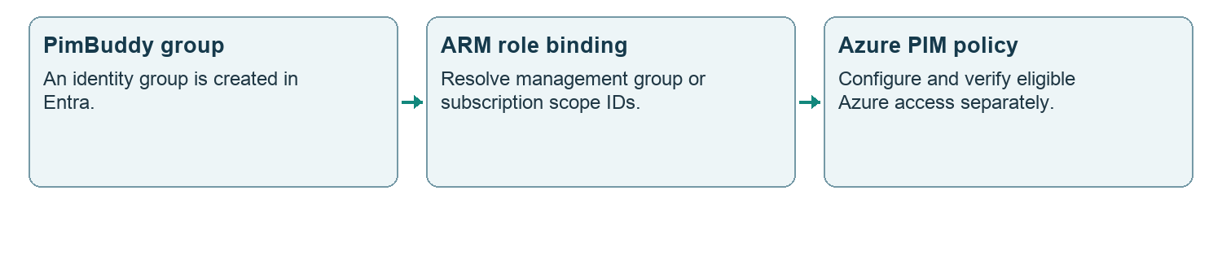
Figure 14. Azure uses its own assignment boundary
Owner and Contributor in this inventory are Azure resource roles. They are not Entra directory roles. Platform, Connectivity, Management, LandingZone, Corp and Online are intended customer scope labels; the catalog is not evidence that those resources exist.

21 Regional Ops custom permissions 1 to 17
INT-ROLE-Regional-Ops permits regional device operations and assignment of centrally managed policies and apps. It does not authorize authoring central policies or administering Intune RBAC.
No | Catalog permission identifier
1 | Microsoft.Intune_ManagedDevices_Read
2 | Microsoft.Intune_ManagedDevices_Update
3 | Microsoft.Intune_ManagedDevices_Delete
4 | Microsoft.Intune_ManagedDevices_SetPrimaryUser
5 | Microsoft.Intune_ManagedDevices_ViewReports
6 | Microsoft.Intune_RemoteTasks_SyncDevice
7 | Microsoft.Intune_RemoteTasks_RebootNow
8 | Microsoft.Intune_RemoteTasks_SetDeviceName
9 | Remote tasks/Collect diagnostics
10 | Microsoft.Intune_RemoteTasks_Wipe
11 | Microsoft.Intune_RemoteTasks_Retire
12 | Microsoft.Intune_RemoteTasks_RotateBitLockerKeys
13 | Microsoft.Intune_RemoteTasks_RotateLocalAdminPassword
14 | Microsoft.Intune_RemoteTasks_RemoteLock
15 | Microsoft.Intune_RemoteTasks_LocateDevice
16 | Microsoft.Intune_RemoteTasks_EnableLostMode
17 | Microsoft.Intune_RemoteTasks_DisableLostMode

This role includes destructive operations such as device deletion, wipe and retire. Customer acceptance must cover these operations and their regional scope. “Regional” limits the target population; it does not make the actions read only.

22 Regional Ops custom permissions 18 to 31
INT-ROLE-Regional-Ops permits regional device operations and assignment of centrally managed policies and apps. It does not authorize authoring central policies or administering Intune RBAC.
No | Catalog permission identifier
18 | Microsoft.Intune_DeviceConfigurations_Read
19 | Microsoft.Intune_DeviceConfigurations_ViewReports
20 | Microsoft.Intune_DeviceConfigurations_Assign
21 | Microsoft.Intune_DeviceCompliancePolices_Read
22 | Microsoft.Intune_DeviceCompliancePolices_ViewReports
23 | Microsoft.Intune_DeviceCompliancePolices_Assign
24 | Microsoft.Intune_MobileApps_Read
25 | Microsoft.Intune_MobileApps_Assign
26 | Microsoft.Intune_ManagedApps_Read
27 | Enrollment programs/Read device
28 | Enrollment programs/Sync device
29 | Audit data/Read
30 | Microsoft.Intune_Organization_Read
31 | Microsoft.Intune_TermsAndConditions_Read

Excluded capability families
The catalog lists three excluded families: create, update or delete any policy, profile, app, script, filter, compliance or endpoint security policy; roles, scope tags, role assignments; tenant settings: enrollment restrictions, MDM authority, connectors. These are descriptions of permissions not granted by this role, not explicit deny rules that override other assignments.
There are 31 allowed entries. Catalog strings include operation identifiers and display-name style entries. Resolve them against the tenant’s current Intune resource operations and verify the resulting role definition. Preserve the catalog spelling DeviceCompliancePolices when comparing source data; do not silently substitute another identifier.
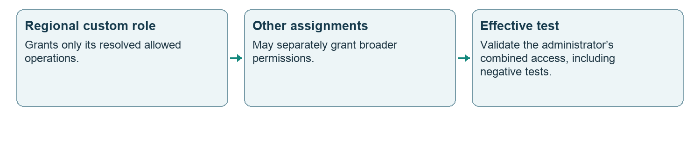
Figure 15. Effective access includes other assignments

23 Protection and external dependencies
Dependency | Required design outcome | Completion evidence
Emergency access | Explicit protected object IDs; intentional CA treatment | Validated recovery sign-in and recorded exclusions
c1 and Conditional Access | Tier 0 context connected to intended strong authentication control | Policy readback and activation test
Approval groups | Real, available approvers and configured routing | Membership IDs and approval test
Notification mailbox | Resolved recipient and operational ownership | Delivered alert and access confirmation
Group membership | Active persona members; eligible Intune members | Schedule and membership readback
Access reviews | Yearly assignment and persona review process | Review schedule or approved manual procedure
Azure RBAC | Real ARM scopes, role assignments and policy | Azure-side readback and activation test
Defender XDR | PIM-SG-XDR groups and Member policies in the tenant; roles, assignments and data sources in the Defender portal | Portal assignment readback naming each group and an activation test
Purview | Separate workload RBAC where required | Workload-specific access verification

The protected account name pattern is only a discovery hint: ^(BG-|BGA\b|BreakGlass|Break-Glass|EmergencyAccess). Protection must use explicit object IDs. PIM-SG-M365-GlobalAdmin is also identified in the protection catalog. Neither a familiar name nor the presence of a group proves emergency access is protected.
Catalog references to old scripts describe historical implementation. The customer target is browser-based deployment. No customer-run local script is a completion requirement in the proposed experience; remaining gaps should become explicit PimBuddy steps or clearly owned service dependencies.

Licensing and platform support
Check current Microsoft licensing and supported role/scope combinations for the customer before deployment, including PIM and dynamic administrative units. A model’s people count is a sizing guide, not a licensing entitlement. [M1, M3, M5]

24 Deployment and verification before handover
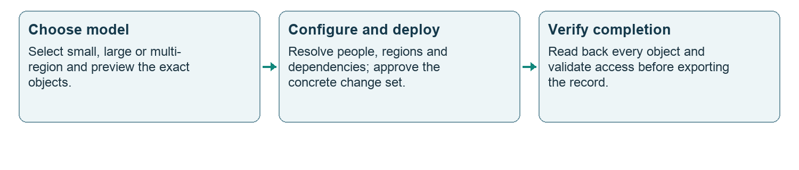
Figure 16. Requested complete browser workflow
Component | Current boundary to document
Groups and role policies | Blocked plans cannot run. Approval changes require a known count of at least two users in an existing approver group; customer operators remain separate
Entra role assignments and AUs | Verify scope IDs, eligible schedules and dynamic membership after deployment
Intune RBAC | Verify expanded role bindings, resolved permissions, groups and tags
Executive RMAU | Optional and not selected by default; population and tests remain deliberate steps
Azure | Optional groups; ARM role assignments and policies are separate
CA context, mailbox and reviews | External or manual dependencies remain; no automatic completion claim
Regional approval gate | Plain approver group is not automatically wired to the default templates
Backup and recovery | PIM policy backup is not a full tenant rollback

Completion criteria
Every planned object has an immutable ID and a recorded outcome. Every assignment has the correct principal, role, scope and schedule. Dynamic populations match intended users and devices. Approval, authentication, alerts and expiry behave as intended. Regional and executive operators pass both allowed-action and denied-action tests. Remaining items have an owner and are visible before handover.
Keep failed, skipped, pending and verified states distinct. A returned request or an aggregate success counter must not hide a pending schedule, unsupported permission, empty approver group or failed access test.

25 Customer decisions and source reference
Decision to record | Customer record
Selected model and optional components | Model ID; Azure option; RMAU option; approved deviations
Identity and approval ownership | Operator, owner and approver object IDs; approval rota
Tenant and communication | Tenant ID, verified domain, notification mailbox owner
Regional scope | Approved rows, attribute authority, device naming and scope populations
Deployment evidence | Run ID, baseline version, object IDs, policy readback and access tests
Operations and recovery | Review cadence, emergency access owner and recovery procedure

Use this reference before the PimBuddy Admin Handover. Attach the completed customer inventory and verification record to the handover; do not substitute catalog names for deployed object IDs.

Repository sources
Primary catalog: js/pimBaselineData.js. Effective profile resolution and region expansion: js/pimbaseline.js. Browser deployment and execution: js/pimdeploy.js and js/pimplan.js. Intune object planning: js/intunerbac.js. Application integration: js/app.js. Restricted unit workflow: js/pimrmau.js. Snapshot: build 32436 (framework 3.0), reviewed 5 October 2026. The model inventories and policy values were checked against the effective catalog. tools/pimdocs.test.cjs detects changes requiring a new documentation review.

Microsoft reference material
M1 Entra roles at administrative unit scope
https://learn.microsoft.com/en-us/entra/identity/role-based-access-control/manage-roles-portal
M2 Teams administrative units
https://learn.microsoft.com/en-us/microsoftteams/teams-administrative-units
M3 PIM for Groups
https://learn.microsoft.com/en-us/entra/id-governance/privileged-identity-management/concept-pim-for-groups
M4 Restricted management administrative units
https://learn.microsoft.com/en-us/entra/identity/role-based-access-control/admin-units-restricted-management
M5 Identity Governance licensing
https://learn.microsoft.com/en-us/entra/id-governance/licensing-fundamentals
M6 Microsoft Defender unified RBAC: custom roles and assignments to Microsoft Entra groups
https://learn.microsoft.com/en-us/defender-xdr/create-custom-rbac-roles
Reference review date: 2 October 2026. Tenant configuration, licensing and supported operations must be checked at implementation time.

