**Q2)**

**a-**

* Ig(gate current)
* Vgt(Gate voltage)
* reverse break down voltage(VDRM)
* rate current (mostly known as on-state current IT{RMS))
* rate rms voltage (V)
* **VTM: Maximum on-state or forward voltage**
* **VDRM: Maximum forward blocking voltage**
* **VRRM: Maximum reverse blocking voltage**
* **VRSM** – Non-repetitive peak reverse voltage
* **VDWM**– Crest working on state voltage, applied in the forward direction.

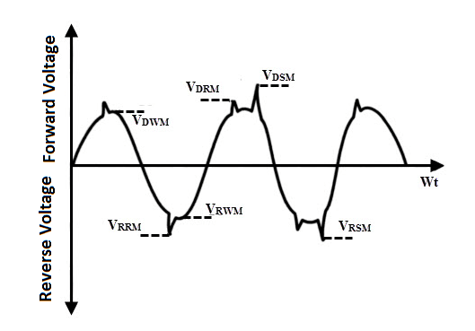

**Most important**: Ig(gate current), Vgt(Gate voltage), reverse break down voltage(VDRM), rate current (mostly known as on-state current IT{RMS)), rate rms voltage (V)

Links: <https://www.yourelectricalguide.com/2019/08/tyristor-scr-selection-tips-ratings-specifications-parameters.html>

<http://indopec.blogspot.com/2011/09/scr-parameters.html>