# ee odtu ile ilgili görsel sonucu

EE 463 STATIC POWER CONVERSION I

PROJECT #3

Students:

Nurettin Çavuş 2094878

Muhammed Barış 2030278

28.11.2019

# 1.Introduction

In our third project of Static Power Conversion-I course, we will investigate half-wave, full-wave and 3-phase full-wave rectifiers. We will try to understand active and reactive power concepts, investigate the effect of firing angle, active and reactive power transferred for different load types, how power will be transferred harmonicwise for various rectifier types and also with respect to change in firing angle. We will also simulate delta-wye connections to see how it affects harmonics of 3rd order. We will also observe active and reactive power transfer to the load side for various cases.

# 2.Q1

# a)

$$V\left(t\right)=V0+V1*cos⁡(w1*t)$$

$$I\left(t\right)=I0+I1*\cos\left(w1,t\right)+∑[i=1,∞)Ii*cos(wi*t)$$

There are two components from voltage and current formula that will create active power. These are DC components and first harmonics. Hence, P=PDC+PAC.

b)Simply putting a resistive component to the load will be enough. Resistors are elements that dissipates active power and voltage is always in-phase with its current. Hence, it will ensure non-zero active power. $II$

# 3.Q2

|  |  |  |  |  |
| --- | --- | --- | --- | --- |
|  | Active Power Supplied  (W) | Reactive Power Supplied  (VAR) | Active Power Loaded  (W) | Reactive Power Loaded  (VAR) |
| DC | 5*e-4 | 0 | 1062 | 0 |
| 1st Harmonic | 2632 | -2 | 1312 | 4*e-12 |
| 2nd Harmonic | 2*e-3 | 6*e-4 | 238 | 1*e-13 |
| 3rd Harmonic | 6*e-5 | 6*e-5 | 1*e-3 | -4*e-15 |
| 4th Harmonic | 1*e-3 | -2*e-4 | 9.5 | -1*e-14 |
| 5th Harmonic | 3*e-5 | 1*e-5 | 5*e-4 | -2*e-15 |
| 6th Harmonic | 1*e-3 | -2*e-4 | 1.7 | -5*e-16 |
| 7th Harmonic | 6*e-5 | -4*e-5 | 3*e-4 | -2*e-15 |
| 8th Harmonic | 9*e-4 | -1*e-4 | 0.5 | -3*e-16 |
| 9th Harmonic | 3*e-5 | -5*e-5 | 2*e-4 | -1*e-15 |
| TOTAL | ~ 2632 | ~ -2 | ~ 2623,7 | ~0 |

Table 1.Active and Reactive Power both in source and load side for “0” delay

.

i_ As it can be observed, active power hasn’t been conserved in harmonicwisely. Input is a sinusoidal and active power comes from first harmonic. However, all of this power is not reflected on the load with the same harmonic due to thyristor. Half-wave has been rectifified on the output. Hence, it is reasonable to model that signal as a combination of DC offset, a strong first harmonic and weaker higher order harmonics. Hence, some of 1st harmonic power is transferred to the output via DC or higher order harmonics.

ii_ Obiously,not. As we can see from the graph, input reactive power and output reactive power values are different. Although it is very little, there is a reactive power from source side that hasn’t been reflected on output.

b)

|  |  |  |  |  |
| --- | --- | --- | --- | --- |
|  | Active Power Supplied  (W) | Reactive Power Supplied  (VAR) | Active Power Loaded  (W) | Reactive Power Loaded  (VAR) |
| DC | -8*e-4 | 0 | 265.8 | 0 |
| 1st Harmonic | 1317 | 833.2 | 459.8 | 3*e-11 |
| 2nd Harmonic | 0.01 | 0.02 | 295.7 | 9*e-12 |
| 3rd Harmonic | -0.01 | -0.01 | 133.3 | 1*e-13 |
| 4th Harmonic | 0.01 | 3*e-3 | 40.3 | 2*e-12 |
| 5th Harmonic | 7*e-2 | 1*e-3 | 14.7 | 1*e-14 |
| 6th Harmonic | 6*e-3 | 4*e-3 | 16 | 1*e-12 |
| 7th Harmonic | 0.01 | 8*e-3 | 14.8 | 2*e-15 |
| 8th Harmonic | 7*e-3 | 2*e-4 | 8.7 | 1*e-12 |
| 9th Harmonic | 2*e-3 | 0.01 | 5.3 | 3*e-16 |
| TOTAL | ~1317 | ~833.2 | ~1254,4 | ~0 |

Table 2.Active and Reactive Power both in source and load side for 5ms delay

i_ In terms of total, active power is conserved.

ii_ Reactive power hasn’t been conserved from source to load. As seen from the table, there is an amount of 833VAR reactive power that hasn’t been reflected at the output. Since we applied a delay at gate signal, it created this amout of reactive power at source side. Although a voltage is applied at the input, it cannot create current value until the thyristor is fired. This causes some of the power to turn into reactive.

iii_ Reactive power isn’t conserved harmonicwise here. Vast amount of reactive power of 1st harmonic isn’t transferred to load side.

iv_ There is a loss in apparent power as well which results from reactive power loss.

v_ Actually, it has increased with vanishing reactive power.

c)

|  |  |  |  |  |
| --- | --- | --- | --- | --- |
|  | Active Power Supplied  (W) | Reactive Power Supplied  (VAR) | Active Power Loaded  (W) | Reactive Power Loaded  (VAR) |
| DC | -0,01 | 0 | 242,3 | 0 |
| 1st Harmonic | 994,6 | 1071 | 404,5 | 127 |
| 2nd Harmonic | -3*e-3 | 0,03 | 232,5 | 146 |
| 3rd Harmonic | -8*e-3 | -4*e-3 | 81,6 | 77 |
| 4th Harmonic | 3*e-3 | 4*e-3 | 13,4 | 17 |
| 5th Harmonic | 2*e-3 | 4*e-3 | 3,3 | 5,2 |
| 6th Harmonic | 2*e-3 | 0,01 | 5,4 | 10,1 |
| 7th Harmonic | 1*e-3 | -3*e-3 | 2,8 | 6,3 |
| 8th Harmonic | 6*e-3 | 5*e-3 | 0,57 | 1,5 |
| 9th Harmonic | 2*e-3 | 4*e-3 | 0,77 | 2,2 |
| TOTAL | ~ 994,6 | ~1071 | ~987,1 | ~392,3 |

Table 3.Active and Reactive Power both in source and load side for 5ms dealy and 10mH Inductance

i_ We have introduced an inductor to the circuit which will cause reactive power at the output. Power factor is higher at the output side than input side since all of the reactive power hasn’t been transferred to the output.

ii_ It is approximately 0.68.

$$PF=P/\sqrt{P^{2}+Q^{2}}$$

iii_ Load power factor is 0.92. It can be seen that power factor is higher at the load side.

# 4.Q3

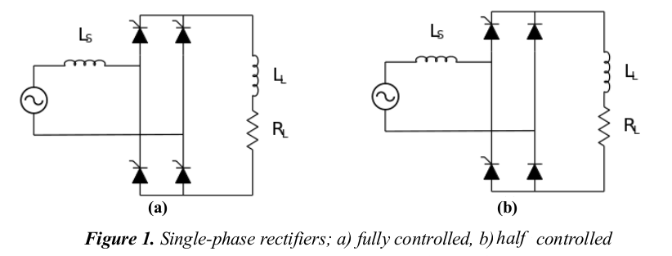

Figure 1. a) Controlled full bridge rectifier b) Half controlled full wave bridge rectifier

1. Both topologies have thyristor that mean output voltage of the rectifier can be controlled by us. Figure X. a) controlled rectifier can be seen. Control of the output voltage is better in this topology. Figure x. b) half-controlled rectifier can be seen. Voltage can be still controlled in this topology but thanks to two diode the output voltage can not be negative values that give us the higher output voltage for firing angle.

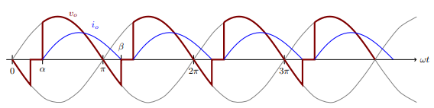

Figure 2. Waveform of Vout and Iout for Controlled rectifier

Commutation is negligible in this rectifier because the resistance and inductance values give us a very short commutation time (10^-6 sec). So, our calculations to obtain firing angle α for controlled full-wave bridge rectifier is given below:

Id avg = 30 ampere for this calculation.

$${Id}_{avg}= \frac{1}{π}\int_{α}^{π+α}{Id\left(wt\right)dwt}$$

$$I_{avg}= \frac{Ai}{π}=30 Ampere$$

$$Vl=L\frac{di}{dt} \\ Vldwt=Lwdİ \\ Vs\left(wt\right)-Ri\left(wt\right)=Lwdi \\ \int_{α}^{π+α}{Vs\left(wt\right)dwt}=\int_{α}^{π+α}{Ri\left(wt\right)dwt} \\ \int_{α}^{π+α}{Vs\left(wt\right)dwt}=150π$$

$$150π=230\sqrt{2} (cosα-cos⁡(π+α) \\ 460\sqrt{2 } cosα= 150π \\ cosα=\frac{150π}{460\sqrt{2}} \\ α=43.5 °$$

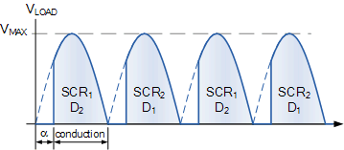

Figure 3. Waveform of Vout for Half Controlled rectifier.

Commutation is also negligible in this topology because we use the same resistance and inductance values in this part too. Commutation time is close to 10^-6 sec. So, our calculations to obtain firing angle α for controlled full-wave bridge rectifier is given below:

$${Id}_{avg}= \frac{1}{π}\int_{α}^{π+α}{Id\left(wt\right)dwt}$$

$$I_{avg}= \frac{Ai}{π}=30 Ampere$$

$$Vl=L\frac{di}{dt} \\ Vldwt=Lwdİ \\ Vs\left(wt\right)-Ri\left(wt\right)=Lwdi \\ \int_{α}^{π}{Vs\left(wt\right)dwt}=\int_{α}^{π+α}{Ri\left(wt\right)dwt} \\ \int_{α}^{π}{Vs\left(wt\right)dwt}=150π \\ 230\sqrt{2}\left(1+cosα\right)=150π \\ 1+cosα=\frac{150π}{230\sqrt{2}} \\ cosα=\frac{150π}{230\sqrt{2}}-1 \\ cosα=63.33°$$

1. Vs and Is was plotted on the Simulink.
2. Full Controlled Rectifier

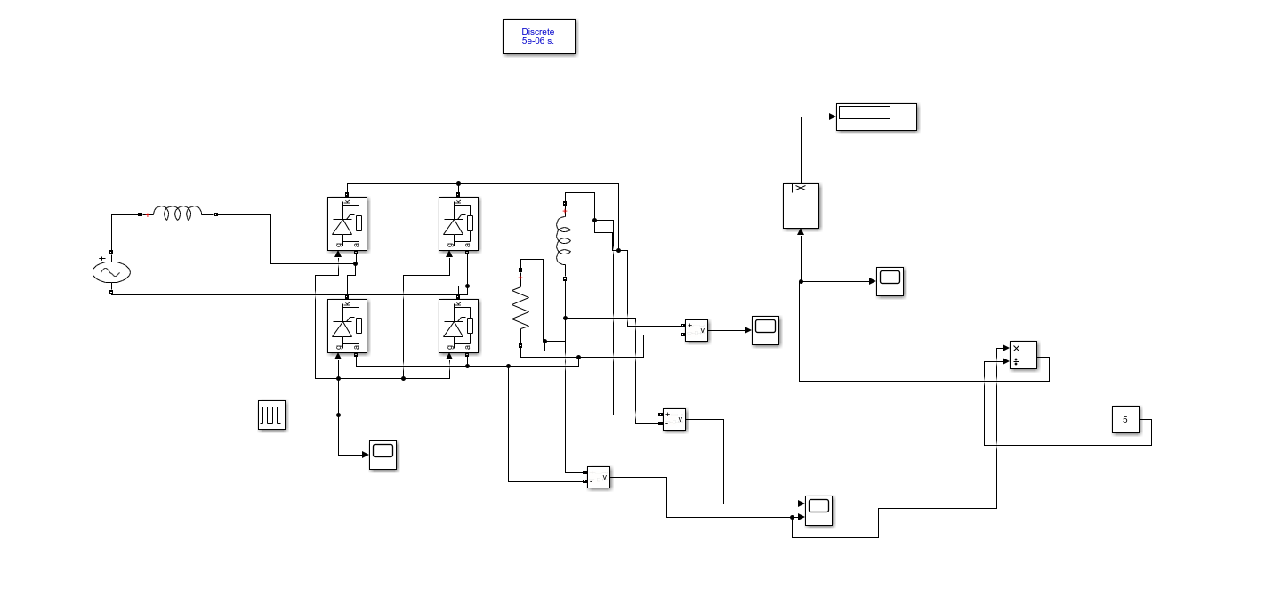

Figure 4. Circuit design of the Full Controlled Rectifier on Simulink

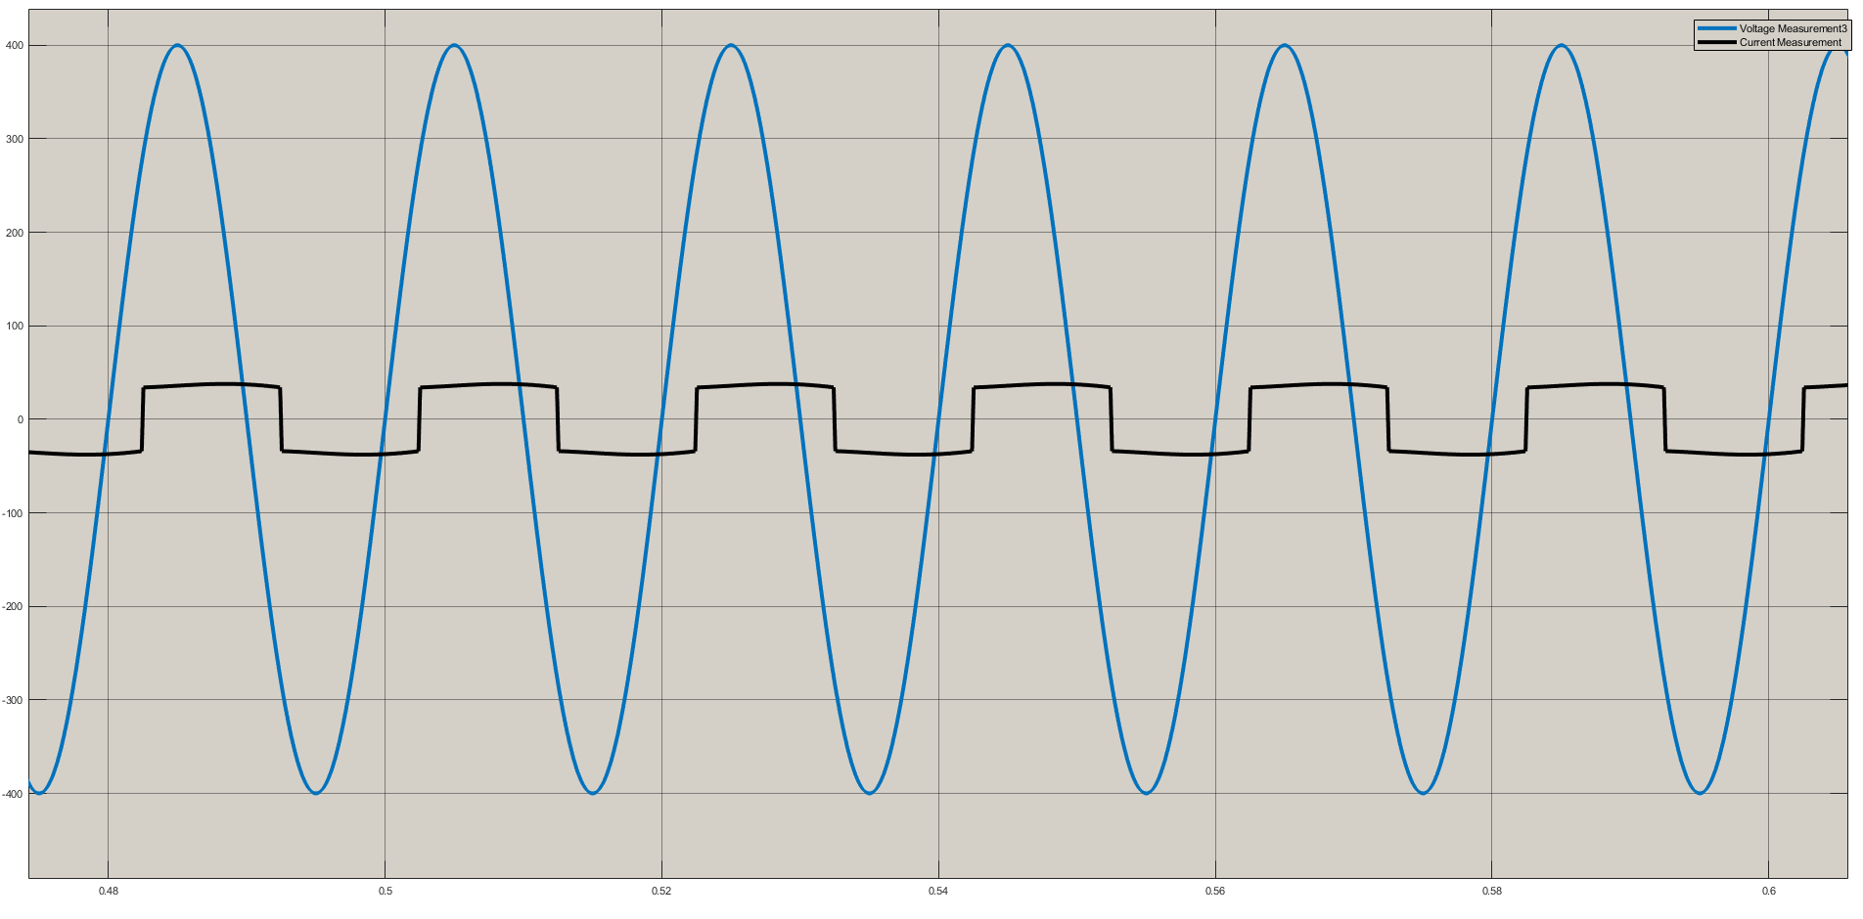

Figure 5 . Input voltage and Input current form of Full Controlled Rectifier(a=43.3).

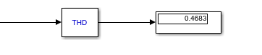

Figure 6. THD of Is ( Full Controlled Rectifier)

1. Half Controlled Rectifier

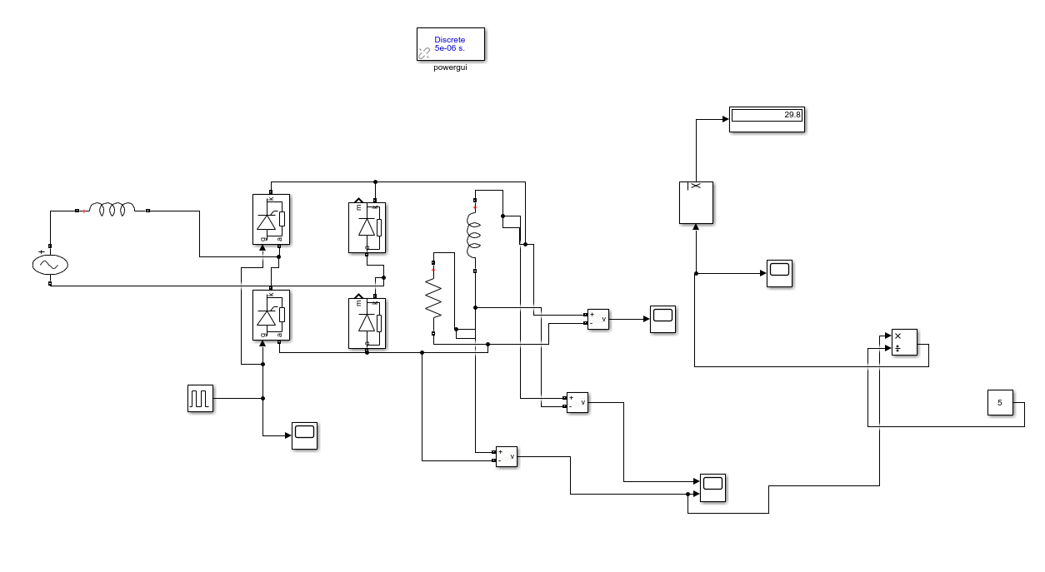

Figure 7 . Circuit design of the Half Controlled Rectifier on Simulink.

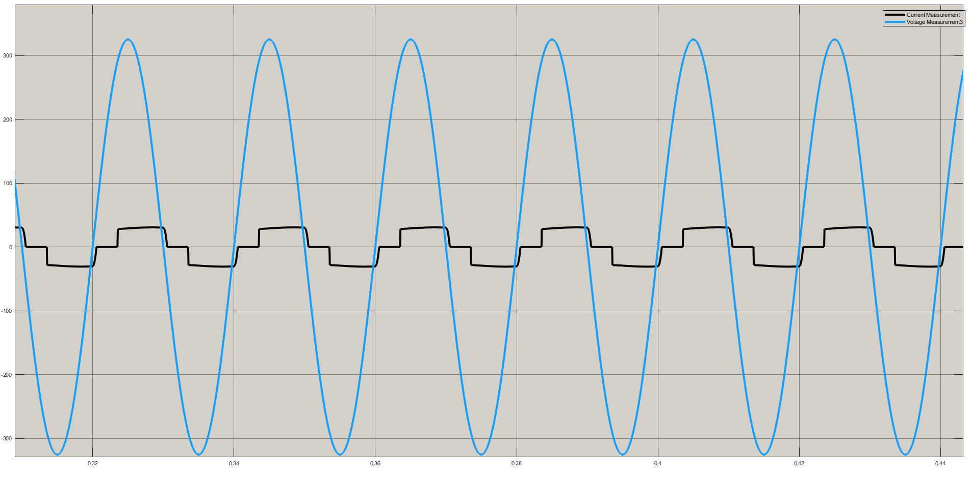

Figure 8. Input voltage and Input current form of Half Controlled Rectifier(a=63.3).

# 

Figure 9. THD of Is (Half Controlled Rectifier)

c) First topology is the controlled full wave bridge rectifier. In this topology our output voltage can be negative. That mean our peak to peak voltage difference is high. We could get a waveform which is less DC. We can use that topology if we need control our system more sensitive. We can control better. But average output voltage is lower cause of negative cycle of V out.

Second topology is the half controlled full wave bridge rectifier. Output voltage cannot be negative. So peak to peak voltage is lower than full controlled FWBR. This topology has higher average output voltage. But the control of the rectifier work with only two thyristors so the control of the FWBR is different than full controlled one. If we need to use more average voltage and we also want to control the output voltage, we should use that topology.

# 5.Q4

a) Name of the topology is twelve pulse generator. The main principle is this topology is generating 12 peaks in one period. To obtain 12 pulse in one period we need 30 degrees phase shifts between each peak. To achieve 30 degrees phase shift we are using delta-wye or wye-delta transformers. In this question delta-wye transformer give us three phase 30 degree shifted waveform so output of the rectifier have 12 pulse in one period.

We can use directly 6 phase voltage sources for this application.6 phase voltage source with full wave bridge rectifier. We need 6 phase voltage source for that.In question we used delta-wye, wye-delta transformer can also be used to obtain 12 pulse generator.

Application area of the 12-pulse generator rectifier

-More Electric Aircraft Applications

-More Average voltage required

-More DC voltage required

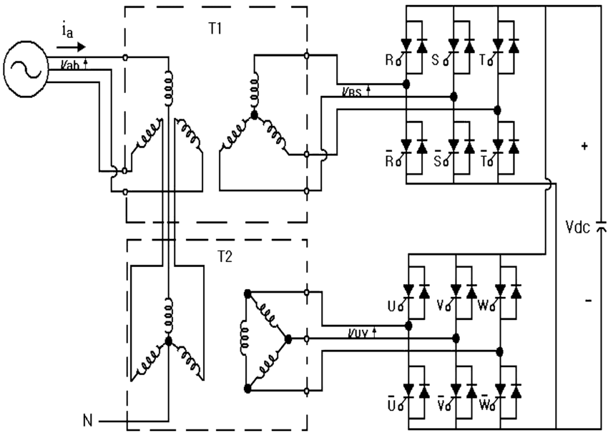

Figure 10. Wye-Delta Transformer used 12 Pulse Rectifier.

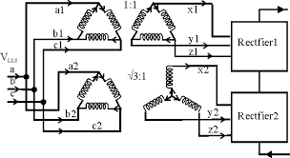

Figure 11. Delta-Wye Transformer used 12 Pulse Rectifier.

b)

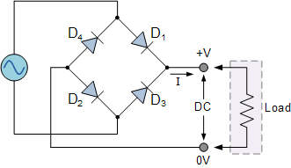

Figure 12. Circuit Schematic of Full Bridge Diode Rectifier .

1. 12 Pulse generator rectifier Vina= 81.65 sin (wt) V

Vinb= 81.65 sin (wt+120) V

Vinc= 81.65 sin (wt-120) V

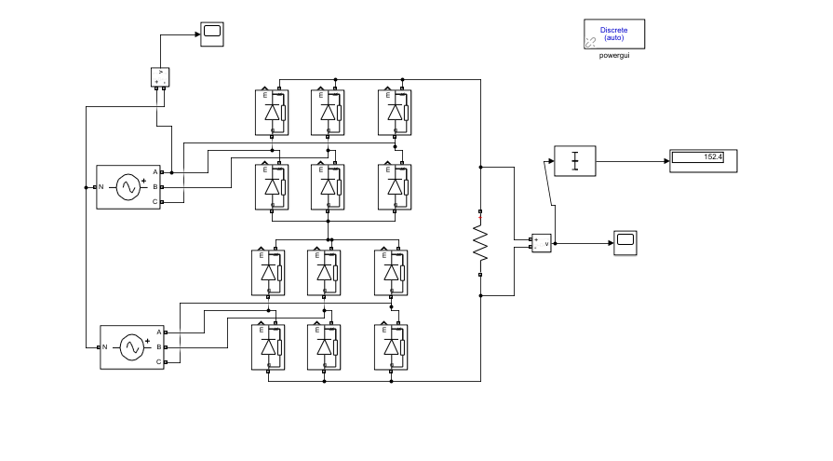

Figure 13 . 12 pulse generator to obtain 152.4 average output voltage

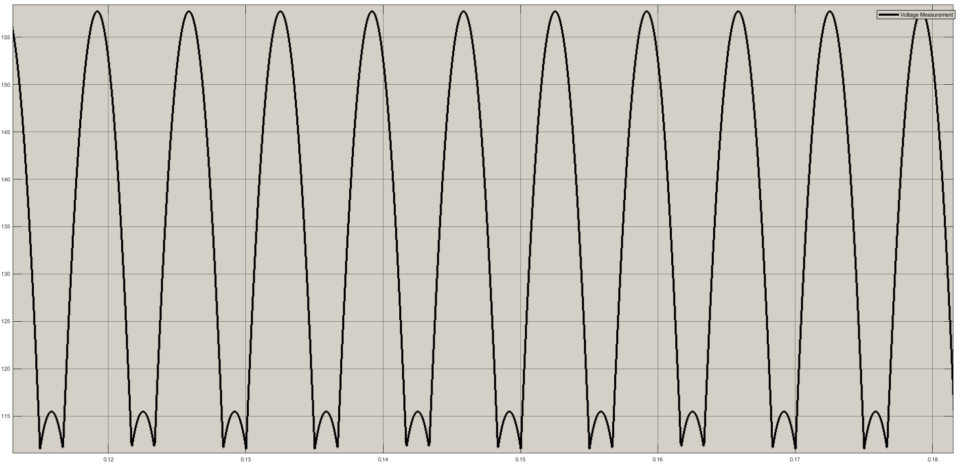

Figure 14. Output waveform of the 12-pulse generator

ii)Full Bridge Diode Rectifier Vin=239.4

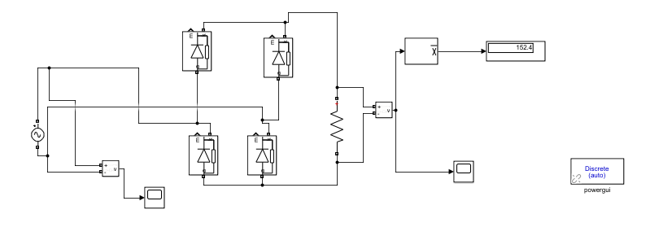

Figure 15. Full Bridge Diode Rectifier to obtain 152.4 average output voltage.

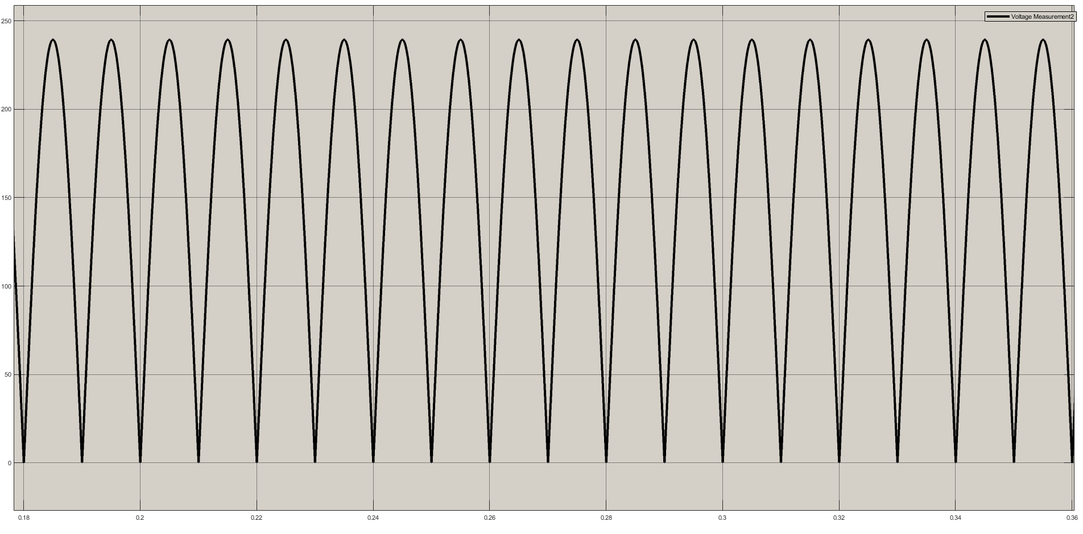

Figure 16. Output voltage waveform of the Full Bridge Diode Rectifier.

As seen from average output voltage to input voltage ratios from the simulations 12 pulse generator have higher ratio. We can observe that average output voltages from Vout graphs.12 pulse generator output voltage cannot be 0. Peak to peak voltage difference of 12 pulse generator is smaller than FBDR’s. Smaller peak to peak – peak ratio gives us the higher average voltage. As seen from simulation results Vin peak = 81.65 Volt for 12 pulse generator to obtain Vavg=152.4 but VinFBDR=239.6 Volt. Three times higher voltage is required.

## REFERENCES

<https://www.electronics-tutorials.ws/diode/diode_6.html>