# ee odtu ile ilgili görsel sonucu

EE 463 STATIC POWER CONVERSION I

PROJECT #3

Students:

Nurettin Çavuş 2094878

Muhammed Barış

28.11.2019

# 1.Introduction

# 2.Q1

# 3.Q2

# 4.Q3

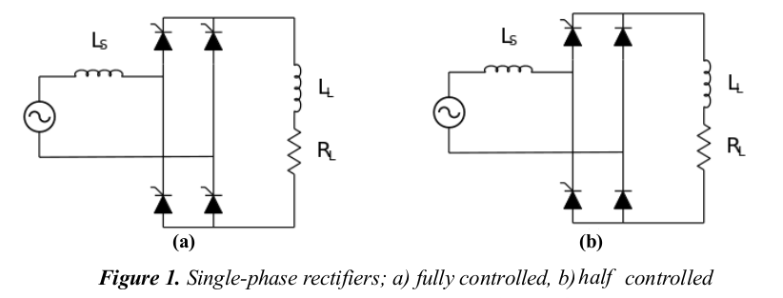

Figure x. a) Controlled full bridge rectifier b)Half controlled full wave bridge rectifier

1. Both topologies have thyristor that mean output voltage of the rectifier can be controlled by us. Figure X. a) controlled rectifier can be seen. Control of the output voltage is better in this topology. Figure x. b) half-controlled rectifier can be seen. Voltage can be still controlled in this topology but thanks to two diode the output voltage can not be negative values that give us the higher output voltage for firing angle .

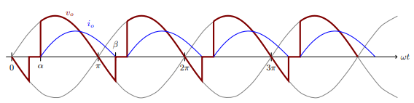

Figure X. Waveform of Vout and Iout for Controlled rectifier

Commutation is negligible in this rectifier because the resistance and inductance values give us a very short commutation time (10^-6 sec). So, our calculations to obtain firing angle α for controlled full-wave bridge rectifier is given below:

Id avg = 30 ampere for this calculation.

$${Id}_{avg}= \frac{1}{π}\int_{α}^{π+α}{Id\left(wt\right)dwt}$$

$$I_{avg}= \frac{Ai}{π}=30 Ampere$$

$$Vl=L\frac{di}{dt} \\ Vldwt=Lwdİ \\ Vs\left(wt\right)-Ri\left(wt\right)=Lwdi \\ \int_{α}^{π+α}{Vs\left(wt\right)dwt}=\int_{α}^{π+α}{Ri\left(wt\right)dwt} \\ \int_{α}^{π+α}{Vs\left(wt\right)dwt}=150π$$

$$150π=230\sqrt{2} (cosα-cos⁡(π+α) \\ 460\sqrt{2 } cosα= 150π \\ cosα=\frac{150π}{460\sqrt{2}} \\ α=43.5 °$$

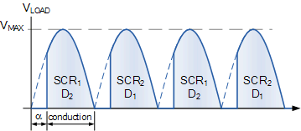

Figure x. Waveform of Vout for Half Controlled rectifier.

Commutation is also negligible in this topology because we use the same resistance and inductance values in this part too. Commutation time is close to 10^-6 sec. So, our calculations to obtain firing angle α for controlled full-wave bridge rectifier is given below:

$${Id}_{avg}= \frac{1}{π}\int_{α}^{π+α}{Id\left(wt\right)dwt}$$

$$I_{avg}= \frac{Ai}{π}=30 Ampere$$

$$Vl=L\frac{di}{dt} \\ Vldwt=Lwdİ \\ Vs\left(wt\right)-Ri\left(wt\right)=Lwdi \\ \int_{α}^{π}{Vs\left(wt\right)dwt}=\int_{α}^{π+α}{Ri\left(wt\right)dwt} \\ \int_{α}^{π}{Vs\left(wt\right)dwt}=150π \\ 230\sqrt{2}\left(1+cosα\right)=150π \\ 1+cosα=\frac{150π}{230\sqrt{2}} \\ cosα=\frac{150π}{230\sqrt{2}}-1 \\ cosα=63.33°$$

1. Vs and Is was plotted on the Simulink.
2. Full Controlled Rectifier

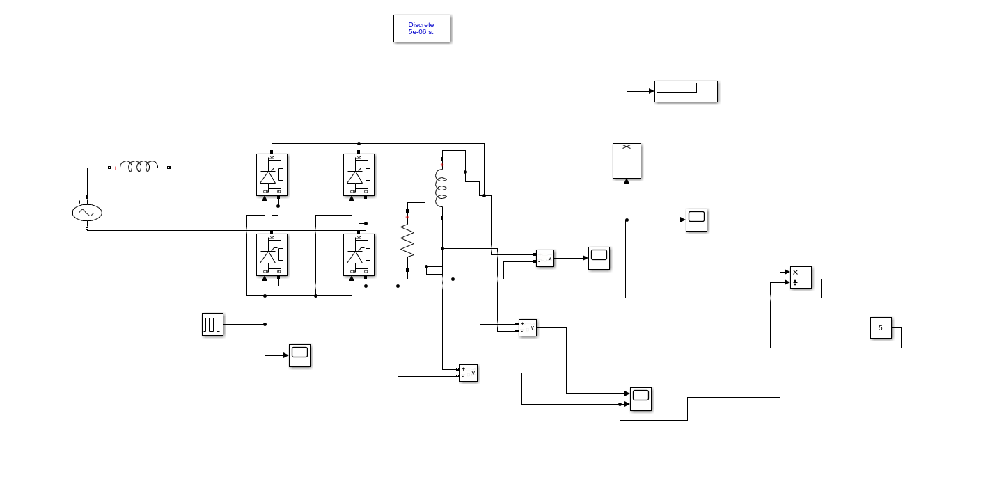

Figure x. Circuit design of the Full Controlled Rectifier on Simulink

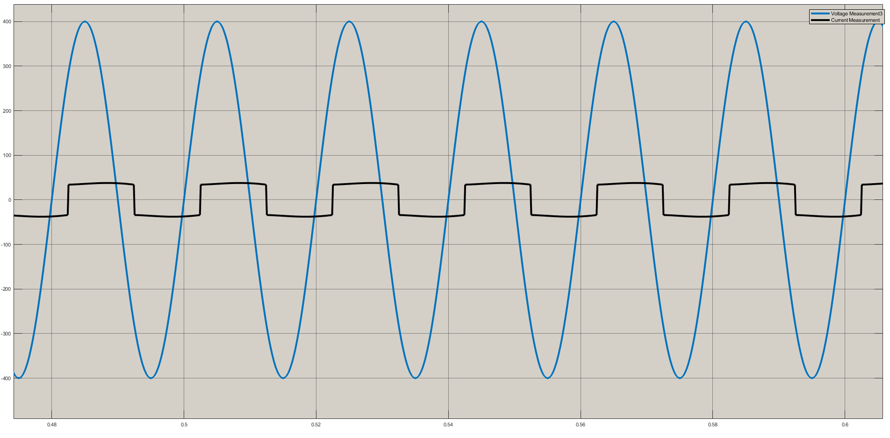

Figure x . Input voltage and Input current form of Full Controlled Rectifier.

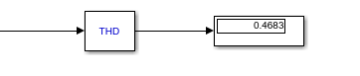

Figure X. THD of Is ( Full Controlled Rectifier)

1. Half Controlled Rectifier

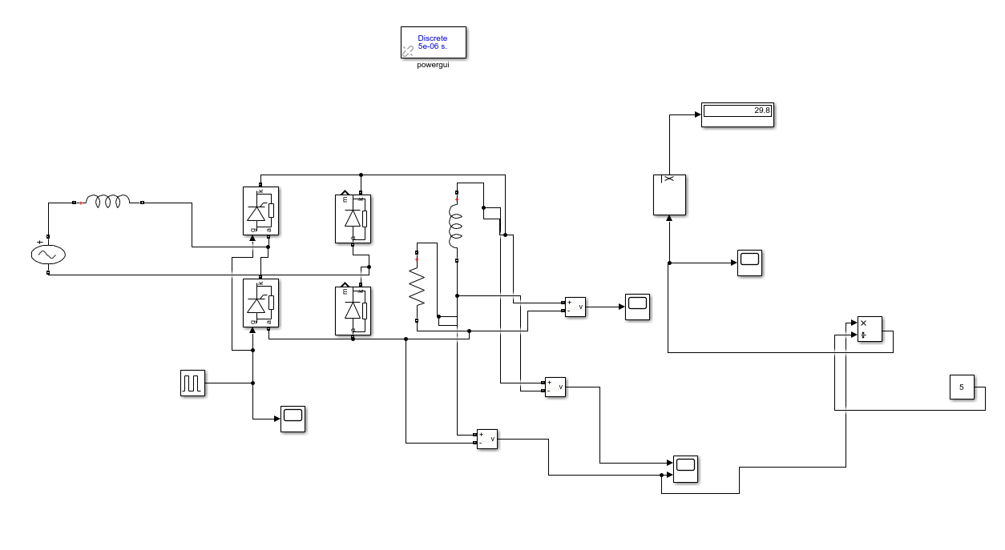

Figure x . Circuit design of the Half Controlled Rectifier on Simulink.

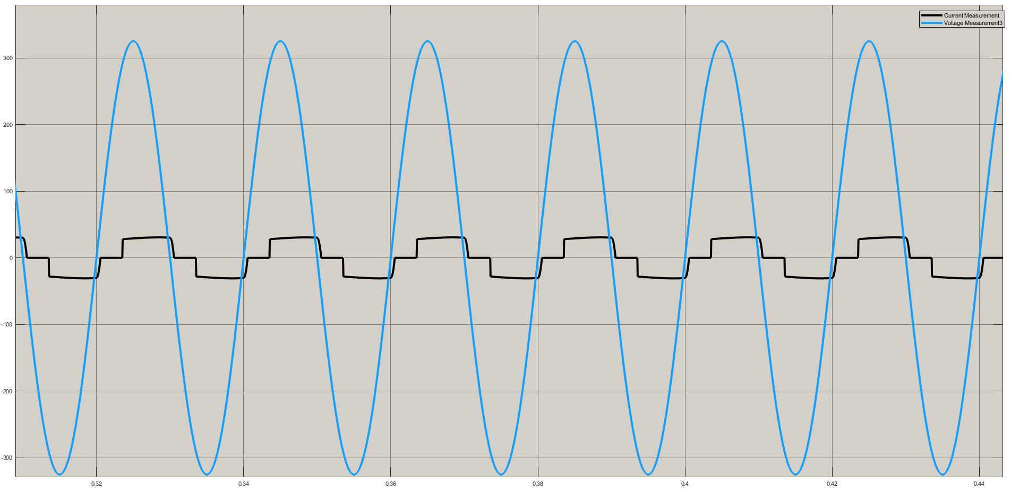

Figure x. Input voltage and Input current form of Half Controlled Rectifier.

# 

Figure x. THD of Is (Half Controlled Rectifier)

c) First topology is the controlled full wave bridge rectifier. In this topology our output voltage can be negative. That mean our peak to peak voltage difference is high. We could get a waveform which is less DC. We can use that topology if we need control our system more sensitive. We can control better. But average output voltage is lower cause of negative cycle of V out.

Second topology is the half controlled full wave bridge rectifier. Output voltage cannot be negative. So peak to peak voltage is lower than full controlled FWBR. This topology has higher average output voltage. But the control of the rectifier work with only two thyristors so the control of the FWBR is different than full controlled one. If we need to use more average voltage and we also want to control the output voltage, we should use that topology.

# 5.Q4

a) Name of the topology is twelve pulse generator. The main principle is this topology is generating 12 peak in one period. To obtain 12 pulse in one period we need 30 degrees phase shifts between each peak. To achieve 30 degrees phase shift we are using delta-wye or wye-delta transformers. In this question delta-wye transformer give us three phase 30 degree shifted waveform so output of the rectifier have 12 pulse in one period.

We can use directly 6 phase voltage source for this application.6 phase voltage source with full wave bridge rectifier.

# 6.Conclusion