

**Assignment 1**

Subject : Technology and Information System (SECP1513)

Session : 202420251

Task : POSTER on INDUSTRY TALK 1

Title : Overview of ICT Jobs in Industry

Due Date : 10 January 2025

Submission : **TEAM** representative

a. upload softcopy poster (in pdf format) via e-learning; and

b. upload softcopy poster (in jpg format) via GitHub.

## Instruction:

1. Each team are required to prepare **ONE** poster on Industry Talk 1.
2. The poster should include an executive summary, introduction, content based on the issues discussed in the talk, and reflection (each student) (see rubric of poster).
3. The poster will contribute **7%** of the course assessment.
4. Size of poster is of **A4** size. You may include diagram in your poster.

Note: the most important content of your poster, is your own opinion and views.

1. Every team should design the poster using your own creativity.
2. Every team should write the poster content using your own words.
3. At the bottom of the poster, include the names, matric card and photos of your group member.
4. PLAGIARISM of the content is prohibited. If any of the content is known to be copied from other website/review/blogs, you will be given 0 mark.
5. You can get photos/information from other resources, but you must include credits (in citation/link) to the original owners.
6. Industry Talk
   1. RunCloud Talk as shows in Figure 1.
   2. CelcomDigi Talk as shows in Figure 2.

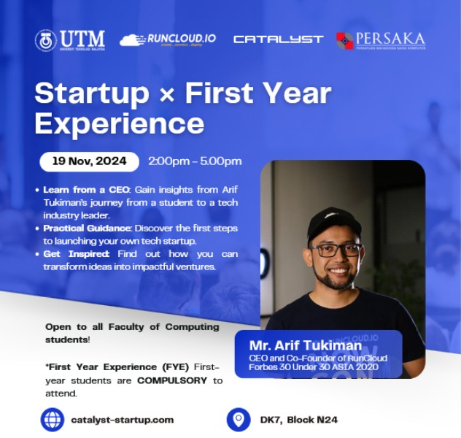

Figure 1: RunCloud

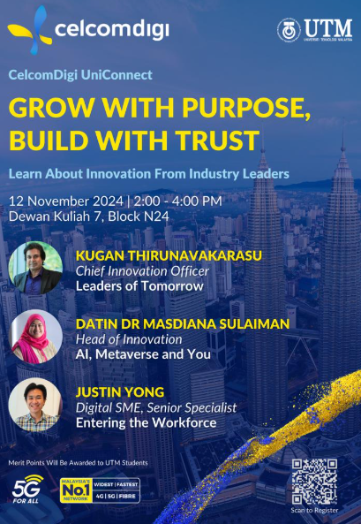

Figure 2: CelcomDigi

**Rubric for poster**

|  |  |  |  |  |  |
| --- | --- | --- | --- | --- | --- |
| **Criteria** | **Excellent**  **10-7** | **Fair**  **6-4** | **Poor**  **3-0** | **WEIGHTAGE** | **MARKS** |
| **Informative and Attractive** | * Provide accurate and complete information (content). * All required information is presented in a logical order. | * Some information (content) is incomplete, inaccurate, but presented in a logical order. * Very few required information are missing and presented in a logical order. | * Most Information (content) are incomplete, inaccurate, or not presented in a logical order, making it difficult to follow. * Most required information are missing and not presented in a logical order, making it difficult to follow. | 10 | ____ X 10  10 |
| **Contents** | Report contents: Executive Summary, Introduction, Content of Talk, Reflection etc. | | | 20 | ____ X 20  10 |
| * All contents included | * Included but not well covered | * Included but poorly covered |
| **Content Poster**   * **Presentation** * **Graphic** | * Very good presentation of content poster and well organized. * Use many graphics, pictures. | * Moderate presentation of content poster and well organized * Use moderate graphics, pictures. | * Lack of content poster and not organized properly. * Use inappropriate graphics or pictures. | 10 | ____ X 10  10 |
| **Reflection** | What is the motivation/insights/information did you gain from this career talk on how the jobs in Information Communication Technology (ICT) is essential to play a meaningful role in industry? | | | 30 | ____ X 30  10 |
| * Excellent explanation of point 1 and 2. | * Fair explanation of point 1 and 2. | * Poor explanation of point 1 and 2. |
| **Design**   * **Creativity** * **Color Harmony** | * Excellent design with high creativity. * Presentation looks neat, professional and well- organized. * Images, pictures, and clip art and drawn artwork are mostly colorful and appropriate. * The layout is very creative. | * Moderate design with some creativity. * Presentation looks fairly, but follows the formatting rules. * Images, pictures, and clip art and drawn artwork are colorful. * Layout shows some degree of creativity but is not organized logically and/or is cluttered. | * Design with lack of creativity. * Presentation looks untidy but violates some formatting rules. * Colors are inappropriate and artwork shows little creativity. * The layout is messy, disorganized or cluttered. | 10 | ____ X 10  10 |
| **Organisation and Structure** | * Structure of poster is interesting and organised very well, easy to understand. | * Structure of poster is quite interesting and organised. | * Most parts of the structure of poster are not really interesting and unorganised. | 10 | ____ X 10  10 |
| **Text** | * All text is easy to read. * Use appropriate font size. * Use not more than three different font styles. | * Most text is easy to read. * Use appropriate font size. * Use more than three different font styles. | * Some texts are difficult to read. * Use medium font size. * Use more than four different font styles. | 5 | ____ X 5  10 |
| **Submission** | * Submit on time | * Submit one day late | * Submit more than one day late | 5 | ____ X 5  10 |
|  | | |  | Total | / 100 |