# Table of Contents

Table of Contents 2

Table of Figures **Error! Bookmark not defined.**

Abstract 3

1. Introduction 3

1.1. Background 4

1.2. Aims and Objectives 6

1.3. Research Questions 8

1.4. Ethical Consideration 9

1.5. Project Timeline 9

1.6. Skills Audit 10

2. Methodology 11

2.1. Literature Review Methodology **Error! Bookmark not defined.**

2.2. Design Methodology **Error! Bookmark not defined.**

2.3. Theoretical Background **Error! Bookmark not defined.**

2.4. Evaluation of the Prototype 13

3. Literature Review 14

3.1 Student’s Behaviour 14

3.2 Student’s Retention and Attrition 15

3.3 Improving Student Infrastructure and Student Services 15

3.4 Student Feedback and Survey Analysis 15

4. Conclusion 15

5. References **Error! Bookmark not defined.**

6. Appendices 18

7. Glossary **Error! Bookmark not defined.**

# Abstract

Our project is shaped as an E-learning platform, which provides user a smooth friendly learning environment through which user can ease itself and have a healthy learning phase. It is more precisely explained as here during some regular based study plans in which all sort of students having different capabilities and capacities have to go with the planned schedule, which makes hard for some students to serve themselves with sufficient learning and it makes bad impact on their studies and results so as for this purpose we developed this E-learning platform which included flexible study plans, so one can choose which is feasible for them to come over with healthy learning. It will surely enhance the learning and teaching quality because we believe in quality not in quantity. We also required some professional skilled individuals which guide users to choose or create their study plan.

# 1. [Introduction](https://learn.solent.ac.uk/mod/book/tool/print/index.php?id=2744#ch1292)

From the beginning all educational institutions facing many challenges which have been over coming using modern techniques and solutions, as modern problems required modern solutions. It is not an issue to enhance learning and teaching methodologies but as far as time passes we have to perform some unique inventions through which we can ease ourselves. submissions of the assignments and getting favour related to these activities, By keeping this view in our eye we invented and E learning platform though which one can perform their study actions smoothly its provides different plans which are sufficiently flexible and healthy to be adopted this attempt would be surely helpful in field of education, ,(association eLearning April. 2015) its main theme is to make easy and approachable for the candidates to do their assignments and homework by the help of electronic platform, the learning the board framework attempts to conquer the obstructions and impersonations which have happened in customary framework which remembers accessibility of class information whenever for instance of missing the class, not understanding the ideas by taking the class for the absolute first time as you can get to the meetings whenever. This feature of attempting the assignments and home works is prioritised, some new tools and helping material would be added in this platform which help out for solving the assignments in better way, it also delivers some job opportunities related to the field of education, as per our requirement we need to hire some professionals which guide and help users to set the study plan and have healthy learning environment, from previous educational record it was very hard to take all the students on same page because everyone has its different learning capabilities, some have sharp minded but weak moral as some have strong commitments but weak in their understandings , so it provides individual a separate learning platform which has set to its own seeking capacities , this issue was not as easy to overcome from the previous methodologies which hurt the students learning phases which are not as strong as study plan is .Through this platform ones can easily evaluate itself, evaluation would be very helpful , it is the measurement of our learning and knowledge gained which provides analysis of our progress

## 1.1. [Background](https://learn.solent.ac.uk/mod/book/tool/print/index.php?id=2744#ch1293)

It goes without saying that modern LMS draw inspiration from a lot of yesteryear’s inventions and innovations. I will be looking at the key milestones in the history of the LMS and give instances of machines/tools which have directly impacted the way LMSs work today.

First developed by Sidney L. Pressey in the 1920s, the teaching machine offered various kinds of practical exercises and multiple-choice questions (MCQs). Resembling a typewriter, the teaching machine required learners to drill in answers instead of typing them out, which would be recorded at the back of the machine. The learner could only advance if their response to the previous question was correct—a feature most of the modern LMSs still use.

Milton Ezra LeZerte in1929 created the problem cylinder, a device which provided instruction without the need for an instructor’s intervention. One of the great features of the problem cylinder was that it not only tested learners’ knowledge with MCQs, but also checked their responses—whether right or wrong, thereby saving the instructor’s time.

In 1953, the University of Houston, USA, televised the first for-credit college course for people to learn right from the comfort of their homes. Video lectures/lessons were aired every evening so that everyone—including full-time workers—could benefit from the lessons, ensuring that learning was not compromised because of work commitments.

SAKI, in a way, was the first machine to offer learning that felt mildly personal. Short for Self-Adaptive Keyboard Instructor, SAKI was pioneered by Gordon Pask and McKinnon Wood in the year 1956. It offered personalized practice questions based on the learner’s performance. As their performance improved over time, SAKI would ‘learn’ and increase the complexity of subsequent questions.

The next big thing was the invention of PLATO (Programmed Logic for Automatic Teaching Operation) by Dr. Donald Bitzer in 1960. PLATO was a computer-based training program which facilitated self-paced learning, allowing learners to monitor their own learning progress. However, what set PLATO apart was that it gave the learning community its first taste of social/collaborative learning. Thanks to its host of networks, learners could interact with other learners using instant chat/messaging, email, and chat rooms.

The HP-9100A, Hewlett-Packard’s first calculator, arrived on the scene in 1968, packed with never-before seen computational abilities. , (Plat core April. 2020) It could process and solve engineering problems 10 times faster than existing machines. The HP-9100 quite literally laid the foundation for the way connections are established today via the Internet, and essentially paved the road for the everyday use of LMS.

Almost a forerunner to the LMS, MIT’s Project Athena in 1983attempted to extend the use of computer machines beyond the fields of general science and engineering. At its core, Project Athena created a distributed computing environment by setting up workstations. In other words, Project Athena made it possible for learners and instructors to access their files from any workstation/desktop computer available on the MIT campus.

In 2000, the world was introduced to the first open-source LMS: Moodle, short for Modular Object-Oriented Dynamic Learning Environment. With Moodle, learners could start learning as soon as they downloaded the application onto their desktop computers. Personalized learning was made possible by letting learners pick the content they wished to store or export. Moodle’s plug-and-play functionality meant that training content could be delivered to the learner/s faster and at a lower price.

SCORM (Sharable Content Object Reference Model) was introduced in 2004, a messaging standard which specified parameters on content packaging and metadata—a staple feature of today’s LMS.

Experience API aka xAPI, an eLearning specification was developed in 2010 as a successor to SCORM. xAPI allowed “learning content and learning systems to speak to each other in a manner that records and tracks all types of learning experiences.”

Educational system have worked enough to overcome this major issue to make learning environment friendly but this methodology is far better than the previous. Many techniques have developed to enhance learning and teaching method, some old technologies were not enough beneficial which didn’t include versatile study plans flexibility, those were alike this, not offering jobs opportunities as we need to hire some professionals.

There are also others software’s available like Moodle which is providing E-Leering facility to the learners but there are some enhanced features used in our LMS which includes direct communication with teachers and remarks or reviews on quizzes , assignments and projects , which features are not available in other running software’s. The teacher can also view the history of the class anytime he/she needs to see, which includes the total number of students there personal history, attendance, quizzes assignments, projects records and their reports.

## 1.2. [Aims and Objectives](https://learn.solent.ac.uk/mod/book/tool/print/index.php?id=2744#ch1293)

The aim of this project is to design and develop a system to support the enhancement of student experience using E learning platform

The above aim raises the following objectives:

* Create electronic based platform which facilitate the candidates to adopt their assignments
* The main aim of this project is that you can communicate, take a class, and have a meeting directly with your teacher.
* The teacher can see the record of his/her created class at any time he/she wants i.e. the informative data, test records, attendance records, assignments records, quiz records etc.
* Our theme aimed to make submissions of Home-works, assignments and projects easy for the students.
* Another major point is that an assignment will be provided on this learning management system which have to be download by the student and submit after completion. The teacher will upload the relative marks and reviews after checking the assignments.
* The learning management system tries to overcome the barriers and imitations which have occurred in traditional system which includes availability of class data at any time in case of missing the class, not understanding the concepts by taking the class for the very first time as you can access the sessions anytime.
* Infections can possibly ruin information, take touchy data, and unleash devastation on your LMS UX. Learning Management Systems outfitted with against infection programming help shield your client information and eLearning content from the most widely recognized virtual dangers. They may likewise have an underlying infection checker with the goal that you can physically examine the framework intermittently.
* At the point when clients sign in to the LMS, their usernames and passwords are communicated to a far off access worker as an across the board document. There may likewise be different conventions required to guarantee that solitary approved clients can get to the information. For instance, online students are simply ready to make an endeavour multiple times before the framework locks them out. This assists with keeping programmers or other threatening destinations from speculating the secret key. At times, clients should type in a code or showed brief to demonstrate they aren't a bot.
* The framework consequently backs up your information and permits you to physically save the most current form of your eLearning content. In that capacity, if your information is ruined by malware or is unintentionally deleted under any circumstance, your information is as yet secure. Remember that reinforcement conventions, (talented learning March. 2020) differ dependent on the LMS merchant. For instance, some may lead daily reinforcements and store the data to a circulated stockpiling administration, while others have committed workers of their own.
* It also do favour in performing multidimensional home works and getting their marks regarding to the performance
* A versatile E learning platform which includes huge variety of study plans, study material and as well different study methodologies
* Our aim to improve the study quality as we are focusing on improvement of quality
* An analyser through which an individual can perform analysis actions to measure its study performance
* Evaluation of learning progress is also be taken as prime segment during the development of this platform ,ones can evaluate its learning period and can perform necessary actions to enhance its plan
* Being Comprehension is on our majors while invented this time saving and efficient learning and teaching platform

## 1.3. Research Questions

As part of this project proposal the following research questions needs to be addressed:

RQ1: How this platform will help users to make their study plans easy and smooth?

RQ2: Does it contains different study schedules for the students having different learning capabilities?

RQ3: Does this platform need a skilled professional person to help users as their guide?

RQ4: What are the fundamental assessment highlights of the LMS on-line system?

RQ5: What is the viability of utilizing Leering Management System?

## 1.4. Ethical Consideration

We make it sure that no harm and religious material is used while developing this platform. Ethical codes have been reviewed for this project

Ethical considerations will be taken care of.

* Data and study material is finely un religious and un harmed
* Any type of communication in relation to the research will be dealt with transparency.
* Acknowledgement of all data and information contained by this learning platform.

**1.5 Project timeline**

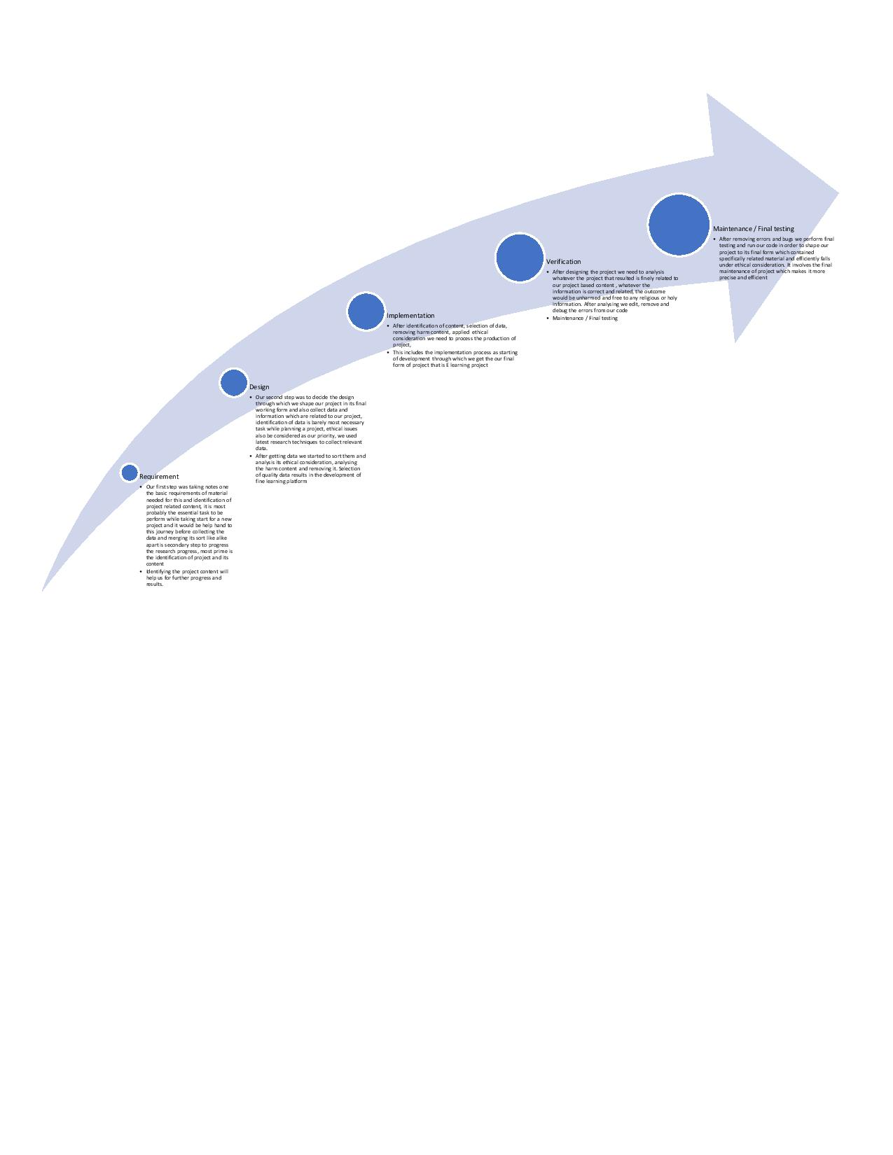

## 

## 1.6. Skills Audit

**Skill audit describing skill indicators, competency and ways to improve.**

|  |  |  |  |
| --- | --- | --- | --- |
| **Skills** | **Skill Indicators** | **Initial competence level** | **Approach to improve competency** |
| Study planning | Should apply effective study plan by analysing its learning capacities and skill | Most preferably needs to be improved | Approach to the study planner professional |
| IT Skills | Experts in computer network based E learning platform. | **Average** Needs Improvement | Approach to the information skilled professional |
| Academic course | Guide a concise well-structured academic research method | Preferably needs to be improved | Approach to skill course guider |

# 

# 2. Methodology

**2.1 Literature review methodology**

As we know information technology has great impact on our community even it has occupied great place in our educational department, so we considered information technology as huge and smooth way for students to educate themselves, taking this review in mind we developed an E learning platform from where one can get their desired study materials and plans.

For this purpose we have fine research on E learning platform through which one can perform attending of lectures, do the given homework and also it provides many other services which are helpful to their learning process

As this platform is time saviour, we don’t have to travel for attending the lecture, also we wouldn’t face any issue regarding our home works .we can attend lectures on our IT devices wherever we can be

**2.2 Design Methodology**

The methodology is a systematic approach to execute and manage the research study in fine result oriented way. It is necessary to utilize appropriate methodology to ensure quality and user friendly

A methodology allows us to select, process, analyse and identify the information related to the project

We used waterfall methodology to design and develop this e learning platform for students

1. Requirement /Identification of project content

Design Here we use five major segments in project developing methodology

1. Implementation
2. Verification
3. Maintenance /Final testing

**Requirement**

Our first step was taking notes one the basic requirements of material needed for this and identification of project related content, it is most probably the essential task to be perform while taking start for a new project and it would be help hand to this journey before collecting the data and merging its sort like alike apart is secondary step to progress the research progress, most prime is the identification of project and its content

Identifying the project content will help us for further progress and results.

**Design**

Our second step was to decide the design through which we shape our project in its final working form and also collect data and information which are related to our project, identification of data is barely most necessary task while planning a project, ethical issues also be considered as our priority, we used latest research techniques to collect relevant data.

After getting data we started to sort them and analysis its ethical consideration, analysing the harm content and removing it. Selection of quality data results in the development of fine learning platform

**Implementation**

After identification of content, selection of data, removing harm content, applied ethical consideration we need to process the production of project,

This includes the implementation process as starting of development through which we get the our final form of project that is E learning project

**Verification**

After designing the project we need to analysis whatever the project that resulted is finely related to our project based content , whatever the information is correct and related, the outcome would be unharmed and free to any religious or holy information. After analysing we edit, remove and debug the errors from our code

**Maintenance / final testing**

After removing errors and bugs we perform final testing and run our code in order to shape our project to its final form which contained specifically related material and efficiently falls under ethical consideration. It involves the final maintenance of project which makes it more precise and efficient

**2.3 Theoretical background**

The definition of most frequent and easy learning with change is E learning, it uses electronic devices to make learning smooth, here ones can choose its learning plan individually because learning is not something done to learners, it is that learners do with themselves, it is use of computer network in general

It identify what one individual can do with the selected plan

It also identify ones desired study plan

It analyse and enhance ones learning process

It is free from strict timings schedule

Don’t bother to move or travel to somewhere for attending lectures

If some lectures could mistakenly skipped, it would available online for reviewing and learning

Ones can do homework there and gets marks through this computer network system

Theoretical background of our project, our idea is to developed an E learning platform which consists the following concepts

User can create its own study plan through which it can easily gain knowledge and sooth its learning period , as on regular physical study concepts or plans which offered by institutes it would be hard for some sort of students to follow and achieve the desired package of knowledge,

It needs some professional skilled persons to guides the users and help them out choosing their friendly study plan, we found it user friendly

It is easy to attend the desired selected lectures through E learning platform

## 2.4. Evaluation of the Prototype

Testing and evaluation of project design is necessary to determine whatever the quality of our project’s final form is sufficiently fine or not, it is beneficial to stimulate the development quality of future research Quantitative evaluation and functional testing of the techniques and the prototype would be beneficial in assessing the efficient functioning of the project outcome.

Some specific specialised measures can be used for evaluating the algorithms design of our project

Evaluation of prototype would also be act as time saviour, testing of design would eliminate the risk of getting cheap product, it also eliminates the risks of getting bugs and glitches.

# 3. [Literature Review](https://learn.solent.ac.uk/mod/book/tool/print/index.php?id=2744#ch1295)

It is shown that many researches has been done in previous time in the field of information technology E learning platform where one individual can perform its study actions individually with friendly using computer network program, such learning platforms will help users to save their time w, attending their lectures without even traveling an inch, location wouldn’t be the issue for them , the can also perfume homework actions and gets their result recorded on this learning platform, it focuses on student needs and feasibility

## 3.1. Student’s Behaviour

It has been observed and noted by the several previous researches that students have versatile behaviour towards their academic relations, it need to be developed a strong bond of commitment of students with their academics activities

Some students have laziness and travelling issues to attend their lectures, their poor academics results disappoint them which leaves bad impact on their learning process

To overcome these issues which were listed or unlisted we have research on E leaning platform contained several study plans and routines

## 3.2. Student’s Retention and Attrition

A big challenge of attrition of students has been observed towards the educational activities, some have distance issue to attend their lectures because now a days it is fuss created on road during universities and offices timings , some students face fever and can attend their lectures it is hard for them to travel outside towards their institutes where they attend their lectures physically, some students get disappoint due to unsuitable study plans or routines and it also leads towards the attrition of students.

To overcome these all issues it is necessary to build a platform where students can attend their lecture without travelling, where they can choose their individual study routine which looks feasible to them to go with.

They would not face issues regarding their homework

By using electronic devices they can fulfil their desired educational and academic needs, it leads the risk of retention and attrition

Students would have more chances to keep firm bond with their learning process

## 3.3. Improving Student Infrastructure and Student Services

The issueof student infrastructure and student services cannot be neglected

Student services were our first priority to handle with,

This E learning platform will surely help students to improve them with their educational matters.

Online homework or academic task will strengthen the interest of student towards its completion or attempt.

Improving infrastructure would lead the whole study plan, as basics matters

They can have easy way to interact with their IT based learning platform

## 3.4. Student Feedback and Survey Analysis

The review was examined utilizing standard spellbinding insights and representations. We moreover mined the content of open-finished inquiries to perceive regular topics and designs and checked these topics utilizing Machine Text Analysis, which assisted us with comprehension the hidden examples between messages. It took a gander at the recurrence of words that happened across reports, the words that showed up in closeness to them, and what their association may be to some secret point or topic. It introduced those words in groups that have a high likelihood of happening close to each other.

# 4. Conclusion

In conclusion, this project proposal supports the academics activities of students and make it easy for them to be firmly committed with their studies without any discontinuity,

The learning management system tries to overcome the barriers and imitations which have occurred in traditional system which includes availability of class data at any time in case of missing the class, not understanding the concepts by taking the class for the very first time as you can access the sessions anytime.

Checking of their assignments and homework will be done instantly through online system, they don’t have to wait for long period

It also provides job opportunities for the skilled professional who has to guide the students to choose the study routine

It is also proven as the time saviour and decrease the risks of road traveling hazards.

**5. References**

Akyol, Z., & Garrison, D. R. (2011). Understanding cognitive presence in an online and blended community of inquiry: Assessing outcomes and processes for deep approaches to learning. British Journal of Educational Technology, 42(2), 233-250.

Bates, A. W. & Poole, G. (2003). Effective teaching with technology in higher education: Foundations for success. Indianapolis, IN: Jossey-Bass.

Bonk, C. J. & Graham, C. R. (Eds.). (2005). Handbook of blended learning: Global Perspectives, local designs. San Francisco, CA: Pfeiffer Publishing.

Conceição, S. C. O., & Lehman, R. M. (2011). Managing online instructor workload: Strategies for finding balance and success. San Francisco, CA: Jossey-Bass.

Duffy, T. M. & Kirkley, J. (2004). Learner-centered theory and practice in distance education: Cases for higher education. Mahwah, NJ: Lawrence Erblaum Associates.

Dziuban, C., Hartman, J., Cavanagh, T. Moskal, P., (2011). Blended Courses as Drivers of Institutional Transformation. A. Kitchenham, Ed. Blended Learning Across Disciplines: Models for Implementation, (pp. 17-37) Hershey: PA: IGI Global.

Garrison, D. R., & Vaughan, N. D. (2008). Blended Learning in Higher Education, Framework, Principles, and Guidelines. San Francisco: Jossey-Bass.

Means, B., Toyama, Y., Murphy, R., & Baki, M. (2013). The effectiveness of online and blended learning: A meta-analysis of the empirical literature. Teachers College Record, 115,1-47.

Palloff, Rena M., Pratt, Keith. (2007) Building online learning communities: Effective strategies for the virtual classroom San Francisco, CA: Jossey-B

# 

# 6. Appendices

As globally computer based E platform has took their place widely, like we usually do our shopping from E commerce based platforms, we get our tickets order to be booked through these electronic based platform,

Looking these views in mind it is not worthy to say that some is additionally delivered information regarding this E learning platform