A Blockchain Based Land Registration and Ownership Management System for Bangladesh

First Author's Name, Initials, and Last name[1]*

First author's affiliation, an Institution with a very long name, xxxx@gmail.com

Second Author's Name, Initials, and Last Name

Second author's affiliation, possibly the same institution, xxxx@gmail.com

Third Author's Name, Initials, and Last Name

Third author's affiliation, possibly the same institution, [xxxx@gmail.com](mailto:xxxx@gmail.com)

Second Author's Name, Initials, and Last Name

Second author's affiliation, possibly the same institution, xxxx@gmail.com

Third Author's Name, Initials, and Last Name

Third author's affiliation, possibly the same institution, xxxx@gmail.com

From the times of Satoshi Nakamoto’s Bitcoins invention in 2008 Blockchain has become one of the most popular technologies to keep records secure, immutable, transparent and in distributed ledger. Blockchain is the underlining technology of Bitcoin. Blockchain technology has been used in many domains such as IoT, healthcare, education, business, Land management and so on. Among them Land Registration and Ownership Management is a very tough process all over the world. Land is a state immovable object and many frauds claim false ownership. It creates disputes among people. Also, many intermediaries are involved in this system. These intermediaries take huge amount of money to solve problems in time. For this reason, many people fail to achieve their own land. Blockchain technology has the all characteristics to solve these problems. It keeps data transparent, immutable and secure, at the same time it does not need any intermediaries. For the powerful characteristics of blockchain technology, the authors of this paper proposed a permissioned blockchain-Hyperledger based solution model to solve the problems of land registration and ownership management system. Here the authors present a system overview of the proposed system, a flowchart of working flow and an architecture. And last of all, some basic algorithms are also built to conduct a proper research.

CCS CONCEPTS • Security and privacy **~** Formal methods and theory of security; Systems security; Software and application security

**Additional Keywords and Phrases:** Blockchain, Chaincode, Hyperledger Fabric, land registration, land registry office (LRO), land management, Smart contract.

1. Introduction

Bangladesh's land registration process began long before the country's birth. It is a small nation with a land area of 1,48,460 square kilometers and a population that is growing by the day. It has a sizable population that is more than 163 million people, according to 2019 estimates. Whereas many people face land crises, land ownership in this small country is entirely managed manually by various government departments. Due to a lack of adequate documentation, people frequently struggle to determine the true owner of any land. A study shows that 80% of cases in rural regions are assessed to be identified with land clashes [6]. These cases take ages to settle. Bangladesh's land administration system is also corrupt and time-consuming. Updating an ownership change record from the sub-register office to the central data base may take up to two years [1]. Blockchain technology is the most widely used technology for keeping any type of data or records secure, immutable, and transparent. It is very hard to alter any data in a blockchain ledger. Not only Bangladesh, but many countries in the world, face issues with land registration and ownership management systems. In different time many scholars suggested various approaches to digitizing the land management system. Taking into count the previous studies, the authors of this paper suggested a permissioned Blockchain hyperledger architecture to provide a secure, immutable land ownership management system. As cryptocurrency is not permitted in Bangladesh, the authors also proposed incorporating bank/s into their system to provide a simple and appropriate solution for Bangladeshis. The subsequent sections provide the paper's structure. In section (2) related work has described, blockchain technology and key elements of blockchain architecture have been described in section (3), in section (4) Hyperledger Fabric has been described. System overview is presented in section (5). System workflow is presented section (6), system architecture and basic algorithm are presented in section (7) and in section (8) respectively. And lastly future work and conclusion is presented in section (9).

1. RELATED WORK

Blockchain becomes popular from the time of its invention (2008) because of its characteristics like immutability, transparency and distributed data/record keeping system [4]. Many times many researchers had shown its efficiency and tried to implement this powerful technology in different field. Land registration and its ownership management system is one of them. It is a very cumbersome process all over the world. Bangladesh's land control and management system is overly complex. Kasphia Nahrin et al. proposed a Land Information System (LIS) for the Land Administration and Management System in Bangladesh to address this issue. GPS is principally used for geological mapping at the Upazila level, with the help of settlement offices and private enterprises, as well as completely computerized data that can be gathered through the use of software in their approach [8]. Shahriar Khan et al. suggested a framework to digitalize all property related information in Bangladesh too [17]. AsBangladeshi land registration system is less transparent, corrupted and mismanagements are placed here, to achieve transparency and availability of information the authors of [1] proposed an architecture to digitize the land management system in Bangladesh. Blockchain is one of the most popular digital platforms to keep any types of record secure, immutable and transparent. In April 2016, The Republic of Georgia and Bitfury (the infrastructural provider of Bitcoin Blockchain) jointly conducted a one-year pilot project to transfer Georgia's land registration systems in a Blockchain based platform [13]. Meghali Nandi et al. proposed a Blockchain-based secure land record keeping system, with the embodiment done using Ethereum and the benchmark data, and the transaction processing time of such a system is relatively very low [12], by highlighting the issues with India's land registration system. The government of Andhra Pradesh in India is also working in collaboration with a Swedish IT firm to establish a Blockchain based land registry system, and Vinay Thakur et al. outlined in their paper that, how the Indian government should introduce blockchain in their land titling system through an architecture [19]. Ashwin Sekhari et al. also introduced a Blockchain based algorithm for India in which various departments of land registration and management systems would work concurrently to easily integrate their work [11]. The authors of [10] propose an open land registration system in GEORGIA using public Blockchain Ethereum. Another study suggested a blockchain based architecture for Bangladeshi Land Registry system where the architecture has six core focuses, which are: Data Security, Data Backup, Data Immutability, Data Synchronicity, Separation of Concern, and Reduced Response Delays. A Hyperledger based land title management system for Bangladesh also proposed by the authors of [9] [7]. Toqeer Ali et al. proposed a property registration systembased on Saudi Arabia where Hyperledger Fabric is used for implementations of their prototype [18]. In Turkey Arif Furkan Mendi et al. also proposed a Hyperledger-based system for their land [2]. Md Sakibul Islam et al. suggested a Land Registration and Ownership Management System for Bangladesh based on Ethereum [14]. On the other hand, the researchers of [16] suggested an Ethereum-based land registry platform for India through which anyone can sell or purchase any land without the assistance of any intermediaries. The authors of [3] suggest how blockchain technology can be used as a very powerful technique for land registration in high conflict states, as well as a more open land and property ownership paradigm that can be built for all deviant countries such as Cyprus. They also suggest that information be kept on the shared Blockchain in real time, so that all stakeholders can be kept updated on the outcome of the land rights dispute at the same time. Most of the related works are described here are proposed their system on public blockchain and suggested to use the cryptocurrency for money transaction. Bangladesh as well as many countries still not support cryptocurrency and a public blockchain has many drawbacks. For instance, public blockchain is slow. Its data transaction rate per second is lower than private blockchain. Moreover, a public blockchain consume more power and energy compared to private blockchain. In this situation a permissioned blockcain is able to prevent the increasing number of enemies which is arising for land day by day. For this reason, the authors of this paper proposed a Hyperledger Fabric (permissioned blockchain) based system where they can also use bank account for money transaction with proper verification.

1. blockchain TechnoloGy

Blockchain is a digital and distributed ledger of transactions or decentralized database that holds continuously updated digital records in real-time through a network of computers [15]. A Google Doc is a basic analogy for blockchain comprehension. But a blockchain provides a decentralized distribution chain that allows everyone to read the text simultaneously. Of course, it is more complicated than Google doc, but the analogy is fair since three significant technological concepts are highlighted. A quick overview of blockchain:

* Digital properties are stored rather than copied or moved.
* The asset is decentralized, providing direct access to the property in real time.
* A straightforward ledger of modifications maintains the credibility of the record, ensuring confidence in the asset.

Blockchain is a fascinating and innovative technology that reduces risk, eliminates fraud and accountability for numerous applications [20]. Based on the pair-to-pair (P2P) topology, blockchain is a technology that enables data to be stored globally on multiple servers – enabling everyone on the network to access the entries of anyone else in almost live time [15] [21] [20]. This makes it really complicated for a user to track a network. Blockchain aims to provide businesses with transactional accountability. It has the potentiality to build reliable real-time communication networks to help partners all over the world. Towards a quick increase in application development and pilot testing in a variety of industries, Blockchain has been powered mainly by financial technology (fintech) investments and produced revenue of more than $10.6 billion dates by 2023, according to an ABI research report. The bulk of this revenue is anticipated from products and services of software [20].

* 1. Key elements of the blockchain architecture

The core components of blockchain architecture [5] [22]:

* Node – a user or device which has an independent copy of the whole ledger in the blockchain architecture.
* Transaction - the smallest records (documents, data, etc.) keeping block of a blockchain that performs as the purpose of blockchain.
* Block - a data structure that keeps track of transactions and distributes them through the network's nodes.
* Chain - a series of blocks in a certain order
* Miners - relevant nodes that verify blocks before putting them on the blockchain framework.
* Consensus Algorithm - a compilation of guidelines and instructions for the implementation of blockchain operations. Any new record or operation inside the blockchain means that a new block is being formed. In order to be genuine a block, it should be digitally proven and authenticated. And many nodes in the network do this job.

Some basic concepts about a block of a blockchain are discussed here. Each blockchain block is made up of three things. They are: a previous block hash, data of its own block and its own block hash.

All the verified and authenticated blocks come from the genesis block (the very first block). Each block preserved data according to the blockchain type. For example, the block contains the receiver, sender, and number of coins in the Bitcoin blocks in system. It's like a long chain consisting of records that makes with some digits and letters. The cryptographic hash algorithm is used to generate each hash block (SHA 256). This helps to quickly distinguish every block in the blockchain system. When a block is generated, it will inevitably add a hash, while any modifications made to the block will also affect the updating of the hash. Simply mentioned, hacks support the identification of block changes. A previous block hash is an ultimate element inside the block. This establishes a blockchain which is the core factor behind the security of the blockchain architecture. In a short, every block is made up with the above three components.

1. HYPERLEDGER FABRIC

Hyperledger Fabric has some special and important characteristics that are necessary for the proposed system of this paper. The characteristics are described below:

* Permissioned Blockchain: Hyperledger Fabric is a permissioned blockchain. It can be controlled that who can be able to access the blockchain and at which level they can get access. It has also a flexible and scalable architecture that meets a wide spectrum of industrial use cases.
* Transaction Consensus: On a transactional basis, Hyperledger can reach consensus. This means that the whole block does not have to be validated for a transaction, but only the exchange. The Hyperledger Fabric consensus network is a mechanism in which network nodes guarantee the order of the company and validate certain transaction blocks that have to be committed to the leader.
* Chaincode Support: Chaincode is a 'smart contract,' which works with peers and transactions in Hyperledger Fabric. It allows users more generally to complete transactions on the shared directory of the Hyperledger Fabric network and update the application's global influence.
* Cryptocurrency Not Required: Unlike Ethereum, Hyperledger can work without the use of a cryptocurrency.
* No Proof of Work/Proof of Stake: Hyperledger does not require machines to solve problems 24 hours a day, and it does not need humans to use cryptocurrency to achieve consensus.
* IBM Open-source support: IBM maintained the Hyperledger fabric and had been open source.

1. SYSTEM OVERVIEW

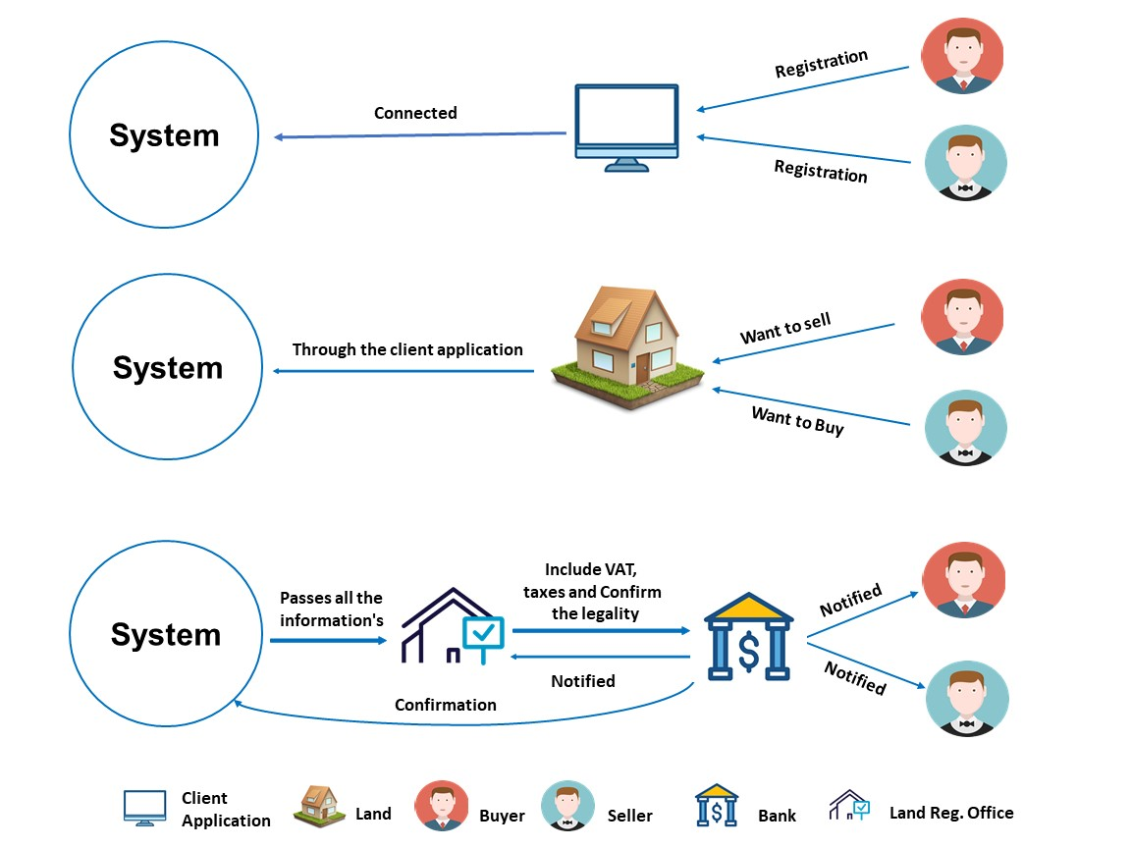

Figure 1: Overview of the proposed system.

This system will have the chaincode that will work under the administration of the Government. The node will add different types of ledgers for another task.

At first, the administration will permit the local land registry office (LRO) and authorized bank as nodes of the system via Membership Service Provider (MSP). LRO will verify and confirm land ownership information. It will also gain permission to record information about the land. And the task of the bank will be to collect the currency from the buyers and pay the Govt. their preferred tax. As well as provide the seller with the money in their account which they have to be paid. This process helps to get an amount of commission to the Bank. After the process is completed, ownership will be transferred, and a new block will be created in the Blockchain. The information will be generated in the new block are: previous block hash, land Info, payment Info, present owner Info, present block hash. There is another type of user, they are: Buyers and Sellers. They can register on the system providing their authentic information for buying and selling. The system will verify information’s authentication. Buyers and Sellers will conduct every task related to the land ownership transfer via the system.

1. SYSTEM WORKFLOW

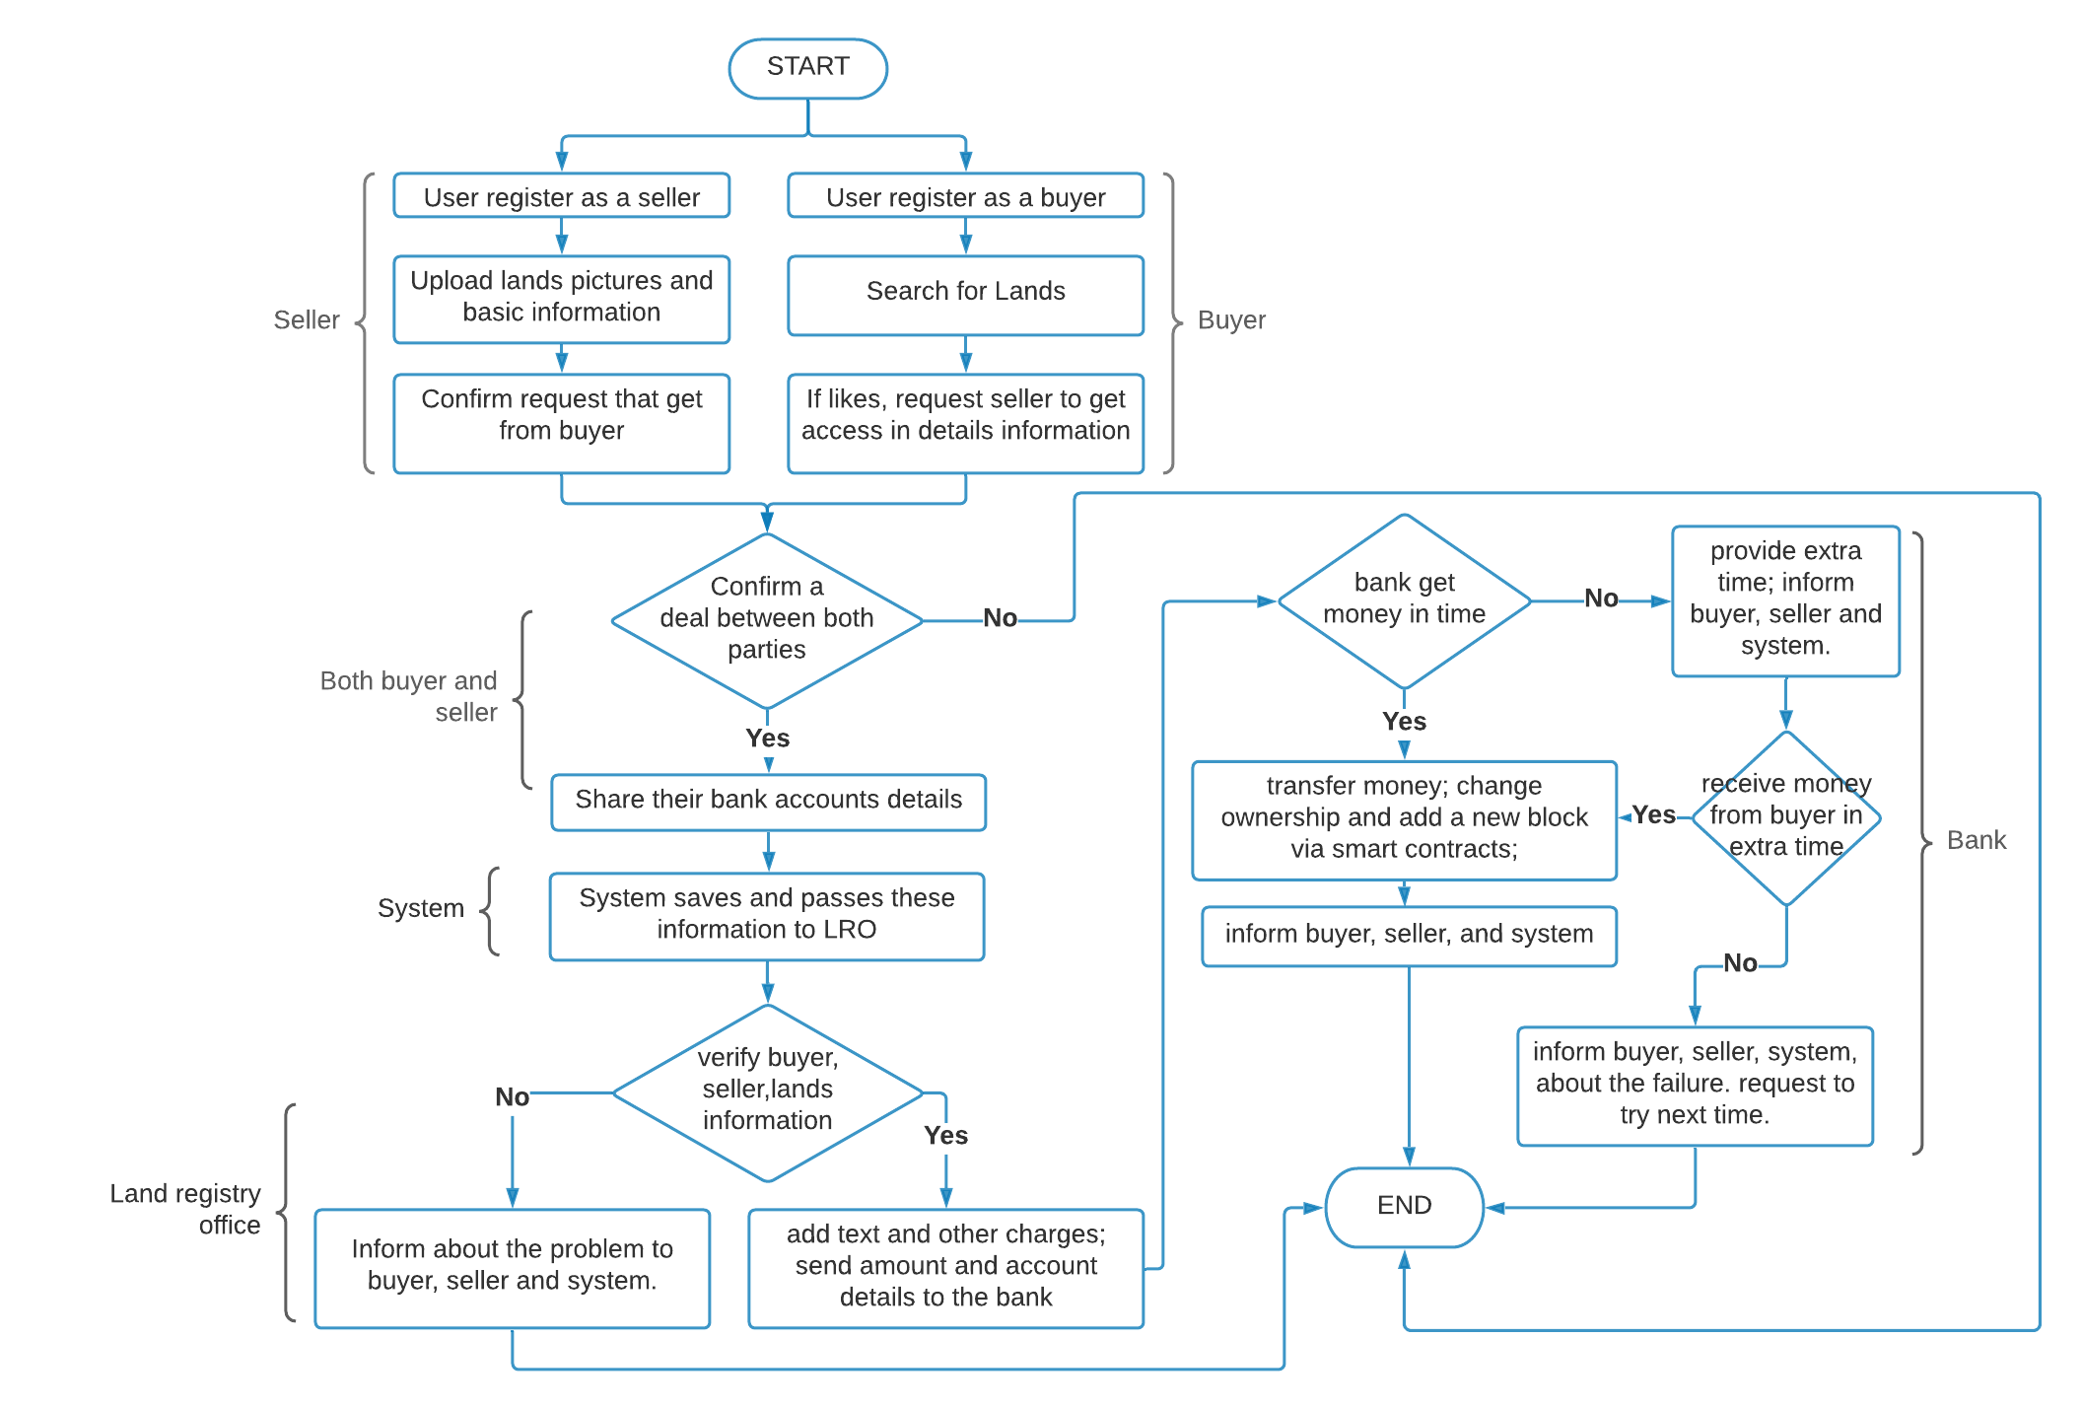

Figure 2: System workflow of the proposed system.

The systems primary focus is to allow the general citizens to transfer their lands, simply. Via this system, buyers and sellers can provide their original information to contact each other if they are interested in buying or selling land.  A step wise working procedure is explained below:

In the very first step a user will register himself to the system as a buyer or seller. After register, if anyone register as a seller, he will upload lands picture and basic information to the system. And if anyone register as a buyer, he will search for lands to buy. If a buyer likes any lands picture and basic information, he can send buyer to get an access request to the details information. After that, a seller will get that request and confirm or deny that. After the initial stage, here buyer and seller can make a deal with negotiation by contact each other. If they confirm the deal, they will share their bank account number by using the system. In the third stage, system will save this information and at the same time pass to land registry office (LRO) to verify the buyer, seller and lands information. If it finds anything wrong, it will notify buyer, seller and system, also close the transaction. And if it finds all information properly it will add tax as well as other charges to the selling amount. Then send the amount and account details to the bank. And the last step will be conduct by bank. If the bank get money from buyer in time, it will transfer the money in respective places, change the ownership through the smart contracts and inform buyer, seller as well system. And close all by adding a new block to the existing blockchain. But if the bank will not get the money in time, it will add extra time and then, inform buyer, seller and the system. If again buyer fail to give money in the extra added time the bank will inform buyer, seller and system about the failure and request to try next time. Then close the transaction. And if this time buyer succeeds then the bank will transfer money and ownership, add a new block, also notify all.

1. SYSTEM ARCHITECTUER

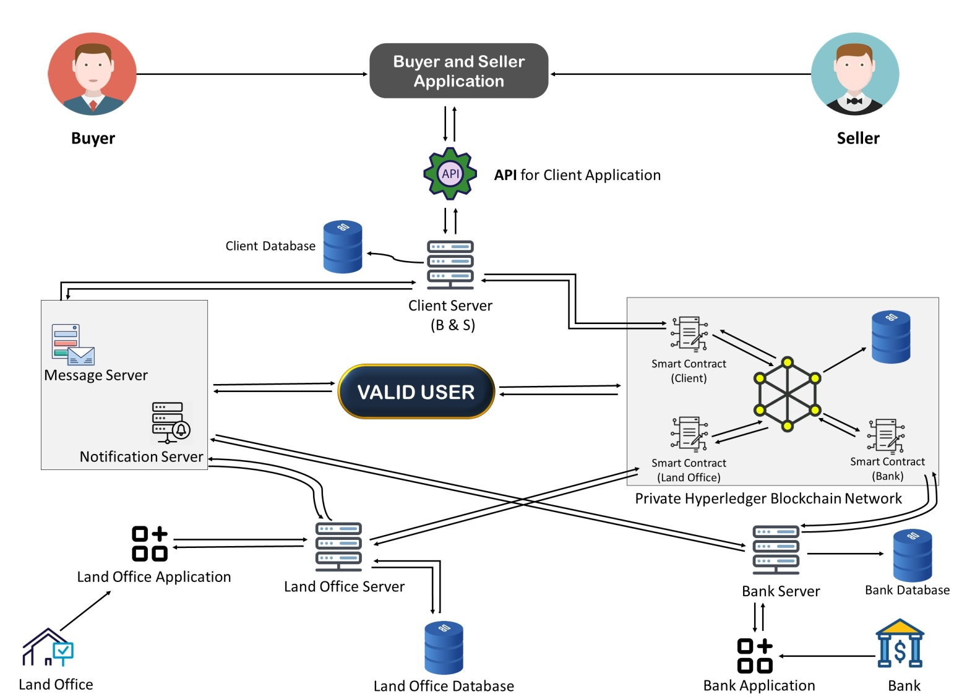

Figure 3: System architecture of the proposed system.

Figure: 3 illustrate that, this architecture has a private hyperledger blockchain network. Under this hyperledger blockchain have three types node. they are Client-Server, Land Office Server, and Bank server. The client-server has a dedicated database (Client Database) and also has a client API for the client Application. Client application will be developed for Buyer and seller. The client-server connected the message server and notification server through the hyperledger blockchain network. Using this server buyers and sellers can do messaging and get all notification. Then the second node is the Land office server. The land office server has a dedicated database which name is the Land office database. And also has a Land office application for land office. Land officers use this application for land, buyer, and seller information verification and after the verification, the land officer can confirm or cancel the land registry. The land server connected the message server and notification server through the hyperledger blockchain network. Using this server land officer gets the notification and sends the notification or message. In this architecture, the third node is Bank Server. The bank server also has a dedicated database (Bank Database), and has a bank application for the bank. The Bank office uses this Application for confirmation of the system after money received. The Bank Server also connected the message server and notification server through the hyperledger blockchain network. using this server Bank office gets the notification and sends the notification or message. In the hyperledger blockchain network generate the three smart contacts for three nodes at the different time. firstly, when the client has done there all tasks then secondly land officer confirmed the system after land verification. And third smart contract generates when the bank office confirms receiving money and transfer the land.

1. BASIC ALGORITHM

Algorithm 1 : Buyer and seller Join the system by using their personal information

1. **Registration**
2. name buyer or seller name
3. nidNumber buyer or seller nidNumber
4. fingerprint buyer or seller fingerprint
5. password buyer or seller password
6. ***If***  **name** && **nidNumbe** && **fingerprint** && **password** verify through the **AP I**
7. then the buyer or seller will be successfully register.
8. ***else*** Registration Fail

Algorithm 2: Seller Send his land information and Buyer get Information

1. **owner Info**
2. ownerId Seller Id
3. ownerName Seller Name
4. ownerAddress Seller Address
5. **Land Info**
6. landid Land Id
7. khatianNo khatian No
8. area Area
9. moujaNo Mouja No
10. dagNo Dag No
11. taxtRecord Taxt Record
12. landLocation Land Location
13. previousOwnerInfo Previous Owner Information
14. Seller Send his lad information Through the API
15. Buyer get owner and Land Information Through the API
16. ***If*** Buyer confirm for buy land
17. **then** the next step
18. ***else*** Registration Fail

Algorithm 3 : after buyer confirm buy then seller add his bank account and land price and conform for sell

1. **Owner Bank Info**
2. bankName Bank Name
3. branc Name Branch Name
4. accountName Account Name
5. accountNumber Account Number.
6. **Land Price Info**
7. landPrice land Price
8. governmentVat Government Vat
9. registationFee Registration Fee
10. bankFee Bank Fee
11. totalpay landPrice **+** govermentVat **+** registationFee **+** bankFee
12. ***If*** seller confirm for sell
13. ***Then***  the next step
14. ***else*** Registration Fail

Algorithm 4: After seller confirm for sell then the Land office get Notification for verify the land information and buyer and seller information

1. Land office get Notification for verify the land information and buyer and seller information
2. Land office verify land information , Buyer Information and Seller information
3. ***If*** all verify success
4. ***Then*** the next step
5. ***else*** Registration Fail

Algorithm 5: After Land office verify all information then bank get notification for receiving money and buyer get notification for pay

1. buyer get notification for pay
2. bank get notification for Receiving money
3. ***if*** Bank get money in time
4. ***then*** bank conform & ***the next step***
5. ***elseif*** bankgive extra time for pay
6. ***else*** transaction
7. Fail

Algorithm 6: After bank confirm Land and money will transfer and buyer,seller, and land registry office get confirmation after transfer land

1. Land Transfer successfully
2. Money transfer successfully
3. Buyer get notification
4. Seller get notification
5. Land office get notification
6. End
7. FUTURE WORK AND CONCLUSION

The use of blockchain technology has been increasing in various sectors in recent years. In different countries currently, it has been used in land registration. This document shows a system where a country can use permissioned blockchain for keeping land records in a secure, transparent and immutable way. Since land is a state object, it is very important to protect the right of this object in an efficient way. Without the proper management of the right ownership of land it is quite impossible. The proposed system will also help in this regard. The Administration of a country, Land registry office as well as Banks are involved in this system. So, the general people who are not familiar with blockchain technology they will also feel free to trust this system. This will be beneficial for the people and the country. Again, this system can prevent the enemies of a person which are arise for land; because everyone will not be able to show everyone’s all land information. After all, the proposed system will also be able to save the records from any type of natural and man-made disaster as well as frauds. There are some future work directions for upcoming researchers on this domain. The authors of this paper try to show the basic algorithm and pseudo code here. They assume that the other needed pseudo code can be written by following the given approach. Smart contracts are also not built here. It can be developed in future. And artificial intelligence can also be integrated in future for further smooth working process.

ACKNOWLEDGMENTS

The authors of this paper acknowledge the American International University-Bangladesh to conduct this research.

REFERENCES

1. A. Imtiaz, M. S. Rahman. Integrated land information system: To ensure the transparency and availability of information, in context of Bangladesh. *IEEE Xplore* (2014), 1-5.
2. Arif Furkan Mendi, Kadir Kaan Sakaklı, Alper Çabuk. A Blockchain Based Land Registration System Proposal for Turkey. *IEEE Xplore* (October 2020), 1-6.
3. Balkiz Yapicioglu, Rebecca Leshinsky. Blockchain as a tool for land rights: ownership of land in Cyprus. *ResearchGate*, 12 (2020), 171-182.
4. Célia G. Ralha, Carolina G. Abreu, Cássio G.C. Coelho, Alexandre Zaghetto, Bruno Macchiavello, Ricardo B. Machado. A multi-agent model system for land-use change simulation. *SienceDirect* (2013), 30-46.
5. Elva Leka, Besnik Selim, and Luis Lamani. Systematic Literature Review of Blockchain Applications: Smart Contracts. *IEEE Xplore* (October 7, 2019), 1-3.
6. Hasan, Mohammad Ikbal. Land administration in Bangladesh: Problems and analytical approach to solution. *International Journal of Law*, 3, 2 (March 2017), 44-49.
7. Kaczorowska, Maria. Blockchain-based Land Registration: Possibilities and Challenges (September 2019), 30–48.
8. Kasphia Nahrin, M Shafiq-Ur Rahman. Land Information System (LIS) for Land Administration and Management in Bangladesh. . *Journal of Bangladesh Institute of Planners*, 2, 116-125.
9. Kazi Masudul Alam, J.M. Ashfiqur Rahman, Anisha Tasnim, Aysha Akther. A Blockchain-based Land Title Management System for Bangladesh (October 16, 2020).
10. Lazuashvili, Nino. INTEGRATION OF THE BLOCKCHAIN TECHNOLOGY INTO THE LAND REGISTRATION SYSTEM. A CASE STUDY OF GEORGIA. *ResearchGate* (May 2019).
11. M. S. Islam, F. S. Iqbal and M. Islam. A Novel Framework for Implementation of Land Registration and Ownership Management via Blockchain in Bangladesh. *IEEE Xplore* (2020), 859-862.
12. Meghali Nandi, Rajat Kanti Bhattacharjee, Amrit Jha,  and Ferdous A. Barbhuiya. A secured land registration framework on Blockchain. *IEEE Xplore* (2020), 130-138.
13. Qiuyun Shang, Allison Price. A BLOCKCHAIN-BASED LAND TITLING PROJECT IN THE REPUBLIC OF GEORGIA. *Innovations Technology Governance Globalization*, 12 (January 2019), 72-78.
14. S. K. Talukder, M. I. I. Sakib and M. M. Rahman. Digital land management system: A new initiative for Bangladesh. *IEEE Xplore* (2014), 1-6.
15. Samiur Khan, Md.Al-Amin, Hrittik Hossain, Nawshad Noor, Md. Wahid Sadik. A Pragmatical Study on Blockchain Empowered Decentralized Application Development Platform. *Association for Computing Machinery* (January 2020), 1-9.
16. Sekhari, A., Chatterjee, R., Negi, R., & Shukla, S.K. Entangled Blockchains in Land Registry Management. *Information Security Research & Development Centre (ISRDC)* (February 2019), 8-13.
17. Shahriar Khan, Mabruka Toaha, M Abdul Awal. Automated Digital Archive for Land Registration and Records. *ResearchGate*, 2, 1 (October 2019).
18. T. Ali, A. Nadeem, A. Alzahrani and S. Jan. A Transparent and Trusted Property Registration System on Permissioned Blockchain. *IEEE Xplore* (2019), 1-6.
19. Vinay Thakur, M.N. Doja, Yogesh K. Dwivedi, Tanvir Ahmad, Ganesh Khadanga. Land records on Blockchain for implementation of Land Titling in India. *ScienceDirect*, 52 (2020).
20. "Blockchain," [Online]. Available: <https://builtin.com/blockchain>.
21. L. Mearian, "FAQ: What is blockchain and how can it help business?," [Online]. Available: https://www.computerworld.com/article/3191077/what-is-blockchain-the-complete-guide.html.
22. A. Lastovetska, "Blockchain Architecture Basics: Components, Structure, Benefits & Creation," 5 January 2021. [Online]. Available: <https://mlsdev.com/blog/156-how-to-build-your-own-blockchain-architecture>.

1. * Place the footnote text for the author (if applicable) here.