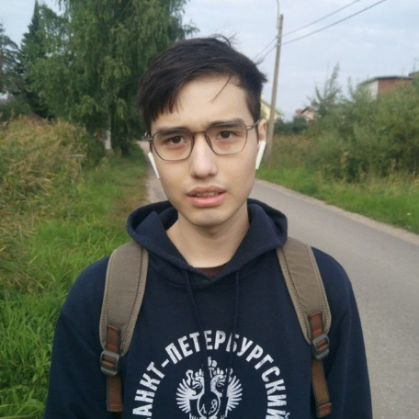

ZHYLKAIDAROV

NURBEK
JUNIOR FRONTEND DEVELOPER

Contact
Location: Saint-Petersburg, Russia
VK: vk.com/nzmmsk
Telegram: t.me/nzmmsk
e-mail: nurbek.math@gmail.com
Github: github.com/nurgitlab
mobile: +7 960 816 18 05

Objective
I plan to become a strong frontend developer and I want to find a company, where I can evolve as a developer.

Education
2022 – Applied Mathematics and Computer Science, Saint-Petersburg University (Bachelors degree)

2017 – Physics & Mathematics, Moscow State University (High School Diploma)

SKILLS
JS (ES6+)
React
Hooks, Redux, CSS3, HTML5, SCSS, CSS in JS, PostCSS Loader
Webpack

Experience
July 2021 – September 2021
Place of work: Food delivery service (biteqr.com)
Position: Frontend-developer
Fixed bugs, added new functionality

languages
English – B2, Russian – native

