Project Proposal by Zhaksylyk Zhadyra and Nugumanova Nurgul

Book Online Shop

Client will register in order to create own account where consumer can observe order status and wishlist. Client will have opportunity to add books to wishlist and cart.

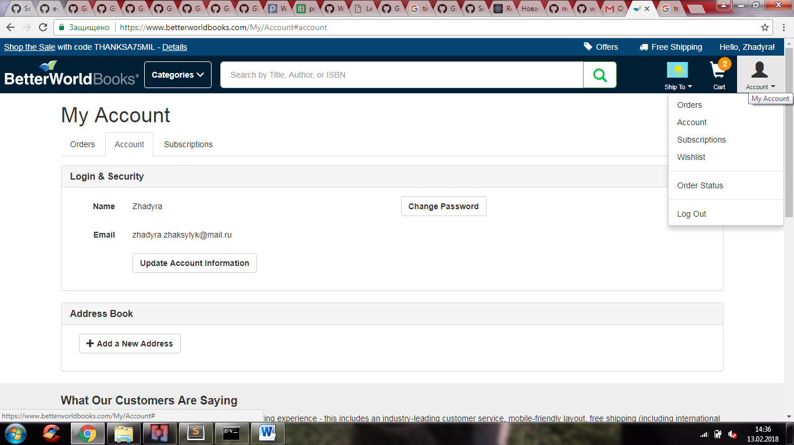

The project consists of 9 components:

|  |  |  |  |  |  |
| --- | --- | --- | --- | --- | --- |
| **<Header/>** | **<Search/>** | | **<Cart/>** | | **<Account/>** |
| **<Home/>** | | **<About/>** | | **<Categories/>** | |
| **<BookList/>** | | | | | |
| **<Footer/>** | | | | | |

In the Home page there will be list of popular books and in About page consumer can able to find detailed information about company. By Search component client can able to find out a book using author’s name or title.

In the Categories page there will be shown different types of genre of books such as Children’s Book, Science Book, Health & Fitness Book and etc. “BookList” component will have an image, author’s name, description, price, Add to Cart button and Add to wishlist button. Also, footer component will have contact and address information of shop.

