**Assignment #1 – HTML Basics (Report)**

**Student Information**

Name: Nurhan Turganbek  
Group: SE-2435

**Objective**

The aim of this task is to develop a simple HTML webpage that demonstrates the use of core elements such as headings, paragraphs, lists, images, links, tables, emojis, buttons, and a form. The page should also be personalized with unique content and made available online.

**Work Process**

**Step 1: HTML Structure**

Created an HTML file (MyMovie.html) with the basic boilerplate structure including <!DOCTYPE html>, <html>, <head>, and <body> tags. Added the page title 'My Favorite Movie'.

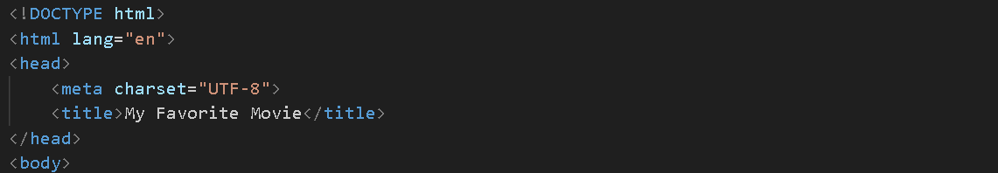

**Step 2: Headings and Paragraphs**

Added headings <h1>, <h2>, and <h3> for the topic of the webpage and a short paragraph describing myself and my favorite movie.

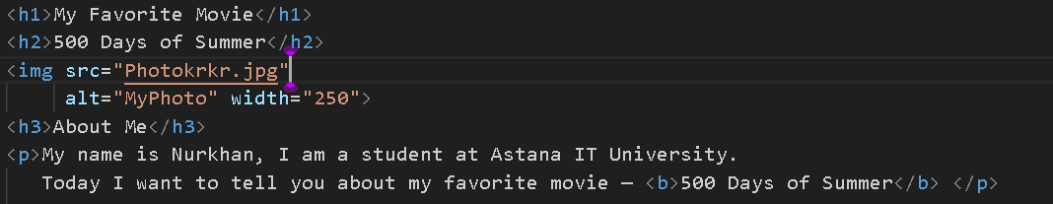

**Step 3: Lists**

Created an ordered list (<ol>) for favorite moments from the movie and an unordered list (<ul>) for favorite actors.

Изображение выглядит как текст, снимок экрана, Шрифт

Содержимое, созданное искусственным интеллектом, может быть неверным.

**Step 4: Images**

Inserted a photo (my photo) and the movie poster using the <img> tag with alt attributes for accessibility.



**Step 5: Links**

Added a hyperlink to the IMDB page of '500 Days of Summer' and a link to GitHub using the <a> tag.

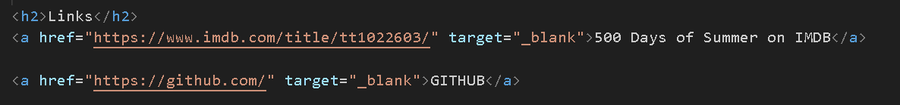

**Step 6: Button**

Added a simple button with the text 'Click Me'. The button does not include functionality yet.

Изображение выглядит как текст, Шрифт, снимок экрана, Графика

Содержимое, созданное искусственным интеллектом, может быть неверным.

**Step 7: Table**

Created a table with three columns (Day, Subject, Time) to display my class schedule.

Изображение выглядит как текст, снимок экрана, Шрифт

Содержимое, созданное искусственным интеллектом, может быть неверным.

**Step 8: Emojis**

Inserted three emojis using their HTML codes: a heart (&#10084;), a rocket (&#128640;), and a smile (&#128512;). This paragraph describes my mood after watching the movie.



**Step 9: Form**

Created a form with input fields for Name, Email, Favorite Color, and a Submit button using the <form> tag.

Изображение выглядит как текст, снимок экрана, Шрифт

Содержимое, созданное искусственным интеллектом, может быть неверным.

**Summary**

In this assignment, I created a simple HTML webpage dedicated to my favorite movie, '500 Days of Summer'. The webpage demonstrates the use of basic HTML tags including headings, lists, images, links, tables, emojis, buttons, and forms. The project was successfully completed and published.