ECOENERGY CONSULTANCY
Desktop Terrain Screening
Kota Setar paddy, Lot A
Kota Setar, Kedah
SCREENING GRADE — NOT A SURVEY

Report ID | BEq_flm-piWOPpdDonFm2w
Generated | 13 October 2026, 14:50 MYT
Site file | flat_site_kedah.kml
Scheme | Large Scale Solar (LSS)
Project stage | Exploring options
Centroid | 6.04221° N, 100.35545° E

About this report
This desktop screening summarises the terrain inside the boundaries supplied in flat_site_kedah.kml, using the Copernicus DEM GLO-30. It is meant for comparing candidate sites at an early stage and for deciding which surveys and studies to commission next.
It reports the area, elevation and slope of each site, the share of each site in the KPKT hill-land slope classes, rule-based findings and recommended follow-up studies. Every finding is generated automatically from the elevation data by fixed rules; nobody has visited the site.
Read the caveats and the disclaimer at the end of the report before relying on any figure in it.

At a glance
Location | Kota Setar, Kedah
Total site area | 42.16 ha
Features analysed | 1 site · 1 route (2.03 km) · 1 point
Elevation range | 1.2–5.4 m (EGM2008)
Overall KPKT split | Class I 100.0% · Class II 0.0% · Class III 0.0% · Class IV 0.0%
Maximum slope | 3.9° (in “Lot A paddy”)
Findings | 0 warnings · 0 cautions · 4 for information
Elevation model (DEM) | Copernicus DEM GLO-30 · DSM (surface model: includes tree canopy and buildings) · 30 m nominal, analysed at 30.7 m

Findings
Each finding below is computed by fixed rules from the elevation data and is listed most severe first: warnings, then cautions, then information.
INFORMATION
Site area screens as KPKT Class I by slope (below 15°)
No site has more than 0.5% of its area at 15° or steeper on this DEM, so by slope alone the land screens as KPKT Class I (low geotechnical constraint). Below 300 m the guideline lets all types of development be considered on Class I ground, subject to the local or development plan. This is a slope-based indication only: the guideline also places gentle ground in a higher class where it shows erosion or instability, lies on colluvium or other sensitive geological material, is limestone, swamp, peat or ex-mining land, or is under flood threat. A 30 m elevation model also smooths out short steep features such as bund faces, drain banks and cuttings.
Source: PLANMalaysia (then JPBD Semenanjung Malaysia, KPKT), Garis Panduan Perancangan Pembangunan di Kawasan Bukit dan Tanah Tinggi (2009), Jadual 1

INFORMATION
Indicative gross capacity from site area
Using IFC (2015) Table 7, about 0.8–1.2 ha per MWp for crystalline-silicon ground-mounted PV in Thailand and Indonesia (the closest climates listed): the total polygon area of 42.16 ha gives about 35–53 MWp; on the DEM all of it is flatter than about 8.5° (15% grade). These are gross figures, before setbacks, access roads, drainage reserves, shading, steep or unsuitable ground and grid limits; the exact area per MWp varies with the tilt angle and row spacing (pitch).
Source: IFC (2015) Utility-Scale Solar Photovoltaic Power Plants: A Project Developer's Guide, Table 7

INFORMATION
Route gradients
Steepest gradient along each route, measured over at least 90 m — “33 kV cable route”: max grade 2.1% over 2.03 km (total climb 5 m). Short pitches at drains, embankments and road crossings can be steeper than a 30 m DEM shows, and a route that crosses a slope at an angle has a lower grade than the slope itself.

INFORMATION
EIA Order 2015: area-based items to check
Solar PV is not listed among the power-generation items of the EIA Order 2015 at any capacity. Area-based items may still apply, depending on the land cover and what is cleared, converted or drained: First Schedule 5(a), conversion of forest at 300 m or more above mean sea level to other land use, 20 ha to under 100 ha (Second Schedule 5(a): 100 ha or more); First Schedule 5(d), conversion of mangrove, peat swamp or freshwater swamp forest for industrial, housing or agricultural use, 20 ha to under 50 ha (Second Schedule 5(f): 50 ha or more); Second Schedule 3(b), drainage of wetland, wildlife habitat or dry inland forest covering 20 ha or more; First Schedule 17, development of an industrial estate of 20 ha or more — whether DOE treats a solar farm as an industrial estate is not settled. The total polygon area is 42.16 ha; the thresholds apply to the area actually cleared, converted or drained. Second Schedule activities also require public display and public comment. Have a DOE-registered EIA consultant confirm which items apply.
Source: Environmental Quality (Prescribed Activities) (Environmental Impact Assessment) Order 2015, P.U. (A) 195/2015, First Schedule items 5(a), 5(d) and 17; Second Schedule items 3(b), 5(a) and 5(f); item 11 (power generation)

Site statistics

Sites
Site | Area (ha) | Elevation min–max (m) | Relief (m) | Slope (°) |  |  | KPKT class (% of site area)
 |  |  |  | Mean | P90 | Max | I | II | III | IV
Lot A paddy | 42.16 | 1.2–5.4 | 4.2 | 0.7 | 1.6 | 3.9 | 100.0 | 0.0 | 0.0 | 0.0
Elevations are DEM surface heights in metres above EGM2008. P90 is the 90th-percentile slope: nine-tenths of the site area is at or below it. KPKT classes: I below 15°, II 15–25°, III 25–35°, IV 35° and steeper.

Slope distribution
Site | Share of site area in each slope band (%)
Site | 0–2° | 2–5° | 5–10° | 10–15° | 15–25° | 25–35° | >35°
Lot A paddy | 92.6 | 7.4 | 0.0 | 0.0 | 0.0 | 0.0 | 0.0

Routes
Route | Length (km) | Elevation min–max (m) | Total ascent (m) | Max grade (%)
33 kV cable route | 2.03 | 2.2–5.5 | 5.3 | 2.1

Points
Point | Latitude (°) | Longitude (°) | Elevation (m)
PMU | 6.05290 | 100.37380 | 5.3

Figures

Figure 1. Site layout
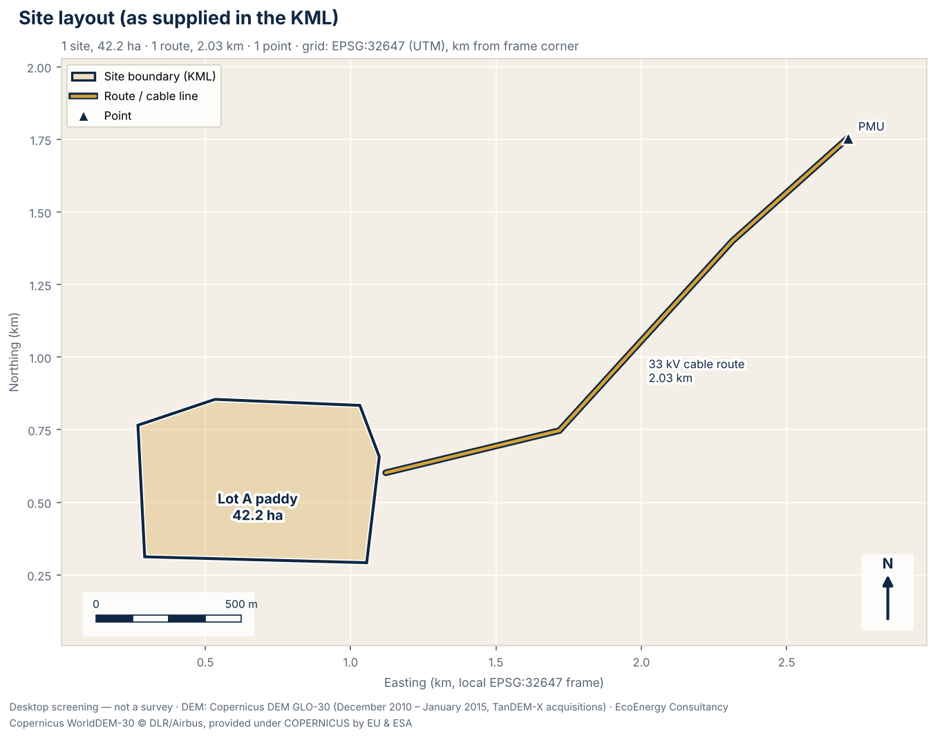
Figure 1. Site boundaries, routes and points as supplied in the KML, with areas in hectares, on a local UTM grid (EPSG:32647).

Figure 2. Elevation and contours
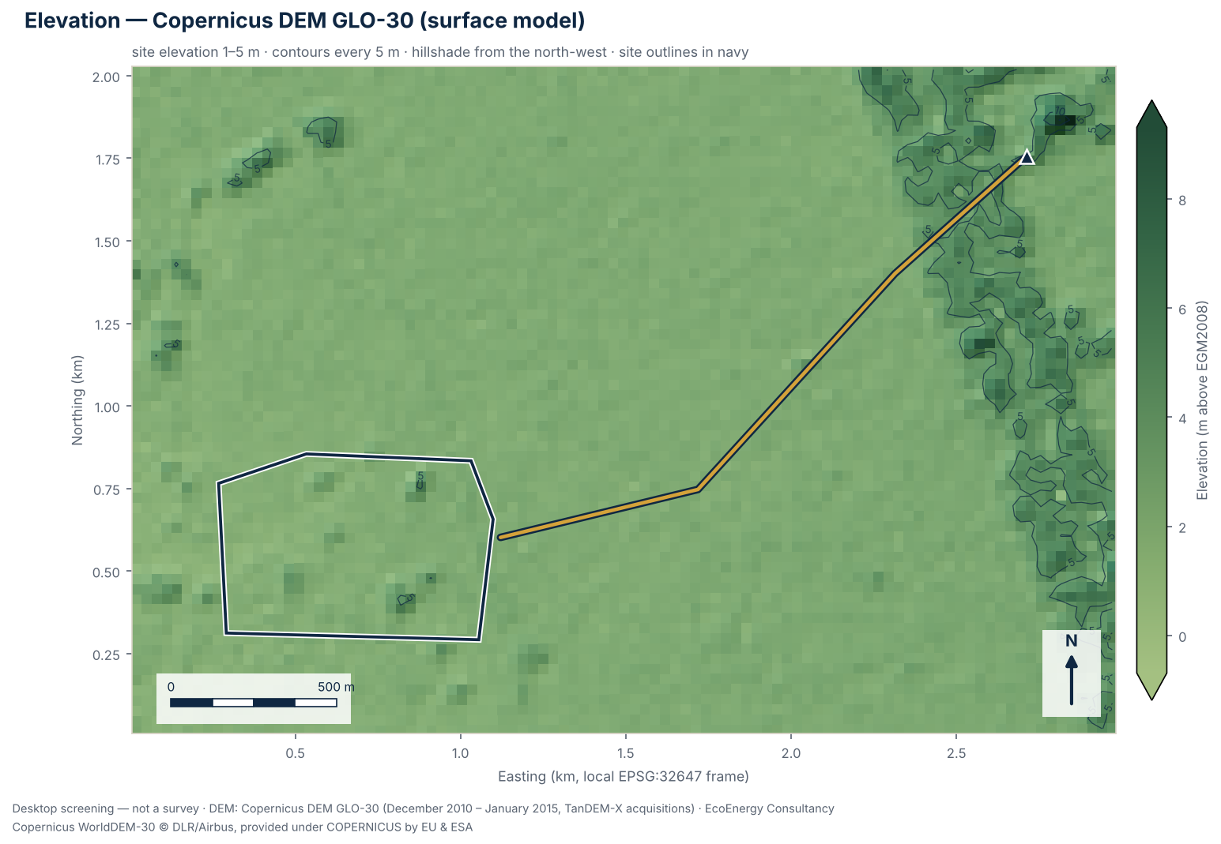
Figure 2. Shaded Copernicus DEM GLO-30 elevation with contours every 5 m; tree canopy and buildings are included in the surface.

Figure 3. Slope classes
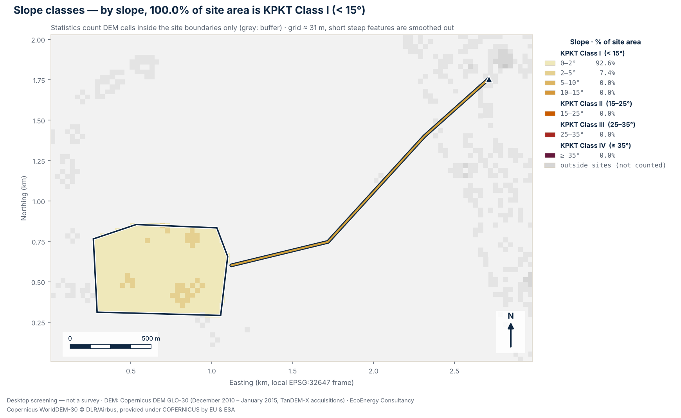
Figure 3. Slope from the elevation model in seven bands, with the KPKT slope-class boundaries at 15°, 25° and 35°; by slope alone, 100.0% of the site area is Class I (below 15°).

Figure 4. Terrain profiles
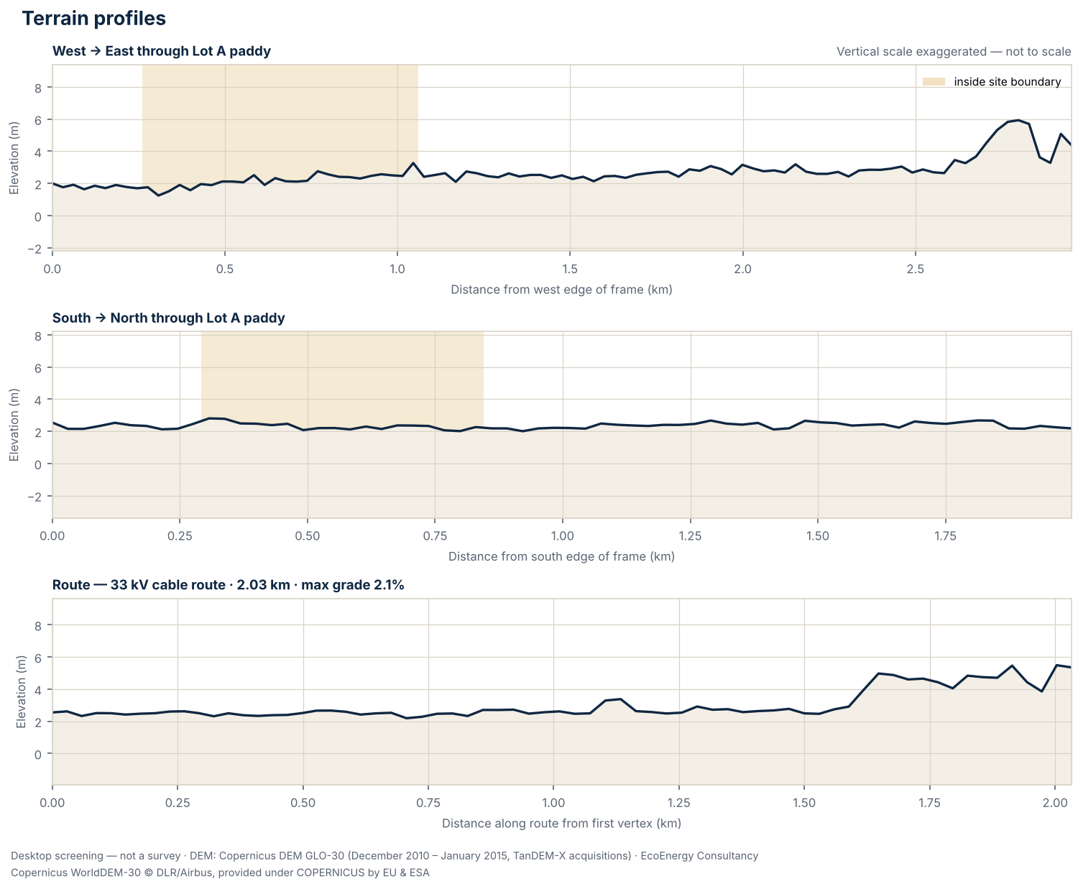
Figure 4. West–east and south–north sections through “Lot A paddy”, plus the elevation profile along 1 route; the vertical scale is exaggerated and not to scale.

Recommended follow-up studies
- Licensed topographic survey
Before layout, earthworks or drainage design, commission a topographic survey by a licensed land surveyor (Licensed Land Surveyors Act 1958, Act 458), or LiDAR / drone photogrammetry tied to surveyed ground control points.
- Geological map review (JMG)
Review the Jabatan Mineral dan Geosains (JMG) geological map sheet for the site: formation, lithology and any karst or ex-mining ground that affects piling, anchoring or foundations.
- Rainfall and climate data (MET Malaysia)
Obtain climate normals and rainfall records from the nearest MET Malaysia station; rainfall intensity feeds stormwater design to MSMA 2nd Edition.
- Surrounding land-use scan (1 / 5 / 10 km)
Map settlements, schools, rivers and water intakes, forest reserves, industry and mining within 1 km, 5 km and 10 km of the site as context for EIA and SIA scoping.
- Land title, zoning and local authority requirements
Confirm the land title, category of land use and any express conditions, the zoning in the local plan (Rancangan Tempatan), and the requirements of the local authority (PBT) for this type of development.
- Confirm EIA applicability with a DOE-registered EIA consultant
Have a DOE-registered EIA consultant check the layout, land cover and areas to be cleared against the First and Second Schedules of the EIA Order 2015 (in Sabah and Sarawak, against the state's requirements) before committing to the site.
- Route wayleave and crossings
Confirm land access and wayleaves along the cable or access route and identify road, river and railway crossings and TNB technical requirements; none of these show on an elevation model.

Caveats and limitations
- Screening grade only: this is a desktop terrain screening from an open global elevation model. It is not a survey under the Licensed Land Surveyors Act 1958 (Act 458), not engineering design, and not for planning applications or any other authority submission.
- The Copernicus DEM GLO-30 is a digital surface model (DSM): vegetation and buildings were not removed, so plantations, forest and built-up areas read higher than the ground beneath them, and slopes at their edges can be exaggerated. Water bodies were flattened during editing, so over water it shows a level surface and nothing about depth.
- Accuracy: the Copernicus DEM specification is an absolute vertical accuracy better than 4 m and a relative vertical accuracy better than 2 m on slopes up to 20% (4 m on steeper slopes), both as 90% linear error (LE90). Independent checks are weaker under forest: in a global study against ICESat-2 ground heights where canopy cover exceeded 50%, 90% of errors were within 26.55 m and the mean error was +12.09 m, so the model read high (Hawker et al. 2022, Environ. Res. Lett. 17 024016). Against 38 GNSS benchmarks in Perlis, Malaysia, its RMSE was 2.45 m (Sibaruddin et al. 2026).
- Elevations show the surface as it was in December 2010 – January 2015 (TanDEM-X acquisitions). Ponds, cuttings, platforms and buildings made since then are not represented.
- Slopes are computed on a grid of about 31 m (nominal 30 m resolution). Each slope value averages over neighbouring cells, so short steep features such as bund faces, drain banks, stream banks and cuttings are smoothed out, and the shares of ground steeper than 15°, 25° and 35° are likely to be understated.
- Contours are drawn every 5 m. The ASPRS Positional Accuracy Standards (2014, repeated in 2023) relate a contour interval to digital elevation data as twice the 90% vertical error (LE90) against true ground; with the specified absolute LE90 of under 4 m that corresponds to about 8 m, and far coarser under forest canopy. Contours are drawn for context only and are not to a mapping standard.
- Slope direction (aspect) is not assessed. At Malaysian latitudes (about 1–7°N) it is secondary to earthworks, drainage and geotechnics: the Global Solar Atlas gives optimum fixed tilts of only 2–8° at four sample points across Malaysia, gaining under 1% over horizontal. IFC (2015, s.6.3.4) says a site should ideally be flat or on a slight south-facing slope in the northern hemisphere.
- State and district come from DOSM boundaries at the centroid of the uploaded features and are for orientation; the state-specific notes depend on that lookup. Local authority areas, Special Management Areas, forest reserves and land titles are not checked.
- Regulatory notes summarise published instruments and, where marked, news reports. They are a screening aid, not legal advice; requirements change and are applied by the relevant authorities, so confirm them before relying on them.
- Site geometry is used exactly as supplied in the uploaded KML/KMZ file; it has not been checked against title plans or survey boundaries.

Data sources and attribution
- Elevation data: Produced using Copernicus WorldDEM-30 © DLR e.V. 2010-2014 and © Airbus Defence and Space GmbH 2014-2018 provided under COPERNICUS by the European Union and ESA; all rights reserved.
- Elevation data notice: The organisations in charge of the Copernicus programme by law or by delegation do not incur any liability for any use of the Copernicus WorldDEM-30.
- Elevation model: Copernicus DEM GLO-30; DSM (surface model: includes tree canopy and buildings); acquired December 2010 – January 2015 (TanDEM-X acquisitions); vertical datum EGM2008; 30 m nominal resolution, analysed at 30.7 m over 6,402 cells (0.0% without data).
- State and district boundaries: Department of Statistics Malaysia (DOSM) open data (github.com/dosm-malaysia/data-open), used under the DOSM Open Data Licence. No endorsement by DOSM is implied.
- Method: areas and lengths are geodesic on the WGS 84 ellipsoid; slopes are computed on the elevation model's geographic grid; maps are drawn on a local UTM grid (EPSG:32647).
- Site geometry: flat_site_kedah.kml, used as supplied (SHA-256 045a5befe1ca93a2…).
- Analysis: EcoEnergy terrain screening engine v1

Disclaimer
This report is a desktop screening produced automatically from open global elevation data, for early-stage site comparison only. It is not a topographic survey, not engineering design and not for submission to any authority. A topographic survey by a licensed land surveyor (Licensed Land Surveyors Act 1958) is required for design. EcoEnergy Consultancy accepts no liability for decisions made solely on the basis of this screening.

Next step
Book a free 30-minute scheme-fit consult
Walk through these results with an EcoEnergy consultant. In 30 minutes we will go over the findings, check which scheme the site fits, and agree which surveys and studies to commission first.
Book your consult »
www.ecoconsultancy.services/consult/

