Closed-Form Optimal Window Width for wNAF Elliptic Curve Scalar Multiplication under Memory and Table-Reuse Constraints: Theory and Statistical Validation

Abstract
Scalar multiplication dominates the cost of elliptic curve cryptography, and its speed depends strongly on the window width w of the scalar recoding and on how often the precomputed table is reused. In practice, w is chosen by exhaustive benchmarking or by rules of thumb. This paper derives a closed-form rule. Modelling the cost in group operations with explicit table normalisation and a table-reuse factor q, we prove that the expected cost of width-w non-adjacent form (wNAF) scalar multiplication is unimodal in w and that its minimiser is w∗ = min{w ≥ 2 : 2^{w−2}(w + 1)(w + 2) ≥ κqt}, where t is the scalar length and κ is the ratio of the mixed-addition cost to the marginal cost of one table point. The rule does not depend on the doubling cost, tolerates a factor-of-two error in κ with a loss of at most one window step, and extends to a memory budget B as min(w∗, w_{B}), to GLV decompositions through an effective scalar length, and to regular (constant-time) recoding. Using renewal theory, we also show that the number of nonzero wNAF digits has variance 2t/(w + 1)³ and is asymptotically normal. We validate the theory on 177,000 timing measurements of seven algorithm families on secp256k1 and NIST P-256, including GLV, comb and two production libraries. With κ = 0.468 derived from operation counts alone, the rule matched the empirically optimal width in 49 of 60 cases and was within one step in all others, with a mean loss of 0.13% (maximum 1.70%). A three-parameter field-operation model predicted execution time on unseen scalars with R² ≥ 0.993.
Keywords: elliptic curve cryptography; scalar multiplication; wNAF; window width optimisation; precomputation; GLV method; performance modelling; renewal theory

1. Introduction
Elliptic curve cryptography (ECC) [1], [2] underpins digital signatures (ECDSA, EdDSA [26]) and key exchange (ECDH, X25519 [25]) in current standards [3]–[5] and in a broad range of applications [36], and its dominant operation is the scalar multiplication Q = [k]P. Window methods based on the width-w non-adjacent form (wNAF) are the standard way to reduce its cost [6]–[8]: a larger w lowers the number of point additions in the main loop but enlarges the table of precomputed odd multiples of P. The best w therefore balances two opposing terms, and the balance shifts with the scalar length, with the relative cost of the group operations, with the memory available for the table and with how many multiplications share one table.
The choice matters in practice. In our measurements on 256-bit curves, a poorly chosen width slowed wNAF scalar multiplication by up to 35% relative to the best one, and a memory limit of 128 bytes cost about 4%. Yet the width is usually fixed by exhaustive benchmarking on the target platform or by tabulated rules of thumb [6], [10], [11]. Both approaches give a number but not a reason: they do not tell a designer how the optimum moves when the platform, the curve size, the memory budget or the reuse pattern changes, and benchmarking must be repeated for each new setting.
This paper replaces the search by a closed-form rule and validates it statistically. Its contributions are as follows:
(1) a cost model of wNAF scalar multiplication in group operations that makes the table normalisation cost and the table-reuse factor q explicit (Section 3);
(2) a proof that the expected cost is unimodal in w, with the optimum w∗ = min{w ≥ 2 : g(w) ≥ κqt}, g(w) = 2^{w−2}(w + 1)(w + 2), which depends on a single cost ratio κ and not on the doubling cost, together with robustness to errors in κ, a memory-constrained optimum min(w∗, w_{B}), extensions to GLV decompositions and to regular recoding, and a break-even rule for fixed-base tables (Section 4);
(3) the variance 2t/(w + 1)³ and asymptotic normality of the number of nonzero wNAF digits, obtained from renewal theory (Section 4);
(4) a statistically rigorous evaluation on 177,000 measurements covering Binary, NAF, wNAF, fixed-window, Montgomery ladder, GLV and comb methods on secp256k1 and P-256, compared with OpenSSL and libsecp256k1 (Sections 5–6);
(5) a three-parameter execution-time model with stated limits of applicability (Section 6).
Section 2 reviews related work. Section 7 discusses the transfer of the results to compiled libraries and constrained devices, and Section 8 concludes.

2. Related Work
Recoding. The NAF and its width-w generalisation reduce the density of nonzero digits from 1/2 to 1/3 and 1/(w + 1), respectively [6], [8]. Muir and Stinson proved that the wNAF has minimal weight among representations with the same digit set and that its length exceeds the binary length by at most one [9]. These results give expected operation counts but do not by themselves select w.
Window selection. Möller analysed window methods for single and multiple exponentiation and chose window parameters numerically [10]. Bernstein and Lange compared coordinate systems, formulas and windowing strategies and optimised the parameters by exhaustive evaluation of operation counts [11]. Hankerson, Menezes and Vanstone tabulate costs that a designer can minimise by hand [6]. To our knowledge, a closed-form necessary and sufficient condition for the optimal width that accounts jointly for table normalisation, table reuse and a memory budget has not been stated or tested statistically.
Operation costs. Jacobian and mixed coordinates remove inversions from the main loop [6], [13], and the Explicit-Formulas Database collects the cheapest known formulas [12]. Montgomery’s simultaneous inversion converts a whole table to affine form with one inversion [14]. Longa and Gebotys reduced the precomputation cost further with special formulas [18].
Endomorphisms and fixed bases. The GLV method splits the scalar into two half-length scalars using an efficiently computable endomorphism [16], which secp256k1 [5] admits. For a fixed base point, the Lim–Lee comb method trades a large table for a w-fold reduction in doublings [17].
Side channels. Timing and power analysis [21]–[23] motivate regular algorithms: the Montgomery ladder [14], [15], unified or complete formulas [19], [20], and regular recodings [24], [37]. Production libraries such as libsecp256k1 [28] and the optimised P-256 code in OpenSSL [27], [29] use constant-time implementations. Our analysis covers both variable-time wNAF (for public scalars) and regular recoding (Section 4.5).

3. Preliminaries and Cost Model
Let E: y² = x³ + ax + b be an elliptic curve over F_{p}, p > 3, with a base point P of prime order n, and let k be a t-bit scalar. We work in Jacobian coordinates, where (X : Y : Z) represents the affine point (X/Z², Y/Z³) and additions and doublings need no inversion. Table 1 lists the formulas used and their costs in field multiplications (M) and squarings (S), with the common convention S = 0.8M [6], [13].
Table 1. Cost of point operations in Jacobian coordinates (formula names from [12])
Operation | Formula | Cost | M-equivalent
Doubling D, a = 0 (secp256k1) | dbl-2009-l | 2M + 5S | 6.0
Doubling D, a = −3 (P-256) | dbl-2001-b | 3M + 5S | 7.0
Full addition A_{J} | add-2007-bl | 11M + 5S | 15.0
Mixed addition A (Jacobian + affine) | madd-2007-bl | 7M + 4S | 10.2
Normalisation N of one table point | simultaneous inversion [14] | ≈ 6M + 1S | 6.8
GLV endomorphism Φ | (x, y) → (βx, y) | 1M | 1.0

Table normalisation. Converting m Jacobian points to affine form by simultaneous inversion costs one inversion I, 3(m − 1)M for the inverses and 3M + 1S per point for the coordinates, that is, about 6M + 1S per additional table point plus a constant I.
wNAF. The wNAF of k uses odd digits d with |d| < 2^{w−1}, each followed by at least w − 1 zeros. Its table {P, 3P, …, (2^{w−1} − 1)P} has 2^{w−2} points; building it takes one doubling, 2^{w−2} − 1 full additions, the same number of normalisations and one inversion. The main loop performs N_{D} ≈ t doublings and N_{A} = ν_{w}(k) − 1 mixed additions, where ν_{w}(k) is the number of nonzero digits.
Cost model. Let the table be shared by q scalar multiplications (q = 1 for a one-off computation, q → ∞ for a fixed base). The expected cost per multiplication is
$C(w)=c_{D}N_{D}+c_{A}E[N_{A}(w)]+\frac{c_{T}(2^{w-2}-1)+c_{P0}}{q}+c_{R},$ (1)
where c_{D} and c_{A} are the costs of a doubling and a mixed addition, c_{T} = c_{A_J} + c_{N} is the marginal cost of one table point, c_{P0} collects the w-independent part of the table (the doubling 2P and the inversion) and c_{R} is the recoding cost. The model makes two quantities explicit that earlier analyses keep implicit [6], [11]: the normalisation cost inside c_{T} and the reuse factor q. From Table 1, c_{A} = 10.2M and c_{T} = 21.8M, so the key ratio is
$κ=\frac{c_{A}}{c_{T}}≈0.468.$ (2)
This value depends only on the formula set, not on the programming language or the processor.

4. Theoretical Results

4.1. Density and variance of nonzero wNAF digits
Lemma 1 (density). If k is uniform on [0, 2^{t}), then E[ν_{w}(k)] = t/(w + 1) + O(1) as t → ∞.
Proof. When the current value is odd, the recoding emits a nonzero digit d ≡ k (mod 2^{w}) and k − d is divisible by 2^{w}, so the next w − 1 digits are zero. The remaining value is ⌊k/2^{w}⌋ + [d < 0]; its residues modulo 2^{j} (j ≤ t − w) are uniform and independent of the low bits that fixed d, and adding a constant preserves uniformity. Hence each later position is odd with probability 1/2 independently of the past, and the number Z of extra zeros is geometric with P(Z = j) = 2^{−(j+1)} and E[Z] = 1. The gaps G = w + Z between consecutive nonzero digits are independent and identically distributed with E[G] = w + 1, and the elementary renewal theorem [35] gives t/(w + 1) + O(1) renewals in t positions. ∎
The density 1/(w + 1) is known [8], [9]; the renewal argument also yields the spread.
Proposition 1 (variance and normality). Under Lemma 1,
$Var[ν_{w}(k)]=\frac{2t}{(w+1)^{3}}(1+o(1)),$ (3)
and (ν_{w} − t/(w + 1))/√(2t/(w + 1)³) converges in distribution to N(0, 1).
Proof. The gaps have mean μ = w + 1 and variance σ² = Var[Z] = (1 − 1/2)/(1/2)² = 2. The central limit theorem for renewal processes [35] gives an asymptotically normal count with mean t/μ and variance tσ²/μ³. ∎
For t = 256 and w = 4 the standard deviation is about 2.02 digits, while changing w by one shifts the mean by t/((w + 1)(w + 2)) ≈ 8.5 digits. Selecting w by the mean cost is therefore justified for individual scalars as well.

4.2. Optimal window width
Substituting E[N_{A}(w)] = t/(w + 1) − 1 into (1) and treating N_{D} as independent of w (the wNAF length is t or t + 1 [9]), define
$g(w)=2^{w-2}(w+1)(w+2).$ (4)
Theorem 1 (optimal window width). Let w∗ = min{w ≥ 2 : g(w) ≥ κqt}. Then C(w) is strictly decreasing on [2, w∗] and non-decreasing for w ≥ w∗. Hence w∗ is a global minimiser over the integers; it is unique unless g(w∗) = κqt, in which case w∗ and w∗ + 1 tie.
Proof. Since N_{D}, c_{P0} and c_{R} do not depend on w, (2^{w−1} − 1) − (2^{w−2} − 1) = 2^{w−2} and 1/(w + 1) − 1/(w + 2) = 1/((w + 1)(w + 2)), we obtain
$ΔC(w)=C(w+1)-C(w)=\frac{c_{T}2^{w-2}}{q}-\frac{c_{A}t}{(w+1)(w+2)}=\frac{c_{T}2^{w-2}}{q}(1-\frac{κqt}{g(w)}).$ (5)
The first factor is positive, so sign ΔC(w) = sign(g(w) − κqt). Because g(w + 1)/g(w) = 2(w + 3)/(w + 1) > 1, g is strictly increasing and the sign changes at most once, from negative to positive, at w∗. ∎
The values of g are 12, 40, 120, 336, 896, 2304 and 5760 for w = 2, …, 8. Fig. 1 shows g(w) together with the thresholds κqt for t = 256, and Fig. 2 shows how the minimum of (1) moves to the right as q grows.
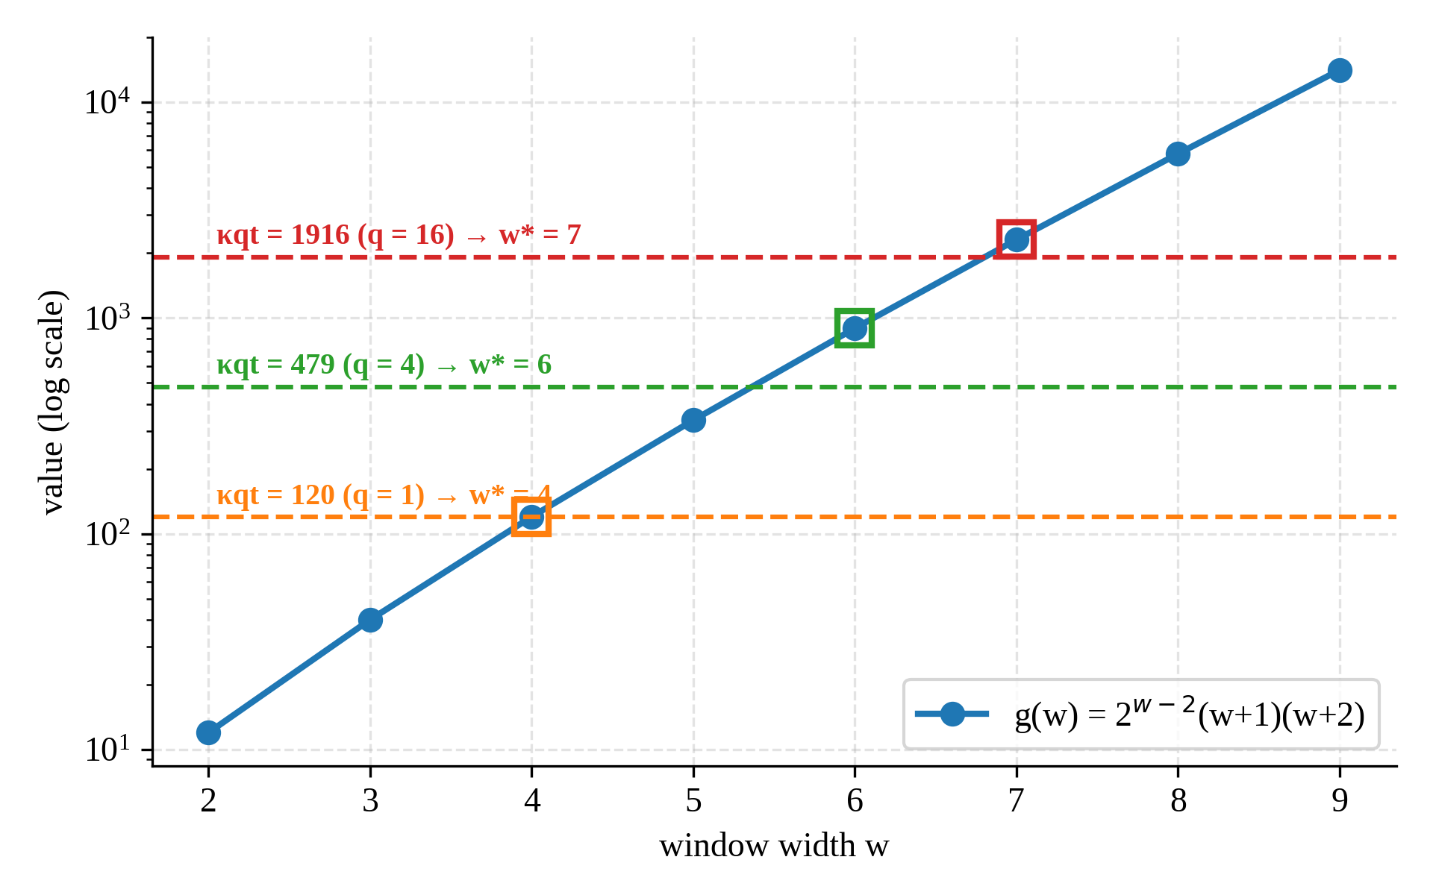
Fig. 1. The function g(w) and the thresholds κqt for t = 256 and κ = 0.468; squares mark w∗ for each q.
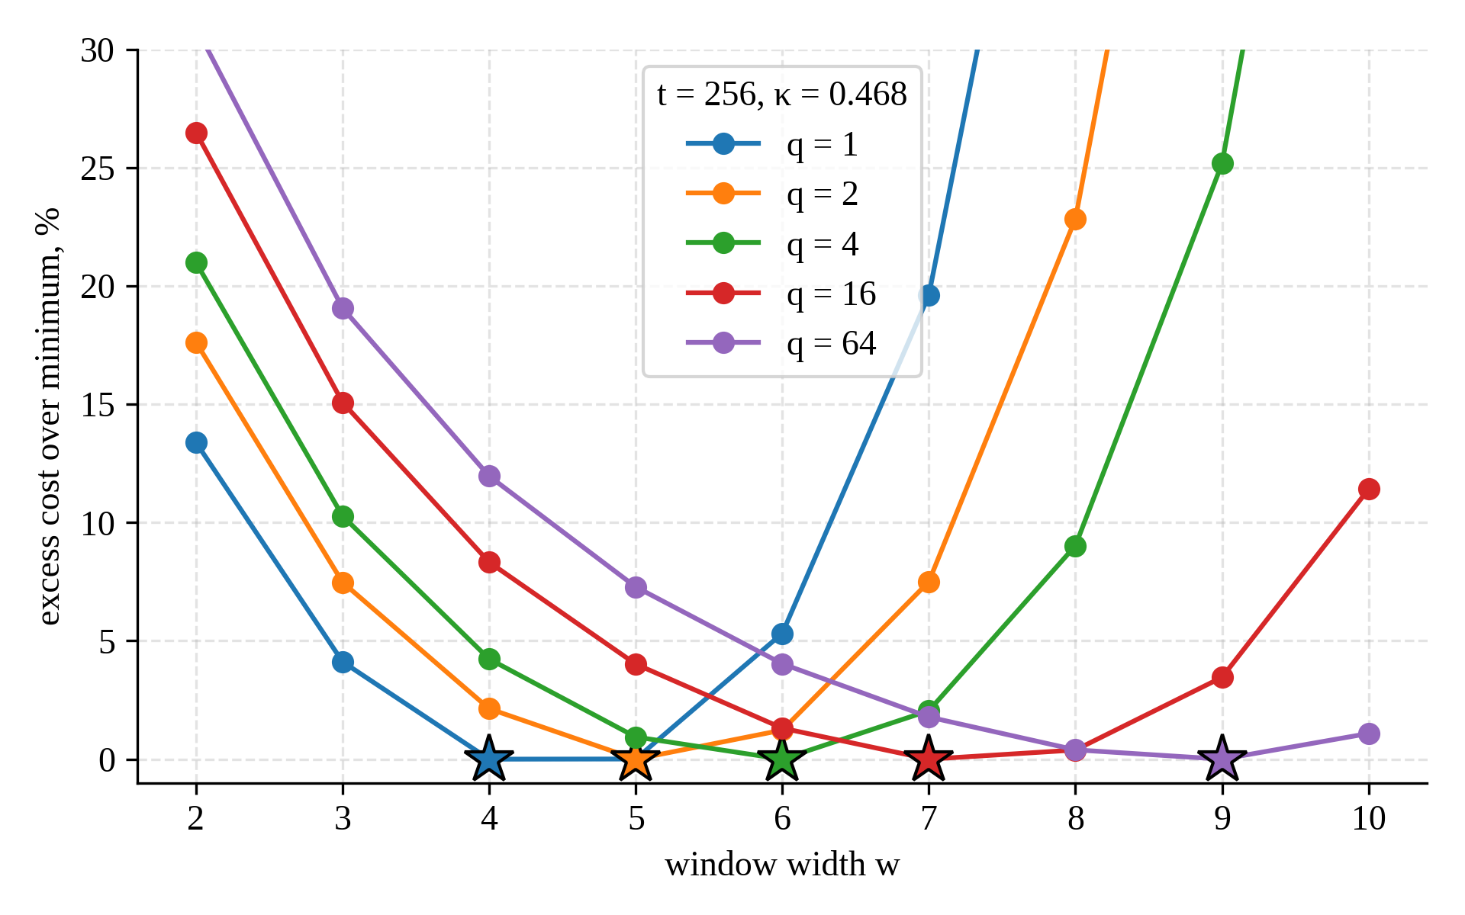
Fig. 2. Model cost (1) relative to its minimum for t = 256 and κ = 0.468; stars mark w∗ from Theorem 1.
Corollary 1. (a) w∗ does not depend on c_{D}. (b) w∗ is non-decreasing in t and in q. (c) Doubling κqt raises w∗ by at most one, because g(w + 1) > 2g(w). (d) w∗ = log₂(κqt) − 2 log₂ log₂(κqt) + O(1). (e) As q → ∞, ΔC(w) < 0 for all w, so the largest table that fits in memory is optimal.
Proposition 2 (near ties). C(w∗ + 1) − C(w∗) = (c_{T}2^{w^{∗}−2}/q)·δ₊, where δ₊ = 1 − κqt/g(w∗) ∈ [0, 1).
When κqt is just below g(w∗), the two widths are practically equivalent. For t = 256, q = 1 and κ = 0.468, κqt = 119.8 against g(4) = 120, so δ₊ ≈ 0.0017 and C(5) − C(4) ≈ 0.007c_{T}, less than 1% of one doubling.
Corollary 2 (robustness to κ). w∗ = w if and only if κ ∈ (g(w − 1)/(qt), g(w)/(qt)]. If an estimate κ̂ satisfies κ/2 ≤ κ̂ ≤ 2κ, the selected width differs from the optimum by at most one.
This follows from Corollary 1(c).

4.3. Memory budget
With m_{P} bytes per affine point (64 bytes for a 256-bit field), the table beyond P occupies M(w) = m_{P}(2^{w−2} − 1) bytes, so M(w) ≤ B if and only if
$w≤w_{B}=2+⌊log_{2}(1+B/m_{P})⌋.$ (6)
Theorem 2 (memory-constrained optimum). The minimum of C(w) over 2 ≤ w ≤ w_{B} is attained at min(w∗, w_{B}).
Proof. If w∗ ≤ w_{B} the global minimiser is feasible. Otherwise [2, w_{B}] ⊂ [2, w∗], where C is strictly decreasing by Theorem 1. ∎
The loss caused by the budget is −ΣΔC(w) over w = w_{B}, …, w∗ − 1, available in closed form from (5).

4.4. GLV decomposition
With k ≡ k₁ + k₂λ (mod n) and |k₁|, |k₂| = O(√n) [16], the two half-scalars are recoded with the same w and interleaved; the second table is obtained from the first by Φ at cost c_{φ} per point. Let t_{GLV} = E[ℓ₁ + ℓ₂] be the expected total length of the two recodings.
Corollary 3 (GLV). Theorems 1 and 2 hold with t replaced by t_{GLV} and κ by κ_{GLV} = c_{A}/(c_{T} + c_{φ}) ≤ κ.
Proof. By Lemma 1 the main loop performs t_{GLV}/(w + 1) + O(1) additions; the max(ℓ₁, ℓ₂) − 1 doublings do not depend on w, and each table point costs c_{T} + c_{φ}. The proof of Theorem 1 then applies verbatim. ∎
Thus GLV halves the doublings but does not raise the optimal width, since the total number of additions is unchanged.

4.5. Regular recoding and fixed-base tables
Proposition 3 (regular recoding). For a regular signed recoding with ⌈t/w⌉ odd digits in {±1, ±3, …, ±(2^{w} − 1)} and a table of 2^{w−1} points [24], [37], the cost with d = t/w is unimodal in w with minimiser
$w_{reg}^{*}=min\{w≥2 : 2^{w-1}w(w+1)≥κqt\}.$ (7)
Proof. ΔC_{reg}(w) = c_{A}t(1/(w + 1) − 1/w) + c_{T}2^{w−1}/q = (c_{T}2^{w−1}/q)(1 − κqt/(2^{w−1}w(w + 1))), and 2^{w−1}w(w + 1) is strictly increasing. ∎
For t = 256 and q = 1 this gives w_{reg}∗ = 4, with 64 additions instead of about 50 for wNAF, a constant-time premium of roughly 6–7% of the total cost.
Proposition 4 (break-even). Write the cost of a configuration as T_{q} = R + P_{tab}/q, with R the per-use part and P_{tab} the table cost. If R_{c} < R_{a} and P_{c} > P_{a}, configuration c is cheaper than a if and only if q > q∗ = (P_{c} − P_{a})/(R_{a} − R_{c}).
The proof is a rearrangement of R_{c} + P_{c}/q < R_{a} + P_{a}/q.

4.6. Selection algorithm
Theorems 1 and 2 give a selection procedure that needs only κ, which two micro-benchmarks provide (the times of a mixed addition and of a full addition plus normalisation).
Algorithm 1. Window width selection
Input: t (t_GLV for GLV), q (may be ∞), B, m_P, κ
Output: w*_B
1. if B = ∞ then w_B ← ∞ else w_B ← 2 + ⌊log2(1 + B/m_P)⌋
2. w ← 2
3. while w < w_B and (q = ∞ or g(w) < κ·q·t): w ← w + 1
4. return w
The algorithm runs in O(log(κqt)) arithmetic operations, whereas exhaustive selection requires a statistically reliable benchmark of every candidate on every platform.

5. Experimental Methodology
Implementation. All algorithms were implemented in Python on top of the gmpy2 multiple-precision library [30], sharing one module for the field arithmetic and the Jacobian formulas of Table 1. Each algorithm is split into recoding, table construction (with simultaneous normalisation) and main loop, and the three phases are timed separately. A separate counting mode records every D, A_{J}, A, N, I and Φ call without affecting the timed runs. The implemented methods are Binary, NAF, wNAF (w = 3, …, 8), fixed-window (w = 2, …, 6), the Montgomery ladder, GLV + interleaved wNAF (w = 3, …, 6; secp256k1 only) and the Lim–Lee comb (w = 2, …, 8; fixed base only). OpenSSL 4.0.3 (through the cryptography package) [29] and libsecp256k1 (through coincurve 21.0.0) [28] served as production references.
Correctness. Every algorithm was checked against an independent affine double-and-add reference with Fermat inversion, against the curve equation, and against the library outputs; the reference itself was verified on a textbook example over F₁₇ ([13]P = (16, 4) on y² = x³ + 2x + 2). All 1,441 tests passed.
Platform. Windows 11 (build 26200), an Intel processor of the Raptor Lake family (family 6, model 183, 28 logical threads) [exact model], Python 3.13.18 and gmpy2 2.3.2.
Design. Two curves (secp256k1 with a = 0 [5]; P-256 with a = −3 [3], [4]) and two scenarios were studied. In the variable-base scenario a fresh random point was used for each scalar and the scalar length took the values t ∈ {64, 128, 192, 256}; in the fixed-base scenario the generator G and t = 256 were used. For each curve, scenario and length, 50 random scalars of exactly t bits were drawn and each was measured 20 times per configuration, giving 177,000 measurements in total. The order of configurations was shuffled in every repetition to spread frequency drift and cache effects, each configuration was warmed up three times, garbage collection was disabled during timing and times were read with a monotonic nanosecond clock. For a reuse factor q, the cost per multiplication was computed from the measured phases as
$T_{q}=T_{rec}+T_{main}+\frac{T_{pre}}{q},$ (8)
so that one data set covers any q, including q → ∞.
Statistics. For each scalar, the median of its 20 repetitions was taken, which is robust to the right-skewed system delays. A configuration’s time is the mean of its 50 per-scalar medians, with a 95% bootstrap confidence interval from 2,000 resamples of scalars [31]. Speedups relative to Binary are geometric means of paired per-scalar ratios; their significance was tested with the paired Wilcoxon signed-rank test [32] and Holm’s correction for multiple comparisons [33]. The median within-scalar coefficient of variation was 2.2% for P-256 and 9.8% for secp256k1, the latter probably due to the hybrid core architecture; the median half-width of the 95% confidence intervals over all 354 configuration–mode pairs was 0.38% of the mean.
Theorem validation. For every curve, family (wNAF, GLV), length t and q ∈ {1, 2, 4, 16, 64, ∞}, the empirically optimal w (minimum mean T_{q}) was compared with Theorem 1 evaluated in two ways: with the measurement-free κ_{th} = 0.468 of Section 3, and with κ estimated from the timings by non-negative least squares on the operation counts. For GLV, t_{GLV} was estimated from the operation counts through Lemma 1. The loss of the predicted width was defined as (T(w_{pred}) − T(w_{emp}))/T(w_{emp}).

6. Results

6.1. Comparative performance
wNAF with w = 5 was the fastest single-table method at t = 256, 1.22 times faster than Binary on both curves, and GLV + wNAF reached 1.82 times on secp256k1 (Table 2, Fig. 3). All speedups differ significantly from 1 (Wilcoxon with Holm correction, p < 10⁻¹⁰). The Montgomery ladder was 1.56 times slower than Binary, which quantifies the price of its regular structure.
Table 2. Variable base, t = 256, q = 1: mean time in ms [95% bootstrap CI] and speedup over Binary
Method | secp256k1, ms | Speedup | P-256, ms | Speedup
Binary | 2.403 [2.385, 2.423] | 1.00 | 2.346 [2.335, 2.357] | 1.00
NAF | 2.174 [2.165, 2.183] | 1.11 | 2.126 [2.117, 2.135] | 1.10
wNAF, w = 4 | 1.987 [1.980, 1.993] | 1.21 | 1.937 [1.932, 1.942] | 1.21
wNAF, w = 5 | 1.973 [1.967, 1.980] | 1.22 | 1.924 [1.919, 1.927] | 1.22
wNAF, w = 6 | 2.028 [2.022, 2.034] | 1.18 | 1.977 [1.972, 1.981] | 1.19
Fixed-window, w = 4 | 2.068 [2.062, 2.074] | 1.16 | 2.007 [2.004, 2.010] | 1.17
Montgomery ladder | 3.752 [3.744, 3.761] | 0.64 | 3.668 [3.667, 3.670] | 0.64
GLV + wNAF, w = 5 | 1.318 [1.313, 1.323] | 1.82 | — | —
OpenSSL 4.0.3 | 1.036 [1.033, 1.039] | 2.32 | 0.212 [0.211, 0.213] | 11.08
libsecp256k1 | 0.232 [0.231, 0.234] | 10.34 | — | —

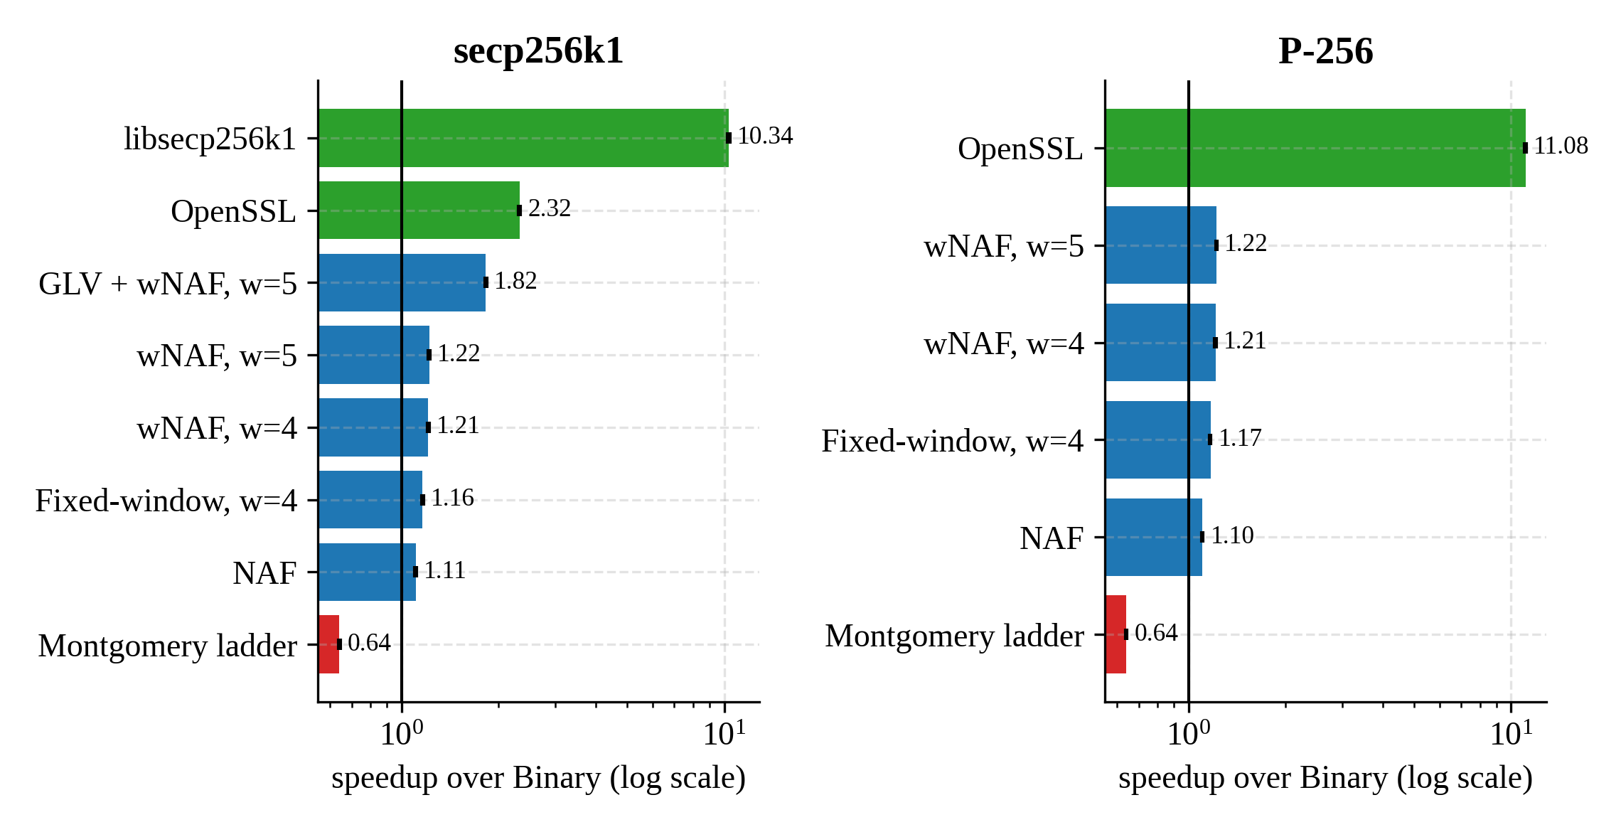
Fig. 3. Speedup over Binary at t = 256, variable base, q = 1 (log scale, 95% bootstrap CI). Red: slower than Binary; green: production libraries.
The production libraries ran in constant time, independent of t. OpenSSL was 4.9 times faster on P-256 than on secp256k1, consistent with its dedicated P-256 implementation [27]. For the fixed base with the table reused, the comb with w = 8 needed 0.537 ms on secp256k1 (4.45 times faster than Binary), but 5.50 ms when its table was rebuilt for each call. By Proposition 4, the comb table pays off against wNAF (w = 5) after 1.2 uses for w = 4 and after 3.7 uses for w = 8 (Fig. 4).
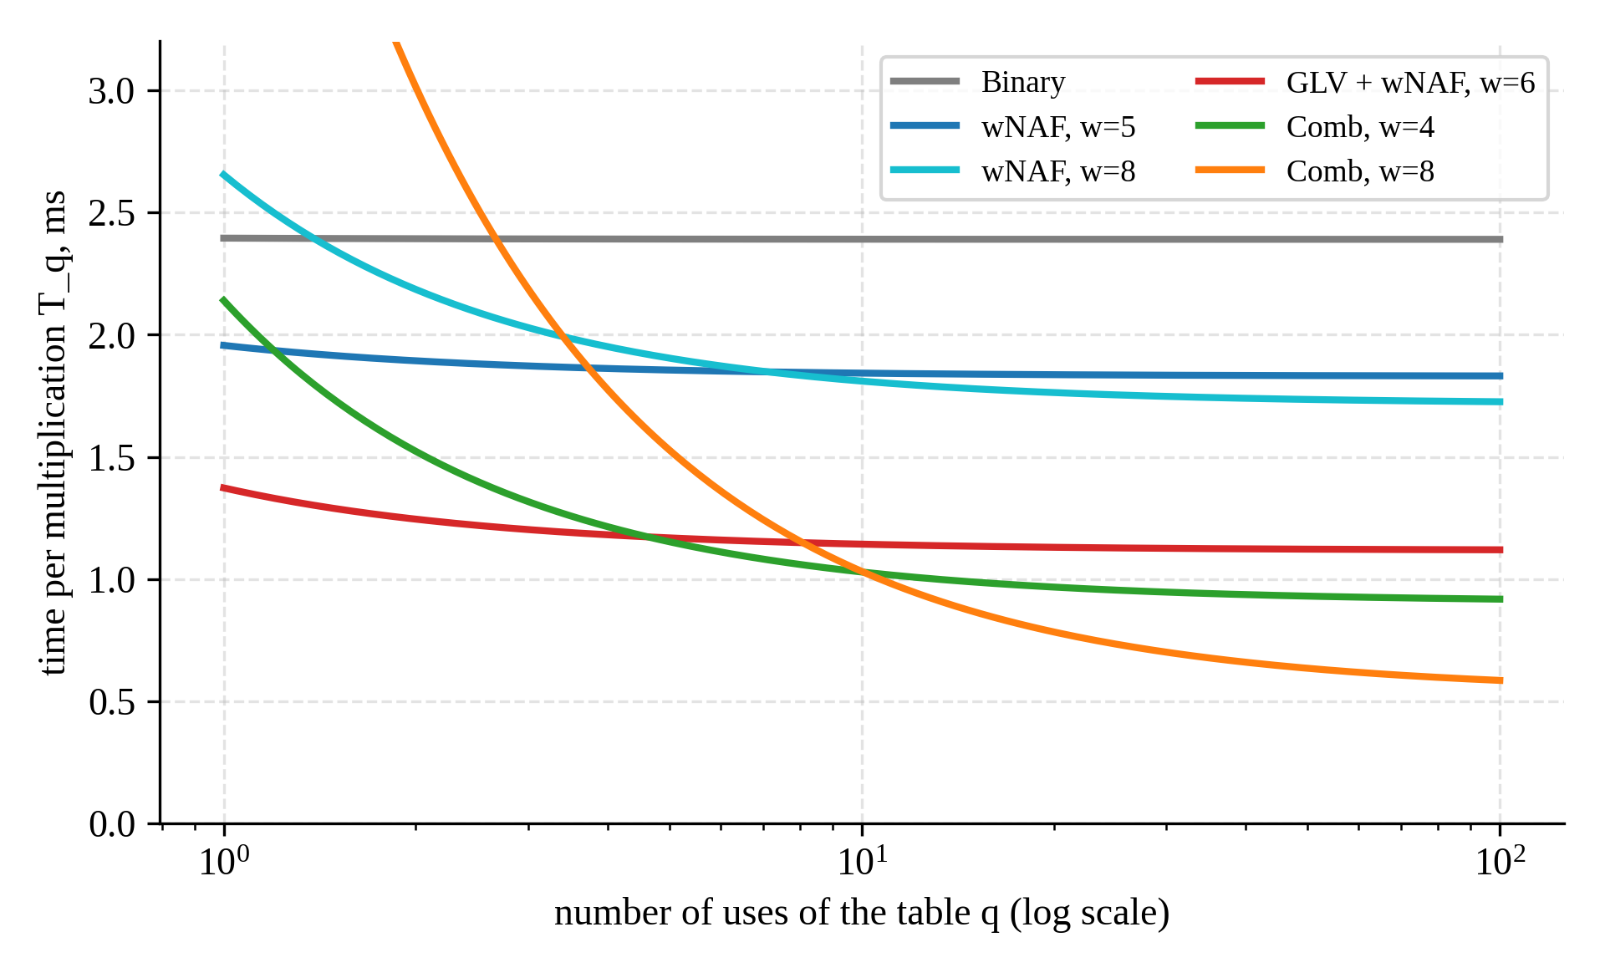
Fig. 4. Fixed base on secp256k1: time per multiplication as a function of the number of uses of the precomputed table.

6.2. Operation counts, density and variance
The measured operation counts matched the expressions of Section 3. At t = 256 the mean number of nonzero wNAF digits differed from t/(w + 1) by 0.6–2.1%, and over all t and w the absolute difference stayed between 0.19 and 0.97 digits, as the O(1) term of Lemma 1 predicts. The sample standard deviations agreed with √(2t/(w + 1)³) of Proposition 1 within 8% (for example 2.00 against 2.02 at w = 4), inside the roughly 7% sampling error of a standard deviation estimated from 100 scalars; the empirical distributions follow the normal approximation (Fig. 5). For Binary, the main-loop time correlated with the Hamming weight of the scalar (r = 0.963 on secp256k1 and 0.994 on P-256), a direct illustration of its timing leakage [21].
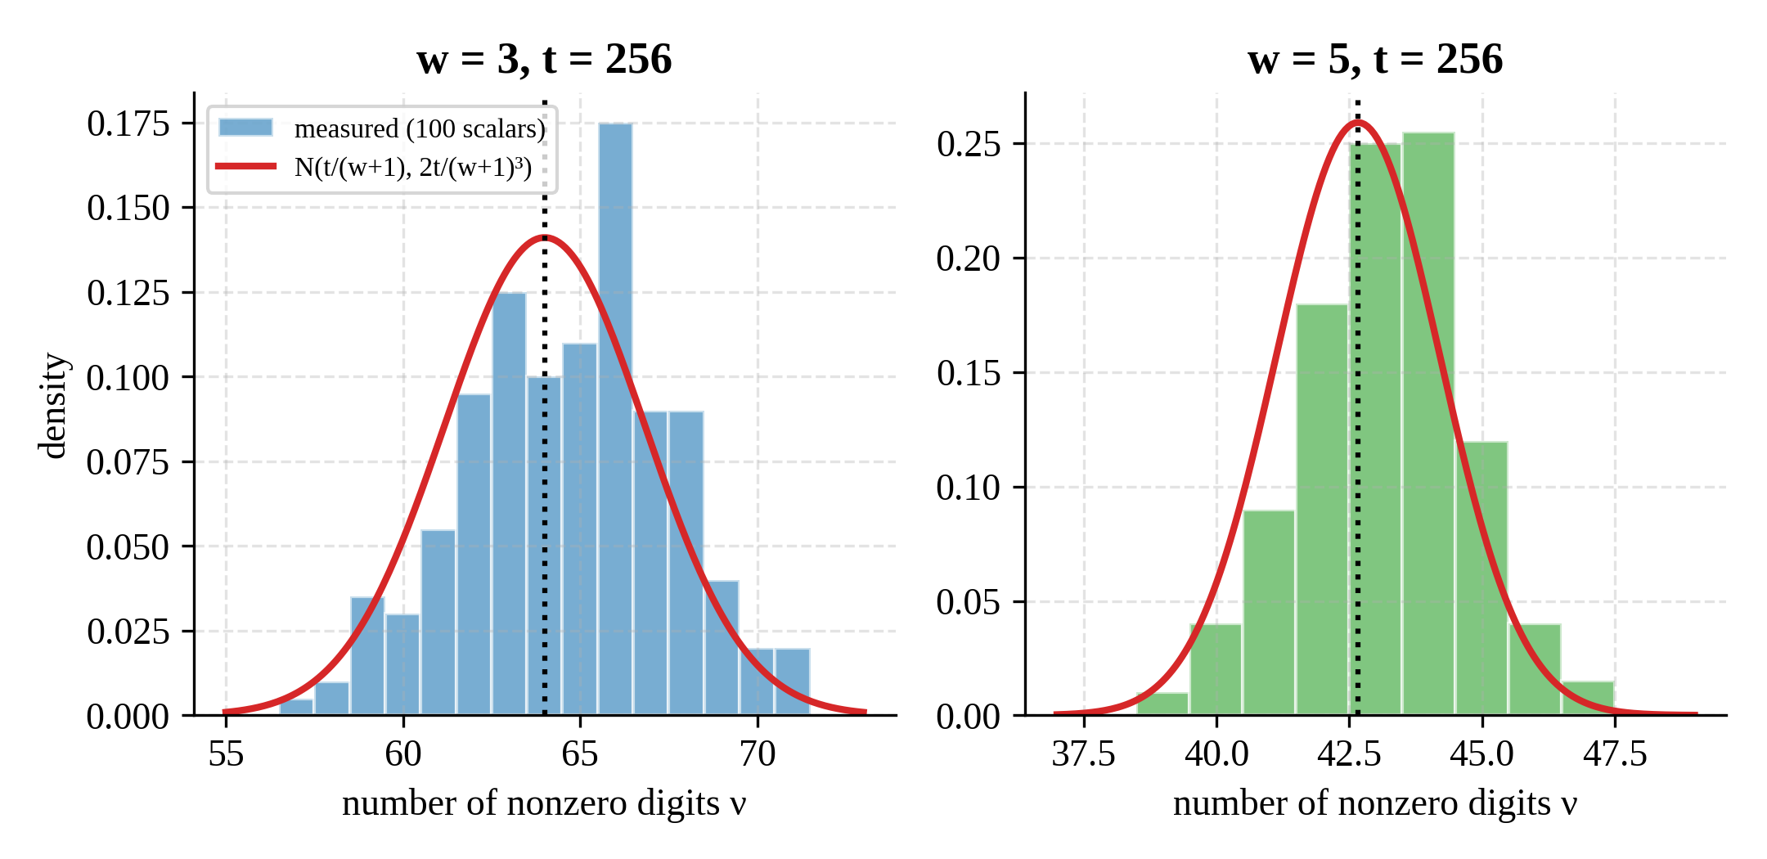
Fig. 5. Distribution of the number of nonzero wNAF digits at t = 256 (100 scalars) and the normal approximation of Proposition 1.

6.3. Validation of Theorem 1
The regression on operation counts gave κ = 0.504 for secp256k1 and 0.467 for P-256, within 8% and 0.3% of κ_{th} = 0.468. The doubling-to-mixed-addition cost ratio, by contrast, was 0.75–0.81 against 0.59–0.69 in theory, because interpreter overhead flattens the costs; Theorem 1 is insensitive to this because it depends on κ only.
Table 3. Agreement of Theorem 1 with the empirical optimum for q ∈ {1, 2, 4, 16, 64}
Family | Cases | Exact (κ_{th}) | Within ±1 (κ_{th}) | Mean / max loss, % (κ_{th}) | Exact (fitted κ) | Mean / max loss, % (fitted κ)
wNAF | 40 | 31 | 40 | 0.16 / 1.70 | 34 | 0.09 / 0.98
GLV + wNAF | 20 | 18 | 20 | 0.08 / 0.90 | 17 | 0.16 / 1.63
Total | 60 | 49 | 60 | 0.13 / 1.70 | 51 | 0.11 / 1.63

With the measurement-free κ_{th}, the predicted width was exact in 49 of 60 cases and one step away in the remaining 11 (Table 3). In all 12 cases with q → ∞ the largest tested table was optimal, as Corollary 1(e) states. For GLV, using t_{GLV} (68, 245, 259 and 260 bits for t = 64, 128, 192 and 256) instead of the nominal t raised the agreement from 14–15 to 18 of 20 cases. Table 4 and Figs. 6–7 show the full comparison.
Table 4. Empirical / predicted optimal width on secp256k1 (κ_{th} = 0.468); ∗ marks a mismatch
Family | t | q = 1 | q = 2 | q = 4 | q = 16 | q = 64
wNAF | 64 | 3 / 3 | 4 / 4 | 5 / 4∗ | 6 / 6 | 8 / 7∗
wNAF | 128 | 4 / 4 | 5 / 4∗ | 6 / 5∗ | 7 / 7 | 8 / 8
wNAF | 192 | 4 / 4 | 5 / 5 | 6 / 6 | 7 / 7 | 8 / 8
wNAF | 256 | 5 / 4∗ | 5 / 5 | 6 / 6 | 7 / 7 | 8 / 8
GLV + wNAF | 64 | 3 / 3 | 4 / 4 | 5 / 5 | 6 / 6 | 6 / 6
GLV + wNAF | 128 | 4 / 4 | 5 / 5 | 6 / 6 | 6 / 6 | 6 / 6
GLV + wNAF | 192 | 5 / 4∗ | 5 / 5 | 6 / 6 | 6 / 6 | 6 / 6
GLV + wNAF | 256 | 5 / 4∗ | 5 / 5 | 6 / 6 | 6 / 6 | 6 / 6

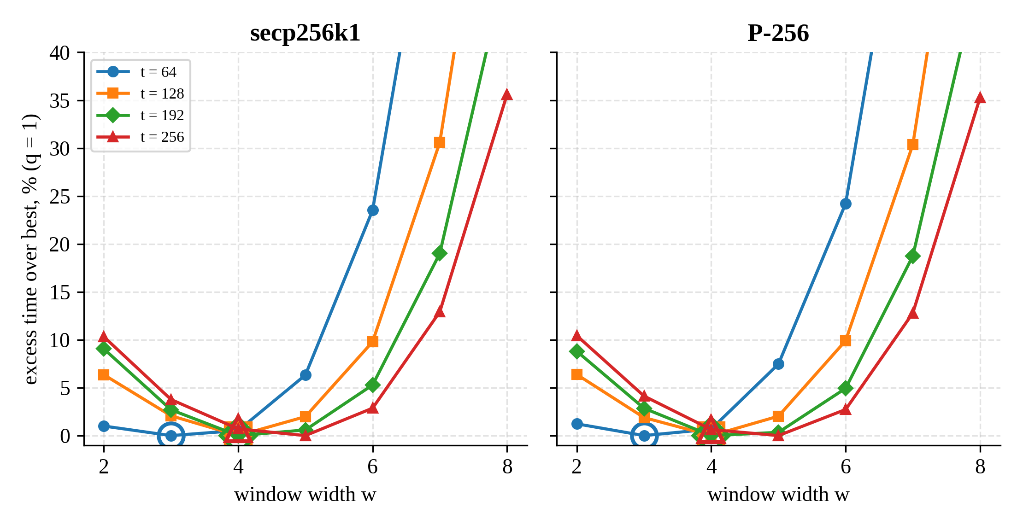
Fig. 6. Excess time over the best width at q = 1; large hollow markers show w∗ predicted by Theorem 1 with κ_{th}.
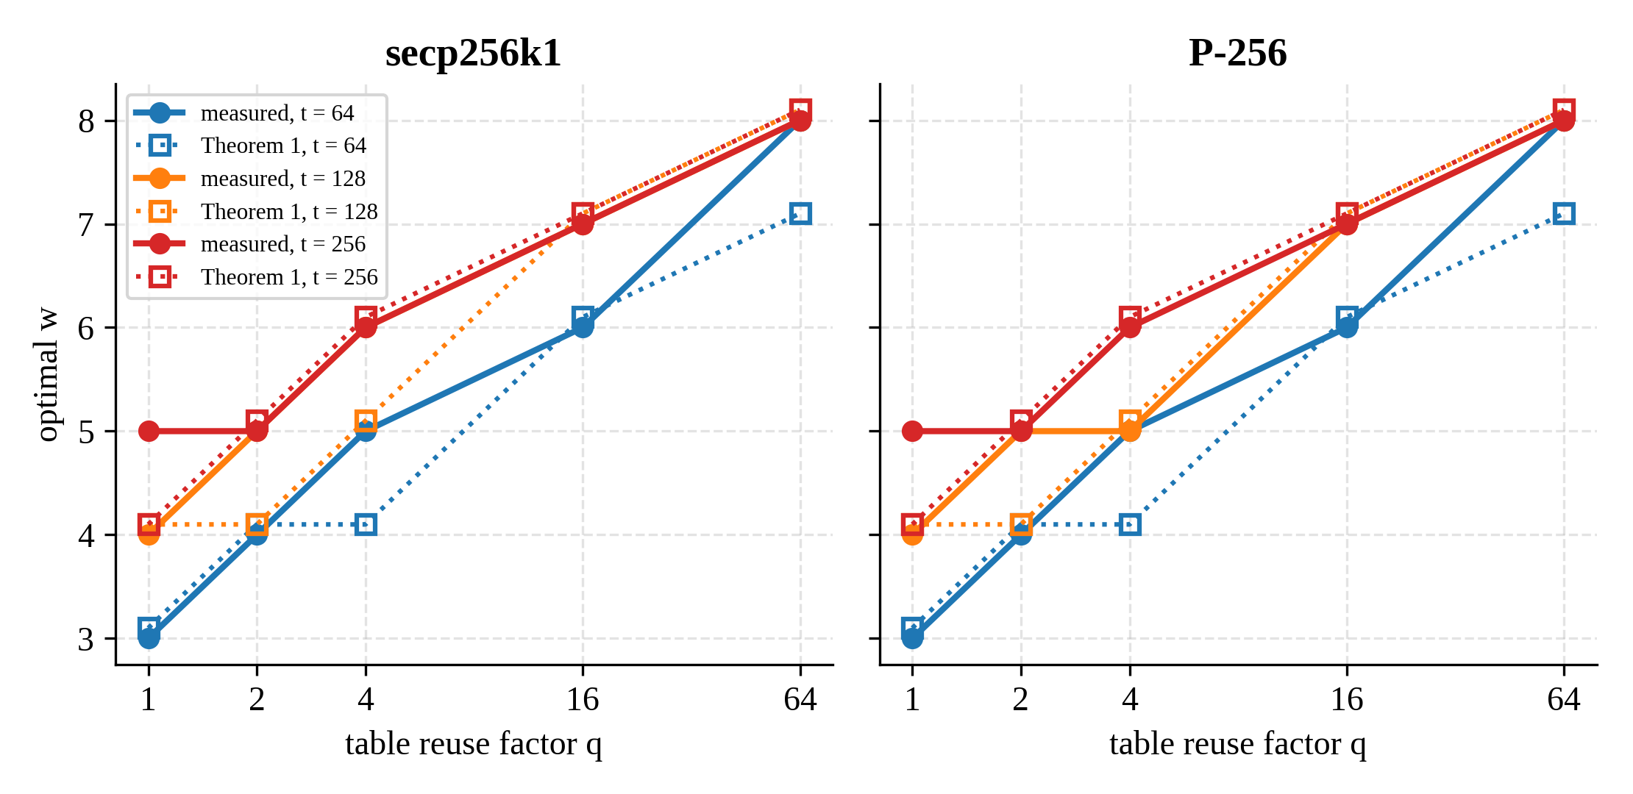
Fig. 7. Optimal window width versus the table reuse factor q: measurements (solid) and Theorem 1 (dotted, slightly offset for visibility).
The mismatches are near ties in the sense of Proposition 2. At t = 256 and q = 1, for instance, κ_{th}t = 119.8 lies just below g(4) = 120; the model rates w = 4 and w = 5 as equal, and the measured difference was 0.70% on secp256k1 and 0.63% on P-256. P-256 gave the same picture as secp256k1. The approximate fixed-window rule 2^{w}w(w + 1) ≥ κ′qt with κ′ = c_{A}/(c_{A} + c_{N}) = 0.6 predicted w = 3, 3, 4, 4 for t = 64, …, 256, against the empirical 2, 3, 4, 4, the single miss being a 1.0–1.2% near tie.

6.4. Sensitivity to κ
The rule is robust to errors in κ, as Corollary 2 guarantees (Table 5, Fig. 8). Even with κ misjudged by a factor of two in either direction, the mean loss over the 40 wNAF cases stayed below 1% and the maximum below 2.2%.
Table 5. Effect of misestimating κ (wNAF, 40 cases)
κ / κ_{th} | κ | Exact matches | Mean loss, % | Max loss, %
0.50 | 0.234 | 10 / 40 | 0.97 | 2.20
0.70 | 0.328 | 23 / 40 | 0.41 | 2.20
0.85 | 0.398 | 27 / 40 | 0.25 | 1.70
1.00 | 0.468 | 31 / 40 | 0.16 | 1.70
1.20 | 0.561 | 37 / 40 | 0.04 | 0.98
1.50 | 0.702 | 31 / 40 | 0.07 | 0.68
2.00 | 0.936 | 23 / 40 | 0.27 | 1.10

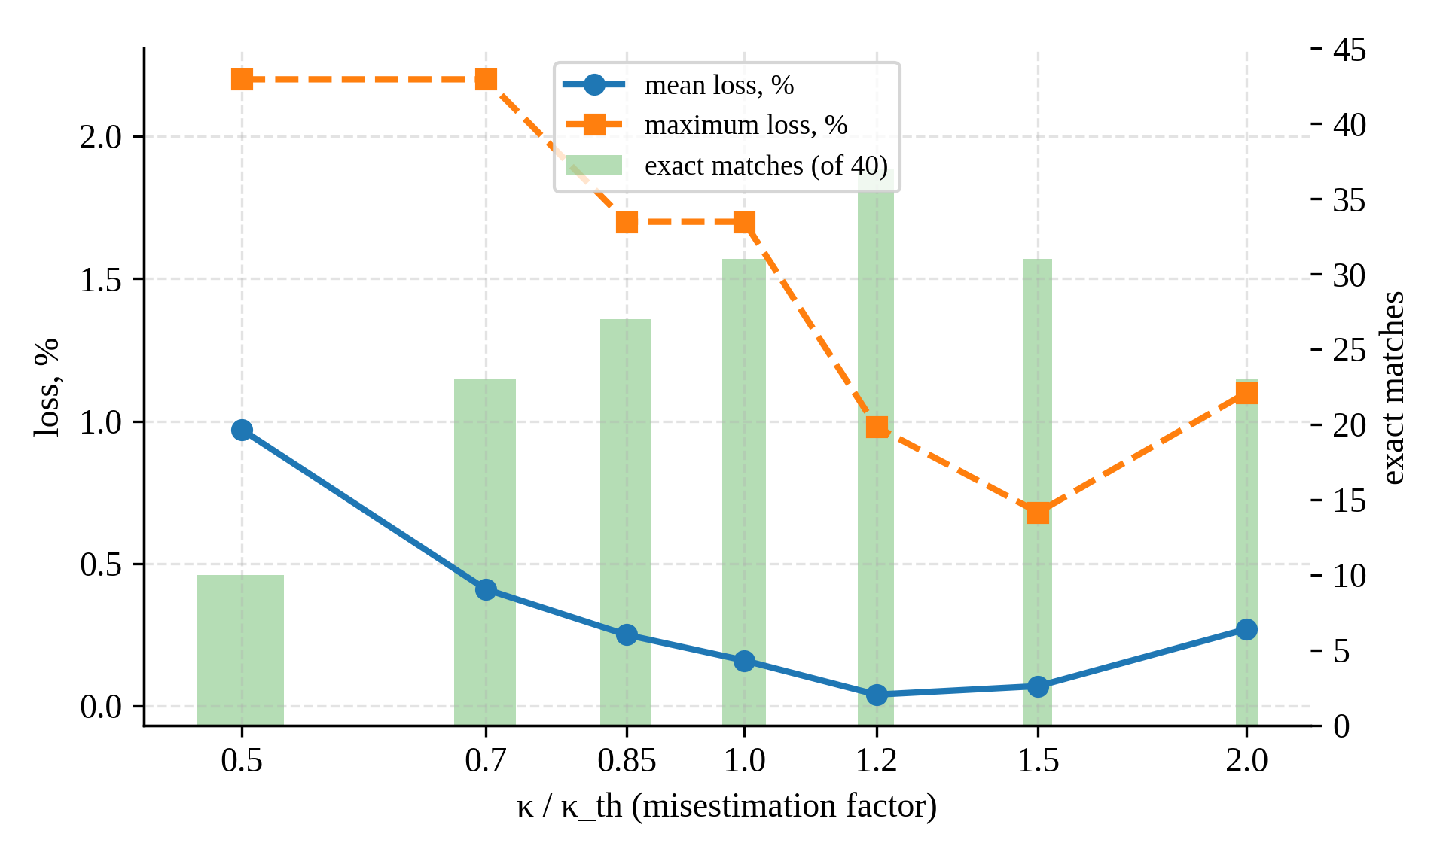
Fig. 8. Sensitivity of the selected width to errors in κ.

6.5. Memory budget
Theorem 2 was checked for budgets B ∈ {0, 64, 128, 256, 512, 1024, 2048, 4096} bytes, q ∈ {1, ∞}, all t and both curves (m_{P} = 64 bytes). The predicted choice was exact in 124 of 128 cases, with a maximum loss of 0.68%; the four misses were the P-256 near tie at t = 256, q = 1. With q = 1, a budget of 256 bytes came within 0.7% of the unconstrained optimum, whereas the table-free NAF was about 10% slower (Fig. 9). The model also predicted the size of the loss: at q = 4 and B = 256 bytes it gave 4.19% against a measured 4.30%. Python objects occupied 2.6–6.3 times the nominal table size, but the ratio was roughly constant across widths, so the model ranks the widths correctly once m_{P} is set for the platform.
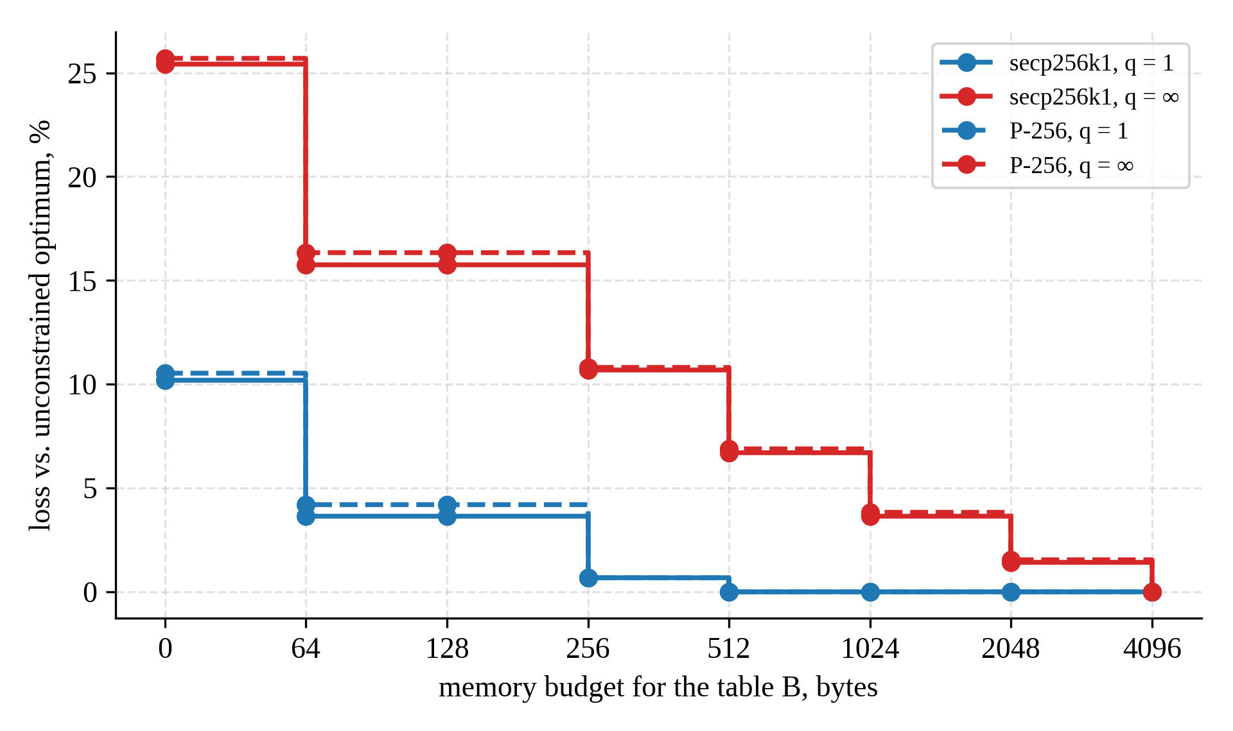
Fig. 9. Loss relative to the unconstrained optimum as a function of the memory budget (t = 256).

6.6. Execution-time prediction
Two linear models were fitted with non-negative coefficients: model A uses the six operation counts and t (8 parameters); model B uses the field-operation cost F in M-equivalents (Table 1, inversion = 100M) and t:
$T=β_{0}+β_{1}F+β_{2}t.$ (9)
Table 6 reports their accuracy under three validation schemes, including cross-validation grouped by scalar so that no scalar appears in both training and test folds [34].
Table 6. Prediction accuracy (per-scalar median times; 4,550 observations for secp256k1 and 3,550 for P-256)
Curve | Model | Validation | R² | MAE, ms | MAPE, %
secp256k1 | A (8 parameters) | unseen scalars, grouped 5-fold | 0.9972 | 0.030 | 2.03
secp256k1 | B (3 parameters) | unseen scalars, grouped 5-fold | 0.9927 | 0.047 | 3.09
secp256k1 | A (8 parameters) | leave-one-configuration-out | 0.9765 | 0.060 | 3.66
secp256k1 | B (3 parameters) | leave-one-configuration-out | 0.9898 | 0.052 | 3.37
secp256k1 | B (3 parameters) | extrapolation t < 256 → 256 | 0.9647 | 0.075 | 4.53
P-256 | A (8 parameters) | unseen scalars, grouped 5-fold | 0.9977 | 0.029 | 1.79
P-256 | B (3 parameters) | unseen scalars, grouped 5-fold | 0.9944 | 0.035 | 1.94
P-256 | A (8 parameters) | leave-one-configuration-out | 0.9788 | 0.058 | 3.09
P-256 | B (3 parameters) | leave-one-configuration-out | 0.9884 | 0.043 | 2.26
P-256 | B (3 parameters) | extrapolation t < 256 → 256 | 0.9876 | 0.037 | 1.56

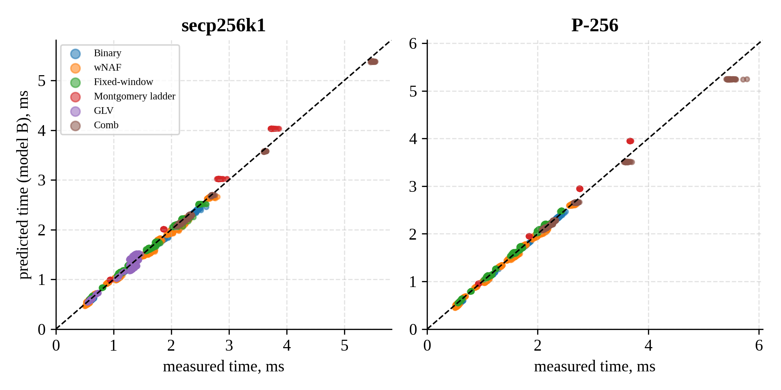
Fig. 10. Model B: predicted versus measured time on scalars not used for fitting (grouped 5-fold cross-validation).
The three-parameter model generalised better than model A to unseen configurations. Its coefficient β₁ (0.64–0.67 μs per field multiplication) agreed with the mixed-addition time divided by 10.2M. The largest errors occurred for the Montgomery ladder, which the model overestimated by 6–7% because full additions are relatively cheaper in an interpreted setting than Table 1 assumes (Fig. 10).

7. Discussion
What the rule changes in practice. Theorem 1 turns window selection from a per-platform search into a one-line computation from t, q, B and a single cost ratio. Because κ is a ratio of two addition-type costs, platform overheads largely cancel: interpreter overhead changed the doubling-to-addition ratio by 17–27% in our setting but κ by at most 8%. Corollary 2 and Table 5 show that even a rough κ is enough, and the measurement-free value 0.468 lost at most 1.7% across all tested cases.
Transfer to compiled libraries. In compiled code the costs track field-operation counts more closely, so κ_{th} should be at least as accurate there. As an external check, the libsecp256k1 source fixes the variable-base wNAF width at 5 [28]; with GLV, t_{GLV} ≈ 256 and q = 1, Corollary 3 places the optimum at 4–5, on the near-tie boundary of Proposition 2. The large precomputed generator tables used by such libraries agree with Corollary 1(e). For the two-scalar operation [u₁]G + [u₂]Q of signature verification, the cost separates into a G part and a Q part, so the same arguments give w_{Q} = w∗(t, κ, 1) for the variable point and the largest feasible width for G.
Constrained devices. On microcontrollers the memory model M(w) = m_{P}(2^{w−2} − 1) is exact with m_{P} = 64 bytes for 256-bit fields, and Theorem 2 applies directly: 512 bytes give w_{B} = 5 and reach the one-off optimum, while 128 bytes give w = 3 and a predicted loss of about 4%. Expensive inversions raise c_{P0}, which cancels in ΔC(w) and therefore affects only the comparison between the table-free NAF and w = 3.
Limitations. The timings come from a Python implementation, whose absolute speed is 10–20 times below the production libraries and which is not constant-time; the results concern relative performance and the validity of the model, while absolute speed is represented by the library baselines. The measurements were taken on one processor family, and secp256k1 showed higher timing noise (median coefficient of variation 9.8%), mitigated by per-scalar medians and paired comparisons. The fixed-window rule is approximate, and the regular-recoding rule (Proposition 3) was derived but not measured. Validating the rules on compiled code and on microcontrollers is the natural next step.

8. Conclusion
The optimal wNAF window width has a closed form: w∗ = min{w ≥ 2 : 2^{w−2}(w + 1)(w + 2) ≥ κqt}, where κ is the ratio of the mixed-addition cost to the marginal table-point cost. We proved that the expected cost is unimodal in w, that the optimum does not depend on the doubling cost and tolerates a factor-of-two error in κ, and that it extends to memory budgets, GLV decompositions and regular recoding; renewal theory also gave the variance 2t/(w + 1)³ of the number of nonzero digits. On 177,000 measurements over two curves and seven algorithm families, the rule with the measurement-free κ = 0.468 selected the optimal width in 49 of 60 cases and was never more than one step away, at a mean cost of 0.13%, and the memory-constrained rule was exact in 124 of 128 cases. A three-parameter field-operation model predicted execution time on unseen scalars with R² ≥ 0.993. Future work will validate the rules on compiled and embedded implementations and extend them to constant-time recodings and multi-scalar multiplication.

Declarations
Data and code availability. The benchmark source code, the raw measurements (raw.csv, counts.csv, memory.csv), the environment record and the analysis scripts are available at [repository URL or DOI, e.g. Zenodo].
Funding. This work was carried out within the project AL-9624115223 of the National University of Uzbekistan named after Mirzo Ulugbek. [Confirm the funding statement.]
Competing interests. The author(s) declare no competing interests.
Author contributions (CRediT). [Name]: conceptualization, methodology, software, investigation, formal analysis, writing – original draft. [Name]: supervision, writing – review and editing.

References
[1] N. Koblitz, “Elliptic curve cryptosystems,” Math. Comput., vol. 48, no. 177, pp. 203–209, 1987.
[2] V. S. Miller, “Use of elliptic curves in cryptography,” in Advances in Cryptology – CRYPTO ’85, LNCS 218. Springer, 1986, pp. 417–426.
[3] NIST, “Digital Signature Standard (DSS),” FIPS PUB 186-5, 2023, doi: 10.6028/NIST.FIPS.186-5.
[4] L. Chen, D. Moody, A. Regenscheid, A. Robinson, and K. Randall, “Recommendations for discrete logarithm-based cryptography: Elliptic curve domain parameters,” NIST SP 800-186, 2023, doi: 10.6028/NIST.SP.800-186.
[5] Certicom Research, “SEC 2: Recommended elliptic curve domain parameters,” version 2.0, 2010.
[6] D. Hankerson, A. Menezes, and S. Vanstone, Guide to Elliptic Curve Cryptography. New York, NY, USA: Springer, 2004.
[7] H. Cohen, G. Frey, et al., Handbook of Elliptic and Hyperelliptic Curve Cryptography. Boca Raton, FL, USA: Chapman & Hall/CRC, 2005.
[8] J. A. Solinas, “Efficient arithmetic on Koblitz curves,” Des. Codes Cryptogr., vol. 19, pp. 195–249, 2000.
[9] J. A. Muir and D. R. Stinson, “Minimality and other properties of the width-w nonadjacent form,” Math. Comput., vol. 75, no. 253, pp. 369–384, 2006.
[10] B. Möller, “Algorithms for multi-exponentiation,” in Selected Areas in Cryptography – SAC 2001, LNCS 2259. Springer, 2001, pp. 165–180.
[11] D. J. Bernstein and T. Lange, “Analysis and optimization of elliptic-curve single-scalar multiplication,” Contemp. Math., vol. 461, pp. 1–20, 2008.
[12] D. J. Bernstein and T. Lange, “Explicit-Formulas Database.” [Online]. Available: https://www.hyperelliptic.org/EFD/
[13] H. Cohen, A. Miyaji, and T. Ono, “Efficient elliptic curve exponentiation using mixed coordinates,” in Advances in Cryptology – ASIACRYPT ’98, LNCS 1514. Springer, 1998, pp. 51–65.
[14] P. L. Montgomery, “Speeding the Pollard and elliptic curve methods of factorization,” Math. Comput., vol. 48, no. 177, pp. 243–264, 1987.
[15] M. Joye and S.-M. Yen, “The Montgomery powering ladder,” in CHES 2002, LNCS 2523. Springer, 2003, pp. 291–302.
[16] R. P. Gallant, R. J. Lambert, and S. A. Vanstone, “Faster point multiplication on elliptic curves with efficient endomorphisms,” in Advances in Cryptology – CRYPTO 2001, LNCS 2139. Springer, 2001, pp. 190–200.
[17] C. H. Lim and P. J. Lee, “More flexible exponentiation with precomputation,” in Advances in Cryptology – CRYPTO ’94, LNCS 839. Springer, 1994, pp. 95–107.
[18] P. Longa and C. Gebotys, “Efficient techniques for high-speed elliptic curve cryptography,” in CHES 2010, LNCS 6225. Springer, 2010, pp. 80–94.
[19] J. Renes, C. Costello, and L. Batina, “Complete addition formulas for prime order elliptic curves,” in Advances in Cryptology – EUROCRYPT 2016, LNCS 9665. Springer, 2016, pp. 403–428.
[20] E. Brier and M. Joye, “Weierstraß elliptic curves and side-channel attacks,” in PKC 2002, LNCS 2274. Springer, 2002, pp. 335–345.
[21] P. C. Kocher, “Timing attacks on implementations of Diffie-Hellman, RSA, DSS, and other systems,” in Advances in Cryptology – CRYPTO ’96, LNCS 1109. Springer, 1996, pp. 104–113.
[22] P. Kocher, J. Jaffe, and B. Jun, “Differential power analysis,” in Advances in Cryptology – CRYPTO ’99, LNCS 1666. Springer, 1999, pp. 388–397.
[23] J.-S. Coron, “Resistance against differential power analysis for elliptic curve cryptosystems,” in CHES ’99, LNCS 1717. Springer, 1999, pp. 292–302.
[24] K. Okeya and T. Takagi, “The width-w NAF method provides small memory and fast elliptic scalar multiplications secure against side channel attacks,” in CT-RSA 2003, LNCS 2612. Springer, 2003, pp. 328–343.
[25] D. J. Bernstein, “Curve25519: New Diffie-Hellman speed records,” in PKC 2006, LNCS 3958. Springer, 2006, pp. 207–228.
[26] D. J. Bernstein, N. Duif, T. Lange, P. Schwabe, and B.-Y. Yang, “High-speed high-security signatures,” J. Cryptogr. Eng., vol. 2, no. 2, pp. 77–89, 2012.
[27] S. Gueron and V. Krasnov, “Fast prime field elliptic-curve cryptography with 256-bit primes,” J. Cryptogr. Eng., vol. 5, no. 2, pp. 141–151, 2015.
[28] Bitcoin Core, “libsecp256k1: Optimized C library for ECDSA signatures and secret/public key operations on curve secp256k1.” [Online]. Available: https://github.com/bitcoin-core/secp256k1
[29] The OpenSSL Project, “OpenSSL: Cryptography and SSL/TLS toolkit.” [Online]. Available: https://www.openssl.org
[30] “gmpy2: Multiple-precision arithmetic for Python.” [Online]. Available: https://github.com/aleaxit/gmpy
[31] B. Efron and R. J. Tibshirani, An Introduction to the Bootstrap. New York, NY, USA: Chapman & Hall, 1993.
[32] F. Wilcoxon, “Individual comparisons by ranking methods,” Biometrics Bull., vol. 1, no. 6, pp. 80–83, 1945.
[33] S. Holm, “A simple sequentially rejective multiple test procedure,” Scand. J. Statist., vol. 6, no. 2, pp. 65–70, 1979.
[34] T. Hastie, R. Tibshirani, and J. Friedman, The Elements of Statistical Learning, 2nd ed. New York, NY, USA: Springer, 2009.
[35] W. Feller, An Introduction to Probability Theory and Its Applications, vol. 2, 2nd ed. New York, NY, USA: Wiley, 1971.
[36] S. Ullah, J. Zheng, N. Din, M. T. Hussain, F. Ullah, and M. Yousaf, “Elliptic curve cryptography; applications, challenges, recent advances, and future trends: A comprehensive survey,” Comput. Sci. Rev., vol. 47, Art. no. 100530, 2023.
[37] M. Joye and M. Tunstall, “Exponent recoding and regular exponentiation algorithms,” in AFRICACRYPT 2009, LNCS 5580. Springer, 2009, pp. 334–349.

