NeX Canonical Domain & Data Model
v2.1
One Canonical Language across Coworker · Work · Plan · Transaction · Work Asset · P/L
Canonical Baseline
물리 DB Table을 먼저 고정하는 문서가 아니라, NeX 전체가 공유할 Entity, Aggregate, Source of Truth, Cardinality, Invariant, Cross-service Reference 의미를 Freeze한다.
Status: CANONICAL DOMAIN BASELINE — v2.1 CP05 | Parent: Platform v2.1 SRS / Master Architecture / ADR Pack

Executive Summary
본 문서는 NeX Platform v2.1 전체 서비스가 공유하는 Canonical Domain Language와 Entity 관계를 고정한다. 물리 PostgreSQL DDL이나 ORM Class가 아니라 무엇이 하나의 Entity인지, 누가 Source of Truth인지, 어떤 관계가 Local FK이고 어떤 관계가 Cross-service Reference인지, 어떤 상태와 이력을 불변으로 보존해야 하는지를 정의한다.
Canonical Rule
Work는 NeX-WC, Agent Runtime/Plan은 NeX-AE-API, Business Transaction/Project/Ledger는 Enterprise OS, Work Asset/Effort Evidence는 NeX-WA, Identity/Role은 NeX-OA가 소유한다. 다른 Context는 stable reference로 연결하고 직접 DB Write하지 않는다.
1. Canonical Modeling Principles
ID | Principle | Meaning
CDM-PRIN-01 | Stable ID와 Business Key를 분리한다. | 모든 주요 Entity는 변경되지 않는 내부 ID를 갖고, 사용자에게 보이는 Code/No는 별도 Business Key로 관리한다.
CDM-PRIN-02 | Bounded Context Ownership을 명확히 한다. | 각 Entity의 Source of Truth는 하나이며 Cross-service에서 같은 Entity를 양방향 수정하지 않는다.
CDM-PRIN-03 | Cross-service Reference와 Local Foreign Key를 구분한다. | 동일 DB/Context 내부는 Local FK를 사용할 수 있지만 다른 서비스 Entity는 stable reference로 연결한다.
CDM-PRIN-04 | Business Effective Time과 Recorded Time을 구분한다. | RoleBinding, 조직/권한 등은 effective_from/to와 created/recorded_at 의미를 구분한다.
CDM-PRIN-05 | 중요한 Definition/Snapshot은 Immutable Version으로 보존한다. | AgentPlan, PlanTemplate, RoutingBinding, Evidence Snapshot 등은 in-place overwrite하지 않는다.
CDM-PRIN-06 | Business Transaction과 Economic Ledger를 분리한다. | Voucher/Labor/Material은 Transaction이고 ProjectFinancialLedgerEntry는 경제효과이다.
CDM-PRIN-07 | Aggregate/Read Model은 Source of Truth가 아니다. | NVT P/L, Team Summary, Work Dashboard는 원천 Event/Ledger에서 재구성 가능해야 한다.
CDM-PRIN-08 | Human/Agent Activity와 Human Effort를 분리한다. | AgentExecution duration, WorkItem lead time, Observed Activity를 Confirmed Human Effort로 직접 간주하지 않는다.
CDM-PRIN-09 | Project Attribution First, Common Work Last를 적용한다. | 실제 Project를 최대한 Resolution하고 정말 특정 Project와 무관한 업무만 Common Work로 귀속한다.
CDM-PRIN-10 | Traceability를 Canonical Relation으로 설계한다. | WorkItem→Execution→Plan/Step→Skill→Approval/Transaction→Artifact→WorkAsset을 correlation/causation/reference로 연결한다.

2. Canonical Domain Map
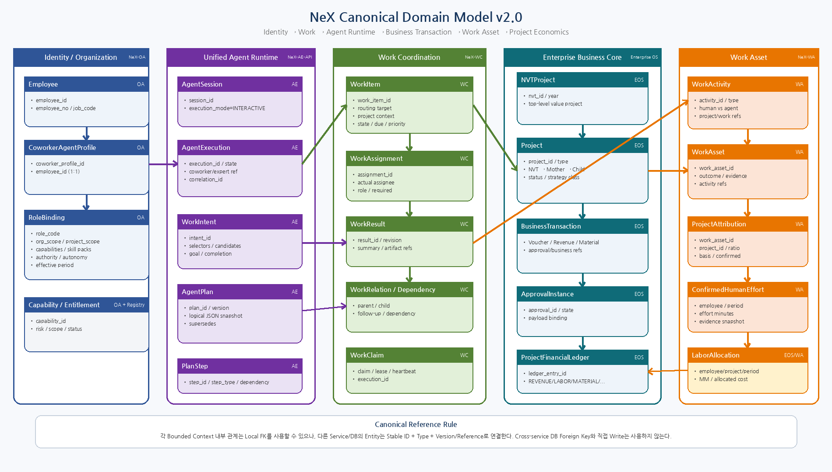
Figure 1. Identity / Agent Runtime / Work Coordination / Enterprise OS / Work Asset를 하나의 Canonical Entity 관계로 연결한 Logical Domain Map.

3. Bounded Context & Data Ownership
Context | Domain | Owned Canonical Entities | Primary Store
NeX-OA | Identity & Authorization | Employee, Organization, RoleBinding, Entitlement, EffectiveAuthorityContext(Tenant/Agent/Scope) | OA DB
NeX-AE-API | Unified Agent Runtime / Agent Registry | AgentIdentity, AgentProfileRef, AgentSession, AgentExecution, WorkIntent, AgentPlan, PlanStep, AgentCheckpoint | AE DB / Agent Registry
Plan Registry | Planning Assets | PlanTemplate, PlanRoutingBinding, PlanExecutionRecord, PlanTemplateStatistics, PlanRoutingStatistics | AE/Registry DB
NeX-WC | Work / Human Workflow / Recurring Work | WorkItem, WorkAssignment, WorkClaim, WorkResult, ApprovalWorkItem, ScheduleSpec, ScheduleOccurrence | WC DB
Skill/Capability | Certified Execution Assets | Capability, Skill semantic artifact, NSPPackage metadata, CertifiedSkillVersion, CapabilityOwnership | Registry / Artifact Store
Enterprise OS | Business Core | NVTProject, Project, BusinessApprovalInstance(when required), Voucher/BusinessTransaction, ProjectFinancialLedgerEntry, EmployeeLaborCostPool, LaborAllocation | EOS DB
NeX-WA | Work Asset | WorkActivity, WorkAsset, ProjectAttribution, EffortAllocation, HumanEffortConfirmation, EvidenceSnapshot, PeriodicWorkReport | WA DB
Artifact/Evidence | Cross-cutting Evidence | Artifact, ArtifactVersion, EvidenceRef, BusinessObjectRef, TraceRef | Artifact service / owner context

4. Canonical Entity Catalog
Entity | Owner | Kind | Canonical Key | Responsibility | Major Relations
Employee | OA | Aggregate Root | employee_id | 직원 Identity와 조직/직무의 기준 Human Principal | Organization membership, CoworkerAgentProfile
CoworkerAgentProfile | OA | Legacy/Employee-bound Security Profile | coworker_profile_id | Employee-bound CA security/profile reference; not generic Agent identity SoR | Employee, RoleBinding, AgentIdentity(CA)
RoleBinding | OA | Entity | role_binding_id | 직원의 복수 직무/역할·Scope·Capability·Autonomy를 Effective-dated로 표현 | Employee/Coworker, Capability
Organization | OA | Aggregate Root | organization_id | 회사 조직단위와 계층 | Employee, RoleBinding, CapabilityOwnership
AgentSession | AE | Entity | session_id | Interactive Workspace/session context; Business/Agent identity SoR 아님 | AgentIdentity(IA), Conversation
AgentExecution | AE | Aggregate Root | execution_id | Unified Agent Runtime의 한 logical execution; 1:N RuntimeJob | AgentIdentity, WorkItem/Claim, WorkIntent, Plan, Checkpoint
WorkIntent | AE | Immutable Value/Object | intent_id | Understand 단계의 구조화된 Goal/Selector/Parameter/Completion Criteria | AgentExecution
AgentPlan | AE | Immutable Versioned Entity | plan_id + version | 실행계획의 Logical JSON IR | AgentExecution, PlanStep
PlanStep | AE | Immutable Entity | plan_id + step_id | LOCAL_CAPABILITY/DELEGATE/AGGREGATE/REPORT 단계 | AgentPlan
PlanStepExecution | AE | Runtime Entity | step_execution_id | PlanStep의 상태, resolved skill, output, retry | PlanStep, AgentExecution
AgentCheckpoint | AE | Snapshot | checkpoint_id | WAITING_* Suspend/Resume를 위한 Context Snapshot | AgentExecution, PlanStep
PlanTemplate | Plan Registry | Aggregate Root | plan_template_id + version | Known Plan의 immutable template | RoutingBinding, ExecutionRecord
PlanRoutingBinding | Plan Registry | Aggregate Root | routing_binding_id + version | Intent/Capability/Condition→PlanTemplate Certified mapping | PlanTemplate
PlanExecutionRecord | Plan Registry | Evidence Entity | plan_execution_id | Template/version 실제 run과 outcome evidence | PlanTemplate, AgentExecution
PlanTemplateStatistics | Plan Registry | Projection | template/version | run/success/failure/replan/diversity 지표 | PlanExecutionRecord
PlanRoutingStatistics | Plan Registry | Projection | binding/version | selection/correction/fallback 지표 | RoutingDecision/Execution
WorkItem | WC | Aggregate Root | work_item_id | 회사가 수행해야 하는 업무의 책임·목표·상태·기한 | Assignments, Results, Relations
WorkAssignment | WC | Entity | assignment_id | 실제 Human/Agent Assignee와 Role/Required 여부 | WorkItem
WorkClaim | WC | Runtime Entity | claim_id | 경쟁 Claim의 Lease/Heartbeat/Execution linkage | WorkItem, AgentExecution
WorkResult | WC | Versioned Entity | result_id + revision_no | 업무 결과/요약/Artifact 참조 | WorkItem
WorkRevisionRequest | WC | Entity | revision_request_id | RESULT_SUBMITTED 이후 보완요청 | WorkItem, WorkResult
WorkRelation | WC | Entity | relation_id | PARENT_CHILD/FOLLOW_UP_OF/RELATED_TO | WorkItem↔WorkItem
WorkDependency | WC | Entity | dependency_id | AgentPlan Step/WorkItem의 wait dependency | WorkItem, AgentExecution/Step
WorkReportRecipient | WC | Entity | recipient_id | FYI/ACK_REQUIRED/REVIEW_REQUIRED | WorkItem
Capability | Registry | Aggregate Root | capability_id | Routing/Permission/Skill Resolution의 공통 업무언어 | RoleBinding, Skill, Ownership
CapabilityOwnership | Registry/WC | Entity | ownership_id | Capability→Owner Org/Pool의 기본 Routing scope | Capability, Organization
CertifiedSkillVersion | Skill | Immutable Versioned Entity | skill_id + version | NSL 기반 Atomic Business Skill 릴리스 | Capability
NVTProject | EOS | Aggregate Root | nvt_id | 연도별 최상위 NURI Value Token Project | Mother Project
Project | EOS | Aggregate Root | project_id | NVT/Mother/Child/Common 구조의 업무·경제 귀속단위 | NVT, Ledger, WorkAsset refs
ApprovalInstance | EOS | Aggregate Root | approval_id | Business Object의 Formal Human Approval state machine | BusinessTransaction
BusinessTransaction | EOS | Abstract Aggregate | business_object_id | Voucher/Revenue/Material 등 실제 Transaction | Project, Approval, Ledger
ProjectFinancialLedgerEntry | EOS | Immutable Posting Entity | ledger_entry_id | Project 손익에 미치는 경제효과 | Project, BusinessTransaction/LaborAllocation
EmployeeLaborCostPool | EOS | Period Aggregate | employee_id + period | 월별 급여/사회보험/퇴직 등 총 인건비 Pool | Employee
LaborAllocation | EOS | Versioned Posting Entity | labor_allocation_id | Confirmed Effort/MM 비율로 Labor Cost Pool을 Project에 배부 | Employee, Project, WA Evidence
WorkActivity | WA | Fact Entity | activity_id | Prompt/Review/Skill/Approval/Meeting 등 관찰가능 업무행위 | Employee/Coworker, Project, WorkItem
WorkAsset | WA | Aggregate Root | work_asset_id | 여러 Activity/Result/Artifact/Evidence를 묶은 업무자산 | ProjectAttribution
ProjectAttribution | WA | Entity | attribution_id | WorkAsset의 Project 귀속/비율/근거/확정상태 | WorkAsset, Project
HumanEffortConfirmation | WA | Entity/Snapshot | effort_confirmation_id | Estimated→Confirmed Human Effort 확정 | Employee, WorkAsset, Period
EffortAllocation | WA | Entity | effort_allocation_id | 하나의 WorkAsset이 여러 Project를 지원할 때 Effort Split | WorkAsset, Project
EvidenceSnapshot | WA | Immutable Snapshot | evidence_snapshot_id | 보고/평가/노무배부 시점의 근거 Freeze | WorkAsset/Artifacts/Outcomes
PeriodicWorkReport | WA | Versioned Entity | report_id + revision | 일/주/월/분기 자동 Draft→Human Submit | Employee/Organization, WorkAsset
AgentIdentity | AE | Aggregate Root | tenant_id + agent_id | IA/CA/PA/EA persistent logical identity/profile; PA project 1:1 invariant | AgentExecution, Project, governance refs
ApprovalWorkItem | WC | Aggregate Root | approval_work_item_id | Human approval workflow/routing/decision lifecycle; NSL binding metadata immutable | AgentExecution/NSLExecution, approver, EOS BusinessApproval ref
ScheduleSpec | WC | Aggregate Root | tenant_id + schedule_id | Durable recurring work definition/policy | ScheduleOccurrence, Project, WorkItem template
ScheduleOccurrence | WC | Runtime/History Entity | tenant_id + schedule_id + nominal_time | One nominal schedule occurrence and idempotent WorkItem materialization | ScheduleSpec, WorkItem
NSPPackage | Skill Artifact Registry | Versioned Artifact | package_ref + exact_version + package_hash | Signed Skill package governed by AG and verified by Skill Artifact Gateway | Skill semantic artifact, Publisher, SigningKey

5. Core Relationship Model
Relationship | Cardinality / Rule
Employee ↔ CoworkerAgentProfile | Employee 1 : 0..1 Active employee-bound CA security profile; PA/EA/IA identities are separate AE AgentIdentity objects
CoworkerAgentProfile ↔ RoleBinding | 1 : N effective-dated bindings
AgentIdentity ↔ AgentExecution | 1 : N; IA/CA/PA/EA logical Agent identity to execution instances
AgentExecution ↔ WorkIntent | 1 : 1 canonical intent snapshot per interpretation cycle
AgentExecution ↔ AgentPlan | 1 : N versioned plans; only one active version per execution
AgentPlan ↔ PlanStep | 1 : N immutable steps
PlanStep ↔ PlanStepExecution | 1 : N attempts/retries possible
WorkItem ↔ AgentExecution | 1 : N; a WorkItem may be retried/revised/delegated
DELEGATE_WORK PlanStep ↔ Child WorkItem | 0..1 generated Child WorkItem per delegation attempt
WorkItem ↔ WorkAssignment/Result/Relation | 1 : N
PlanTemplate ↔ PlanExecutionRecord | 1 version : N runs/evidence
PlanRoutingBinding ↔ PlanTemplate | N bindings : 1 target template version
NVTProject ↔ Project | NVT 1:N Mother; Mother 1:N Child
WorkAsset ↔ WorkActivity | 1:N or M:N via link/projection depending final DD
WorkAsset ↔ ProjectAttribution | 1:N project attribution entries
HumanEffortConfirmation → LaborAllocation | Confirmed/frozen evidence required before cost posting
Project ↔ Project Agent(PA) | Project 1 : 0..1 active PA per tenant/project baseline; PA identity is AE-owned
ScheduleSpec ↔ ScheduleOccurrence ↔ WorkItem | 1:N occurrences; each occurrence materializes at most one semantic WorkItem
ApprovalWorkItem ↔ NSL ApprovalRequest | 1:1 workflow envelope for NSL_WRITE domain; NSL owns binding/evidence semantics
6. Canonical Cross-Service Reference Types
Reference | Minimum Fields | Purpose
EntityRef | entity_type, entity_id | Cross-context Entity의 stable logical reference
BusinessObjectRef | object_type, object_id, version/status | Enterprise OS Transaction 참조
ArtifactRef | artifact_id, version_id | 문서/파일 산출물 참조
EvidenceRef | evidence_type, source_ref, snapshot/hash | 업무 근거 참조
TraceRef | correlation_id, causation_id, execution_id | E2E 실행/원인관계
ProjectRef | project_id, project_type | NVT/Mother/Child/Common Project 참조
Cross-service Referential Integrity
다른 서비스 DB 간 Physical Foreign Key를 만들지 않는다. 대신 owner service의 Stable ID와 entity_type/schema_version/hash/snapshot metadata를 필요한 수준으로 보존하고, 존재/권한/상태 검증은 API 또는 Event Projection으로 수행한다.
7. State Ownership
State Domain | Owner | Canonical Meaning
Agent identity/profile + role | AE Agent Registry + OA | Agent profile status in AE; current RoleBinding/authority in OA
Agent execution state | AE | QUEUED/RUNNING/WAITING_*/SUCCEEDED/FAILED
WorkItem state | WC | CREATED/ASSIGNED/ACKNOWLEDGED/IN_PROGRESS/RESULT_SUBMITTED/CLOSED/...
Approval workflow state | WC | PENDING/APPROVED/REJECTED/EXPIRED/CANCELLED; NSL binding state remains NSL
Business transaction state | EOS Domain | Voucher/PO/etc domain-specific
PlanTemplate lifecycle | Plan Registry | DRAFT/PILOT/VALIDATED/READY/CERTIFIED/...
WorkAsset/report state | WA | DRAFT/CONFIRMED/SUBMITTED/FROZEN etc.
Ledger state | EOS Ledger | POSTED/REVERSED/ADJUSTED
Domain business approval state | EOS Domain | Authoritative formal business approval record when domain requires
Schedule state | WC | ScheduleSpec enabled/version/next_run and ScheduleOccurrence state

8. Canonical Trace & Economic Lineage
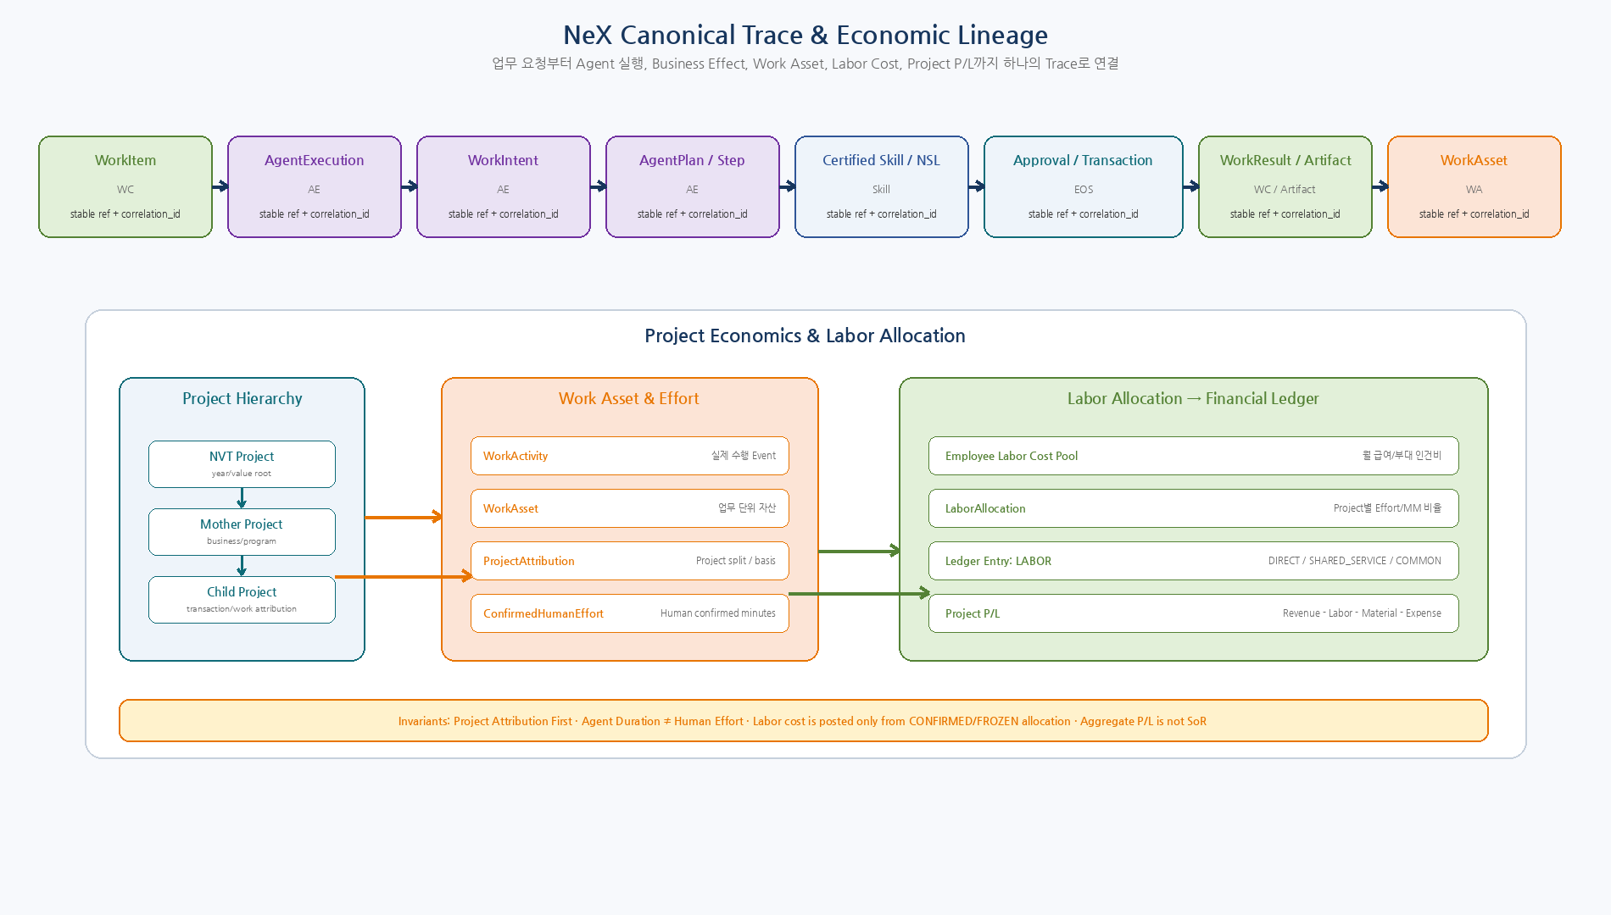
Figure 2. WorkItem에서 Agent/Plan/Skill/Transaction/WorkAsset을 거쳐 Confirmed Human Effort와 Labor Allocation, Project P/L까지 이어지는 E2E Trace.

9. Canonical Business Invariants
ID | Invariant
INV-001 | Employee-bound CA는 0..1 active CoworkerAgentProfile과 연결될 수 있으나 PA/EA/IA는 별도 AE AgentIdentity로 관리한다.
INV-002 | RoleBinding은 OA authority이며 AgentIdentity와 분리된다. 실행 시 current Effective Authority Context를 명시한다.
INV-003 | WorkItem과 AgentExecution은 1:1이 아니며 하나의 WorkItem은 Retry/Revision/협업으로 여러 Execution을 가질 수 있다.
INV-004 | AgentPlan Version은 Immutable이며 Replan은 새 Version으로 supersede한다.
INV-005 | PlanStep Definition과 PlanStepExecution Runtime State를 동일 Record에 in-place 혼합하지 않는다.
INV-006 | DELEGATE_WORK PlanStep의 Actual Assignee를 Planner LLM이 고정하지 않는다.
INV-007 | Cross-service Entity는 다른 DB의 physical FK로 묶지 않는다.
INV-008 | CLOSED WorkItem은 기본적으로 reopen하지 않고 추가 업무는 FOLLOW_UP WorkItem을 생성한다.
INV-009 | PlanTemplate/CertifiedSkill/PlanRoutingBinding 통계는 Version별로 분리한다.
INV-010 | LaborAllocation은 CONFIRMED/FROZEN Human Effort 근거 없이 Ledger에 Posting할 수 없다.
INV-011 | AgentExecution duration 또는 WorkItem lead time을 Human Effort로 직접 Posting하지 않는다.
INV-012 | NVT/Mother/Child P/L Aggregate는 Ledger에서 재구성 가능해야 하며 Aggregate 자체가 SoR가 아니다.
INV-013 | Project 미선택을 이유로 즉시 Common Work에 귀속하지 않는다.
INV-014 | LLM이 생성한 Selector/Candidate는 Stable Business ID가 아니다.
INV-015 | Evidence/Trace의 원본 참조를 삭제·덮어쓰기보다 Version/Status/Reverse로 보존한다.
INV-016 | TenantId는 OrgScope/ProjectScope와 독립된 hard identity boundary이며 모든 cross-layer identity에 명시적으로 보존한다.
INV-017 | Project Agent(PA)는 tenant/project 1:0..1 active logical identity baseline을 가지며 Project Business SoR가 아니다.
INV-018 | Agent FORMAL_APPROVAL과 NSL WRITE Approval은 서로 다른 control이며 Human workflow state는 WC, NSL binding은 NSL이 소유한다.
INV-019 | ScheduleOccurrence는 WorkItem을 materialize하며 AgentExecution을 직접 생성하지 않는다.
INV-020 | Actual NSL WRITE IdempotencyKey는 NSL Runtime이 TenantId+BusinessOperationId+WriteNodeId로 생성한다.
10. Unified Agent Runtime Data Model
AgentExecution은 Unified Agent Runtime의 실제 실행 Aggregate이다. WorkIntent와 Plan은 실행 의미를 보존하는 immutable snapshot이며, 실행 중 상태와 Retry/Output은 PlanStepExecution/AgentCheckpoint에 분리한다.
Entity | Lifecycle / Mutation Rule
AgentSession | Interactive Context만 mutable; Business SoR 아님
AgentExecution | 상태전이 mutable; execution_id는 immutable
WorkIntent | LLM output + selector/candidate snapshot; immutable/versioned interpretation
AgentPlan | immutable version; Replan은 새 Version + supersedes
PlanStep | Plan Definition의 일부로 immutable
PlanStepExecution | 실행 state/output/retry; mutable runtime entity
AgentCheckpoint | WAITING_* 시점 snapshot; Resume 후에도 audit 보존
11. Plan Asset & Certification Model
Entity | Purpose | Important Rule
PlanTemplate | 재사용 가능한 Known Plan | Version immutable; lifecycle 관리
PlanRoutingBinding | Intent/Capability/Condition→Plan mapping | Template certification과 별도 certification
PlanExecutionRecord | 각 Template run의 raw evidence | template_id + version 단위
PlanTemplateStatistics | run/success/failure/replan/diversity projection | SoR가 아니라 재계산 가능한 projection
PlanRoutingStatistics | selection/correction/fallback projection | Routing 품질 평가
12. Work Coordination Data Model
WorkItem은 회사 업무의 Aggregate Root이다. Routing Target은 ‘누가 처리할 수 있는가’를 표현하고 WorkAssignment는 ‘실제로 누가 처리하는가’를 표현한다. WorkClaim은 경쟁 Pull/Lease를 위한 Runtime coordination entity다.
Sub-entity | Rule
WorkAssignment | 대표/기여자/Agent 등 실제 할당과 acknowledgement 이력
WorkResult | revision_no로 versioning; overwrite 금지
WorkRevisionRequest | CLOSED 전 보완요청은 동일 WorkItem에서 처리
WorkRelation | PARENT_CHILD/FOLLOW_UP_OF/RELATED_TO
WorkDependency | AgentExecution/PlanStep wait 해소 조건과 연결
WorkReportRecipient | FYI / ACK_REQUIRED / REVIEW_REQUIRED; Formal Approval과 분리
13. Project / Economic Data Model
Concept | Canonical Rule
NVT Project | 연도별 최상위 Value Project
Mother Project | 반드시 NVT에 연결되는 사업/프로그램
Child Project | 전표/세금계산서/재료비/업무/인건비의 실제 귀속단위
Common Work Project | 실제로 Project와 무관한 업무만 사용
BusinessTransaction | Project 관련 실제 Transaction; Ledger와 분리
ProjectFinancialLedgerEntry | Project P/L의 Economic SoR; posting/reversal 보존
LaborAllocation | EmployeeLaborCostPool을 Project별 LABOR로 배부한 posting source
14. NeX-WA / Human Effort Model
Entity | Meaning | Rule
WorkActivity | 실제 관찰된 Prompt/Review/Skill/Approval/Meeting 등 | Fact; Human/Agent source 구분
WorkAsset | 업무결과를 회사 자산으로 묶은 Aggregate | Activity/Artifact/Evidence/WorkItem refs
ProjectAttribution | WorkAsset의 실제 Project 귀속 | Project first / Common last
EffortAllocation | 한 WorkAsset의 Multi-project split | ratio/effort basis 기록
HumanEffortConfirmation | Estimated→Confirmed Human Effort | Agent duration과 별도
EvidenceSnapshot | 보고/평가/노무배부 근거 Freeze | immutable
PeriodicWorkReport | Daily/Weekly/Monthly/Quarterly report | Auto Draft→Human Submit
15. Time & Version Semantics
Field / Concept | Canonical Meaning
effective_from / effective_to | Business validity period; half-open interval 권장
created_at / recorded_at | System recording time
started_at / completed_at | Activity/Execution actual time
version / revision_no | Immutable Definition/Result의 version
supersedes_* | 새 version이 이전 version을 대체하는 관계
snapshot_at | Evidence/Policy/Registry snapshot 기준시점
period | Payroll/MM/reporting accounting period
16. Deferred Physical Design
- PostgreSQL physical type(UUID/ULID/sequence)와 구체 DDL
- Index / Partition / Retention / Archive
- Alembic migration strategy
- SQLAlchemy ORM / Repository interface
- ExecutablePlan v1의 concrete physical schema
- Artifact binary/object-store layout
- API/Event JSON DTO 및 Schema Registry
- Cross-service cache/read-model materialization strategy
17. Traceability to SRS / ADR
Area | ADR | SRS
Coworker / RoleBinding | ADR-001~005 | NEX-ID-FR-001~006
Work Coordination | ADR-006~012 | NEX-WC-FR-001~012
NSL / Governance | ADR-013~016 | NEX-SKL-FR-001~006
Enterprise OS / WA / Labor | ADR-017~026 | NEX-EOS-FR-001~007; NEX-WA-FR-001~016
Unified Runtime / Planning | ADR-027~048 | NEX-AR-FR; NEX-PLAN-FR-001~037
Deployment / Data | ADR-049~052 | NEX-SYS-ARC; NEX-DATA-NFR
18. Canonical Model Quality Gate
Gate | Pass Criteria
CDM-QG-01 | 모든 주요 Entity에 하나의 Source of Truth Owner가 정의되어 있다.
CDM-QG-02 | WorkItem/AgentExecution/AgentPlan/PlanStep가 서로 다른 Entity로 정의되어 있다.
CDM-QG-03 | Employee 1:1 Coworker + RoleBinding 1:N 구조가 반영되어 있다.
CDM-QG-04 | PlanTemplate/RoutingBinding/Statistics가 runtime instance와 분리되어 있다.
CDM-QG-05 | WorkAsset/ProjectAttribution/HumanEffort/LaborAllocation 연결이 존재한다.
CDM-QG-06 | Cross-service DB FK/write 금지와 Reference 의미가 정의되어 있다.
CDM-QG-07 | Immutable Version/Snapshot/Effective-time 의미가 정의되어 있다.
CDM-QG-08 | Project Economics는 Ledger에서 재구성 가능하도록 정의되어 있다.
CDM-QG-09 | AgentExecution Duration과 Confirmed Human Effort가 분리되어 있다.
CDM-QG-10 | 04 SRS/06 ADR과 Canonical Model 간 명백한 충돌이 없다.
19. Next Step
Document 08 — Canonical API / Event / MCP / A2A Contract
다음 공식 산출물은 `08_NeX_Canonical_API_Event_MCP_A2A_Contract_v2.0`이다. 본 Canonical Entity/Reference와 Source of Truth를 기준으로 Command/Query API, Event payload, correlation/causation, idempotency, MCP Capability, A2A Task Mapping을 Freeze한다.

PLAT-CP05 — Canonical Schedule / Recurring Work Domain Model
Status: PLAT-CP05 Controlled Amendment — Canonical Schedule/Recurring Work
v2.1은 WC bounded context에 ScheduleSpec과 ScheduleOccurrence를 추가한다.
ScheduleSpec은 반복 업무의 durable definition이고 ScheduleOccurrence는 특정 nominal time의 실행 기회를 나타낸다.
Occurrence의 business effect는 직접 AgentExecution이 아니라 WorkItem materialization이다.
Entity | Owner | Type | Identity | Meaning
ScheduleSpec | WC | Aggregate Root | tenant_id + schedule_id | Recurring work definition / policy
ScheduleOccurrence | WC | Runtime/History Entity | tenant_id + schedule_id + nominal_time | One nominal occurrence / materialization state
WorkItem | WC | Aggregate Root | work_item_id | Materialized enterprise work
AgentExecution | AE | Aggregate Root | execution_id | Started only after eligible Agent claim

Platform v2.1 Consolidated Canonical Domain Back-propagation
Status: FINAL v2.1 MASTER BACK-PROPAGATION — PASS 01~07 CONSOLIDATED
Canonical Domain Model은 Agent v2.1 / NSL v0.2 / Platform v2.1 ADR을 반영하여 Agent Identity, Approval Workflow, Schedule, Package Trust 경계를 명시적으로 포함한다.
- AE AgentIdentity/Profile SoR와 OA security identity/RoleBinding을 분리한다.
- WC는 Work/Claim뿐 아니라 ApprovalWorkItem과 ScheduleSpec/Occurrence를 소유한다.
- EOS는 Business Transaction과 필요한 Domain Business Approval record를 소유한다.
- NSP Package는 Registry/Artifact Store의 versioned asset이며 AG가 governance하고 AE Skill Artifact Gateway가 runtime verify한다.

E2E Step 5 — Canonical Result Publication Domain
Status: E2E Step 5 Result Publication Contract Hardening v1.6 — Normative
Canonical AE domain에 AgentResult, ResultDelivery, ResultPublicationPreflight, PublicationReconciliationCase를 추가한다.
- AgentResult = AgentExecution 전체의 immutable verified structured result; SoR = AE Runtime.
- ResultDelivery = one AgentResult × one target의 publication operational aggregate; required/optional, stable PublicationOperationId, idempotency identity, ACK state를 보존한다.
- ResultPublicationPreflight = AS_OF_NOW current OA/scope/classification/visibility decision evidence.
- PublicationReconciliationCase = UNKNOWN_DELIVERY 전용 recovery aggregate. Step 4 ReconciliationCase(UNKNOWN_COMMIT_STATE)와 identity/state를 공유하지 않는다.
- NotificationView = presentation projection. Notification UNREAD/READ/HANDLED != ResultDelivery ACKNOWLEDGED.
- Identity chain은 AgentResultId → ResultDeliveryId → PublicationOperationId → external_delivery_ref까지 추적한다.

E2E Step 6 — Schedule Canonical Domain/Data Hardening
Status: E2E Step 6 Schedule Contract Hardening v1.7 — Normative
- ScheduleSpec: versioned schedule policy + WC_SCHEDULE_TIME_V1 + singular ScheduleTarget.required_capability + optional project binding.
- ScheduleOccurrence: schedule_version + nominal_time(UTC instant) + materialization_key를 보존한다.
- ScheduleMaterialization: occurrence당 하나의 semantic WorkItem을 소유하며 materialization_key / work_item_payload_hash / work_item_id를 durable하게 연결한다.
- WorkItem.source는 SCHEDULE을 허용하고 SCHEDULE이면 source_ref=OccurrenceId가 mandatory다.
- PA scheduled WorkItem은 project_ref(entity_type=PROJECT)와 routing_target.project_scope_ref를 ScheduleSpec.project_id에 bind한다.
- ScheduleAuditEvent는 actor/service identity, current authorization decision, correlation, schedule/version/occurrence/work-item refs를 보존한다.

E2E Step 8 — Background WC WorkResult / Claim-Lineage Closure
CA/PA/EA AgentExecution이 successful WC Claim에서 시작된 경우 immutable AgentResult는 source WorkItem, Claim, ClaimGeneration, claimant Agent, Assignment lineage를 모두 보존해야 한다.
ResultDelivery planner는 해당 background AgentResult마다 정확히 하나의 required WC_WORK_RESULT delivery를 생성해야 하며 WC_WORK_RESULT는 optional로 선언할 수 없다.
WC_WORK_RESULT publication preflight는 current WC claim 상태, ClaimGeneration, claimant, Assignment, source AgentExecution lineage를 AS_OF_NOW로 검증한다. stale/reclaimed/tenant-mismatch lineage는 DENY하며 WorkResult를 publish하지 않는다.
AgentExecution은 required WC_WORK_RESULT를 포함한 모든 required ResultDelivery가 durable ACKNOWLEDGED된 뒤에만 canonical SUCCEEDED가 될 수 있다. WA projection/Notification은 optional post-work fan-out이며 completion gate가 아니다.

