NeX Security, Identity & Governance Architecture
Platform v2.1 Controlled Amendment — CP02/CP06: Employee/Coworker 중심 Security Context를 generic Agent Identity + explicit TenantId로 확장한다.
v2.1
Principal · RoleBinding · Capability · Risk · Human Gate · Trust Boundary · Audit · Kill Switch
Security North Star
LLM/Agent가 무엇을 ‘원한다’고 판단하는지와 무엇을 ‘실행할 수 있는지’를 분리한다. 실행권한은 server-side Identity, RoleBinding, Capability Contract, Scope, Risk, Human Gate, Kill Switch로만 결정한다.
Status: NORMATIVE SECURITY ARCHITECTURE | Parent: 04~08 | 2026.08.28

Executive Summary
본 문서는 NeX v2.1의 Human/Coworker/Expert/System/External Agent가 실제 기업업무를 실행할 때 적용되는 Identity, Authorization, Capability Risk, Human Gate, Protocol Trust Boundary, Audit, Secret, Kill Switch 및 Data Protection Architecture를 Freeze한다. 핵심 원칙은 `Authentication Principal ≠ Business Actor ≠ Effective Agent Authority`이며, Background CA는 사용자 로그인 Token을 재사용하지 않고 Service Principal로 인증한 뒤 특정 WorkItem/RoleBinding/Capability/Scope에 제한된 Effective Authority Context를 받아 실행한다.
Critical Boundary
Coworker Agent는 Human Accountable Owner와 연결되지만 Human Token/권한을 그대로 복제하는 기술적 Principal이 아니다. Background Worker는 Service Principal로 인증하고, 실행마다 제한된 권한 Context를 재구성한다.
1. Security Architecture Principles
ID | Principle | Meaning
SEC-PRIN-01 | Zero Trust for Agent Execution | 모든 Human/Service/Agent/External 호출은 인증·권한·Scope·Capability Policy를 매 실행에서 검증한다.
SEC-PRIN-02 | Authentication Principal ≠ Business Actor | 실제 인증주체(Service/User)와 업무책임 주체(Employee/Coworker)를 분리한다.
SEC-PRIN-03 | Background Worker Never Reuses User Session Token | Background CA는 장기 Employee browser token을 재사용하지 않고 Service Principal + Effective Authority Context로 실행한다.
SEC-PRIN-04 | RBAC + ABAC Hybrid | RoleBinding 기반 Role과 Project/Org/Resource/Risk/WorkItem Context를 함께 판단한다.
SEC-PRIN-05 | Capability is the Security Unit | Tool 이름이 아니라 Canonical Capability Contract가 Permission/Risk/Exposure/Human Gate의 기준이다.
SEC-PRIN-06 | Least Privilege / Least Capability | Coworker·Expert·Service는 현재 업무에 필요한 Capability와 Scope만 사용한다.
SEC-PRIN-07 | Fail Closed | Identity/Permission/Scope/Approval/Contract/Commit 상태가 모호한 중요 Write는 실행하지 않는다.
SEC-PRIN-08 | Human Accountability Preserved | CA/PA/EA는 Human Accountable Owner와 Enterprise Approval 책임을 대체하지 않는다.
SEC-PRIN-09 | Untrusted Content Never Grants Authority | Prompt/RAG 문서/MCP/A2A metadata/외부 Artifact는 데이터이며 권한·Policy의 Source가 아니다.
SEC-PRIN-10 | Every Side Effect is Governed | R3+ write는 idempotency, policy, human gate, kill switch, contract validation, audit를 통과한다.
SEC-PRIN-11 | Secrets by Reference | Secret value를 Prompt/WorkItem/Artifact/Log/DB business field에 저장하지 않고 secret_ref로 참조한다.
SEC-PRIN-12 | Audit is Independent Evidence | Security decision과 Business audit를 execution trace와 연결하되 변경/삭제 가능한 일반 application log와 구분한다.
SEC-PRIN-13 | Protocol Adapters are Trust Boundaries | MCP/A2A는 외부/agent-facing boundary로 input/output validation, exposure allowlist, rate/scope control을 적용한다.
SEC-PRIN-14 | Kill Switch is Hierarchical | Global→Service→Agent Profile→Skill/Plan→Capability→Connector/External Agent 수준의 즉시 차단 수단을 제공한다.
SEC-PRIN-15 | Policy and Contract are Versioned | RoleBinding/Policy/Capability/Skill/Plan/Approval 기준 버전을 execution evidence에 남긴다.

2. Identity & Trust Boundary Architecture
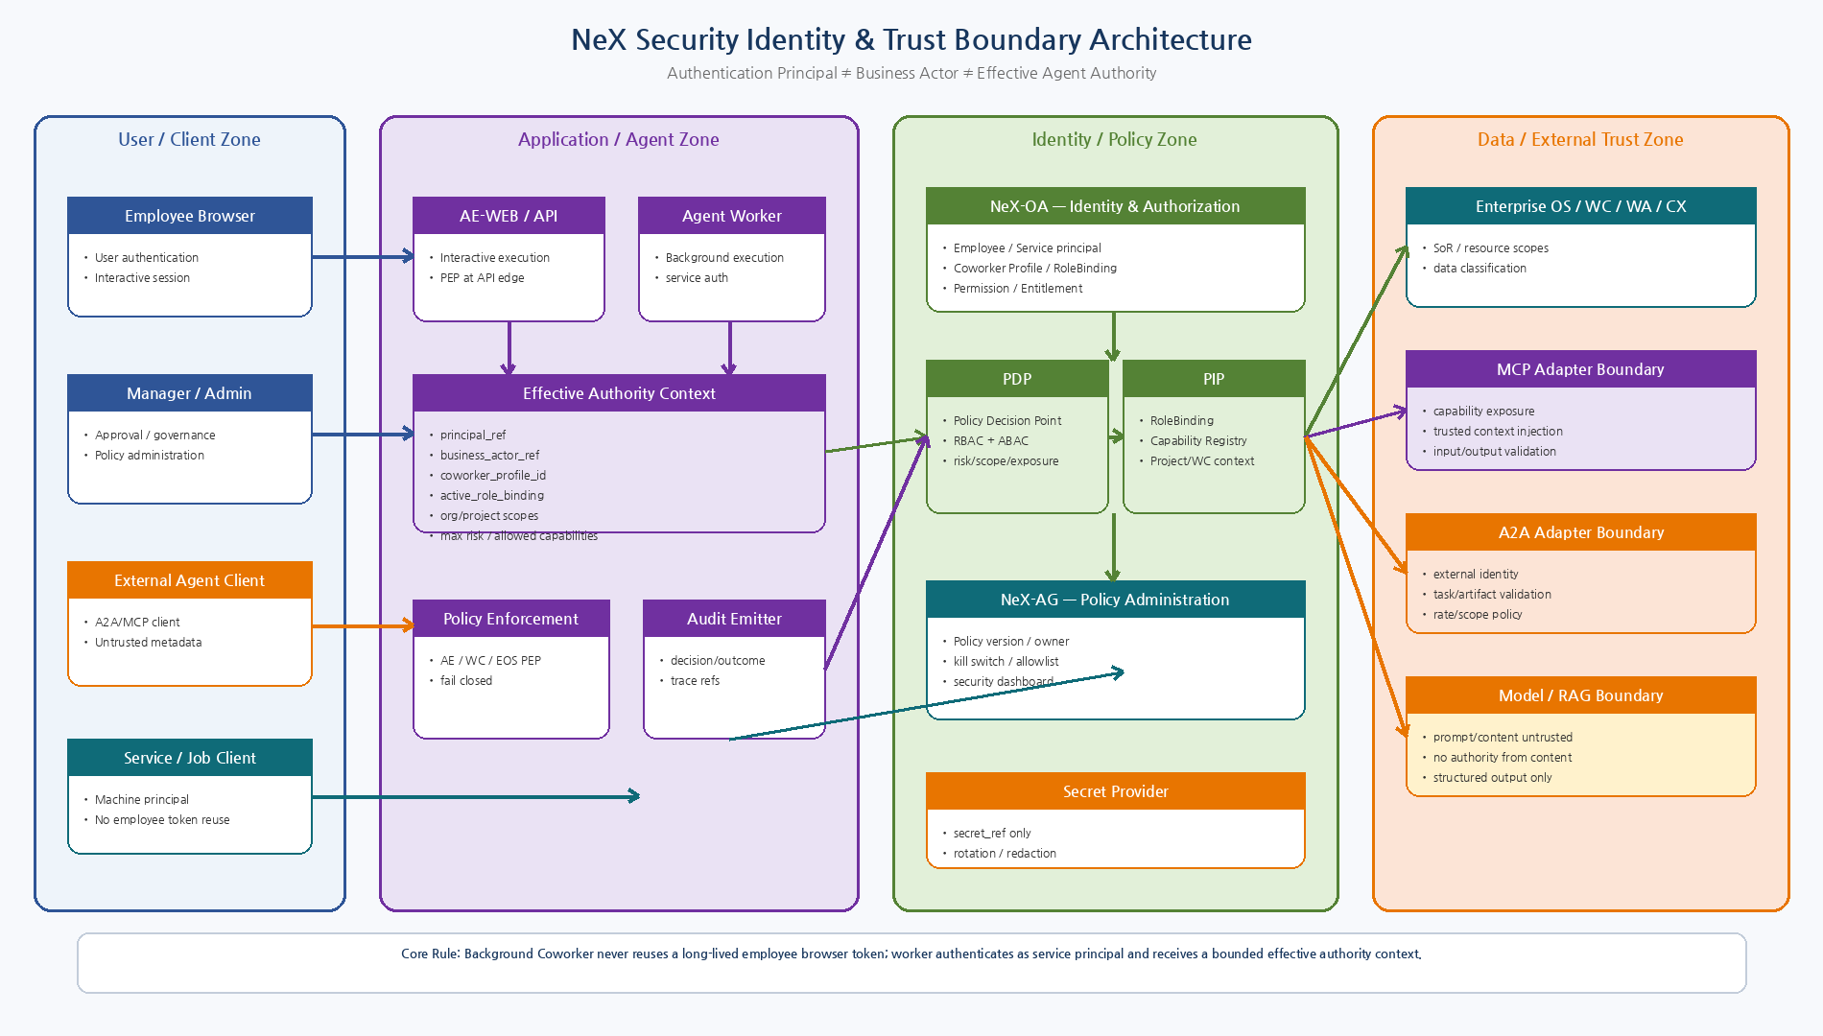
Figure 1. User/Agent/Application/Identity/External 영역을 구분하고 Background CA의 Effective Authority Context와 Trust Boundary를 표현.

3. Principal / Actor / Effective Authority
3.1 Authentication Principals
Principal Type | Meaning | Authentication | Use
HUMAN_USER | 직원/관리자/승인자 | OID/session based user principal | Interactive request / Approval
SERVICE_ACCOUNT | AE Worker/WC Worker/Projection Worker | service identity / short-lived credential | Background execution
SYSTEM_JOB | Scheduler/monitor | service principal + scheduled policy | Periodic trigger
EXTERNAL_AGENT | A2A/MCP peer | external authenticated principal | External collaboration
ADMIN_OPERATOR | 운영/보안 관리자 | strong admin principal | Policy/kill-switch/admin operation
3.2 Effective Authority Context
Field | Meaning | Source
authenticated_principal | 실제 인증 주체 | server-side only
business_actor | Employee/Coworker/Expert/External Agent 업무 주체 | server-side derived
coworker_profile_id | Employee와 연결된 Persistent Coworker | OA lookup
active_role_binding_id | 현재 실행에 사용되는 RoleBinding | explicit selection/resolution
org_scope | 조직 Scope | RoleBinding/PDP
project_scope | Project Scope | RoleBinding + WorkItem/EOS
work_item_id | 현재 업무 Context | WC
capability_id | 실행 대상 Capability | Registry
risk_level | Capability Risk | Registry
autonomy_level | Background 자동실행 상한 | Coworker policy
human_gate_state | Confirmation/Approval 충족 여부 | AE/EOS
policy_snapshot_ref | 평가한 Policy Version | AG/OA
valid_until | Effective Authority 만료시점 | short-lived
3.3 Interactive vs Background
- Interactive execution은 Employee user principal의 authenticated session에서 시작한다.
- Background Worker는 SERVICE_ACCOUNT로 인증하며 Employee browser token을 장기 credential로 재사용하지 않는다.
- Background 권한은 WorkItem, Coworker Profile, Active RoleBinding, Project/Org Scope, Capability, Autonomy Policy, validity를 결합해 bounded context로 만든다.
- WAITING_* Resume 시 checkpoint의 과거 권한을 신뢰하지 않고 Effective Authority를 다시 구축한다.
4. Authorization — RBAC + ABAC
NeX-OA는 Policy Decision Point(PDP)를 제공하고 NeX-AG는 Policy Administration Point 역할을 담당한다. AE/WC/EOS/WA/Protocol Adapter는 PEP로서 정책을 강제하며, RoleBinding/Capability/Project/WorkItem/Data Classification은 Policy Information Point의 Attribute다.
Decision Input | Examples
Principal | user/service/external agent identity
Role | RoleBinding, authority level, effective period
Capability | capability_id, owner, risk, exposure
Scope | org/project/business object/global
Work Context | WorkItem assignment/requester/delegation
Resource State | project open/closed, voucher state, approval state
Autonomy | coworker autonomy level/risk ceiling
Human Gate | confirmation/approval state
Data | classification, field sensitivity
Operation | kill switch/policy version/time
5. Capability Risk Model
Risk | Meaning | Example | Human Gate | Autonomous Policy
R0 | Pure/local logic | No external read/write | None | Allowed if runtime trusted
R1 | General Read | non-sensitive query | None | Allowed with scope check
R2 | Sensitive Read/Analyze | HR/finance/project sensitive data | Policy dependent | Allowed with entitlement/data classification
R3 | Draft/Reversible Write | WorkItem/Voucher Draft/Project Draft | Confirmation or policy | Idempotency required; Background allowed only if autonomy permits
R4 | Important Business State Write | Submit/Close/Approve-like actions | Confirmation/Formal Approval/domain policy | Stronger scope + owner accountability
R5 | Final/Financial/External High-impact | Posting/payment/finalize/external irreversible effect | Formal Approval / explicit governance | Default no autonomous execution; highly restricted exposure
Risk는 Permission을 대신하지 않는다. 동일 R3라도 Employee Role/Project Scope/Work Assignment가 없으면 실행할 수 없다.
6. Capability Exposure Model
Exposure | Meaning | Rule
INTERNAL_API | Internal service only | Service-to-service API
AE_RUNTIME | Unified Agent Runtime may invoke | Interactive/Background controlled
NSL_READ | NSL READ may invoke | R0~R2 typical
NSL_WRITE | NSL Controlled Write may invoke | R3 limited; R4/5 restricted by domain policy
MCP_EXPOSED | General MCP tool exposure | Read/low risk only by default
MCP_RESTRICTED | MCP available under strict role/scope/gate | Sensitive read/R3/R4 selected
MCP_INTERNAL_ONLY | Only trusted internal MCP client/adapter | High risk selected
MCP_PROHIBITED | Never expose via MCP | Low-level ledger/security/secret/admin write
A2A_EXPOSED | External Agent may request through A2A adapter | Explicitly allowlisted capabilities only
ADMIN_ONLY | Admin/operator only | Governance/kill switch/system control
7. Human Gate
Gate | Typical Use | Meaning
NONE | R0/R1 and some R2 | No human interaction required after policy checks
CONFIRMATION | R3 or ambiguous business write | Requester confirms structured interpretation/payload; not enterprise approval
FORMAL_APPROVAL | R4/R5 or company approval rule | Approval Engine state machine; approver separate from requester when policy requires
DOMAIN_POLICY | Risk alone insufficient | Domain rule chooses NONE/CONFIRMATION/FORMAL_APPROVAL based on amount/project/account/etc.
Confirmation ≠ Formal Approval
Confirmation은 시스템이 이해한 요청/Parameter를 요청자가 확인하는 UX/Control이고, Formal Approval은 Enterprise Approval Engine의 Business Governance다. MCP/A2A input-required는 Formal Approval의 대체 수단이 아니다.

8. Secure Agent Execution Gate
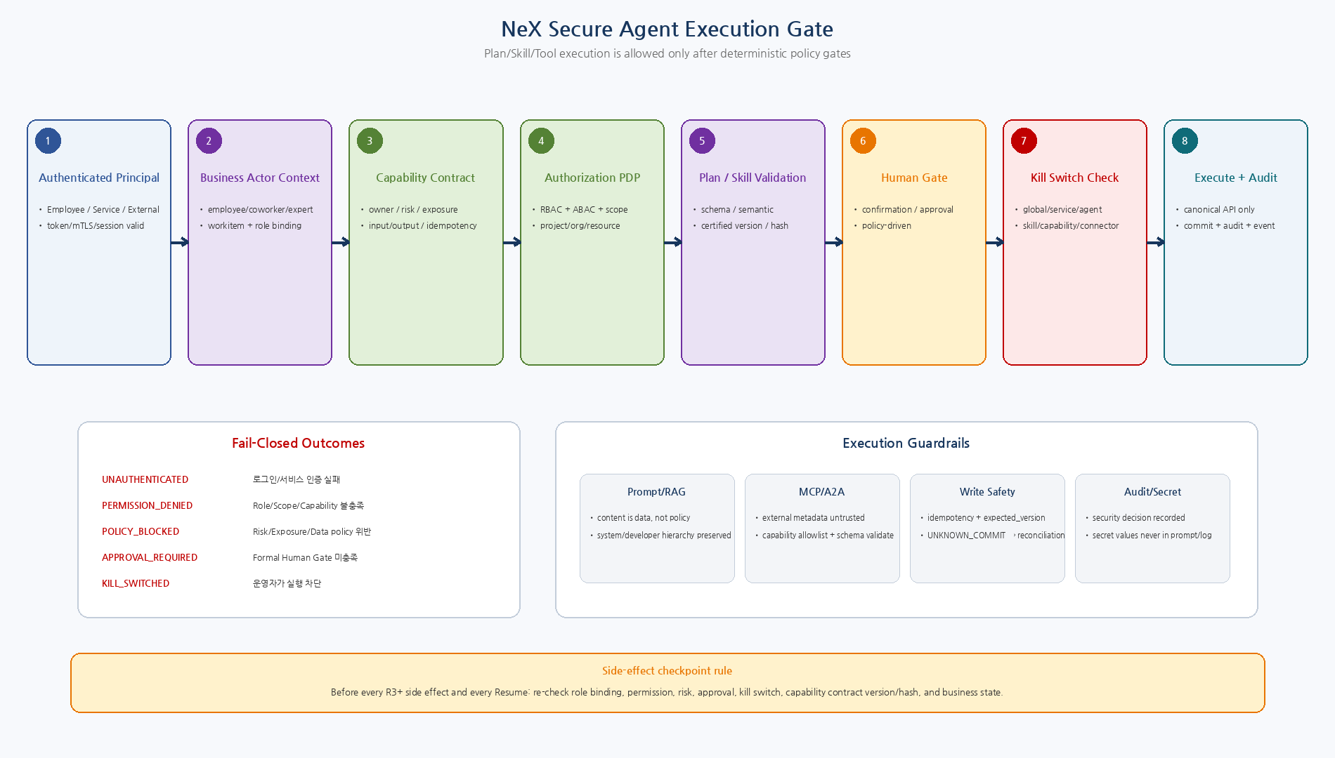
Figure 2. Authenticated Principal부터 Capability Contract, PDP, Plan/Skill Validation, Human Gate, Kill Switch를 거친 뒤 Canonical API를 실행하는 Security Gate.

9. MCP Trust Boundary
Control | Requirement
Inbound client auth | Allowed MCP client/service principal only
Capability exposure | Registry exposure=MCP_* allowlist; discovery output itself is filtered
Tool arguments | Schema validation + ignored/rejected authority fields
Trusted context | Principal/role/scope/correlation injected server-side
Prompt injection | Tool descriptions/results cannot change permission/risk/approval policy
Output | Structured schema, data-classification filtering/redaction
High risk | MCP_PROHIBITED or MCP_INTERNAL_ONLY by default
Session | Business identity/idempotency must not depend on hidden session state
10. A2A Trust Boundary
Control | Requirement
Peer identity | External Agent principal/certificate/token maps to registered external agent
Capability allowlist | Only A2A_EXPOSED capabilities accepted/delegated
Task mapping | A2A Task linked to NeX Child WorkItem; never becomes Work SoR
Artifact import | type/size/hash/schema/malware policy before Artifact/Evidence linking
Message content | untrusted input; no policy authority
Remote state | COMPLETED/FAILED/CANCELED does not auto-close/cancel enterprise WorkItem
Rate/resource | per peer limits, concurrency, timeout, max artifact/message sizes
Revocation | external agent blocklist/connector kill switch takes immediate effect
11. Prompt / RAG / Tool Injection Defense
Control | Requirement
Instruction hierarchy | System/developer/security policy cannot be overridden by retrieved/user/external content
Content labeling | User/RAG/MCP/A2A content is tagged as untrusted data/context
Tool selection | Model suggests; Capability Registry/Plan Compiler/PEP decide executable actions
Data exfiltration | Output filtering and scope policy applied before model/tool response leaves boundary
Indirect injection | Retrieved document instructions cannot grant tools, permissions, secrets, or approval
Plan validation | LLM WorkIntent/AgentPlan must pass JSON schema + semantic validator
Sensitive context | Only minimum required classified fields are added to model context
Logging | Raw sensitive prompt retention minimized; security/audit stores refs/hash/summary where possible
Structural Containment
Prompt Injection을 ‘모델이 속지 않게 만드는 문제’로만 다루지 않는다. 비신뢰 Content가 Tool/Capability/Permission/Human Gate를 바꿀 수 없도록 구조적으로 Execution Path를 분리한다.
12. Secret Management
- Secret value는 LLM Prompt, AgentPlan, WorkIntent, WorkItem description, Artifact metadata, Application log에 포함하지 않는다.
- Application은 `secret_ref` 또는 provider-specific logical key만 보관한다.
- Secret Provider는 최소권한 Service Identity, scope, rotation, audit를 지원한다.
- Connector credential은 Connector/Service scope로 분리하고 Employee 개인 credential을 background worker가 재사용하지 않는다.
- Debug/exception serialization 전에 token/password/API key 패턴을 redaction한다.
- Secret rotation은 running service restart 없이 가능한 구조를 우선한다.
- Secret 접근 실패 시 중요 Write는 fail-closed한다.
13. Data Classification & Protection
Class | Meaning | Example | Minimum Controls
PUBLIC | 외부 공개 가능 | 공개 제품자료/정책 | 기본 보안
INTERNAL | 사내 일반 | 일반 WorkItem/프로젝트 정보 | authenticated internal
CONFIDENTIAL | 민감 업무 | 계약/재무/인사/고객 | role/scope + encrypted + audit
RESTRICTED | 고위험 개인정보/재무/보안 | 급여/인사평가/credential/고위험 transaction | strict need-to-know, masked output, stronger audit
- Service-to-service traffic은 TLS를 기본으로 하고 외부/고위험 통신은 strong client authentication/mTLS를 지원한다.
- RESTRICTED data는 Model Context에 최소필드만 제공하고 masking/tokenization을 우선한다.
- NeX-WA/Performance Evidence는 업무수행 관찰데이터이므로 목적제한과 별도 retention/policy를 적용한다.
- Raw Prompt full text를 장기 Security Audit의 필수 데이터로 보지 않고 필요한 최소정보/reference/hash를 우선한다.
- Artifact export/download 시 Project/Capability/Data classification을 다시 확인한다.
14. Security Audit
Security Event | Meaning
AUTH_SUCCESS / AUTH_FAILURE | principal/session/service authentication
AUTHZ_ALLOWED / AUTHZ_DENIED | capability/scope policy decision
ROLE_BINDING_SELECTED | active role used by execution
CAPABILITY_EXECUTION_REQUESTED | requested capability/risk/resource
HUMAN_GATE_REQUESTED / SATISFIED / REJECTED | confirmation/approval evidence
KILL_SWITCH_CHANGED | who changed what scope and reason
SKILL_OR_PLAN_DISABLED | governance asset disable/revalidate
SECRET_ACCESS | secret_ref access, never value
MCP_TOOL_CALLED | tool/capability/client/result category
A2A_REQUEST_ACCEPTED / REJECTED | external principal/task mapping
UNKNOWN_COMMIT_DETECTED / RECONCILED | critical transaction uncertainty
POLICY_VERSION_CHANGED | policy owner/version/change reason
14.1 Minimum Audit Fields
Category | Fields
Identity | security_event_id, principal_ref, business_actor_ref, coworker_profile_id, role_binding_id
Policy | capability_id, risk_level, decision, reason_codes, policy_version
Resource | resource_refs, work_item_id, execution_id
Trace | correlation_id, causation_id, request_id
Environment | occurred_at, source_ip/device/client where applicable
Outcome | commit_state, result_category, evidence_refs
15. Kill Switch / Emergency Control
Switch | Scope | Behavior
GLOBAL_AUTONOMY_STOP | All background side-effect execution | Continue read-only/interactive diagnostics where safe
SERVICE_STOP | AE worker/WC/MO/etc specific service | Stop new claims/execution; preserve checkpoints
COWORKER_PROFILE_DISABLE | One employee Coworker | No new background execution; active side effects stopped at next gate
EXPERT_AGENT_DISABLE | Shared expert profile/domain | Stop expert work routing
SKILL_VERSION_DISABLE | One Certified Skill version | Compiler/runtime rejects new/Resume executions
PLAN_TEMPLATE_DISABLE | One PlanTemplate version | Routing cannot select/bind; active plan checks policy before next side effect
ROUTING_BINDING_DISABLE | One certified intent→plan binding | Fallback to retrieval/dynamic/human policy
CAPABILITY_DISABLE | One Canonical capability | PEPs deny execution globally
CONNECTOR_DISABLE | MCP/legacy/A2A connector | Block calls; dependent work becomes BLOCKED/ESCALATED
EXTERNAL_AGENT_BLOCK | One remote A2A agent | No new external delegation; open work reviewed/reassigned
Kill Switch는 실행 중 상태를 즉시 DB rollback하는 기능이 아니다. 새 실행/Claim/Resume/R3+ Side Effect를 차단하고 이미 COMMITTED된 Business Effect는 Domain Reversal/Reconciliation 절차로 처리한다.
16. Policy Lifecycle & Governance
- Policy는 policy_id/version/status/owner/effective period를 가진 Versioned Asset으로 관리한다.
- Production policy change는 reviewer/approver separation 또는 조직의 변경승인 절차를 적용한다.
- Capability/Skill/Plan exposure/risk 변경은 Active Execution의 다음 side-effect gate에 반영한다.
- Plan/Skill certification은 통계 threshold가 READY 상태까지만 만들고 Governance Owner가 명시적으로 CERTIFIED를 승인한다.
- Emergency change는 reason/ticket/correlation과 함께 Audit하고 사후 review한다.
- 과거 policy/rolebinding/capability contract version은 Audit 재현을 위해 보존한다.
17. Background CA Security Flow
Step | Security Action
1 | WC WorkItem is assigned/claimed
2 | Worker authenticates as SERVICE_ACCOUNT
3 | Resolve CoworkerAgentProfile + Employee + current RoleBinding
4 | Build short-lived Effective Authority Context bound to WorkItem/Capability/Scopes
5 | Plan/Skill schema/semantic/certification/contract validation
6 | PDP authorization + autonomy/risk/data policy
7 | Human gate / kill switch / idempotency immediately before R3+ side effect
8 | Execute Canonical Capability; record commit/event/audit/evidence
9 | WAITING_* → checkpoint + worker release; Resume starts again from step 3/4
18. Security Monitoring / Alerting
Metric / Alert | Purpose
Authorization denial rate | Role/scope/policy configuration errors or abuse
R4/R5 execution attempts | High-impact activity visibility
Kill switch change | Emergency operational security
UNKNOWN_COMMIT backlog | Financial/business integrity risk
MCP/A2A auth failures | External boundary attack/misconfiguration
Unexpected capability requests | Prompt/tool abuse or routing issue
Policy-blocked / injection signals | Agent safety monitoring
Secret access anomaly | Credential misuse
Queue repeated policy-denial loop | Bad worker/routing configuration
Audit pipeline lag/drop | Loss of security evidence
19. Security Requirements to Carry Forward
ID | Requirement
SEC-REQ-001 | Background Worker SHALL NOT reuse Employee interactive access token as its long-lived execution credential.
SEC-REQ-002 | All capability execution SHALL be authorized server-side using authenticated principal and effective authority context.
SEC-REQ-003 | R3+ side effects SHALL re-evaluate permission/risk/human-gate/kill-switch immediately before execution.
SEC-REQ-004 | Resume from WAITING_* SHALL rebuild/revalidate effective authority rather than trust checkpoint authority blindly.
SEC-REQ-005 | MCP/A2A/user/RAG content SHALL NOT grant permission, role, approval or secret access.
SEC-REQ-006 | Secrets SHALL be referenced/redacted/audited and raw values SHALL NOT enter Prompt/WorkItem/Artifact/log.
SEC-REQ-007 | Security Audit SHALL preserve principal/business actor/policy/capability/decision/trace references.
SEC-REQ-008 | Kill switches SHALL exist at global/service/profile/skill-plan/capability/connector/external-agent scopes.
SEC-REQ-009 | High-risk low-level economic/security capabilities SHALL default to protocol exposure prohibited/internal only.
SEC-REQ-010 | Cross-service authorization SHALL NOT depend on client-provided actor/role fields.
20. Deferred Detailed Decisions
- OAuth/OIDC provider와 구체 Token/JWT Claim
- mTLS certificate lifecycle / PKI implementation
- Secret Provider product/OS implementation
- Security Audit immutable/tamper-evident storage mechanism
- Data retention periods by classification
- Artifact malware/DLP implementation
- Device posture/risk score를 ABAC에 포함할지 여부
- External A2A/MCP peer onboarding and certificate exchange
- Admin break-glass authentication details
21. Security Quality Gate
Gate | Pass Criteria
SEC-QG-01 | Interactive principal과 Background service principal 권한모델이 분리되어 있다.
SEC-QG-02 | Employee 1:1 Coworker + RoleBinding 1:N 권한 derivation이 정의되어 있다.
SEC-QG-03 | Capability Permission/Risk/Exposure/Human Gate가 server-side decision chain으로 연결된다.
SEC-QG-04 | MCP/A2A/RAG content가 authority source가 아닌 것이 명시되어 있다.
SEC-QG-05 | R3+ side effect와 Resume 시 reauthorization 규칙이 있다.
SEC-QG-06 | Secret value가 Prompt/WorkItem/Artifact/log에 저장되지 않는다.
SEC-QG-07 | Security Audit 최소 Event/Field가 정의되어 있다.
SEC-QG-08 | 계층형 Kill Switch가 정의되어 있다.
SEC-QG-09 | UNKNOWN_COMMIT/Reconciliation과 Security Monitoring이 연결된다.
SEC-QG-10 | 08 Canonical Contract의 Risk/Exposure/Identity boundary와 충돌하지 않는다.

21A. Platform v2.1 Agent Identity / Tenant Security Closure
AgentIdentity의 logical SoR는 NeX-AE Agent Registry이며 OA는 Agent Identity 자체의 lifecycle SoR가 아니다. OA는 AgentIdentityRef/AgentType을 security subject context로 받아 current RoleBinding/Scope/Policy를 평가한다.
Effective Authority Context v2.1은 tenant_id, authenticated_principal, business_actor, agent_identity_ref, agent_type, role_binding, org_scope, project_scope, capability, risk/auth context를 포함한다.
TenantId는 OrgScope/ProjectScope와 별도 identity이며 초기 single-tenant 배포도 설정 기반 고정 TenantId를 명시적으로 주입한다. Resume/Retry/Protected Action에서는 current authority를 rebuild하고 cross-tenant mismatch는 fail-closed한다.
PA의 authority는 project-scoped EAC로 제한되며 프로젝트 구성원의 권한 합집합으로 만들지 않는다.
22. Next Step
Document 10 — Architecture Gap Analysis
다음 공식 산출물은 `10_NeX_Architecture_Gap_Analysis_and_Migration_Matrix_v2.0`이다. 다만 Source Repository 현황은 보완 예정이므로, 문서는 Baseline/평가기준/Matrix 구조를 먼저 만들고 실제 KEEP/REFACTOR/REPLACE 판정은 Repository 확인 후 확정한다.

PLAT-CP04 — Approval Security Boundary
Status: PLAT-CP04 Controlled Amendment — Canonical Approval Architecture
Approval recipient와 current authorized approver는 동일하다고 가정하지 않는다.
Decision submission 시 OA는 tenant_id, principal, business actor/delegation, role binding, org/project scope, approval target/action을 현재 상태로 평가한다.
WC ApprovalWorkItem은 NSL binding metadata를 opaque immutable data로 취급한다.
OA ALLOW는 NSL ApprovalEvidence validation을 대체하지 않으며, NSL Approval APPROVED도 current OA DENY를 override하지 못한다.

PLAT-CP07/CP08 — Governance / UX Security Boundary
Status: PLAT-CP07/CP08 Controlled Amendment — Canonical v2.1
AG는 PAP/Governance이고 OA는 PDP다. AG의 APPROVE/CERTIFY 상태가 current runtime authorization을 생성하지 않는다.
AgentProfile governance는 AE Agent Registry의 identity/profile state를 복제하지 않고 exact ref/version/hash를 대상으로 decision projection을 유지한다.
NSP package/publisher/signing-key governance와 runtime PackageTrustEvidence를 분리한다.
AE-WEB/IA Notification은 표시/상호작용 채널이며 authorization authority가 아니다. 모든 protected action과 approval decision은 current OA check를 사용한다.

PLAT-CP09 — CX Tenant / Evidence Security Boundary
Status: PLAT-CP09 Controlled Amendment — Canonical Context/Evidence Boundary
CX permission enforcement는 OA current authority를 Root of Trust로 사용한다.
TenantId를 OrgScope/ProjectScope와 분리하여 hard isolation boundary로 취급한다.
OA EAC/authority reference에서 TenantId와 current scope/classification을 CX에 전달하고, CX는 이를 재해석하거나 완화하지 않는다.
EvidenceBundle/CX Evidence Context는 authority_hash/policy_version과 TenantId를 함께 보존한다.
Cache/retrieval/evidence fetch에서 tenant mismatch는 fail-closed한다.

E2E Step 3 — Security Control Composition Hardening
Status: E2E Step 3 Contract Hardening v1.4 — Normative
Protected WRITE는 하나의 ALLOW로 통과하지 않는다.
Current OA ALLOW AND required EA Operation Trust ALLOW AND current Package Trust valid AND NSL Approval valid AND current NSL Policy/Business Preconditions PASS를 모두 요구한다.
OA DENY는 Trust ALLOW로 override할 수 없고, revoked/suspended package는 기존 artifact reference가 있어도 재사용할 수 없다.
Approval decision evidence, operation fingerprint, package governance/evidence는 각각 별도 typed control로 유지한다.

E2E Step 5 — Result Publication Security Boundary
Status: E2E Step 5 Result Publication Contract Hardening v1.6 — Normative
Result Publication은 별도의 protected side effect이며 WC Claim success, 과거 AgentContext, prior OA ALLOW를 publication 권한으로 재사용하지 않는다.
- 각 target publish/retry 직전에 current OA decision을 AS_OF_NOW로 획득한다.
- Org/Project Scope, Data Classification, recipient visibility, resource visibility를 모두 current state로 검증한다.
- Preflight DENY이면 target adapter 호출은 0이며 required delivery는 fail/block/escalation policy로 남는다.
- Notification/Email deep-link는 조회 시점에도 current resource authorization을 재검증한다.

E2E Step 6 — Schedule Security / Authority Hardening
Status: E2E Step 6 Schedule Contract Hardening v1.7 — Normative
- Schedule CRUD/query는 AS_OF_NOW OA authorization을 요구하고 tenant/project scope를 다시 검증한다.
- Durable Scheduler worker는 SERVICE_ACCOUNT identity와 occurrence-materialization capability만 가지며 일반 사용자/Agent 권한을 union하지 않는다.
- PA Schedule은 project mismatch를 fail-closed하고 Project member permission union을 Agent authority로 승격하지 않는다.
- ScheduleAuditEvent는 authorization_decision_ref를 mandatory로 보존하며 cross-tenant schedule/occurrence/work-item ref는 거부한다.

