NeX Coworker Agent
Semi-autonomous Detailed Design v2.0
ExecutablePlan · Router · Validator · Compiler · JobQueue · Checkpoint / Resume
Implementation Blueprint
11 Runtime SRS를 Python/FastAPI/PostgreSQL 구현 수준으로 내려간다. LLM이 만든 Logical Plan은 직접 실행하지 않고 Schema/Semantic Validator와 deterministic Compiler를 거쳐 immutable ExecutablePlan으로 고정한 뒤에만 실행한다.
Reference contracts: JSON Schema + Python Protocol skeleton + PostgreSQL DDL | 2026.08.31
Status: HISTORICAL / SUPERSEDED FOR PLATFORM v2.1
Document 12는 Platform v2.0 시점의 historical Agent baseline이다. Platform v2.1의 normative Agent semantic/runtime authority는 NeX Agent v2.1 Final Frozen 12-document set이다. 본문은 migration/reference 목적으로 유지하며 신규 구현의 normative source로 사용하지 않는다.
Historical Baseline Notice —
Executive Summary
본 문서는 11 Coworker Agent Runtime SRS의 구현 Blueprint다. Unified Runtime을 planning/execution/persistence/adapters로 분리하고, PostgreSQL durable JobQueue/Lease와 Checkpoint/Event Resume를 사용해 장기 Background 업무를 Worker 점유 없이 처리한다. Cross-service write는 distributed transaction으로 묶지 않고 Canonical idempotency + explicit commit state + reconciliation으로 안전하게 연결한다.
Most Important Rule
Worker Lease는 누가 Job을 처리하는지 정하고, Business Idempotency는 실제 기업 데이터가 중복 변경되지 않도록 한다. Lease가 만료됐다는 이유만으로 Side Effect를 다시 실행해서는 안 된다.
1. Detailed Design Principles
ID | Decision | Implementation Meaning
DD-01 | Protocol-first dependency inversion | planning/execution code depends on Python Protocol interfaces; HTTP/DB/vendor details remain adapters.
DD-02 | Immutable definitions, mutable runtime | WorkIntent/AgentPlan/ExecutablePlan/Checkpoint snapshots are immutable; execution/step/job states are versioned mutable records.
DD-03 | PostgreSQL-first durability | Agent state, JobQueue, Event Inbox/Outbox and checkpoints use PostgreSQL; Kafka/Redis are not mandatory for v1.
DD-04 | No network transaction illusion | Cross-service API call and AE DB transaction are not treated as one distributed transaction; idempotency + reconciliation closes the gap.
DD-05 | LLM boundedness | LLM produces structured intent/plan/selector output only; validator/compiler/PDP control execution.
DD-06 | Side-effect checkpoint | R3+ command rechecks authority, gate, kill switch, contract and idempotency immediately before invocation.
DD-07 | Resume reauthorization | Checkpoint preserves context but never permanently freezes old authority.
DD-08 | Trace every boundary | request/correlation/causation/execution/work/plan/step references propagate through jobs/events/API/audit.

2. Python Package & Component Boundary
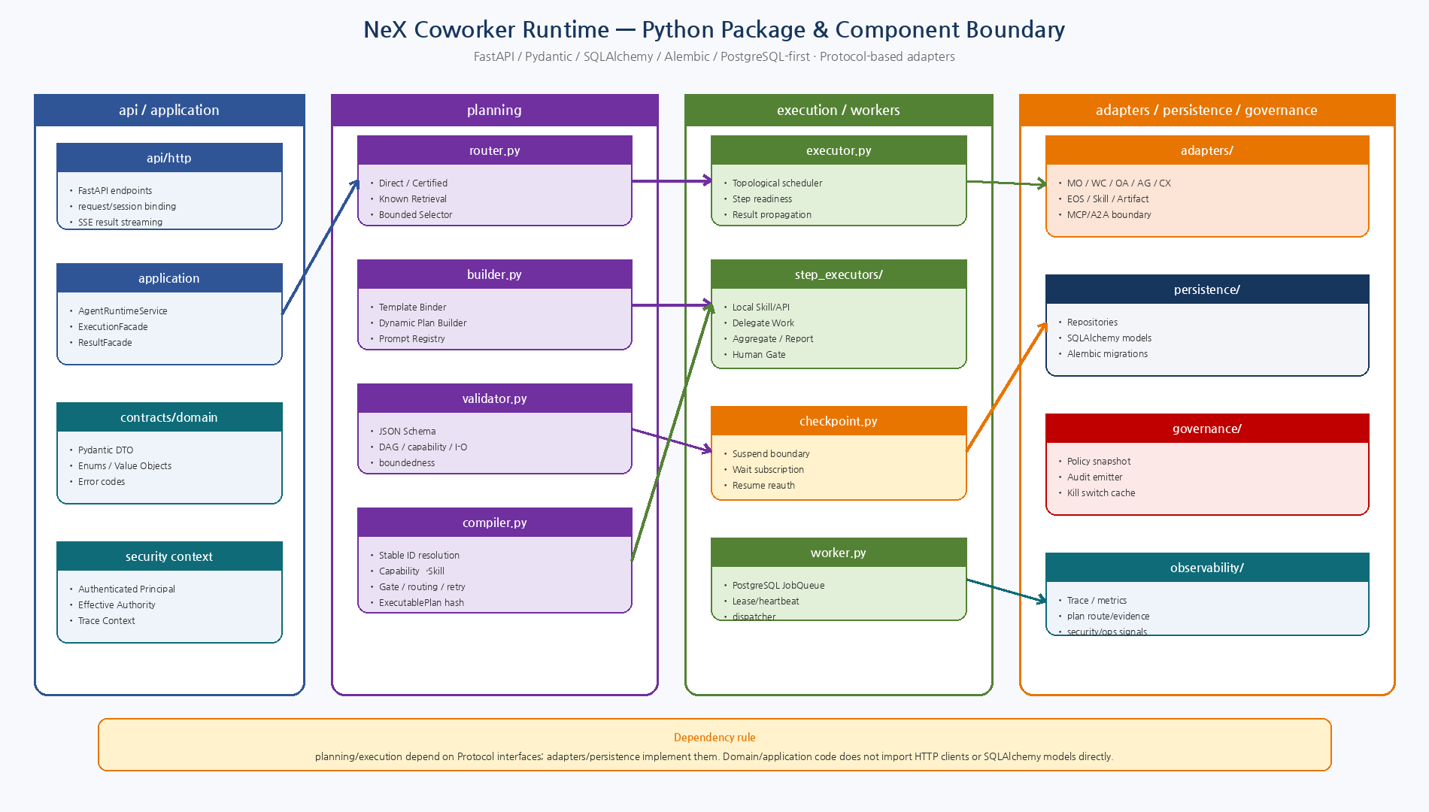
Figure 1. Domain/planning/execution이 Protocol에 의존하고 adapter/persistence가 구현하는 Python package boundary.

3. Recommended Package Tree
src/nex_ae/
├── api/
│ ├── http.py
│ └── dependencies.py
├── application/
│ ├── runtime_service.py
│ ├── execution_facade.py
│ └── result_facade.py
├── contracts/
│ ├── intent.py
│ ├── plan.py
│ ├── executable_plan.py
│ ├── checkpoint.py
│ └── errors.py
├── domain/
│ ├── enums.py
│ ├── value_objects.py
│ └── state_machine.py
├── planning/
│ ├── router.py
│ ├── retrieval.py
│ ├── selector.py
│ ├── builder.py
│ ├── validator.py
│ ├── compiler.py
│ └── template_binder.py
├── execution/
│ ├── executor.py
│ ├── checkpoint.py
│ ├── reconciliation.py
│ └── step_executors/
│ ├── local.py
│ ├── delegate.py
│ ├── human_gate.py
│ ├── aggregate.py
│ └── report.py
├── workers/
│ ├── worker.py
│ ├── dispatcher.py
│ ├── event_consumer.py
│ └── outbox_publisher.py
├── adapters/
│ ├── mo.py
│ ├── wc.py
│ ├── oa.py
│ ├── ag.py
│ ├── cx.py
│ ├── eos.py
│ ├── skill.py
│ └── artifact.py
├── persistence/
│ ├── models.py
│ ├── repositories.py
│ └── jobqueue.py
├── governance/
│ ├── policy.py
│ └── audit.py
└── observability/
├── metrics.py
└── tracing.py
권장 방향은 초기부터 Microservice codebase를 여러 Repository로 쪼개기보다 AE-API 내부를 package boundary로 먼저 강제하는 것이다. 실제 Repository 구조는 Source Inventory v1.1 확인 후 조정한다.
4. Core Python Protocol Interfaces
Protocol | Method | Responsibility
ModelGateway | generate_structured(request) | MO structured generation; no business prompt ownership
CapabilityRegistry | get/search | Capability contract/risk/exposure/input/output
SkillRegistry | resolve_certified | Capability→Certified Skill/Version
AuthorizationPDP | authorize | Principal/actor/role/scope/risk policy decision
CanonicalResolver | resolve | Selector→stable EntityRef or ambiguity
WorkCoordinator | create_child_work/report_result | WC WorkItem/Result canonical API
CanonicalInvoker | query/command | EOS/OA/WA/etc canonical capability invocation
PlanRepository | save/load logical/executable plan | Immutable plan persistence
ExecutionRepository | load/update execution | Optimistic runtime state transition
JobQueue | enqueue/claim/heartbeat/complete/fail | Durable PostgreSQL worker coordination
EventPublisher | append_outbox | Transactional domain event publication

5. Plan Routing → ExecutablePlan Pipeline
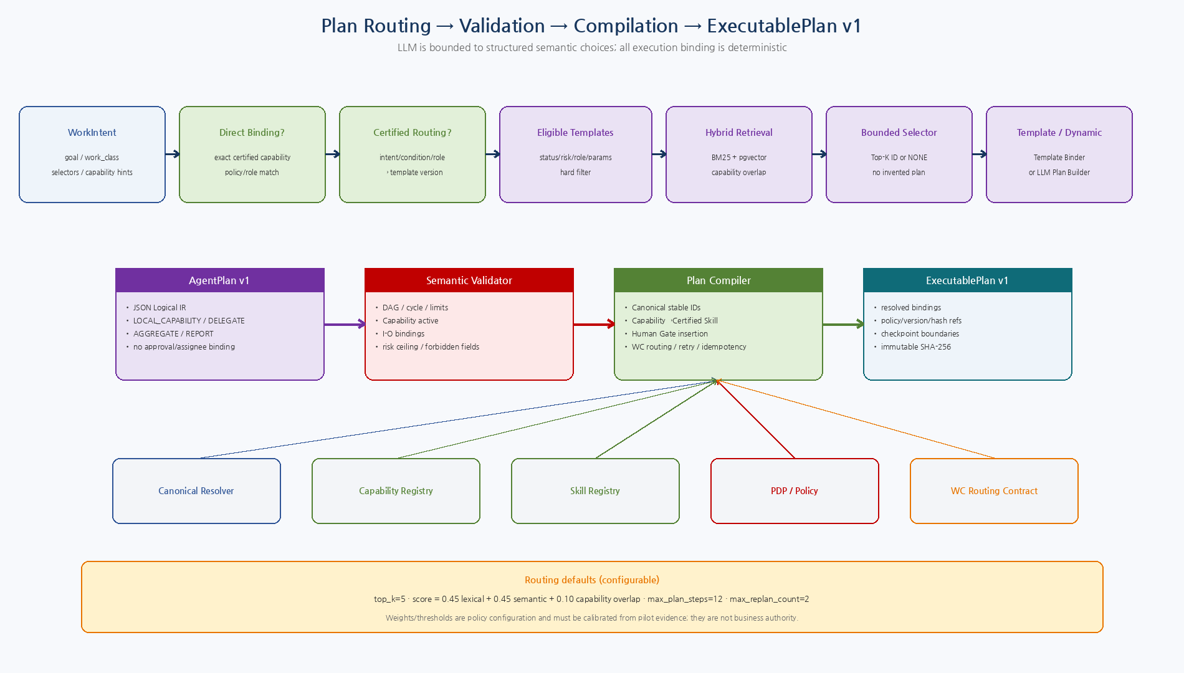
Figure 2. WorkIntent에서 Direct/Certified/Known/Dynamic 경로를 선택하고 Semantic Validation/Compilation을 통해 ExecutablePlan으로 고정.

6. ExecutablePlan v1
ExecutablePlan은 `실행 가능한 계획 정의`이며 mutable 실행상태가 아니다. Compiler가 Stable ID, Capability/Skill version, Human Gate, Routing, Retry/Idempotency/Commit 정책을 고정한다. Current permission token이나 Secret은 포함하지 않는다.
6.1 Top-level Contract
Field | Meaning
schema_version / executable_plan_id | Contract identity
execution_id / work_item_id / work_intent_id | Runtime/Work trace
agent_plan_id / agent_plan_version / plan_kind | Logical source definition
compiler_provenance | compiler + policy/capability/skill/resolver snapshot refs
resolved_context_refs | Stable EntityRef collection; foreign SoR data copy 금지
steps[] | Resolved executable steps
completion_criteria | Execution completion contract
source_plan_template | Template/binding provenance if known plan
supersedes_executable_plan_id | Recompile/Replan lineage
plan_hash | Canonical JSON SHA-256
6.2 Executable Step Kinds
Kind | Responsibility | Rule
LOCAL_SKILL | Certified NSL skill execution | Capability+Skill binding required; canonical command/query underneath.
CANONICAL_CAPABILITY | Direct canonical API invocation | Useful for read/simple capability without NSL artifact.
DELEGATE_WORK | Create/await WC Child WorkItem | Idempotent child creation; transition WAITING_DEPENDENCY.
HUMAN_CONFIRMATION | Structured user/requester confirmation | No business write; waiting state.
FORMAL_APPROVAL | Enterprise Approval Engine gate | Approval result comes from EOS; never model-generated.
AGGREGATE | Combine step outputs | Deterministic or schema-bounded MO synthesis.
REPORT | Build interactive/WC result | No new business transaction unless separate capability step.
Schema
`executable-plan-v1.schema.json`은 JSON Schema Draft 2020-12로 작성했으며 machine-readable reference package에 포함했다. Step type별 deeper conditional validation은 Schema + Python semantic validation을 함께 사용한다.
7. Plan Router Algorithm
Step | Phase | Rule
R1 | Normalize WorkIntent | Reject invalid/missing mandatory fields before routing.
R2 | Direct Binding | Check exact certified capability binding matching work class/role/scope. If valid → ONE_STEP.
R3 | Certified Routing Binding | Deterministically match certified intent/condition/role/scope→PlanTemplate version.
R4 | Eligibility Filter | Only CERTIFIED/allowed templates satisfying domain/work_class/role/risk/required parameters/capabilities.
R5 | Hybrid Retrieval | Score eligible manifests with lexical + semantic + capability overlap. Produce Top-K.
R6 | Bounded LLM Selector | MO PLAN_SELECTOR sees only Top-K manifests and may output candidate ID or NONE.
R7 | Selection Validation | Reject any ID not in candidate set, disabled template, stale version, risk/scope mismatch.
R8 | Bind or Dynamic | Selected template→Template Binder; NONE/no candidates→Dynamic Plan Builder if allowed.
R9 | Audit | Persist PlanRoutingDecision with candidate scores, prompt/model versions, policy version, context hash.
7.1 Hybrid Retrieval Scoring
초기 Pilot Default는 `score = 0.45 × lexical + 0.45 × semantic + 0.10 × capability_overlap`, `top_k=5`로 둔다. BM25/pgvector score는 [0,1]로 정규화한다. 가중치/threshold는 Plan Routing Policy Version으로 관리하며 운영 Evidence로 Calibration한다.
7.2 Router Pseudocode Contract
direct = direct_binding.match(intent, context)
if direct:
return DIRECT(direct.capability)
cert = certified_binding.match(intent, context)
if cert:
return CERTIFIED_BINDING(cert.template)
eligible = template_registry.filter(intent, context)
ranked = hybrid_retriever.rank(eligible, top_k=5)
if not ranked:
return DYNAMIC
selection = plan_selector.select_only(ranked.ids_or_NONE)
if selection is NONE:
return DYNAMIC
assert selection.id in ranked.ids
return KNOWN_TEMPLATE(selection.id)
7.3 Router Failure / Fallback Policy
Condition | Action | Audit / Safety
No eligible template / retrieval empty | DYNAMIC if policy allows; otherwise clarification/escalation | Never pick arbitrary template
Selector timeout / invalid schema | DYNAMIC or clarification by policy | Record selector failure/model/prompt refs
Selector returns non-candidate ID | Reject selection | PLAN_SELECTOR_RETURNED_NON_CANDIDATE
Selected template disabled/stale/revalidation-required | Invalidate route and reroute | Do not bind stale template version
Dynamic planning not allowed at current risk/policy | Clarification or Human escalation | No silent downgrade of governance
7.4 PlanRoutingDecision Persistence
Field | Purpose
routing_decision_id / execution_id / work_intent_id | Identity and runtime trace
route_type | DIRECT / CERTIFIED_BINDING / KNOWN_TEMPLATE / DYNAMIC / CLARIFICATION_REQUIRED / BLOCKED
candidate_set | Template ID/version + lexical/semantic/capability-overlap/retrieval scores
selector provenance | Model profile/ref + prompt template/version + selected candidate or NONE + confidence
selected binding/template refs | Exact registry IDs and versions; no generated ID
policy_version / input_context_hash / decided_at | Reproducibility, audit and routing certification evidence

8. Semantic Validator Rule Set
Code | Area | Validation
VAL-001 | Schema | AgentPlan v1 schema valid; unknown fields rejected where contract says closed.
VAL-002 | Step Count | step_count ≤ configurable max_plan_steps (initial 12).
VAL-003 | Step IDs | Unique S# IDs; all dependency refs exist.
VAL-004 | DAG | No cycle; topological order exists.
VAL-005 | Allowed Types | Only LOCAL_CAPABILITY/DELEGATE_WORK/AGGREGATE/REPORT in logical plan v1.
VAL-006 | Capability | Required capability exists, active, not disabled/deprecated for execution.
VAL-007 | Risk Ceiling | Capability risk does not exceed runtime/profile plan risk ceiling.
VAL-008 | Forbidden Binding | No actual_assignee_id, approval result, secret, raw HTTP/SQL/script/code.
VAL-009 | I/O Binding | STEP_OUTPUT references earlier reachable step; target input path exists; schema type compatibility check.
VAL-010 | Delegation | DELEGATE_WORK has required capability, routing scope/result contract; depth ≤ configured max.
VAL-011 | Aggregate | All source step outputs exist; aggregation mode declared.
VAL-012 | Report | Report has target/result contract and is reachable from required predecessors.
VAL-013 | Completion | Plan completion criteria non-empty and at least one terminal result/report path exists.
VAL-014 | Boundedness | No LOOP/WHILE/GOTO/recursive script; max delegation/replan limits not exceeded.

9. Plan Compiler
Stage | Action | Implementation
C1 | Freeze Inputs | Load WorkIntent, logical AgentPlan, resolved context, current catalog/policy snapshots.
C2 | Topological Order | Use validator-approved DAG ordering.
C3 | Resolve Entity Bindings | Canonical Resolver converts selectors/bindings to stable EntityRef; ambiguity blocks compile.
C4 | Resolve Capability Contract | Load owner/risk/schema/idempotency/commit/exposure contract.
C5 | Resolve Skill | For LOCAL_CAPABILITY select active CertifiedSkillVersion or canonical API binding.
C6 | Evaluate Policy | PDP/policy registry determines permissions/scopes/autonomy and required Human Gate.
C7 | Insert Gates | Create executable HUMAN_CONFIRMATION/FORMAL_APPROVAL step before protected side effect; rewire deps.
C8 | Build Command Policy | Set operation_key, idempotency scope, expected_version source, retry/timeout/commit semantics.
C9 | Compile Delegation | Create WC routing contract with required capability + org/project scope + result schema; no actual assignee.
C10 | Hash & Persist | Canonical JSON serialization → SHA-256 plan_hash; persist immutable ExecutablePlan.
9.1 Human Gate Insertion
Logical Plan에는 Confirmation/Approval 결과를 Planner가 넣지 않는다. Compiler가 Capability Risk/Domain Policy를 조회하여 Human Gate ExecutableStep을 Side Effect 앞에 삽입하고 dependency를 재연결한다. Resume 시 Gate 결과와 current policy를 다시 확인한다.
9.2 Idempotency Operation Identity
각 Side Effect에는 `operation_key`가 있다. Retry는 동일 operation key를 사용하고 Runtime이 execution/work scope와 결합해 `idempotency_key`를 생성한다. Replan이 동일 Business Operation을 재사용하는 경우 prior verified result 또는 prior operation identity를 명시적으로 연결해야 하며, 새 Step ID가 생겼다는 이유로 동일 효과를 다시 실행해서는 안 된다.
10. Plan Executor & Step Executors
Step Kind | Executor | Key Runtime Behavior
LOCAL_SKILL | LocalSkillExecutor | Certified NSL/Canonical capability, pre-side-effect authorization, idempotency/commit handling
CANONICAL_CAPABILITY | CapabilityExecutor | Canonical query/command envelope; no direct DB
DELEGATE_WORK | DelegateWorkExecutor | Idempotent Child Work creation → checkpoint WAITING_DEPENDENCY
HUMAN_CONFIRMATION | ConfirmationExecutor | Create/await structured confirmation; WAITING_CONFIRMATION
FORMAL_APPROVAL | ApprovalExecutor | Create/await EOS approval; WAITING_APPROVAL
AGGREGATE | AggregateExecutor | Deterministic or MO schema-bounded synthesis
REPORT | ReportExecutor | Interactive/WC structured result; artifact/evidence refs
11. Runtime Persistence Model
Table | Purpose
agent_execution | Mutable aggregate state/version/current step/replan/trace
work_intent | Immutable structured interpretation/provenance
agent_plan | Immutable logical plan version + supersedes/hash
executable_plan | Immutable compiled plan JSON/hash/provenance
plan_step_execution | Mutable step attempts/output/error/idempotency
agent_checkpoint | Immutable suspend snapshots
execution_wait | Active external wait conditions and satisfying event
plan_routing_decision | Routing candidates/selector/provenance
plan_execution_record | Template run/business outcome/certification evidence
runtime_job | Durable worker jobs/lease
runtime_event_inbox | At-least-once event dedup
runtime_outbox | Transactional event publication
Canonical JSON snapshot과 relational operational columns를 함께 둔다. JSON은 schema/provenance/복합 contract를 보존하고, relational columns는 state/concurrency/lease/indexing을 담당한다.

12. PostgreSQL JobQueue / Lease
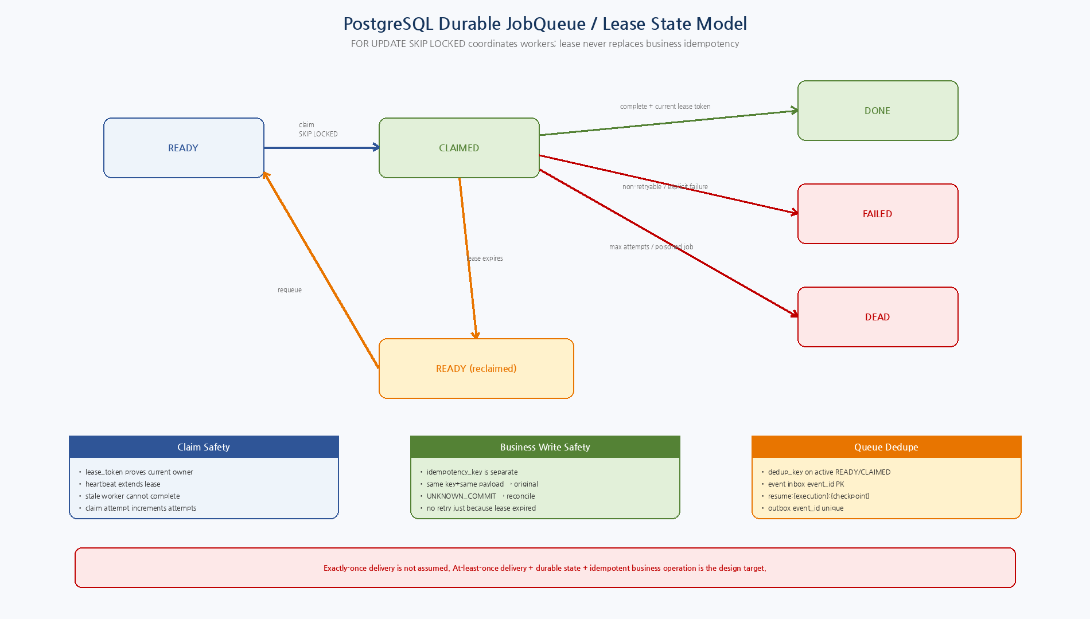
Figure 3. SKIP LOCKED + Lease Token + Heartbeat를 이용한 Worker coordination과 Business Idempotency의 분리.

12.1 Job Schema
Field | Meaning
job_id | UUID/ULID application generated
job_type | START_EXECUTION / RESUME_EXECUTION / RECONCILE / OUTBOX etc.
state | READY / CLAIMED / DONE / FAILED / DEAD / CANCELLED
priority / available_at | claim ordering and scheduled retry
payload_json | small reference payload; not full secret/context blob
execution_id / work_item_id | trace linkage
dedup_key | active READY/CLAIMED duplicate prevention
attempts / max_attempts | job processing attempts
claimed_by / lease_token / lease_until | current worker ownership
heartbeat_at | long execution liveness
last_error_json | operational error summary
12.2 Claim Query
WITH candidate AS (
SELECT job_id
FROM nex_ae.runtime_job
WHERE state='READY'
AND available_at <= now()
AND attempts < max_attempts
ORDER BY priority DESC, available_at, created_at
FOR UPDATE SKIP LOCKED
LIMIT 1
)
UPDATE nex_ae.runtime_job j
SET state='CLAIMED',
claimed_by=:worker_id,
lease_token=:lease_token,
lease_until=now()+(:lease_seconds * interval '1 second'),
heartbeat_at=now(),
attempts=attempts+1
FROM candidate c
WHERE j.job_id=c.job_id
RETURNING j.*;
초기 Default 예시는 lease 90초, heartbeat 약 30초, max_attempts 5다. 모두 운영설정이며 Load/Fault Test 후 조정한다. `complete()`는 동일 lease_token이며 lease가 아직 유효할 때만 성공한다.

13. Checkpoint Transaction Boundary
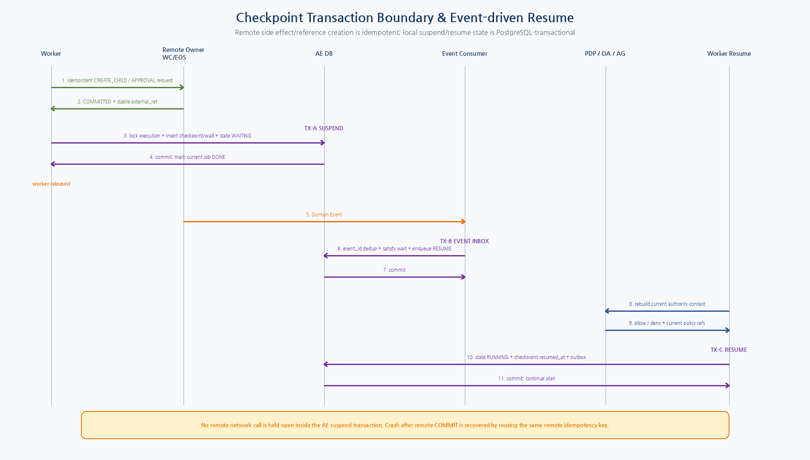
Figure 4. Remote idempotent call, Local Suspend TX, Event Inbox/Resume TX, current Authority 재검증의 분리.

13.1 AgentCheckpoint Contract
Field | Meaning
checkpoint_id | Immutable suspend snapshot ID
execution_id / executable_plan_id / plan_version | runtime identity
current_step_id | step that caused wait or next continuation point
wait_state | WAITING_INPUT/CONFIRMATION/APPROVAL/DEPENDENCY/BLOCKED
wait_condition | condition type + external_ref + expected event/schema
completed_step_refs / output refs | already completed results by reference
resolved_entity_refs | stable references, not copies of foreign authoritative records
runtime_values | non-secret ephemeral values needed for continuation
trace | correlation/causation/request refs
policy_snapshot_ref | audit only; Resume uses current authorization
checkpoint_hash | SHA-256 integrity/reference
13.2 Local Transaction Boundaries
TX | Atomic Actions
TX-A Suspend | After external child/approval/reference creation is idempotently committed, local transaction locks execution, inserts checkpoint+wait, updates WAITING state, appends outbox, completes current job.
TX-B Event→Resume | Inbox inserts event_id; locks matching wait; marks SATISFIED; enqueues one resume job with unique dedup key; marks inbox handled.
TX-C Resume | Worker rebuilds current Effective Authority outside/around transaction; if allowed, locks execution/checkpoint, transitions RUNNING, sets resumed_at, appends outbox.
TX-D Step Result | For local non-network result: update step output/state and execution progress atomically. Remote command commit itself remains protected by idempotency/commit state, not 2PC.
No Distributed 2PC
WC/EOS 등 Remote Canonical API 호출을 AE DB Transaction 안에 묶지 않는다. Remote call은 idempotency key로 먼저/다시 안전하게 호출할 수 있고, local checkpoint/status는 PostgreSQL transaction으로 commit한다. Crash window는 same-key replay + reconciliation으로 닫는다.
14. Event Inbox / Outbox
- `runtime_event_inbox.event_id`가 At-least-once Consumer Dedup의 기준이다.
- Matching Wait를 `FOR UPDATE`로 잠그고 WAITING→SATISFIED와 Resume Job enqueue를 동일 TX에서 수행한다.
- Resume active dedup key는 `resume:{execution_id}:{checkpoint_id}` 형태를 권장한다.
- `runtime_outbox.event_id`는 Unique이며 Publisher 실패 시 재시도한다.
- Outbox publish 실패가 이미 commit된 Runtime/Business Transaction을 rollback하지 않는다.
15. Execution State / Concurrency
Area | Rule
Execution optimistic lock | agent_execution.version; stale transition rejected
Plan definitions | AgentPlan/ExecutablePlan immutable; new version/supersede
Step attempts | PlanStepExecution append attempts; prior evidence retained
Job lease | Current lease_token required for heartbeat/complete/fail
Event resume | Inbox event_id + wait row + resume dedup prevents duplicate resume
Work closure | Runtime SUCCEEDED does not imply WC CLOSED
Unknown commit | First-class RECONCILIATION_REQUIRED state
16. Prompt Registry / NeX-MO
Prompt Purpose | Model Profile | Output Contract
INTENT | INTENT_FAST | WorkIntent v1
PLAN_SELECTOR | PLAN_SELECTOR | Candidate ID or NONE only
PLAN_BUILDER | PLAN_REASONING | AgentPlan v1
EXPERT_REASONING | EXPERT_REASONING | Expert result schema
AGGREGATE | PLAN_REASONING or domain profile | Aggregate output schema
RESULT_FORMATTING | RESULT_FORMATTING | User/WC result schema
Prompt Template/Version과 Model Profile/Model Ref, input_context_hash는 provenance에 남긴다. AE가 Prompt를 소유하고 MO는 structured generation을 수행한다.
17. Error / Retry / Reconciliation
Error | State / Behavior | Rule
PLAN_SCHEMA_INVALID | No execution | Return validation report; builder may retry bounded once or escalate by policy.
PLAN_SEMANTIC_INVALID | No execution | Dynamic rebuild/replan only if bounded policy allows.
ENTITY_AMBIGUOUS | Clarification required | Never guess stable ID.
POLICY_DENIED | BLOCKED/ESCALATED | No side effect.
APPROVAL_REQUIRED | WAITING_APPROVAL | Persist checkpoint and release worker.
DEPENDENCY_PENDING | WAITING_DEPENDENCY | Child/remote work result event resumes.
TRANSIENT_TIMEOUT | Retry if contract says retryable | Same operation idempotency key.
STATE_CONFLICT | Re-read/re-evaluate | Do not overwrite newer business state.
UNKNOWN_COMMIT_STATE | RECONCILIATION_REQUIRED | No blind retry.
STALE_JOB_LEASE | Operational error | Old worker cannot mark job done; business effect handled via idempotency/evidence.
SKILL_OR_CAPABILITY_DISABLED | Replan/Escalate | Resume/side-effect gate catches policy change.
18. Security Checkpoints
- Execution creation: authenticated principal/service + Effective Authority Context.
- Compile: profile/role/risk ceiling/capability visibility.
- R3+ side effect immediately before invocation: permission/scope/risk/human gate/kill switch/business state.
- Remote command: idempotency/expected_version/commit evidence.
- Resume: current RoleBinding/Policy/Capability/Skill/Plan status 재검증.
- Result/Artifact export: Project/Data Classification scope 재검증.

19. Observability & Test Matrix
Metric | Labels / Purpose
runtime_execution_total | mode/source/terminal_state
runtime_execution_duration_seconds | mode/route_type
runtime_state_current | RUNNING/WAITING/BLOCKED/etc.
plan_route_total | DIRECT/CERTIFIED_BINDING/KNOWN_TEMPLATE/DYNAMIC
plan_selector_none_rate | domain/work_class
plan_validation_failure_total | validation code
plan_compile_failure_total | compiler code
plan_replan_total | reason/domain
step_execution_total | kind/capability/outcome
job_queue_depth / oldest_age | job_type/priority
job_lease_expired_total | worker/job_type
checkpoint_wait_age | wait_state
resume_reauthorization_denied_total | reason
unknown_commit_total / backlog | capability
plan_template_verified_success_rate | template/version
Test Layer | Required Coverage
Unit | Router branches, DAG cycle, schema/validator rules, compiler gate insertion, idempotency key, state transitions.
Property/Boundary | max steps/depth/replan, duplicate IDs, empty/ambiguous selector, malformed bindings, stale versions.
Repository | PostgreSQL optimistic updates, partial unique dedup, SKIP LOCKED concurrency, expired lease reclaim.
Fault Injection | Crash before/after checkpoint commit, remote commit then local crash, duplicate event, lease expiry, unknown commit.
Integration | MO structured generation stub, WC child/result, OA/PDP, Canonical API, NSL runtime.
E2E | CAR-GS-01~07 plus GS-A/B/D.
Regression | Every source change; statement ≥95%, branch ≥85%; isolated test DB reset.

20. Implementation Sequence
Wave | Area | Deliverable
I1 | Contracts & Domain | Pydantic models/enums/error codes/JSON schema tests; no business network calls.
I2 | Persistence & State Machine | agent_execution/plan/step/checkpoint/job/inbox/outbox migrations + repositories.
I3 | Router / Validator | Direct/Certified/Known/Dynamic routing, retrieval contract, semantic validator.
I4 | Compiler | Resolver/Capability/Skill/PDP bindings, human gate insertion, ExecutablePlan hash.
I5 | Executor / JobQueue | step executors, lease worker, checkpoint/resume, event consumer/outbox.
I6 | WC / NSL / EOS Integration | Delegation/result, canonical command/query, idempotency/reconciliation.
I7 | Plan Evidence / Certification | PlanExecutionRecord, statistics, Ready/Certified governance integration.
I8 | E2E / Hardening | CAR-GS-01~07, load/fault/security tests, observability, release gates.
21. Machine-readable Reference Package
Artifact | Validation
executable-plan-v1.schema.json | JSON Schema Draft 2020-12 meta-schema PASS
agent-checkpoint-v1.schema.json | JSON Schema Draft 2020-12 meta-schema PASS
plan-route-decision-v1.schema.json | JSON Schema Draft 2020-12 meta-schema PASS
Python Protocol / Router / Validator / Compiler / Worker skeleton | Python syntax compilation PASS
001_runtime_core.sql | Reference PostgreSQL runtime physical model
002_jobqueue_inbox_outbox.sql | Reference lease/inbox/outbox SQL
003_checkpoint_transactions.sql | Reference suspend/event/resume transaction boundaries
Reference package는 Production Source가 아니라 구현팀이 Interface/Schema/Transaction Semantics를 동일하게 이해하기 위한 실행가능한 설계 보조물이다.
22. Detailed Design Quality Gate
Gate | Pass Criteria
DD-QG-01 | ExecutablePlan separates logical plan from resolved execution bindings.
DD-QG-02 | Router cannot accept an LLM-invented Plan ID.
DD-QG-03 | Semantic validator rejects cycles/unbounded/forbidden plans deterministically.
DD-QG-04 | Compiler binds stable IDs, skill version, gates, routing, idempotency and hashes.
DD-QG-05 | Job lease and business idempotency are independently enforced.
DD-QG-06 | WAITING_* is checkpoint + worker release + event resume.
DD-QG-07 | No distributed 2PC assumption across WC/EOS/AE.
DD-QG-08 | Resume reauthorizes current authority and kill switches.
DD-QG-09 | Persistence/trace/metrics reconstruct end-to-end execution.
DD-QG-10 | Machine-readable reference artifacts were generated and validated.
23. Next Step
Document 13 — Representative Workflows v2.0
다음 문서는 실제 업무 Scenario를 본 Detailed Design의 Object/State/API에 태운다. Accounting/Finance/HR/GA/Manufacturing/Procurement 대표 Workflow를 Sequence/Activity와 Acceptance Test까지 연결하면 구현 Backlog로 바로 전환할 수 있다.

