NeX Coworker Agent
Representative Workflows v2.0
Accounting · Finance · HR · General Affairs · Manufacturing · Procurement
Workflow Baseline
설계를 더 추상화하지 않고 실제 업무를 Runtime Object/API/State/PlanStep/WorkItem/Checkpoint에 태운다. 각 Workflow는 Sequence와 Acceptance Test를 함께 제공해 구현 Backlog/Test Fixture로 바로 전환할 수 있게 한다.
Status: PHASE 1 REPRESENTATIVE WORKFLOW BASELINE | 2026.09.01
Status: HISTORICAL / SUPERSEDED FOR PLATFORM v2.1
Document 13는 Platform v2.0 시점의 historical Agent baseline이다. Platform v2.1의 normative Agent semantic/runtime authority는 NeX Agent v2.1 Final Frozen 12-document set이다. 본문은 migration/reference 목적으로 유지하며 신규 구현의 normative source로 사용하지 않는다.
Historical Baseline Notice —
Executive Summary
본 문서는 NeX Unified Agent Runtime의 Object/API/State/PlanStep/WorkItem/Checkpoint를 실제 기업업무에 적용한 대표 Workflow 설계다. 회계·재무·인사·총무·제조·구매 6개 업무에서 Prompt/WorkItem이 WorkIntent/Plan으로 변환되고, Compiler가 Human Gate/Stable ID/Skill/Idempotency/Routing을 삽입한 뒤 실행·위임·대기·재개·결과·Work Asset까지 이어지는 과정을 정의한다.
Scope Boundary
여기서 사용하는 업무규칙과 Capability 이름은 NeX v2.0 Target Workflow 기준이다. 실제 회사 ERP/인사/구매 규정, 금액 Threshold, 상태코드와 API 명칭은 실제 Repository와 업무규정 확인 후 Domain Detailed Design에서 최종 확정한다.

1. Representative Workflow Portfolio
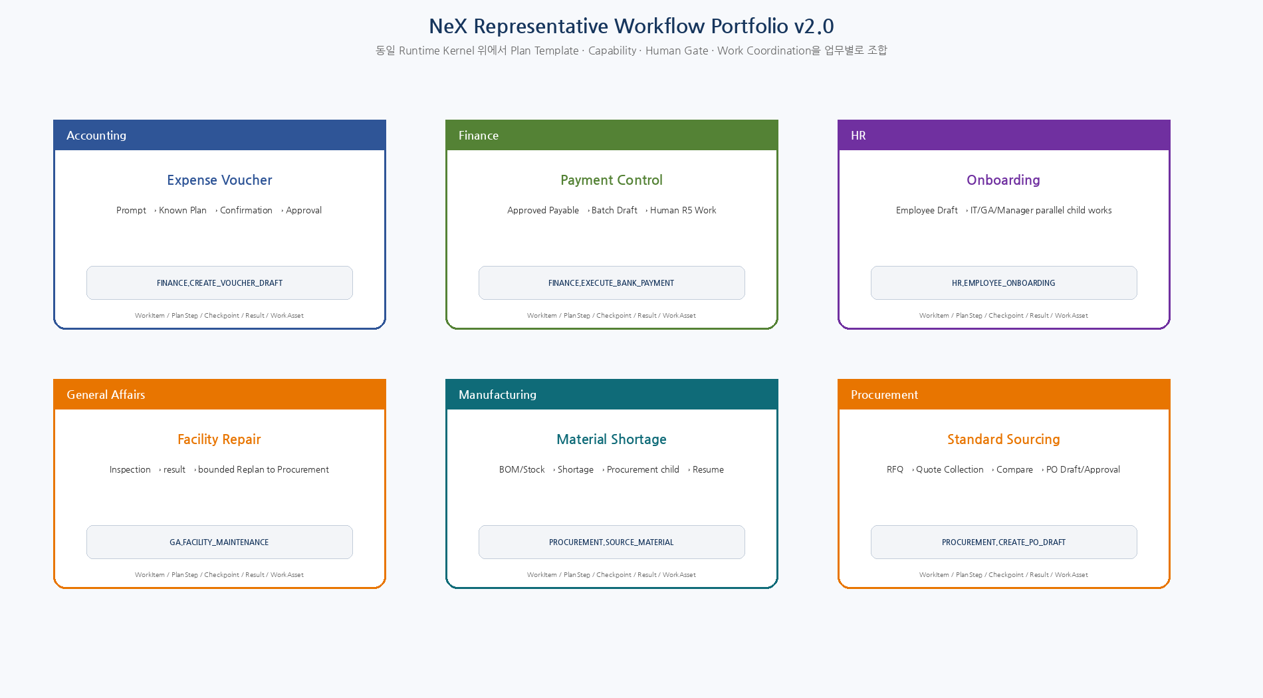
Figure 1. 동일 Unified Agent Runtime 위에서 업무 Domain별 Known Plan, Capability, Human Gate, Work Coordination을 조합하는 대표 Workflow.

2. Common Runtime Mapping
Runtime Stage | Workflow Mapping
Work Intake | PROMPT or WORKITEM → AgentExecution
Context | Coworker Profile / RoleBinding / Project / WorkItem / Evidence / Effective Authority
Understand | WorkIntent v1; selectors/candidates only
Route | Direct / Certified Binding / Known Template / Dynamic
Plan | AgentPlan v1 logical steps
Compile | Stable ID + Skill + Gate + Routing + Idempotency + Checkpoint
Execute | NSL / Canonical API / WC Child Work
Wait | Checkpoint + Worker Release
Resume | Event Inbox → Resume Job → Reauthorization/Freshness
Complete | WorkResult / Artifact / WorkAsset / PlanExecutionRecord

3. WF-ACC-01 — Project Expense Voucher Draft & Approval
Domain | Trigger | Route / Template | Risk / Data
Accounting | Employee Interactive Prompt + receipt Artifact | CERTIFIED_BINDING / Known Plan 우선  ACCOUNTING.PROJECT_EXPENSE_VOUCHER_STANDARD | R2~R4 / CONFIDENTIAL
영수증/증빙이 있는 프로젝트 비용을 자연어 요청으로 시작해 계정/프로젝트를 검증하고 전표 Draft→제출/승인→결과까지 처리한다.
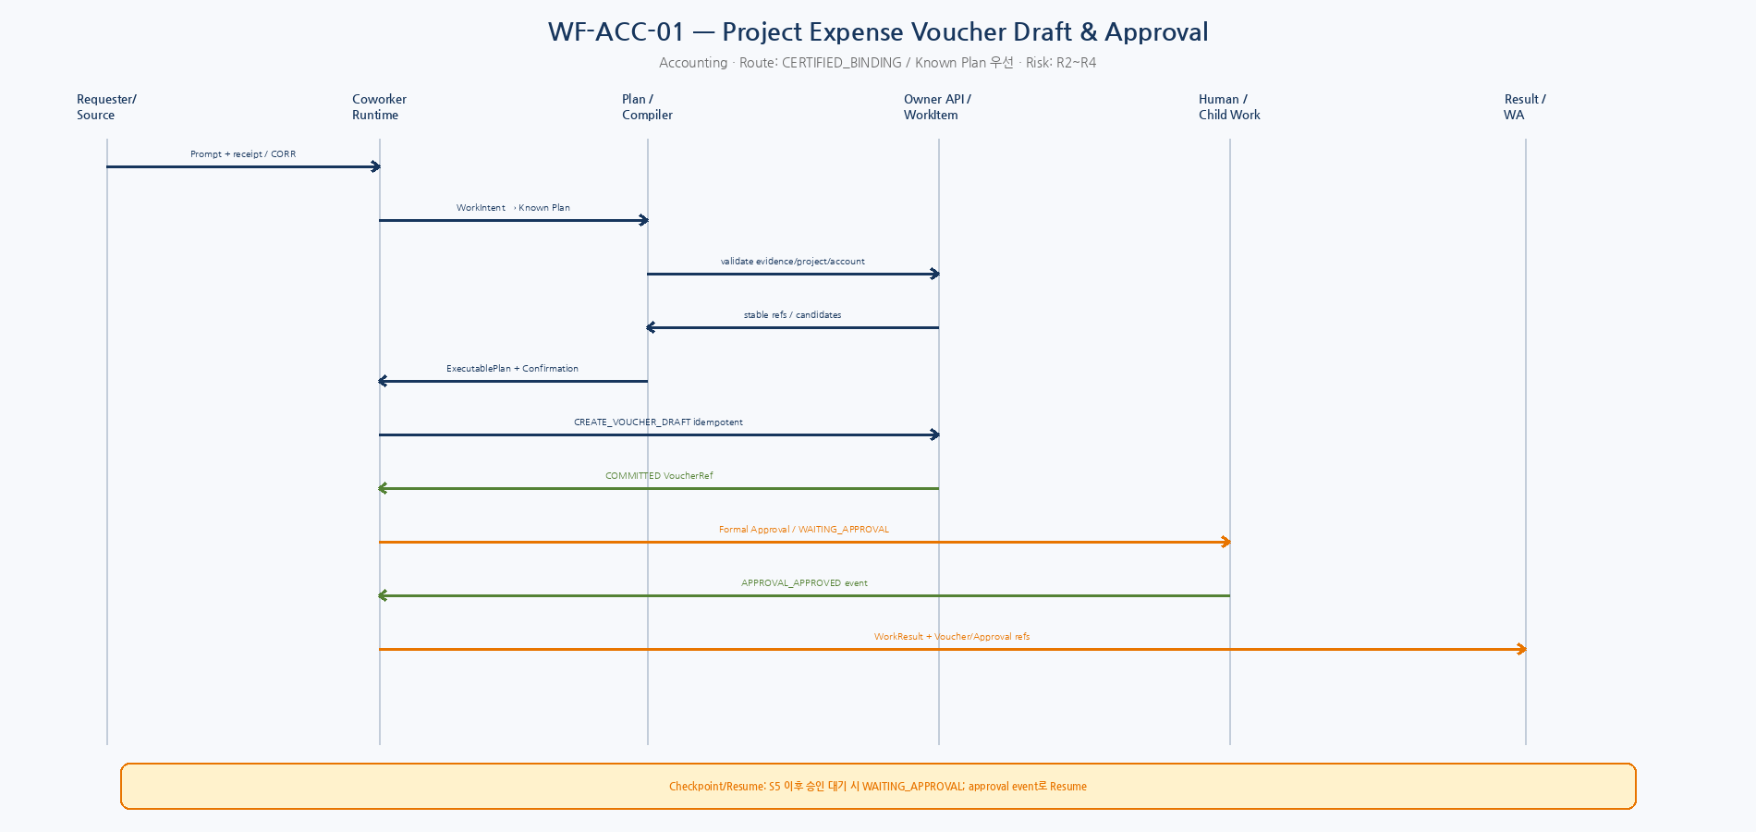
Sequence. WF-ACC-01 — Runtime/Plan/Owner API/Human or Child Work/Result interactions.
Logical AgentPlan / Runtime Mapping
Step | Type | Capability | Objective | Depends | Risk
S1 | LOCAL_CAPABILITY | ARTIFACT.VALIDATE_EXPENSE_EVIDENCE | 증빙 형식/필수항목 확인 | - | R2
S2 | LOCAL_CAPABILITY | PROJECT.RESOLVE | 프로젝트 Selector→Stable Project ID | S1 | R2
S3 | LOCAL_CAPABILITY | ACCOUNT.SEARCH_ACCOUNT_CODES | 계정과목 후보/정책 조회 | S2 | R2
S4 | LOCAL_CAPABILITY | FINANCE.CREATE_VOUCHER_DRAFT | Voucher Draft 생성 | S3 | R3
S5 | LOCAL_CAPABILITY | FINANCE.SUBMIT_VOUCHER | 전표 제출/승인 프로세스 시작 | S4 | R4
S6 | REPORT | REPORT.ACCOUNTING_RESULT | Voucher/Approval/Ledger refs 결과보고 | S5 | R1
Compiler / Runtime Transformation | Checkpoint / Result
S4 앞 Structured Confirmation 삽입 • S5에 Domain Policy상 Formal Approval 필요 시 Approval Gate 삽입 • 각 Write에 stable operation_key/idempotency_key/commit semantics 삽입 | S5 이후 승인 대기 시 WAITING_APPROVAL; approval event로 Resume  Result: VoucherRef + ApprovalRef + LedgerRef(if posted) + evidence refs

Canonical Interfaces & Work Asset
- Canonical API: ARTIFACT.GET/VALIDATE, PROJECT.RESOLVE, ACCOUNT.SEARCH_ACCOUNT_CODES, FINANCE.CREATE_VOUCHER_DRAFT, FINANCE.SUBMIT_VOUCHER, APPROVAL.GET_INSTANCE, WORKITEM.REPORT_RESULT
- Work Asset: WorkActivity(prompt/review/confirmation) → WorkAsset(accounting transaction support) → ProjectAttribution
Acceptance Tests
ID | Given | When | Then
ACC-AT-01 | 정상 프로젝트/증빙/금액 | Known Plan 선택→Draft→승인대기→승인 후 Result | PASS
ACC-AT-02 | 프로젝트명이 중복/모호 | PROJECT.RESOLVE ambiguous | WAITING_INPUT; Stable ID guess 금지
ACC-AT-03 | 증빙 누락 | Evidence validation fail | Write 없음; clarification
ACC-AT-04 | S4 응답 timeout 후 remote commit 가능 | same idempotency key replay | Voucher 중복 없음
ACC-AT-05 | 승인대기 중 RoleBinding 취소 | approval event 후 Resume | reauthorization fail→ESCALATED/BLOCKED
ACC-AT-06 | 동일 요청 재전송 | operation identity 동일 | 중복 Voucher 생성 금지

4. WF-FIN-01 — Payment Request Preparation & Controlled Disbursement
Domain | Trigger | Route / Template | Risk / Data
Finance | Finance WorkItem or Finance Manager Prompt | Known Plan  FINANCE.PAYMENT_REQUEST_CONTROLLED | R2~R5 / RESTRICTED
승인된 지급대상 채무를 검증하고 지급 Batch/Draft를 준비한 뒤 Human Approval과 실제 지급 담당자에게 위임하여 지급 결과를 회수한다.
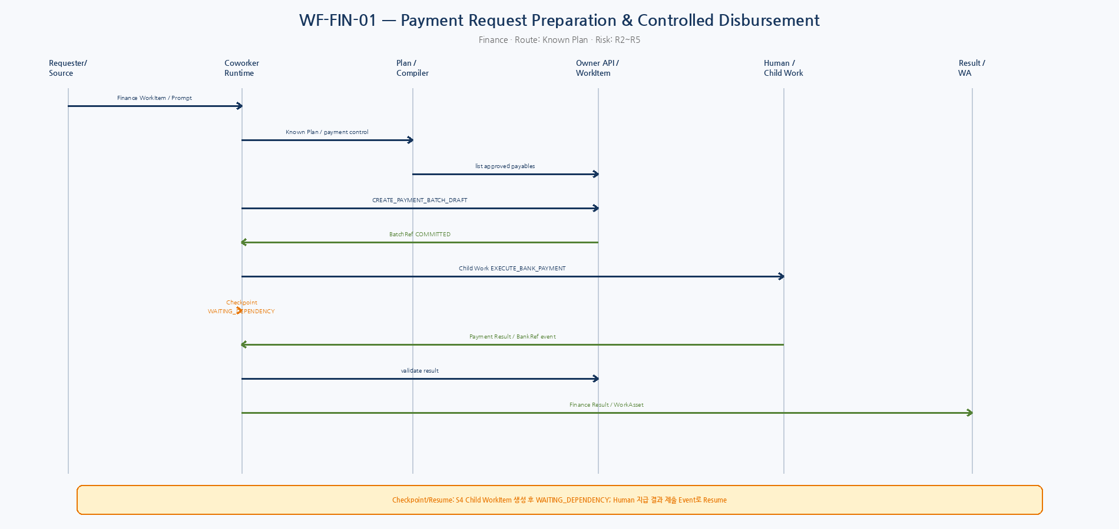
Sequence. WF-FIN-01 — Runtime/Plan/Owner API/Human or Child Work/Result interactions.
Logical AgentPlan / Runtime Mapping
Step | Type | Capability | Objective | Depends | Risk
S1 | LOCAL_CAPABILITY | FINANCE.LIST_APPROVED_PAYABLES | 지급가능 채무 조회 | - | R2
S2 | AGGREGATE | FINANCE.BUILD_PAYMENT_BATCH | 지급대상/은행/일자 기준 Batch 구성 | S1 | R2
S3 | LOCAL_CAPABILITY | FINANCE.CREATE_PAYMENT_BATCH_DRAFT | 지급 Batch Draft 생성 | S2 | R3
S4 | DELEGATE_WORK | FINANCE.EXECUTE_BANK_PAYMENT | 승인된 Batch 실제 지급 수행 Human Work | S3 | R5
S5 | AGGREGATE | FINANCE.VALIDATE_PAYMENT_RESULT | 지급 결과/오류/BankRef 검증 | S4 | R2
S6 | REPORT | REPORT.FINANCE_PAYMENT_RESULT | 지급결과/미지급/예외 보고 | S5 | R1
Compiler / Runtime Transformation | Checkpoint / Result
S3 앞 Confirmation • S4 Child WorkItem은 Finance capability pool/승인권한 Scope로 Routing • S4 실제 Assignee는 WC가 결정 • R5 execution은 Agent가 직접 bank write하지 않음 | S4 Child WorkItem 생성 후 WAITING_DEPENDENCY; Human 지급 결과 제출 Event로 Resume  Result: PaymentBatchRef + HumanExecution WorkResult + Bank/ERP ResultRefs

Canonical Interfaces & Work Asset
- Canonical API: FINANCE.LIST_APPROVED_PAYABLES, FINANCE.CREATE_PAYMENT_BATCH_DRAFT, WORKITEM.CREATE_CHILD, WORKITEM.GET/RESULT, ARTIFACT.GET, WORKITEM.REPORT_RESULT
- Work Asset: 지급 준비와 Human 지급작업을 각각 Activity/Evidence로 남기고 Finance WorkAsset로 집계
Acceptance Tests
ID | Given | When | Then
FIN-AT-01 | 승인된 채무만 존재 | Batch Draft 후 Human Work 위임 | Agent 직접 bank 지급 없음
FIN-AT-02 | 미승인 Voucher 포함 | eligibility validation | 대상 제외/정책오류; 지급 금지
FIN-AT-03 | Child WorkItem 중복 생성 retry | same idempotency key | 하나의 Child WorkItem만 존재
FIN-AT-04 | Human 지급 실패 | WorkResult=FAILED | Parent Resume→예외보고/재배정 정책
FIN-AT-05 | Remote result artifact 변조/스키마 불일치 | Result validation fail | Parent 완료 금지
FIN-AT-06 | R5 Capability kill switch | Side-effect/위임 직전 check | BLOCKED/ESCALATED

5. WF-HR-01 — Employee Onboarding Orchestration
Domain | Trigger | Route / Template | Risk / Data
HR | HR Manager Prompt / HR WorkItem | Certified Binding / Known Plan  HR.EMPLOYEE_ONBOARDING_STANDARD | R2~R4 / RESTRICTED
신규 입사자의 Employee Draft/RoleBinding 준비와 IT 계정·총무 장비·조직 안내를 여러 Child WorkItem으로 병렬 위임하고 완료를 집계한다.
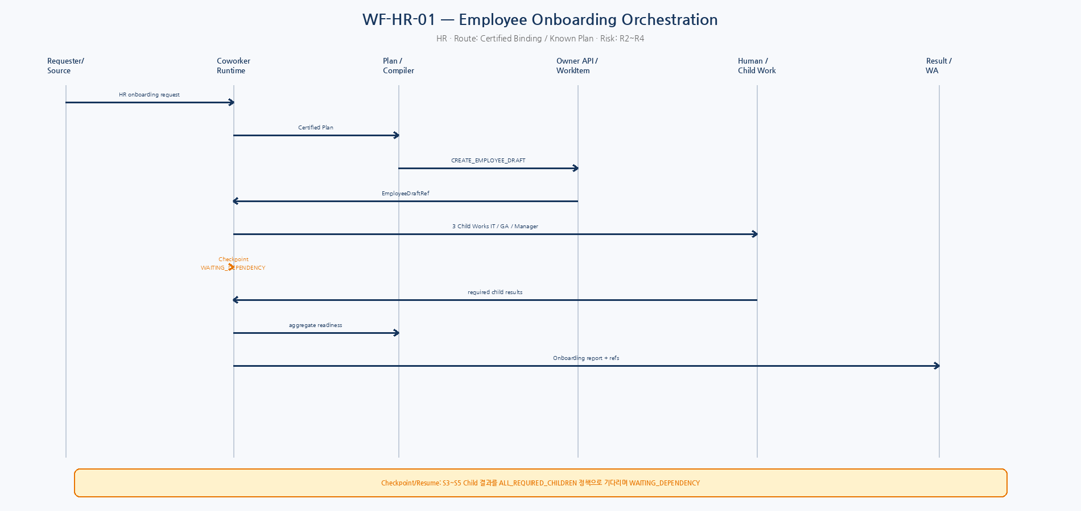
Sequence. WF-HR-01 — Runtime/Plan/Owner API/Human or Child Work/Result interactions.
Logical AgentPlan / Runtime Mapping
Step | Type | Capability | Objective | Depends | Risk
S1 | LOCAL_CAPABILITY | HR.VALIDATE_ONBOARDING_INPUT | 입사일/조직/Manager/필수정보 검증 | - | R2
S2 | LOCAL_CAPABILITY | HR.CREATE_EMPLOYEE_DRAFT | Employee Draft 생성 | S1 | R4
S3 | DELEGATE_WORK | IT.PROVISION_EMPLOYEE_ACCESS | 메일/계정/접근권한 준비 | S2 | R3
S4 | DELEGATE_WORK | GA.PROVIDE_EMPLOYEE_EQUIPMENT | 노트북/출입/좌석/비품 준비 | S2 | R3
S5 | DELEGATE_WORK | HR.MANAGER_ONBOARDING_PREP | 부서 안내/멘토/첫주 일정 준비 | S2 | R2
S6 | AGGREGATE | HR.ONBOARDING_READINESS | S3~S5 결과를 readiness로 집계 | S3,S4,S5 | R2
S7 | REPORT | REPORT.HR_ONBOARDING | 완료/미완료/Blocker 보고 | S6 | R1
Compiler / Runtime Transformation | Checkpoint / Result
S2 Formal Approval 또는 HR Domain Gate 삽입 가능 • S3~S5를 Child WorkItem으로 병렬 생성 • 각 Child는 capability+org scope로 Routing • PII는 최소 stable refs로 전달 | S3~S5 Child 결과를 ALL_REQUIRED_CHILDREN 정책으로 기다리며 WAITING_DEPENDENCY  Result: EmployeeDraftRef + IT/GA/Manager Child Work Results + readiness report

Canonical Interfaces & Work Asset
- Canonical API: HR.CREATE_EMPLOYEE_DRAFT, WORKITEM.CREATE_CHILD, WORKITEM.GET/RESULT, IDENTITY/ORG queries, REPORT/ARTIFACT
- Work Asset: HR WorkAsset와 각 지원부서 WorkAsset을 분리하고 하나의 onboarding correlation_id로 연결
Acceptance Tests
ID | Given | When | Then
HR-AT-01 | 정상 신규입사 | 3개 Child 병렬 생성 | 모든 required child 후 readiness complete
HR-AT-02 | Manager 미지정 | validation fail | WAITING_INPUT
HR-AT-03 | 민감 개인정보가 Prompt에 과다 포함 | data filter | Model context 최소화/마스킹
HR-AT-04 | GA Child만 실패 | ALL_REQUIRED_CHILDREN | Parent 완료 금지; blocker 표시
HR-AT-05 | 같은 입사자 onboarding 재요청 | dedup/business key | 중복 Employee Draft/Child 금지
HR-AT-06 | 대기 중 조직 RoleBinding 변경 | Resume | 현재 Scope 재검증 후 재Routing/ESCALATE

6. WF-GA-01 — Facility / Office Asset Repair & Procurement Escalation
Domain | Trigger | Route / Template | Risk / Data
General Affairs | Employee Prompt → GA WorkItem | Known Plan + possible bounded Replan  GA.FACILITY_MAINTENANCE_STANDARD | R1~R4 / INTERNAL
시설/비품 문제를 접수해 현장점검을 위임하고 결과에 따라 수리종료 또는 구매/조달이 필요한 경우 bounded Replan으로 Procurement 업무를 생성한다.
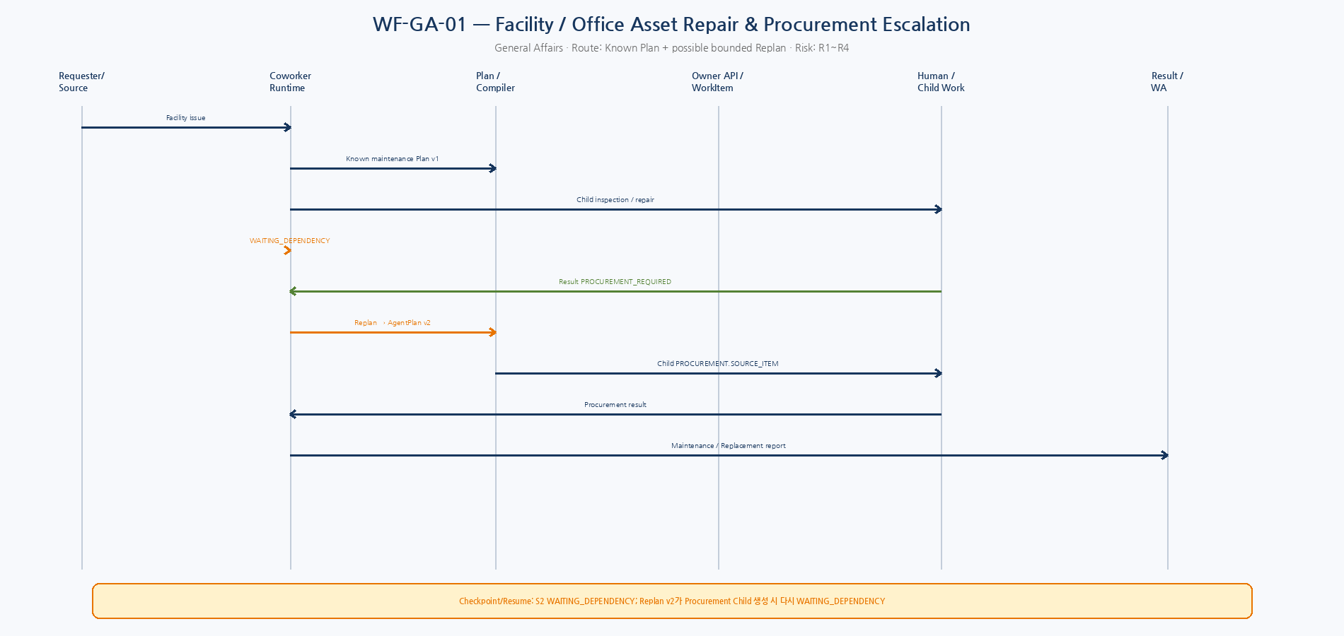
Sequence. WF-GA-01 — Runtime/Plan/Owner API/Human or Child Work/Result interactions.
Logical AgentPlan / Runtime Mapping
Step | Type | Capability | Objective | Depends | Risk
S1 | LOCAL_CAPABILITY | GA.RESOLVE_ASSET_LOCATION | 자산/장소 확인 | - | R1
S2 | DELEGATE_WORK | GA.INSPECT_AND_REPAIR_ASSET | 현장점검/가능하면 수리 | S1 | R3
S3 | AGGREGATE | GA.VALIDATE_MAINTENANCE_RESULT | 수리완료/교체필요/구매필요 판정 | S2 | R2
S4 | REPORT | REPORT.GA_MAINTENANCE | 초기 Plan은 점검결과 보고 | S3 | R1
Compiler / Runtime Transformation | Checkpoint / Result
S2 Child WorkItem으로 Facility capability pool에 Routing • S2 결과가 구매필요인 경우 기존 Plan in-place 수정 금지 • Replan v2에서 PROCUREMENT.SOURCE_ITEM DELEGATE_WORK 추가 | S2 WAITING_DEPENDENCY; Replan v2가 Procurement Child 생성 시 다시 WAITING_DEPENDENCY  Result: Maintenance Result + optional Procurement WorkRef + repair/replacement Artifact

Canonical Interfaces & Work Asset
- Canonical API: GA asset queries, WORKITEM.CREATE_CHILD, WORKITEM.RESULT, PLAN replan/versioning, PROCUREMENT child contract
- Work Asset: 시설업무 WorkAsset; 구매로 넘어가면 GA와 Procurement WorkAsset를 별도 보존
Acceptance Tests
ID | Given | When | Then
GA-AT-01 | 현장 수리완료 | S2 result=REPAIRED | S4 report; Replan 없음
GA-AT-02 | 교체/구매 필요 | S2 result=PROCUREMENT_REQUIRED | AgentPlan v2 생성, 기존 v1 immutable
GA-AT-03 | 동일 설비 기존 Open WorkItem | duplicate check | 새 중복 Work 대신 기존 Work 연결/정책
GA-AT-04 | Replan 횟수 초과 | max_replan_count | ESCALATED
GA-AT-05 | Procurement Child 실패 | dependency result failure | GA Parent 예외보고/대체조치
GA-AT-06 | 시설 담당자 lease 만료 | WC claim/reassign | 중복 수리 Side Effect는 business control로 방지

7. WF-MFG-01 — Production Material Shortage Response
Domain | Trigger | Route / Template | Risk / Data
Manufacturing | Manufacturing Manager Prompt or integration-created WorkItem | Known Plan  MFG.MATERIAL_SHORTAGE_RESPONSE | R2~R4 / CONFIDENTIAL
생산계획/BOM/재고를 조회해 부족자재를 확정하고 구매 Coworker에게 조달업무를 위임한 뒤 납기결과를 받아 생산영향 보고/조정 Draft를 만든다.
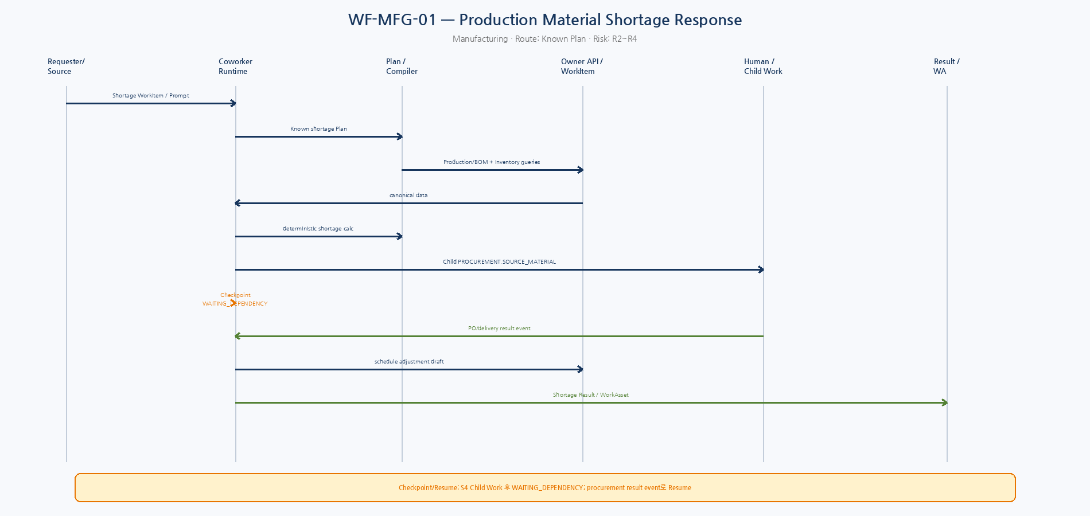
Sequence. WF-MFG-01 — Runtime/Plan/Owner API/Human or Child Work/Result interactions.
Logical AgentPlan / Runtime Mapping
Step | Type | Capability | Objective | Depends | Risk
S1 | LOCAL_CAPABILITY | MFG.GET_PRODUCTION_REQUIREMENTS | 생산계획/BOM 요구량 조회 | - | R2
S2 | LOCAL_CAPABILITY | INVENTORY.GET_AVAILABLE_STOCK | 가용재고/확정입고 조회 | S1 | R2
S3 | AGGREGATE | MFG.CALCULATE_SHORTAGE | 부족수량/필요일 deterministic 계산 | S1,S2 | R2
S4 | DELEGATE_WORK | PROCUREMENT.SOURCE_MATERIAL | 부족자재 조달 Child Work 생성 | S3 | R3
S5 | AGGREGATE | MFG.ASSESS_PRODUCTION_IMPACT | 조달결과+생산계획 영향 분석 | S4 | R2
S6 | LOCAL_CAPABILITY | MFG.CREATE_SCHEDULE_ADJUSTMENT_DRAFT | 필요시 생산조정 Draft | S5 | R3
S7 | REPORT | REPORT.MFG_SHORTAGE | 부족/구매/납기/조정 Draft 보고 | S6 | R1
Compiler / Runtime Transformation | Checkpoint / Result
S4 capability+plant/project scope로 Procurement Routing • S6 앞 Confirmation/Manager Gate 정책 가능 • 부족수량 계산은 LLM이 아닌 canonical data + deterministic formula | S4 Child Work 후 WAITING_DEPENDENCY; procurement result event로 Resume  Result: Shortage Analysis + Procurement WorkResult + ScheduleAdjustmentDraftRef

Canonical Interfaces & Work Asset
- Canonical API: MFG/ERP production query, INVENTORY query, WORKITEM.CREATE_CHILD, MFG.CREATE_SCHEDULE_ADJUSTMENT_DRAFT, WORKITEM.REPORT_RESULT
- Work Asset: Manufacturing 분석 WorkAsset와 Procurement 실행 WorkAsset를 correlation으로 연결; Project/Product/Plant attribution
Acceptance Tests
ID | Given | When | Then
MFG-AT-01 | 부족 없음 | shortage=0 | Procurement Child 생성 금지
MFG-AT-02 | 부족 존재 | deterministic shortage | 정확한 qty/due/project로 Child 생성
MFG-AT-03 | 중복 shortage WorkItem | same shortage operation | 중복 구매요청 방지
MFG-AT-04 | Procurement 납기 불가 | WorkResult exception | S5 영향분석→조정 Draft/ESCALATE
MFG-AT-05 | 재고가 대기 중 변경 | Resume freshness check | S5에서 최신 상태 재평가
MFG-AT-06 | S6 승인/권한 취소 | side-effect gate | Draft 생성 차단

8. WF-PROC-01 — Purchase Requisition → RFQ → Quote Compare → PO Draft
Domain | Trigger | Route / Template | Risk / Data
Procurement | Procurement Child WorkItem from MFG/GA or Procurement Prompt | Known Plan  PROCUREMENT.STANDARD_SOURCING | R2~R4 / CONFIDENTIAL
구매요청을 검증하고 공급사/RFQ/견적회수/비교를 거쳐 PO Draft를 생성하고 승인 프로세스로 넘긴다.
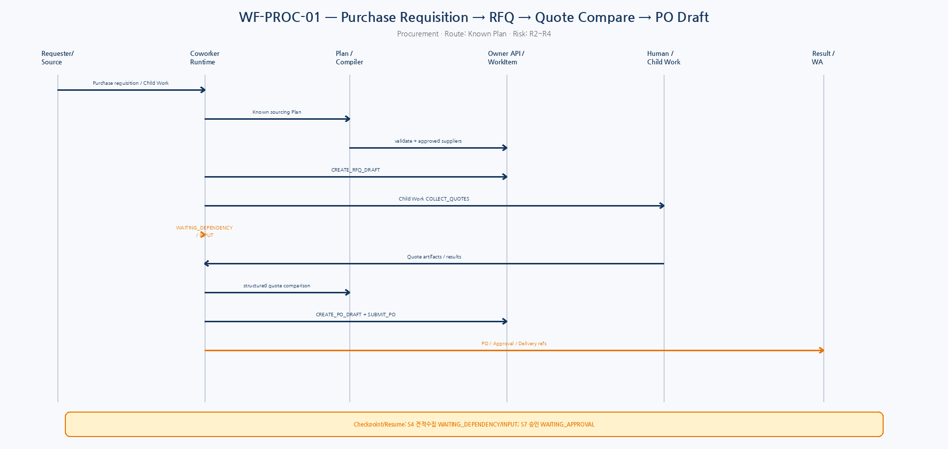
Sequence. WF-PROC-01 — Runtime/Plan/Owner API/Human or Child Work/Result interactions.
Logical AgentPlan / Runtime Mapping
Step | Type | Capability | Objective | Depends | Risk
S1 | LOCAL_CAPABILITY | PROCUREMENT.VALIDATE_REQUISITION | 품목/수량/납기/예산/프로젝트 검증 | - | R2
S2 | LOCAL_CAPABILITY | PROCUREMENT.LIST_APPROVED_SUPPLIERS | 적격 공급사 조회 | S1 | R2
S3 | LOCAL_CAPABILITY | PROCUREMENT.CREATE_RFQ_DRAFT | RFQ Draft 생성 | S2 | R3
S4 | DELEGATE_WORK | PROCUREMENT.COLLECT_QUOTES | Buyer가 RFQ 발송/견적 수집 | S3 | R3
S5 | AGGREGATE | PROCUREMENT.COMPARE_QUOTES | 가격/납기/조건 정규화 비교 | S4 | R2
S6 | LOCAL_CAPABILITY | PROCUREMENT.CREATE_PO_DRAFT | 선정안 기반 PO Draft 생성 | S5 | R3
S7 | LOCAL_CAPABILITY | PROCUREMENT.SUBMIT_PO | PO 승인 프로세스 시작 | S6 | R4
S8 | REPORT | REPORT.PROCUREMENT_RESULT | PO/Approval/납기정보 Parent에 반환 | S7 | R1
Compiler / Runtime Transformation | Checkpoint / Result
S3/S6 Confirmation • S7 Formal Approval Domain Gate • S4 Human Buyer capability pool Child WorkItem • 견적 비교 LLM 사용 시 구조화된 가격/납기 원천값은 변경 금지 | S4 견적수집 WAITING_DEPENDENCY/INPUT; S7 승인 WAITING_APPROVAL  Result: RFQRef + QuoteArtifacts + Comparison + PODraft/ApprovalRef + committed delivery info

Canonical Interfaces & Work Asset
- Canonical API: PROCUREMENT queries/commands, WORKITEM.CREATE_CHILD/RESULT, APPROVAL, ARTIFACT, REPORT
- Work Asset: Procurement sourcing WorkAsset; Parent Manufacturing/GA WorkItem refs를 evidence로 연결
Acceptance Tests
ID | Given | When | Then
PROC-AT-01 | 정상 구매 | approved suppliers+quotes | PO Draft/approval flow
PROC-AT-02 | 적격 공급사 없음 | supplier list empty | ESCALATED/Dynamic sourcing policy; PO 금지
PROC-AT-03 | 견적 Artifact 누락/스키마 오류 | S4 result invalid | S5 진행 금지
PROC-AT-04 | LLM 비교가 원가격 변경 시도 | schema/source validation | 원천 numeric value 보존; invalid output
PROC-AT-05 | PO Draft command timeout | same idempotency key | 중복 PO Draft 금지
PROC-AT-06 | 승인 중 Supplier/price change | business state/freshness | 재검토/approval invalidation 정책

9. XWF-01 — Manufacturing Shortage → Procurement → Resume
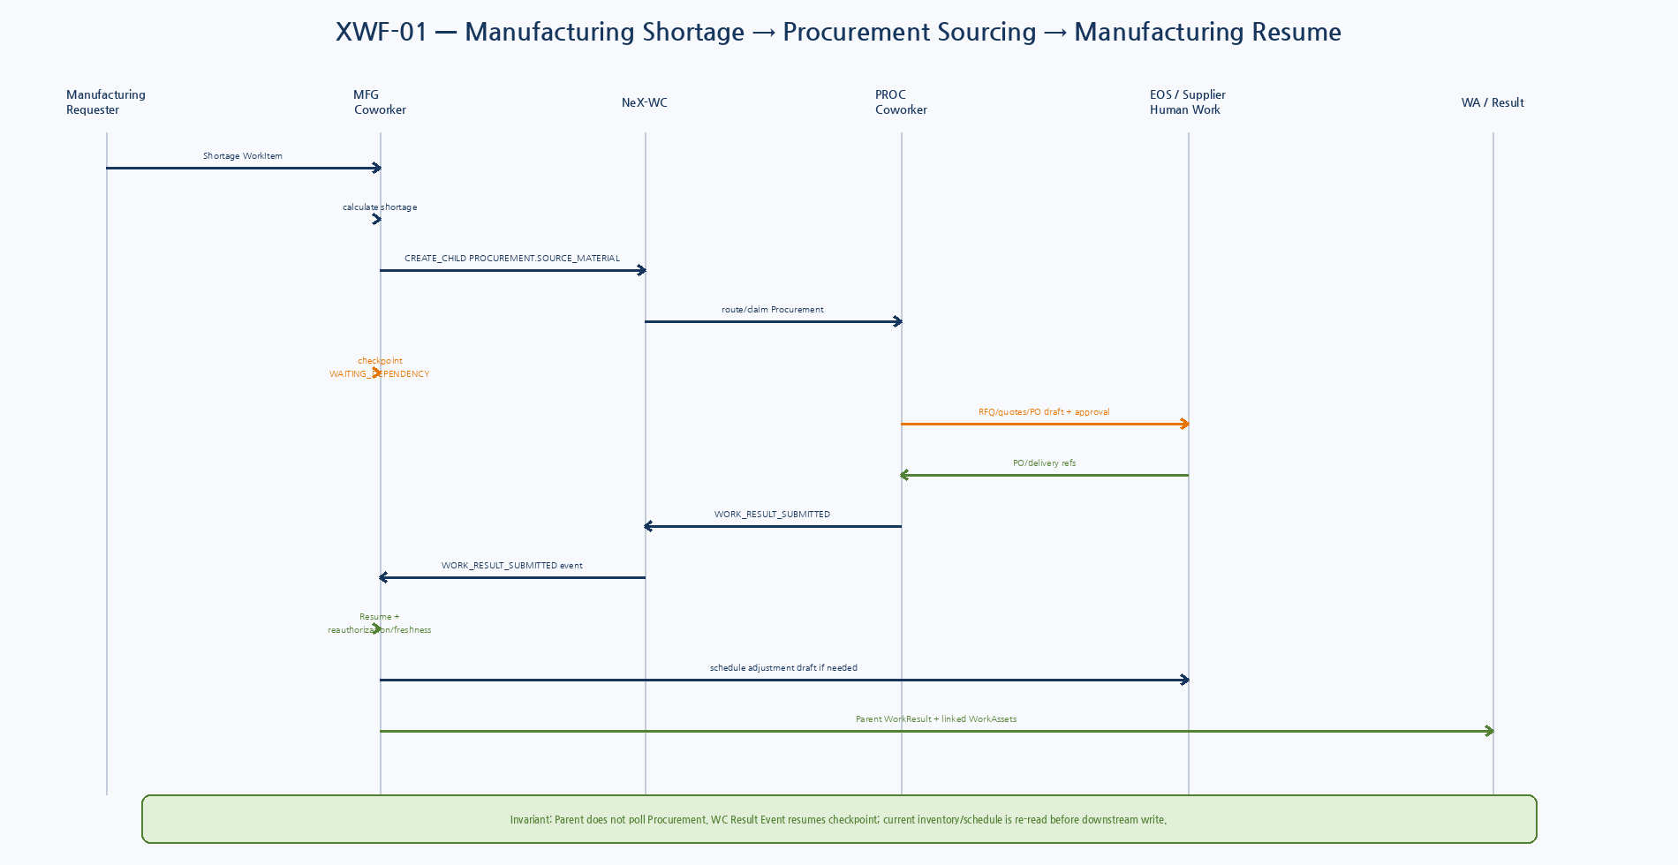
Figure 8. MFG Parent Execution이 Procurement Child WorkItem을 만들고 polling 없이 WAITING_DEPENDENCY에서 Result Event로 Resume하는 Cross-domain Golden Workflow.

10. Workflow State Mapping
Business Situation | AgentExecution | WorkItem | PlanStep | Checkpoint
Interactive clarification | WAITING_INPUT | Open/optional | clarification/gate | INPUT_RECEIVED
Formal approval | WAITING_APPROVAL | Parent open | FORMAL_APPROVAL | APPROVAL_RESOLVED
Child team work | WAITING_DEPENDENCY | Parent + Child | DELEGATE_WORK | WORK_RESULT_SUBMITTED
Unknown commit | RECONCILIATION_REQUIRED | Open/blocked | write unresolved | reconciliation ref
Policy revoked | BLOCKED/ESCALATED | Open | resume blocked | old snapshot kept
Runtime completed | SUCCEEDED | RESULT_SUBMITTED or open | required steps done | none
11. Cross-workflow Business Invariants
- Accounting/Finance numeric values come from Canonical source or validated user input; model never silently alters amount/account/project IDs.
- R5 payment/low-level ledger effects are not autonomous by default.
- HR restricted PII is minimized/masked and stable references are preferred.
- GA unexpected inspection result uses versioned Replan; no in-place plan mutation.
- Manufacturing shortage quantity is deterministic from production/BOM/inventory data.
- Procurement LLM may explain quote comparison but cannot alter source price/lead-time/terms.
- Internal inter-department collaboration uses WC WorkItem/Result rather than hidden agent messages.
- Runtime SUCCEEDED never auto-means WorkItem CLOSED.
12. Acceptance Coverage Matrix
Runtime Feature | ACC | FIN | HR | GA | MFG | PROC
Known/Certified Plan | ✓ | ✓ | ✓ | ✓ | ✓ | ✓
Structured Confirmation | ✓ | ✓ | △ | - | ✓ | ✓
Formal Approval | ✓ | ✓ | △ | - | △ | ✓
DELEGATE_WORK | - | ✓ | ✓ | ✓ | ✓ | ✓
WAITING_DEPENDENCY | - | ✓ | ✓ | ✓ | ✓ | ✓
WAITING_APPROVAL | ✓ | △ | △ | - | △ | ✓
Replan Versioning | - | △ | △ | ✓ | △ | △
Unknown Commit | ✓ | △ | - | - | - | ✓
Restricted Data | △ | ✓ | ✓ | - | △ | △
WorkAsset / Project | ✓ | ✓ | ✓ | ✓ | ✓ | ✓
✓ primary coverage, △ secondary/policy-dependent, - not central to representative scenario.
13. Test Backlog Extraction
Backlog | Implementation/Test Mapping
Plan Fixtures | 각 WF Logical AgentPlan을 JSON fixture로 작성; compiler golden output 보유
Acceptance IDs | ACC/FIN/HR/GA/MFG/PROC AT IDs를 pytest integration/E2E ID로 그대로 사용
Multi-child | HR-01, MFG/PROC collaboration dependency aggregation tests
Replan | GA-01 AgentPlan v1→v2 supersede test
Idempotency Fault | ACC-01/PROC-01 remote commit timeout + same-key replay
Cross-domain Regression | XWF-01을 GS-B minimum regression으로 유지
Playwright | ACC/GA interactive prompt→clarification/confirmation/result UI
14. Domain Confirmation Required
Domain | To Confirm Before Domain Detailed Design
Accounting | 계정과목, 전표상태, 승인 금액/프로젝트 정책
Finance | 지급 Batch, ERP/은행 실제 실행 경계, 지급권한/결재
HR | Employee creation state, onboarding 승인, IT/GA responsibility
General Affairs | 자산/시설 체계, repair→procurement threshold
Manufacturing | Production/BOM/Inventory canonical sources and freshness semantics
Procurement | Supplier approval, RFQ/Quote/PO states, approval threshold and vendor communication
15. Workflow Quality Gate
Gate | Pass Criteria
WF-QG-01 | Six domains map to the same Unified Runtime objects/states.
WF-QG-02 | Every workflow contains WorkIntent, PlanSteps, compiler transformation, APIs, wait/resume and result.
WF-QG-03 | Internal delegation uses WC Child WorkItem.
WF-QG-04 | Human Gate/R5 restrictions are explicit.
WF-QG-05 | Resume includes current authorization/freshness checks.
WF-QG-06 | Acceptance tests cover ambiguity/duplicate/failure/stale/idempotency/revocation.
WF-QG-07 | Every workflow produces WorkAsset/evidence linkage.
WF-QG-08 | Unconfirmed domain-specific business rules are clearly listed.
16. Next Step
NeX-WC Detailed Baseline
다음 단계에서는 대표 Workflow 중 HR/MFG/PROC/FIN의 Child Work, Assignment, Claim, Dependency, Result, Closure를 NeX-WC의 SRS/상세설계로 내려가는 것이 자연스럽다. 이 단계가 완료되면 Coworker Runtime과 Work Coordination을 실제 코드 Boundary로 연결할 수 있다.

