NeX Work Coordination
Platform v2.1 Controlled Amendment — CP02: existing Pool→Atomic Claim implementation을 유지하고 generic Agent/PA identity semantics를 추가한다.
Detailed Design v2.1
PostgreSQL · Routing Resolver · Claim / Lease · Result / Revision · Closure · AE Resume
Implementation Rule
Routing Target은 누가 처리할 수 있는지, WorkAssignment는 누가 실제로 처리하는지, WorkClaim은 현재 누가 실행권을 갖는지를 의미한다. 세 개를 같은 컬럼/상태로 합치지 않는다.
Reference contracts: JSON Schema + Python Protocol skeleton + PostgreSQL DDL/SQL | 2026.09.01

Executive Summary
본 문서는 NeX-WC를 실제 구현 가능한 Python/PostgreSQL 설계로 내린다. WorkItem을 Enterprise Work Aggregate Root로 두고 Capability Ownership→Routing→Assignment→Claim/Lease→Dependency→WorkResult→Revision→Closure를 각각 독립 책임으로 분리한다. AE의 DELEGATE_WORK는 idempotent Child WorkItem 생성으로 변환되며 Parent Runtime은 WAITING_DEPENDENCY로 Suspend한 뒤 WC의 WORK_RESULT_SUBMITTED Event를 AE Event Inbox가 소비하여 Resume한다. WC는 AE Runtime state를 직접 수정하지 않는다.
Critical Boundary
NeX-WC는 회사 Work state의 SoR이고 NeX-AE는 Agent execution state의 SoR다. Result Event가 두 시스템을 연결하지만 Cross-service DB Update나 distributed 2PC로 결합하지 않는다.
1. Detailed Design Principles
ID | Decision | Implementation Meaning
WC-DD-01 | Work SoR first | WorkItem/Assignment/Result/Closure are WC-owned durable business-work state, independent from AE runtime state.
WC-DD-02 | Routing ≠ Assignment ≠ Claim | Routing chooses target scope/pool; Assignment records actual participants; Claim coordinates an active Human/Agent worker. Agent claimant identity is AE Agent Registry based, not a WC-owned profile.
WC-DD-03 | Capability-first unnamed routing | Default target is required capability + organization/project scope; individual assignee is selected later.
WC-DD-04 | Deterministic eligibility | RoleBinding/permission/risk/scope/load/availability are server-side routing inputs; LLM cannot authorize a candidate.
WC-DD-05 | Append/version work evidence | Result revisions, timeline, routing decisions and audits preserve history rather than overwrite.
WC-DD-06 | Lease is not idempotency | Lease prevents simultaneous active claimant; business commands/results still use idempotency.
WC-DD-07 | Event-driven dependency | Parent/AE waits are resumed by canonical result events, never by busy polling.
WC-DD-08 | Closure is governance | Completion and closure are distinct; runtime/A2A completion never closes work automatically.
WC-DD-09 | Cross-service reference only | WC stores stable refs to AE/Project/EOS/Artifact/WA; no cross-DB FK/direct write.
WC-DD-10 | PostgreSQL-first | Core work/routing/claim/result/inbox/outbox are transactional PostgreSQL structures; broker is optional.

2. Python / Service Boundary
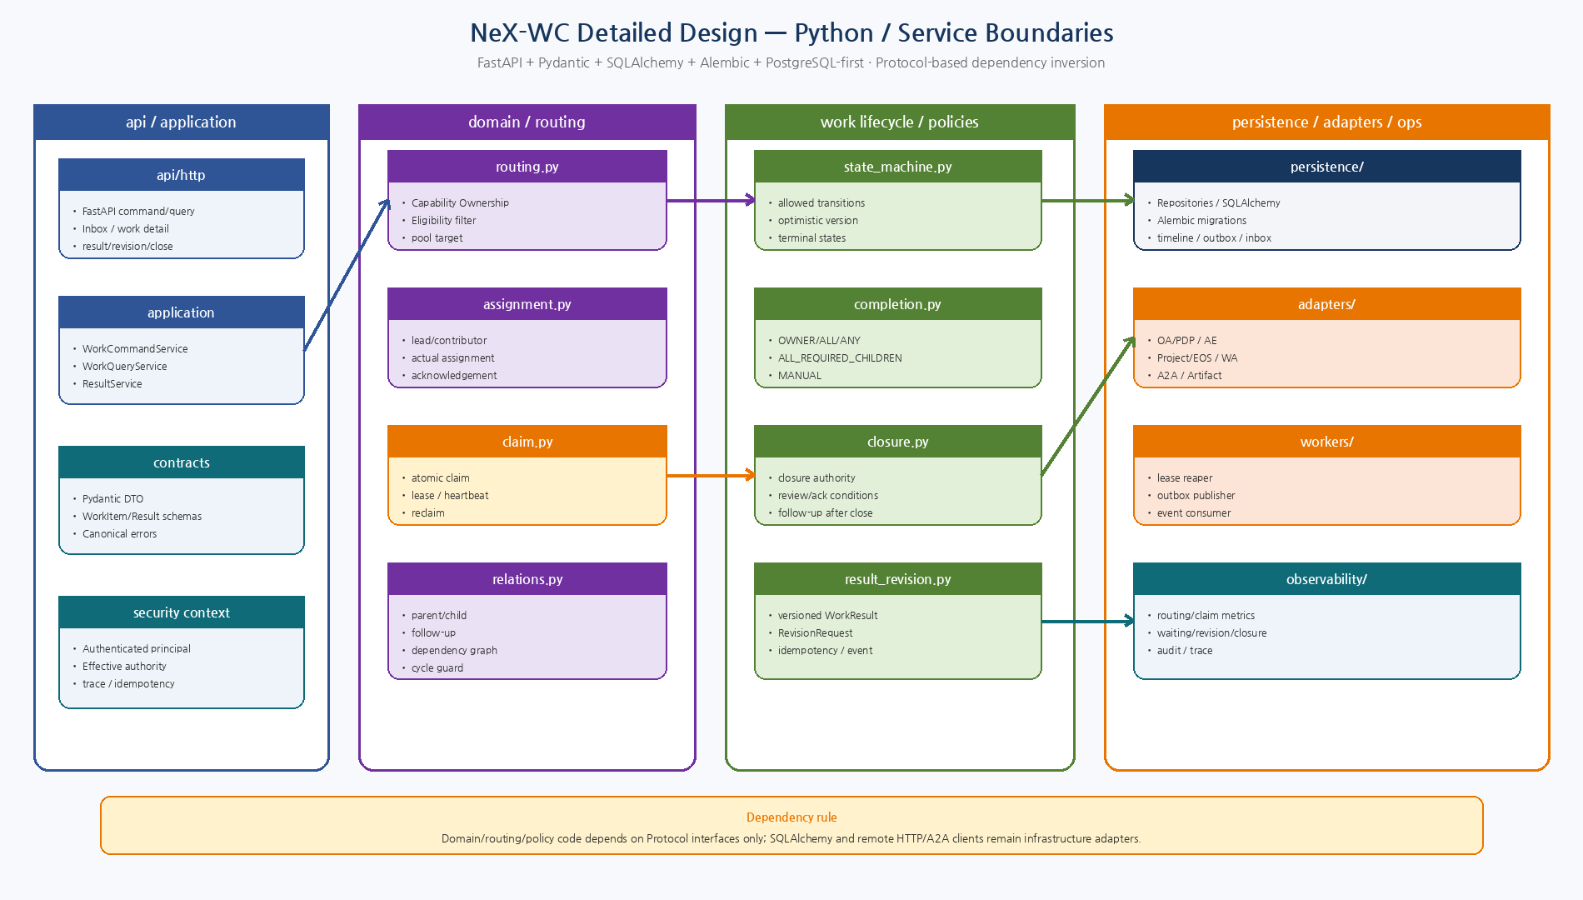
Figure 1. WC domain/routing/coordination/result가 Protocol에 의존하고 persistence/adapters가 구현하는 package boundary.

3. Recommended Package Tree
src/nex_wc/
├── api/
│ ├── commands.py
│ ├── queries.py
│ └── dependencies.py
├── application/
│ ├── command_service.py
│ ├── query_service.py
│ ├── result_service.py
│ └── closure_service.py
├── contracts/
│ ├── work_item.py
│ ├── routing.py
│ ├── assignment.py
│ ├── result.py
│ ├── revision.py
│ └── errors.py
├── domain/
│ ├── state_machine.py
│ ├── policies.py
│ ├── value_objects.py
│ └── invariants.py
├── routing/
│ ├── resolver.py
│ ├── ownership.py
│ ├── eligibility.py
│ └── load_policy.py
├── coordination/
│ ├── assignment.py
│ ├── claim.py
│ ├── dependency.py
│ ├── relation.py
│ └── timeline.py
├── result/
│ ├── result_service.py
│ ├── revision_service.py
│ └── review.py
├── persistence/
│ ├── models.py
│ ├── repositories.py
│ ├── claim_repository.py
│ └── migrations/
├── adapters/
│ ├── oa.py
│ ├── ae.py
│ ├── project.py
│ ├── artifact.py
│ ├── wa.py
│ └── a2a.py
├── workers/
│ ├── outbox_publisher.py
│ ├── event_consumer.py
│ └── lease_reaper.py
└── observability/
├── metrics.py
└── tracing.py
4. Core Python Protocol Interfaces
Protocol | Method | Responsibility
CapabilityOwnershipRegistry | resolve_owners(capability, org_scope) | Capability→owner org/pool lookup
EligibilityProvider | list_candidates(...) | Role/capability/load/availability candidates
AuthorizationPDP | can_assign / can_close | Routing/assignment/closure security decision
WorkRepository | get/update/save routing/assignment | Aggregate persistence and optimistic state update
ClaimRepository | claim/heartbeat/release | Atomic active claimant/lease
ResultRepository | submit_result/request_revision/close | Versioned result/revision/closure
CompletionPolicyEvaluator | evaluate(work_item) | OWNER/ALL/ANY/ALL_CHILDREN/MANUAL
ClosurePolicyEvaluator | evaluate(work_item, actor) | Closure authority/review decision
EventOutbox | append(event) | Transactional domain event publication

5. Canonical Data / Aggregate Model
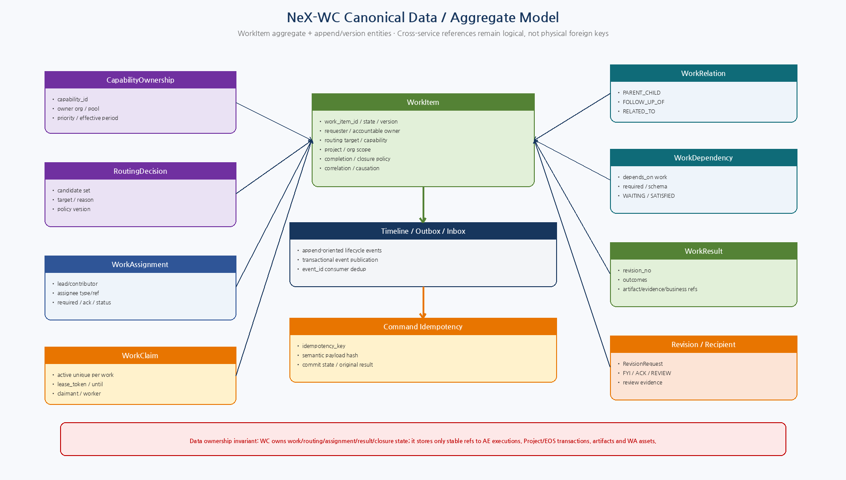
Figure 2. WorkItem aggregate, routing/assignment/claim/result/revision/dependency/timeline/idempotency 구조.

6. PostgreSQL Core Tables
Table | Purpose
capability_ownership | Capability→owner org/pool, priority, effective period, policy version
work_item | Aggregate identity/state/context/routing/completion/closure/version
work_assignment | Actual participants/lead/contributors/status/ack timestamps
work_claim | One active claim per work; claimant/worker/lease token/until
routing_decision | Candidate/target/reason/policy evidence
work_relation | PARENT_CHILD/FOLLOW_UP_OF/RELATED_TO
work_dependency | depends-on work/result contract/required/satisfied result
work_result | Versioned result + outcomes + refs + idempotency
work_revision_request | Target result/reason/requested changes/status
work_report_recipient | FYI/ACK/REVIEW state/evidence
work_timeline_event | Append-oriented work actions/state evidence
command_idempotency | Command key + payload hash + original result/commit
event_inbox / event_outbox | At-least-once dedup and transactional publication
Reference DDL은 `sql/001_wc_core.sql`에 포함했다. Cross-service Entity는 varchar/UUID stable reference로 보존하며 WC DB가 다른 service table에 physical FK를 만들지 않는다.

7. WorkItem State Transition Table
From | To | Authority / Trigger | Required Condition
CREATED | ROUTED | RoutingResolver | RoutingDecision persisted
CREATED | ASSIGNED | Explicit assignment policy | Routing may be skipped only for validated direct target
CREATED/ROUTED | CANCELLED | Authorized requester/owner | No committed business rollback
ROUTED | ASSIGNED | Assignment service | Actual participant relation created
ASSIGNED | ACKNOWLEDGED | Human/agent acknowledgement | Policy may allow agent auto-ack
ASSIGNED/ACKNOWLEDGED | IN_PROGRESS | Authorized assignee / claim holder | Current eligibility/claim valid
IN_PROGRESS | BLOCKED | Assignee/system | block reason + required action
IN_PROGRESS | WAITING_INPUT | Assignee/system | external/input wait ref
BLOCKED/WAITING_INPUT | IN_PROGRESS | Resolution event/action | Current authorization rechecked
IN_PROGRESS | RESULT_SUBMITTED | Authorized result submission | Valid WorkResult revision
RESULT_SUBMITTED | REVISION_REQUESTED | Reviewer/owner | RevisionRequest created
REVISION_REQUESTED | IN_PROGRESS | Assigned owner/assignee | new execution/revision linkage if agent
RESULT_SUBMITTED | CLOSED | Closure service | Completion + review + authority pass

8. Capability Ownership Registry
- `capability_ownership`은 capability_id + optional organization scope를 owner org/pool로 연결한다.
- Ownership row는 effective_from/to, active, priority, policy_version을 갖는다.
- Ownership은 책임조직/Pool을 결정하지만 특정 Employee를 고정하지 않는다.
- RoleBinding/Capability entitlement/load/availability read model은 EligibilityProvider가 제공한다.
- 조직개편 시 Plan/Agent 코드를 바꾸지 않고 ownership/routing data를 변경한다.

9. Routing Resolver Algorithm
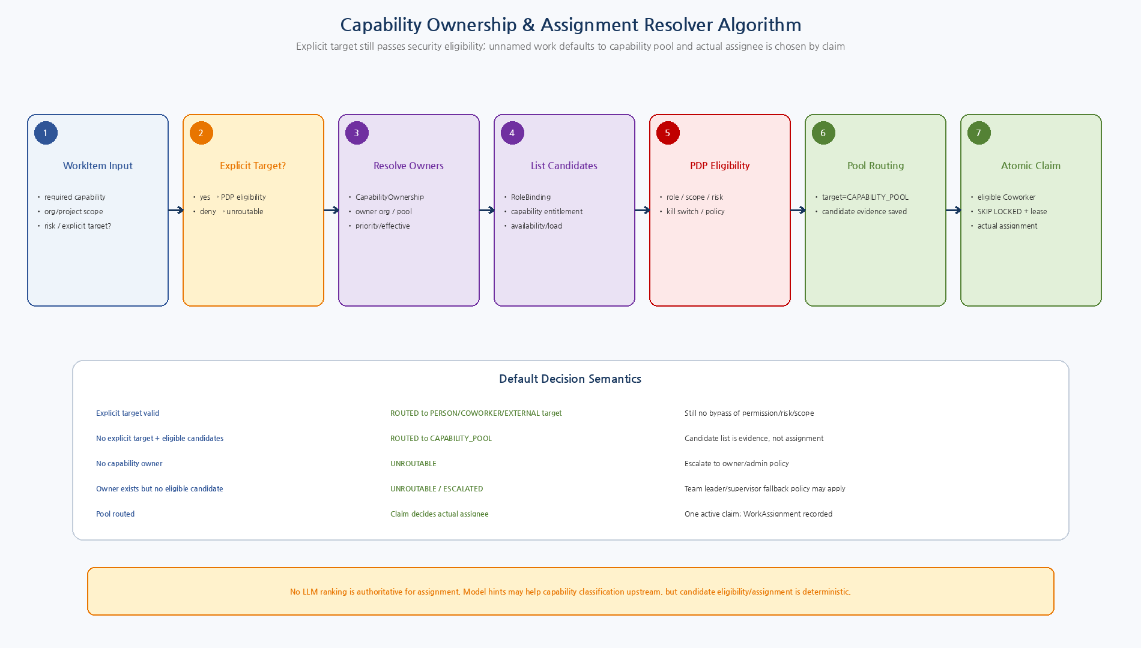
Figure 3. Explicit target도 PDP 검증을 거치며, unnamed work는 Capability Pool로 Routing하고 실제 Assignee는 Claim에서 정한다.
Step | Phase | Rule
R1 | Normalize routing request | required_capability/org/project/risk/explicit target.
R2 | Explicit target validation | PDP checks target role/scope/capability/risk; deny means unroutable.
R3 | Resolve ownership | CapabilityOwnershipRegistry returns effective owner org/pool in priority order.
R4 | Load candidates | Candidates from RoleBinding/capability entitlement/availability/load read model.
R5 | PDP eligibility | Filter by project/org/resource/risk/kill switch/policy.
R6 | Load policy | Reject overloaded/unavailable candidates if configured.
R7 | Route to pool | Default result = CAPABILITY_POOL, save candidate evidence.
R8 | Claim | Eligible Human/Agent(CA/PA/EA) claims; successful claim materializes WorkAssignment/WorkClaim as the actual participant/runtime owner. PA eligibility is project-scoped.
R9 | No candidate | UNROUTABLE or ESCALATED; supervisor/team-lead fallback only by explicit policy.

10. Assignment Modes
Mode | Structure | Completion / Accountability
LEAD_WITH_CONTRIBUTORS | One lead + optional/required contributors | Lead accountable for submitted result unless policy differs
JOINT_WORK | Multiple required assignees on one WorkItem | Completion evaluates all/any required assignment results
PARALLEL_INDIVIDUAL | Parent work split into independent Child WorkItems | Preferred for HR onboarding and distributed execution
11. Claim / Lease
Rule | Design
Atomicity | One active unexpired claim per WorkItem via partial unique index + locked target row.
Lease ownership | lease_token proves current claimant/worker; stale token cannot heartbeat/release.
Reclaim | lease reaper marks expired; another eligible actor may claim.
Actual assignment | Claim may create/update actual WorkAssignment; routing target remains unchanged.
Business side effects | Claim never guarantees exactly-once business effects; canonical command idempotency does.
Human work | Manual human assignment may not need heartbeat lease; policy distinguishes interactive human vs background worker.
11.1 Reference Claim SQL
WITH target AS (
SELECT wi.work_item_id
FROM nex_wc.work_item wi
WHERE wi.work_item_id=:work_item_id
AND wi.state IN ('ROUTED','ASSIGNED','ACKNOWLEDGED')
FOR UPDATE SKIP LOCKED
)
INSERT INTO nex_wc.work_claim(
claim_id, work_item_id, claimant_type, claimant_ref,
worker_ref, state, lease_token, lease_until
)
SELECT :claim_id, work_item_id, :claimant_type, :claimant_ref,
:worker_ref, 'ACTIVE', :lease_token,
now()+(:lease_seconds * interval '1 second')
FROM target
ON CONFLICT DO NOTHING
RETURNING *;
Partial unique index `WHERE state='ACTIVE'`가 한 WorkItem의 active claim 하나만 허용한다. Claim 성공 이후에도 Start/Result 시점의 현재 Role/Scope를 다시 검증한다.
12. Dependency / Completion Policy
Policy | Completion Rule
OWNER_SUBMITS | Accountable owner/lead result exists and contract valid
ALL_ASSIGNEES_SUBMIT | All required assignments have acceptable result
ANY_ASSIGNEE_SUBMITS | Any required assignment has acceptable result
ALL_REQUIRED_CHILDREN | Every required Child is RESULT_SUBMITTED/CLOSED with valid result
MANUAL | System never marks completion automatically
ALL_REQUIRED_CHILDREN은 Child가 단순 terminal state에 도달한 것만으로 충족되지 않는다. required result contract/schema와 허용 business outcome까지 만족해야 한다.
13. WorkResult / Revision
Rule | Design
Immutable revisions | UNIQUE(work_item_id, revision_no); prior results remain.
Idempotent submit | idempotency_key unique; same-key/same-payload returns original result.
Technical vs business outcome | SUCCEEDED/PARTIAL/FAILED separated from VERIFIED/REVISED/REJECTED/etc.
Stable refs | Artifact/Evidence/BusinessObject values remain owner-service references.
Dependency satisfaction | Only validated result schema/outcome may satisfy required dependency.
Event publication | Result transaction appends WORK_RESULT_SUBMITTED outbox event.
13.1 Revision Flow
RESULT_SUBMITTED → REVISION_REQUESTED → IN_PROGRESS → 새 WorkResult revision. 기존 WorkResult와 RevisionRequest는 감사증거로 남는다. CLOSED 이후 보완은 Revision이 아니라 FOLLOW_UP_OF WorkItem이다.
14. Closure Policy
Authority | Typical Use
Requester | Requester may close if policy allows and completion passes
Accountable Owner | Default enterprise closure authority
Designated Reviewer | Review-required workflows
Policy Role | e.g., team lead/accounting manager for higher-risk work
Manual/Admin | Exceptional operational closure with reason/audit
ClosureService는 CompletionPolicy, required review/ack, current authority를 모두 통과한 경우에만 RESULT_SUBMITTED→CLOSED를 허용한다. Agent auto-close는 명시적 low-risk policy에서만 opt-in이다.

15. Claim / WorkResult / AE Resume Transactions
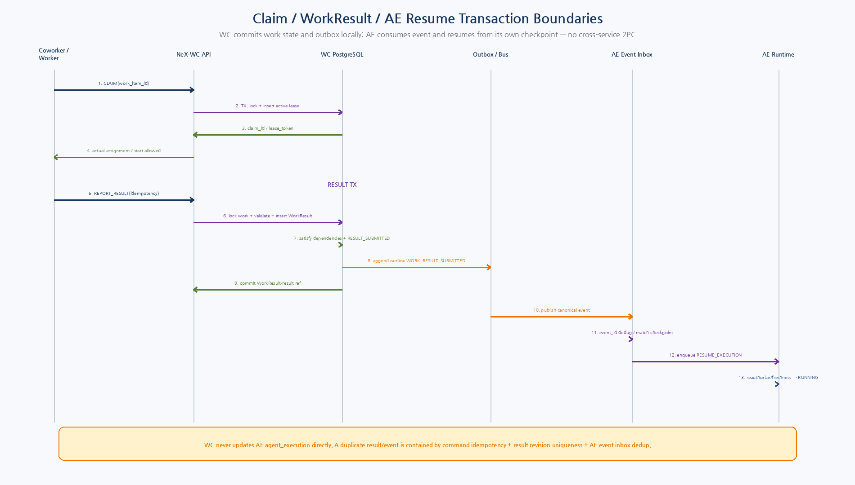
Figure 4. WC Claim/Result local transaction과 WORK_RESULT_SUBMITTED Outbox, AE Inbox/Resume의 서비스 경계.

16. AE Event Resume Contract
- AE의 DELEGATE_WORK는 WORKITEM.CREATE_CHILD command로 변환하고 parent execution/plan-step refs와 idempotency key를 전달한다.
- Child 생성 후 AE는 반환된 work_item_id를 Checkpoint wait condition에 저장하고 WAITING_DEPENDENCY로 전환한다.
- WC Result TX는 WorkResult, WorkItem RESULT_SUBMITTED, dependency satisfaction, timeline, outbox event를 로컬 DB transaction으로 commit한다.
- AE는 event_id dedup 후 matching checkpoint를 찾아 one Resume job을 enqueue한다.
- Resume는 current RoleBinding/Capability/Policy/Business freshness를 재검증하고 downstream step을 계속한다.
- WC는 AE DB/AgentExecution을 직접 update하지 않는다.
17. Canonical Command / Query Surface
17.1 Commands
Capability | Meaning | Risk | Safety
WORKITEM.CREATE | Create root WorkItem | R3 | Idempotent
WORKITEM.CREATE_CHILD | Create child with parent/execution/plan-step refs | R3 | Idempotent
WORKITEM.CREATE_FOLLOWUP | Create new work after closed item | R3 | Idempotent
WORKITEM.ROUTE | Resolve routing target | R3 | Expected version
WORKITEM.ASSIGN | Create actual assignment | R3 | Expected version
WORKITEM.CLAIM | Atomic claim | R3 | Lease
WORKITEM.ACKNOWLEDGE | Assignment acknowledgment | R3 | Expected version
WORKITEM.START | Transition to IN_PROGRESS | R3 | Expected version
WORKITEM.BLOCK | Set blocker/wait | R3 | Expected version
WORKITEM.REPORT_RESULT | Submit WorkResult revision | R3 | Idempotent
WORKITEM.REQUEST_REVISION | Request correction | R3 | Expected version
WORKITEM.CLOSE | Closure policy/authority | R4 | Idempotent + expected version
WORKITEM.CANCEL | Cancel open work | R4 | Expected version
17.2 Queries
Capability | Meaning
WORKITEM.GET | Work aggregate detail
WORKITEM.LIST_ASSIGNED | Human/agent assigned inbox
WORKITEM.LIST_POOL | Eligible capability pool inbox
WORKITEM.GET_CHILDREN | Parent children/result state
WORKITEM.GET_DEPENDENCIES | Dependency/readiness
WORKITEM.GET_RESULTS | Result revisions
WORKITEM.GET_TIMELINE | Append lifecycle timeline
WORKITEM.GET_ROUTING_DECISION | Routing candidates/decision evidence
18. Work Events
Event | Meaning
WORKITEM_CREATED | Root/Child/Follow-up created
WORKITEM_ROUTED | Routing target/capability pool decided
WORKITEM_ASSIGNED | Actual participant assigned
WORKITEM_CLAIMED | Active claimant/lease created
WORKITEM_STARTED | Work enters IN_PROGRESS
WORKITEM_BLOCKED | Block/wait condition recorded
WORK_RESULT_SUBMITTED | Versioned result submitted; dependency consumers may resume
WORK_REVISION_REQUESTED | Result revision requested
WORKITEM_CLOSED | Closure policy passed
WORKITEM_CANCELLED | Authorized cancellation
State-changing transaction은 Work Timeline을 append하고, 다른 서비스가 필요로 하는 Event만 Transactional Outbox에 기록한다. Timeline은 내부 감사/사용자 조회, Domain Event는 서비스간 계약이라는 목적 차이가 있다.
19. Security / Governance
Checkpoint | Rule
Creation | principal/requester/owner refs are server-validated; client actor fields are non-authoritative.
Routing | explicit target and pool candidates pass current PDP/RoleBinding/risk/scope/kill-switch checks.
Claim | claimant must still be eligible for required capability/scope.
Start/Result | current assignment/claim/authority rechecked; stale revoked Coworker denied.
Closure | completion policy + review conditions + current closure authority.
Secrets | raw secrets never stored in WorkItem/result/timeline.
External A2A | registered peer + A2A_EXPOSED capability + artifact validation; task state not authoritative Work state.
20. Observability
Metric | Purpose
wc_workitem_current | state/work_class/domain/project
wc_workitem_created_total | source_type/capability
wc_routing_total | decision/required_capability
wc_unroutable_total | reason/capability
wc_assignment_total | assignee_type/mode
wc_claim_total | claimant_type/outcome
wc_claim_expired_total | capability
wc_waiting_age_seconds | state/capability
wc_result_submitted_total | result_type/outcome
wc_revision_total | domain/reason
wc_close_duration_seconds | work_class/capability
wc_event_outbox_lag_seconds | event_name
21. Test Strategy
Layer | Required Test
Unit | State transition table, completion/closure policies, routing branches, relation/dependency rules.
Boundary/Robustness | duplicate child/follow-up/result, zero candidates, expired ownership, stale version, malformed result.
Concurrency | 10+ simultaneous claimants; one active claim; stale lease cannot release/complete.
Fault | Crash after result commit before publish; outbox retry; duplicate event; duplicate result command.
Integration | OA/PDP ownership/eligibility, AE child/resume, Artifact refs, Project context, A2A mapping.
E2E | WC-GS-01~07 + WF-HR-01/WF-MFG-01/WF-PROC-01/XWF-01.
UI/Playwright | Inbox, assignment, result, revision, review, close, follow-up.
22. Implementation Sequence
Wave | Area | Deliverable
I1 | Contracts/State | Pydantic models, enums, transition table, schema tests
I2 | PostgreSQL Core | work/assignment/claim/result/dependency/revision/timeline/outbox migrations
I3 | Routing | CapabilityOwnership + Eligibility/PDP + routing decision
I4 | Assignment/Claim | modes, SKIP LOCKED claim, heartbeat/reaper
I5 | Result/Revision/Closure | idempotent result, completion/closure evaluator, follow-up
I6 | AE Integration | Child work, result event, event-driven resume
I7 | A2A/WA/Project | external mapping, work asset/event refs, project scope
I8 | Hardening | fault/load/security/E2E, observability, migration gates
23. Machine-readable Reference Package
Artifact | Purpose / Validation
work-item-v2.schema.json | Canonical WorkItem contract — Draft 2020-12 PASS
routing-decision-v2.schema.json | Routing candidate/target evidence — Draft 2020-12 PASS
work-result-v2.schema.json | Versioned result contract — Draft 2020-12 PASS
protocols.py / routing.py | Python Protocol + deterministic RoutingResolver — syntax PASS
state_machine.py / policies.py | Transition + Completion/Closure policies — syntax PASS
001_wc_core.sql | PostgreSQL core physical model
002_claim_lease.sql | SKIP LOCKED claim/heartbeat/reclaim
003_result_dependency_resume.sql | Result/dependency/outbox/AE resume boundary
Reference Package는 Production Source가 아니라 구현팀의 Contract/Transaction Semantics 일치를 위한 Blueprint다. 실제 Repository를 확인한 후 package path/ORM naming/migration revision을 맞춰야 한다.
24. Detailed Design Quality Gate
Gate | Pass Criteria
WC-DD-QG-01 | WorkItem and AgentExecution remain separate ownership boundaries.
WC-DD-QG-02 | Routing target, assignment and claim are separate structures.
WC-DD-QG-03 | Capability routing is deterministic and auditable.
WC-DD-QG-04 | One active lease and stale-claim protection are enforced.
WC-DD-QG-05 | Completion and closure are independently evaluated.
WC-DD-QG-06 | WorkResult revisions preserve history and idempotency.
WC-DD-QG-07 | AE resumes through WORK_RESULT_SUBMITTED event, not cross-DB writes.
WC-DD-QG-08 | Parent/Child/Follow-up/A2A preserve WorkItem SoR.
WC-DD-QG-09 | Outbox/inbox/timeline reconstruct work lineage.
WC-DD-QG-10 | Reference schemas/Python/SQL were generated and validated.

24A. v2.1 Agent Participant / Claim Contract
RoutingDecision v2.1은 candidate_type=HUMAN|AGENT|EXTERNAL_AGENT를 사용하고 candidate_type=AGENT이면 agent_type=CA|PA|EA를 포함한다. Legacy COWORKER/EXPERT vocabulary는 migration alias로만 유지한다.
Claim record는 claimant_ref와 함께 agent_type, tenant_id, claim_generation을 audit 가능한 metadata로 보존한다. Physical claim/lease atomicity와 one-active-claim invariant는 기존 설계를 유지한다.
PA WorkItem은 project_id/project_scope가 명확해야 하며 eligibility/PDP는 current OA authority와 project scope를 사용한다. PA는 claim 성공 전 AgentExecution을 시작하지 않는다.
WC는 Agent Identity/Profile을 생성하거나 lifecycle 관리하지 않는다. Agent Registry reference를 사용한다.
25. Next Step
Core Execution Baseline Complete
11~15 문서로 Coworker Runtime과 NeX-WC의 Core Execution 경계가 구현 수준까지 연결됐다. 다음 문서는 Master Plan 순서에 맞춰 NSL/Certified Skill 또는 Enterprise Business Effect 쪽으로 진행하면 자연스럽다.

PLAT-CP04 — ApprovalWorkItem Detailed Model
Status: PLAT-CP04 Controlled Amendment — Canonical Approval Architecture
ApprovalWorkItem은 기존 WorkItem/Assignment/Event/Timeout 기반을 재사용하는 Human Decision work subtype이다.
State: PENDING / APPROVED / REJECTED / EXPIRED / CANCELLED.
NSL_WRITE Approval은 NSL-owned request를 workflow envelope로 받아 저장하며 payload/write-intent hash를 재계산하지 않는다.
Agent FORMAL_APPROVAL이 EOS domain approval을 요구하면 WC는 EOS BusinessApprovalAdapter를 호출하여 authoritative domain record를 연결한다.
Decision idempotency: 동일 approval_work_item_id + 동일 decision version은 exactly-once semantic outcome을 보장해야 한다.
Field | Meaning
approval_work_item_id | WC workflow identity
approval_domain | AGENT_FORMAL | NSL_WRITE
source_ref | Agent/NSL source reference
agent_execution_id | Agent execution correlation
nsl_execution_id | NSL WRITE approval only
business_operation_id | Stable semantic operation
approval_request_id | NSL-owned request identity when NSL_WRITE
target_approver / role | Routing target
status / decision | Workflow state / human decision
resume_target_ref | Agent runtime resume target

PLAT-CP05 — WC Recurring Work / Schedule Detailed Design
Status: PLAT-CP05 Controlled Amendment — Canonical Schedule/Recurring Work
WC Schedule subsystem은 기존 Work Core/Routing/Claim과 분리된 durable recurrence definition + occurrence materializer다.

Processing Loop
Scheduler scanner → due ScheduleSpec lease → misfire/concurrency evaluation → ScheduleOccurrence upsert → idempotent WorkItem materialization → outbox/event → normal WC routing/claim.

Idempotency
OccurrenceKey = canonical(tenant_id, schedule_id, nominal_time UTC). 동일 key는 하나의 occurrence와 최대 하나의 materialized WorkItem만 가진다.

Recovery
Scheduler crash 후 due scan을 재수행해도 unique occurrence/materialization key로 duplicate WorkItem을 방지한다. Materialized WorkItem 이후 Agent runtime failure는 Schedule이 아니라 normal WC/AE retry semantics로 처리한다.
Table / Component | Key Constraint
wc_schedule_spec | unique tenant_id + schedule_id; versioned
wc_schedule_occurrence | unique tenant_id + schedule_id + nominal_time
wc_schedule_materialization | unique occurrence_id → work_item_id
Scheduler Worker | lease/heartbeat; no in-process sleep ownership
WorkItem | source_type=SCHEDULE; source_ref=occurrence_id

E1 Contract Hardening — Typed Claim Handoff
Status: E1 Contract Hardening v1.2 — Normative
- RoutingDecision v2.1의 AGENT candidate는 non-null agent_type(CA/PA/EA)를 가진다.
- ClaimExecutionHandoff v2.1 fields: tenant_id, work_item_ref, claim_ref, claim_generation, claimant_agent_ref, claimant_agent_type, project_id, assignment_ref, correlation_id, causation_id.
- handoff publication은 successful claim + assignment materialization과 같은 durable ownership result 뒤에 발생한다.
- AE Trigger Adapter는 handoff를 Frozen ExecutionTrigger v2.1(source_type=CLAIMED_WORKITEM)로 정규화한다.

Step2 E2E Contract Hardening — Routing and Result Event Design
Status: Step2 E2E Contract Hardening v1.3 — Normative
- RoutingContextV21 carries required_agent_type. Non-null required_agent_type must match every eligible AGENT candidate and successful claimant.
- PA-targeted routing requires project_scope_ref and a WorkItem project_ref; PA is never inferred only from project scope.
- WorkResult v2.1 Agent submissions require source_execution_ref, claim_ref, claim_generation and assignment_ref.
- WORK_RESULT_SUBMITTED v2.1 is written via WC outbox after WorkResult + RESULT_SUBMITTED commit; AE deduplicates event_id and resumes exactly once after result-contract validation.

E2E Step 6 — WC Schedule Materialization Detailed Hardening
Status: E2E Step 6 Schedule Contract Hardening v1.7 — Normative
Materialization transaction은 다음 순서를 하나의 WC local commit boundary로 수행한다.
- 1) ScheduleSpec row lock → enabled=true 및 version==expected_schedule_version 확인.
- 2) Tenant/project/service authorization 및 PA project binding 검증.
- 3) ScheduleOccurrence create-or-get(schedule_version, nominal UTC time, materialization_key).
- 4) WorkItem source=SCHEDULE/source_ref=OccurrenceId, singular required_capability, project refs를 deterministic하게 생성하고 payload hash 계산.
- 5) 같은 occurrence/key+same hash면 기존 WorkItem을 반환하고 different hash면 MATERIALIZATION_CONFLICT.
- 6) WorkItem + ScheduleMaterialization + Occurrence MATERIALIZED를 동일 transaction으로 commit.
- 7) commit 이후에도 AgentExecution은 생성하지 않으며 successful atomic Claim이 별도 CLAIMED_WORKITEM trigger를 만든다.
Time semantics: CRON5_V1은 IANA timezone에서 평가하고 DST gap은 skip, overlap은 earlier offset 1회만 선택한다. FIXED_INTERVAL은 instant-based ISO8601 interval이며 nominal/next/last time은 UTC RFC3339로 저장한다.

E2E Step 8 — Background WC WorkResult / Claim-Lineage Closure
CA/PA/EA AgentExecution이 successful WC Claim에서 시작된 경우 immutable AgentResult는 source WorkItem, Claim, ClaimGeneration, claimant Agent, Assignment lineage를 모두 보존해야 한다.
ResultDelivery planner는 해당 background AgentResult마다 정확히 하나의 required WC_WORK_RESULT delivery를 생성해야 하며 WC_WORK_RESULT는 optional로 선언할 수 없다.
WC_WORK_RESULT publication preflight는 current WC claim 상태, ClaimGeneration, claimant, Assignment, source AgentExecution lineage를 AS_OF_NOW로 검증한다. stale/reclaimed/tenant-mismatch lineage는 DENY하며 WorkResult를 publish하지 않는다.
AgentExecution은 required WC_WORK_RESULT를 포함한 모든 required ResultDelivery가 durable ACKNOWLEDGED된 뒤에만 canonical SUCCEEDED가 될 수 있다. WA projection/Notification은 optional post-work fan-out이며 completion gate가 아니다.

