NeX Skill Language

Language Specification v0.2 Baseline
Non-Turing-complete · Typed · Atomic · Controlled Write
Language Boundary
NSL은 자연어를 해석하지 않고 장기 Workflow를 조정하지 않는다. 이미 구조화·Resolution·Policy-bound된 입력을 deterministic하게 검증하고, strict profile에서는 하나의 Controlled Business Write만 수행한다.
Normative requirements: 57 | NSL 0.2 · NSO IR 1.1 · NSL-0.2-STRICT | 2026.09.01

Executive Summary
NSL v0.2는 v0.1의 READ/CALCULATE/LET/CHECK/EMIT 기반 deterministic execution에 제한된 Controlled Write를 추가하는 Atomic Business Skill DSL이다. v2.1 Platform에서는 Frozen NSL v0.2를 유일한 NSL semantic authority로 사용한다. NSL Runtime은 actual WRITE intent를 freeze한 뒤 ApprovalRequestId와 checkpoint를 생성하고 WAITING_FOR_APPROVAL로 suspend하며, Agent/Platform은 Human Workflow와 Resume scheduling을 소유한다. actual WRITE IdempotencyKey와 Package Trust도 Frozen NSL contract를 따른다.
Important Semantic Update
`approve ... approved_by ...`는 장기 Human workflow 문법이 아니다. NSL-0.2-STRICT에서 WRITE approval requirement의 정적 관계만 표현하며, Runtime은 WriteIntent를 freeze하고 ApprovalRequestId/Checkpoint를 생성하여 WAITING_FOR_APPROVAL로 suspend한다. Human workflow/Resume scheduling은 Unified Agent Runtime이 담당하고, NSL은 Resume 시 typed ApprovalEvidence binding을 검증한다.

1. NSL Architectural Boundary
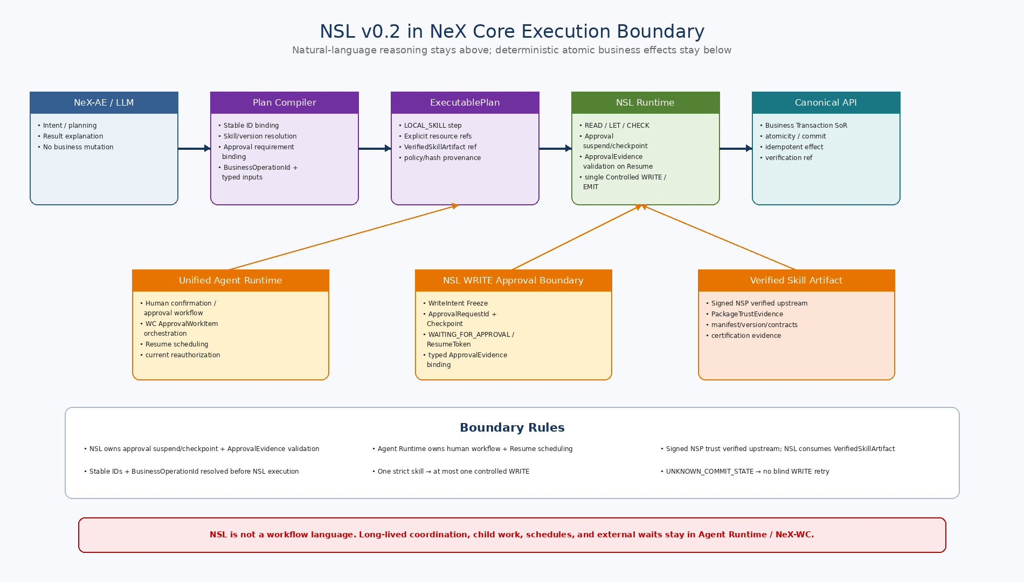
Figure 1. AE/Plan Compiler, Agent Runtime Human Workflow, NSL Runtime, Canonical Business API의 책임경계.

2. Language Principles
ID | Principle | Meaning
NSL-P-01 | Atomic Skill | 한 Skill은 짧고 bounded한 하나의 업무능력을 수행하며 장기 Workflow를 소유하지 않는다.
NSL-P-02 | Non-Turing-complete | 무한 Loop/재귀/동적 코드실행을 제공하지 않는다.
NSL-P-03 | Deterministic Runtime | NSL Runtime 내부에서 LLM/자연어 추론을 호출하지 않는다.
NSL-P-04 | Typed Business Values | Business numeric은 Decimal/Money를 사용하고 Float를 제공하지 않는다.
NSL-P-05 | Canonical Capability Only | READ/WRITE는 Registry의 Canonical Capability Contract만 호출한다.
NSL-P-06 | Single Controlled Write | NSL-0.2-STRICT Skill은 최대 1개의 WRITE node만 가진다.
NSL-P-07 | NSL WRITE Approval Boundary | NSL Runtime은 STRICT WRITE에서 WriteIntent를 freeze하고 ApprovalRequestId/Checkpoint를 생성하여 WAITING_FOR_APPROVAL로 suspend한다. Unified Agent Runtime은 WC human workflow와 Resume scheduling을 담당하며, NSL은 Resume 시 typed ApprovalEvidence를 검증한다.
NSL-P-08 | ApprovalEvidence Binding | ApprovalEvidence는 BusinessOperationId, ApprovalRequestId, skill semantic hash, PayloadHash, WriteIntentHash에 binding되어야 한다.
NSL-P-09 | Fail Closed | CHECK FAIL/UNKNOWN, 권한/계약/서명 불일치 시 WRITE하지 않는다.
NSL-P-10 | No Distributed Workflow Semantics | Retry/rollback/child work/event wait를 언어문법으로 만들지 않는다.
NSL-P-11 | Signed Executable Asset | Production WRITE execution은 Signed NSP 검증 결과인 PackageTrustEvidence를 포함한 VerifiedSkillArtifact를 요구한다.
NSL-P-12 | Backward Compatibility | v0.1 source/IR read-only skill compatibility를 유지한다.
3. Version & Compatibility Baseline
Item | Version / Target | Meaning
NSL Language | 0.2 | Controlled Write language baseline
NSO IR | 1.1 | Typed IR + approval/write metadata
Strict Profile | NSL-0.2-STRICT | Default enterprise write profile
v0.1 Source | compatible target | v0.2 compiler should compile supported v0.1 syntax
v0.1 NSO IR 1.0 | runtime compatibility target | Read/Calculate/Check/Emit execution
4. Type System
Type | Representation | Rule
Bool | true/false | Logical values
Int | bounded integer | Counters/quantities where integer semantics are correct
Decimal | exact decimal | Rates/precise numeric calculation
Money | amount + currency | Financial values; no Float conversion
String | UTF-8 string | Text/data, not executable code
Date | calendar date | Business date
DateTime | timezone-aware datetime recommended | Event/effective timestamp
Duration | bounded duration | Timeout/period values
EntityRef | entity_type + stable ID (+ version/status) | Canonical cross-service reference
Json | schema-bounded structured value | Only where explicit schema contract exists
List<T> | bounded collection | FOREACH requires explicit limit
Optional<T> | T or null | Missing value is not silently defaulted by NSL
4.1 Numeric / Null / Date Semantics
Area | Rule
Decimal precision | Compiler/runtime preserve exact decimal representation; no Float intermediate.
Money | Contains Decimal amount + ISO-like currency code; arithmetic requires currency compatibility.
Division | Must define rounding/scale explicitly when target type requires it.
Null | Optional value remains null unless explicit `coalesce` or domain-provided default is passed in.
Date/DateTime | Natural language date resolution occurs before NSL; NSL receives canonical typed value.
5. Language Constructs
Construct | Meaning | Restriction
include | Compile-time source composition | No runtime network loading
requires | Declares every callable capability | Compiler checks manifest/tool contracts
input/output | Typed skill boundary | Schema generated/validated
read | QUERY capability invocation | No business state mutation
let / calculate | Immutable deterministic expression binding | No reassignment
check | Three-state validation | FAIL/UNKNOWN blocks downstream write
approve | Declares NSL WRITE approval requirement | NSL Runtime owns suspend/checkpoint; no human workflow orchestration inside NSL
write | Single allowed controlled command | CREATE/CREATE_DRAFT only in strict profile
approved_by | Static linkage from WRITE to approval requirement | ApprovalRequestId / PayloadHash / WriteIntentHash binding checked at Resume
foreach | Bounded iteration | Explicit limit; no WRITE inside
emit | Structured result output | Prefer refs/schema values

6. Compile → Signed Certified Skill Pipeline
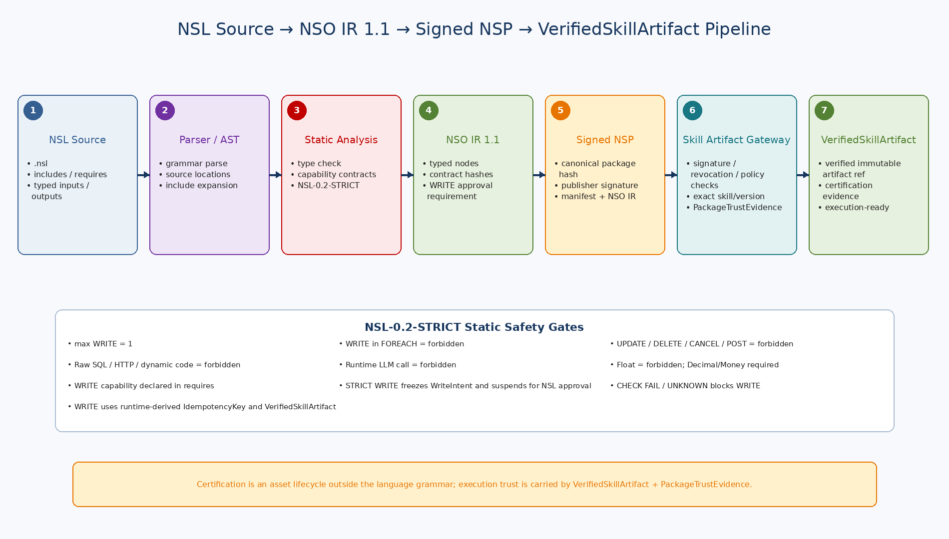
Figure 2. Source→Typed NSO IR 1.1→NSP Package→Package Verification→VerifiedSkillArtifact로 이어지는 Skill Asset Pipeline.

7. NSL-0.2-STRICT Safety Profile
ID | Normative Rule
SR-01 | All callable capabilities MUST appear in `requires`.
SR-02 | READ MUST bind to a QUERY/READ capability.
SR-03 | WRITE MUST bind to a write-capable Canonical Capability Contract.
SR-04 | Maximum WRITE nodes per skill = 1.
SR-05 | WRITE inside FOREACH is forbidden.
SR-06 | UPDATE/DELETE/CANCEL/POST/FINALIZE operations are not language features in v0.2 strict.
SR-07 | Raw SQL, raw HTTP, shell/script, dynamic import/eval are forbidden.
SR-08 | Runtime LLM invocation is forbidden.
SR-09 | Every WRITE MUST statically reference its NSL WRITE approval requirement; Runtime creates ApprovalRequestId only after WriteIntent Freeze.
SR-10 | Every WRITE MUST use NSL Runtime-owned idempotency derived from TenantId + BusinessOperationId + WriteNodeId.
SR-11 | CHECK FAIL or UNKNOWN MUST prevent WRITE.
SR-12 | ApprovalEvidence PayloadHash and WriteIntentHash MUST match the frozen actual write intent/payload binding.
SR-13 | WRITE Tool Contract MUST declare atomicity and commit semantics.
SR-14 | UNKNOWN_COMMIT_STATE MUST NOT auto-retry.
SR-15 | Replay MUST NOT invoke the WRITE provider.
SR-16 | WRITE execution requires a valid Signed NSP / VerifiedSkillArtifact and allowed Skill Version.
SR-17 | Runtime MUST validate Tool Contract hash/capability contract compatibility.
SR-18 | Runtime MUST validate current entitlement/risk/policy before WRITE.
SR-19 | Float type and implicit binary floating conversion are forbidden.
SR-20 | FOREACH limit MUST be statically bounded and runtime-enforced.
8. CHECK Semantics
Result | Meaning | Runtime Behavior
PASS | Expression is true | Execution continues
FAIL | Expression is false | Skill stops with deterministic validation failure
UNKNOWN | Required value/state cannot be determined | Skill stops; caller may clarify/re-resolve/retry context
[SUPERSEDED v2.0 — see PLAT-CP03] 9. Human Gate Semantics
Legacy Agent Control (NON-NORMATIVE) | Meaning | Owner | Historical Evidence
CONFIRMATION | Requester confirms structured interpretation/payload | Unified Agent Runtime / structured review | confirmation_token + payload hash
FORMAL_APPROVAL | Authorized approver approves business decision | Enterprise Approval Engine + Agent Runtime wait/resume | ApprovalInstance proof + payload binding
Agent/Platform control gate와 NSL WRITE Approval을 분리한다. NSL Runtime NEW 실행에서 Approval이 필요하면 NSL이 ApprovalRequest/Checkpoint를 생성하고 WAITING_FOR_APPROVAL로 suspend한다. Resume 시 ApprovalEvidence를 BusinessOperationId/ApprovalRequestId/PayloadHash/WriteIntentHash/SkillSemanticHash에 binding 검증한다.
10. Controlled WRITE Profile
Item | Strict Rule
Allowed | CREATE / CREATE_DRAFT via Canonical aggregate command
Not language-level | UPDATE / DELETE / CANCEL / POST / FINALIZE / ROLLBACK / RETRY
Maximum | 1 WRITE node per NSL-0.2-STRICT skill
Aggregate effect | One command may atomically create WorkItem + Assignments + Timeline or Voucher + lines
Transaction owner | Canonical Business API / domain SoR
Idempotency owner | Canonical API final guarantee; Runtime derives actual key from TenantId + BusinessOperationId + WriteNodeId
Commit states | COMMITTED / NOT_COMMITTED / UNKNOWN_COMMIT_STATE

11. Controlled Write Execution Semantics
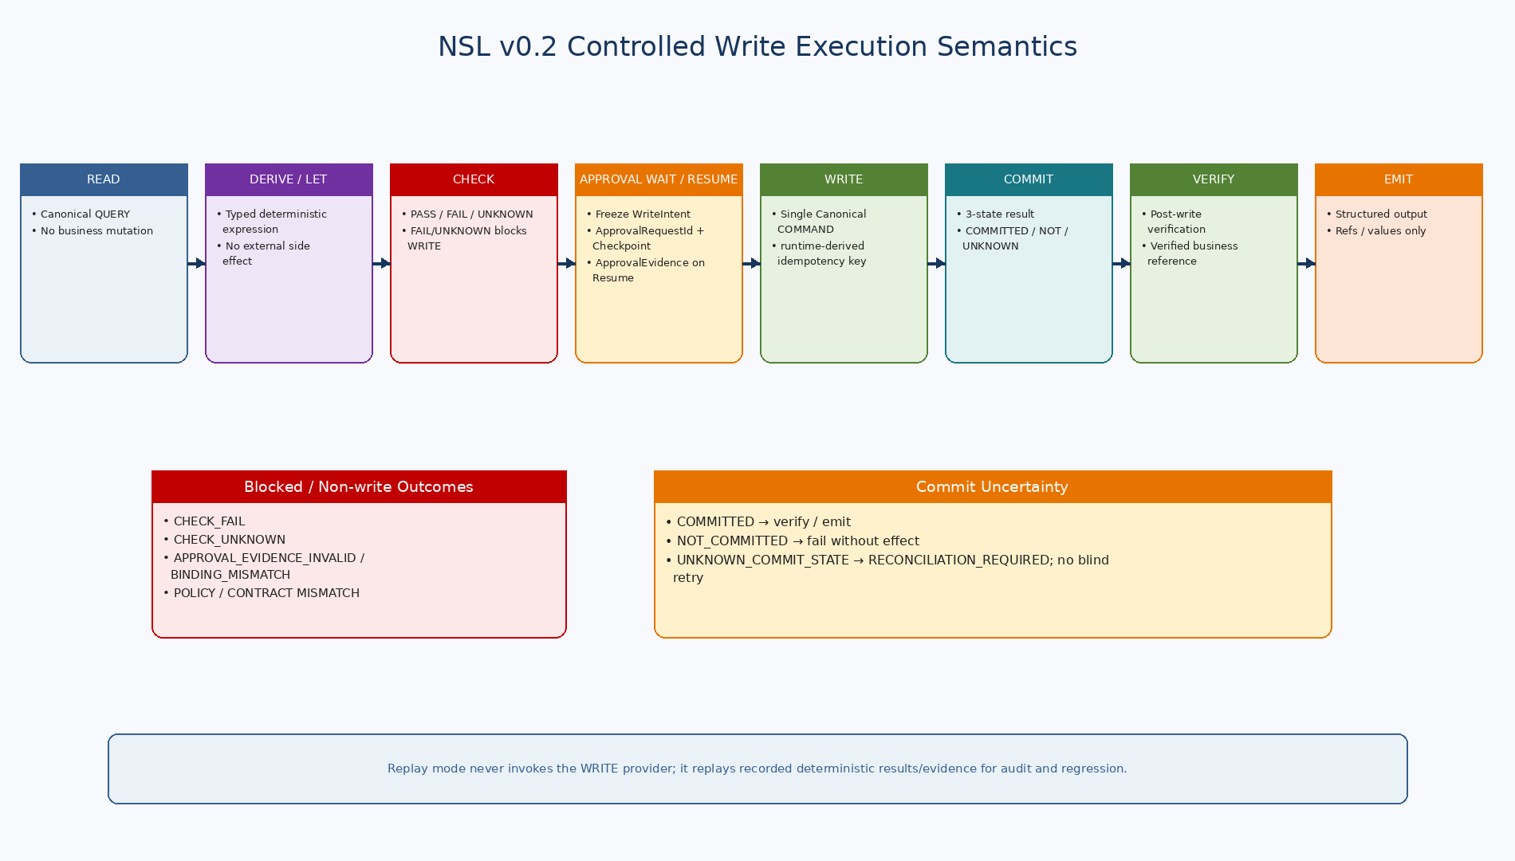
Figure 3. READ→CHECK→WriteIntent Freeze→Approval Suspend/Resume→Single WRITE→3-state Commit→Verification→EMIT의 결정적 실행흐름.

12. NSO IR 1.1 Semantic Nodes
IR Node | Meaning
READ | Capability query contract + typed output
BIND | LET/CALCULATE typed expression binding
CHECK | Typed condition + error/message metadata
WRITE_APPROVAL_REQUIREMENT | Approval requirement/policy binding metadata; no long-lived wait state in NSO IR
WRITE | Capability command + approval-requirement binding + write-intent fingerprint metadata
EMIT | Typed output projection
FOREACH_BOUNDED | Bounded read/derive/check/emit body
13. Certified Skill Asset Boundary
Asset Part | Meaning
Source | Versioned .nsl source and include dependencies
NSO | Canonical compiled Typed IR 1.1
Manifest | Skill ID/version/capability/risk/input/output/dependencies
Contract snapshot | Capability/Tool Contract IDs, versions, hashes
Security | Signature/publisher/entitlement/exposure policy
Tests | Unit/Golden/negative/security/replay test references
Metrics | Execution/verified success/failure/reconciliation statistics
Lifecycle | DRAFT/TESTING/CERTIFIED/SUSPENDED/DEPRECATED/RETIRED — detailed in Document 17
14. Backward Compatibility
Input | v0.2 Behavior
v0.1 .nsl | Compile with v0.2 compiler if it uses supported v0.1 constructs
IR 1.0 .nso | Execute in compatibility read-only path
IR 1.1 .nso | Supports approval/write metadata
v0.2 WRITE skill on old runtime | Rejected; runtime version/capability mismatch
v0.2 strict → future profile | No silent semantic widening; profile version is explicit
15. Representative Skill Patterns
Skill | Flow
Accounting Voucher Draft | READ Project/Account → CHECK → NSL WRITE Approval Suspend/Resume → WRITE FINANCE.CREATE_VOUCHER_DRAFT → verify → EMIT VoucherRef
WorkItem Directive | READ requester → CHECK authority/assignees → NSL WRITE Approval Suspend/Resume → WRITE WORKITEM.CREATE aggregate → EMIT WorkItemRef
Project Draft | READ parent/project policy → CHECK duplicate/period → NSL WRITE Approval Suspend/Resume → WRITE PROJECT.CREATE_PROJECT_DRAFT → EMIT ProjectRef

16. Normative Requirements
ID | Pri. | Requirement | Verification | Parent
NSL-LANG-001 | MUST | NSL v0.2 shall remain non-Turing-complete and bounded. | Grammar/static test | P-01/02
NSL-LANG-002 | MUST | Runtime LLM or natural-language interpretation shall not be part of NSL execution. | Inspection/test | P-03
NSL-LANG-003 | MUST | Variables/bindings shall be immutable after definition. | Compiler test | Type semantics
NSL-LANG-004 | MUST | The language shall provide exact Decimal and Money but no Float type. | Compiler negative test | P-04
NSL-LANG-005 | MUST | Every external operation shall reference a Canonical Capability declared in requires. | Static analysis | P-05
NSL-LANG-006 | MUST | NSL-0.2-STRICT shall allow at most one WRITE node. | Compiler negative test | SR-04
NSL-LANG-007 | MUST | WRITE shall be forbidden in FOREACH. | Compiler negative test | SR-05
NSL-LANG-008 | MUST | FOREACH shall require an explicit static/runtime bounded limit. | Boundary test | SR-20
NSL-LANG-009 | MUST | Raw SQL/HTTP/shell/dynamic code execution shall be unavailable. | Negative grammar/compiler test | SR-07
NSL-LANG-010 | MUST | UPDATE/DELETE/CANCEL/POST/FINALIZE shall not be expressible as strict v0.2 language operations. | Grammar test | SR-06
NSL-TYPE-001 | MUST | Input/output/local values shall be statically typed. | Type checker | Types
NSL-TYPE-002 | MUST | Money arithmetic shall reject incompatible currencies unless an explicit conversion capability/value is supplied. | Unit test | Money
NSL-TYPE-003 | MUST | Decimal arithmetic shall not implicitly convert through binary floating point. | Unit/property test | Decimal
NSL-TYPE-004 | MUST | Optional values shall preserve null and shall not invent domain defaults. | Unit test | Null
NSL-TYPE-005 | MUST | Date/DateTime inputs shall already be canonical typed values; natural language date resolution belongs upstream. | Integration test | AE boundary
NSL-TYPE-006 | SHOULD | Json values shall require an explicit schema contract when crossing a Skill boundary. | Schema test | Contracts
NSL-CHECK-001 | MUST | CHECK shall have PASS/FAIL/UNKNOWN semantics. | Unit test | Check
NSL-CHECK-002 | MUST | FAIL and UNKNOWN shall block WRITE. | Negative test | SR-11
NSL-CHECK-003 | MUST | CHECK failure shall return deterministic code/message/evidence rather than trigger LLM recovery inside NSL. | Test | P-03
NSL-APPROVAL-001 | MUST | NSL WRITE Approval은 Runtime이 WriteIntent Freeze 후 ApprovalRequestId를 생성하고 WAITING_FOR_APPROVAL로 suspend하는 canonical lifecycle을 사용해야 한다. | Integration test | Frozen NSL v0.2
NSL-APPROVAL-002 | MUST | For NSL WRITE Approval, NSL Runtime shall create the ApprovalRequest identity/checkpoint and return WAITING_FOR_APPROVAL; Unified Agent Runtime shall own human workflow coordination and Resume scheduling. | E2E test | NeX Agent v2.1
NSL-APPROVAL-003 | MUST | NSL Runtime은 Resume 직전 ApprovalEvidence의 execution/BusinessOperation/ApprovalRequest/skill semantic/PayloadHash/WriteIntentHash binding과 expiry/integrity를 검증해야 한다. | Security test | Frozen NSL v0.2
NSL-APPROVAL-004 | MUST | Missing/invalid/expired/mismatched ApprovalEvidence는 WRITE를 차단해야 한다. | Negative test | Frozen NSL v0.2
NSL-APPROVAL-005 | MUST | Human Confirmation과 Agent FORMAL_APPROVAL은 NSL WRITE Approval과 별도 control이며 어느 것도 NSL STRICT Approval을 대체하지 않아야 한다. | Test/inspection | Agent↔NSL Integration
NSL-WRITE-001 | MUST | WRITE shall invoke a write-capable Canonical Capability Contract only. | Contract test | SR-03
NSL-WRITE-002 | MUST | NSL Runtime shall derive and reuse the actual WRITE IdempotencyKey from TenantId + BusinessOperationId + WriteNodeId. | Fault test | SR-10
NSL-WRITE-003 | MUST | Tool/Capability contract shall define atomicity and commit semantics. | Contract test | SR-13
NSL-WRITE-004 | MUST | Runtime shall handle COMMITTED/NOT_COMMITTED/UNKNOWN_COMMIT_STATE distinctly. | Fault test | 08
NSL-WRITE-005 | MUST | UNKNOWN_COMMIT_STATE shall transition caller/runtime to reconciliation and shall not auto-retry. | Fault test | SR-14
NSL-WRITE-006 | MUST | Replay mode shall not call the real write provider. | Replay test | SR-15
NSL-WRITE-007 | MUST | Post-write verification shall be supported by Tool Contract verification reference or query, without requiring a new language-level workflow. | Integration test | Baseline v0.2
NSL-WRITE-008 | MUST | Successful EMIT after a write shall prefer verified business references/results. | Test | Verification
NSL-COMP-001 | MUST | Compiler shall parse source against the v0.2 grammar/profile. | Compiler test | Grammar
NSL-COMP-002 | MUST | Compiler shall resolve includes at compile time and freeze dependency hashes. | Compiler test | v0.1 include
NSL-COMP-003 | MUST | Compiler shall validate all required capability contracts and hashes. | Contract test | SR-17
NSL-COMP-004 | MUST | Compiler는 NSL-0.2-STRICT의 단일 WRITE와 Approval semantic node/reference의 정적 관계를 검증하되 Runtime ApprovalRequestId를 생성해서는 안 된다. | Negative test | Frozen NSL v0.2
NSL-COMP-005 | MUST | Compiler shall emit typed NSO IR 1.1 for v0.2 skills. | Golden compiler test | NSO
NSL-COMP-006 | MUST | Compiler shall reject strict-profile violations before artifact signing. | Negative test | Strict
NSL-NSO-001 | MUST | NSO shall carry language_version, ir_version, profile_id and skill version. | Schema test | Version
NSL-NSO-002 | MUST | NSO shall preserve capability/tool contract version/hash metadata required for runtime preflight. | Schema test | Contract hash
NSL-NSO-003 | MUST | NSO/Skill artifact는 source/dependency/semantic integrity hashes를 보존하고 NSP package binding에 포함되어야 한다. | Integrity test | Frozen NSL v0.2
NSL-NSO-004 | MUST | Production WRITE 가능한 Skill artifact는 allowed publisher의 Signed NSP에 포함되고 package verification을 통과해야 한다. | Security test | Frozen NSL v0.2
NSL-NSO-005 | MUST | Runtime은 invalid/missing PackageTrustEvidence 또는 artifact/package mismatch를 Provider operation 전에 fail-closed해야 한다. | Security test | Frozen NSL v0.2
NSL-RUNTIME-001 | MUST | Runtime preflight는 VerifiedSkillArtifact, skill/runtime compatibility, capability/tool contract, current policy/entitlement/risk를 검증해야 하며 raw NSO signature verification을 Runtime 내부에서 재수행하지 않는다. | Security test | Frozen NSL v0.2
NSL-RUNTIME-002 | MUST | Runtime shall execute deterministic nodes without model calls. | Unit/integration test | P-03
NSL-RUNTIME-003 | MUST | Runtime shall expose trace correlation with AgentExecution/PlanStep/Capability invocation. | Trace test | 08/12
NSL-RUNTIME-004 | MUST | Runtime shall not directly own enterprise transaction state; Canonical API/SoR owns commit. | Architecture test | 05/08
NSL-RUNTIME-005 | MUST | Runtime shall return structured validation/commit/reconciliation outcomes to its caller. | Contract test | 12
NSL-CERT-001 | MUST | Certified Skill은 source/NSO semantic identity, exact NSP package/version/hash, publisher/signing-key governance, contracts/test evidence를 versioned asset으로 연결해야 한다. | Inspection/test | Frozen NSL v0.2
NSL-CERT-002 | MUST | Certification shall verify schema/type/static safety/golden/security/replay compatibility before status CERTIFIED. | Test pipeline | Certified Skill
NSL-CERT-003 | MUST | Runtime shall execute only allowed skill statuses for write-capable operations. | Security test | Registry
NSL-CERT-004 | MUST | Skill version/contract changes shall not silently mutate an already certified version. | Version test | Immutable asset
NSL-CERT-005 | SHOULD | Execution statistics and verified business outcomes shall feed certification/revalidation evidence. | Projection test | Plan/skill governance
NSL-COMPAT-001 | MUST | Supported v0.1 source shall compile under v0.2 compatibility rules. | Regression | Backward compatibility
NSL-COMPAT-002 | MUST | IR 1.0 read-only objects shall remain executable in compatibility mode where declared. | Regression | Backward compatibility
NSL-COMPAT-003 | MUST | A v0.2 WRITE object shall be rejected by a runtime that cannot prove compatible IR/profile/write semantics. | Compatibility test | Fail closed
NSL-COMPAT-004 | MUST | Profile/version identifiers shall prevent silent safety-semantic widening. | Compatibility test | Versioning

17. Out of Scope
- Natural-language parsing / intent classification / entity candidate ranking
- Long-running approval wait, checkpoint and resume
- General while/goto/recursive workflow constructs
- Dynamic child WorkItem generation loops
- Raw SQL / HTTP / shell / arbitrary plugin scripting
- UPDATE / DELETE / CANCEL / POST / FINALIZE / rollback language in strict v0.2
- Marketplace commercial/partner/billing policy
18. Acceptance Examples
ID | Acceptance
NSL-AC-01 | v0.1 read-only skill compiles/executes in compatibility mode.
NSL-AC-02 | Valid voucher draft skill compiles with one approval-bound controlled write.
NSL-AC-03 | Two WRITE nodes are rejected.
NSL-AC-04 | WRITE inside FOREACH is rejected.
NSL-AC-05 | Float type/implicit floating arithmetic is rejected.
NSL-AC-06 | Undeclared write capability is rejected.
NSL-AC-07 | Missing/invalid/expired ApprovalEvidence or ApprovalRequestId/BusinessOperationId/PayloadHash/WriteIntentHash mismatch blocks WRITE.
NSL-AC-08 | UNKNOWN_COMMIT_STATE returns reconciliation without auto retry.
NSL-AC-09 | Replay does not invoke real write provider.
NSL-AC-10 | Invalid/missing PackageTrustEvidence or VerifiedSkillArtifact/package binding mismatch is rejected before Provider execution.
19. Quality Gate
Quality Gate | Pass Criteria
NSL-QG-01 | Language remains non-Turing-complete and atomic.
NSL-QG-02 | No LLM/natural-language reasoning exists inside NSL Runtime.
NSL-QG-03 | Single controlled write and no-write-in-foreach are explicit.
NSL-QG-04 | NSL owns WRITE approval suspend/checkpoint and ApprovalEvidence validation; Agent Runtime owns human workflow and Resume scheduling.
NSL-QG-05 | Decimal/Money exact semantics exclude Float.
NSL-QG-06 | Unknown commit/replay/package-trust rules are normative.
NSL-QG-07 | NSO/Capability/Tool Contract versions/hashes are part of executable trust.
NSL-QG-08 | Certified Skill asset boundary is defined without overloading grammar.
NSL-QG-09 | v0.1 compatibility path is preserved.
NSL-QG-10 | Baseline feeds Document 17 runtime/registry/certification design.
20. Next Step
Document 17 — NSL Runtime & Certified Skill Detailed Design
다음 문서에서는 NSO IR 1.1 JSON Schema, Compiler Pipeline/Class/Protocol, Runtime ExecutionContext/Preflight, ApprovalPort/Checkpoint/ApprovalEvidence, Idempotency/Commit/Replay, Signed NSP/VerifiedSkillArtifact/PackageTrustEvidence and Certification Lifecycle, Golden Test와 Python/PostgreSQL 구현계약을 구체화한다.

PLAT-CP03 Canonical NSL Semantics for Platform v2.1
본 절은 Platform v2.0에 포함된 기존 proof-before-NSL Human Gate 해석을 대체한다.
Human Confirmation과 Agent FORMAL_APPROVAL은 Agent/business control이며 NSL STRICT WRITE Approval과 별도다. 모든 NSL STRICT WRITE는 NSL-owned Approval↔WRITE 1:1 semantics를 따른다.
Approval lifecycle: WriteIntent Freeze → ApprovalRequestId → Checkpoint → ApprovalPort.publish → WAITING_FOR_APPROVAL → ResumeToken → ApprovalEvidence validation → current Policy/Preconditions → WRITE.
Identity lifecycle: AgentExecutionId ≠ NSLExecutionId; BusinessOperationId는 Agent/Platform이 공급하며 Suspend/Resume/Retry/Reconciliation 동안 stable하다.
Actual WRITE IdempotencyKey = TenantId + BusinessOperationId + WriteNodeId. PayloadHash는 canonical WRITE arguments에서 별도로 계산한다.
Production artifact trust = Signed NSP → PackageTrustEvidence → VerifiedSkillArtifact.
Normative status: PLAT-CP03 / NeX Platform v2.1 Controlled Amendment

