NeX NSL Runtime & Certified Skill

Detailed Design v2.0
NSO IR 1.1 · Signed NSP · VerifiedSkillArtifact · RuntimePreflight · Approval Suspension · Idempotency · Replay · Certification
Executable Skill Trust = VerifiedSkillArtifact + PackageTrustEvidence + Exact Skill/Package Version + Immutable Hashes + Current Capability Contracts + Current PDP/Policy + (WRITE 시) valid ApprovalEvidence + NSL runtime-derived Idempotency. CERTIFIED label 하나만으로 실행을 허용하지 않는다.
Machine-readable package: 6 JSON Schemas + Python reference + PostgreSQL DDL/transactions | 2026.09.01

Executive Summary
본 문서는 NSL v0.2 Source를 실제 운영 가능한 Certified Skill Asset으로 변환하고 실행하는 Compiler/Registry/Runtime/Certification 상세설계다. Compiler는 typed NSO IR 1.1을 생성하고 Signed NSP가 source/NSO/capability-contract hashes와 publisher/signing metadata를 묶는다. Skill Artifact Gateway가 package trust를 검증해 PackageTrustEvidence를 포함한 VerifiedSkillArtifact를 생성하며, NSL Runtime은 raw signature를 재검증하지 않는다. STRICT WRITE는 WriteIntent Freeze → ApprovalRequestId/Checkpoint → WAITING_FOR_APPROVAL → Resume → typed ApprovalEvidence validation을 거친 뒤 Runtime이 TenantId + BusinessOperationId + WriteNodeId로 actual IdempotencyKey를 파생하여 하나의 Controlled WRITE만 수행한다.
Critical Runtime Rule
UNKNOWN_COMMIT_STATE는 Retry 신호가 아니다. Runtime은 operation reference와 idempotency evidence를 보존하고 RECONCILIATION_REQUIRED를 AE에 반환한다. Replay mode는 real WRITE provider를 호출하지 않는다.

1. Runtime & Certified Skill Architecture
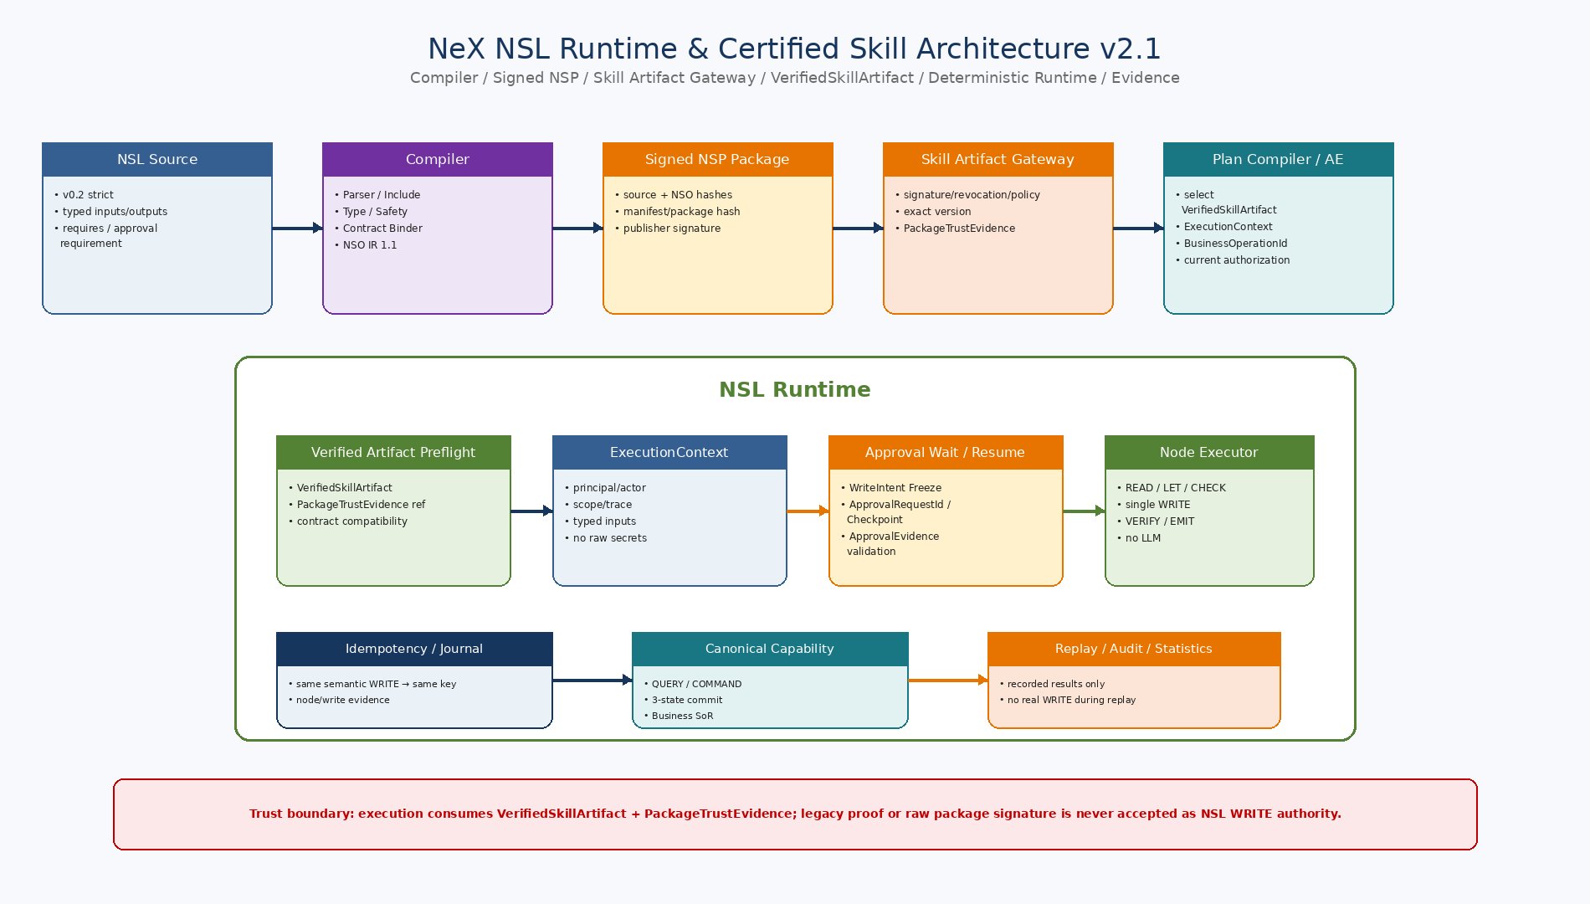
Figure 1. NSL Source/Compiler/Sign/Registry/Plan Compiler/Runtime/Canonical API/Evidence의 전체 Trust 및 실행경계.

2. Detailed Design Principles
ID | Decision | Implementation Meaning
NSL-DD-01 | Verified package artifact | Verified package artifact | Production WRITE는 exact skill/version/semantic hash와 current PackageTrustEvidence + ADMITTED ArtifactAdmissionDecision을 포함한 VerifiedSkillArtifact v2.1에 고정되어야 한다.
NSL-DD-02 | Preflight before interpretation | Runtime validates trust, compatibility and authorization before executing the first NSO node.
NSL-DD-03 | Current policy wins | Current policy/governance wins | CERTIFIED status/과거 artifact ref만으로는 부족하며 revoked/suspended package, invalid key/publisher, current PDP denial은 provider 호출 전에 실행을 차단해야 한다.
NSL-DD-04 | ApprovalEvidence-bound WRITE | RESUME은 typed ApprovalEvidence + NSLApprovalResume binding으로 execution/BusinessOperationId/ApprovalRequestId/checkpoint/event/PayloadHash/WriteIntentHash를 검증해야 한다.
NSL-DD-05 | Stable idempotency identity | Stable business/idempotency identity | Agent/Platform supplies stable BusinessOperationId; NSL Runtime derives TenantId+BusinessOperationId+WriteNodeId IdempotencyKey and reuses it on safe retry/resume.
NSL-DD-06 | Explicit commit uncertainty | UNKNOWN_COMMIT_STATE becomes RECONCILIATION_REQUIRED and is never a retry hint.
NSL-DD-07 | Replay without real effects | Replay uses recorded node results and never invokes the real WRITE provider.
NSL-DD-08 | Evidence-driven certification | Evidence-driven package eligibility | Compiler/test/contracts plus Signed NSP package/publisher/key governance establish eligibility; runtime receives VerifiedSkillArtifact.
NSL-DD-09 | Contract drift is observable | Capability contract hash change triggers rejection or revalidation, never silent compatibility.
NSL-DD-10 | PostgreSQL-first auditability | Registry, test evidence, execution journal, idempotency and replay references are durable PostgreSQL records.
3. Version / Contract Baseline
Contract | Version | Meaning
NSL | 0.2 | Language source baseline
NSO | IR 1.1 | Compiled typed executable object
Skill Manifest | 2.0 | Registry/certification/signature metadata
ExecutionContext | 1.0 | Runtime authority/trace/input/approval/idempotency context
NSL ApprovalEvidence | 1.0 | Typed NSL WRITE ApprovalEvidence bound to ApprovalRequestId / frozen WriteIntent
Golden Test | 1.0 | Compile/runtime/replay/negative/security fixture
Runtime Result | 1.0 | Structured outcome/commit/verification/error
Signature algorithm | Ed25519 | Concrete v2 reference choice; private key outside runtime DB
4. Recommended Package Tree
src/nex_skill/
├── compiler/
│ ├── parser.py
│ ├── includes.py
│ ├── type_checker.py
│ ├── safety_checker.py
│ ├── contract_binder.py
│ └── emitter.py
├── runtime/
│ ├── preflight.py
│ ├── runtime.py
│ ├── node_executor.py
│ ├── evaluator.py
│ ├── approval.py
│ ├── replay.py
│ └── verification.py
├── registry/
│ ├── manifest.py
│ ├── repository.py
│ ├── package_trust.py
│ ├── lifecycle.py
│ └── certification.py
├── contracts/
│ ├── models.py
│ ├── schemas.py
│ └── protocols.py
├── persistence/
│ ├── models.py
│ ├── execution_repository.py
│ ├── idempotency.py
│ └── migrations/
├── testing/
│ ├── golden.py
│ ├── fixtures.py
│ └── replay_runner.py
├── adapters/
│ ├── capability_registry.py
│ ├── canonical_invoker.py
│ ├── authorization.py
│ ├── approval_evidence.py
│ └── artifact.py
└── observability/
├── metrics.py
└── audit.py
5. Core Python Protocol Interfaces
Protocol | Method | Responsibility
SourceParser | parse(source, ref) | Source→AST with locations
IncludeResolver | resolve(ast, ref) | Compile-time expansion + dependency hashes
TypeChecker | check(ast) | Typed symbol/expression validation
StaticSafetyChecker | check(ast, profile) | Strict safety rules: one write, no write in loop, no raw code
CapabilityRegistry | get(capability_id) | Current capability contract/hash/status
AuthorizationPDP | authorize_skill(...) | Current principal/actor/role/scope/risk/skill policy
ApprovalEvidenceValidator | validate(approval_request_id, approval_evidence) | Validate typed NSL ApprovalEvidence against frozen WriteIntent/checkpoint
VerifiedSkillArtifactLoader | load_verified_artifact(...) | Consume gateway-verified PackageTrustEvidence/VerifiedSkillArtifact; no raw runtime signature verification
SkillRegistry | get_manifest/get_nso | Immutable exact skill version assets
CapabilityInvoker | query/command/verify | Canonical provider boundary
IdempotencyStore | get/begin/complete | Runtime short-circuit/conflict/journal
ReplayProvider | node_result(bundle,node) | Recorded result provider; no real WRITE
AuditSink | append(event,detail,context) | Security/business trace evidence
ExpressionEvaluator | evaluate(expr,symbols) | Deterministic typed expression evaluation

6. Compiler → Signed Package → Certification
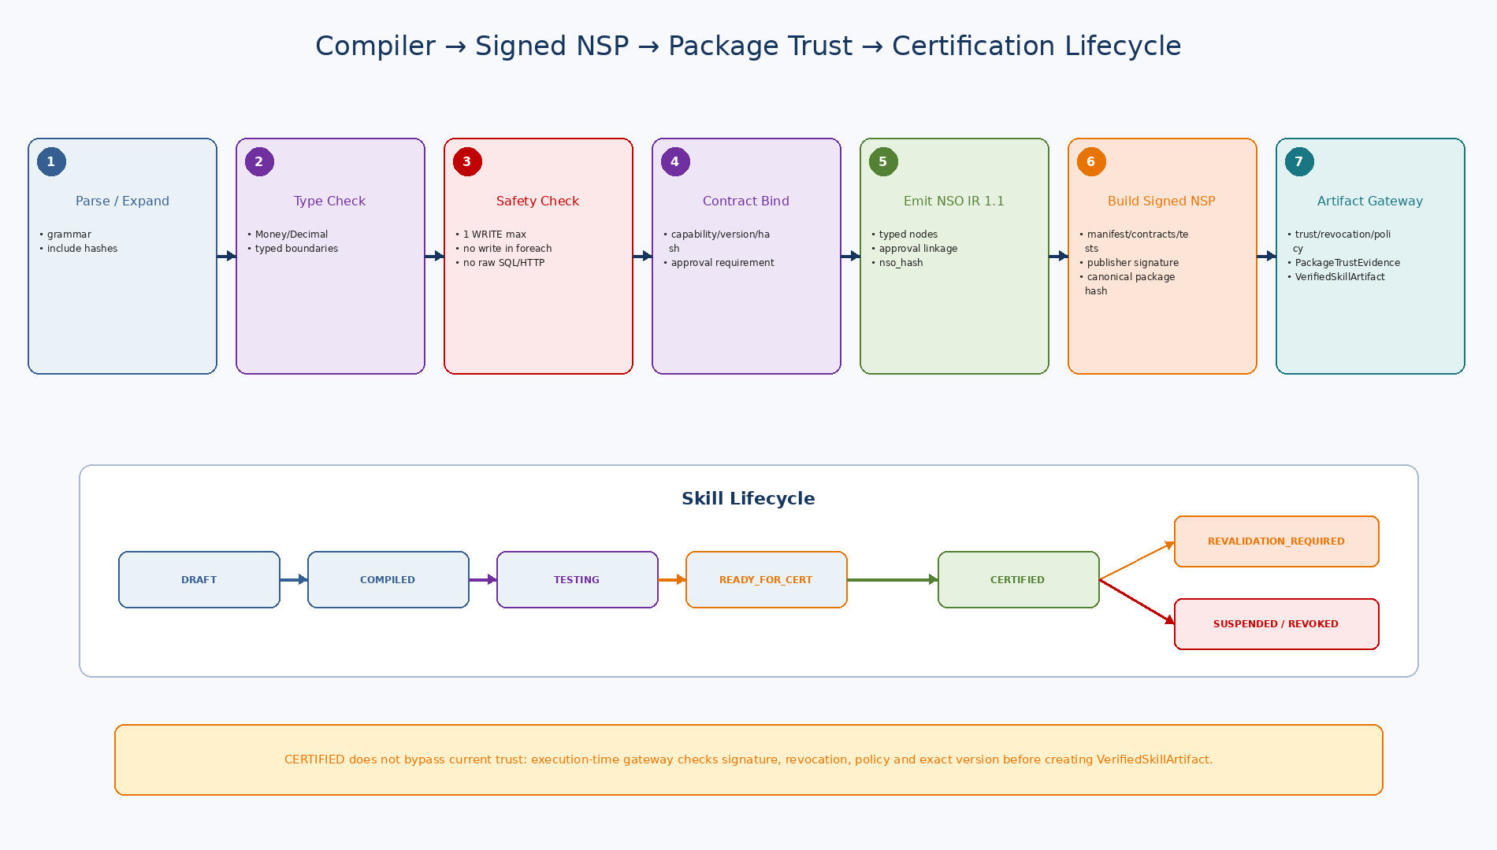
Figure 2. NSL Source를 typed NSO/Manifest/Ed25519 Signature/Registry Evidence로 전환하고 Governance Certification까지 진행하는 lifecycle.

7. NSO IR 1.1
Area | Fields / Semantics
Identity | ir_version, language_version, profile_id, skill_id, skill_version
Boundary | requires, typed inputs[], typed outputs[]
Nodes | READ/BIND/CHECK/WRITE_APPROVAL_REQUIREMENT/WRITE/EMIT/FOREACH_BOUNDED
Contracts | capability id/version/hash/operation/risk/atomicity/commit semantics
WRITE approval requirements | approval policy/requirement id + write_node + frozen payload/intent binding
Write profile | max writes/no loop write/runtime-derived idempotency/package trust
Source integrity | root source hash + include dependency hashes
Compiler provenance | compiler version/time
Integrity | nso_hash = SHA-256 canonical object excluding its own hash field
NSO는 canonical JSON으로 정규화하고 SHA-256을 계산한다. `nso_hash`는 자신을 제외한 NSO object의 canonical representation에 대한 hash다. NSO는 장기 Wait 상태를 가지지 않고 WRITE approval requirement metadata만 포함한다.
8. Compiler Pipeline
Stage | Implementation
Parse / source location | NSL grammar parse; source ref/line/column retained
Include expansion | Compile-time only; dependency source hashes frozen
Symbol / type checking | Immutable symbol table; Decimal/Money/EntityRef boundaries
Strict safety | one write, no write in loop, no raw SQL/HTTP/LLM/dynamic code
Contract binding | requires capability version/hash/READ-WRITE/risk/atomicity/commit
NSO emission | Typed node objects + approval/write linkage + source/contract provenance
Integrity | source_hash, nso_hash, contract_set_hash, manifest_hash/package hash
Signing eligibility | Static/compiler errors block signing/certification pipeline
9. Skill Manifest v2
Area | Fields / Semantics
Identity | skill_id/version/display/description/language/IR/profile
Lifecycle | status/risk/exposure/write capability/approval policy
Contracts | capability dependencies + versions + hashes
Schemas | input/output schema refs
Artifacts | source_ref/hash, nso_ref/hash, contract_set_hash
Publisher | publisher_id + signing_key_id
Signature | algorithm=ED25519 + signature_b64 + signed_digest
Certification | owner, golden test set, evidence status, certifier/time
Compatibility | minimum/maximum runtime target
Integrity | manifest_hash/package_hash
10. Signing / Integrity
- v2 reference signature algorithm은 Ed25519로 구체화한다.
- Private signing key는 Runtime DB에 두지 않고 별도 Signing Service/Secret Provider/HSM-like boundary에서 사용한다.
- Registry에는 publisher_id, signing_key_id, trusted public key/status/effective dates만 둔다.
- 서명 Digest는 Manifest 내용과 exact NSO hash를 결합한다.
- AE Skill Artifact Gateway는 NSL Runtime 진입 전에 exact NSP/package signature, key status, publisher, hash linkage를 검증하고 PackageTrustEvidence를 포함한 VerifiedSkillArtifact를 생성한다. NSL Runtime은 raw signature verification을 재수행하지 않는다.
- 키 Revocation은 기존 immutable Manifest를 수정하지 않고 별도 key status/policy로 해당 Skill 실행을 중단시킨다.
11. Skill Registry & Certification Lifecycle
Status | Meaning
DRAFT | Source/manifest draft; not executable in production
COMPILED | NSO produced; static validation passed
TESTING | Automated tests/certification evidence running
READY_FOR_CERTIFICATION | Required tests/contracts/signature pass; system eligibility only
CERTIFIED | Governance Owner explicitly approves production use
REVALIDATION_REQUIRED | Contract/security/runtime evidence changed or quality degraded
SUSPENDED | Emergency/administrative block; no new live write execution
DEPRECATED | No new selection by default; migration to replacement
RETIRED | Execution prohibited; historical evidence remains
Human Certification Boundary
Automated Compiler/Test/Contract/Signature evidence는 TESTING→READY_FOR_CERTIFICATION까지 올릴 수 있다. CERTIFIED는 반드시 Governance Owner의 명시적 승인으로 전환한다.
12. ExecutionRequest / internal ExecutionContext
Category | Fields
Skill | skill_id/version, mode LIVE/REPLAY
Runtime | agent_execution_id, work_item_id, plan_step_id
Identity | principal_ref, business_actor_ref, coworker/role binding refs
Scope | org_scope_refs, project_scope_refs
Trace | correlation_id, causation_id, request_id
Policy | policy_snapshot_ref; current PDP is still executed
Write identity | idempotency_key, optional expected_version
Inputs | typed inputs
NSL WRITE approval | approval_request_id / approval_evidence_ref / checkpoint binding
Replay | replay_bundle_ref
Secrets | opaque secret_refs only; raw secret values forbidden

13. Runtime Preflight & Controlled Write
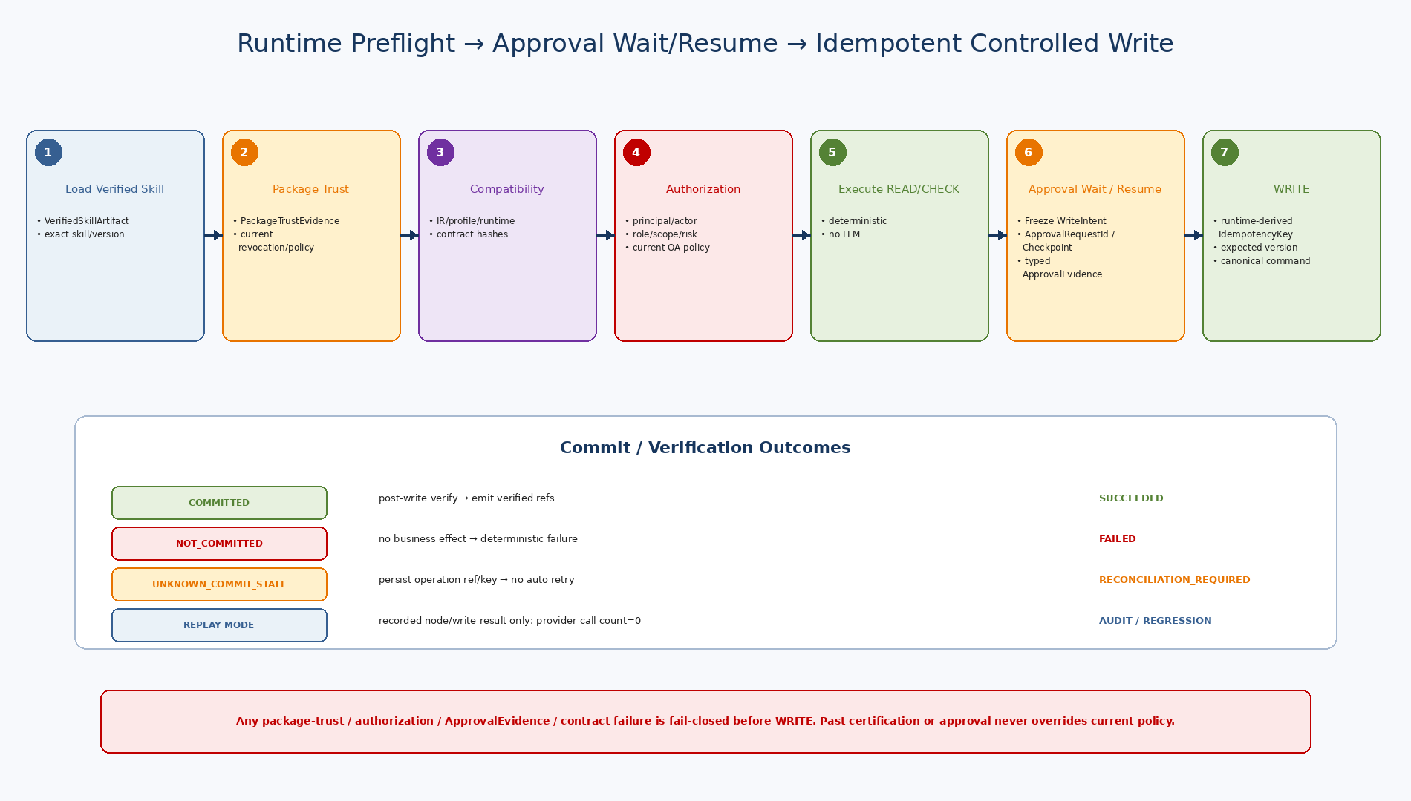
Figure 3. VerifiedSkillArtifact/contract/current-policy Preflight, NSL Approval Suspend/Resume, runtime-derived Idempotent WRITE와 3-state Commit/Replay.

14. Runtime Preflight
Step | Check | Fail Behavior
PF-01 | Load exact assets | skill_id/version from ExecutionContext; no ‘latest’ resolution after compile.
PF-02 | Status | LIVE write skill must be CERTIFIED; suspended/revalidation/deprecated/retired policy blocks or limits.
PF-03 | Hash linkage | Verified NSP must contain the exact expected Skill semantic artifact/package binding; profile/IR/language/runtime compatibility must match.
PF-04 | Signature | VerifiedSkillArtifact contains valid PackageTrustEvidence for an allowed/current Signed NSP and exact artifact/package hash binding.
PF-05 | Runtime compatibility | Runtime/IR/profile versions supported.
PF-06 | Capability drift | Every current Capability Contract hash/status matches manifest dependency.
PF-07 | PDP | Authenticated principal/business actor/RoleBinding/scope/risk/autonomy/skill exposure allowed.
PF-08 | Context | No raw secret, required inputs/schema present, trace/idempotency valid.
PF-09 | Result | Any reason code → fail closed before first node.
[SUPERSEDED / NON-NORMATIVE v2.0] 15. Legacy Approval Proof Model — canonical v2.1은 PLAT-CP03을 따른다.
ID | Validation
AP-01 | Typed ApprovalEvidenceValidator is invoked only for the active NSL WRITE approval wait.
AP-02 | ApprovalEvidence decision/status must be valid and current for the active wait; revoked/invalid evidence blocks WRITE.
AP-03 | ApprovalRequestId and ApprovalEvidence must match the frozen WriteIntent/checkpoint and exact WRITE node semantics.
AP-04 | skill_id/version + agent_execution_id + plan_step_id must match current ExecutionContext.
AP-05 | PayloadHash must match exact bound WRITE payload.
AP-06 | WriteIntentHash must match skill/version/capability/operation semantics.
AP-07 | Agent FORMAL_APPROVAL or Confirmation evidence cannot substitute for NSL WRITE ApprovalEvidence.
AP-08 | Any approval binding mismatch returns APPROVAL_* error and zero WRITE provider calls.
Legacy v2.0 proof-before-NSL 모델은 비규범 migration reference다. Canonical v2.1에서 NSL Runtime은 client-authored approval/proof를 신뢰하지 않으며, 자신이 생성한 ApprovalRequestId/Checkpoint에 대해 Resume 시 typed ApprovalEvidence의 BusinessOperationId, Skill semantic hash, PayloadHash, WriteIntentHash, expiry/integrity를 검증한다.
16. Deterministic Runtime Node Execution
Node | Runtime Behavior
READ | Canonical QUERY; structured result bound to symbol
BIND | Typed deterministic expression evaluation
CHECK | Only literal True passes; False/unknown blocks write
WRITE_APPROVAL_REQUIREMENT | Carries deterministic approval requirement binding; NSL creates runtime ApprovalRequestId/Checkpoint only when executing STRICT WRITE
WRITE | Validated ApprovalEvidence → Canonical COMMAND once with NSL-derived IdempotencyKey/expected version
VERIFY | Runtime/Capability contract verification after COMMITTED when defined
EMIT | Structured typed output / stable refs
FOREACH_BOUNDED | Deterministic bounded executor; strict profile forbids WRITE in body
[SUPERSEDED v2.0 — see PLAT-CP03] 17. Idempotency
Rule | Implementation
Stable key source | ExecutablePlan/Agent Runtime supplies key from work/execution operation identity, never current timestamp.
Local journal | (skill_id, version, idempotency_key) stores semantic_payload_hash + runtime result/commit.
Same key / same payload | If completed locally, return original RuntimeResult without provider call.
Same key / different payload | IDEMPOTENCY_CONFLICT, fail closed.
Provider guarantee | Canonical API still receives same idempotency key and is final business-effect guard.
Crash after provider commit | Retry same key obtains original provider result; local journal then completes.
Replan reuse | If same business operation is carried forward, reuse prior operation/key or verified result rather than generate new write identity.
18. Commit / Reconciliation
Commit State | Runtime Behavior
COMMITTED | Provider confirms effect; perform verification if contract provides it; emit verified refs.
NOT_COMMITTED | No effect; return deterministic failure/outcome; safe future new attempt depends on caller policy.
UNKNOWN_COMMIT_STATE | Do not auto retry; persist operation_ref/key/evidence and return RECONCILIATION_REQUIRED.
Verification | Separate from commit truth; detects business result/freshness/invariant, not a replacement for provider commit semantics.
Reconciliation | Owned by caller/AE/domain workflow; may query SoR using operation_ref/key and resolve journal.
19. Replay
Rule | Design
Mode | ExecutionContext.mode=REPLAY with replay_bundle_ref.
Provider behavior | READ/WRITE node results come from ReplayProvider; real CapabilityInvoker WRITE is never called.
ApprovalEvidence | Recorded approval evidence may be validated for audit lineage; pure replay never requests new human action.
Node evidence | Replay bundle maps node_id→recorded result/commit/evidence refs.
Use cases | Audit reconstruction, deterministic regression, certification revalidation.
Non-goal | Replay is not rollback and does not alter business state.

20. Registry / Runtime Evidence PostgreSQL Model
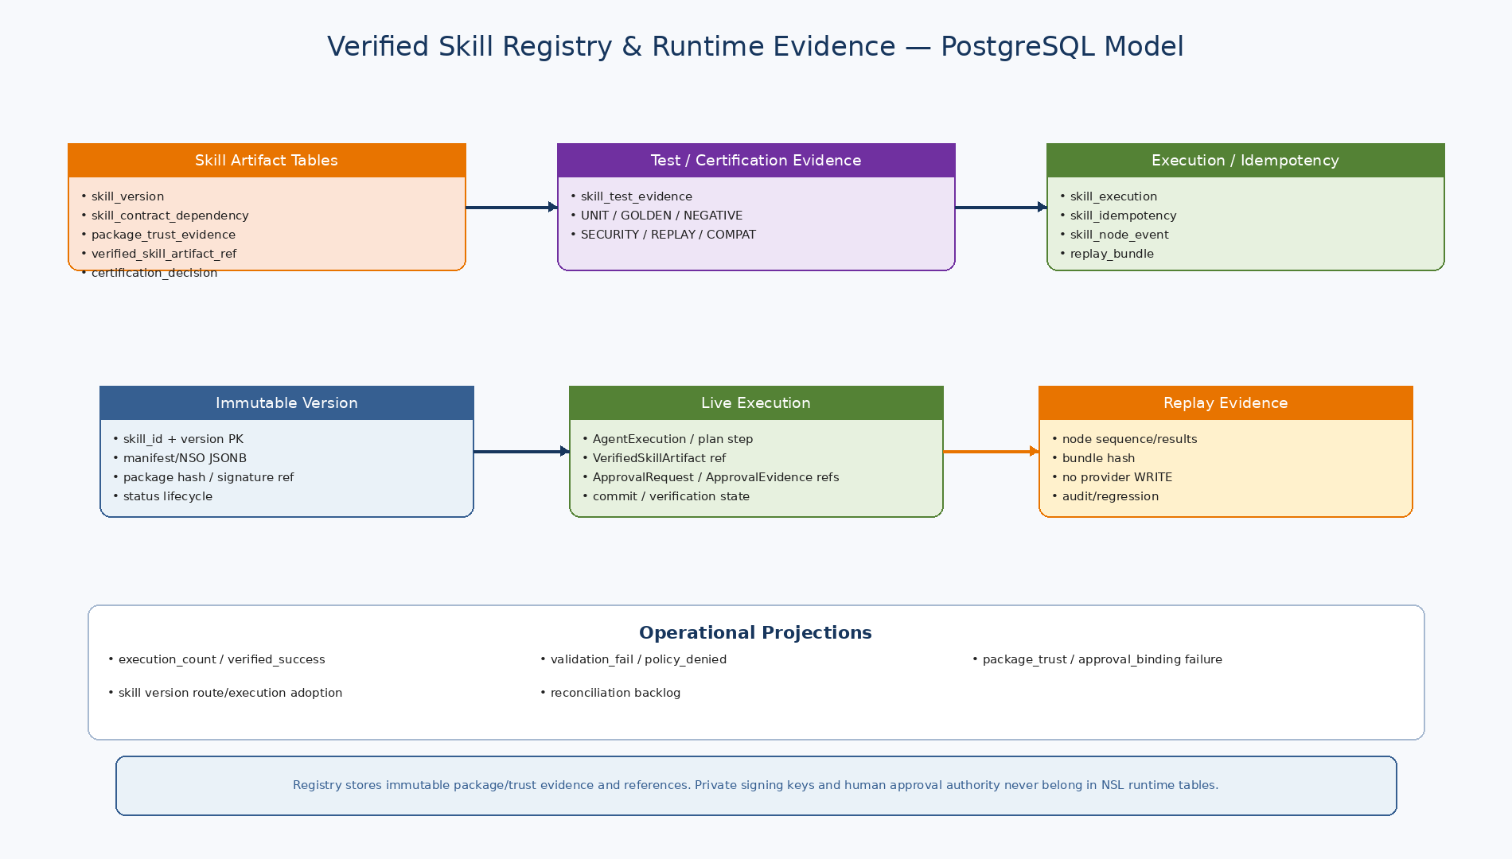
Figure 4. Immutable Skill Asset/Certification Evidence와 Live Execution/Idempotency/Node Event/Replay Evidence를 분리한 PostgreSQL model.

21. PostgreSQL Tables
Table | Purpose
publisher_key | Publisher identity/public key/status/effective dates; no private key
skill_version | Immutable source/NSO/manifest hashes/signature/status/certification
skill_contract_dependency | Capability version/hash dependencies
skill_test_evidence | UNIT/GOLDEN/NEGATIVE/SECURITY/REPLAY/COMPATIBILITY evidence
skill_certification_decision | System eligibility/human certification/suspend/revalidation audit
skill_execution | Per runtime invocation authority/input/output/commit/verification/trace
skill_idempotency | Stable key + payload hash + original RuntimeResult/commit
skill_node_event | Ordered node execution/evidence for audit/replay
skill_replay_bundle | Portable frozen recorded-node bundle
skill_execution_statistics | Version-window execution/verified success/reconciliation/failure projections
Canonical provider WRITE는 local `nex_skill` PostgreSQL Transaction 밖에서 수행한다. Local journal을 먼저 commit하고 provider에 같은 idempotency key를 전달한 뒤 결과를 다시 local journal에 기록한다. 이 구조로 distributed 2PC를 피하면서 crash window를 닫는다.
22. Certification Evidence
Evidence Type | Required Coverage
UNIT | Parser/type/evaluator/runtime unit tests
GOLDEN | Stable known input→output/write contract fixtures
NEGATIVE | Multiple write, loop write, bad type, unknown capability, approval binding mismatch
SECURITY | Tampered NSO/manifest, revoked key, permission/scope/skill status
REPLAY | Provider write call count=0 and expected replay result
COMPATIBILITY | Runtime/IR/profile/capability contract compatibility
23. Golden Test Contract
Field | Meaning
test_id / skill_ref | Immutable fixture identity
test_type | COMPILE/LIVE_SANDBOX/REPLAY/NEGATIVE/SECURITY
inputs/context overrides | Typed test inputs and deterministic runtime identity
capability read fixtures | Recorded/stub QUERY responses
ApprovalEvidence fixtures | Typed ApprovalEvidence fixtures bound to ApprovalRequestId/BusinessOperationId/PayloadHash/WriteIntentHash
write response | COMMITTED/NOT/UNKNOWN provider fixture
verification response | Expected post-write verification fixture
expected runtime_state | SUCCEEDED/VALIDATION/APPROVAL/POLICY/RECONCILIATION/FAILED
provider_write_call_count | Must be 0 for replay/blocked paths and ≤1 strict live path
expected output/error | Golden structured result assertions
24. Observability
Metric | Purpose
nsl_execution_total | skill/version/mode/state
nsl_execution_duration_seconds | skill/version
nsl_preflight_denied_total | reason/skill
nsl_package_trust_failure_total | key/publisher/skill
nsl_contract_mismatch_total | capability/skill
nsl_approval_failure_total | approval_binding/reason
nsl_write_total | capability/commit_state
nsl_idempotency_replay_total | skill/capability
nsl_idempotency_conflict_total | skill
nsl_reconciliation_required_total | capability/skill
nsl_replay_total | skill/result
nsl_certification_status_current | skill/status
nsl_verified_success_rate | skill/version/window
25. Test Strategy
Layer | Required Tests
Compiler | Grammar/include/type/strict safety/contract binding/NSO golden hash
Schema | NSO/Manifest/VerifiedSkillArtifact/ApprovalRequest/ApprovalEvidence/NSLResultSummary Draft 2020-12 validation
Signature | Valid PackageTrustEvidence/VerifiedSkillArtifact; tampered/revoked/expired NSP is blocked by package-trust admission
Preflight | Skill status/profile/runtime/contract drift/PDP/no secret
Approval | expired/revoked/wrong approver/wrong execution/wrong payload/wrong intent/wrong ApprovalRequestId/binding
Idempotency | same key same payload, same key different payload, crash/retry
Commit | COMMITTED, NOT_COMMITTED, UNKNOWN_COMMIT_STATE zero auto-retry
Replay | real provider write call count=0; node outputs equal recorded bundle
Certification | test evidence completeness, READY auto eligibility, CERTIFIED human only, revalidation/suspend
E2E | WF-ACC-01 voucher draft and WORKITEM.CREATE directive through AE ExecutablePlan LOCAL_SKILL
26. Implementation Sequence
Wave | Area | Deliverable
I1 | Schemas / Models | Pydantic contracts + six JSON Schemas + fixtures
I2 | Compiler | Parser adapter, include resolver, type/safety checker, contract binder, NSO emitter
I3 | Signing / Registry | Manifest/package hash, Ed25519 signing/verification, registry tables/lifecycle
I4 | Runtime Preflight | VerifiedSkillArtifact load, exact version/hash/contract/current-policy/profile checks
I5 | Evaluator, READ/CHECK/ApprovalEvidence/WRITE/VERIFY/EMIT, ExecutionContext | Evaluator, READ/CHECK/Gate/WRITE/VERIFY/EMIT, ExecutionContext
I6 | Idempotency / Replay | Journal, commit handling, replay bundle/evidence, reconciliation result
I7 | Certification | Golden runner, evidence store, readiness/certification/revalidation
I8 | Integration / Hardening | AE/Canonical API integration, fault/security/load/observability
27. Machine-readable Reference Package
Artifact | Validation / Purpose
6 JSON Schemas | Draft 2020-12 meta-schema PASS
Example NSO / Manifest / VerifiedSkillArtifact / ApprovalEvidence / Golden | Sample schema validation PASS
models/protocols/compiler/preflight/approval/runtime | Python syntax PASS
packaging/package_signing.py | Signed NSP/package trust generation PASS; tampered package rejected before VerifiedSkillArtifact creation
registry/golden.py | Certification lifecycle / Golden runner reference
001_skill_registry.sql | Registry/publisher/test/certification tables
002_runtime_execution.sql | Execution/idempotency/node/replay/statistics tables
003_runtime_idempotency_transactions.sql | Provider call crash-window transaction semantics
004_certification_lifecycle.sql | READY/CERTIFIED/REVALIDATION/SUSPEND transitions
PostgreSQL SQL은 Reference DDL/transaction pattern이며 실제 개발 PostgreSQL에 아직 실행하지 않았다. Repository alignment 이후 Alembic revision으로 옮겨 concurrency/fault test와 함께 검증한다.
28. Detailed Design Quality Gate
Quality Gate | Pass Criteria
NSL-DD-QG-01 | Exact Skill/NSP/VerifiedSkillArtifact identity is pinned.
NSL-DD-QG-02 | VerifiedSkillArtifact/package trust, status, contracts and current PDP/policy are checked before any capability call.
NSL-DD-QG-03 | ApprovalEvidence binds exact ApprovalRequestId, BusinessOperationId, PayloadHash and WriteIntentHash.
NSL-DD-QG-04 | Idempotency key cannot be reused with a different semantic payload.
NSL-DD-QG-05 | UNKNOWN_COMMIT_STATE never auto-retries.
NSL-DD-QG-06 | Replay never calls the real write provider.
NSL-DD-QG-07 | Automation stops at READY_FOR_CERTIFICATION.
NSL-DD-QG-08 | Certified versions are immutable and contract drift triggers revalidation.
NSL-DD-QG-09 | PostgreSQL evidence reconstructs execution/certification/replay lineage.
NSL-DD-QG-10 | Reference schemas/Python/package-trust and Approval suspend/resume smoke are validated.
29. Next Step
Document 18 — Approval & Human Workflow Detailed Design
Confirmation과 Formal Approval의 domain 분리, ApprovalRequest/ApprovalEvidence binding, Approver authority, WAITING/Resume/Audit를 AE/WC/OA/EOS/NSL 경계에 걸쳐 상세화한다.

PLAT-CP03 — Runtime v2.1 Canonical Contract
External invocation: RuntimeEngine.execute(VerifiedSkillArtifact, ExecutionRequest, RuntimePorts) → ExecutionResult.
ExecutionRequest는 execution_id, BusinessOperationId, inputs, bounded runtime_context, ExecutionPrincipal, DataPolicy, mode NEW|RESUME, ResumeToken을 포함한다. NSL internal ExecutionContext는 caller가 생성하지 않는다.
Skill Artifact Gateway가 exact NSP를 load/verify하고 PackageTrustEvidence를 포함한 VerifiedSkillArtifact를 생성한다. NSL Runtime 내부 raw PackageTrustEvidence/VerifiedSkillArtifact Boundary 경로는 제거한다.
NSL WRITE Approval은 Runtime에서 WriteIntent/PayloadHash/WriteIntentHash를 freeze하고 ApprovalRequestId/checkpoint를 생성한 뒤 ApprovalPort.publish와 StatementSuspended를 반환한다.
IdempotencyKeyFactory domain = TenantId + BusinessOperationId + WriteNodeId. Agent retry는 same BusinessOperationId를 유지하고 actual key는 NSL이 재도출한다.
Provider 호출 전 durable WRITE_REQUESTED evidence를 기록한다. UNKNOWN_COMMIT_STATE는 RECONCILIATION_REQUIRED이며 automatic WRITE retry가 아니다.
ExecutionResult는 status, pre_write_eligibility, approval, write.commit_state, verification.status, suspension을 typed field로 유지한다.
Contract | Canonical v2.1
Invocation | VerifiedSkillArtifact + ExecutionRequest + RuntimePorts
Approval | NSL-owned ApprovalRequest + suspend/resume
Idempotency | NSL Runtime-derived key
Trust | Signed NSP / PackageTrustEvidence
Result | typed status / commit / verification / suspension
Normative status: PLAT-CP03 / NeX Platform v2.1 Controlled Amendment

PLAT-CP07 — Governance-facing NSL Package/Skill Boundary
Status: PLAT-CP07/CP08 Controlled Amendment — Canonical v2.1
Certified Skill / NSP package의 runtime trust와 governance를 분리한다.
- AG는 exact Skill/NSP package/version/hash, publisher/signing key, certification/revalidation/revocation policy를 governance한다.
- AE Skill Artifact Gateway가 current governance state를 참조해 exact NSP를 resolve/verify하고 PackageTrustEvidence/VerifiedSkillArtifact를 생성한다.
- NSL Runtime은 VerifiedSkillArtifact를 소비하며 AG를 hot-path authorization/trust evidence SoR로 사용하지 않는다.
- EA-Trust operation decision과 Package Trust는 별도 typed evidence다.

E2E Step 3 — NSL Integration Contract Hardening
Status: E2E Step 3 Contract Hardening v1.4 — Normative
RESUME mode의 SkillExecutionRequest는 non-empty resume_token_ref + approval_evidence_ref를 필수로 한다.
ApprovalEvidence v2.1은 Frozen NSL fields를 Platform contract로 직접 표현한다.
GovernedWriteExecutionPort는 ProtectedOperationDescriptorV21/OperationTrustDecisionV21 typed input과 current OA result를 받아 actual WriteCallRequest operation fingerprint conformance를 fail-closed 검증한다.
SkillArtifactGateway.resolve_verified()는 Any가 아니라 VerifiedSkillArtifactV21을 반환하고 current package governance/trust admission을 통과하지 못하면 artifact를 생성하지 않는다.

E2E Step 4 — NSL Idempotency / Commit / RetrySafety Closure
Status: E2E Step 4 Reliability Contract Hardening v1.5 — Normative
NSL v0.2 Frozen semantic을 Platform v2.1 contract pack에 다음과 같이 고정한다.

Durable Idempotency
IdempotencyRecord는 `(tenant_id,idempotency_key)` 및 `(tenant_id,BusinessOperationId,WriteNodeId)` uniqueness를 보존한다. 같은 key+같은 PayloadHash는 original result/business reference를 반환하거나 기존 operation을 continue하고, 다른 PayloadHash는 IDEMPOTENCY_CONFLICT로 Provider WRITE 전에 차단한다.

Result State
CommitState는 COMMITTED / NOT_COMMITTED / UNKNOWN_COMMIT_STATE, VerificationStatus는 NOT_REQUESTED / VERIFIED / FAILED / UNKNOWN으로 제한한다.
UNKNOWN_COMMIT_STATE는 ExecutionStatus=RECONCILIATION_REQUIRED와 RetrySafety=REQUIRES_RECONCILIATION을 강제한다.
COMMITTED는 RetrySafety=UNSAFE_TO_RETRY를 강제한다. Verification FAILED/UNKNOWN은 CommitState를 바꾸거나 동일 WRITE 재실행을 허용하지 않는다.

