v2.1 CP04 Authority: NeX Agent v2.1 Final Frozen + NSL v0.2 Final Frozen + Agent↔NSL Integration Contract v1.0 + NeX Platform v2.1 Architecture Decision Pack v1.0 + Architecture Consistency Closure & Unified Change Ledger v1.0.
NeX Approval & Human Gate
Detailed Design v2.1
Confirmation · Agent FORMAL_APPROVAL · NSL WRITE Approval · EOS Business Approval · WAITING / Resume
Safety Invariant | Human decision은 사람이 본/승인한 exact protected operation과 exact canonical payload에만 효력이 있다. Amount/Project/Capability/BusinessOperation/WriteIntent가 바뀌면 해당 domain의 새 확인/승인이 필요하다.
Canonical reference: Batch04 CP04 — 7 JSON Schemas + approval_protocols_v2_1.py; persistence/transactions follow WC/AE canonical contracts | 2026.09.01

Executive Summary
Structured Confirmation은 NeX-AE가 소유하며 요청자가 시스템이 구성한 해석/요청을 확인하는 안전제어다. Agent FORMAL_APPROVAL과 NSL WRITE Approval의 Human Workflow는 NeX-WC ApprovalWorkItem으로 조정하고, Enterprise OS는 도메인에서 요구되는 Business Formal Approval의 authoritative record를 유지한다. Agent FORMAL_APPROVAL과 NSL WRITE Approval은 서로 다른 semantic domain이다. NSL WRITE Approval은 NSL이 생성한 ApprovalRequestId, BusinessOperationId, PayloadHash, WriteIntentHash, SkillSemanticHash binding을 그대로 보존한다. Agent Runtime은 Gate가 미충족이면 WAITING_CONFIRMATION/WAITING_APPROVAL로 Checkpoint하고 Worker를 해제하며 결정 Event로 Resume한다.
Client의 `approved=true` 또는 legacy proof_ref는 NSL WRITE 권한이 아니다. NSL은 자신이 freeze한 WriteIntent/ApprovalRequestId/Checkpoint에 대해 typed ApprovalEvidence의 execution, BusinessOperationId, skill semantic hash, PayloadHash, WriteIntentHash, expiry/integrity를 검증한 경우에만 WRITE한다.

1. Approval Domains Are Distinct
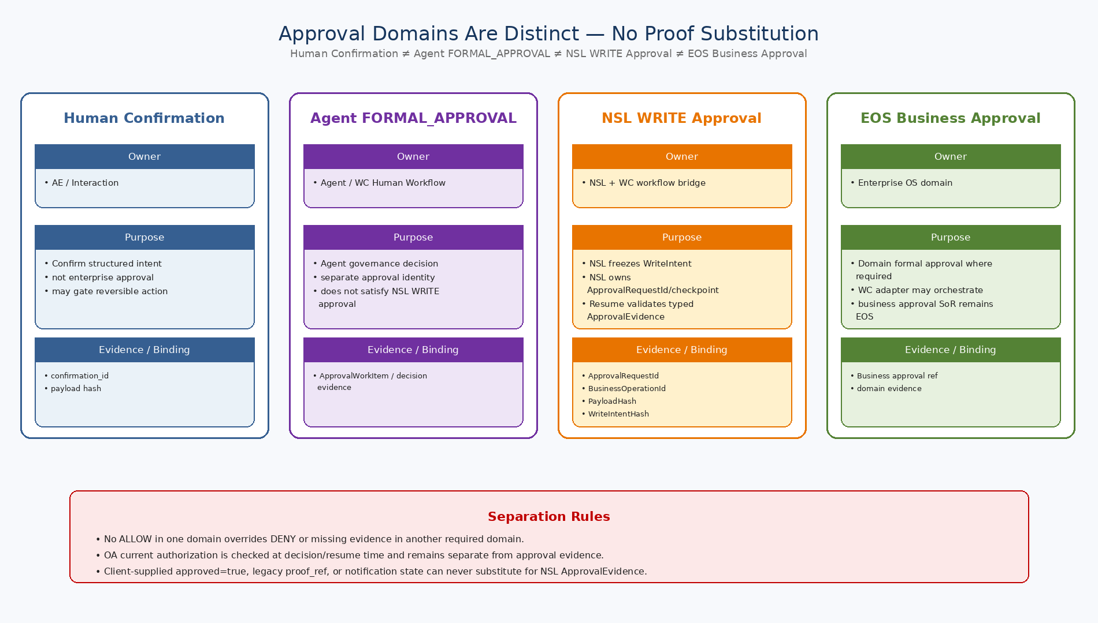
Figure 1. Human Confirmation, Agent FORMAL_APPROVAL, NSL WRITE Approval, EOS Business Approval의 Owner/Purpose/Evidence 경계.

2. Design Principles
ID | Decision | Implementation Meaning
HG-DD-01 | Four domains, no substitution | Human Confirmation, Agent FORMAL_APPROVAL, NSL WRITE Approval, EOS Business Approval은 서로 다른 semantic domain이며 evidence를 대체할 수 없다.
HG-DD-02 | Owner-specific SoR | Confirmation=AE, Agent FORMAL workflow=WC/Agent, NSL approval identity/binding=NSL with WC human workflow bridge, Business Formal Approval=EOS where required.
HG-DD-03 | Runtime/NSL wait ownership separated | Agent Runtime schedules human wait/resume; NSL owns NSLExecution checkpoint/ApprovalRequestId and validates ApprovalEvidence on Resume.
HG-DD-04 | Exact payload and intent binding | Every decision/evidence is bound to frozen canonical payload and protected operation identity appropriate to its domain.
HG-DD-05 | Current authorization is separate | OA current authorization/step-up is re-evaluated and cannot be replaced by approval evidence.
HG-DD-06 | No client boolean authority | approved=true, UI state, notification state, legacy proof_ref cannot authorize NSL WRITE.
HG-DD-07 | Fail closed on binding mismatch | ApprovalRequestId/BusinessOperationId/PayloadHash/WriteIntentHash mismatch → WRITE=0.
HG-DD-08 | Current policy before side effect | RoleBinding/scope/policy/kill-switch/business preconditions are checked AS_OF_NOW.
HG-DD-09 | Decision persistence before Resume | Unauthorized approver decisions are not persisted and Resume=0.
HG-DD-10 | Committed effect is not rolled back by approval state | Post-commit cancellation/revocation triggers follow-up/reversal domain flow, not rollback by approval state.
3. Approval Domain Comparison
Area | Human Confirmation | Approval Domains (Agent / NSL / EOS)
Purpose | Requester confirms structured interpretation/parameters | Agent FORMAL=process governance; NSL WRITE=exact atomic WRITE approval; EOS Business Approval=domain formal approval
Owner | NeX-AE Interaction/Confirmation | WC/Agent workflow; NSL ApprovalRequest/binding; EOS authoritative business approval where required
Typical actor | Original requester / responsible human | Authorized approver(s) resolved by domain policy and current OA authority
Typical risk | Ambiguity/reversible/request confirmation | Agent governance and/or high-impact business WRITE depending on domain
Canonical evidence | confirmation_id + frozen payload hash | Agent decision evidence; NSL ApprovalEvidence 4-way binding; EOS business approval ref
Wait/Resume | Agent Runtime WAITING_CONFIRMATION | WC human workflow + Agent Resume; NSL WAITING_FOR_APPROVAL is NSL execution checkpoint
Current authorization | Requester identity/scope as needed | OA current authorization is checked independently at decision/resume/execution time
Substitution | Cannot satisfy approval domains | No domain evidence substitutes for another required approval/control
Cancellation | Before satisfaction | Before final approve/reject
Historical meaning | I intended this exact payload | Authorized business decision approved exact operation/payload
4. Service Ownership
Component | Responsibility
Plan Compiler | Declares deterministic control/approval requirement; never creates NSL ApprovalRequestId or decides outcome.
Unified Agent Runtime | Owns AgentExecution wait/resume scheduling, current reauthorization and decision event consumption.
AE Confirmation Service | Owns Human Confirmation request/decision/evidence.
NeX-WC Approval Workflow | Owns ApprovalWorkItem, routing, authorized human decision persistence and decision event.
NSL Runtime | Owns WRITE ApprovalRequestId, WriteIntent Freeze, NSL checkpoint and ApprovalEvidence binding validation.
NeX-OA | Owns current approver authorization / RoleBinding / scope / PDP / step-up.
Enterprise OS | Owns domain Business Formal Approval transaction where required.
AE-WEB / IA | Presentation/action surface only; never authoritative approval SoR.

5. NSL WRITE Approval End-to-End Sequence
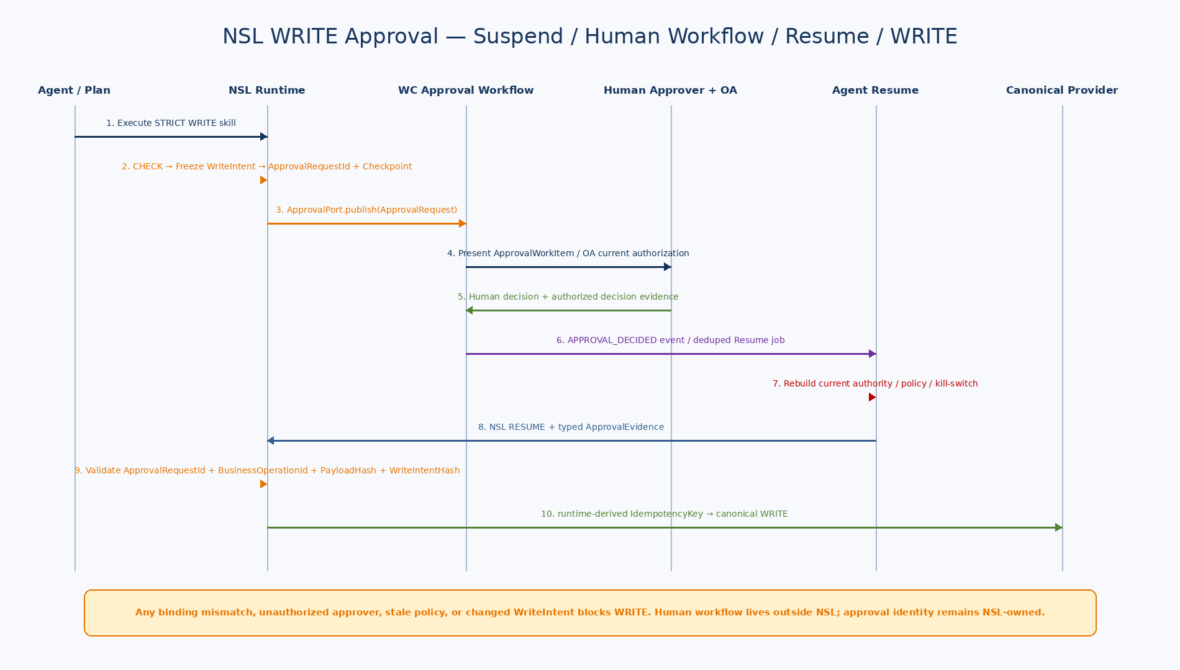
Figure 2. NSL WriteIntent Freeze→ApprovalRequest→WC ApprovalWorkItem→Interactive Agent/AE-WEB Notification→Approver Decision(OA current authorization)→Decision Event→Agent Resume→NSL ApprovalEvidence Validation→WRITE.

6. Human Control / Approval Requirement
Field | Meaning
control_id / approval_domain | Control requirement identity and domain (CONFIRMATION / AGENT_FORMAL / NSL_WRITE / EOS_BUSINESS)
protected_step_id | Executable step protected
skill_id/version | Exact Certified Skill version
capability_id / operation_key | Protected write identity
policy_ref | Risk/domain control policy and current authorization requirement
requester_ref | Confirmation requester
approver_policy_ref | Formal approval policy
payload_binding | WRITE_INTENT_HASH / PAYLOAD_HASH / BOTH
valid_for_seconds | Request/proof validity

7. Payload / Write Intent Hash Binding
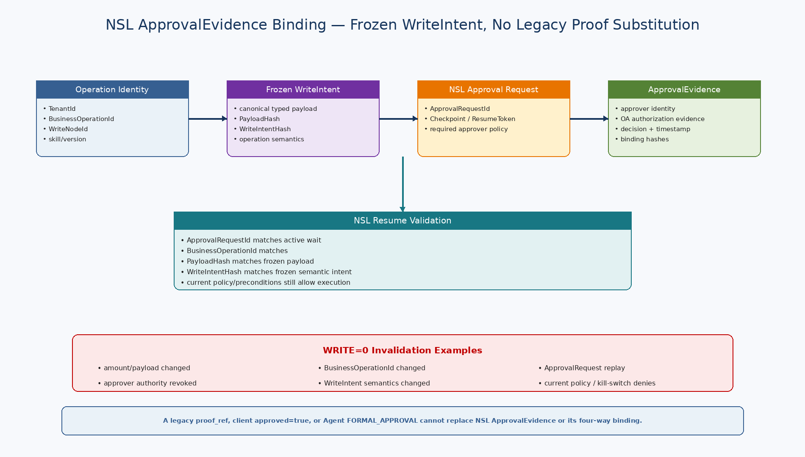
Figure 3. NSL ApprovalEvidence의 ApprovalRequestId/BusinessOperationId/PayloadHash/WriteIntentHash binding과 invalidation 조건.

7.1 Hash Definitions
Hash | Canonical Input | Purpose
write_intent_hash | skill_id, version, capability_id, operation_key, protected_step_id | Binds semantic protected operation
payload_hash | Canonical exact typed WRITE payload | Binds material business values/Stable IDs
control_request_hash | control domain/policy + intent/payload hashes + requester/approver context | Idempotency/audit identity
evidence_hash | Canonical domain evidence object integrity/reference | Integrity/evidence reference
UI는 hash 대상 payload_snapshot과 동일한 frozen snapshot에서 표시값을 렌더링해야 한다. 표시 payload와 실행 payload를 별도 조립하지 않는다.
8. Structured Confirmation
8.1 State Model
State | Meaning
REQUIRED | Request exists; not yet decided
PRESENTED | Human has seen structured payload
SATISFIED | Exact payload confirmed; durable confirmation evidence recorded
REJECTED | Requester declined
CANCELLED | Cancelled before satisfaction
EXPIRED | No decision before expiry
REVOKED | Satisfied proof invalidated before effect
- ConfirmationRequest 생성은 idempotent하며 snapshot/hash를 Freeze한다.
- Requester는 server-side effective authority에서 결정한다.
- CONFIRM→SATISFIED + Proof, REJECT→REJECTED + no proof.
- Background delay는 WAITING_CONFIRMATION; immediate interactive confirmation은 동기 처리 가능.
- Payload/operation change before effect revokes the old proof and requires a new confirmation.

9. Human Approval Workflow State / Policy / Authority
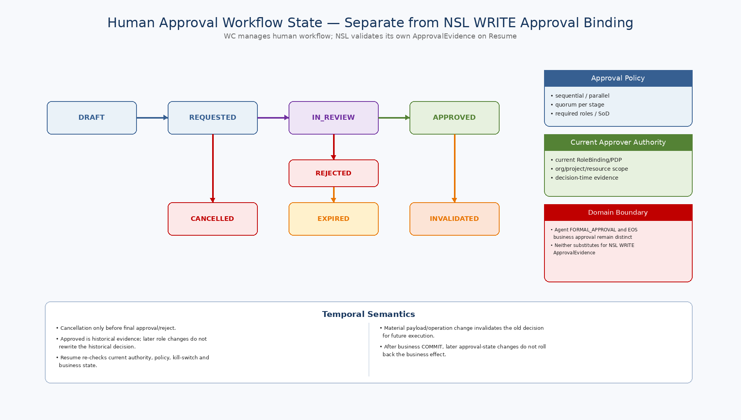
Figure 4. Approval lifecycle, stage/quorum, authority/SoD and temporal semantics.

9.1 Approval State Model
State | Meaning
DRAFT | Policy resolved/instance initialized
REQUESTED | Approval requested
IN_REVIEW | Active stage under review
APPROVED | All required stages/quorums passed
REJECTED | Business approval rejected
CANCELLED | Withdrawn before final decision
EXPIRED | Pending approval timed out
INVALIDATED | Historically approved but no longer usable for this write
9.2 Approval Stage / Quorum
Rule | Meaning
SEQUENTIAL | Stage N+1 starts only after N approves.
PARALLEL | Multiple approvers may decide concurrently.
quorum | Minimum distinct approvals required in a stage.
required_roles | Only current eligible role bindings may approve.
reject semantics | Policy defines reject behavior; default high-risk policy treats required reject as blocking.
candidate resolution | ApproverResolver uses OA RoleBinding/org/project/resource scope; no LLM authority.
10. Approver Authority / Separation of Duties
Rule | Implementation
Decision-time authority | ApprovalDecision stores approver_ref, role_binding_ref and PDP decision ref.
Separation of duties | Policy may prohibit requester==approver and conflicting roles.
Multi-role user | Active RoleBinding for approval purpose must match required role/scope.
Delegated approver | Allowed only when policy and OA/PDP explicitly support delegation.
Expired role before decision | Cannot approve.
Role changes after decision | Historical approval remains; current protected-operation authorization still runs.
Agent as approver | Formal Approval is Human-only by default.
Temporal Authority
APPROVED는 그 시점에 권한 있는 Human이 exact payload/operation을 승인했다는 역사적 증거다. 이후 Approver Role 변경은 과거 결정을 수정하지 않지만 보호된 Write는 현재 Caller/Capability/Scope/Policy를 다시 통과해야 한다.
11. Legacy Agent Control Proof v1.1 — NON-NORMATIVE Migration Reference (NSL WRITE에 사용 금지)
Area | Fields / Meaning
Identity | proof_id, gate_id/type/status/source object
Actor | actor_ref + role_binding_ref
Runtime binding | skill/version, execution, work, plan step
Operation binding | capability_id + operation_key
Data binding | write_intent_hash + payload_hash
Policy | policy_ref/version
Temporal | issued_at + expires_at
Source | AE_CONFIRMATION / EOS_APPROVAL
Consumption | consumed_operation_key for audit/same-operation retry
11.1 Proof Validation
ID | Validation
AE-01 | NSL WRITE validates typed ApprovalEvidence for the active ApprovalRequestId/Checkpoint; legacy Agent-control proof_ref is never accepted as NSL authority.
AE-02 | ApprovalEvidence decision/status must be valid and its owner/current authorization evidence must be acceptable.
AE-03 | ApprovalRequestId and BusinessOperationId must match the active NSL execution wait.
AE-04 | agent_execution_id / plan_step_id / NSLExecutionId must match current execution context where present.
AE-05 | PayloadHash must match exact frozen typed WRITE payload.
AE-06 | WriteIntentHash must match the exact protected skill/capability/operation semantics.
AE-07 | Current OA authorization, policy, kill-switch and business preconditions must still ALLOW.
AE-08 | Any mismatch/unauthorized decision/replay attempt → WRITE=0 and auditable failure.
PV-09 | Proof consumed for a different operation key is rejected.
PV-10 | Any mismatch fail-closes with zero provider WRITE calls.
12. WAITING / Checkpoint / Resume
Phase | Implementation
Control / approval object create | Owner service creates stable object idempotently; NSL creates ApprovalRequestId only inside NSL WRITE approval flow
AE suspend TX | Checkpoint + execution_wait + WAITING_* + outbox
Worker release | No polling/busy waiting
Human decision TX | Authorized decision/evidence persisted by owner + outbox event; unauthorized decision persistence denied
AE event inbox | event_id dedup + one Resume job
Resume preflight | Current authority + decision/evidence validity + freshness + business state
Continue | Legacy Agent-control proof_ref may support migration-only Agent domains; NSL WRITE uses typed ApprovalEvidence only
13. Cancellation / Expiry / Invalidation
Situation | Rule
Confirmation expiry | REQUIRED/PRESENTED → EXPIRED; caller may request again.
Confirmation rejection | REJECTED event; cancel/replan/clarification path.
Confirmation revocation | SATISFIED proof revoked before write on change/policy.
Approval cancellation | DRAFT/REQUESTED/IN_REVIEW → CANCELLED by authorized actor.
Approval expiry | REQUESTED/IN_REVIEW → EXPIRED.
Approved proof expiry | Historical APPROVED may remain, while proof valid-until expires.
Approval invalidation | APPROVED → INVALIDATED before execution on material change.
After COMMIT | No gate state change rolls back business effect; domain reversal/follow-up required.
14. NSL WRITE Approval Integration — Canonical v2.1
- ExecutionContext는 typed approval identity/reference만 전달하며 legacy proof_ref를 NSL WRITE 권한으로 사용하지 않는다.
- NSL WRITE Approval은 NSL-owned ApprovalRequestId/Checkpoint와 typed ApprovalEvidence를 사용한다. Unified Agent Runtime은 WC human workflow/decision event를 연결하고 Resume를 scheduling하며, NSL은 Resume 시 ApprovalEvidence binding을 검증한다.
- NSL은 WRITE 직전 frozen WriteIntent/PayloadHash/WriteIntentHash와 current policy/preconditions를 재검증한다.
- ApprovalEvidence는 active ApprovalRequestId, BusinessOperationId, exact payload/intent hash, execution/step identity에 binding되어야 한다.
- Current OA authorization, RoleBinding, policy, kill-switch 또는 protected operation이 변경되면 fail-closed 하고 WRITE하지 않는다.
- 동일 semantic operation의 retry는 동일 runtime-derived IdempotencyKey를 사용하며, 변경된 payload/operation은 기존 ApprovalEvidence로 실행할 수 없다.
15. Canonical Events
Event | Meaning
CONFIRMATION_REQUIRED | Confirmation created/presented
CONFIRMATION_SATISFIED | Proof issued
CONFIRMATION_REJECTED | Requester rejected
CONFIRMATION_CANCELLED | Cancelled
CONFIRMATION_EXPIRED | Expired
CONFIRMATION_REVOKED | Satisfied proof revoked
APPROVAL_REQUESTED | Formal approval requested
APPROVAL_STAGE_COMPLETED | One stage completed
APPROVAL_APPROVED | All stages passed; proof issued
APPROVAL_REJECTED | Rejected
APPROVAL_CANCELLED | Pending approval cancelled
APPROVAL_EXPIRED | Pending approval expired
APPROVAL_INVALIDATED | Approved instance invalidated
APPROVAL_EVIDENCE_CONSUMED | Domain evidence consumed/linked for audit; NSL ApprovalEvidence consumption remains bound to active ApprovalRequestId
16. Audit Evidence
Evidence | Purpose
Control / Approval / Decision / Evidence IDs | Cross-service immutable lineage by domain
Actor / approver refs | Who requested/decided/consumed
RoleBinding / authority decision | Why actor was authorized
Policy/stage/quorum | Governance basis
Skill/step/capability/operation | Protected executable identity
write_intent_hash / payload_hash | Exact binding
State/reason | Reject/cancel/expire/invalidate/revoke
Trace refs | correlation/causation/work_item
Timestamps | issued/expires/decided/consumed
17. PostgreSQL Model
Table | Purpose
nex_ae.confirmation_request | AE-owned confirmation snapshot/state/idempotency
nex_ae.confirmation_decision | Append-only decision evidence
nex_ae.confirmation_proof | Proof JSON/hash/status/expiry/consumption
nex_eos.approval_policy | Versioned criteria/SoD/expiry/proof validity
nex_eos.approval_policy_stage | Stage mode/quorum/required roles
nex_eos.approval_instance | Frozen payload/policy/lifecycle/version
nex_eos.approval_stage_instance | Runtime stage state
nex_eos.approval_decision | Append-only approver decision + authority
nex_eos.approval_proof | Formal proof/expiry/consumption
nex_eos.approval_event_outbox | Transactional approval events
AE Confirmation과 EOS Formal Approval은 별도 SoR다. Physical Cross-DB FK 없이 stable refs + canonical events로 연결한다. ApprovalDecision은 append-only이고 instance version으로 concurrent decision을 제어한다.
18. Canonical API Surface
Capability | Owner | Meaning | Risk
HUMANGATE.CREATE_CONFIRMATION | AE | Create structured confirmation | R3
HUMANGATE.GET_CONFIRMATION | AE | Read confirmation | R2
HUMANGATE.DECIDE_CONFIRMATION | AE | Requester confirm/reject | R3
HUMANGATE.REVOKE_CONFIRMATION | AE/Admin | Revoke proof before effect | R4
APPROVAL.CREATE_REQUEST | EOS | Create approval instance | R3/R4
APPROVAL.GET_INSTANCE | EOS | Read approval/stages | R2
APPROVAL.DECIDE | EOS | Human approve/reject | R4/R5
APPROVAL.CANCEL | EOS | Cancel pending approval | R4
APPROVAL.INVALIDATE | EOS/Gov | Invalidate approved before effect | R4/R5
HUMANGATE.GET_PROOF | AE/EOS Adapter | Fetch trusted proof | Internal
HUMANGATE.MARK_CONSUMED | AE/EOS Adapter | Bind proof use to operation | Internal
19. Security / Failure Semantics
- LLM은 Confirmation/Approval Decision, NSL ApprovalEvidence, Approver Authority를 생성하거나 위조할 수 없다.
- Formal Approval은 Human-only를 기본으로 한다.
- Payload/WriteIntent/BusinessOperation binding mismatch는 기존 evidence 갱신이 아니라 새로운 확인/승인 또는 재계획 사유다.
- Duplicate human decision/event는 idempotency + optimistic version + inbox dedup으로 제어한다.
- Approval 취소/만료/무효화는 이미 COMMITTED된 Business Effect를 rollback하지 않는다.
- High-risk path는 stale cached approval/confirmation evidence가 owner current status 및 OA current authorization check를 우회해서는 안 된다.
20. Observability
Metric | Purpose
human_gate_request_total | gate_type/domain/risk
human_gate_wait_age_seconds | gate_type/domain
confirmation_decision_total | confirm/reject/cancel/expire
approval_decision_total | policy/stage/approve/reject
approval_duration_seconds | policy/domain
approval_sod_denied_total | policy/role
approval_evidence_validation_failure_total | reason/approval_domain
approval_evidence_invalid_total | reason/approval_domain
approval_invalidated_total | reason/domain
human_gate_resume_total | gate_type/outcome
human_gate_duplicate_event_total | gate_type
21. Test Strategy
Area | Required Test
Hash binding | Amount/project/capability/BusinessOperation/PayloadHash/WriteIntentHash changes invalidate prior domain evidence for new execution.
Confirmation | Requester mismatch, double click/idempotency, reject, expire, revoke, duplicate event.
Approval policy | Sequential stages, parallel quorum, reject policy, no candidate, version pin.
Authority/SoD | Wrong role, expired role, self-approval denial, allowed delegation.
Lifecycle | ApprovalEvidence binding mismatch / unauthorized approver / replay / expiry / current-policy deny all result in WRITE=0.
Resume | Duplicate approved event→one Resume; caller RoleBinding revoked→no side effect.
NSL | Valid typed ApprovalEvidence → one WRITE; payload/intent/binding mismatch or expiry → zero WRITE provider calls.
Retry | Same ApprovalEvidence + same frozen semantic operation uses the same runtime-derived idempotency identity; changed operation requires new approval/evidence.
Post-commit | Invalidation after COMMITTED does not rollback; domain reversal required.
Audit | Authority/payload/policy/trace reconstructable.
22. Implementation Sequence
Wave | Area | Deliverable
I1 | Schemas / Models | ControlRequirement / Confirmation / Approval / Decision / Evidence Pydantic + JSON
I2 | Confirmation Service | AE confirmation state/idempotency/evidence/event endpoints
I3 | Approval Policy Engine | Policies/stages/quorum/SoD/approver resolver
I4 | Approval Runtime | Approval instance/stage/decision/cancel/expiry/invalidation/evidence/outbox
I5 | AE Integration | WAITING_CONFIRMATION/APPROVAL checkpoint + event resume
I6 | NSL ApprovalEvidence Integration | ApprovalEvidence validator + four-way binding + current-policy/precondition check + idempotent WRITE handoff
I7 | UI / Notifications | Structured confirmation + approver inbox/history
I8 | Hardening | race/expiry/security/fault/audit/E2E/metrics
23. Machine-readable Canonical Reference Package
Artifact | Validation / Purpose
7 JSON Schemas — Batch04 CP04 | Draft 2020-12 structural validation; canonical Platform v2.1 approval contracts
approval_protocols_v2_1.py | Typed ApprovalRequest / ApprovalDecision / ApprovalEvidence / NSL Resume protocol helpers
agent-formal-approval-request-v2.1.schema.json | Agent FORMAL_APPROVAL request identity and binding
approval-work-item-v1.schema.json | WC human approval workflow projection / task contract
approval-decision-v2.1.schema.json | Authorized human decision + OA decision reference
approval-evidence-v2.1.schema.json | Typed evidence consumed by the required approval domain; NSL binding fields explicit
nsl-write-approval-request-v2.1.schema.json | NSL-owned ApprovalRequestId / frozen WriteIntent approval request
nsl-approval-resume-v2.1.schema.json | Resume binding to active NSL checkpoint / ApprovalEvidence / event identity
human-gate-view-v2.1.schema.json | AE-WEB presentation-only approval/human-action view; not an approval SoR
Runtime / persistence contracts | WC decision persistence + Agent Resume scheduling + current OA reauthorization; no client boolean authority
Legacy v2.0 implementation package | 04_LEGACY_REFERENCE_CONTRACTS only — NON-NORMATIVE; never NSL WRITE authority
Legacy v2.0 PostgreSQL DDL/transaction package는 reference-only NON-NORMATIVE이다. Canonical v2.1 persistence와 decision/resume transaction semantics는 NeX-WC / Agent Runtime / Batch04 CP04 approval contracts를 따른다.
24. Detailed Design Quality Gate
Quality Gate | Pass Criteria
HG-QG-01 | Confirmation / Agent FORMAL / NSL WRITE / EOS Business Approval are separated by meaning, owner and evidence.
HG-QG-02 | Each control domain binds the exact payload/operation identity required by that domain.
HG-QG-03 | Approval records authority and SoD evidence.
HG-QG-04 | WAITING uses checkpoint/worker release/event resume.
HG-QG-05 | Invalid/unauthorized approval evidence cannot cause side effect; NSL binding mismatch always yields WRITE=0.
HG-QG-06 | Current authorization runs after resume/before write.
HG-QG-07 | Historical approval is not rewritten by later role changes.
HG-QG-08 | Post-commit cancellation does not imply rollback.
HG-QG-09 | NSL ApprovalEvidence validation, exact binding, and same-semantic-operation idempotent retry are explicit; legacy proof_ref is never NSL authority.
HG-QG-10 | Canonical JSON Schemas + Python protocols + independent negative probes validate.
25. Phase 1 Completion Note
Core Execution Safety Layer Complete | 11~18 문서로 Coworker Runtime, Work Coordination, NSL/Certified Skill, Approval Domains/Human Workflow를 요구사항→구현계약까지 연결했다. 이제 이 안전한 실행계층 위에서 Enterprise OS의 Project/Voucher/Ledger 등 실제 Business Effect를 상세화할 수 있다.

PLAT-CP04 — Canonical Approval Domains and Workflow
Status: PLAT-CP04 Controlled Amendment — Canonical Approval Architecture
이 문서의 v2.0 legacy Agent-control proof 중심 lifecycle은 v2.1에서 아래 canonical model로 대체한다.

Control Domains
- Human Confirmation: requester interpretation confirmation.
- Agent FORMAL_APPROVAL: business/process governance control.
- NSL WRITE Approval: NSL-owned exact WRITE approval semantic.
- OA Step-up: authentication/authority control.

NSL WRITE Approval
NSL WriteIntent Freeze → ApprovalRequestId → WC ApprovalWorkItem → IA/AE-WEB Notification → Approver Decision + OA Check → WC Decision Event → Agent Resume → NSL ApprovalEvidence Validation → WRITE.

Agent FORMAL_APPROVAL
Agent gate → WC ApprovalWorkItem → human decision. Domain formal approval record가 필요한 경우 EOS adapter를 통해 authoritative approval transaction을 연결한다.
ApprovalWorkflowProvider는 WC workflow를 기준으로 provider-agnostic contract를 노출한다.

PLAT-CP08 — Approval Notification / Interactive Agent Projection
Status: PLAT-CP07/CP08 Controlled Amendment — Canonical v2.1
Approval workflow state는 WC, NSL binding은 NSL, domain business approval은 EOS가 소유하며 AE-WEB/IA는 presentation channel이다.
WC ApprovalWorkItem event는 AE Notification projection으로 변환되고, 승인자의 IA/AE-WEB에 user-safe summary와 action을 표시한다.
Approve/Reject는 WC Decision API로 제출하며 OA current authorization을 통과한 뒤 persistence/event가 발생한다.
IA가 직접 Agent Runtime resume()나 NSL WRITE를 호출해서는 안 된다.

E2E Step 3 — Approval Evidence / Resume Contract
Status: E2E Step 3 Contract Hardening v1.4 — Normative
ApprovalWorkItem은 approval_domain별 exact binding을 요구한다.
- NSL_WRITE: AgentExecutionId + StepId + NSLExecutionId + BusinessOperationId + ApprovalRequestId + protected evidence ref.
- AGENT_FORMAL: AgentExecutionId + StepId + BusinessOperationId + protected evidence ref.
ApprovalDecision은 accepted decision마다 non-null oa_decision_ref를 요구한다.
APPROVAL_DECIDED 이후 Agent Resume는 nsl_checkpoint_version/event_id/correlation_id/ApprovalEvidenceRef/ResumeTokenRef를 포함한 NSLApprovalResume v2.1로만 연결한다.

