NeX Enterprise OS Core Domain
Detailed Design v2.0
Project · Account · Voucher · Approval · Ledger · Fiscal Period
Core Domain Invariant
Voucher material data freezes at Submit, LedgerEntry is immutable, P/L is derived from Ledger, and Project/Account/Period/Approval are revalidated at posting time.
Reference package: 6 JSON Schemas + Python Domain/Protocols + 5 PostgreSQL SQL files | 2026.09.01

Executive Summary
본 문서는 Enterprise OS SRS의 Project/Voucher/Approval/Ledger/P&L 요구를 실제 Aggregate/State/Invariant/Python/PostgreSQL 구현설계로 내린다. Project는 NVT/Mother/Child/Common을 하나의 typed Aggregate family로 모델링하고, Voucher는 VoucherLine을 소유하는 Aggregate Root로 설계한다. Formal Approval은 Document 18의 Enterprise OS Approval Aggregate를 재사용한다. 금융 사실은 LedgerPosting atomic batch와 immutable LedgerEntry로 기록하며 P/L은 Ledger 기반 read model이다.
Accounting Integrity
Posted financial facts are never corrected by UPDATE/DELETE. A correction is another domain transaction: reversal or adjustment with explicit lineage.

1. Aggregate & Ownership Map
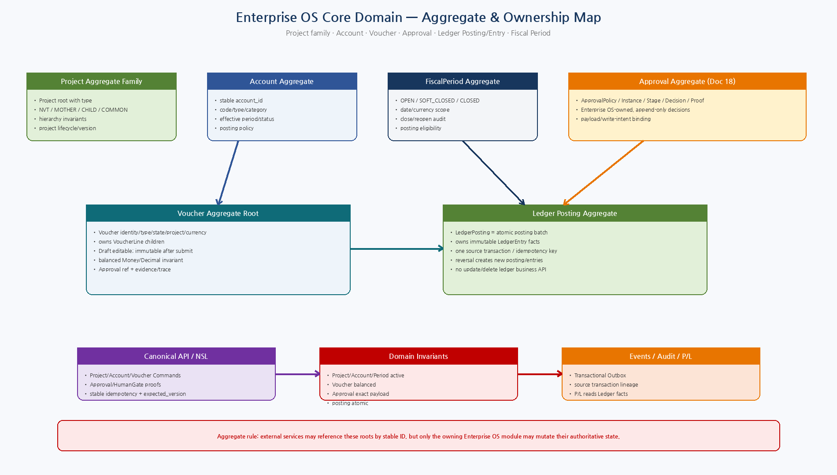
Figure 1. Project/Account/Voucher/Approval/FiscalPeriod/LedgerPosting aggregate ownership and side-effect boundary.

2. Detailed Design Principles
ID | Decision | Implementation Meaning
EOS-DD-01 | Typed Project aggregate family | NVT/Mother/Child/Common share one root/model while domain invariants enforce hierarchy-specific rules.
EOS-DD-02 | Aggregate-local transactional consistency | Voucher+VoucherLine and LedgerPosting+LedgerEntry are committed within their owning aggregate transaction boundaries.
EOS-DD-03 | Approval reused, not duplicated | Approval Aggregate from Document 18 remains Enterprise OS-owned and is referenced by protected transactions.
EOS-DD-04 | Immutable financial facts | Submitted voucher business values and ledger facts are corrected by new reversal/adjustment, not destructive update/delete.
EOS-DD-05 | Money/Decimal only | Financial values use Decimal/Money semantics; Float is excluded.
EOS-DD-06 | Project Attribution First | Direct financial transactions resolve an ACTIVE non-NVT Project; Common is never an automatic null-project fallback.
EOS-DD-07 | P/L is a projection | P/L is calculated from ledger facts and cannot be written as an authoritative standalone number.
EOS-DD-08 | Deterministic posting | Project/account/period/approval/balance/idempotency are revalidated at the posting boundary.
EOS-DD-09 | Cross-service refs only | WC/OA/WA/Artifact references are stable IDs; Enterprise OS does not direct-write foreign service DBs.
EOS-DD-10 | PostgreSQL-first | Core aggregates, optimistic versions, idempotency, audit/outbox and ledger facts use PostgreSQL transactions.
3. Aggregate Boundaries
Domain Object | Role | Ownership / Boundary
Project | Aggregate Root | NVT/MOTHER/CHILD/COMMON typed variants; hierarchy/lifecycle/financial scope
Account | Aggregate Root | Account code/type/category/effective period/status/version
Voucher | Aggregate Root | Voucher header owns VoucherLine; edit rules/state/approval/trace
VoucherLine | Owned Entity | Account/side/Money/category/evidence; immutable after submit
ApprovalInstance | Aggregate Root (Doc 18) | Policy/stage/decision/proof; referenced by Voucher/Posting
FiscalPeriod | Aggregate Root | Open/soft-close/close/reopen governance
LedgerPosting | Aggregate Root | Atomic posting batch and idempotency identity
LedgerEntry | Owned immutable financial fact | Project/account/category/Money/source/reversal lineage
P/L | Read Model / Projection | Aggregated from LedgerEntry, not an aggregate root
Ledger aggregate choice
LedgerEntry는 핵심 financial fact이지만, 한 Voucher에서 여러 debit/credit entry가 반드시 원자적으로 생성되어야 하므로 write aggregate root는 LedgerPosting으로 둔다. LedgerEntry는 그 Posting이 소유하는 immutable entity다.
4. Recommended Python Package
src/nex_eos/
├── api/
│ ├── project_commands.py
│ ├── finance_commands.py
│ ├── ledger_queries.py
│ └── dependencies.py
├── application/
│ ├── project_service.py
│ ├── voucher_service.py
│ ├── ledger_service.py
│ ├── period_service.py
│ └── pl_query_service.py
├── domain/
│ ├── models.py
│ ├── state_machines.py
│ ├── invariants.py
│ ├── project/
│ ├── accounting/
│ └── ledger/
├── contracts/
│ ├── project.py
│ ├── voucher.py
│ ├── ledger.py
│ └── errors.py
├── persistence/
│ ├── models.py
│ ├── repositories.py
│ └── migrations/
├── adapters/
│ ├── oa.py
│ ├── approval.py
│ ├── artifact.py
│ ├── wc.py
│ └── legacy.py
├── workers/
│ ├── outbox_publisher.py
│ └── reconciliation.py
└── observability/
├── metrics.py
└── audit.py
5. Core Protocol Interfaces
Protocol | Method | Responsibility
ProjectRepository | get/create/update_state/list_children | Project aggregate persistence
AccountRepository | get/search | Account master and candidate resolution
VoucherRepository | get/create_draft/update_state | Voucher aggregate persistence with optimistic version
FiscalPeriodRepository | get_for_date/update_state | Posting period governance
ApprovalGateway | get_instance/get_proof | Reuse Document 18 formal approval aggregate
AuthorizationPDP | authorize(capability,context,resources) | Current server-side business authorization
HumanGateVerifier | verify(proof,payload,intent,context) | Proof/hash/current policy binding
LedgerRepository | find_posting_by_idempotency/append_posting/list_entries | Atomic ledger posting and immutable facts
EventOutbox | append(event) | Transactional domain-event publication
IdempotencyStore | get/begin/complete | Command crash-window/result reuse

6. Project Aggregate Family
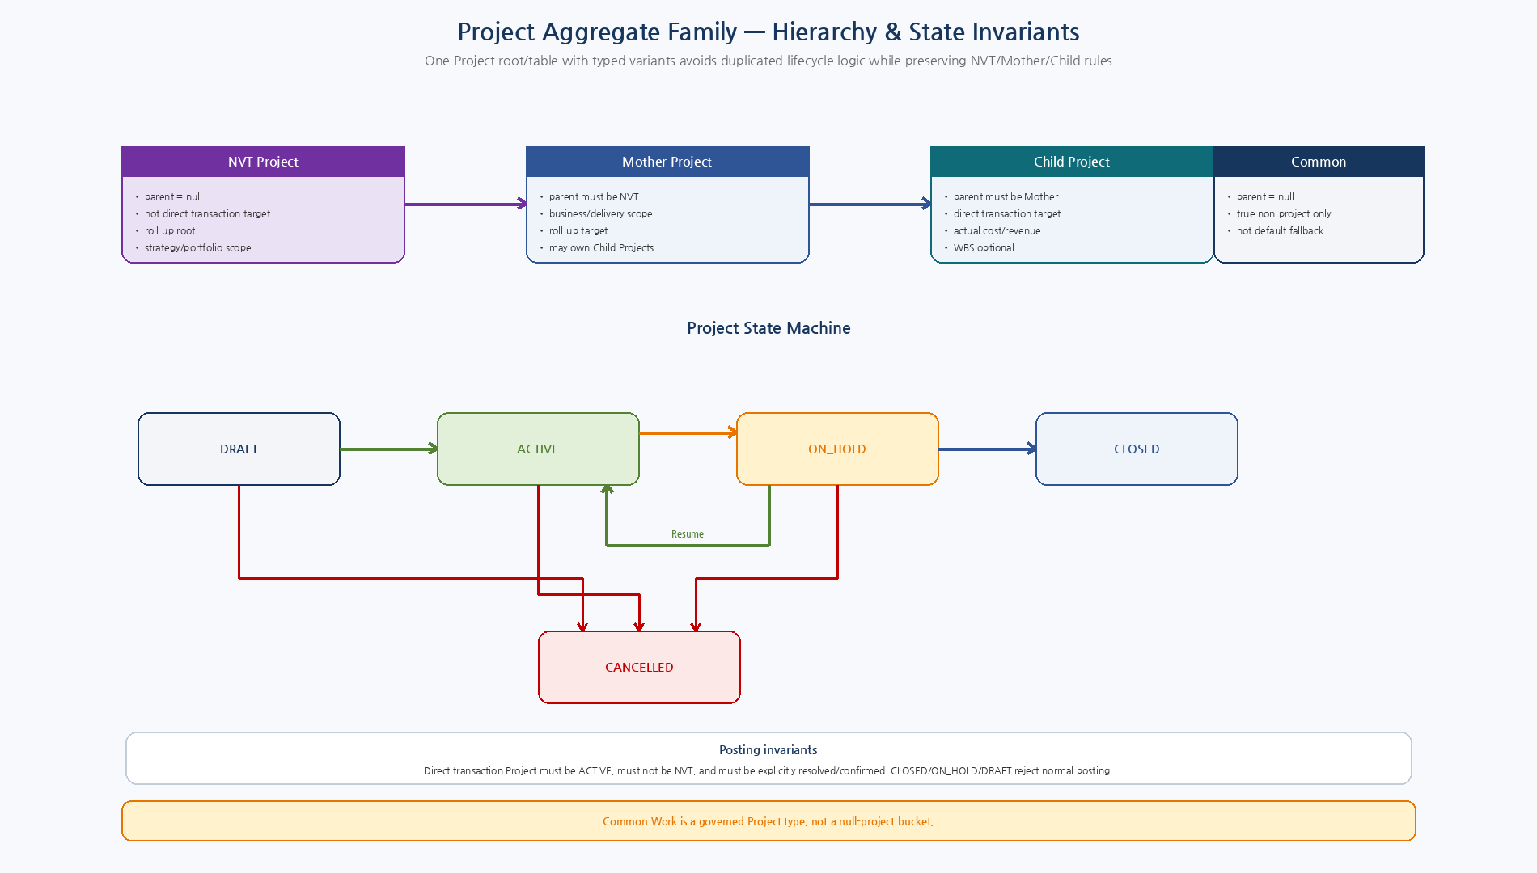
Figure 2. 하나의 Project root를 NVT/Mother/Child/Common typed variant로 관리하고 hierarchy/state invariants를 강제.

6.1 Project Domain Invariants
ID | Invariant
PRJ-INV-01 | NVT and COMMON projects have no parent.
PRJ-INV-02 | Mother Project must have an NVT parent; Child Project must have a Mother parent.
PRJ-INV-03 | NVT Project is not a direct Business Transaction target.
PRJ-INV-04 | Normal posting target must be ACTIVE; DRAFT/ON_HOLD/CLOSED/CANCELLED reject normal posting.
PRJ-INV-05 | end_date must be null or >= start_date.
PRJ-INV-06 | Project code may change only under governance; project_id never changes.
PRJ-INV-07 | Project hierarchy changes cannot break historical transaction/ledger refs.
PRJ-INV-08 | COMMON is explicit governed type, not default missing-project assignment.
6.2 Project State Machine
From | To | Meaning
DRAFT | ACTIVE | Activate
DRAFT | CANCELLED | Cancel before active
ACTIVE | ON_HOLD | Suspend new normal posting/work
ON_HOLD | ACTIVE | Resume
ACTIVE/ON_HOLD | CLOSED | Close
ACTIVE/ON_HOLD | CANCELLED | Exceptional cancel
7. Account Aggregate
ID | Invariant
ACC-INV-01 | Account code is unique; account_id immutable.
ACC-INV-02 | New transaction usage requires ACTIVE account.
ACC-INV-03 | Transaction/posting date must fall within account effective range.
ACC-INV-04 | Historical LedgerEntry retains account_ref and sufficient posting snapshot/contract evidence after rename/deactivation.
ACC-INV-05 | Management category NONE is not allowed for final ledger facts unless posting rule resolves a category elsewhere.
7.1 Account State Machine
From | To | Meaning
DRAFT | ACTIVE | Activate
ACTIVE | INACTIVE | Temporarily disable
INACTIVE | ACTIVE | Re-enable
DRAFT/ACTIVE/INACTIVE | RETIRED | Retire permanently
8. FiscalPeriod Aggregate
ID | Invariant
PER-INV-01 | Period date range is valid and unique by fiscal_year/period_no/currency.
PER-INV-02 | OPEN permits normal posting; SOFT_CLOSED/CLOSED require privileged policy for corrections.
PER-INV-03 | CLOSE/REOPEN requires human/governance authority and reason/audit.
PER-INV-04 | Reopen changes period status but never rewrites existing ledger facts.
8.1 FiscalPeriod State Machine
From | To | Meaning
OPEN | SOFT_CLOSED | Soft close
OPEN/SOFT_CLOSED | CLOSED | Close
SOFT_CLOSED | OPEN | Operational reopen
CLOSED | OPEN | Privileged explicit reopen with audit
9. Voucher Aggregate / VoucherLine
ID | Invariant
VCH-INV-01 | Voucher contains at least two lines and unique line_no values.
VCH-INV-02 | All line Money currencies equal Voucher currency.
VCH-INV-03 | All line amounts are positive Decimal/Money values.
VCH-INV-04 | Debit total equals Credit total for standard double-entry voucher.
VCH-INV-05 | Voucher can be freely edited only in DRAFT; after SUBMITTED, material data is immutable.
VCH-INV-06 | Project and Account refs are stable canonical IDs, never unresolved text.
VCH-INV-07 | Approval-required voucher stores exact ApprovalInstance/Proof lineage.
VCH-INV-08 | POSTED voucher cannot be edited/deleted; corrections create REVERSAL/ADJUSTMENT voucher.
VCH-INV-09 | Voucher draft creation and posting use stable idempotency keys.
9.1 Voucher State Machine
From | To | Meaning
DRAFT | SUBMITTED | Freeze material data
DRAFT | CANCELLED | Cancel draft
SUBMITTED | APPROVAL_PENDING | Create formal approval
SUBMITTED | APPROVED | No formal approval required by policy
APPROVAL_PENDING | APPROVED | Approval approved
APPROVAL_PENDING | REJECTED | Approval rejected
APPROVED | POSTING | Posting transaction begins
POSTING | POSTED | Ledger posting committed
POSTED | REVERSED | Linked reversal posted
DRAFT에서만 Project/Account/Amount/Line material edit를 허용한다. SUBMITTED 이후 값은 Approval/Hash의 대상이므로 freeze하고, correction은 new reversal/adjustment Voucher를 생성한다.
10. Approval Aggregate Integration
- ApprovalPolicy/Instance/Stage/Decision/Proof는 Document 18 Enterprise OS Approval Engine을 그대로 authoritative aggregate로 사용한다.
- Voucher는 ApprovalInstance stable ref와 payload/write-intent hash lineage를 보존한다.
- Formal Approval event가 APPROVED를 만들더라도 posting은 current Proof/PDP/Project/Period/Account를 다시 검증한다.
- Material Voucher payload 변경은 old approval proof를 invalid하게 하므로 새 Approval을 요구한다.

11. Voucher → Approval → Ledger Posting Transaction
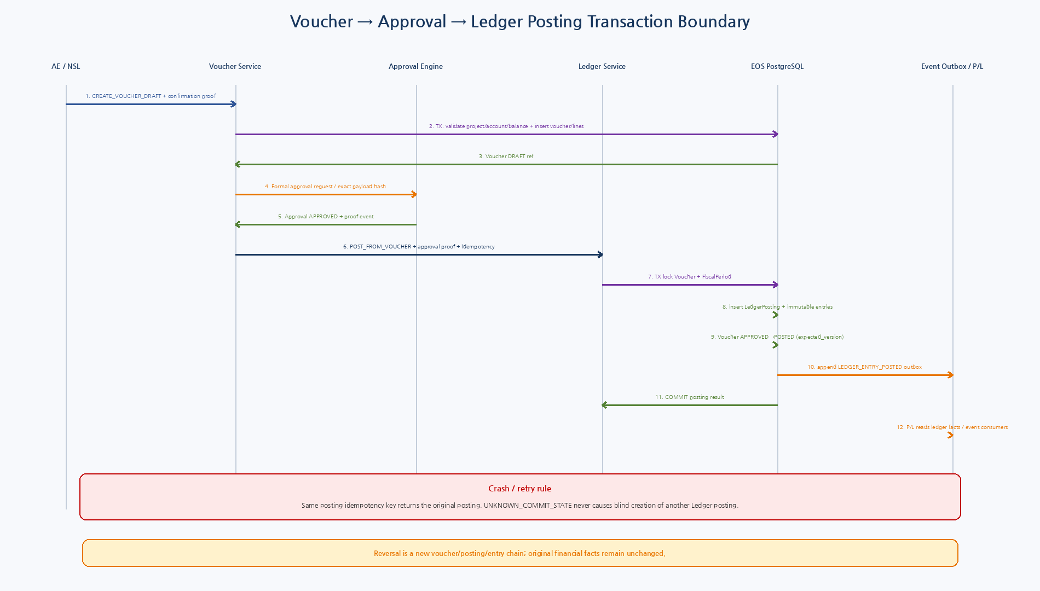
Figure 3. Voucher Draft/Approval과 Ledger Posting의 local PostgreSQL transaction 및 idempotency boundary.

11.1 Posting Transaction Boundary
Step | Boundary | Rule
T1 | Validate outside/inside transaction | Load/validate current Project, Account, Approval proof, Period, Voucher balance.
T2 | Lock aggregate roots | SELECT Voucher and FiscalPeriod FOR UPDATE; check expected versions/state again.
T3 | Insert posting identity | ledger_posting with stable idempotency key; duplicate returns original.
T4 | Append entries | Insert immutable LedgerEntry rows generated deterministically from VoucherLine.
T5 | Advance Voucher | APPROVED/POSTING → POSTED with expected version; no material voucher mutation.
T6 | Append event/audit | LEDGER_ENTRY_POSTED outbox + audit in same EOS transaction.
T7 | Commit | Return Posting/Entry refs. If DB result uncertain, caller uses reconciliation; never blind duplicate posting.
11.2 Reference SQL pattern
BEGIN;
SELECT * FROM nex_eos.voucher
WHERE voucher_id=:voucher_id FOR UPDATE;
SELECT * FROM nex_eos.fiscal_period
WHERE period_id=:period_id FOR UPDATE;
-- recheck APPROVED + expected_version + OPEN period
-- validate project/account/balance/proof/current PDP
INSERT INTO nex_eos.ledger_posting(..., idempotency_key, ...)
VALUES (...)
ON CONFLICT (idempotency_key) DO NOTHING;
INSERT INTO nex_eos.ledger_entry(...)
SELECT ... FROM :deterministic_entries;
UPDATE nex_eos.voucher
SET state='POSTED', posting_date=:posting_date,
version=version+1
WHERE voucher_id=:voucher_id
AND state='APPROVED'
AND version=:expected_version;
INSERT INTO nex_eos.event_outbox(... 'LEDGER_ENTRY_POSTED' ...);
COMMIT;
12. LedgerPosting / LedgerEntry
ID | Invariant
LDG-INV-01 | LedgerPosting is unique by idempotency key for a protected posting operation.
LDG-INV-02 | LedgerEntry is append-only immutable business fact.
LDG-INV-03 | Every LedgerEntry has Project, Account, Category, Money, PostingDate, FiscalPeriod and source transaction.
LDG-INV-04 | Posting currency matches voucher/source transaction currency unless explicit FX policy says otherwise.
LDG-INV-05 | FiscalPeriod must be postable at transaction boundary.
LDG-INV-06 | Source Voucher must be APPROVED and still business-valid at posting time.
LDG-INV-07 | Reversal creates new posting/entries and links original entry/posting; original remains unchanged.
LDG-INV-08 | No direct public/MCP low-level update/delete/post API for LedgerEntry.
LDG-INV-09 | P/L is derived exclusively from accepted LedgerEntry facts.

13. Project Financial Ledger & P/L
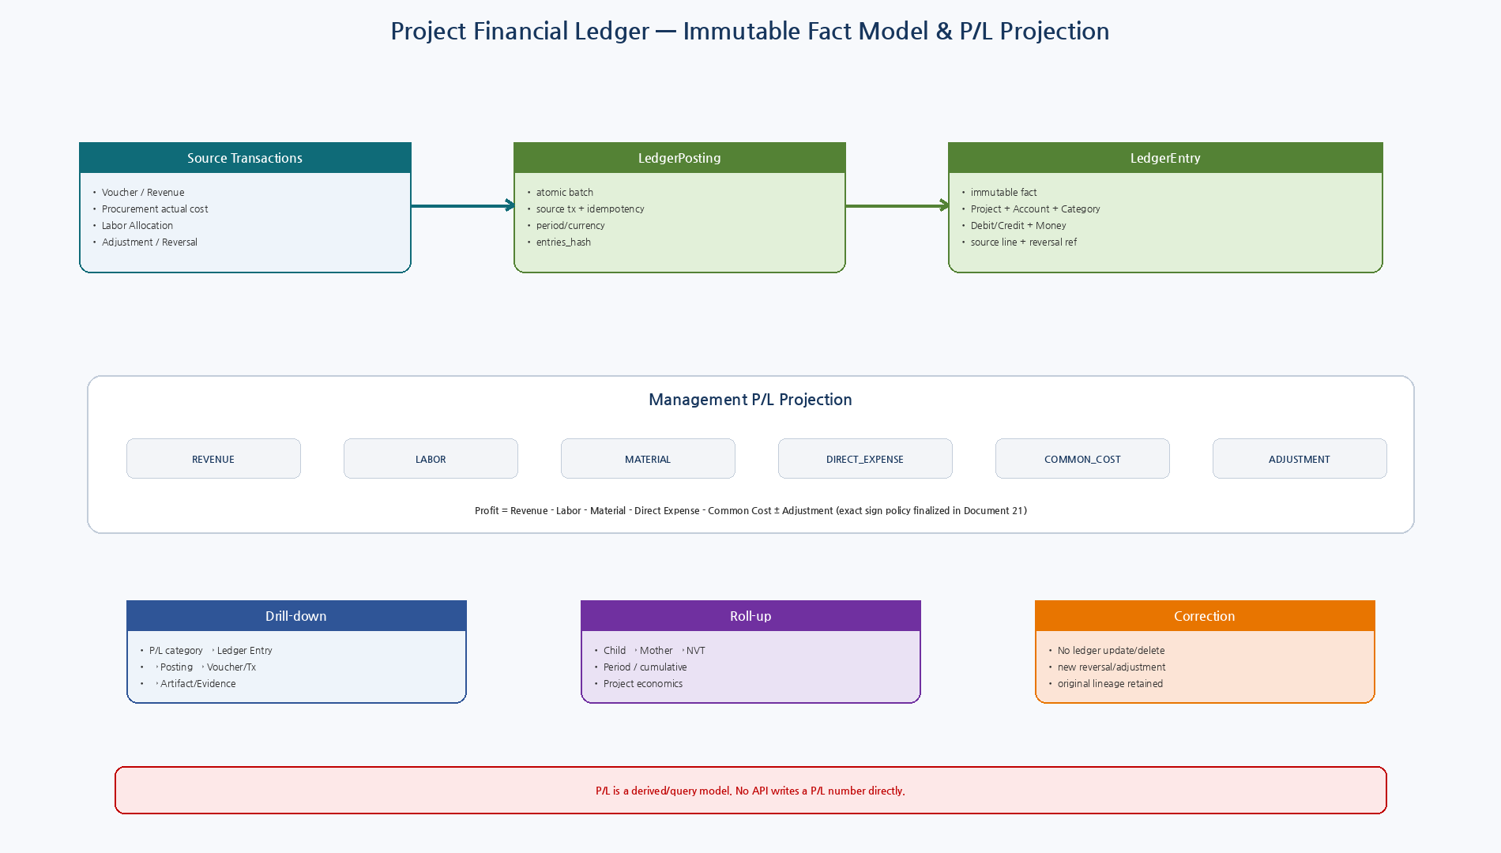
Figure 4. Source transaction→atomic posting→immutable ledger facts→P/L projection/roll-up/drill-down.

13.1 P/L Read Model Rules
Area | Rule
Fact source | Only accepted LedgerEntry rows.
Dimensions | Project hierarchy, FiscalPeriod, category, account, source transaction, optional management dimensions.
Categories | REVENUE / LABOR / MATERIAL / DIRECT_EXPENSE / COMMON_COST / ADJUSTMENT.
Roll-up | Child→Mother→NVT by stable hierarchy/ref; Common separate.
Time | Period and cumulative views.
Drill-down | P/L cell → LedgerEntry → LedgerPosting → Voucher/Source Tx → Artifact/Evidence.
Write model | No P/L command; P/L is query/read-model only.
Performance | May use materialized/pre-aggregated read model, but ledger remains authoritative.
14. PostgreSQL Physical Model
Table | Purpose
project | Typed NVT/Mother/Child/Common root; hierarchy/state/version/trace
account | Account master/effective status/management category
fiscal_period | Posting window and close governance
voucher | Voucher aggregate root, approval/project/trace/idempotency
voucher_line | Owned accounting lines; restricted delete after aggregate state change
ledger_posting | Atomic posting batch/source/idempotency/entries hash
ledger_entry | Immutable financial facts and reversal linkage
command_idempotency | Capability/key/payload hash/commit/result journal
event_outbox | Transactional cross-service events
domain_audit_event | State/governance/financial audit trail
Enterprise OS 내부 Project/Account/Voucher/Ledger에는 local FK를 사용한다. 반대로 WC/OA/WA/Artifact 등 다른 bounded context ID에는 cross-DB FK를 만들지 않고 stable ref로 저장한다.
15. Domain Events
Event | Meaning
PROJECT_CREATED | Project root created
PROJECT_STATE_CHANGED | Project lifecycle changed
ACCOUNT_STATE_CHANGED | Account lifecycle/governance changed
VOUCHER_DRAFT_CREATED | Voucher/lines created
VOUCHER_SUBMITTED | Material transaction data frozen
VOUCHER_APPROVAL_PENDING | Formal Approval linked
VOUCHER_APPROVED | Approval complete / postable subject to current checks
VOUCHER_REJECTED | Approval/business rejection
LEDGER_ENTRY_POSTED | Posting and immutable entries committed
LEDGER_ENTRY_REVERSED | Reversal posting committed
FISCAL_PERIOD_CLOSED | Posting policy changed to closed
FISCAL_PERIOD_REOPENED | Privileged reopen
16. Security / Business Write Boundaries
Boundary | Rule
Project / Account master | High-risk governance change, optimistic version, audit
Voucher Draft | R3 Certified Skill + Confirmation + idempotency
Formal Approval | Document 18 Human-only approval policy/proof
Ledger Posting | Internal domain capability, current PDP + proof + state/invariant recheck
Ledger correction | Reversal/Adjustment only; no update/delete
MCP / External tools | Business capability surface only; no raw table/ledger mutation
17. Test Strategy
Area | Required Tests
Project | Hierarchy shape, NVT direct-post rejection, Common non-default, closed/on-hold posting rejection.
Account | Effective date/status, category mapping, retired account historical query.
Voucher | Unique line numbers, currency, positive amount, debit=credit, post-submit immutability.
Approval | Exact payload/intent proof matches; invalid/expired proof blocked.
Posting | Concurrent same idempotency, closed period, stale voucher version, disabled account/project.
Ledger | No update/delete API, reversal links, original entries unchanged.
P/L | Category totals, Child→Mother→NVT roll-up, drill-down lineage.
Fault | Crash after commit/outbox lag/duplicate event/unknown commit reconciliation.
Migration | Legacy mapping/backfill invariant comparison, no uncontrolled dual-write.
E2E | Golden Slice A natural language→NSL→Voucher→Approval→Ledger→P/L.
18. Implementation Sequence
Wave | Area | Deliverable
I1 | Contracts / Domain Types | Pydantic models, 6 JSON Schemas, enums/value objects
I2 | Project / Account / Period | Domain state/invariants + PostgreSQL tables/repositories
I3 | Voucher Aggregate | Voucher/lines/idempotent draft/submit/freeze/approval linkage
I4 | Ledger Aggregate | Posting batch/entry generation/reversal/idempotency/outbox
I5 | Approval Integration | Doc18 gateway/proof binding and voucher state transitions
I6 | P/L Query Model | Project/category/period roll-up and drill-down
I7 | Legacy / Reconciliation | Adapter mapping, import/backfill/dual-run validation
I8 | Hardening | Concurrency/fault/security/E2E/metrics/Alembic release
19. Machine-readable Reference Package
Artifact | Validation / Purpose
6 JSON Schemas | Draft 2020-12 meta-schema PASS
6 Example objects | Exact schema validation PASS
models/state_machines/invariants/protocols | Python syntax PASS
project_service.py | Project create/state reference service
voucher_service.py | Voucher create/submit/approval linkage reference
ledger_service.py | Deterministic voucher→ledger posting reference
001_project_account_period.sql | Project/Account/FiscalPeriod tables
002_voucher.sql | Voucher/VoucherLine aggregate tables
003_ledger.sql | LedgerPosting/immutable LedgerEntry tables
004_voucher_to_ledger_transaction.sql | Atomic posting transaction pattern
005_common_idempotency_outbox.sql | EOS idempotency/outbox/audit structures
Design smoke | Balanced Money voucher, Float absent, no LedgerEntry update/delete API
SQL은 Reference Physical Design이다. 실제 Repository 확인 이후 SQLAlchemy model/Alembic revision으로 정렬하고 PostgreSQL에서 constraint/concurrency/fault test를 수행한다.
20. Detailed Design Quality Gate
Gate | Pass Criteria
EOS-DD-QG-01 | Project typed hierarchy invariants are explicit.
EOS-DD-QG-02 | Voucher owns lines and freezes material data after submit.
EOS-DD-QG-03 | Formal Approval reuses the Document 18 aggregate.
EOS-DD-QG-04 | LedgerPosting atomically owns immutable LedgerEntry facts.
EOS-DD-QG-05 | Posting revalidates Project/Account/Period/Approval/balance.
EOS-DD-QG-06 | Idempotency prevents duplicate Voucher/Posting effects.
EOS-DD-QG-07 | Reversal/Adjustment preserves original facts.
EOS-DD-QG-08 | P/L is a ledger-derived read model with drill-down.
EOS-DD-QG-09 | Cross-service ownership boundaries are preserved.
EOS-DD-QG-10 | Schemas/Python/SQL references are generated and validated.
21. Next Step
21 — NVT / Project Financial Ledger & P/L Design
다음 문서는 Project hierarchy/attribution, Ledger posting/reversal, P/L category sign rules, Child→Mother→NVT roll-up, period/cumulative query, materialized read model 및 Evidence drill-down을 집중 상세화한다. 이후 22에서 Voucher/Accounting/Procurement Transaction으로 확장한다.

