NeX NVT / Project Financial Ledger & P/L
Design v2.0
Attribution · Posting / Reversal · Sign Rules · Roll-up · Period / Cumulative · Evidence Drill-down
P/L Invariant
Revenue = Credit−Debit, Cost = Debit−Credit, Profit = Revenue−Costs+AdjustmentProfitEffect. P/L read models are rebuildable; immutable Ledger facts remain the only source of Project financial truth.
Reference package: 5 JSON Schemas + Python + 6 PostgreSQL SQL files | 2026.09.01

Executive Summary
본 문서는 Enterprise OS의 Project Economics를 집중 상세화한다. Project Attribution은 deterministic context를 우선 사용하고 애매할 때만 canonical candidate + Human Confirmation으로 확정한다. Project Financial Ledger는 Voucher 전체 복식부기 GL의 복사본이 아니라 P/L-relevant economic facts를 기록하는 management subledger다. Full Reversal은 반대 Debit/Credit Side의 새로운 Posting/Entry를 만들며 원본은 수정하지 않는다. P/L은 명시적 sign rule로 Period DIRECT/ROLLUP bucket을 만들고 hierarchy closure로 Child→Mother→NVT roll-up한다.
Critical Accounting Clarification
Voucher balance와 Project P/L Ledger는 목적이 다르다. Expense Voucher의 Cash/Payable credit line은 회계 균형에는 필요하지만 economic category NONE이면 Project Financial Ledger에는 투영하지 않는다. 이 구분이 P/L 이중계상을 막는다.
1. Detailed Design Principles
ID | Decision | Implementation Meaning
PL-DD-01 | Attribution before posting | Every atomic economic fact must have a resolved ProjectRef before ledger posting.
PL-DD-02 | Common is explicit | Missing context never silently becomes Common Work.
PL-DD-03 | Management subledger, not GL clone | Project Financial Ledger stores P/L-relevant economic facts, not every balance-sheet offset line.
PL-DD-04 | Append-only correction | Full reversal and partial adjustment are new postings; original facts remain immutable.
PL-DD-05 | Deterministic sign rules | Revenue and cost buckets use explicit debit/credit polarity; Adjustment uses signed profit effect.
PL-DD-06 | Hierarchy roll-up without duplication | Closure-table aggregation maps each descendant entry to each ancestor exactly once.
PL-DD-07 | Period buckets are rebuildable | P/L read models can be refreshed/materialized but Ledger remains financial SoR.
PL-DD-08 | Cumulative is derived | Cumulative P/L is a sum of period buckets, not a separate authoritative value.
PL-DD-09 | Lineage is mandatory | P/L numbers drill down to Ledger→Source Transaction→Work/Agent/Skill/Approval/Evidence.
PL-DD-10 | No silent FX | Cross-currency roll-up requires explicit versioned conversion policy.

2. Project Attribution First
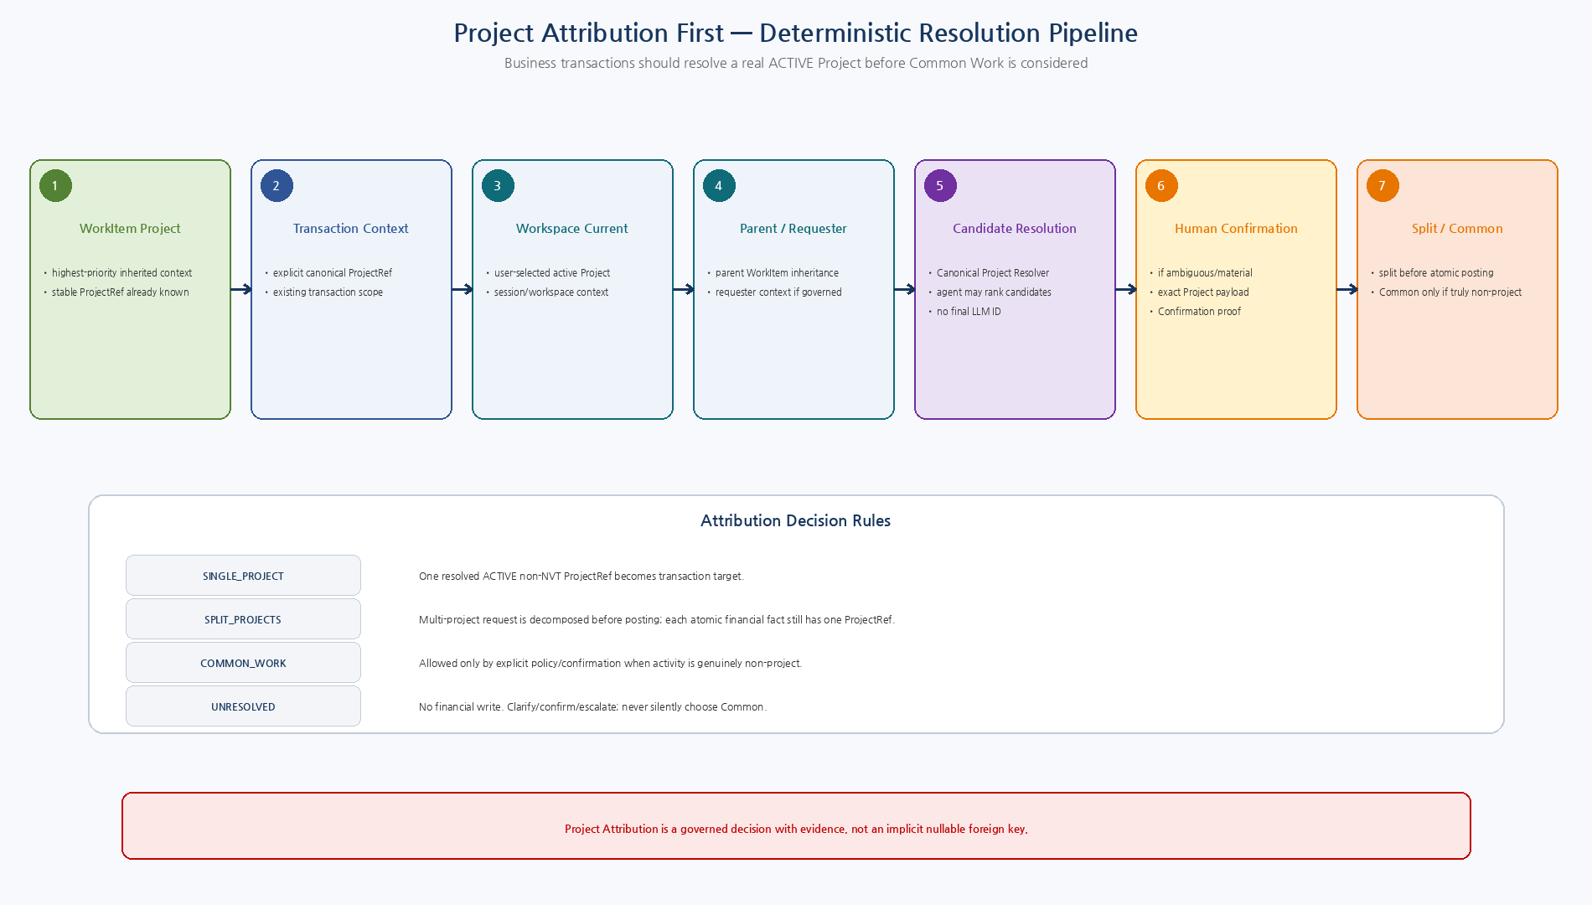
Figure 1. WorkItem/Transaction/Workspace/Parent→Candidate/Confirmation→Split/Common으로 이어지는 governed Project Attribution.

2.1 Resolution Priority
Order | Source | Rule
1 | WorkItem Project | Deterministic inheritance if valid ACTIVE direct Project
2 | Business Transaction Project | Explicit transaction context
3 | Workspace Current Project | User-selected current Project
4 | Parent / Requester Context | Governed inherited context
5 | Canonical Candidate Resolution | Resolver returns stable Project candidates; LLM score is advisory only
6 | Human Confirmation | Required for ambiguity/material business choice
7 | Split Projects | Decompose multi-project request before atomic posting
8 | Common Work | Only explicit truly non-project decision
2.2 Attribution Invariants
ID | Invariant
ATTR-INV-01 | Selected direct Project must be ACTIVE and must not be NVT.
ATTR-INV-02 | A Project text/LLM guess is never a posting key; only canonical stable ProjectRef is accepted.
ATTR-INV-03 | Ambiguous candidates require Confirmation/explicit resolution before financial write.
ATTR-INV-04 | Common Work requires explicit decision source/policy; it is not null fallback.
ATTR-INV-05 | One atomic LedgerEntry always has exactly one direct ProjectRef.
ATTR-INV-06 | Multi-project business requests are split before posting or supplied by an explicit allocation source such as LaborAllocation.
ATTR-INV-07 | Attribution decision keeps source/candidate/confirmation/evidence trace.
ATTR-INV-08 | Changing Project after protected transaction approval requires a new Human Gate.
2.3 Multi-project Atomicity
각 LedgerEntry는 하나의 direct ProjectRef만 가진다. 여러 Project가 섞인 요청은 Posting 이전에 분리한다. LaborAllocation은 여러 Project로 분할된 upstream source의 대표 사례다. v2 Voucher는 single-project baseline이므로 multi-project expense는 project별 Voucher/Posting으로 분해한다.
3. Project Financial Ledger vs General Ledger
Layer | Rule
Voucher / Accounting layer | Maintains balanced accounting transaction including balance-sheet offset lines.
Project Financial Ledger | Receives only economic/P&L-relevant lines/categories for project profitability.
Excluded offset example | Expense debit is DIRECT_EXPENSE; credit Cash/Payable with economic category NONE is not projected to PFL.
Statutory/General Ledger | If required, integrate as separate accounting/legacy domain; do not force Project P/L ledger to mirror it.
Reason | Prevents double counting while preserving Voucher debit/credit accounting integrity.

4. Posting / Reversal / Adjustment
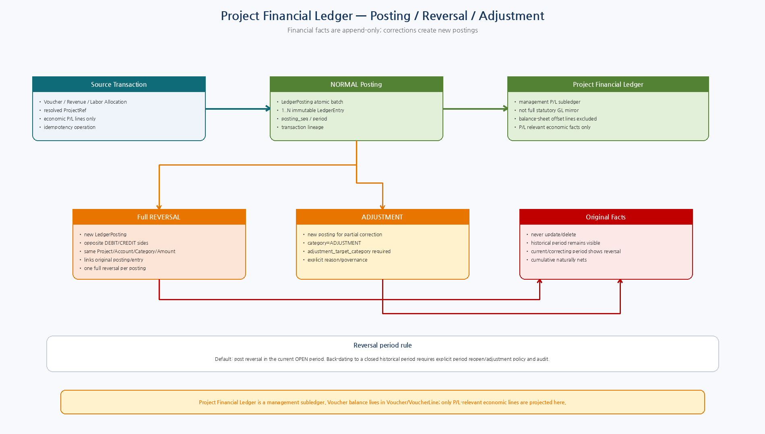
Figure 2. Management subledger posting과 immutable full reversal / explicit adjustment correction model.

4.1 Posting Rules
ID | Rule
POST-01 | Posting batch is idempotent and atomic.
POST-02 | All projected entries use same Posting/Period/Currency and source operation context.
POST-03 | Only P/L-relevant economic lines are mapped to Project Financial Ledger.
POST-04 | Project/Account/FiscalPeriod/current authorization are revalidated at posting boundary.
POST-05 | Entries are immutable; posting has monotonic posting_seq for projection ordering.
POST-06 | Transactional outbox follows committed posting.
POST-07 | UNKNOWN_COMMIT_STATE does not create another posting; reconcile by idempotency/operation ref.
4.2 Full Reversal Rules
ID | Rule
REV-01 | Full reversal creates a new posting with opposite side for every original entry.
REV-02 | Reversal preserves original Project, Account, Category, Amount and source lineage.
REV-03 | Reversal posting/entries link reversal_of_posting_id / reversal_of_entry_id.
REV-04 | Only one full reversal is allowed per original posting by unique constraint.
REV-05 | Default reversal posts in current OPEN period; historical back-date requires privileged period policy.
REV-06 | Partial correction/reclassification uses ADJUSTMENT posting, not partial mutation/full reversal abuse.
REV-07 | Original period remains historically true; cumulative later period naturally nets reversal.
4.3 Adjustment Rules
ID | Rule
ADJ-01 | ADJUSTMENT entry must declare adjustment_target_category ∈ REVENUE/LABOR/MATERIAL/DIRECT_EXPENSE/COMMON_COST.
ADJ-02 | ADJUSTMENT Credit produces positive profit effect; Debit produces negative profit effect.
ADJ-03 | Target category is audit/reclassification semantics; the Adjustment line remains separately visible.
ADJ-04 | Normal full reversal should keep the original category and opposite side, not change category to ADJUSTMENT.

5. P/L Sign Rules & Hierarchy Roll-up
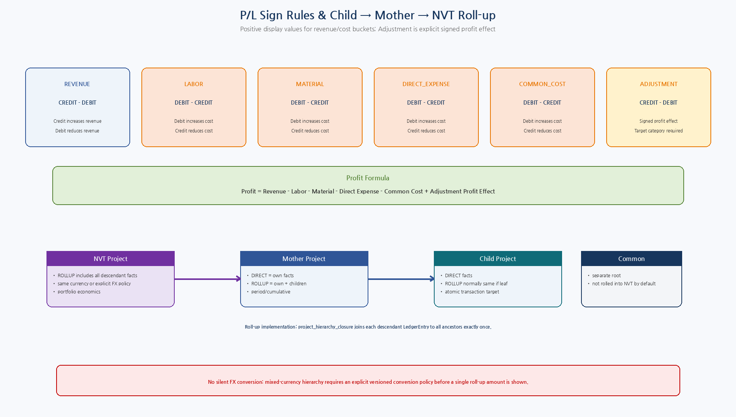
Figure 3. Category별 Debit/Credit polarity, Profit formula와 closure-table 기반 Child→Mother→NVT roll-up.

5.1 P/L Category Sign Rules
Category | Formula | Interpretation
REVENUE | Credit − Debit | Positive displayed revenue. Debit is contra-revenue/reversal.
LABOR | Debit − Credit | Positive displayed labor cost. Credit reduces/reverses cost.
MATERIAL | Debit − Credit | Positive displayed material cost.
DIRECT_EXPENSE | Debit − Credit | Positive displayed direct expense.
COMMON_COST | Debit − Credit | Positive displayed common cost.
ADJUSTMENT | Credit − Debit as Profit Effect | Positive improves profit; negative reduces profit. `adjustment_target_category` required.
Profit Formula
Profit = Revenue - Labor - Material - Direct Expense - Common Cost + Adjustment Profit Effect
LedgerEntry amount는 항상 positive Decimal/Money + Side로 저장하고, 경제적 부호는 계산시 deterministic rule로 도출한다. 이 방식은 임의 signed amount와 Float 사용을 차단한다.
6. Child → Mother → NVT Roll-up
Scope | Rule
DIRECT | Only LedgerEntries whose direct project_id equals requested Project.
ROLLUP Child | Child plus descendants; for leaf Child normally equals DIRECT.
ROLLUP Mother | Mother direct facts + all descendant Child facts.
ROLLUP NVT | NVT direct facts if any governed non-transaction facts plus Mother/Child descendants; normal financial transactions do not target NVT directly.
Common | Separate root; excluded from NVT roll-up unless an explicit future policy establishes allocation.
No double count | Closure table has one ancestor/descendant pair; aggregation groups by ancestor once.
Hierarchy change | Historical LedgerEntry keeps direct ProjectRef; current roll-up hierarchy semantics must be versioned/auditable if reorganizations can alter reporting.
7. Period / Cumulative Read Model
Rule | Design
Period view | One project + one fiscal period + scope + currency bucket.
Cumulative view | Sum of ordered period buckets between from/to periods.
Projection source | Immutable LedgerEntry facts.
Projection watermark | Monotonic LedgerPosting.posting_seq.
Incremental refresh | Find postings after watermark, collect affected direct projects/ancestors/periods, recompute affected buckets.
Checkpoint | Advance projection checkpoint only after all bucket updates commit.
Rebuild | Full rebuild is always possible; read model never owns financial truth.
Freshness | API returns source_ledger_version/refreshed_at so UI can show as-of state.
8. Currency / FX Boundary
Area | Rule
Hierarchy baseline | Prefer same Project currency through NVT/Mother/Child hierarchy.
Mixed currency | Do not sum unlike currencies into one amount.
FX conversion | Requires explicit exchange-rate source, rate date, policy/version, rounding and audit evidence.
Read model | Store original-currency buckets; converted management view is a separate reproducible projection.

9. P/L Read Model & Evidence Drill-down
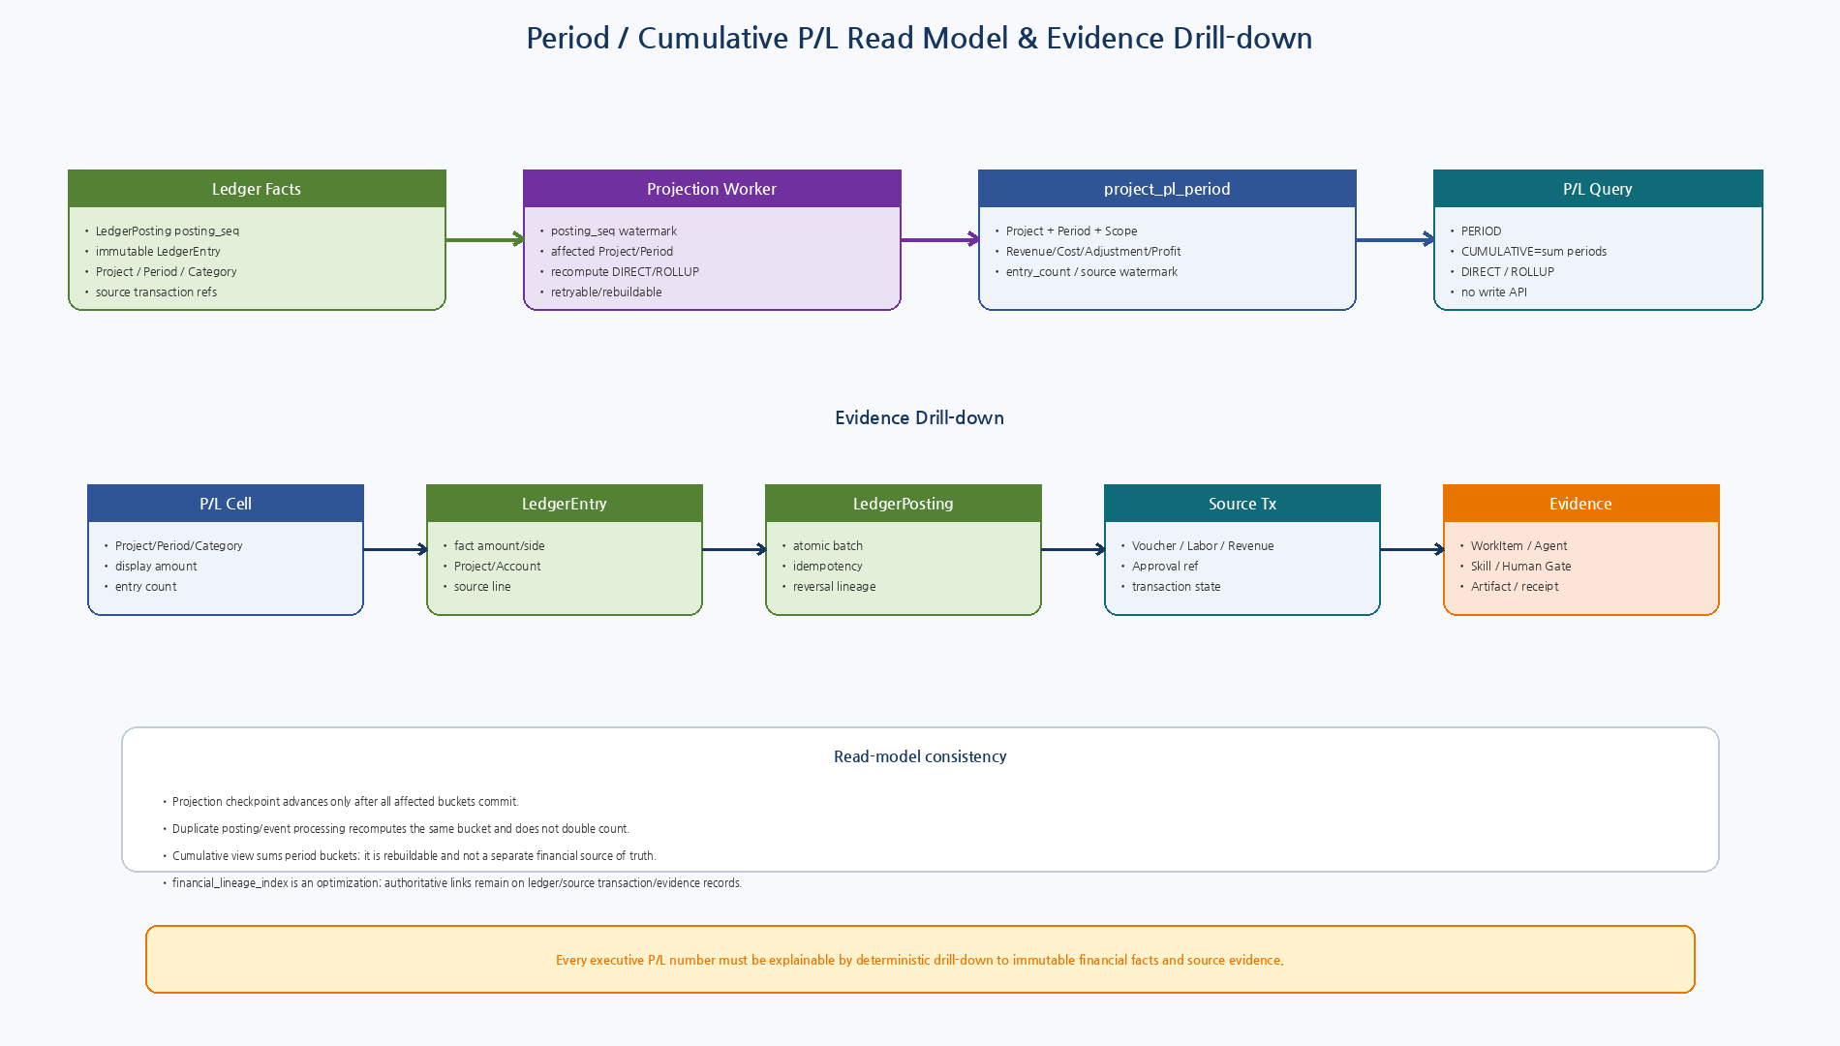
Figure 4. posting_seq watermark 기반 Period/ROLLUP projection과 P/L→Ledger→Transaction→Execution/Evidence drill-down.

9.1 Evidence Drill-down Contract
Level | Object | Meaning
1 | P/L Cell | Project + period/range + scope + category + displayed amount
2 | P/L Bucket | project_pl_period / cumulative components + entry_count + watermark
3 | LedgerEntry | Immutable economic fact: project/account/category/side/amount/period
4 | LedgerPosting | Atomic posting, idempotency, reversal/adjustment lineage
5 | Source Transaction | Voucher/Revenue/LaborAllocation/Procurement actual cost
6 | Execution Trace | WorkItem, AgentExecution, PlanStep, Certified Skill
7 | Governance | Confirmation/Formal Approval proof and policy evidence
8 | Evidence | Artifact/receipt/contracts/source documents
10. Canonical API Surface
10.1 Queries
Capability | Meaning
PL.GET_PROJECT_PL | Period DIRECT/ROLLUP P/L
PL.GET_PROJECT_PL_CUMULATIVE | Cumulative period-range P/L
PL.GET_CATEGORY_DRILLDOWN | P/L category → LedgerEntry page
LEDGER.GET_ENTRY | Immutable entry detail
LEDGER.GET_POSTING | Posting/reversal/adjustment detail
LEDGER.LIST_ENTRIES | Project/period/category/source query
PROJECT.GET_HIERARCHY | NVT/Mother/Child tree/path
PROJECT.GET_ATTRIBUTION | Attribution decision/evidence
FINANCIAL.GET_LINEAGE | Entry → source/work/agent/skill/approval/evidence
10.2 Commands
Capability | Meaning | Risk
PROJECT.RESOLVE_ATTRIBUTION | Resolve/persist Project attribution decision | R2/R3
LEDGER.REVERSE_POSTING | Full reversal posting | R4/R5
LEDGER.CREATE_ADJUSTMENT | Explicit management adjustment posting | R4/R5
PL.REBUILD_PROJECTION | Admin/internal rebuild of read model | ADMIN_ONLY
11. PostgreSQL Structures
Structure | Purpose
project_hierarchy_closure | Ancestor/descendant/depth for deterministic roll-up
project_attribution_decision | Source/candidates/selected projects/confirmation/evidence
ledger_posting posting_seq | Monotonic financial fact watermark
ledger_posting posting_kind | NORMAL/REVERSAL/ADJUSTMENT
ledger_entry adjustment_target_category | Required only for ADJUSTMENT semantics
project_pl_period | DIRECT/ROLLUP Project+Period+Currency P/L bucket
financial_projection_checkpoint | Last fully applied posting_seq per projection
financial_lineage_index | Rebuildable drill-down optimization
Projection table과 lineage index는 rebuild 가능한 Read Model이다. authoritative financial facts는 LedgerPosting/LedgerEntry에 남고, Project hierarchy와 source transaction/evidence refs가 원본 lineage를 유지한다.
12. Python Reference Components
Component | Responsibility
ProjectAttributionService | Deterministic context inheritance → candidate resolution → confirmation
sign_rules.py | Exact Decimal Revenue/Cost/Adjustment/Profit rules
LedgerReversalService | Opposite-side full reversal without original mutation
ProjectPLProjectionService | DIRECT/ROLLUP period buckets + cumulative sum
FinancialLineageService | LedgerEntry → source/work/agent/skill/approval/evidence
13. Observability
Metric | Purpose
project_attribution_total | decision_source/status/project_type
project_attribution_unresolved_total | reason/domain
ledger_posting_total | posting_kind/category/project
ledger_reversal_total | reason/project/period
ledger_adjustment_total | target_category/reason
pl_projection_lag_postings | current posting_seq - checkpoint
pl_projection_refresh_seconds | bucket/project count
pl_direct_rollup_gap | diagnostic consistency
pl_drilldown_query_seconds | category/project/period
financial_lineage_missing_total | source type
mixed_currency_rollup_denied_total | project/currencies
14. Test Strategy
Area | Required Tests
Attribution | Priority inheritance, ambiguous candidate, no-context unresolved, Common explicit, split allocation validation.
Subledger mapping | Voucher balanced but balance-sheet offset category NONE is excluded from PFL; no double count.
Sign rules | Revenue credit/debit, each cost debit/credit, adjustment target required, exact Decimal.
Reversal | Opposite sides net original cumulatively; original facts unchanged; duplicate reversal blocked.
Adjustment | Partial correction has explicit target category and signed profit effect.
Roll-up | Child→Mother→NVT totals equal descendant union exactly once; Common excluded.
Period/Cumulative | Period buckets sum to cumulative; reversal in later period preserves historical period and nets cumulative.
Projection | Duplicate events/restarts recompute affected buckets; watermark advances only after commit.
Currency | Mixed currency roll-up denied without FX policy.
Lineage | P/L cell drills to entry/posting/source/work/agent/skill/approval/artifact.
15. Implementation Sequence
Wave | Area | Deliverable
I1 | Attribution | Decision schema/service/policy + Project hierarchy closure
I2 | Ledger correction | Posting kind, reversal service, adjustment semantics
I3 | Sign rules | Deterministic Python/SQL P/L polarity and Decimal tests
I4 | Period P/L projection | project_pl_period DIRECT buckets + posting_seq watermark
I5 | Hierarchy roll-up | Closure-based Mother/NVT ROLLUP buckets
I6 | Cumulative query | Period-range aggregation/freshness/as-of contract
I7 | Evidence lineage | financial_lineage_index and drill-down APIs
I8 | Hardening | currency policy, projection fault/rebuild, E2E Golden A, load/audit
16. Machine-readable Reference Package
Artifact | Validation / Purpose
5 JSON Schemas | Draft 2020-12 meta-schema PASS
5 Example objects | Exact schema validation PASS
Python modules | Syntax PASS
sign_rules.py smoke | Revenue=900, DirectExpense=280, Adjustment=10, Profit=630 PASS
Reversal smoke | Opposite-side, original immutable, one full reversal unique PASS
001_project_hierarchy_attribution.sql | Closure + attribution decisions
002_ledger_reversal_adjustment.sql | Posting kind / reversal / adjustment constraints
003_pl_period_projection.sql | Deterministic direct period P/L formula
004_rollup_cumulative_queries.sql | Hierarchy roll-up / cumulative query
005_financial_lineage.sql | Drill-down read model
006_projection_watermark.sql | Monotonic posting_seq and projection checkpoint
17. Detailed Design Quality Gate
Gate | Pass Criteria
PL-QG-01 | Project attribution never silently falls back to Common.
PL-QG-02 | Project Financial Ledger is a P/L management subledger, not a full GL mirror.
PL-QG-03 | Full reversal creates opposite-side immutable entries.
PL-QG-04 | Adjustment requires explicit target-category semantics.
PL-QG-05 | Revenue/cost/adjustment sign rules are deterministic and Decimal-based.
PL-QG-06 | Closure-table roll-up prevents descendant double counting.
PL-QG-07 | Period/cumulative views are rebuildable with posting-seq watermark.
PL-QG-08 | No silent cross-currency roll-up is allowed.
PL-QG-09 | Every P/L number supports end-to-end evidence drill-down.
PL-QG-10 | Schemas/Python/SQL and sign/reversal smoke tests pass.
18. Next Step
22 — Voucher / Accounting / Procurement Transaction Design
다음 문서는 Voucher debit/credit line generation, Account mapping, Expense/Revenue/Purchase transaction types, Requisition→PO→Actual Cost 인식시점, Invoice/Expense/Voucher 연결, Approval threshold, Procurement WorkResult와 Ledger Cost posting을 transaction/state/API 수준으로 상세화한다.

