NeX Voucher / Accounting / Procurement
Transaction Design v2.0
Account Mapping · Voucher Lines · Requisition / PO / Invoice · Match · Commitment · Actual Cost
Recognition Invariant
PO ISSUED = Commitment, Invoice MATCHED = Eligible, Voucher POSTED = Actual Cost Recognized. Procurement WorkResult reports commitment/delivery, not premature actual cost.
Reference package: 8 JSON Schemas + Python + 6 PostgreSQL SQL files | 2026.09.01

Executive Summary
본 문서는 Voucher debit/credit line generation, Account Mapping, Expense/Revenue/Purchase accounting, Purchase Requisition→Sourcing→PO→Receipt→Supplier Invoice→Match→Purchase Voucher→Project Financial Ledger를 구현 수준으로 연결한다. 핵심 회계 경계는 PO commitment와 Project actual cost의 분리다. Supplier Invoice가 deterministic Match와 필요한 Approval을 통과해 Purchase Voucher가 생성되고, 그 Voucher가 Ledger에 POSTED될 때만 actual Project cost가 인식된다.
Critical Accounting Boundary
Voucher는 전체 복식부기 균형을 유지하지만 Project Financial Ledger는 economic_category != NONE인 P/L 경제효과 Line만 받는다. 따라서 Recoverable VAT, AP, Cash, AR 같은 Balance Sheet Offset이 Project P/L을 중복시키지 않는다.
1. Detailed Design Principles
ID | Decision | Implementation Meaning
TX-DD-01 | Accounting rule first | Stable Account Mapping rules generate balanced Voucher lines; LLM suggestions are never authoritative Account IDs.
TX-DD-02 | Voucher and PFL have different purposes | Voucher preserves accounting balance; Project Financial Ledger receives only P/L economic lines.
TX-DD-03 | Commitment ≠ Actual | Requisition/PO are commitment/sourcing facts; actual Project cost starts only with Ledger posting.
TX-DD-04 | Match before cost | PO/receipt/invoice facts must pass deterministic match/exception governance before purchase Voucher generation.
TX-DD-05 | Approval is operation-bound | PO commitment approval and later actual-cost posting approval are separate protected operations unless policy explicitly says no second approval.
TX-DD-06 | Single-project transaction baseline | Requisition/PO/Invoice/Voucher each carry one Project in v2; multi-project needs split before transaction creation.
TX-DD-07 | Tax is explicit | Recoverable tax is normally P/L category NONE; non-recoverable tax may map to cost by versioned rule.
TX-DD-08 | Settlement is not recognition | Supplier Payment clears AP/Cash but does not create a second Project P/L cost.
TX-DD-09 | Work result truthfulness | Procurement WorkResult returns PO/commitment/delivery, never invented or premature actual cost.
TX-DD-10 | All corrections preserve history | Invoice match override, Voucher reversal and procurement cancellation are explicit governed records.

2. Account Mapping & Voucher Line Generation
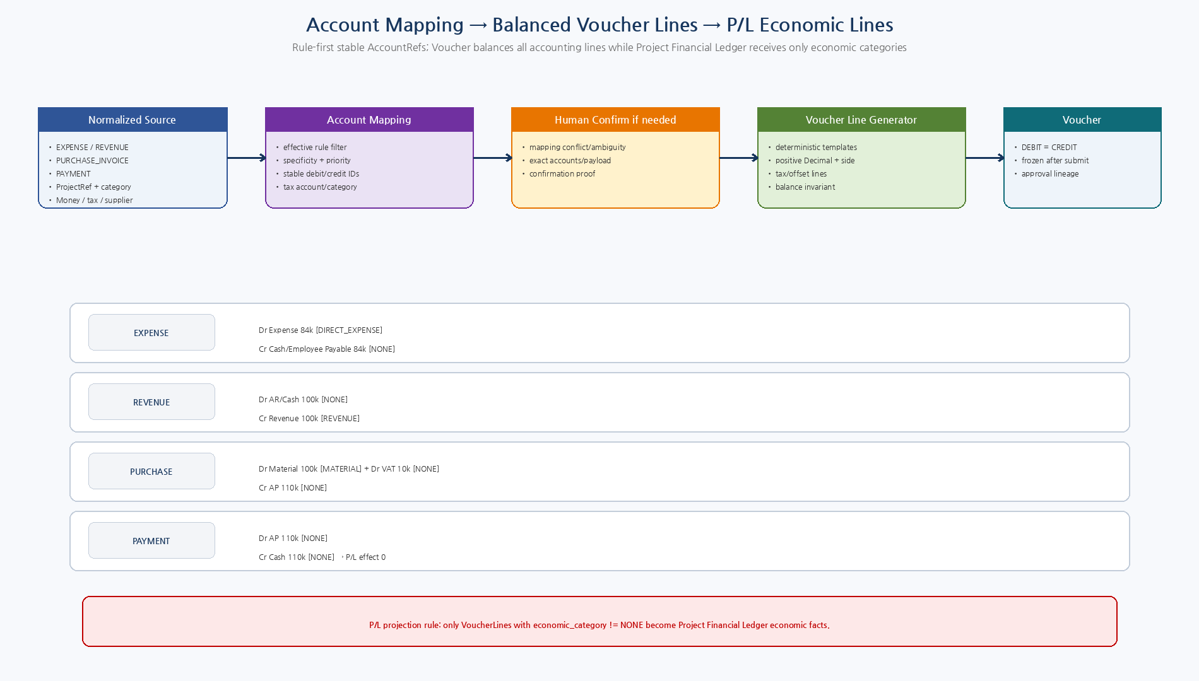
Figure 1. Rule-first Account Mapping으로 stable AccountRef를 확정하고 balanced Voucher를 만든 뒤 P/L economic line만 Project Financial Ledger로 투영.

2.1 Voucher Debit / Credit Templates
Transaction | Debit | Credit | Project P/L Effect
EXPENSE | Debit Expense/Cost Account | Credit Cash / Employee Payable / AP | Debit economic category DIRECT_EXPENSE/COMMON_COST; offset NONE
REVENUE | Debit AR / Cash | Credit Revenue | Revenue credit category REVENUE; receivable/cash NONE
PURCHASE_INVOICE | Debit Material/Expense (+ recoverable tax) | Credit AP | Base line MATERIAL/DIRECT_EXPENSE/COMMON_COST; recoverable VAT + AP NONE
PAYMENT | Debit AP | Credit Cash | Both NONE; P/L effect zero
REVERSAL | Opposite side of original lines | Opposite side of original lines | Original categories retained; new Voucher/Posting
ADJUSTMENT | Policy-specific balanced lines | Policy-specific balanced lines | ADJUSTMENT semantics explicit; no arbitrary direct P/L number write
3. Account Mapping Resolution
Step | Rule | Behavior
1 | Exact active AccountMappingRule | transaction_type + source_category + item class + project/org/supplier/tax conditions
2 | Deterministic specificity | Higher specificity_score, then lower business priority number, then rule_id
3 | Conflict detection | Equal precedence with different mappings → CONFLICT; never choose arbitrarily
4 | Account validation | Mapped accounts ACTIVE/effective and allowed for transaction type
5 | Confirmation | Rule can require Human Confirmation for sensitive/ambiguous mapping
6 | Unresolved | No rule → no Voucher write; accounting/domain owner must add/confirm mapping
AccountMappingDecision은 Source Snapshot Hash, Rule ID/Version, exact Debit/Credit/Tax AccountRef와 Economic Category를 기록한다. 동일 precedence의 규칙이 서로 다른 Mapping을 만들면 CONFLICT로 차단한다.
4. Tax Treatment
Case | Rule
Recoverable VAT | Debit VAT receivable account, economic category NONE; excluded from Project P/L actual cost.
Output VAT on revenue | Credit VAT payable, economic category NONE.
Non-recoverable tax | Mapping rule may classify as DIRECT_EXPENSE/COMMON_COST/MATERIAL according to accounting policy.
Tax total | Gross = Net + Tax invariant; account/tax mapping is versioned and auditable.
No silent tax guessing | Unknown tax code/account blocks line generation or requires domain correction.

5. Procurement Lifecycle & Cost Recognition
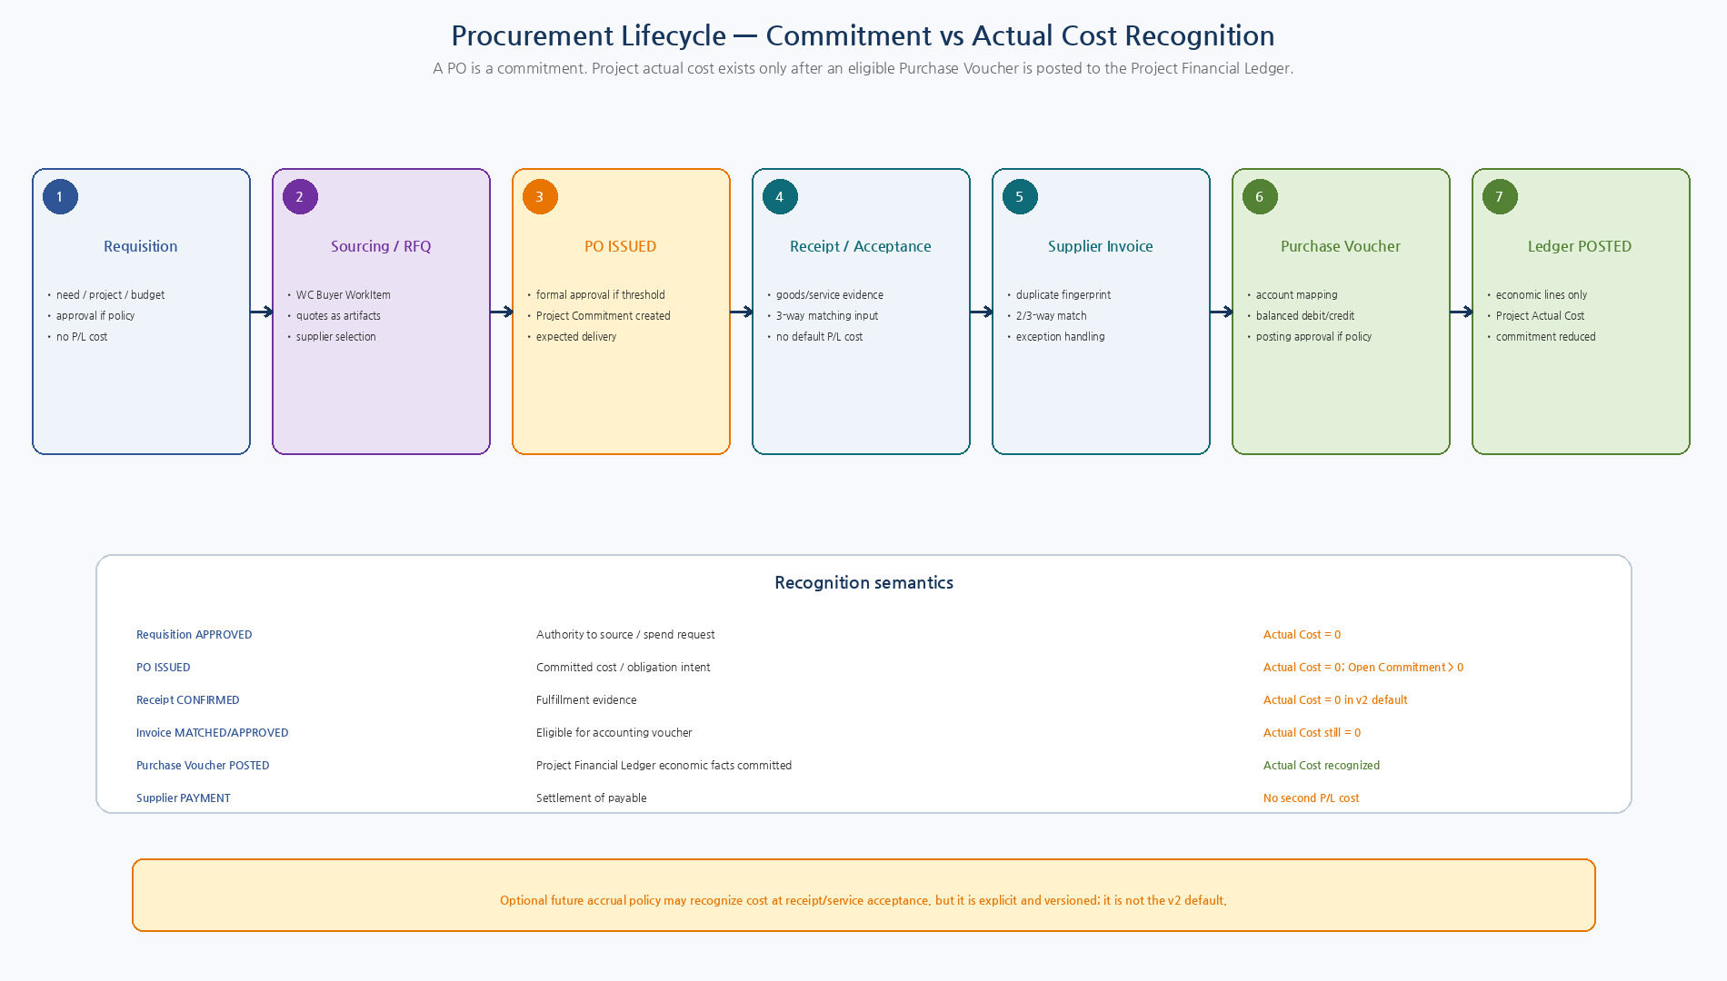
Figure 2. Requisition/RFQ/PO Commitment와 Receipt/Invoice/Match/Voucher/Ledger Actual Cost의 단계 분리.

6. Purchase Requisition State
From | To | Meaning
DRAFT | SUBMITTED | Requester finalizes need/project/amount
SUBMITTED | APPROVAL_PENDING | Threshold policy requires Formal Approval
SUBMITTED | APPROVED | No approval required
APPROVAL_PENDING | APPROVED | Approval passed
APPROVAL_PENDING | REJECTED | Approval rejected
APPROVED | SOURCING | WC Procurement Child Work starts
SOURCING | CONVERTED_TO_PO | Issued PO created from sourcing
CONVERTED_TO_PO | CLOSED | Procurement request fulfilled/closed
v2에서 RFQ/Quote는 NeX-WC Procurement WorkItem과 Artifact/Evidence 중심으로 관리한다. Enterprise OS는 Requisition과 PO를 authoritative transaction으로 소유하며 PO에는 selected_quote_refs를 보존한다.
7. Purchase Order State
From | To | Meaning
DRAFT | APPROVAL_PENDING | Issue commitment requires approval
DRAFT | APPROVED | Policy requires no formal approval
APPROVAL_PENDING | APPROVED | Approval passed
APPROVED | ISSUED | PO sent/committed
ISSUED | CLOSED | All lines complete/cancelled/invoiced per policy
DRAFT/APPROVED | CANCELLED | Cancel before issue
Commitment Boundary
PO state가 ISSUED가 될 때 ProjectCommitment를 생성/갱신한다. APPROVED지만 아직 발행되지 않은 PO는 v2 baseline에서 Supplier Commitment로 보지 않는다.
8. Receipt / Service Acceptance
- GOODS receipt는 PO Line별 confirmed received quantity를 기록한다.
- SERVICE_ACCEPTANCE는 PO Line별 accepted quantity/amount를 기록한다.
- Receipt는 3-way Matching 및 제조/납기 Evidence다.
- v2 Default에서는 Receipt만으로 Actual P/L Cost를 인식하지 않는다.
- 향후 receipt accrual이 필요하면 별도의 versioned RecognitionPolicy + Reversal mechanism으로 추가한다.
9. Supplier Invoice State
From | To | Meaning
RECEIVED | VALIDATED | Schema/supplier/project/amount/duplicate validation
VALIDATED | MATCH_PENDING | Match workflow starts
MATCH_PENDING | MATCHED | 2/3-way/non-PO checks passed
MATCH_PENDING | EXCEPTION | One or more checks failed
EXCEPTION | APPROVAL_PENDING | Override allowed only via Formal Approval
APPROVAL_PENDING | APPROVED | Exception override approved
MATCHED/APPROVED | VOUCHER_CREATED | Purchase Voucher generated
VOUCHER_CREATED | POSTED | Voucher Ledger posting committed
EXCEPTION/APPROVAL_PENDING | REJECTED | Rejected/disputed
Invoice fingerprint는 Supplier/Invoice identity/amount/date 등의 canonical 요소에서 생성하며 command idempotency와 별개다. 같은 청구서를 다른 API request로 다시 수신하는 Business Duplicate를 차단한다.

10. Invoice Match & Approval Threshold
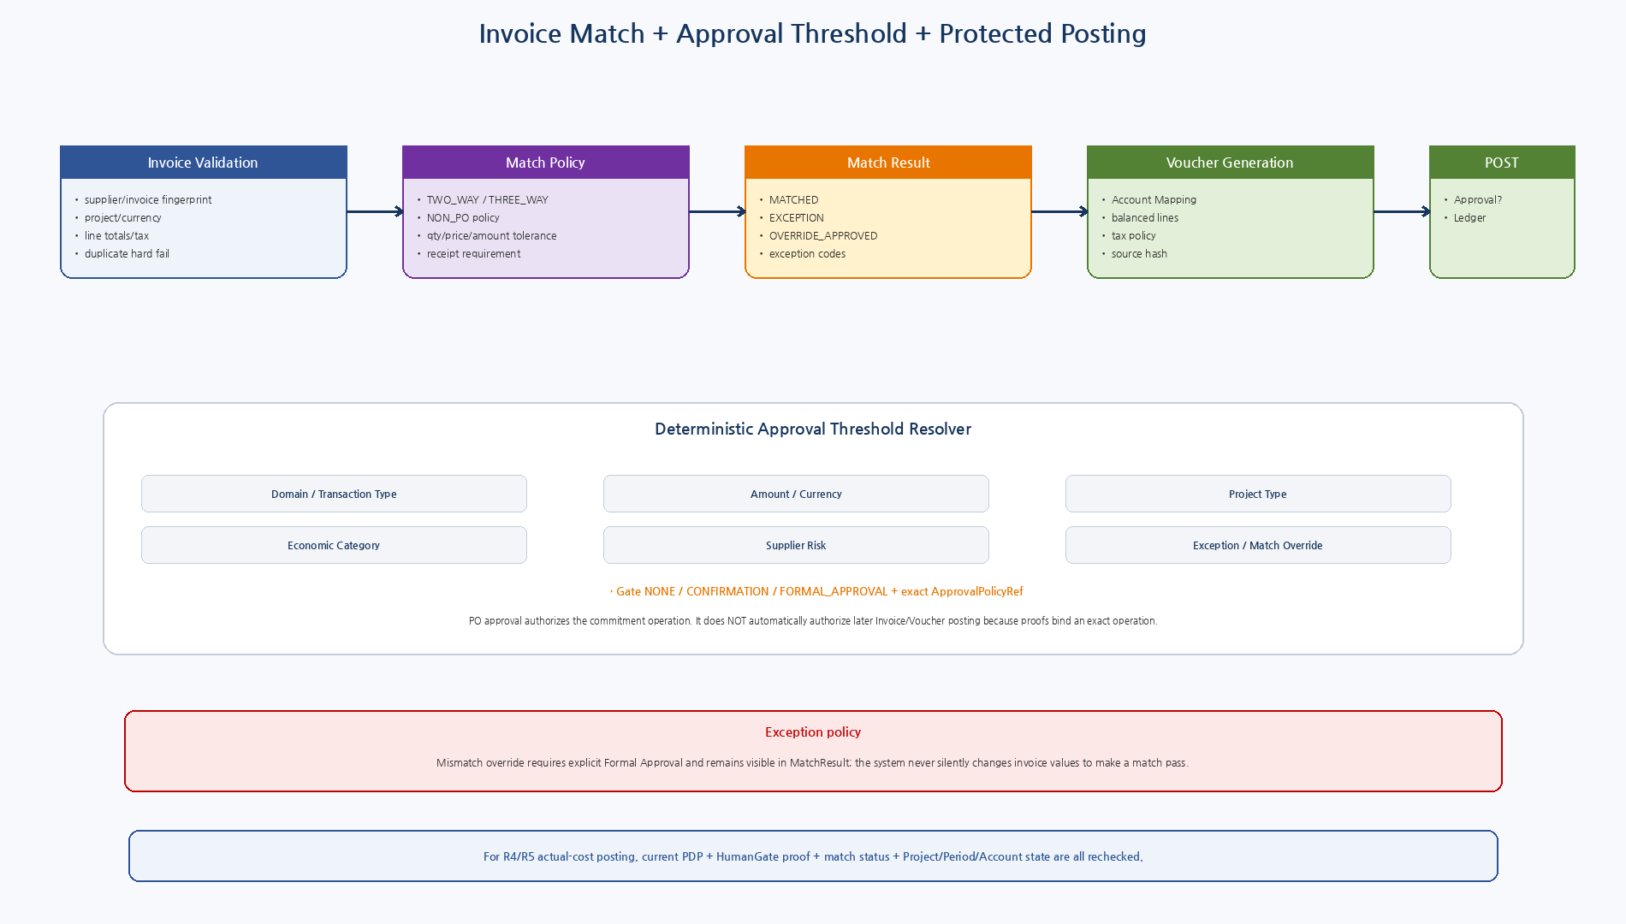
Figure 3. 2/3-way Matching, Exception Governance, deterministic approval threshold, exact operation-bound Human Gate.

10.1 Match Checks
Check | Rule
DUPLICATE | Supplier invoice fingerprint is unique; duplicate is hard fail.
SUPPLIER | Invoice supplier must equal PO supplier for PO-based match.
PROJECT | Invoice/PO/Receipt ProjectRef must match v2 single-project baseline.
CURRENCY | Exact currency match unless explicit FX procurement policy exists.
QUANTITY | Invoice quantity within ordered/received tolerance.
UNIT_PRICE | Invoice unit price within policy tolerance vs PO.
NET_AMOUNT | Line/aggregate net amount within tolerance.
TAX | Tax code/rate/amount within policy; recoverability mapping validated.
RECEIPT | THREE_WAY requires confirmed goods/service receipt.
Reference Python matcher는 일부 aggregate check를 단순화해 보여준다. Production 구현은 PO/Receipt/Invoice Line별 Quantity, Unit Price, Net/Tax/Total Tolerance를 모두 검증해야 하며, exception을 통과시키려면 별도 Formal Approval이 필요하다.
11. Approval Threshold Resolver
Rule | Design
Resolver inputs | domain, transaction type, amount/currency, Project type, economic category, supplier risk, exception flag.
Rule ordering | Effective-dated deterministic specificity/priority; ambiguous overlapping final rules are configuration error.
No rule high risk | R4/R5 fails closed to Formal Approval/default high-risk policy.
Requisition/PO approval | Protects spend/commitment operation such as PROCUREMENT.ISSUE_PO.
Invoice exception approval | Protects explicit override decision; mismatch remains visible.
Voucher posting approval | Protects exact final `LEDGER.POST_FROM_VOUCHER` payload/operation if threshold policy requires.
No automatic proof reuse | PO approval proof cannot authorize later Invoice/Voucher posting because operation/payload hashes differ.
Streamlining | Policy may decide no second Formal Approval for low-risk, perfectly matched invoice inside an approved PO threshold, but current PDP and state checks still run.
12. Actual Cost Recognition
Milestone | Business Meaning | P/L / Cost Status
Requisition APPROVED | Sourcing authorization | No commitment/P&L unless later PO
PO ISSUED | Project Commitment created | Not actual cost
Receipt CONFIRMED | Fulfillment/acceptance evidence | No default actual cost
Invoice MATCHED | Eligible for accounting transaction | Not actual cost
Invoice exception OVERRIDE_APPROVED | Governed eligibility | Still not actual cost
Purchase Voucher created | Balanced accounting draft | Not actual cost
Purchase Voucher POSTED | Project Financial Ledger economic line committed | Actual cost recognized
Supplier Payment | AP settlement | No second P/L cost
Actual Cost Truth
Project Actual Cost는 CostRecognitionDecision이 ‘eligible’이라고 말할 때가 아니라, 해당 Purchase Voucher의 economic lines가 Project Financial Ledger에 COMMITTED/POSTED 되었을 때만 존재한다.
13. Project Commitment
Rule | Design
Authoritative source | Issued PurchaseOrder/Line; commitment table is read model.
Creation | PO ISSUED creates/refreshes line-level Project Commitment.
Open amount | Committed - recognized actual - cancelled amount, floored at 0 according to policy.
Actual linkage | Recognized actual refreshed from Project Financial Ledger facts linked to purchase invoice/PO.
Dashboard | Actual and Commitment are separate columns; never add commitment into Actual P/L.
Closure | Commitment closes when fully recognized/cancelled or PO closed under policy.

14. Procurement WorkResult → Commitment → Later Actual Cost
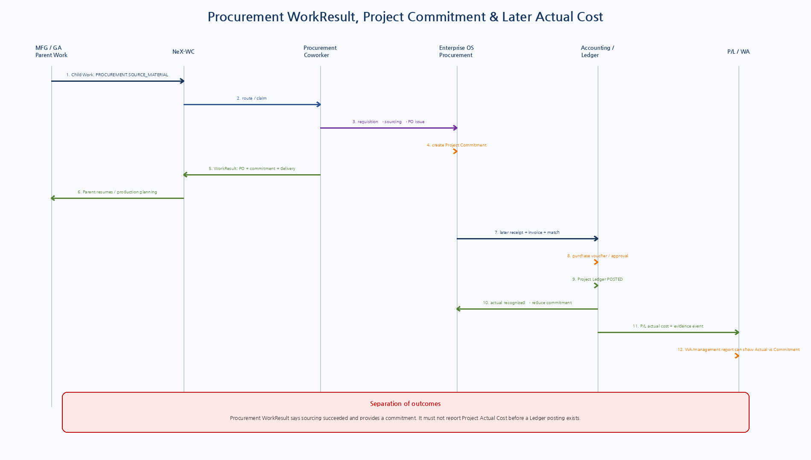
Figure 4. Procurement Child Work는 ISSUED PO/Commitment로 Parent를 Resume하고, 실제 비용은 이후 별도 Invoice/Ledger chain에서 인식.

14.1 Procurement WorkResult Contract
Field | Meaning
outcome | SOURCING_COMPLETED / NO_ELIGIBLE_SUPPLIER / DELIVERY_UNAVAILABLE / CANCELLED / FAILED
source_requisition_ref | Canonical PurchaseRequisition
project_ref | Exact Project
supplier_ref | Selected supplier if success
po_ref | ISSUED PO if success
commitment_ref | ProjectCommitment read-model reference
ordered_amount | Committed PO amount
expected_delivery | Planning input for Manufacturing/GA parent
selected_quote_refs | Evidence artifacts
exception_codes | Delivery/supplier/sourcing exceptions
15. Expense / Revenue / Purchase / Payment Recognition
Transaction | Recognition Design
Expense | Evidence→Mapping→Expense Voucher→Approval policy→Ledger POST→DIRECT_EXPENSE/COMMON_COST
Revenue | Explicit revenue recognition source→Revenue Voucher→Ledger POST→REVENUE; sales order alone is not revenue
Purchase | Requisition/PO/Receipt/Invoice/Match→Purchase Voucher→Ledger POST→MATERIAL/DIRECT_EXPENSE/COMMON_COST
Payment | Dr AP / Cr Cash; both economic category NONE; Project P/L unchanged
Reversal/Adjustment | New Voucher/Posting; original financial facts and approval/evidence lineage retained
16. Canonical API Surface
Capability | Meaning | Risk
ACCOUNT.RESOLVE_MAPPING | Resolve stable debit/credit/tax mapping | R2/R3
FINANCE.GENERATE_VOUCHER_LINES | Deterministic balanced line generation | R2
FINANCE.CREATE_EXPENSE_VOUCHER_DRAFT | Expense Voucher draft | R3
FINANCE.CREATE_REVENUE_VOUCHER_DRAFT | Revenue Voucher draft | R3
PROCUREMENT.CREATE_REQUISITION | Create project purchase need | R3
PROCUREMENT.SUBMIT_REQUISITION | Submit/approval routing | R3/R4
PROCUREMENT.CREATE_PO_DRAFT | Create PO from approved requisition | R3
PROCUREMENT.ISSUE_PO | Commit to supplier | R4/R5
PROCUREMENT.CONFIRM_RECEIPT | Goods/service receipt | R3/R4
PROCUREMENT.RECEIVE_INVOICE | Register supplier invoice/fingerprint | R3
PROCUREMENT.MATCH_INVOICE | 2/3-way deterministic match | R2
PROCUREMENT.APPROVE_MATCH_OVERRIDE | Formal approval exception | R4/R5
FINANCE.CREATE_PURCHASE_VOUCHER | Create Voucher from accepted match | R3
LEDGER.POST_FROM_VOUCHER | Recognize actual revenue/cost | R4/R5
FINANCE.POST_PAYMENT | AP/Cash settlement; P/L NONE | R4/R5
17. PostgreSQL Model
Table / Aggregate | Purpose
account_mapping_rule | Effective deterministic debit/credit/tax/economic mapping
account_mapping_decision | Frozen source→mapping rule/version/confirmation trace
approval_threshold_rule | Amount/risk/domain/exception→gate/approval policy
purchase_requisition / line | Project sourcing request
purchase_order / line | Issued commitment and received/invoiced progress
goods_receipt / line | Goods/service acceptance evidence
supplier_invoice / line | Invoice identity/fingerprint/amount/project
invoice_match_result | 2/3-way/non-PO checks/exceptions/override approval
project_commitment | PO commitment read model, separate from actual P/L
voucher / voucher_line | Existing Doc20 accounting aggregate
ledger_posting / ledger_entry | Existing Doc20/21 actual P/L facts
18. Domain Events
Event | Meaning
PURCHASE_REQUISITION_APPROVED | Requisition eligible for sourcing
PURCHASE_ORDER_ISSUED | Supplier commitment authoritative
PROJECT_COMMITMENT_CHANGED | Open commitment changed
GOODS_RECEIPT_CONFIRMED | Fulfillment evidence
SUPPLIER_INVOICE_RECEIVED | Invoice registered/deduplicated
INVOICE_MATCHED | Invoice eligible for Voucher
INVOICE_MATCH_EXCEPTION | Match exception requires action
PURCHASE_VOUCHER_CREATED | Accounting Voucher generated from invoice
LEDGER_ENTRY_POSTED | Project actual cost/revenue committed
PROJECT_ACTUAL_COST_RECOGNIZED | Actual purchase cost recognized
SUPPLIER_PAYMENT_POSTED | Settlement only; no Project P/L effect
19. Test Strategy
Area | Required Tests
Account mapping | Specificity, tie conflict, inactive account, unknown rule, human-confirmed mapping.
Voucher lines | Expense/Revenue/Purchase/Payment templates, tax, exact Decimal, debit=credit.
PFL projection | Only economic_category != NONE lines projected; recoverable VAT/AP/Cash excluded.
Requisition/PO | State transitions, single-project invariant, approval threshold, issued commitment.
Invoice duplicate | Same supplier fingerprint rejected even under retry.
2-way/3-way match | Supplier/project/currency/qty/price/tax/receipt tolerances and exceptions.
Override | Exception remains recorded; Formal Approval required; no silent invoice modification.
Recognition | PO/receipt/match/voucher draft produce no actual cost; Ledger POSTED produces actual cost.
Commitment | Issued PO creates commitment; partial actual reduces open commitment without altering P/L actual.
WorkResult | Result requires ISSUED PO for success and contains commitment, not actual cost.
Approval | PO proof cannot be reused for different Voucher posting operation; low-risk no-second-approval policy tested.
Payment | Dr AP / Cr Cash is balanced and has zero PFL effect.
Fault | Duplicate PO issue/invoice voucher/posting events; idempotency and unknown commit reconciliation.
E2E | MFG shortage→Procurement WorkResult→receipt/invoice/match→purchase Voucher→Ledger actual cost→P/L.
20. Implementation Sequence
Wave | Area | Deliverable
I1 | Mapping / Voucher Templates | Account rule engine + balanced Expense/Revenue/Purchase/Payment lines
I2 | Requisition / PO | Project sourcing aggregates + approval/issue + WorkResult/commitment
I3 | Receipt / Invoice | Receipt and supplier invoice/fingerprint states
I4 | Invoice Matching | 2-way/3-way/non-PO policy, tolerances, exception/override
I5 | Purchase Voucher | Match→mapping→Voucher creation + approval threshold
I6 | Actual Cost | Voucher posting→PFL actual recognition + commitment reduction
I7 | Revenue / Settlement | Revenue Voucher and AP payment zero-double-count tests
I8 | Hardening | Fault/concurrency/security/E2E/legacy adapters/observability
21. Machine-readable Reference Package
Artifact | Validation / Purpose
8 JSON Schemas | Draft 2020-12 meta-schema PASS
8 Example objects | Exact schema validation PASS
Python modules | Syntax PASS
Voucher generation smoke | Debit=Credit=110,000; PFL cost=100,000 PASS
Recognition smoke | PO commitment / invoice eligibility / Ledger actual / payment zero P/L PASS
001_account_mapping_approval_policy.sql | Mapping + approval threshold rules
002_requisition_purchase_order.sql | Requisition/PO aggregates
003_receipt_invoice_match.sql | Receipt/Invoice/Match aggregates
004_project_commitment.sql | Commitment read model
005_purchase_actual_cost_transaction.sql | Match→Voucher→Ledger actual recognition
006_transaction_state_recognition_notes.sql | Recognition/state/index invariants
SQL은 Reference Physical Design이다. 실제 Repository 정렬 후 SQLAlchemy/Alembic으로 옮기고 Line-level Match tolerance, concurrent invoice intake, PO partial receipt/invoice, commitment refresh와 Ledger posting fault를 PostgreSQL에서 검증한다.
22. Detailed Design Quality Gate
Gate | Pass Criteria
TX-QG-01 | Account mapping is deterministic/versioned/stable-ID based.
TX-QG-02 | Voucher templates are balanced and distinguish economic vs offset lines.
TX-QG-03 | Recoverable tax/AP/Cash offsets do not double-count Project P/L.
TX-QG-04 | Requisition/PO are commitment transactions, not actual cost.
TX-QG-05 | Invoice matching is deterministic and exceptions are governed.
TX-QG-06 | Approval thresholds/proofs bind each exact protected operation.
TX-QG-07 | Actual purchase cost exists only after Project Financial Ledger posting.
TX-QG-08 | Procurement WorkResult reports issued PO/commitment/delivery, not premature actual.
TX-QG-09 | Supplier payment does not recognize project cost twice.
TX-QG-10 | Schemas/Python/line-generation/recognition smoke tests pass.
23. Next Step
23 — Work Asset / Human Effort / Labor Allocation
다음 Phase 2 핵심은 WA→Confirmed Human Effort→MM→LaborAllocation→Project Financial Ledger LABOR 연결이다. AgentExecution Duration과 Human Effort를 분리하고, Project Attribution 기반 월별 Effort/MM/Cost allocation과 Ledger Posting을 상세화하면 Project P/L의 비용축이 완성된다.

