NeX Work Asset / Human Effort
Labor Allocation Design v2.0
WorkActivity · WorkAsset · Confirmed Effort · MM · Labor Cost · Project Financial Ledger
Labor Accounting Invariant
MM = Confirmed Effort / Standard Work Minutes. Labor Cost Allocation Ratio = Confirmed Project Effort / Final Allocation Base Effort. These are different measures and must not accidentally share a denominator.
Reference package: 8 JSON Schemas + Python + 6 PostgreSQL SQL files | 2026.09.02

Executive Summary
본 문서는 NeX-WA WorkActivity/WorkAsset Evidence를 Human Effort로 확인하고 월별 MM/Labor Allocation으로 변환하여 Enterprise OS Project Financial Ledger의 LABOR 비용으로 Posting하는 구조를 상세화한다. 목표는 수기 Timesheet를 그대로 전산화하는 것이 아니라 시스템이 업무 Evidence와 Estimate를 자동으로 준비하고 직원은 Review/Correction만 수행하도록 하는 것이다. AgentExecution Duration과 Human Effort를 분리하고, Estimate는 Advisory로 유지하며, FROZEN Confirmed Effort만 Financial Allocation Source가 된다.
Privacy / Governance Boundary
WorkActivity와 Project P/L은 업무 증거/관리회계 자료이지 자동 인사평가 점수가 아니다. Raw telemetry나 AgentExecution duration을 직원 성과점수로 직접 변환하는 기능은 본 설계 범위에서 금지한다.

1. WA Effort → EOS Labor Architecture
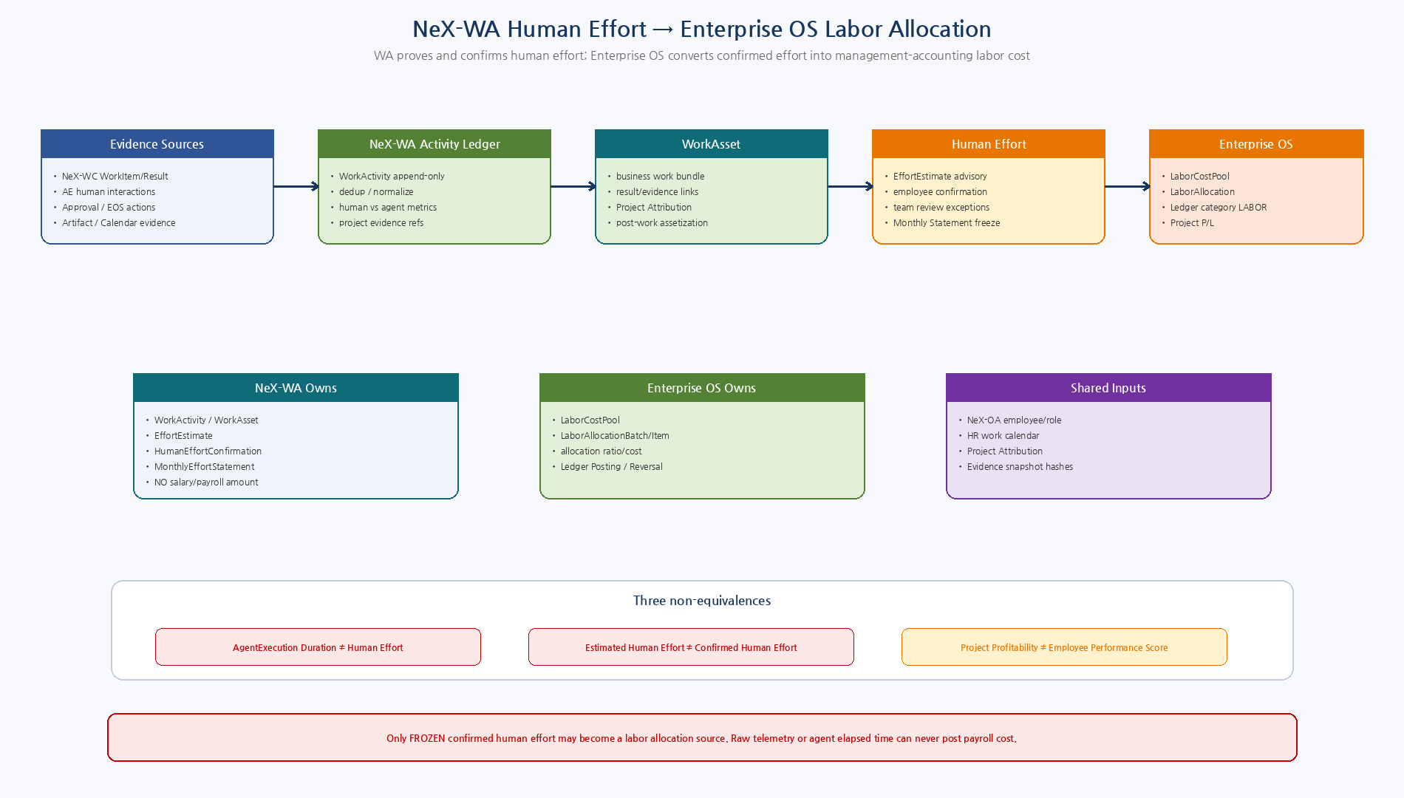
Figure 1. NeX-WA Evidence/Confirmation과 Enterprise OS Payroll Cost/Allocation/Ledger의 소유권 경계.

2. Detailed Design Principles
ID | Decision | Implementation Meaning
LAB-DD-01 | Evidence, not surveillance | WA records business-relevant work evidence and outcomes, not invasive raw telemetry for employee scoring.
LAB-DD-02 | Agent time is separate | AgentExecution/background tool duration is excluded from Human Effort.
LAB-DD-03 | Estimate is advisory | EffortEstimate helps reduce manual entry; only confirmed/frozen effort feeds cost allocation.
LAB-DD-04 | Project Attribution First | Every final effort item resolves an actual Project whenever supported; Common is explicit only.
LAB-DD-05 | MM and cost ratio differ | MM uses Standard Work Minutes; payroll cost ratio uses Final Allocation Base Effort.
LAB-DD-06 | Cost pool balances exactly | Allocated item costs sum exactly to the frozen Employee/Period LaborCostPool.
LAB-DD-07 | WA/EOS ownership split | WA proves effort; EOS owns payroll cost, allocation and financial posting.
LAB-DD-08 | Shared service stays attributable | HR/GA/Finance/Procurement support effort can post to the actual supported Project with SHARED_SERVICE nature.
LAB-DD-09 | Posted allocation is immutable | Corrections use reversal + replacement allocation, never in-place ledger edit.
LAB-DD-10 | Profitability is not performance scoring | Project P/L/labor evidence must not automatically become employee performance rating.
3. Ownership Boundary
Component | Owns
NeX-WA | WorkActivity, WorkAsset, EffortEstimate, HumanEffortConfirmation, MonthlyEffortStatement
Enterprise OS | LaborCostPool, LaborAllocationBatch/Item, LABOR Ledger Posting/Reversal
NeX-OA / HR | Employee/RoleBinding, employment status, standard work calendar/schedule/leave inputs
NeX-WC | WorkItem/WorkResult/participant/work timeline evidence
NeX-AE | Human interaction evidence and AgentExecution refs; background Agent duration stays separate
Project Attribution | Document 21 Project-first resolution/confirmation
Artifact / Approval / EOS | Business result/evidence/decision refs used to explain work

4. Observed Activity vs Human Effort
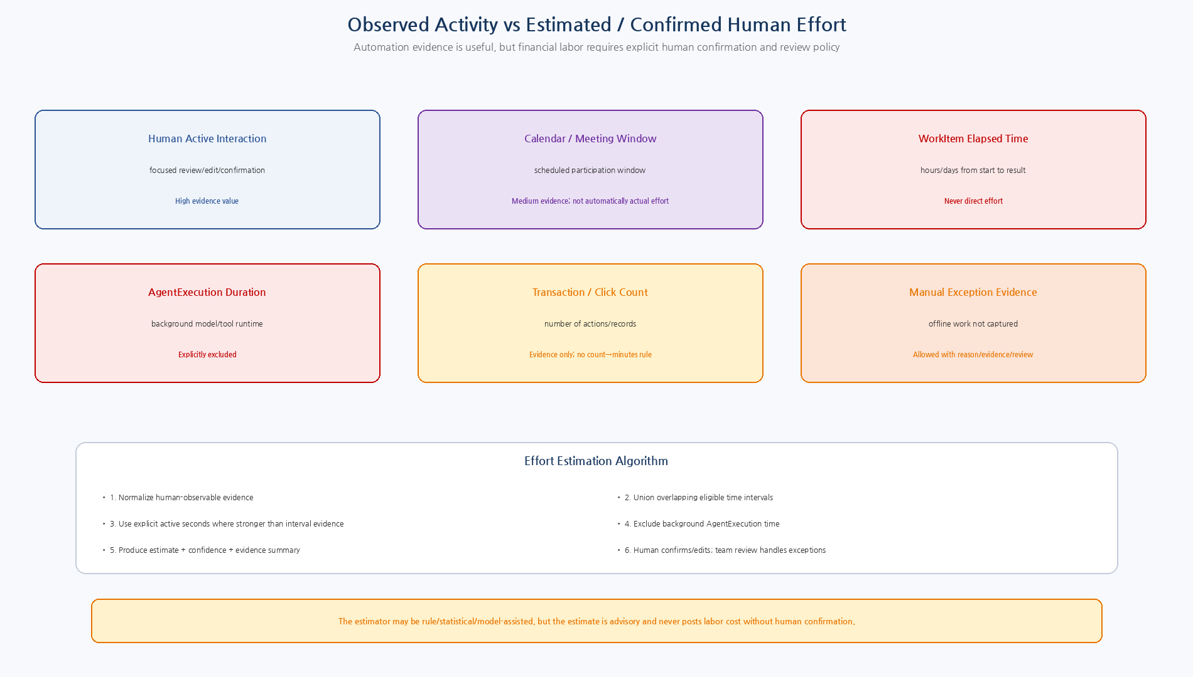
Figure 2. 업무 Evidence 종류별 Human Effort 의미와 Estimate→Human Review 구조.

4.1 WorkActivity Evidence Rules
Evidence | Rule
Human active interaction | Eligible direct evidence when system can measure purposeful review/edit/confirmation time without idle inflation.
Calendar/meeting | Supporting interval evidence; scheduled duration is not automatically confirmed effort.
WorkItem elapsed | Never direct effort because waiting/dependencies may dominate.
AgentExecution elapsed | Never human effort; stored separately for automation metrics only.
Transaction/action count | Evidence only. No automatic `N records × minutes` payroll basis.
Manual exception | Allowed only for offline/non-captured work with reason/evidence and review.
Overlap | Eligible intervals are unioned before estimate to avoid double-counting simultaneous activities.
5. WorkAsset
- WorkAsset은 WorkActivity, WorkResult/Business Object, Artifact/Evidence를 업무 결과 단위로 묶는 post-work 자산이다.
- WorkAsset은 Scheduling/Calendar Timesheet가 아니다.
- Project Attribution은 Document 21 기준을 사용하고 unresolved 상태에서는 effort freeze로 진행하지 않는다.
- 한 팀 업무에서도 개인별 Human Effort Evidence는 employee_ref 기준으로 분리될 수 있다.
- WA는 급여/인건비 금액을 소유하지 않는다.
6. Human Effort Estimate
Rule | Design
Estimator types | RULE / INTERVAL_UNION / STATISTICAL_MODEL / LLM_ADVISORY / MANUAL_SEED.
Default design | Use deterministic interval/active-time evidence where available; statistical/LLM estimates remain lower-authority advisory.
Confidence | Stored with estimator version and evidence summary.
Agent exclusion | agent_execution_seconds is explicitly subtracted/excluded, never added.
No hidden defaults | Missing evidence produces low-confidence/zero estimate and human review, not invented time.
Human review | Every estimate used for management accounting must be accepted/edited by employee; policy may require team review.
7. Human Effort Confirmation
State | Meaning
DRAFT | Estimate/Project context prepared
EMPLOYEE_CONFIRMED | Employee accepted/edited estimate; no team review required
REVIEW_REQUIRED | Policy requires team/manager review
TEAM_CONFIRMED | Reviewer confirmed/overrode with evidence
FROZEN | Period-close source; immutable for allocation
ADJUSTED | Later correction linked to original
REJECTED | Invalid work/effort evidence excluded
Employee Review가 기본이며 Team Review는 예외 중심이다. 큰 Estimate 수정, 낮은 신뢰도, Shared/Common 분류, 높은 재무영향 등 versioned policy 조건일 때만 Team Review를 요구하여 매일 수기 Timesheet를 다시 만들지 않도록 한다.
8. Labor Nature
Nature | Meaning
DIRECT | Core delivery/revenue-generating work directly attributable to a Project
SHARED_SERVICE | Support-function work attributable to a specific Project; e.g., procurement/accounting/HR support
CORPORATE_COMMON | Genuinely non-project corporate work, posted to explicit Common Work Project

9. Monthly Effort Close Pipeline
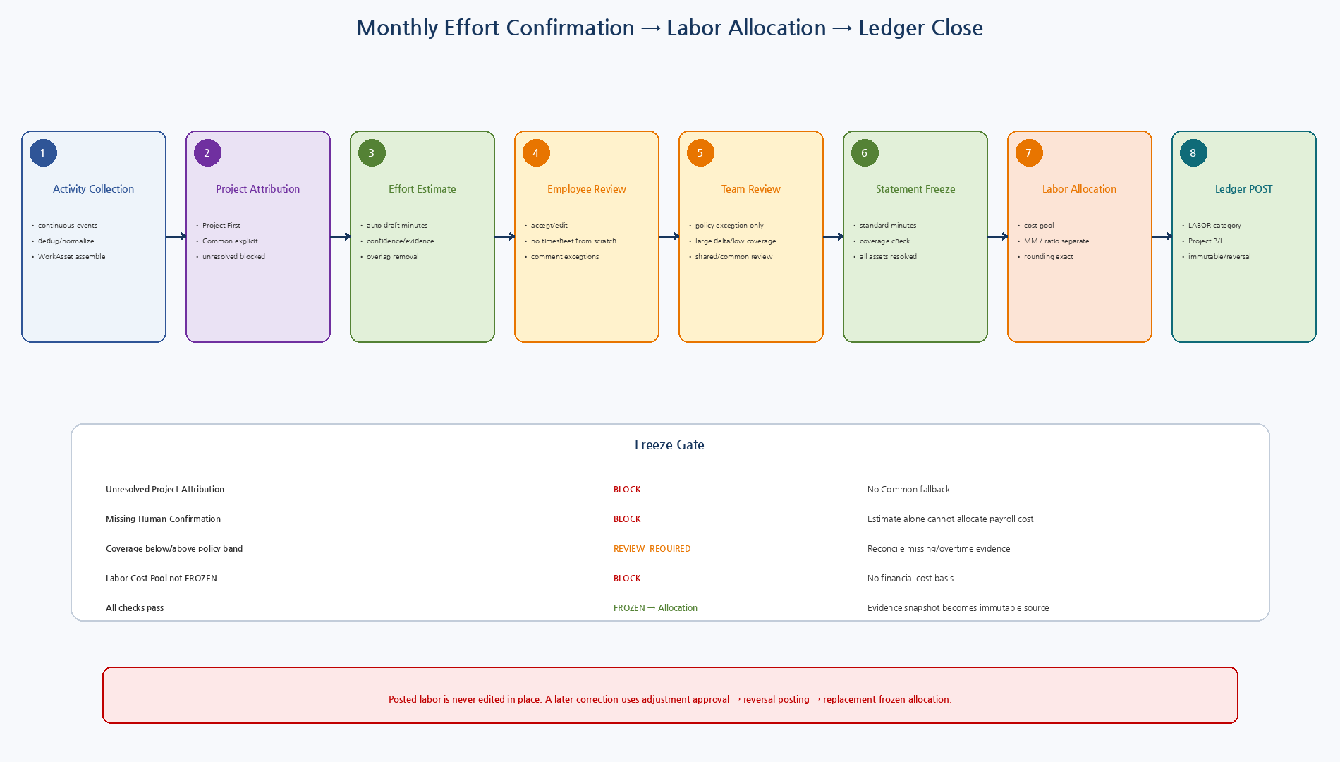
Figure 3. WorkActivity부터 Monthly Statement Freeze, Labor Cost Allocation, Ledger LABOR Posting까지의 월말 흐름.

9.1 Monthly Statement State
State | Meaning
DRAFT | Auto-generated monthly effort statement
EMPLOYEE_REVIEWED | Employee reviewed all evidence/effort items
TEAM_REVIEWED | Required manager/team exception review completed
FROZEN | Attribution/effort evidence frozen; source for labor allocation
POSTED | Labor allocation posted to Project Financial Ledger
ADJUSTMENT_REQUIRED | Post-close correction requested
ADJUSTED | Reversal + replacement allocation completed
9.2 Freeze Gates
Gate | Rule
Unresolved WorkAsset Project | Must resolve/confirm/split; cannot silently use Common.
Unconfirmed Effort | Estimate alone cannot freeze.
Coverage outside policy band | Requires explicit review/reconciliation; threshold is versioned policy, not hardcoded in domain.
Invalid employee/calendar | Standard Work Minutes must come from authoritative calendar/employment context.
Missing/floating cost pool | EOS LaborCostPool must be frozen before financial allocation.
Zero allocation base | Cannot allocate cost with zero confirmed final effort.

10. MM / Coverage / Labor Cost Formula
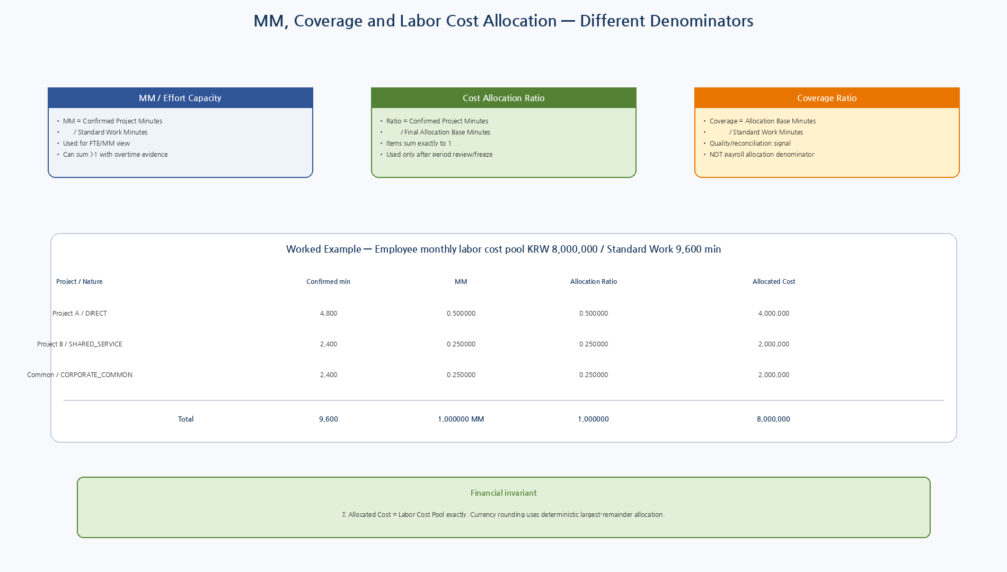
Figure 4. MM, Coverage Ratio, Payroll Allocation Ratio의 서로 다른 denominator와 월 8백만원 예시.

10.1 Formula Definitions
Metric | Formula | Meaning
MM | confirmed_effort_minutes / standard_work_minutes | FTE/MM capacity view; not payroll cost ratio
Coverage Ratio | allocation_base_minutes / standard_work_minutes | Evidence completeness/reconciliation indicator
Allocation Ratio | confirmed_project_minutes / allocation_base_minutes | Final payroll cost distribution; sum=1
Allocated Cost | labor_cost_pool × allocation_ratio | Management-accounting labor cost by Project
Rounding | Largest remainder to currency minor unit | Guarantees allocated item sum == frozen cost pool
11. Labor Cost Pool
Rule | Design
Source | Payroll/Finance/legacy authoritative source; WA never stores salary as effort evidence.
Components | May include base pay, employer contributions/benefits/other management labor components according to policy.
Period identity | One frozen Employee/Period pool per allocation cycle/version.
Currency | Allocation items use the same cost-pool currency in v2 baseline.
Privacy | Access is restricted; WorkAsset UI does not need payroll values for ordinary employee effort review.
12. Labor Allocation
Rule | Design
Final denominator | Sum of final FROZEN confirmed effort across all Project/LaborNature items.
100% allocation | Final allocation ratios sum to 1 and allocate the entire cost pool.
Coverage review | Coverage ratio may be < or > 1 due to evidence gaps/overtime; freeze policy determines whether manual reconciliation is required.
Shared service | Posts LABOR to the actual supported Project with dimension labor_nature=SHARED_SERVICE.
Corporate common | Posts to explicit Common Work Project; never redistributed to revenue projects by a hidden revenue-ratio rule.
Evidence snapshot | Each item stores frozen confirmation refs/hash for audit/reproducibility.
Posted correction | Use LaborAllocationAdjustment → reverse old posting → replacement frozen batch → new posting.
Allocation Reconciliation
Cost allocation uses confirmed final effort ratios and deterministic largest-remainder currency rounding. Σ Allocated Cost must equal the frozen Employee/Period LaborCostPool exactly.
13. Project Financial Ledger LABOR Posting
Boundary | Rule
Source Transaction | LABOR_ALLOCATION batch per Employee/Period.
Ledger category | LABOR.
Project amount | One economic LedgerEntry per allocation item/project (or deterministic aggregation preserving employee/item dimensions).
Account | Management labor expense account configured by EOS accounting policy.
Dimensions | employee_ref, labor_nature, MM, confirmed minutes, evidence hash.
P/L | LABOR flows through Document 21 Project/Mother/NVT roll-up.
General ledger | If statutory payroll accounting is required, salary expense/payroll payable balancing remains payroll/accounting domain; PFL gets management labor economic facts.
14. Domain Events
Event | Meaning
WORK_ACTIVITY_OBSERVED | Normalized human-work evidence appended
WORK_ASSET_ASSEMBLED | Post-work asset built from activities/results/evidence
PROJECT_ATTRIBUTION_REQUIRED | WorkAsset cannot yet resolve Project
EFFORT_ESTIMATE_CREATED | Advisory estimate generated
HUMAN_EFFORT_CONFIRMED | Employee confirmed/edited effort
HUMAN_EFFORT_REVIEWED | Team/manager review completed
MONTHLY_EFFORT_STATEMENT_FROZEN | Period effort source frozen
LABOR_COST_POOL_FROZEN | EOS payroll cost basis frozen
LABOR_ALLOCATION_CONFIRMED | Allocation batch ready for posting
LABOR_ALLOCATION_POSTED | LABOR financial facts committed
LABOR_ALLOCATION_ADJUSTED | Reversal/replacement correction completed
15. Canonical API Surface
Capability | Meaning | Risk
WA.INGEST_ACTIVITY | Normalize source event to WorkActivity | Internal
WA.GET_WORK_ASSET | WorkAsset evidence/detail | R1/R2
WA.ESTIMATE_HUMAN_EFFORT | Create advisory estimate | R2
WA.CONFIRM_HUMAN_EFFORT | Employee confirm/edit | R3
WA.REVIEW_HUMAN_EFFORT | Manager/team exception review | R3/R4
WA.GET_MONTHLY_EFFORT_STATEMENT | Monthly effort/evidence summary | R2
WA.FREEZE_MONTHLY_EFFORT | Freeze period source | R4
LABOR.GET_COST_POOL | Restricted cost pool query | R4
LABOR.CREATE_ALLOCATION | EOS labor allocation calculation | R3/R4
LABOR.CONFIRM_ALLOCATION | Finance/management review | R4
LEDGER.POST_LABOR_ALLOCATION | Post Project Financial Ledger LABOR facts | R4/R5
LABOR.ADJUST_ALLOCATION | Governed reversal/replacement | R4/R5
16. PostgreSQL Model
Table | Purpose
nex_wa.work_activity | Append-oriented normalized observable human-work evidence
nex_wa.work_asset | Business work/evidence bundle and Project attribution
nex_wa.effort_estimate | Advisory minutes/confidence/estimator/evidence
nex_wa.human_effort_confirmation | Employee/reviewer-confirmed Project effort
nex_wa.monthly_effort_statement | Employee/Period close/freeze source
nex_wa.activity_event_inbox | At-least-once source-event dedup
nex_eos.labor_cost_pool | Restricted payroll/finance Employee/Period cost basis
nex_eos.labor_allocation_batch | Employee/Period allocation aggregate
nex_eos.labor_allocation_item | Project/Nature/MM/ratio/cost/evidence item
nex_eos.labor_allocation_adjustment | Post-close correction workflow
nex_eos.ledger_posting / ledger_entry | Existing Project Financial Ledger LABOR facts
17. Privacy / Performance-Evaluation Boundary
- WorkActivity/Effort data의 목적은 업무증거, Project Costing, Handover/Reporting, Management Accounting이다.
- Keystroke-style raw telemetry 또는 AgentExecution duration은 성과평가 점수로 변환하지 않는다.
- Project profitability와 높은/낮은 Human Effort는 Context를 가진 경영자료이지 개인 품질점수가 아니다.
- Payroll Cost는 Finance/authorized role로 제한하고 일반 Employee WA Review 화면에는 급여금액이 필요하지 않다.
- Employee는 자신의 Effort Confirmation에 사용된 Evidence/Estimate를 확인하고 수정할 수 있으며 Correction 이력은 Audit한다.
18. Observability
Metric | Purpose
wa_activity_total | source/activity type
wa_work_asset_total | asset/state/project attribution
wa_effort_estimate_minutes | estimator/confidence
wa_agent_minutes_excluded_total | automation time excluded from human effort
wa_effort_confirm_delta_minutes | estimated vs confirmed delta
wa_unresolved_project_assets | employee/period/team
wa_effort_coverage_ratio | employee/period; governance diagnostic
labor_allocation_cost_total | period/project/nature
labor_allocation_ratio_sum_error | should be zero per batch
labor_posting_total | period/project/nature
labor_adjustment_total | reason/period
19. Test Strategy
Area | Required Tests
Activity | Event dedup, background agent duration exclusion, overlapping interval union, void/supersede.
WorkAsset | WorkItem/Result/Evidence grouping, Project Attribution First, Common non-default.
Estimate | Active/interval evidence, overlap removal, no hidden count→minutes, low-confidence path.
Employee review | Accept/edit/manual exception, identity check, negative minutes denied.
Team review | Threshold/exception policy, reviewer authorization, override audit.
Monthly close | Coverage policy, unresolved asset block, zero standard minutes, overtime >1 coverage review.
MM / allocation | MM denominator vs cost-ratio denominator, exact Decimal.
Rounding | Largest-remainder allocation sums exactly to payroll cost pool.
Labor nature | DIRECT/SHARED_SERVICE/CORPORATE_COMMON posting to correct Project/nature dimension.
Ledger | One batch idempotency, LABOR category, P/L roll-up, no in-place edit.
Correction | Posted batch reversal + replacement, original evidence preserved.
Security/privacy | Ordinary WA review cannot read payroll amounts; financial roles required.
E2E | WorkActivity→WorkAsset→Confirmed Effort→MM→LaborAllocation→Ledger LABOR→Project/NVT P/L.
20. Implementation Sequence
Wave | Area | Deliverable
I1 | WA Activity Ledger | Event inbox/normalizer/dedup/activity tables
I2 | WorkAsset | Asset builder + WorkItem/Result/Artifact/Project attribution
I3 | Effort Estimate | Interval/active evidence estimator + confidence/agent exclusion
I4 | Human Review | Employee confirmation + exception team review + UI workflow
I5 | Monthly Statement | Standard work calendar + coverage/freeze policy
I6 | Labor Cost / Allocation | Restricted cost pool + MM/ratio/cost allocator/rounding
I7 | Ledger Integration | LABOR posting + Project P/L + adjustment/reversal
I8 | Hardening | privacy/fault/E2E/load/observability/legacy payroll adapter
21. Machine-readable Reference Package
Artifact | Validation / Purpose
8 JSON Schemas | Draft 2020-12 meta-schema PASS
Example objects | Exact schema validation PASS
Python modules | Syntax PASS
Effort semantics smoke | Agent 25 min ≠ Human estimate 7 min PASS
Labor allocation smoke | MM 0.5/0.25/0.25; cost 4M/2M/2M; total 8M PASS
001_wa_activity_asset.sql | WA Activity/Asset evidence
002_effort_confirmation_statement.sql | Estimate/Confirmation/Monthly Statement
003_eos_labor_cost_allocation.sql | Cost Pool/Batch/Items
004_labor_allocation_to_ledger.sql | LABOR Project Financial Ledger posting
005_event_ingestion_projection.sql | At-least-once evidence ingestion/dedup
006_adjustment_reconciliation.sql | Post-close reversal/replacement correction
22. Detailed Design Quality Gate
Gate | Pass Criteria
LAB-QG-01 | AgentExecution/WorkItem elapsed time cannot become Human Effort.
LAB-QG-02 | EffortEstimate is advisory; frozen Human confirmation is financial source.
LAB-QG-03 | Project Attribution First and explicit Common Work are preserved.
LAB-QG-04 | MM and payroll allocation ratio use separate denominators.
LAB-QG-05 | Allocated cost reconciles exactly to the frozen LaborCostPool.
LAB-QG-06 | SHARED_SERVICE remains attributable to real supported Projects.
LAB-QG-07 | Labor posting creates Project Financial Ledger LABOR facts with evidence lineage.
LAB-QG-08 | Posted allocation correction uses reversal/replacement.
LAB-QG-09 | Work evidence/project profitability are not automatic performance ratings.
LAB-QG-10 | Schemas/Python/allocation smoke tests pass.
23. Phase 2 Economics Status / Next Step
Project Economics Core Nearly Complete
19~23 문서로 Revenue / Material / Direct Expense / Procurement Commitment & Actual Cost / Labor의 authoritative 경로가 Project Financial Ledger와 P/L에 연결되었다. 다음은 Accounting+Procurement+Labor를 한 Project/NVT Golden Slice에서 end-to-end reconciliation하는 통합 설계가 자연스럽다.

