NeX Enterprise Business Core

End-to-End Golden Slice & Reconciliation Design v2.0
Revenue · Procurement Commitment / Material Actual · Direct Expense · Labor · P/L · Evidence
Golden Invariant
Source Transaction → Immutable Ledger Fact → Project P/L → Mother/NVT Roll-up → Evidence가 동일한 경제적 사실을 가리키고 모든 Required Reconciliation이 PASS할 때만 Golden PASS.
Reference package: 6 JSON Schemas + Python Golden/Reconciliation Engine + 7 SQL checks | 2026.09.02

Executive Summary
본 문서는 Revenue, Material, Direct Expense, Procurement Commitment/Actual Cost, Labor를 Child Project P-300에서 하나의 End-to-End Golden Slice로 실행하고 서로 다른 Source of Truth를 독립적으로 Reconcile하는 기준을 정의한다. API 성공만으로는 PASS하지 않으며, Voucher/PO/Invoice/Labor Allocation과 immutable Project Financial Ledger, DIRECT/ROLLUP P/L, Evidence Lineage가 모두 명시된 Expected Economics와 일치해야 한다.
Reference vs Current Implementation
이 문서는 Target Integration Harness/Acceptance Baseline이다. 실제 Source Repository와 개발 DB를 아직 이 대화에서 검증한 것은 아니므로, Reference Python/SQL 구조를 현재 구현 사실로 해석하지 않는다.

1. End-to-End Golden Slice
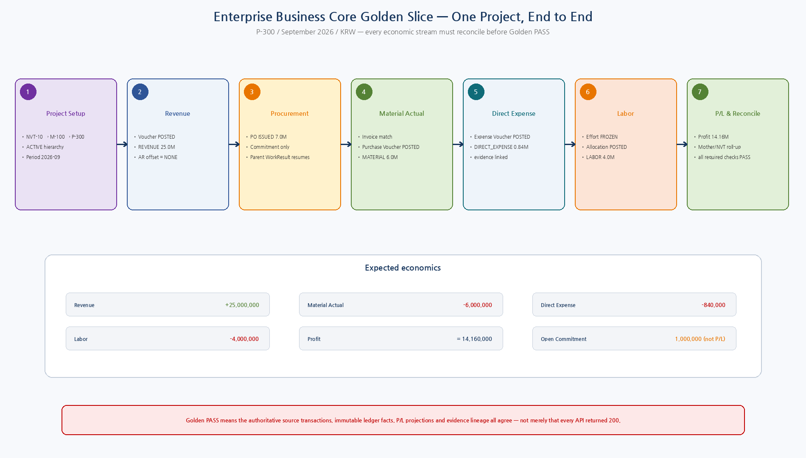
Figure 1. P-300 단일 Project에 Revenue/Procurement/Material/Expense/Labor를 발생시키고 P/L과 Reconciliation까지 완료하는 전체 흐름.

2. Design Principles
ID | Decision | Implementation Meaning
GS-DD-01 | One canonical fixture | All Phase 2 economic streams are validated against one fixed Child Project/Period/Currency dataset.
GS-DD-02 | API-first test execution | Golden setup/actions use canonical service APIs and isolated test DB; direct DB writes are only for test fixture infrastructure where explicitly safe.
GS-DD-03 | SoR reconciliation | A successful command is insufficient; source transaction, ledger, commitment, labor and P/L must agree.
GS-DD-04 | Expected economics is explicit | Golden expected totals are versioned data, not inferred from current implementation output.
GS-DD-05 | Eventual consistency is bounded | Projection lag may enter WAITING_CONVERGENCE but cannot produce a false PASS.
GS-DD-06 | Idempotency is economically tested | Retries/duplicate events must leave the same final financial facts and P/L.
GS-DD-07 | Lineage is part of correctness | An unexplained P/L number is a Golden failure even if the arithmetic is correct.
GS-DD-08 | Failure tests assert prevention | Fault cases pass only when unsafe side effects are blocked/reconciled as designed.
GS-DD-09 | Legacy compare is non-authoritative | Dual-run comparison can flag mismatch but never causes automatic dual-write or correction.
GS-DD-10 | Rebuildable read models | P/L/lineage projections may be dropped/rebuilt; reconciliation always returns to authoritative facts.
3. Golden Fixture
Item | Value | Meaning
NVT Project | NVT-10 | ACTIVE roll-up root
Mother Project | M-100 | ACTIVE, child of NVT-10
Child Project | P-300 | ACTIVE direct transaction target
Fiscal Period | FP-2026-09 | September 2026 / KRW
Revenue | KRW 25,000,000 | Posted Revenue Voucher / PFL REVENUE
Purchase Commitment | KRW 7,000,000 | PO ISSUED; not actual P/L cost
Material Actual | KRW 6,000,000 | Matched invoice → Purchase Voucher POSTED / PFL MATERIAL
Open Commitment | KRW 1,000,000 | 7M - 6M recognized actual
Direct Expense | KRW 840,000 | Expense Voucher POSTED / PFL DIRECT_EXPENSE
Labor | KRW 4,000,000 | FROZEN Effort/Allocation → PFL LABOR
Profit | KRW 14,160,000 | 25M - 6M - 0.84M - 4M

4. Expected Project Economics
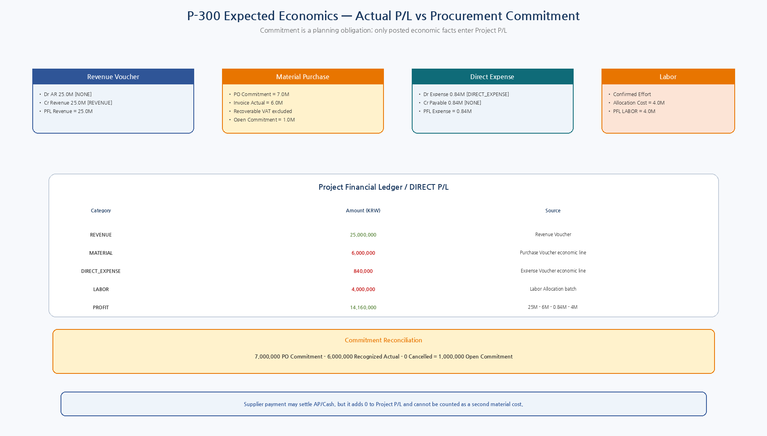
Figure 2. Project P/L Actual과 Procurement Commitment를 분리한 P-300 Expected Economics.

4.1 Accounting / Economic Line Expectations
Source | Debit | Credit | PFL Effect
Revenue Voucher | Dr AR 25M [NONE] | Cr Revenue 25M [REVENUE] | REVENUE +25M
Purchase Voucher | Dr Material 6M [MATERIAL] + Dr VAT 0.6M [NONE] | Cr AP 6.6M [NONE] | MATERIAL +6M
Expense Voucher | Dr Travel 0.84M [DIRECT_EXPENSE] | Cr Employee Payable 0.84M [NONE] | DIRECT_EXPENSE +0.84M
Labor Allocation | Management LABOR economic fact 4M | No PFL balance-sheet offset | LABOR +4M
Supplier Payment | Dr AP 6.6M [NONE] | Cr Cash 6.6M [NONE] | P/L effect 0
5. End-to-End Step Sequence
Step | Area | Action | Expected Effect
GS24-S01 | Project Setup | Verify/create NVT-10→M-100→P-300; P-300 ACTIVE; period OPEN | No financial effect
GS24-S02 | Revenue Post | Post balanced Revenue Voucher | PFL REVENUE +25M
GS24-S03 | Procurement Commitment | Approve/issue PO net 7M and submit Procurement WorkResult | Commitment +7M; P/L 0
GS24-S04 | Purchase Actual | Receipt + matched invoice + Purchase Voucher + Ledger POST | PFL MATERIAL +6M; open commitment 1M
GS24-S05 | Direct Expense | Expense Voucher + required gate + Ledger POST | PFL DIRECT_EXPENSE +0.84M
GS24-S06 | Labor | FROZEN effort/cost pool/allocation + Ledger POST | PFL LABOR +4M
GS24-S07 | Supplier Payment | Settle AP/Cash | P/L 0
GS24-S08 | P/L Refresh | Projection watermark converges to max ledger posting_seq | DIRECT/ROLLUP read models fresh
GS24-S09 | Reconcile | Run required and optional reconciliation checks | Final Golden PASS/FAIL

6. Reconciliation Control Plane
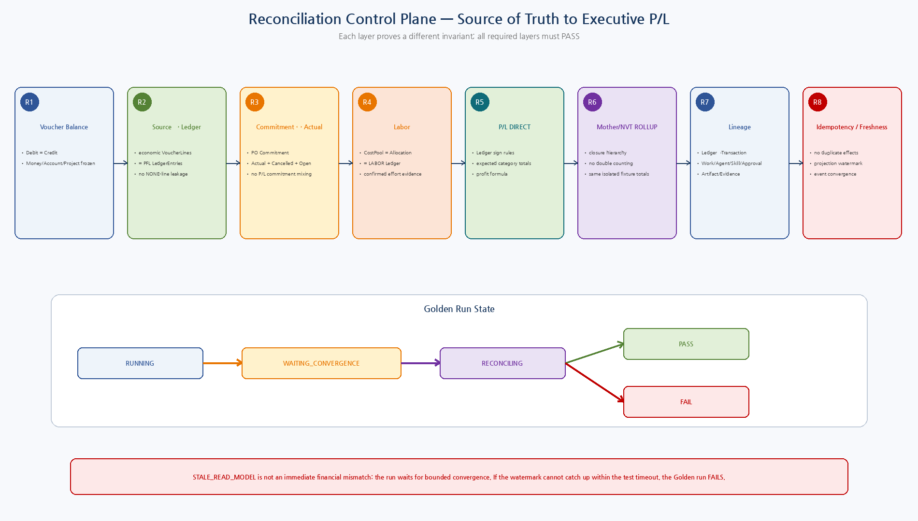
Figure 3. Voucher/Source→Ledger/Commitment/Labor/P-L/Roll-up/Lineage/Idempotency/Freshness의 다층 Reconciliation.

6.1 Reconciliation Catalog
ID | Check | Req. | Invariant
REC-01 | VOUCHER_BALANCE | Required | Every accounting Voucher Debit total = Credit total
REC-02 | SOURCE_TO_LEDGER | Required | Each POSTED Voucher economic effect = PFL entries from that Voucher
REC-03 | COMMITMENT_ACTUAL | Required | Commitment = Recognized Actual + Cancelled + Open Commitment
REC-04 | LABOR_COST | Required | LaborCostPool = Allocation total = LABOR Ledger effect
REC-05 | PL_DIRECT | Required | P-300 DIRECT category totals/profit = explicit expected economics
REC-06 | PL_ROLLUP_MOTHER | Required | M-100 ROLLUP = P-300 fixture totals
REC-07 | PL_ROLLUP_NVT | Required | NVT-10 ROLLUP = P-300 fixture totals
REC-08 | LINEAGE | Required | Every economic LedgerEntry has transaction/project/trace/evidence lineage
REC-09 | IDEMPOTENCY | Required | Retry/duplicate event leaves one economic effect
REC-10 | PROJECTION_FRESHNESS | Required | P/L projection watermark >= relevant max ledger posting_seq
REC-11 | LEGACY_DUAL_RUN | Optional | If comparator configured, legacy/NEX category totals are compared without dual-write
6.2 Reconciliation Status
Status | Meaning
PASS | Required invariant matches exactly within configured Decimal/currency tolerance.
MISMATCH | Both sides exist but values/state disagree.
MISSING_SOURCE | Ledger/read model references missing source transaction/evidence.
MISSING_LEDGER | Authoritative source says posted/recognized but expected ledger fact is absent.
DUPLICATE | More than one economic effect exists for one idempotent operation.
STALE_READ_MODEL | Authoritative ledger is ahead of P/L projection watermark.
UNVERIFIED | Evidence/lineage or source state cannot be verified.
NOT_APPLICABLE | Only for optional checks such as unconfigured Legacy comparator.
7. Golden PASS / WAITING / FAIL Rules
- All required reconciliation checks = PASS.
- No required UNKNOWN_COMMIT_STATE or unresolved reconciliation backlog.
- Projection watermark has converged to the relevant LedgerPosting sequence.
- P-300 DIRECT P/L equals Revenue 25M, Material 6M, Direct Expense 0.84M, Labor 4M, Profit 14.16M.
- M-100 and NVT-10 ROLLUP equal the isolated P-300 fixture totals without duplication.
- Procurement commitment is 7M, recognized actual 6M, open 1M.
- Every required financial fact has source and trace/evidence lineage.
- Optional Legacy check may be NOT_APPLICABLE; if configured and mismatched, Golden core can be reported PASS-with-legacy-warning only if governance policy explicitly treats it optional. Migration cutover gate should require it PASS.
STALE_READ_MODEL만 존재하는 경우에는 즉시 실패시키지 않고 WAITING_CONVERGENCE로 둔다. 다만 테스트 Harness의 bounded timeout 내 watermark가 authoritative Ledger에 수렴하지 않으면 최종 FAIL이다. 이는 Test Read Polling이며 Production Agent의 Dependency Polling을 허용한다는 의미가 아니다.
8. End-to-End Trace Matrix
Economic Stream | Source Path | Ledger | P/L | Evidence
Revenue | Work/AE/NSL → Revenue Voucher | Ledger REVENUE | P/L REVENUE | Voucher/Approval/Work/Evidence
Material | WC Procurement → PO → Invoice Match → Purchase Voucher | Ledger MATERIAL | P/L MATERIAL | PO/Quote/Receipt/Invoice/Voucher
Direct Expense | AE/NSL → Expense Voucher | Ledger DIRECT_EXPENSE | P/L DIRECT_EXPENSE | Receipt/Confirmation/Approval
Labor | WA WorkActivity/Asset → Effort → Allocation | Ledger LABOR | P/L LABOR | Effort confirmations/cost pool/allocation
Commitment | PurchaseOrder ISSUED | ProjectCommitment read model | Not included in P/L Actual | PO/WorkResult/quotes

9. Golden Fault Injection
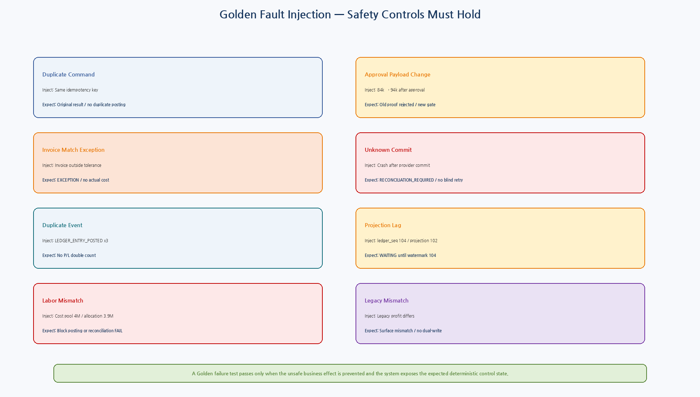
Figure 4. Duplicate, Approval Change, Match Exception, Unknown Commit, Duplicate Event, Projection Lag, Labor/Legacy mismatch의 기대 제어.

9.1 Fault Case Catalog
ID | Fault | Injection | Expected Control
FC-01 | Duplicate Command | Repeat S04 with same idempotency key | Original posting/result returned; no duplicate MATERIAL
FC-02 | Approval Payload Change | Change direct expense 840k→940k after approval | Old proof rejected; no ledger write until new gate
FC-03 | Invoice Match Exception | Invoice exceeds PO/tolerance | Invoice EXCEPTION; no Purchase Voucher/Actual Cost absent override
FC-04 | UNKNOWN_COMMIT_STATE | Crash after provider commit | RECONCILIATION_REQUIRED; same key used to recover original result
FC-05 | Duplicate Event | Deliver LEDGER_ENTRY_POSTED 3 times | P/L remains 14.16M; no double count
FC-06 | Projection Lag | Ledger seq=104, projection seq=102 | Run WAITING_CONVERGENCE; no false PASS
FC-07 | Labor Cost Mismatch | CostPool 4M, Allocation 3.9M | Posting blocked or reconciliation FAIL
FC-08 | Legacy Mismatch | Legacy profit 14.0M vs NEX 14.16M | Mismatch surfaced; no automatic data correction
10. Legacy Dual-run Reconciliation
- Legacy 비교는 Core 기능 Golden에서는 optional이지만 해당 Legacy Domain의 migration/cutover 시에는 필수 Gate로 승격한다.
- Legacy facts는 Adapter/Staging Snapshot과 explicit Canonical ID Mapping을 통해 비교한다.
- Raw row count가 아니라 Project/Period/Category/Currency Economic Effect를 비교한다.
- Mismatch는 Evidence/Queue로 노출하고 Cutover를 막을 수 있지만 어느 시스템에도 자동 Write/Correction하지 않는다.
- Migration 단계별 Authoritative Writer는 항상 하나다.
11. Test Environment / Isolation
Area | Rule
Database | Isolated resettable PostgreSQL test DB; no production data.
Clock | Fixed/fake test clock where needed for deterministic period/approval/expiry behavior.
IDs | Stable fixture IDs or deterministic test ID provider.
Service calls | Canonical APIs/adapters only; no cross-service direct writes.
Async convergence | Test harness may poll read-only status/watermark with bounded timeout; production Agent workflow still uses events.
Cleanup | Reset DB/schema and queues between independent destructive/fault cases.
Assertions | Business state + ledger facts + P/L + trace, not HTTP status alone.
Artifacts | Use deterministic fixture Artifact/Evidence refs; binary content may be minimal test fixtures.
12. Golden Runner / Reconciliation Engine
Component | Responsibility
GoldenSliceRunner | Dependency-ordered canonical actions; step result persistence
Expected Economics Fixture | Explicit versioned Revenue/Cost/Profit/Commitment targets
SourceSnapshotReader | Voucher/Procurement/Labor authoritative source snapshots
LedgerSnapshotReader | Immutable Project Financial Ledger facts and posting_seq
PLReader | DIRECT/ROLLUP P/L and projection watermark
LineageReader | LedgerEntry→source/work/agent/skill/approval/evidence
ReconciliationEngine | Independent checks + PASS/WAITING/FAIL decision
LegacyComparator | Optional non-authoritative migration comparison
13. Reconciliation SQL / Data Contracts
File | Purpose
002_source_to_ledger_reconciliation.sql | Posted Voucher economic effect vs PFL entries
003_commitment_actual_reconciliation.sql | PO Commitment vs recognized/cancelled/open
004_labor_reconciliation.sql | LaborCostPool vs allocation vs LABOR ledger
005_pl_reconciliation.sql | Ledger category totals vs DIRECT P/L bucket
006_lineage_reconciliation.sql | Transaction/Project/Correlation/lineage completeness
007_projection_legacy_reconciliation.sql | Projection watermark + optional legacy comparator boundary
14. CI / Regression Acceptance
- 관련 EOS/WC/AE/WA/NSL contract 또는 financial posting path가 변경되면 reset된 test DB에서 Golden Core Run을 수행한다.
- Normal Golden과 Required Fault Cases를 pytest Integration/E2E marker로 유지한다.
- Financial contract 변경은 Unit Coverage만으로 Merge/Release를 허용하지 않는다.
- 최소 Voucher Balance, Source→Ledger, Commitment/Actual, Labor, P/L, Roll-up, Projection Freshness, Lineage가 PASS해야 한다.
- UI Acceptance는 Playwright로 Confirmation/Approval/P-L Drill-down 화면을 검증하되 숫자 정합성은 Backend Reconciliation으로 별도 검증한다.
15. Observability
Metric | Purpose
golden_run_total | scenario/final_status
golden_step_duration_seconds | step/status
reconciliation_check_total | check_type/status/required
reconciliation_required_fail_total | check_type
golden_wait_convergence_seconds | scenario
golden_duplicate_effect_detected_total | operation type
golden_unknown_commit_total | capability
golden_lineage_missing_total | source type
golden_legacy_mismatch_total | category/project/period
16. Implementation Sequence
Wave | Area | Deliverable
I1 | Fixture Contract | Golden scenario/expected economics/fault JSON and deterministic IDs
I2 | Action Gateway | Canonical test actions for Project/Revenue/Procurement/Expense/Labor/Payment
I3 | Reconciliation Readers | Source/Ledger/P-L/Lineage snapshot readers
I4 | Reconciliation Engine | Required/optional checks and PASS/WAITING/FAIL semantics
I5 | Fault Harness | Idempotency/gate/match/unknown-commit/event/projection/labor fault injection
I6 | Legacy Comparator | Optional canonical mapping/staging comparison
I7 | CI Integration | Resettable PostgreSQL, pytest markers, reports/artifacts
I8 | Release Gate | Golden PASS required for Enterprise Business Core migration/cutover candidate
17. Machine-readable Reference Package
Artifact | Validation / Purpose
6 JSON Schemas | Draft 2020-12 meta-schema PASS
Golden + Snapshot + Run/Step/Check examples | Exact schema validation PASS
8 Fault Cases | Exact schema + expected-control catalog PASS
Python Golden/Reconciliation modules | Syntax PASS
Golden economics smoke | Profit 14.16M PASS
Commitment smoke | 7M = 6M actual + 1M open PASS
001_golden_run_tables.sql | Run/Step/Reconciliation evidence
002~007 SQL | Source/Ledger/Commitment/Labor/P-L/Lineage/Freshness reference checks
Reference SQL은 실제 개발 PostgreSQL에 아직 실행하지 않았다. 실제 Repository 정렬 후 Schema/API 명칭을 맞추고 isolated reset DB에서 end-to-end/fault regression을 수행해야 한다.
18. Detailed Design Quality Gate
Gate | Pass Criteria
GS-QG-01 | Expected economics is explicit/versioned.
GS-QG-02 | Voucher balance and source-to-ledger reconciliation pass.
GS-QG-03 | Commitment, recognized actual and open commitment reconcile.
GS-QG-04 | Labor cost pool, allocation and LABOR ledger reconcile.
GS-QG-05 | P-300 DIRECT P/L equals expected economics.
GS-QG-06 | Mother/NVT roll-up matches isolated Child facts without duplication.
GS-QG-07 | Every financial fact has end-to-end lineage.
GS-QG-08 | Duplicate/unknown-commit/approval-change faults produce no unsafe effect.
GS-QG-09 | Projection freshness is required before PASS; legacy compare never dual-writes.
GS-QG-10 | Golden/Reconciliation contracts are machine-readable and CI-ready.
19. Phase 2 Completion / Next Step
Enterprise Business Core End-to-End Baseline Complete
19~24 문서로 Project/Transaction SoR, Project Financial Ledger/P-L, Procurement Commitment/Actual, Direct Expense, Revenue, Labor와 E2E Reconciliation까지 연결되었다. 다음은 Phase 2 Operational Acceptance/Migration Cutover 기준을 고정한 뒤 Phase 3 Platform Services로 넘어가는 것이 자연스럽다.

PLAT-CP03 — Business Operation / Reconciliation Identity Alignment
Golden/Reconciliation flow에서 BusinessOperationId를 Agent→NSL→EOS evidence를 관통하는 stable semantic operation identity로 사용한다.
actual NSL IdempotencyKey는 NSL Runtime-owned이며 EOS reconciliation은 provider transaction reference/business reference/idempotency evidence를 사용한다.
CONFIRMED_NOT_COMMITTED일 때만 동일 BusinessOperationId로 retry할 수 있으며 NSL Runtime은 동일 key domain을 재도출한다.
COMMITTED + Verification FAILED/UNKNOWN은 새 business WRITE를 만들지 않으며 후속 verification/Agent completion semantics로 처리한다.
Normative status: PLAT-CP03 / NeX Platform v2.1 Controlled Amendment

E2E Step 4 — Unknown Commit Reconciliation v2.1
Status: E2E Step 4 Reliability Contract Hardening v1.5 — Normative
Canonical handoff: NSLResultSummary(UNKNOWN_COMMIT_STATE) → NSLReconciliationEvidence → AE ReconciliationCase → RuntimeJob(job_type=RECONCILE_EXECUTION) → authoritative EOS query → ReconciliationOutcome.
Outcome은 CONFIRMED_COMMITTED / CONFIRMED_NOT_COMMITTED / STILL_UNKNOWN / CONFLICT 네 상태로 제한한다.
CONFIRMED_COMMITTED는 existing business/result를 복원하고 WRITE retry를 금지한다.
CONFIRMED_NOT_COMMITTED는 곧바로 retry를 의미하지 않는다. RetrySafety=SAFE_TO_RETRY와 Agent policy가 모두 허용할 때만 동일 BusinessOperationId/IdempotencyKey domain으로 retry 가능하다.
STILL_UNKNOWN은 bounded backoff 또는 escalation으로 재조정하며 새 business operation/key를 만들지 않는다.
CONFLICT는 BLOCK/ESCALATE하고 자동 WRITE retry를 금지한다.

