NeX Enterprise Business Core
Operational Acceptance / Migration Cutover Baseline v2.0
Phase 2 Exit Gate · Go/No-Go · SoR Writer Fencing · Reconciliation · Failback
Exit Invariant
All HARD Gates PASS + one authoritative writer + financial reconciliation zero unexplained difference + proven restore/failback가 없으면 CUTOVER_CANDIDATE가 아니다.
12 Operational Acceptance Gates · 7 JSON Schemas · Machine-readable Gate Catalog | 2026.09.02

Executive Summary
본 문서는 Phase 2 Enterprise Business Core의 Exit Gate를 고정한다. 19~24에서 Business Core와 E2E Golden/Reconciliation을 설계했지만 설계 완료 자체가 운영 전환을 의미하지 않는다. CUTOVER_CANDIDATE가 되려면 Golden, 재무 정합성, Security/Human Gate, Idempotency/Unknown Commit, Operability, Backup-Restore, Legacy Mapping/Writer Fencing, Cutover Rehearsal을 증거로 통과해야 한다.
Boundary with Phase 4
본 문서는 운영 전환의 의사결정 Contract를 Freeze한다. 실제 Production Deployment topology, DR/RPO/RTO, 전사 Cutover 세부 Runbook과 최종 Go-Live는 Phase 4에서 구체화한다.
CUTOVER_CANDIDATE Definition
• 19~24 Business Core 기능/재무 Contract가 Release 단위로 Freeze되어 있다.
• Golden, 재무 Reconciliation, Security, Recovery, Migration/Writer Fencing Evidence가 Gate Matrix로 평가 가능하다.
• 각 Domain은 정확히 하나의 Authoritative Writer를 가지며 Dual-run은 비교만 수행한다.
• Failback은 사전에 분류/연습되어 있으며 Committed Financial Fact를 파괴적으로 되돌리지 않는다.
• 이 상태는 Phase 4에서 Production Go-Live를 구체화할 수 있는 후보 상태이며 그 자체가 Go-Live 승인은 아니다.

1. Phase 2 Exit Gate
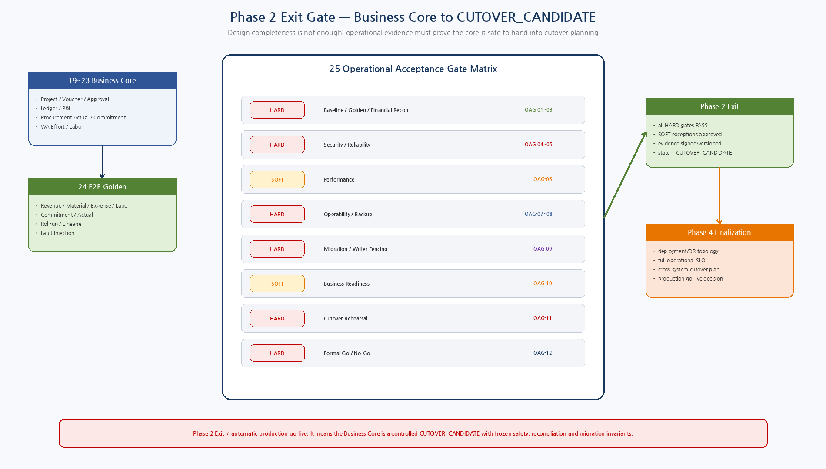
Figure 1. 19~24 Business Core/Golden Evidence를 12개 Operational Gate로 평가하여 CUTOVER_CANDIDATE로 만드는 Phase 2 Exit.

2. Design Principles
ID | Decision | Implementation Meaning
CUT-DD-01 | Exit Gate, not automatic Go-Live | Phase 2 completion produces a CUTOVER_CANDIDATE; final deployment/DR topology and production go-live are finalized in Phase 4.
CUT-DD-02 | Evidence-based acceptance | Every gate requires versioned evidence; verbal confidence or API success alone is insufficient.
CUT-DD-03 | Hard gates cannot be waived | Financial reconciliation, security, reliability, backup/restore, migration/writer fencing and rehearsal are mandatory.
CUT-DD-04 | Soft exceptions are bounded | Only explicitly allowed soft gates may use approved exception with owner, mitigation and expiry.
CUT-DD-05 | One writer always | DUAL_RUN_VALIDATION compares outcomes while exactly one system remains authoritative writer.
CUT-DD-06 | Cutover is transactional governance | Baseline freeze, backup, fence, delta, reconciliation, Golden, switch, smoke, observe and legacy-read-only are ordered controlled steps.
CUT-DD-07 | Failback is not DB rollback | Committed NeX facts require freeze/reconciliation/delta handling; immutable financial history is never deleted to simulate rollback.
CUT-DD-08 | Read models must converge | P/L/lineage projections may lag briefly but must converge to Ledger before acceptance/cutover PASS.
CUT-DD-09 | Operations owns runtime evidence | Dashboards, alerts, runbooks, owners and recovery tests are acceptance evidence, not post-go-live TODOs.
CUT-DD-10 | Migration is domain-scoped | SoR transitions are recorded per Project/Account/Approval/Voucher/Procurement/Ledger/Labor domain with explicit authoritative writer.

3. Operational Acceptance Gate Matrix
Gate | Severity | Area | Acceptance Rule | Owner
OAG-01 | HARD | Release / Contract Baseline | Frozen release, schema/API/Skill/Policy/mapping hashes | Architecture Owner
OAG-02 | HARD | Golden PASS | 24 normal path + required fault cases PASS | QA Owner
OAG-03 | HARD | Financial Reconciliation | Zero unexplained Voucher/Ledger/Commitment/Labor/P-L difference | Finance Owner
OAG-04 | HARD | Security / Human Gate | No critical bypass; R4/R5 reauth/gate/kill-switch verified | Security Owner
OAG-05 | HARD | Reliability | Idempotency/duplicate/unknown-commit recovery proven | Runtime Owner
OAG-06 | SOFT | Performance | Release SLA and bounded queue/projection lag met | Operations Owner
OAG-07 | HARD | Operability | Dashboards/alerts/runbooks/on-call owners tested | Operations Owner
OAG-08 | HARD | Backup / Restore | Restore proven; restored Golden/reconciliation valid | DB/Operations
OAG-09 | HARD | Migration / SoR | Mapping complete; one writer; dual-run not dual-write | Migration Owner
OAG-10 | SOFT | Business Readiness | UAT/access/training/exception procedure ready | Business Owner
OAG-11 | HARD | Cutover Rehearsal | Fence/delta/recon/switch/smoke/failback dry-run proven | Cutover Manager
OAG-12 | HARD | Formal Decision | All HARD PASS; SOFT exceptions approved | Go/No-Go Board

4. HARD NO-GO Criteria
- Required Golden/financial reconciliation has FAIL/MISSING/DUPLICATE/UNVERIFIED.
- Unresolved UNKNOWN_COMMIT_STATE or duplicate financial effect exists in cutover scope.
- Known critical authorization/HumanGate/kill-switch bypass exists.
- Canonical ID mapping is incomplete for cutover-scope financial master/transaction data.
- Legacy and NeX can both independently write the same target business domain.
- Backup restore has not been proven or restored data fails financial reconciliation.
- Writer fencing/failback rehearsal has not been proven.
- P/L/read-model projection cannot converge within agreed acceptance SLA.
- Critical operational owner/sign-off role is unavailable for the cutover window.
5. Exception Policy
Rule | Design
Eligible | Only SOFT gates explicitly marked `allowed_exception=true`.
Not eligible | All HARD gates including financial/security/recovery/migration/rehearsal.
Required fields | Description, residual risk, mitigation, owner, approvers, expiry.
Expiry | Exception automatically becomes invalid after expiry and must be re-evaluated.
Decision | GO_WITH_APPROVED_EXCEPTIONS is distinct from unconditional GO.

6. SoR Migration & Writer Fencing
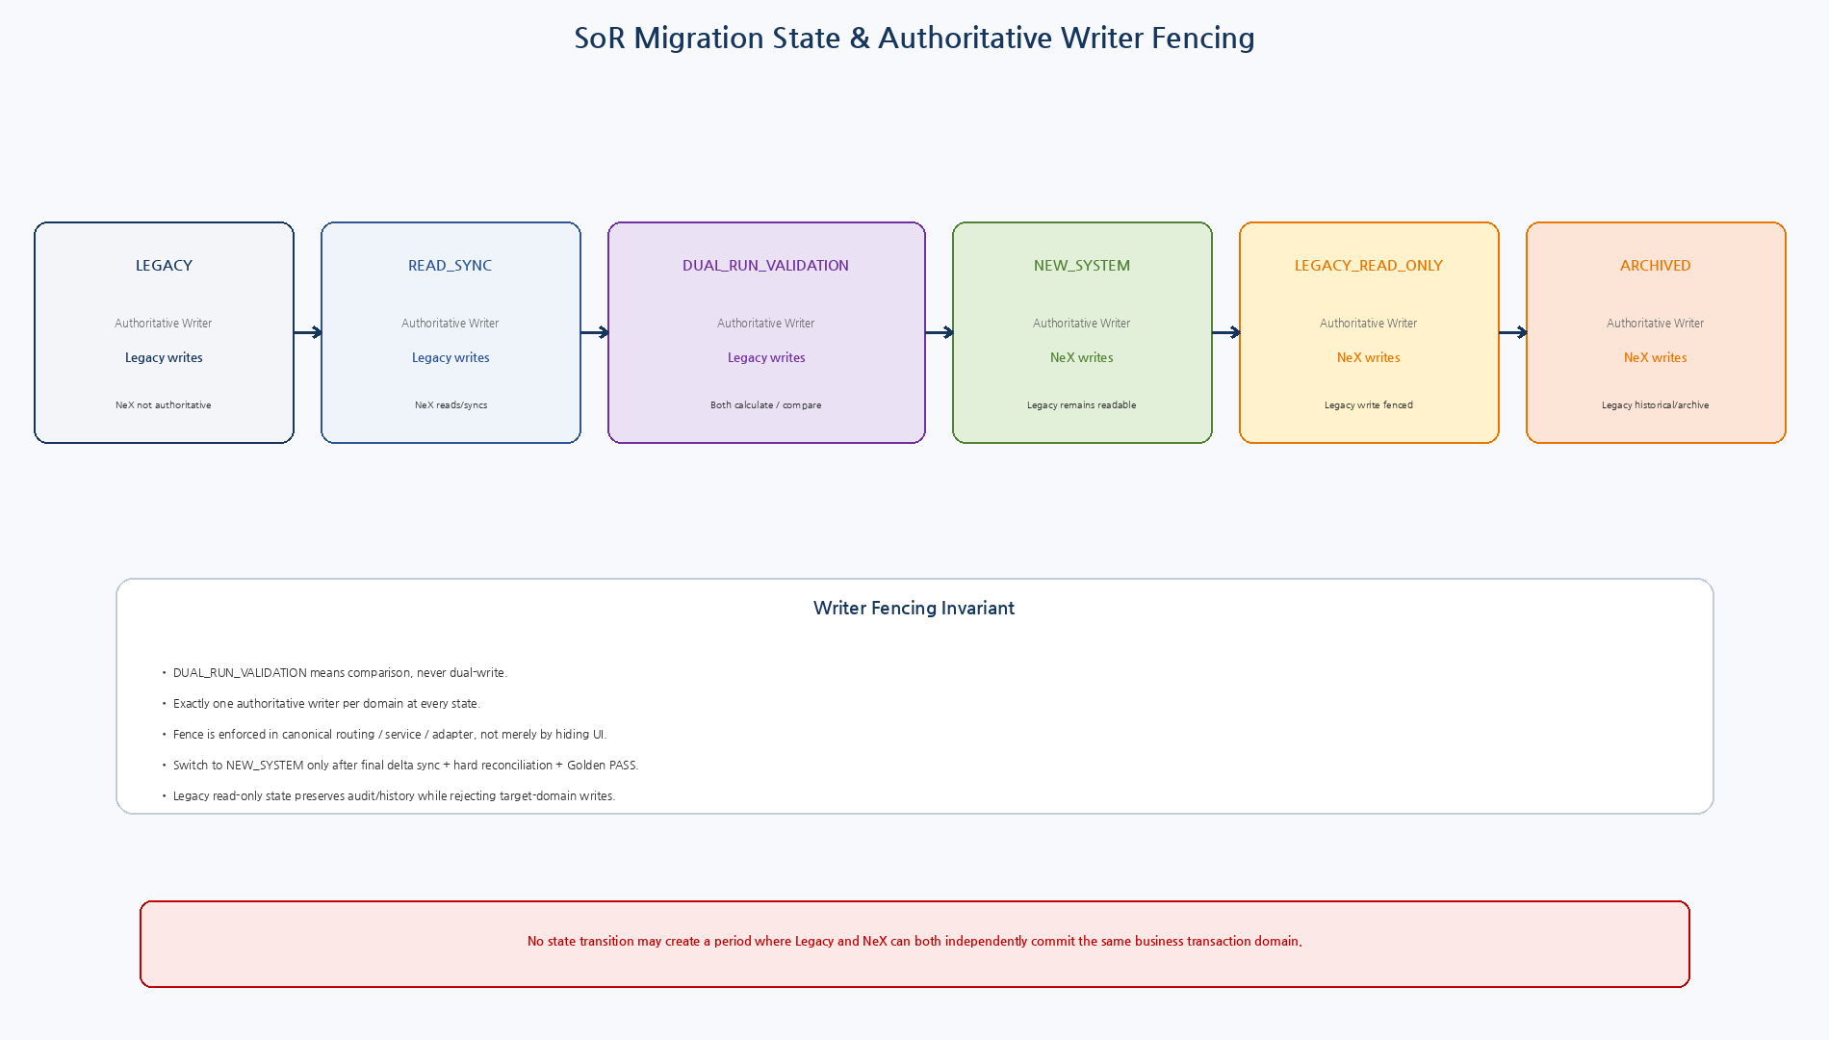
Figure 2. LEGACY→READ_SYNC→DUAL_RUN_VALIDATION→NEW_SYSTEM→LEGACY_READ_ONLY→ARCHIVED와 단일 Authoritative Writer invariant.

6.1 SoR State Contract
State | Writer Field | Real Writer | Meaning
LEGACY | LEGACY | Legacy | NeX not authoritative
READ_SYNC | LEGACY | Legacy | NeX imports/reads
DUAL_RUN_VALIDATION | LEGACY | Legacy | Both calculate/compare; only Legacy writes
NEW_SYSTEM | NEX | NeX | Canonical business writes switched to NeX
LEGACY_READ_ONLY | NEX | NeX | Legacy remains readable; target writes fenced
ARCHIVED | NEX | NeX | Legacy historical/archive only
7. Migration Acceptance
Check | Rule
Mapping completeness | All in-scope Project/Account/Transaction identifiers mapped or explicitly excluded with approved disposition.
Data shape | Required master/history fields transformed with schema/type/invariant checks.
Financial facts | Migrated source/ledger/P-L sample/complete scope reconciles with zero unexplained economic difference.
Open transactions | Pending Approval/Voucher/PO/Invoice/Labor states have explicit migration/resume policy.
Idempotency history | Cutover cannot re-create already committed business effects due missing operation identity.
Trace/evidence | Required source/evidence/approval references remain resolvable after migration.
Closed period history | Historical financial facts remain immutable and queryable.
Legacy compare | Dual-run compares canonical economic result, not only raw row counts.

8. Controlled Cutover Runbook
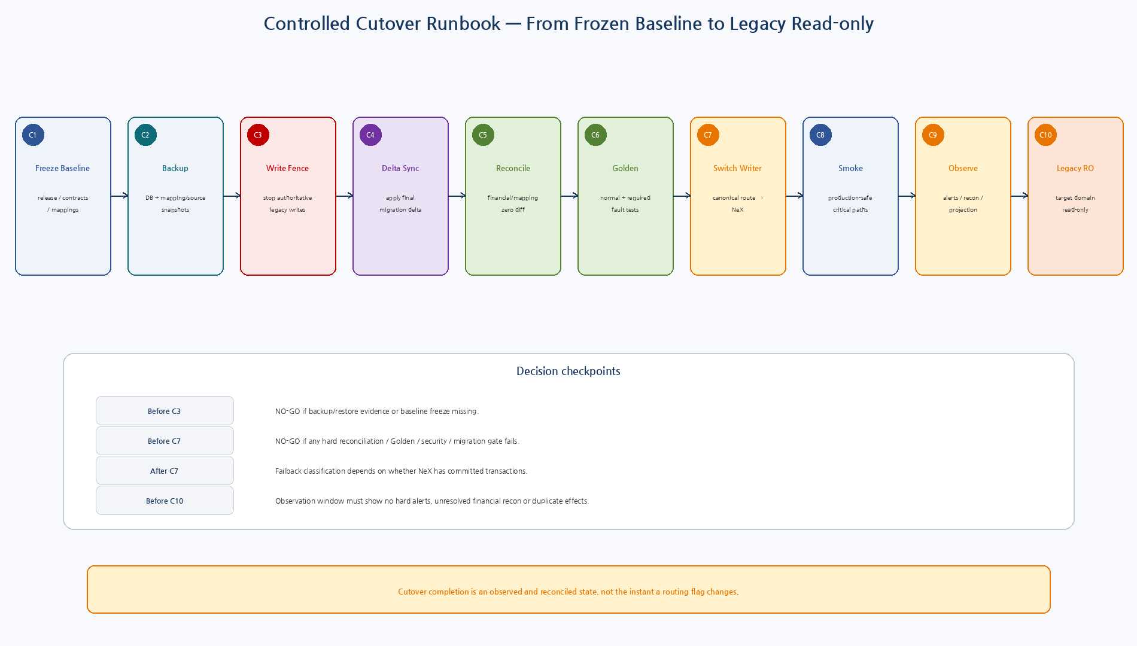
Figure 3. Frozen baseline에서 Legacy Read-only까지 C1~C10의 ordered cutover와 decision checkpoint.

8.1 Cutover Step Contract
Step | Phase | Success Condition
C1 | Freeze Baseline | Freeze release/config/schema/mapping hashes
C2 | Backup / Snapshot | Create verified DB/source/mapping snapshots
C3 | Write Fence | Fence authoritative Legacy writes for target scope
C4 | Delta Sync | Apply final target-domain delta
C5 | Reconcile | Run migration/financial hard checks
C6 | Golden Run | Run EBC Golden + required fault/smoke
C7 | Switch Writer | Canonical route/SoR record → NeX
C8 | Business Smoke | Production-safe Project/Voucher/Approval/Ledger/P-L smoke
C9 | Observe | Monitor alerts/reconciliation/projection within window
C10 | Legacy Read-only | Keep legacy query/history, reject target-domain writes

9. Go / No-Go & Controlled Failback
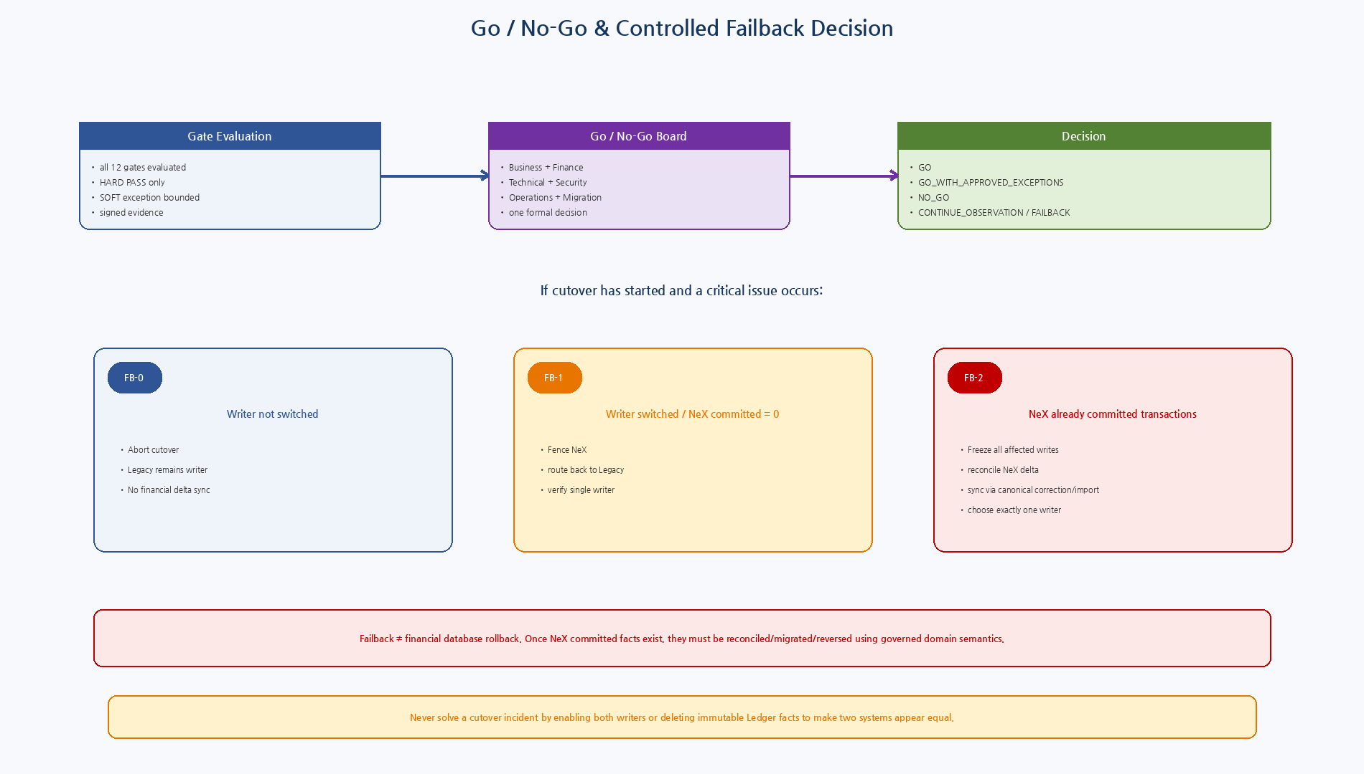
Figure 4. Formal Go/No-Go Board와 Writer Switch 전/후 committed fact 여부에 따른 FB-0/1/2.

9.1 Failback Classes
Class | Condition | Rule
FB-0 | Before writer switch | Abort cutover; Legacy remains writer; no delta reconciliation required.
FB-1 | After switch, NeX committed transactions = 0 | Fence NeX and switch canonical route back to Legacy; verify one writer.
FB-2 | After NeX committed transactions > 0 | Freeze all affected writes → snapshot/reconcile NeX delta → migrate/reverse via domain rules → choose one writer.
10. Operability Acceptance
Area | Required Evidence
Dashboards | Transaction error/unknown commit, outbox/queue age, approval wait, projection lag, reconciliation backlog, cutover state.
Alerts | Hard financial/security/recovery conditions page an owner, not merely log.
Runbooks | Unknown commit, duplicate effect, approval issue, projection lag, backup restore, cutover abort/failback.
Ownership | Business, Finance, Security, Runtime, Database, Operations, Migration and Cutover Manager named for window.
Audit | Every writer switch, gate decision, exception, backup, reconciliation and failback action is append-oriented evidence.
11. Backup / Restore Acceptance
Area | Required Evidence
Pre-cutover backup | Database plus external source/mapping/config snapshot refs.
Restore proof | Restore to isolated environment, not merely ‘backup command succeeded’.
Post-restore validation | Golden critical subset + financial reconciliation + lineage queries.
RPO/RTO | Concrete targets finalized in Phase 4 Deployment/Operation design; Phase 2 requires measured restore evidence and no silent lineage loss.
12. Business Operational Readiness
Role / Area | Readiness
Finance | Voucher/Approval/Ledger/P-L/reversal/reconciliation operational procedures validated.
Procurement | Requisition/PO/Invoice exception/commitment/actual workflow validated.
Project users | Project attribution/selection and P/L drill-down understood.
Support/Operations | Incident routing and Runbook ownership confirmed.
Access | RoleBinding/Scope matrix validated for normal and emergency operations.
Training | Critical users know how to stop/escalate; cutover does not depend on hidden developer-only knowledge.
13. Formal Go / No-Go Decision
Decision | Condition
GO | All HARD gates PASS; all SOFT gates PASS; no open invalid exception.
GO_WITH_APPROVED_EXCEPTIONS | All HARD PASS; only allowed SOFT exceptions remain with owner/mitigation/expiry.
NO_GO | Any HARD FAIL/NOT_EVALUATED, invalid SOFT exception, or HARD NO-GO condition.
CONTINUE_OBSERVATION | Writer switched but observation/freshness/reconciliation evidence not sufficient for completion.
FAILBACK | Post-switch critical issue triggers FB-1/FB-2 controlled path.
14. Machine-readable Reference Package
Artifact | Validation / Purpose
7 JSON Schemas | Draft 2020-12 meta-schema PASS
12 Gate Catalog | All gate objects schema-valid
HARD NO-GO checklist | Machine-readable release blocker list
Gate Evaluator | All PASS → GO smoke PASS
SoR State Machine | Single-writer + DUAL_RUN→NEW_SYSTEM smoke PASS
Failback Classifier | FB-0 / FB-1 / FB-2 smoke PASS
001_cutover_evidence.sql | Reference cutover/check/SoR evidence model
002_pre_cutover_hard_checks.sql | Unknown commit/outbox/projection/labor hard checks
003_writer_fencing_transition.sql | Single-writer state transition reference
004_failback_reference.sql | Controlled failback semantics
Reference SQL/ops schema는 Phase 2 acceptance baseline이며 실제 운영 DB에 아직 적용하지 않았다. Phase 4에서 Deployment/Operation architecture와 정렬한 뒤 production migration으로 고정한다.
15. Phase 2 Exit Criteria
- 19~24 deliverables and release configuration are frozen.
- OAG-01~OAG-12 are evaluated with versioned evidence.
- Every HARD gate is PASS.
- Any allowed SOFT exception is approved, owned and time-bounded.
- Formal Go/No-Go decision evidence exists.
- Every cutover domain has a SoR transition and authoritative-writer record.
- Business Core may be declared CUTOVER_CANDIDATE.
16. Phase 3 Platform Services Handoff
ID | Document | Focus
26 | NeX-OA SRS & Detailed Design v2.0 | Auth/Identity/RoleBinding/Service Account
27 | NeX-CX SRS & Detailed Design v2.0 | Ingestion/BM25/pgvector/Evidence
28 | NeX-MO SRS & Detailed Design v2.0 | Embedding/Reranker/LLM Serving
29 | NeX-AE-API SRS v2.0 | Agent Control Plane requirements
30 | NeX-AE-API Detailed Design v2.0 | Runtime/WC/NSL/CX/MO integration
31 | NeX-AE-WEB SRS & Detailed Design v2.0 | Unified Workspace
32 | NeX-AG SRS & Detailed Design v2.0 | Operations/Governance
Next — 26 NeX-OA
Phase 3는 `26_NeX_OA_SRS_and_Detailed_Design_v2.0`으로 시작한다. 19~25에서 Freeze한 Business Transaction/Financial SoR와 Human Gate/Writer Fencing 원칙은 Platform Service가 소비하는 상위 Constraint이며, OA/CX/MO/AE/AG 설계가 이를 다시 변경하지 않는다.

