Duysenbaeva Aynura Veb dasturlew 3-tapsirma
Uliwma korinisi
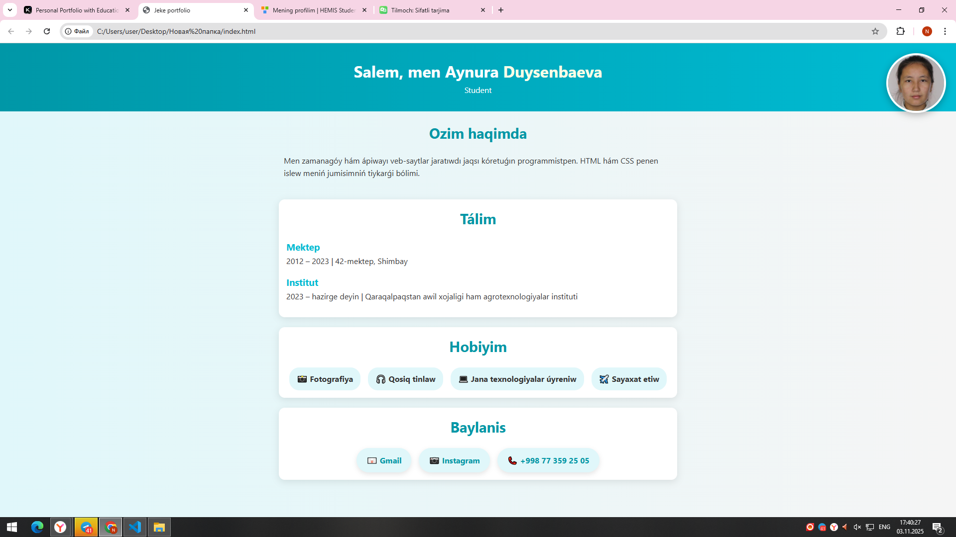

Html kodi
<!DOCTYPE html>
<html lang="uz">
<head>
<meta charset="UTF-8" />
<meta name="viewport" content="width=device-width, initial-scale=1.0"/>
<title>Jeke portfolio</title>
<link rel="stylesheet" href="style.css" />
</head>
<body>

<header>
<img src="https://hemis.tdaunukus.uz/static/crop/2/1/120_140_90_2166771066.jpg" alt="Profil" class="profile-img">
<h1>Salem, men Aynura <span>Duysenbaeva </span></h1>
<p>Student</p>
</header>

<section class="about">
<h2>Ozim haqimda</h2>
<p>Men zamanagóy hám ápiwayı veb-saytlar jaratıwdı jaqsı kóretuǵın programmistpen. HTML hám CSS penen islew meniń jumisimniń tiykarǵi bólimi.</p>
</section>

<section class="education">
<h2>Tálim</h2>
<div class="edu-card">
<h3>Mektep</h3>
<p>2012 – 2023 | 10-mektep, Shimbay</p>
</div>
<div class="edu-card">
<h3>Institut</h3>
<p>2023 – hazirge deyin | Qaraqalpaqstan awil xojaligi ham agrotexnologiyalar instituti</p>
</div>
</section>

<section class="hobbies">
<h2>Hobiyim</h2>
<ul>
<li>📸 Fotografiya</li>
<li>🎧 Qosiq tinlaw</li>
<li>💻 Jana texnologiyalar úyreniw</li>
<li>✈️ Sayaxat etiw</li>
</ul>
</section>

<section class="contact">
<h2>Baylanis</h2>
<div class="social-links">
<a href="duysenbaevaaynura@gmail.com">📧 Gmail</a>
<a href="https://instagram.com/nurik.ainusha_9405" target="_blank">📷 Instagram</a>
<a href="tel:+998773592505">📞 +998 77 359 25 05</a>
</div>
</section>

</body>
</html>

Css kodi
* {
margin: 0;
padding: 0;
box-sizing: border-box;
}

body {
font-family: 'Segoe UI', sans-serif;
background: linear-gradient(to right, #e0f7fa, #f5f5f5);
color: #333;
line-height: 1.6;
animation: fadeIn 1.5s ease-in;
}

header {
position: relative;
background: linear-gradient(to right, #0097a7, #00bcd4);
color: #fff;
padding: 30px 15px;
text-align: center;
animation: slideDown 1s ease-out;
}

.profile-img {
width: 120px;
height: 120px;
border-radius: 50%;
object-fit: cover;
border: 4px solid #fff;
box-shadow: 0 4px 15px rgba(0, 0, 0, 0.3);
position: absolute;
top: 20px;
right: 20px;
animation: fadeIn 1.5s ease-in;
transition: transform 0.3s ease;
}

.profile-img:hover {
transform: scale(1.1);
}

header h1 span {
color: #fffde7;
}

section {
padding: 20px 10px;
max-width: 800px;
margin: auto;
}

h2 {
text-align: center;
margin-bottom: 20px;
font-size: 1.8em;
color: #0097a7;
}

.education, .hobbies, .contact {
background: #fff;
margin: 20px auto;
border-radius: 12px;
box-shadow: 0 4px 15px rgba(0,0,0,0.1);
padding: 15px;
transition: transform 0.3s ease;
}

.education:hover, .hobbies:hover, .contact:hover {
transform: translateY(-5px);
}

.edu-card {
margin-bottom: 15px;
}

.edu-card h3 {
color: #00bcd4;
}

.hobbies ul {
list-style: none;
display: flex;
flex-wrap: wrap;
gap: 15px;
justify-content: center;
}

.hobbies li {
background: #e0f7fa;
padding: 10px 15px;
border-radius: 20px;
font-weight: bold;
transition: transform 0.3s ease;
}

.hobbies li:hover {
transform: scale(1.05);
background: #b2ebf2;
}

.social-links {
display: flex;
flex-wrap: wrap;
gap: 15px;
justify-content: center;
}

.social-links a {
text-decoration: none;
color: #0097a7;
background: #e0f7fa;
padding: 12px 20px;
border-radius: 30px;
font-weight: bold;
transition: all 0.3s ease;
box-shadow: 0 4px 10px rgba(0,0,0,0.1);
}

.social-links a:hover {
background: #00bcd4;
color: #fff;
transform: scale(1.05);
}

footer {
text-align: center;
padding: 20px;
background: #222;
color: #fff;
margin-top: 40px;
}

@keyframes fadeIn {
from {
opacity: 0;
}
to {
opacity: 1;
}
}

@keyframes slideDown {
from {
transform: translateY(-30px);
opacity: 0;
}
to {
transform: translateY(0);
opacity: 1;
}
}

